NEB · CLASS 11 CHEMISTRY
Probable Long Questions with Full Model Answers
Atomic Structure · Chemical Bonding (up to types of bonds) · Periodic Table & Trends

Built strictly from the NEB Curriculum 2076 (Grade 11, Che. 201) syllabus scope:
Unit 3 – Atomic Structure (3.1–3.13) | Unit 4 – Periodic Classification (4.1–4.4) | Unit 5 – Chemical Bonding (5.1–5.13).

How to use this book. Each question gives the board-style wording, why it keeps appearing, and a complete academic answer with every point the marker looks for — definitions, named postulates, equations, worked examples and the labelled diagrams. Read the answer first, then cover it and reconstruct it from memory. Memorise the short “must-write” lines; they are what earn full marks.

Contents & Exam Strategy
Contents
- Section A — Atomic Structure: 6 long questions (Rutherford, Bohr + H spectrum, de Broglie & Heisenberg, quantum-mechanical model & quantum numbers, Aufbau/Pauli/Hund & configurations, orbital shapes).
- Section B — Chemical Bonding (up to types): 11 long questions (octet rule, ionic bond & Fajan, covalent & σ/π, coordinate bond, ionic vs covalent properties, Lewis structures, resonance, VSEPR, the four types of bonding forces, valence-bond theory & hybridisation, and bond characteristics — bond length, ionic character, dipole moment).
- Section C — Periodic Table & Trends: 7 long questions (modern law & table layout, effective nuclear charge, atomic & ionic radii, ionization energy, electron affinity, electronegativity & metallic character, inert N₂ & H/He).
What the NEB marker actually awards
- A correct definition in the first line (usually 1 mark).
- Named postulates / factors / a numbered list, complete (the bulk of the marks).
- At least one concrete example with numbers or formulae where the concept allows it.
- A labelled diagram exactly where the syllabus demands one (orbitals, overlaps, VSEPR, scattering setup).
- Closing with the defect / anomaly / exception — top-mark questions always reward the exception.
Verb discipline (do not mix)
- Describe = what happens / how it is done — sequence + labels + diagram.
- Discuss = explain + give reasons + state exceptions.
- Explain = reason + supporting evidence/equation; always ends with the “why”.

SECTION A — Atomic Structure
Syllabus 3.1–3.13: Rutherford model & its limits, Bohr postulates & the hydrogen spectrum, Bohr's defects, de Broglie, Heisenberg, probability idea, quantum numbers, s/p orbital shapes, Aufbau, Pauli, Hund, configurations up to Z = 30.

Q. A1 Rutherford's α-particle scattering experiment and his atomic model
QUESTION: Describe Rutherford's α-particle scattering experiment and the conclusions he drew about the structure of the atom. State the main limitations of this model.
Why it is probable (board pattern): The single most frequent Atomic-Structure long question. NEB repeatedly pairs 'describe the experiment' with 'state its limitations' in the same mark. The experiment is drawn from syllabus 3.1–3.2.
The experiment (as it was done, 1911)
- A radioactive source (radium / polonium) emitted a narrow beam of fast α-particles (helium nuclei, +2e, ~1% c).
- The beam was fired at a very thin gold foil (a few thousand atoms thick) inside an evacuated chamber.
- A thin zinc-sulphide (ZnS) screen, mounted on a movable arm, could be placed at any angle around the foil; each α-particle hitting it produced a tiny flash (scintillation) that was counted through a microscope.
Observations
- Most of the α-particles passed straight through the foil with little or no deflection.
- A few were deflected through small angles.
- A very few (about 1 in 20 000) were scattered through angles greater than 90°, some even bounced straight back.
Conclusions (Rutherford's nuclear model)
- Since almost all α-particles passed through, the atom is mostly empty space.
- Since a few were strongly repelled backward, the entire positive charge and nearly all the mass are concentrated in a tiny central region — the nucleus.
- The nucleus is positively charged and about 10⁻¹⁴ m in radius, whereas the atom is ~10⁻¹⁰ m (nucleus is ~10 000 times smaller).
- Electrons revolve around the nucleus in the surrounding space.
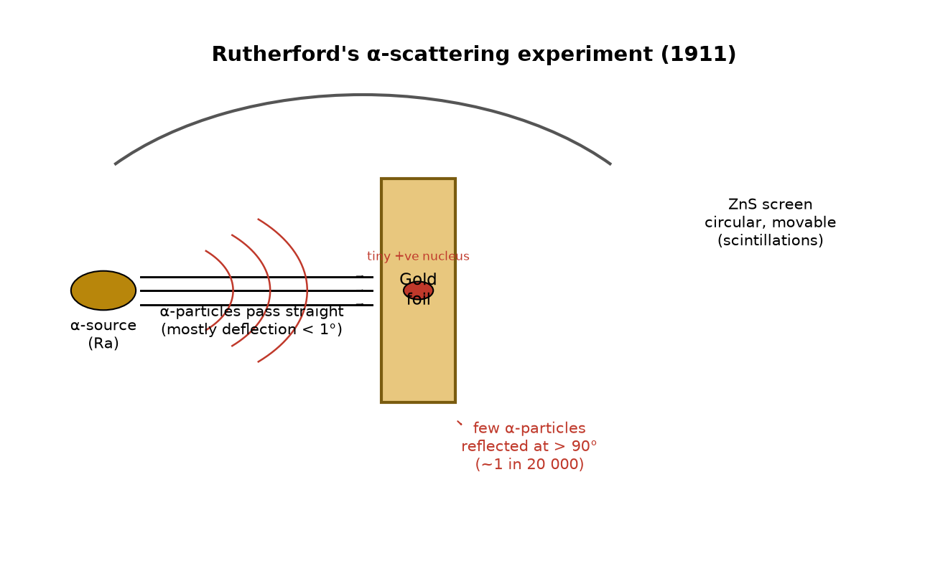
Fig. A1 — Rutherford's α-scattering setup: α-source, thin gold foil, movable circular ZnS screen.
Limitations of Rutherford's model
- It could not explain why revolving electrons did not spiral into the nucleus by continuously radiating energy (per classical electromagnetism), i.e. it could not account for atomic stability.
- It gave no line spectrum; the atom should have given a continuous spectrum, which is not observed.
- It treated electrons classically and contained no idea of quantized energy.
- It could not explain the spectra of multi-electron atoms or the periodicity of properties.

Q. A2 Bohr's postulates and the line spectrum of hydrogen
QUESTION: State the postulates of Bohr's atomic model. Using them, explain how Bohr's theory explains the line spectrum of the hydrogen atom. Discuss the defects of Bohr's theory.
Why it is probable (board pattern): Examined every year. The question has three parts (postulates → spectrum → defects) and is worth the most marks in Atomic Structure. Bohr's model is syllabus 3.3–3.5.
Postulates of Bohr's model
- An electron moves in a fixed circular orbit (stationary orbit) of definite energy without radiating, even though a classical orbiting charge should radiate.
- Only those orbits are allowed for which the angular momentum is an integral multiple of h/2π:
mvr = n·h/2π , n = 1, 2, 3 …
- Energy is emitted or absorbed only when the electron jumps between two stationary orbits; the photon frequency is
hν = E₂ − E₁ (= hc/λ).
- For hydrogen the energy of the nth orbit is quantized:
Eₙ = −13.6/n eV (or Eₙ = −2.18×10⁻¹⁸/n² J).
Bohr's explanation of the hydrogen line spectrum
Because the orbits have discrete energies, an electron falling from a higher orbit n₂ to a lower orbit n₁ can emit only a fixed amount of energy, E = hν. This produces a discrete (line) spectrum, not a continuous one. The wavenumber of each line is given by the Rydberg formula:
1/λ = R_H (1/n₁² − 1/n₂²), R_H = 1.097×10⁷ m⁻¹ (n₂ > n₁).
- Lyman series (n₁ = 1): ultraviolet; the strongest UV lines of H. (n₂ = 2 → Hα = 121.6 nm).
- Balmer series (n₁ = 2): visible lines (Hα 656.3 nm red, Hβ 486.1 nm, Hγ 434.1 nm, Hδ 410.2 nm).
- Paschen (n₁=3), Brackett (n₁=4): infrared series.
- The fact that each observed line matches a calculated value from this formula was the key proof of quantized orbits.
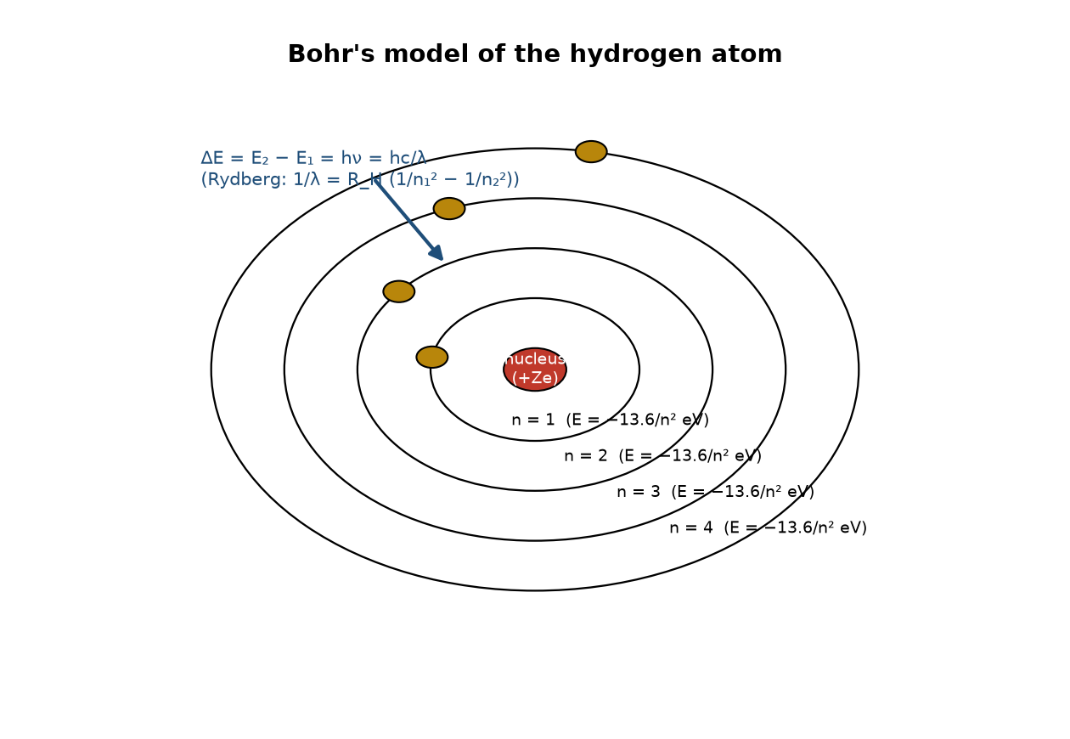
Fig. A2 — Bohr orbits and a downward transition (n₂ → n₁) that emits a photon of energy ΔE = hν.
Defects of Bohr's theory
- Explains only one-electron (H-like) species — it fails for helium and multi-electron atoms.
- Ignores the wave nature of the electron (de Broglie) and electron spin.
- Mixes classical circular orbits with a quantum 'jump'; the jump itself is unexplained.
- Cannot predict the relative intensities of spectral lines or their fine structure.
- Fails in external electric/magnetic fields (no Stark/Zeeman splitting).
- The stationary-orbit postulate was an ad hoc rule, not derived from first principles.

Q. A3 de Broglie's wave equation and Heisenberg's uncertainty principle
QUESTION: Write de Broglie's wave equation and Heisenberg's uncertainty principle. Discuss the significance of each in the development of the quantum-mechanical model of the atom.
Why it is probable (board pattern): A regular 'describe the two ideas + significance' question. Bridges Bohr to the wave-mechanical model (syllabus 3.6–3.8). Markers want the formulas and the physical meaning, not just the names.
de Broglie's hypothesis (wave nature of matter)
Every moving particle of mass m and velocity v is associated with a wave of wavelength
λ = h / (m v) [h = Planck's constant].
- For electrons in an atom this means the electron behaves as a standing matter-wave around the nucleus.
- An orbit is stable only when an integral number of wavelengths fits around it (2πr = nλ), which reproduces Bohr's angular-momentum condition mvr = nh/2π.
- Significance: it justifies quantization, shows why electrons have no fixed classical path, and is the reason diffraction of electrons (Davisson–Germer) was observed.
Heisenberg's uncertainty principle
Δx · Δp ≥ h / 4π
It is impossible to determine exactly and simultaneously the position (Δx) and momentum (Δp) of a particle. The smaller the uncertainty in position, the larger the uncertainty in momentum.
- Significance: a moving electron cannot have a well-defined orbit; the concept of a definite path is replaced by an orbital — a three-dimensional region of high probability of finding the electron.
- This is the direct reason Bohr's orbits were abandoned for the quantum-mechanical (Schrödinger) model.
- For macroscopic bodies Δx·Δp is negligible, which is why the principle is only visible at the atomic scale.

Q. A4 Quantum-mechanical model and the four quantum numbers
QUESTION: Explain the quantum-mechanical (wave-mechanical) model of the atom and describe the four quantum numbers with suitable examples.
Why it is probable (board pattern): Core descriptive question (syllabus 3.8–3.9). The 'example set' at the end is where most students lose marks — always finish with a concrete electron, e.g. a 2p electron.
The wave-mechanical picture
Instead of an orbit, the electron is described by a wave function ψ that is the solution of the Schrödinger wave equation. The square of the wave function, ψ² (probability density), tells where the electron is most likely to be found. An orbital is therefore a region of space around the nucleus in which the probability of finding the electron is high (~90%). The orbital is identified by four quantum numbers, and its properties (size, shape, orientation, spin) are all encoded in them.
The four quantum numbers
- Principal quantum number, n = 1, 2, 3 … fixes the shell, the size and the main energy of the orbital. Larger n → larger, higher-energy orbital.
- Azimuthal (orbital angular-momentum) quantum number, ℓ = 0, 1, …, (n−1) fixes the subshell / shape. ℓ = 0 → s, 1 → p, 2 → d, 3 → f.
- Magnetic quantum number, m_ℓ = −ℓ … 0 … +ℓ fixes the orientation of the orbital in space; there are (2ℓ + 1) values, hence that many orbitals per subshell (s:1, p:3, d:5, f:7).
- Spin quantum number, m_s = +½ or −½ describes the electron spin; an orbital holds at most two electrons with opposite spins (Pauli).
Worked example — a 2p electron: n = 2, ℓ = 1, m_ℓ ∈ {−1, 0, +1}, m_s = +½ or −½. For a 3d electron: n = 3, ℓ = 2, m_ℓ ∈ {−2…+2}.
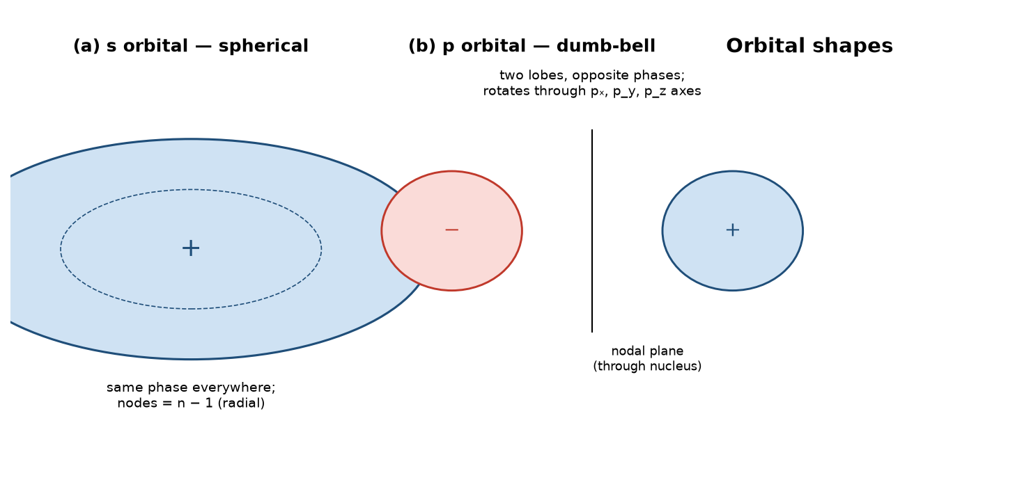
Fig. A4 — shape of the s orbital (spherical) and the p orbital (dumb-bell, opposite phases, nodal plane).

Q. A5 Aufbau, Pauli, Hund — and configurations up to Z = 30 (with exceptions)
QUESTION: State the Aufbau principle, Pauli's exclusion principle and Hund's rule of maximum multiplicity. Using these, write the electronic configurations of atoms and ions up to atomic number 30, explaining the cases of chromium and copper.
Why it is probable (board pattern): This is a favourite and recurring question because it tests application (not just recall). The Cr and Cu exceptions and the ion configurations (Fe²⁺, Cu²⁺) are the 'top-mark' part (syllabus 3.11–3.13).
The three rules
- Aufbau principle — electrons occupy the orbital of lowest energy first, filling in order of increasing (n + ℓ); when (n + ℓ) is equal, the smaller n is filled first. The order (Madelung) is shown below.
- Pauli exclusion principle — no two electrons in the same atom may have all four quantum numbers identical; an orbital holds at most two electrons, and they must have opposite spins.
- Hund's rule of maximum multiplicity — before any pairing begins, electrons occupy degenerate orbitals singly with parallel spins; this minimises electron–electron repulsion and gives extra stability.
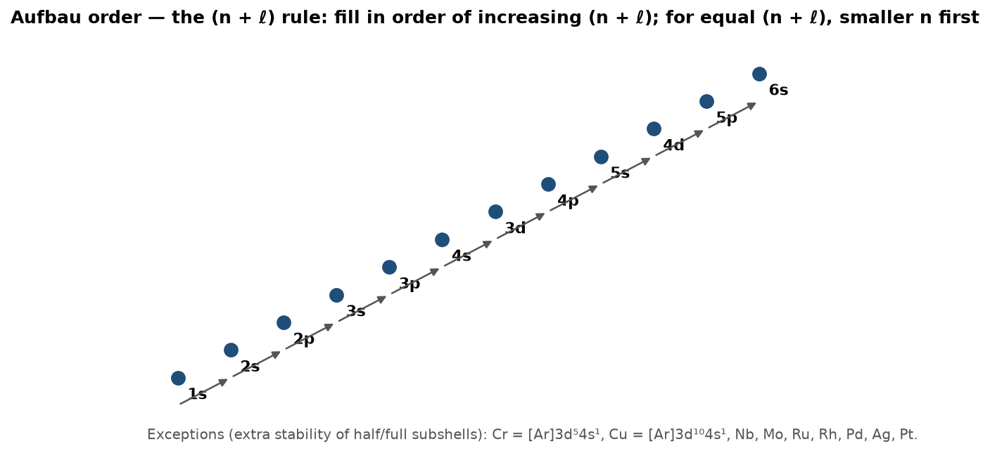
Fig. A5 — Aufbau (n + ℓ) filling order and the Cr / Cu exceptions called out.
Configurations and the two exceptions
- Sc (21) = [Ar] 3d¹4s²; Ti (22) = [Ar] 3d²4s²; V (23) = [Ar] 3d³4s².
- Cr (24) = [Ar] 3d⁵4s¹ (NOT 3d⁴4s²) — a half-filled 3d⁵ is extra-stable, so one 4s electron is promoted to 3d.
- Mn (25) = [Ar] 3d⁵4s² — naturally half-filled, no exception needed.
- Fe (26) = [Ar] 3d⁶4s²; Co (27) = [Ar] 3d⁷4s²; Ni (28) = [Ar] 3d⁸4s².
- Cu (29) = [Ar] 3d¹⁰4s¹ (NOT 3d⁹4s²) — a fully-filled 3d¹⁰ is extra-stable.
- Zn (30) = [Ar] 3d¹⁰4s².
Common ions (remove 4s before 3d)
- Fe²⁺ = [Ar] 3d⁶ (loses the two 4s electrons first), Fe³⁺ = [Ar] 3d⁵ (extra-stable, why Fe³⁺ is more stable).
- Cu²⁺ = [Ar] 3d⁹, Zn²⁺ = [Ar] 3d¹⁰ (fully filled d — chemically inert / diamagnetic).

Q. A6 Shapes of the s and p orbitals
QUESTION: Describe the shapes of the s and p orbitals. Why does a p orbital have a nodal plane at the nucleus?
Why it is probable (board pattern): Short but repeated; often combined with the quantum-numbers question. Must be answered with a labelled sketch (syllabus 3.10).
s orbital
Spherical, symmetric about the nucleus; the electron density is the same in every direction. The number of radial nodes is (n − 1): 1s has none, 2s has one, 3s has two. The s orbital has no preferred orientation in space.
p orbital
Each p orbital is dumb-bell (two-lobed) with a nodal plane passing through the nucleus; the two lobes carry opposite phases (one shaded, one unshaded). Three mutually perpendicular p orbitals exist — pₓ, p_y, p_z — all degenerate (equal energy). The nodal plane exists because the 2p wave function changes sign at the nucleus: the probability density ψ² is zero on the plane containing the nucleus.
This shape is exactly the diagram in Fig. A4 above; redraw it with phases labelled when writing the exam answer.

SECTION B — Chemical Bonding (up to types of bonds)
Syllabus 5.1–5.13: octet theory; ionic bond & its properties; covalent & coordinate covalent bonds & their properties; Lewis structures; resonance; VSEPR shapes; valence-bond idea; hybridization (s, p only); bond length, ionic character, dipole moment; van der Waals forces & molecular solids; hydrogen bonding; metallic bonding. This section is written 'up to the types of bonds' as requested — ionic, covalent (σ/π), coordinate, and the intermolecular forces (van der Waals, H-bond, metallic) — with VBT/hybridization and bond-characteristics included as the two bonding sub-topics most often asked alongside these.

Q. B1 The octet (electrovalency / duplet) rule and its limitations
QUESTION: Explain the octet rule (duplet rule) as a basis of chemical bonding. Discuss the main limitations of this rule.
Why it is probable (board pattern): Always the opening bonding question (syllabus 5.1). The 'limitations' half is where marks are won — list at least four distinct cases.
The rule
Atoms of the second and third periods (C, N, O, F and the alkali/alkaline-earth metals) tend to gain, lose or share electrons so that their valence shell holds eight electrons — a noble-gas (ns²np⁶) configuration. Hydrogen (and helium) are the duplet case: they become stable with two electrons (1s²). This tendency to complete the outer shell is the driving force behind ionic, covalent and coordinate bonding.
Limitations of the octet rule
- Hydrogen / helium — stable with 2 (duplet), not 8 electrons.
- Electron-deficient compounds — boron and beryllium are stable with 6 (BF₃) and 4 (BeCl₂) valence electrons; they are electron acceptors, not octet species.
- Odd-electron molecules — NO, NO₂, O₂ have unpaired electrons and cannot satisfy the octet for every atom.
- Expanded octets — third-period and heavier elements (P, S, Cl, Xe) can hold more than eight: PCl₅ (10), SF₆ (12), XeF₄ (14), because they have vacant d-orbitals / a large, polarizable shell.
- Coordinate and multicentre bonds — the shared pair can come from one atom only (coordinate), or three-centre delocalised bonding (e.g. in diborane) breaks the simple two-body octet picture.
- No quantitative information — the rule says whether a bond tends to form, but not the bond energy or the magnetic behaviour of the molecule.

Q. B2 The ionic (electrovalent) bond and its properties
QUESTION: Explain the formation of an ionic (electrovalent) bond and discuss the properties of ionic compounds. Explain how the ionic character of a bond is affected by the nature of the ions involved (Fajan's rules).
Why it is probable (board pattern): Extremely frequent (syllabus 5.2). Expect 'formation + properties + Fajan' in one 5-mark question. Give a concrete example (Na + Cl → NaCl) and at least three Fajan factors.
Formation
A highly electropositive atom (low ionization energy, e.g. sodium) transfers its valence electron(s) to a highly electronegative atom (high electron affinity, e.g. chlorine).
Na → Na⁺ + e⁻ Cl + e⁻ → Cl⁻ Na⁺ + Cl⁻ → NaCl
The resulting oppositely charged ions are held together by electrostatic attraction — the ionic bond. The bond has no fixed direction: each ion is surrounded on all sides by ions of the opposite charge (no specific atom-to-atom pairing).
Properties of ionic compounds
- Exist as crystalline solids (giant ionic lattices) at room temperature, with high melting and boiling points (strong, non-directional Coulomb attraction).
- Soluble in polar solvents such as water; generally insoluble in non-polar organic solvents.
- Do not conduct electricity in the solid state (ions fixed), but conduct in the molten state or in aqueous solution (ions are free to move).
- Undergo fast ionic reactions; show no geometrical/optical isomerism; are not associated in solution.
- Reactivity is proportional to the charge on the ion: higher charges give stronger attraction and higher melting points (e.g. MgO mp > NaCl mp).
Factors affecting ionic character (Fajan's rules)
- Charge on the cation — higher cationic charge gives greater polarizing power, more covalent (e.g. Fe³⁺ > Fe²⁺).
- Size of the cation — a small cation polarizes the anion more, giving more covalent character (Ag⁺ is large and weakly polarizing, Be²⁺ small and strongly polarizing).
- Size of the anion — a large, easily-polarized anion (I⁻ > F⁻) gives more covalent character.
- Electronic configuration of the cation — d- and f-block cations (e.g. Zn²⁺, Cu⁺) have strong polarizing power and give more covalent compounds than s-/p-block cations of similar charge.
- Summary trend: maximum ionic character is shown by a large cation + small anion + low charge; the minimum (most covalent) character by a small, highly-charged cation + a large anion.

Q. B3 The covalent bond and the difference between σ and π bonds
QUESTION: Explain the covalent bond. Distinguish between single, double and triple bonds and between σ (sigma) and π (pi) bonds with examples.
Why it is probable (board pattern): One of the two most-asked bonding questions (syllabus 5.3, 5.10). A clean σ/π table plus a worked example (N₂, C₂H₄) is exactly what the answer should contain.
The covalent bond
When two atoms of similar electronegativity approach each other, each contributes one valence electron and the two are shared, so both atoms effectively complete their valence shells. The shared pair is attracted to both nuclei, and a minimum of potential energy (the bond) is reached at a definite internuclear distance — the bond length. If the two atoms differ in electronegativity the pair is shared unequally and the bond is polar (δ⁺—δ⁻).
Single, double, triple bonds
- Single bond = 1 shared pair = 1 σ bond (e.g. H–H, H–Cl).
- Double bond = 2 shared pairs = 1 σ + 1 π (e.g. C=C in ethylene, O=O).
- Triple bond = 3 shared pairs = 1 σ + 2 π (e.g. N≡N in dinitrogen, C≡C in ethyne).
- More shared pairs → shorter, stronger overall bond; but a π bond alone is weaker than a σ bond.
σ vs π bonds — the key distinctions
Property | σ (sigma) bond | π (pi) bond
Type of overlap | head-on / axial (end-to-end) | lateral / sideways
Electron density | along the internuclear axis | above and below the axis
Symmetry | cylindrically symmetric about the axis | has a nodal plane through the axis
Strength | stronger (more overlap) | weaker (less overlap)
Rotation | free rotation about the bond axis | rotation is restricted (gives cis–trans isomerism)
Example | the C–C σ in ethylene, H–H σ in H₂ | the C=C π in ethylene; N≡N two π in N₂

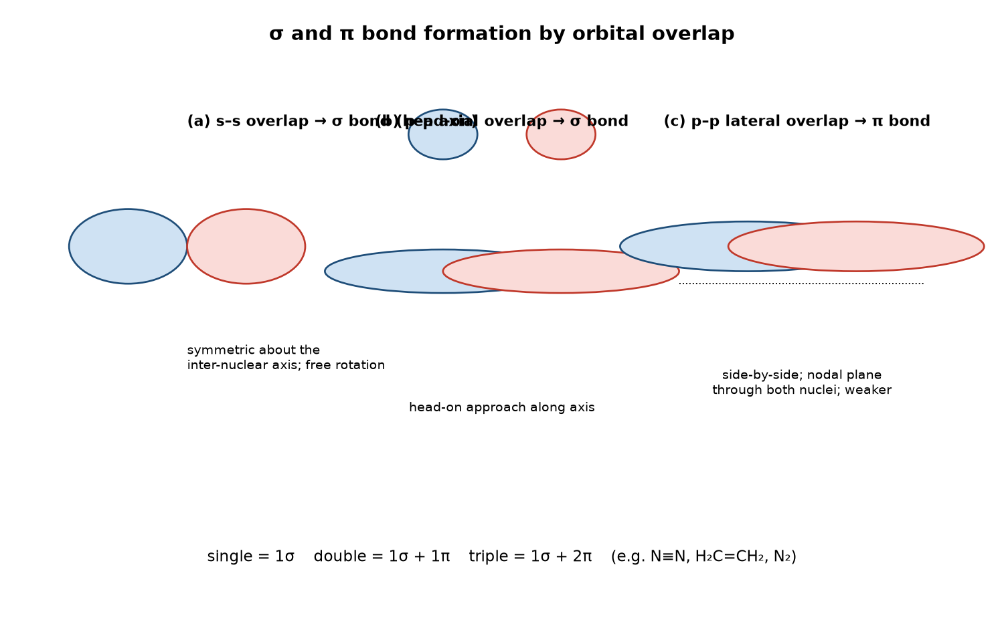
Fig. B3 — (a) s–s σ overlap, (b) p–p axial σ overlap, (c) p–p lateral π overlap.

Q. B4 The coordinate (dative) covalent bond
QUESTION: Explain the coordinate (dative) covalent bond. How does it differ from an ordinary covalent bond? Give two examples.
Why it is probable (board pattern): Regularly asked, usually alongside Lewis structures (syllabus 5.3). The 'difference from an ordinary covalent bond' line is the decisive point: both electrons come from one atom.
Definition
A coordinate (dative) bond is formed when one atom — the donor — supplies both electrons of the shared pair, and the other atom — the acceptor — provides only an empty orbital. It is shown with an arrow pointing from donor to acceptor (A → B). The donor must have a lone pair; the acceptor must have a vacant orbital.
Examples
- NH₃ + H⁺ → NH₄⁺ : nitrogen donates its lone pair to the empty 1s orbital of H⁺.
- F₃B + :NH₃ → F₃B→NH₃ : N donates its lone pair to the electron-deficient B (which had only 6 valence electrons).
- H₂O + H⁺ → H₃O⁺ ; Cu²⁺ forms [Cu(NH₃)₄]²⁺ by accepting four N lone pairs.
Difference from an ordinary covalent bond
- In an ordinary covalent bond each atom contributes one electron; in a coordinate bond one atom contributes both.
- Once formed, a coordinate bond is indistinguishable from a normal covalent bond — in NH₄⁺ all four N–H bonds are identical (109.5° apart); the arrow only tells how the bond was made.
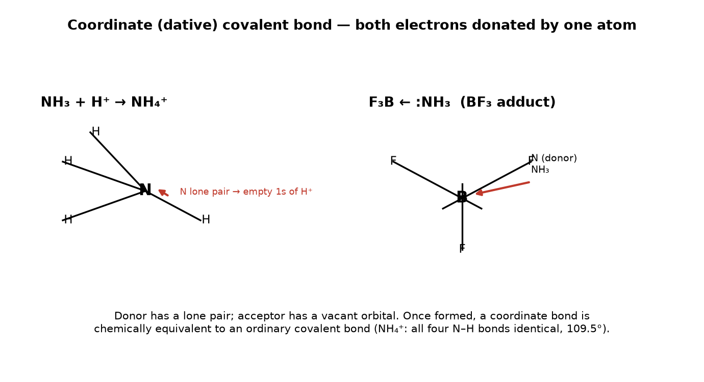
Fig. B4 — coordinate-bond formation: the NH₄⁺ and F₃B←NH₃ adducts (arrows = donated lone pair).

Q. B5 Ionic vs covalent compounds — a comparison
QUESTION: Compare the properties of ionic and covalent compounds.
Why it is probable (board pattern): Classic 'draw a two-column comparison' question (syllabus 5.2 & 5.4). A short, accurate table wins full marks; do not just list ionic properties.
Property | Ionic (e.g. NaCl, CaO) | Covalent (e.g. H₂O, CH₄, CO₂)
Physical state (r.t.) | crystalline solid | gas, liquid or low-melting solid (molecular lattice)
Melting / boiling point | high (strong lattice) | low (weak intermolecular forces)
Electrical conductivity | none solid; conducts molten / aqueous | none in any state (no free ions)
Solubility | soluble in water (polar), insoluble in organics | often soluble in organic / non-polar solvents
Reaction type | fast ionic reactions | slower molecular reactions
Isomerism | no geometrical / optical isomerism | geometrical and optical isomerism possible
Nature of bond | non-directional electrostatic | directional, fixed bond angles

Q. B6 Lewis dot structures of common s- and p-block species
QUESTION: Draw the Lewis dot structures of N₂, CO₂, H₂O, NH₃, CH₄, Cl₂, NO₃⁻ and NH₄⁺. Explain how to work out formal charge for the charged species.
Why it is probable (board pattern): A 'do the diagrams' question that recurs because Lewis structures (syllabus 5.5) also underpin resonance and VSEPR questions — getting them right pays off on three questions at once.
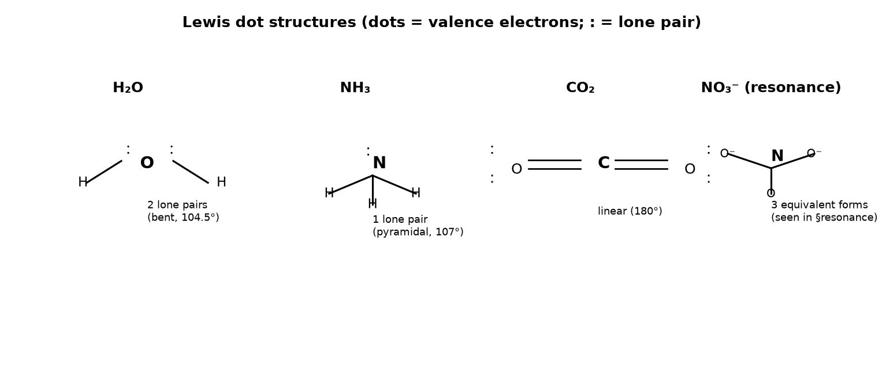
Fig. B6 — Lewis dot structures of H₂O, NH₃, CO₂ and NO₃⁻ (dashes = lone pairs; : = lone pair).
Method (apply to every structure)
- Count the total valence electrons (add/subtract for the ionic charge: −1 adds one e⁻, +1 removes one).
- Place the least-electronegative atom in the centre; connect with single bonds.
- Distribute the remaining electrons as lone pairs so that the outer atoms get an octet (H gets a duplet).
- If the central atom lacks an octet, form multiple bonds (lone pair → bond).
- For ions, compute the formal charge on each atom: FC = (valence e⁻) − (non-bonding e⁻) − ½(bonding e⁻). The best structure has formal charges near zero and puts any negative charge on the more electronegative atom.
NO₃⁻: 24 valence e⁻. With three C–O-style bonds and the formal charges worked out, one N=O and two N–O⁻ give a total charge of −1; the three equivalent arrangements are the resonance forms of Fig. B7. NH₄⁺: 8 valence e⁻; four N–H bonds (one of them a coordinate bond from N's lone pair to H⁺), N formal charge 0, overall +1.

Q. B7 Resonance and the resonance hybrid
QUESTION: Explain the concept of resonance with examples. What is a resonance hybrid and why does resonance stabilize a molecule or ion?
Why it is probable (board pattern): Regularly asked and closely tied to Lewis structures (syllabus 5.6). The CO₃²⁻ and benzene examples are the standard 'with example' requirements.
The concept
Some species cannot be represented by a single correct Lewis structure. When two or more valid Lewis structures can be written that differ only in the placement of electrons (the atoms stay in fixed positions), none of them is the true structure and the real species is an average (resonance hybrid) of all of them. The individual drawings are resonance (contributing) structures; the double-headed arrow ⇌ links them. Only the electron distribution changes, never the nuclear positions or the total electron count.
Examples
- CO₃²⁻ three equivalent structures, each with one C=O and two C–O⁻; in the true ion every C–O bond is identical at 1.28 Å — intermediate between C=O (1.16 Å) and a C–O single bond (1.43 Å).
- Benzene, C₆H₆ two Kekulé structures with alternating double bonds; all six C–C bonds are equal (1.39 Å), intermediate between C–C (1.54) and C=C (1.34). This equalisation is the source of benzene's unusual stability (resonance energy ≈ 150 kJ mol⁻¹).
- NO₂⁻ two equivalent structures, N–O bonds equal at ~1.24 Å.
The more (and the more stable) the contributing structures, the greater the resonance stabilization; the hybrid is always lower in energy than any single contributor — that extra lowering is the resonance (delocalisation) energy.
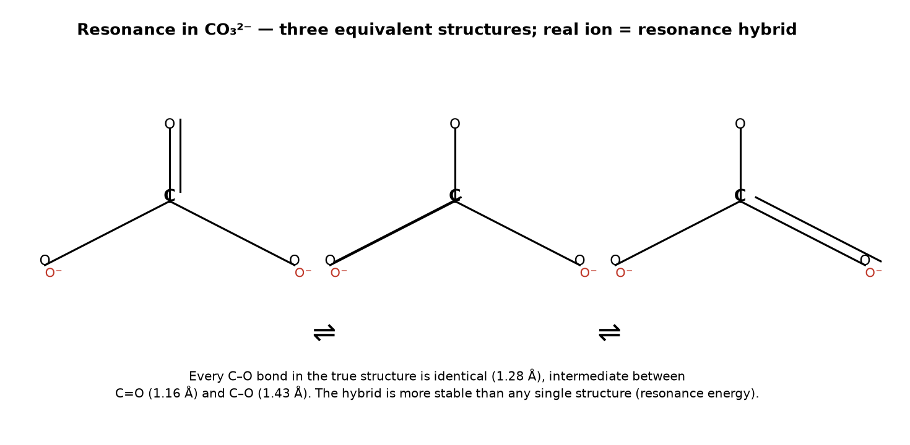
Fig. B7 — the three equivalent resonance structures of CO₃²⁻ (charge shown on the singly-bonded O atoms).

Q. B8 VSEPR theory and the shapes of simple molecules
QUESTION: Explain VSEPR theory and, using it, predict the shapes of BeF₂, BF₃, CH₄, NH₃, H₂O and CO₂. Why does the H–O–H angle in water (104.5°) differ from the C–H–C angle in methane (109.5°)?
Why it is probable (board pattern): The single most frequent bonding-descriptive question in recent years (syllabus 5.7). The last sentence — the lone-pair explanation — is a near-certain sub-part, so the answer must end with it.
The theory
Valence-Shell Electron-Pair Repulsion (VSEPR) theory states that the electron pairs in a valence shell arrange themselves to be as far apart as possible, so the repulsion (and therefore the energy) is minimised. The molecular shape is the shape defined by the atoms (lone pairs occupy space but are not part of the shape). The order of repulsion strength is lone-pair / lone-pair > lone-pair / bond-pair > bond-pair / bond-pair.
Predicted shapes
- AX₂ — BeF₂, CO₂ : 2 bond pairs, 0 lone pairs → linear, 180°.
- AX₃ — BF₃ : 3 bond pairs → trigonal planar, 120°.
- AX₄ — CH₄ : 4 bond pairs → tetrahedral, 109.5°.
- AX₃E — NH₃ : 3 bond pairs + 1 lone pair → trigonal pyramidal, 107°.
- AX₂E₂ — H₂O : 2 bond pairs + 2 lone pairs → bent (angular), 104.5°.
Because a lone pair repels a bond pair more strongly than a bond pair repels another bond pair, the two lone pairs in water squeeze the H–O–H angle down from the ideal tetrahedral 109.5° to 104.5°; in NH₃ one lone pair reduces it only to 107°. The more lone pairs at the central atom, the smaller the bond angle: AX₄ (109.5°) > AX₃E (107°) > AX₂E₂ (104.5°).
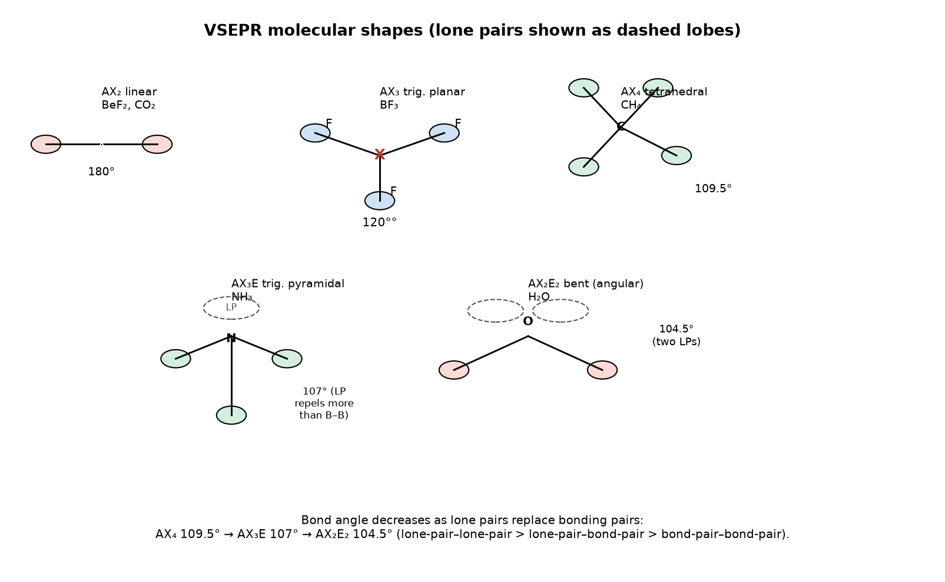
Fig. B8 — VSEPR shapes: linear, trigonal planar, tetrahedral, trigonal pyramidal and bent, with bond angles.

Q. B9 The four types of bonding / intermolecular forces and the substances they produce
QUESTION: Explain metallic bonding, van der Waals forces and hydrogen bonding. Relate each to the physical properties of the substances in which it occurs, and describe molecular solids.
Why it is probable (board pattern): The 'types of bonds' part of the syllabus (5.11–5.13) — almost always asked as 'describe the three types of non-ionic bonding + examples'. Give one named example for each force and one property it explains.
Metallic bonding
Metal atoms form a lattice of positive ions (kernels) immersed in a 'sea' of delocalized valence electrons. The attraction between the cations and the mobile electrons is the metallic bond. Because the electrons are free, metals are lustrous, malleable, ductile, good conductors of heat and electricity (and the conductivity falls with temperature, opposite to insulators). Examples: Na, Cu, Al.
Van der Waals forces (weak, intermolecular)
- Keesom (permanent dipole–dipole) — between polar molecules, e.g. CH₃Cl; aligned head-to-tail.
- Debye (dipole–induced dipole) — a permanent dipole induces a dipole in a neighbour, e.g. a polar molecule next to a non-polar one.
- London dispersion — between all molecules, from instantaneous dipoles; grows with molar mass and polarizability, so it sets the low b.p. of the noble gases and of non-polar molecules (N₂, O₂, CH₄, C₆H₆).
Van der Waals forces are far weaker than chemical bonds (a few kJ mol⁻¹), which is why the substances are gases or low-melting solids and why their boiling points rise smoothly with molecular size.
Hydrogen bonding (a strong, special dipole–dipole)
Occurs when H is covalently bonded to a small, very electronegative atom (F, O, N) and is attracted to a lone pair on a neighbouring F/O/N. It is much stronger than an ordinary van der Waals force (~20–40 kJ mol⁻¹).
- Intermolecular H-bonds (water, HF, alcohols, amines) → abnormally high boiling points: water (373 K) vs H₂S (188 K), HF (293 K) vs HCl (188 K).
- Anomalous density of water / ice: in ice the H-bonds hold a hexagonal open lattice, so solid ice is less dense than liquid water (ice floats — a rare, life-critical anomaly).
- Intramolecular H-bonds (o-nitrophenol) reduce intermolecular association → lower b.p. and greater volatility.
- Biological role: H-bonds pair the DNA bases and help fix the shape of proteins and enzymes.
Molecular solids
Solids in which the whole lattice is held only by van der Waals forces (or H-bonds), e.g. solid CO₂ (dry ice), sugar, ice. They are soft, low-melting and non-conducting — properties that directly follow from the weak intermolecular forces.
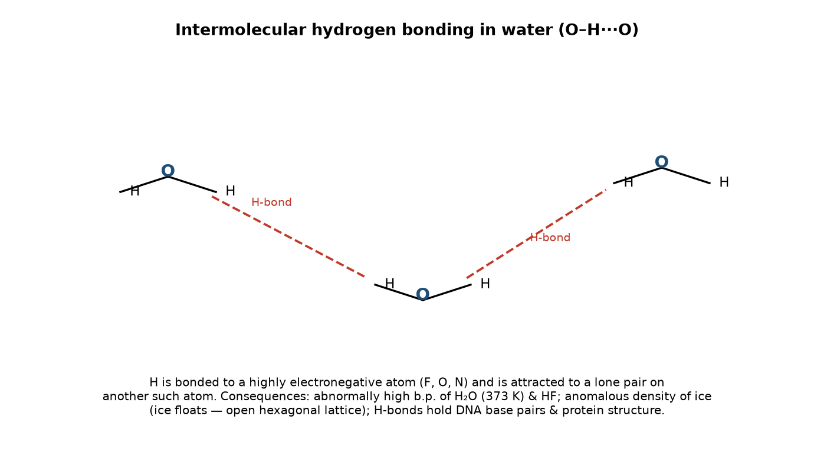
Fig. B9 — intermolecular H-bonding between water molecules (dashed lines = O–H···O H-bonds).

Q. B10 Valence Bond Theory and hybridization (s and p orbitals only)
QUESTION: Explain the basic idea of Valence Bond (V-B) theory. Define hybridization and describe sp, sp² and sp³ hybridization with the shapes and examples they produce.
Why it is probable (board pattern): Syllabus 5.8–5.9 specifically. The three hybrid types + their shapes + one example each, plus 'hybridization does not change with lone pairs' (NH₃/H₂O are both sp³) is the complete answer. A common 4–5 mark question.
Valence Bond Theory (the idea)
V-B theory says a covalent bond is formed when an unpaired electron in a half-filled valence orbital of one atom pairs with an unpaired electron in a half-filled orbital of another atom, the two atoms coming close enough for their orbitals to overlap. The more the orbitals overlap, the stronger the bond. However, the number of half-filled orbitals in the ground state does not always match the number of bonds an atom forms (e.g. C has only two unpaired 2s/2p electrons in the ground state yet forms four bonds in CH₄). This is resolved by hybridization.
Hybridization
Hybridization is the mixing of equal-energy valence atomic orbitals of the same atom to form a new set of identical-energy orbitals of equal size and shape, called hybrid orbitals. Bonding happens through these hybrids.
- sp = mix of one s + one p → 2 linear hybrids at 180°. Example: BeCl₂, C₂H₂ (each C is sp), HgCl₂.
- sp² = mix of one s + two p → 3 trigonal-planar hybrids at 120° (the p orbital stays unhybridized for π bonding). Example: BF₃, C₂H₄, SO₃.
- sp³ = mix of one s + three p → 4 tetrahedral hybrids at 109.5°. Example: CH₄, CCl₄, SiCl₄.
Lone pairs also occupy hybrid orbitals: in NH₃ all four sp³ hybrids hold 3 bonds + 1 lone pair → trigonal pyramidal (107°); in H₂O, 2 bonds + 2 lone pairs → bent (104.5°). The hybridization type is unchanged; only the molecular shape (atom positions) differs.
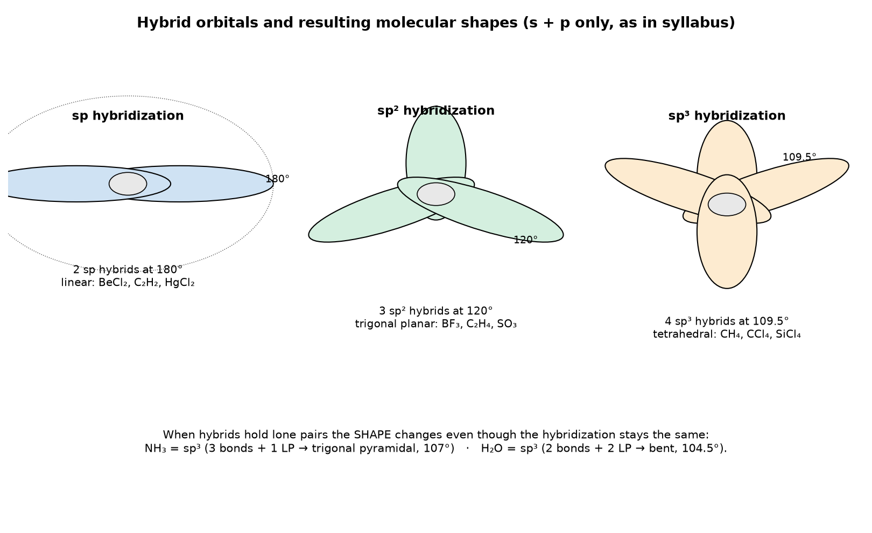
Fig. B10 — sp, sp² and sp³ hybrid orbitals with the shapes and examples they produce.

Q. B11 Bond characteristics: bond length, ionic character and dipole moment
QUESTION: Define bond length, ionic character (percentage ionic character) and dipole moment. How does bond length vary across and down the group, and how is the dipole moment related to molecular polarity?
Why it is probable (board pattern): Syllabus 5.10. This is often asked as three short definitions together, or as a 3-mark discussion. Each concept needs its own correct definition + one trend/example; the dipole part should end with the CO₂ vs H₂O distinction.
Bond length
Bond length is the equilibrium distance between the centres of two bonded atoms. It depends on the atomic sizes (larger atoms → longer bonds) and the bond order (triple < double < single; N≡N 110 pm < C=C 134 pm < C–C 154 pm). Across a period bond length decreases (atoms smaller, Z_eff rises); down a group bond length increases (extra shell, larger atomic radius).
Ionic character
An ionic bond is ideal only if electron transfer is complete; most bonds have a covalent fraction. The percentage ionic character of a bond can be estimated from the difference in electronegativity (Pauling's relation: % ionic ≈ (1 − exp[−(ΔEN)²/4]) × 100) or from the measured dipole moment relative to that expected for a purely ionic bond. Greater ΔEN → greater ionic character. Fajan's rules also apply (small, highly-charged cation → more covalent character).
Dipole moment
Dipole moment (µ) of a molecule is the product of the charge on either end of a dipole and the distance between them: µ = q × d. It is a vector quantity measured in debye (1 D = 3.34 × 10⁻³⁰ C·m). The net molecular dipole is the vector sum of all bond dipoles; for a molecule with a net dipole moment the shape is asymmetric, and the dipole moment can be used to confirm that shape. CO₂ is linear so its two C=O dipoles cancel → µ = 0 (non-polar even though each C=O bond is polar); H₂O is bent, so the two O–H dipoles add to give µ = 1.85 D (net polar).
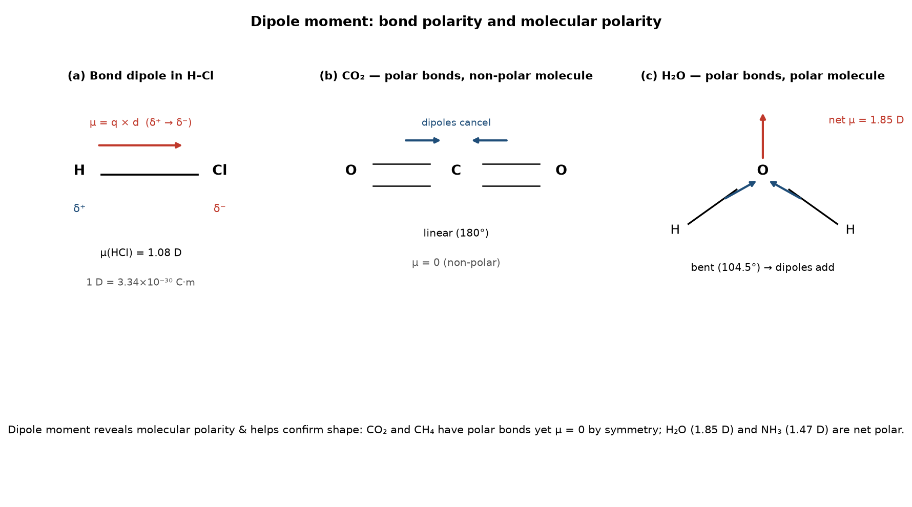
Fig. B11 — Bond dipole in H–Cl, cancellation in CO₂ and addition in H₂O (dipole vectors shown).

SECTION C — Classification of Elements & the Periodic Table
Syllabus 4.1–4.4: modern periodic law & modern table (groups, periods, blocks); IUPAC classification; nuclear charge & effective nuclear charge; periodic trends — atomic radii, ionic radii, ionization energy, electron affinity, electronegativity, metallic character.

Q. C1 The modern periodic law and the layout of the periodic table
QUESTION: State the modern periodic law. Describe the modern periodic table: its periods, groups and the s, p, d and f blocks, and explain the IUPAC classification of elements.
Why it is probable (board pattern): The anchor question of the Periodic Table section (syllabus 4.1). Moseley's law + the block map are the two required pieces.
The law
Modern periodic law: 'The physical and chemical properties of the elements are periodic functions of their atomic numbers.' Moseley (1913) showed, by measuring X-ray wavelengths, that the property repetitions are governed by Z, not atomic mass. This fixed the earlier anomalies (Ar before K, Co before Ni) that appeared in Mendeleev's mass-ordered table. Moseley's law: √ν = a(Z − b).
The layout
- 7 periods — horizontal rows; the period number equals the principal quantum number n of the outermost electrons (period 2 → n = 2).
- 18 groups — vertical columns; the group number (IUPAC 1–18) equals the number of valence electrons for the main-group elements. Familiar names: Group 1 = alkali metals, Group 2 = alkaline earth, Group 16 = chalcogens, Group 17 = halogens, Group 18 = noble gases; Groups 3–12 = transition (d-block) metals.
- Blocks by subshell being filled — s-block (Groups 1–2 and He), p-block (Groups 13–18), d-block (transition metals, Groups 3–12), f-block (lanthanides & actinides, the inner-transition series placed below the table).
IUPAC systematic naming (for new elements)
For elements not yet given a permanent name, the IUPAC systematic name is built from the digits of the atomic number: 1 = un, 2 = bi, 3 = tri, 4 = quad, 5 = pent, 6 = hex, 7 = sept, 8 = oct, 9 = enn, 0 = zero, each followed by '-ium'. Example: element 118 = un-un-unn-enn-ium. This convention guarantees a name for any element even before its properties are fully known.
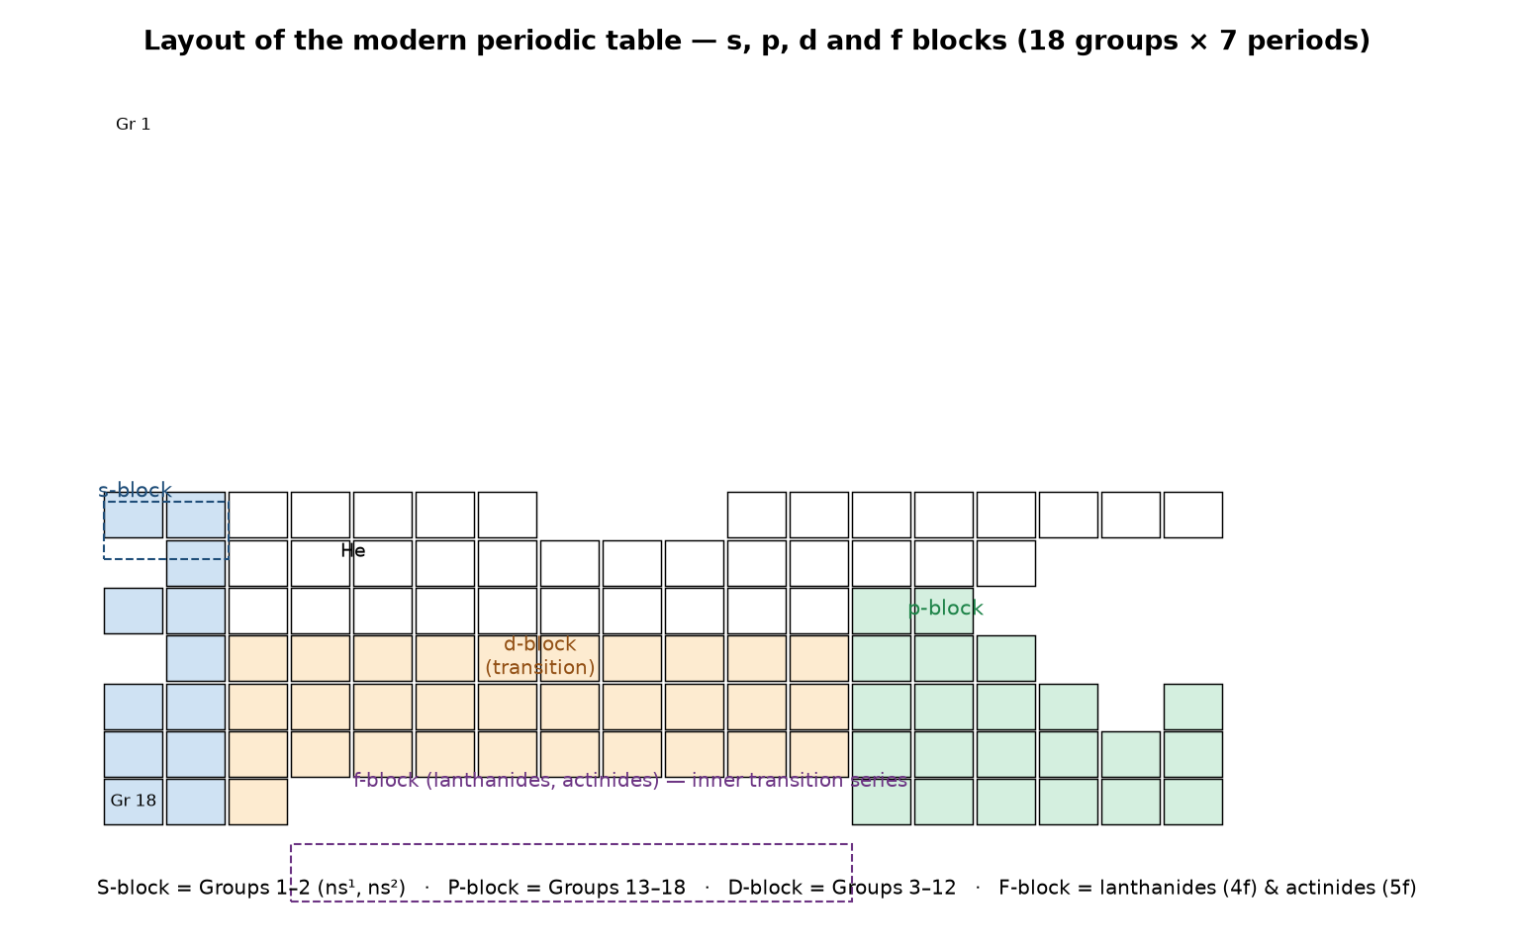
Fig. C1 — the periodic table divided into s, p, d and f blocks (18 groups × 7 periods).

Q. C2 Nuclear charge and effective nuclear charge
QUESTION: Define nuclear charge and effective nuclear charge. Explain why the effective nuclear charge increases as we move from left to right across a period.
Why it is probable (board pattern): A short but recurring 'exactly-what' question (syllabus 4.3); it is also the key to explaining every later trend, so know it cold.
Definitions
- Nuclear charge, Z = the number of protons in the nucleus; it equals the atomic number.
- Effective nuclear charge, Z_eff = the net positive charge actually felt by a valence electron, reduced by the shielding (screening) of inner-shell electrons: Z_eff = Z − σ , where σ is the shielding constant.
Why Z_eff rises across a period
Going from left to right, each successive element adds one proton (Z goes up by 1) and one valence electron, both in the same outer shell. The added valence electron does not shield the other valence electrons very effectively (same shell), while the core of inner electrons stays essentially constant, so σ is nearly unchanged. Therefore Z_eff = Z − σ increases steadily. A higher Z_eff pulls the valence electrons closer and more tightly, which is the single reason behind (i) shrinking atomic/ionic radius, (ii) rising ionization energy, and (iii) rising electronegativity across a period. Down a group the opposite happens: a new inner shell is added, σ increases more than Z, so Z_eff felt by the outermost electron roughly stays the same or changes little, and the effects of the larger distance dominate — radius and IE trend the other way.

Q. C3 Periodic trends of atomic and ionic radius
QUESTION: Discuss the periodic variation of atomic radius and ionic radius, explaining each trend with reference to nuclear charge, shielding and the number of shells.
Why it is probable (board pattern): One of the two guaranteed radius questions (syllabus 4.4.1–4.4.2). Must state both directions (period & group) for atomic radius, then the cation < atom < anion relationship and an isoelectronic example.
Atomic radius
- Across a period (left → right): radius decreases. Z increases and Z_eff rises while all electrons enter the same shell, so the nucleus pulls them in closer.
- Down a group (top → bottom): radius increases. Each new element adds a full new shell (higher n) and more inner shielding, outweighing the larger Z_eff.
- Three measures: covalent radius (half the bond length in a covalent molecule), metallic/atomic radius (half the distance between like atoms in a metal/solid lattice), and van der Waals radius (half the distance between two non-bonded touching atoms).
Ionic radius
- Cation < parent atom: losing the outer electrons removes a shell and increases Z_eff, so the ion contracts (Na⁺ < Na).
- Anion > parent atom: gaining electrons increases repulsion and lowers Z_eff, so the ion expands (Cl⁻ > Cl).
- Isoelectronic series: species with the same electron count differ by nuclear charge; the larger the charge, the smaller the ion — F⁻ > Na⁺ > Ne > Mg²⁺ > Al³⁺ (all have 10 electrons).
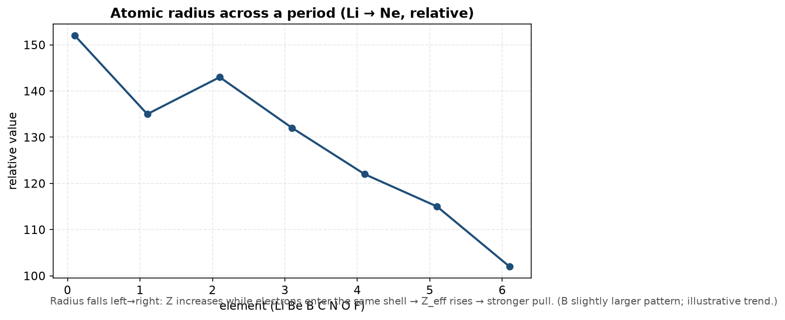
Fig. C3 — the periodic decrease of atomic radius across a period (illustrative relative values).

Q. C4 Periodic trends of ionization energy
QUESTION: Define ionization energy. Discuss its periodic variation and explain the anomalies seen between Be and B and between N and O. Why is the second ionization energy always greater than the first?
Why it is probable (board pattern): The single most-asked Periodic Table long question (syllabus 4.4.3). The Be/B and N/O anomalies are a near-certain sub-part, so they must be stated with orbital reasoning.
Definition & notation
Ionization energy (IE) is the minimum energy required to remove the most loosely held electron from an isolated gaseous atom: X(g) → X⁺(g) + e⁻. The first, second, third IEs are I₁, I₂, I₃ … always I₁ < I₂ < I₃ < … because after the first electron is removed the remaining electrons are held more tightly by the same charge (and I₂, I₃ remove electrons from a positive ion and from a filled core shell).
Periodic variation
- Across a period, IE increases: Z_eff rises and atomic size falls, so the outer electron is harder to remove.
- Down a group, IE decreases: the outer electron is in a higher shell, further away and better shielded.
- The highest IE belongs to He (smallest, most tightly held atom); the lowest among the elements to the large, shielded alkali metals.
The two key anomalies
- Be (2s²) vs B (2s²2p¹) — I₁(Be) > I₁(B): removing Be's electron opens a stable, empty 2p; removing B's single 2p electron is easier because a 2p electron is higher in energy and less penetrating than a 2s electron.
- N (2p³) vs O (2p⁴) — I₁(N) > I₁(O): N has a half-filled 2p³ (all three 2p orbitals singly occupied, maximum multiplicity, extra stable); O's fourth electron sits in an already-occupied 2p orbital and is pushed out by electron–electron repulsion, so it is easier to remove.
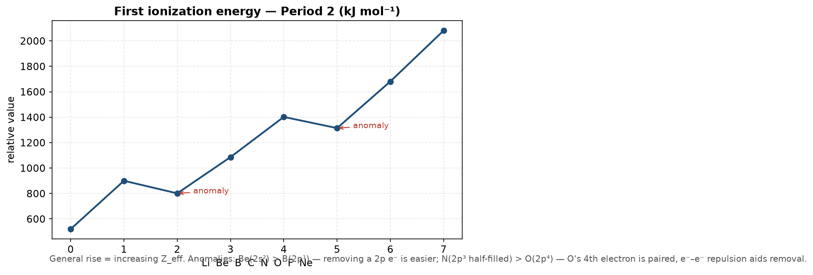
Fig. C4 — first ionization energy across Period 2, with the B and O anomalies marked.

Q. C5 Periodic trends of electron affinity
QUESTION: Define electron affinity. Discuss its periodic variation and explain why nitrogen has a very low (even negative) electron affinity and why chlorine's electron affinity is greater than that of fluorine.
Why it is probable (board pattern): Appears regularly and is the natural 'twin' of the ionization-energy question (syllabus 4.4.4). The two named exceptions (N and Cl > F) are what separate a full-mark answer.
Definition & trend
Electron affinity (EA) is the energy released when an electron is added to an isolated gaseous atom: X(g) + e⁻ → X⁻(g). A more exothermic (more negative) EA means a greater tendency to gain an electron. Across a period EA generally becomes more negative (atoms smaller, Z_eff larger, new electron held more tightly); down a group it becomes less negative (new shell, more shielding).
The two exceptions
- Nitrogen: N has a half-filled, extra-stable 2p³ configuration; adding an 8th electron to make 2p⁴ costs stability and introduces e⁻–e⁻ repulsion in a small orbital, so N's EA is close to zero (or even slightly endothermic). The same reasoning makes P low and O lower than S.
- Cl > F: the 2p orbital of fluorine is very small, so the incoming electron feels strong repulsion from the existing electrons; in chlorine the 3p is larger and the added electron is held more comfortably, so Cl releases more energy on gaining an electron than F does.

Q. C6 Electronegativity and metallic character
QUESTION: Define electronegativity and discuss its periodic trend. Define metallic character and explain how it varies across and down the table.
Why it is probable (board pattern): The 'two-in-one' question of syllabus 4.4.5–4.4.6 that NEB likes to combine. Give the Pauling-scale value of F (4.0) and state the inverse relationship between electronegativity and metallic character.
Electronegativity (EN)
Electronegativity is the relative tendency of an atom in a covalent bond to attract the shared electron pair toward itself. On the Pauling scale the most electronegative atom is F (4.0) and the least is the large, electropositive Cs (~0.7).
- Across a period, EN increases: Z_eff rises and the atom gets smaller, so it pulls the shared pair more strongly.
- Down a group, EN decreases: the bond pair is held by a larger, more shielded atom.
- EN is not the same as ionization energy (no gas-phase atom is involved; it is a bond quantity) nor as electron affinity (EA adds an electron to a single atom; EN shares a pair in a bond).
Metallic character
Metallic character is the tendency of an element to lose electrons and form cations (electropositive / reducing behaviour) — essentially the reverse of electronegativity. It decreases across a period (atoms hold electrons more tightly) and increases down a group (outer electron is larger, more shielded, easier to lose). Metals therefore sit at the lower-left of the table, non-metals at the upper-right, and a diagonal staircase separates the two (the 'metal / non-metal' boundary from B to At).
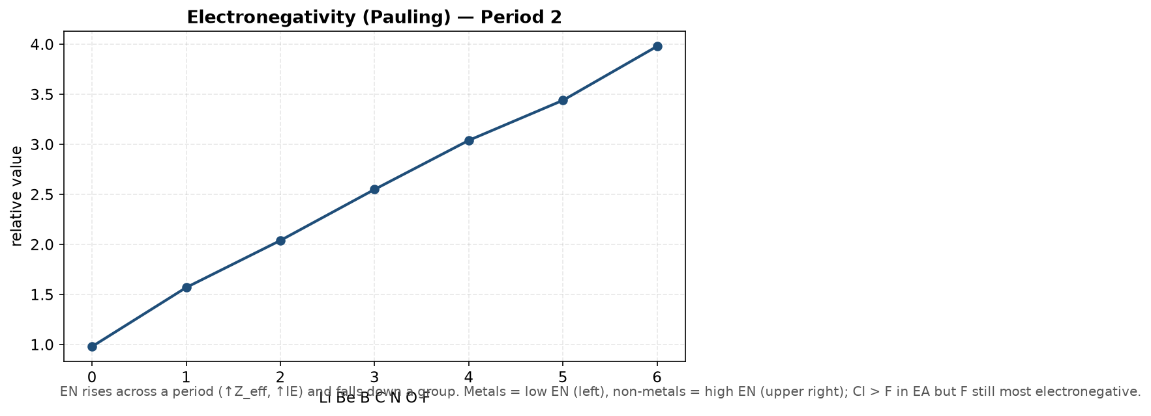
Fig. C6 — electronegativity across Period 2 (Pauling scale).

Q. C7 Inertness of nitrogen; anomalous position of H and He
QUESTION: Explain why nitrogen (N₂) is chemically inert. Discuss the anomalous position of hydrogen and helium in the periodic table.
Why it is probable (board pattern): This 'explain the anomaly' question recurs because it tests whether the student can justify an apparent exception in syllabus 4. The N₂ bond-energy figure and the dual-group argument for H are the mark-bearing lines.
Inertness of nitrogen
N₂ has a very strong N≡N triple bond (1 σ + 2 π) with a bond enthalpy of about 945 kJ mol⁻¹ and a short, non-polar molecule, so breaking it requires a great deal of energy; at ordinary conditions N₂ is therefore essentially inert. Under forcing conditions (very high temperature, e.g. the Haber process ~450 °C / high pressure with a Fe catalyst, or a discharge) the N≡N bond is broken and the highly reactive 'active nitrogen' is produced — which is why lightning can fix atmospheric N₂ into oxides of nitrogen.
The anomalous position of hydrogen
Hydrogen (1s¹) does not fit cleanly anywhere: it may sit at the top of Group 1 (it loses one electron to give H⁺, like the alkali metals, and has a single s-electron like Li) or at the top of Group 17 (it gains one electron to give H⁻, the hydride ion, like the halogens). In fact its behaviour — a gas at room temperature, forming the covalent H₂, showing both oxidising and reducing chemistry — matches neither alkali metal nor halogen, so it is placed alone, usually above Group 1 with the understanding that it is unique.
The anomalous position of helium
Helium has a filled 1s² configuration and is the most stable, monatomic, non-reactive element of all — it is a noble gas, yet its ns² outer shell matches the Group-1 (alkali) configuration. It is therefore placed in Group 18 (noble gases), not Group 1. The first period (H, He) is 'anomalous' throughout because no n = 1 p-orbital exists, so elements of period 1 cannot show the same periodicity as period 2 and beyond.
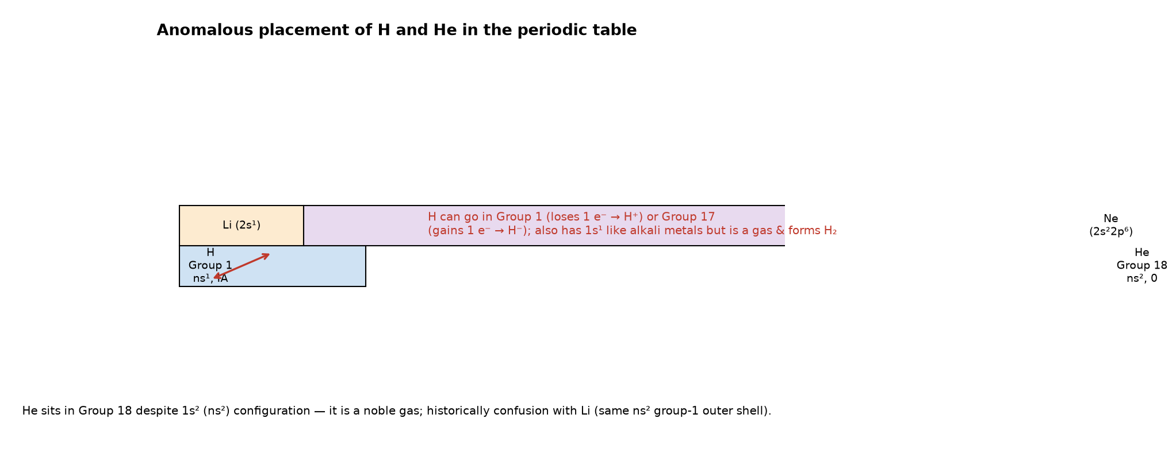
Fig. C7 — hydrogen placed at the top of Group 1 (its 1s¹, IA face) while also showing its Group-17 (halogen) behaviour; helium in Group 18.

Quick-Revision & Diagram Index
The five highest-probability questions (prioritise these first)
- Bohr's postulates + hydrogen spectrum + defects (Q A2).
- σ vs π bonds, single/double/triple (Q B3).
- The four types of bonding forces — metallic, van der Waals, hydrogen (Q B9).
- Ionization-energy trend + Be/B and N/O anomalies (Q C4).
- VSEPR shapes + the lone-pair explanation of the H–O–H angle (Q B8).
Diagrams to be able to draw from memory
- Rutherford scattering setup (Fig. A1).
- Bohr orbits with a labelled transition + Rydberg formula (Fig. A2).
- s (spherical) and p (dumb-bell) orbitals with phases (Fig. A4).
- Head-on σ overlap vs lateral π overlap (Fig. B3).
- VSEPR: linear, planar, tetrahedral, pyramidal, bent (Fig. B8).
- Resonance of CO₃²⁻ (Fig. B7).
- H-bonding between water molecules (Fig. B9).
- sp / sp² / sp³ hybrid orbitals and their shapes (Fig. B10).
- Dipole moments: H–Cl, CO₂ cancellation, H₂O addition (Fig. B11).
- The s/p/d/f block map of the periodic table (Fig. C1).
- The IE trend curve with the two anomalies marked (Fig. C4).
Numbers to remember
- He = most IE; H-bond strength ≈ 20–40 kJ mol⁻¹; benzene resonance energy ≈ 150 kJ mol⁻¹; N≡N ≈ 945 kJ mol⁻¹.
- F Pauling EN = 4.0; R_H = 1.097×10⁷ m⁻¹; H ground-state energy = −13.6 eV; de Broglie λ = h/mv.
- Octet: Be 6 e⁻ (BF₃), B 6, P in PCl₅ = 10, S in SF₆ = 12, Xe in XeF₄ = 14.
- Bond-angle order: AX₄ 109.5° > AX₃E 107° (NH₃) > AX₂E₂ 104.5° (H₂O).

