CELL DIVISION & BACTERIA

Conceptual Study Guide — Units 1 to 5
Written in simple language, with a diagram in each unit
and a memory hook for every idea.

How to Use This Guide
- Every unit follows the same shape: WHAT it is → HOW it works → WHY it matters → MNEMONIC → QUICK TEST.
- The mnemonics are the 'cheat codes' — you can recall the whole unit from the short phrase alone.
- Do the Quick Test at the end of each unit. Answers are one line below the question.
- Look at the diagram at the end of each unit — it makes the text click.

UNIT 1 — BACTERIA (Prokaryotic Cell)

What Is It?
Bacteria are the oldest, simplest, and most numerous living things on Earth. A single drop of soil water can hold millions of them. They are prokaryotes — tiny cells that do NOT have a real nucleus or membrane-bound organelles. Their DNA just floats free in the cell, called the nucleoid.

Why It Matters
- Some bacteria are harmful (they cause disease).
- But most are helpful: they make your food (yogurt, curd, cheese, bread rise), fix nitrogen in the soil for plants, and break down waste so the planet stays clean.
- Because a bacterium is a single cell, 'cell' and 'organism' are the same thing.

How It Is Built — 6 Must-Know Parts
- Cell wall (peptidoglycan) — A stiff jacket that keeps shape and stops bursting.
- Cell membrane (plasma membrane) — The gate that decides what goes in and out.
- Cytoplasm — The jelly filling.
- Nucleoid / DNA loop — The genetic instructions, with NO nuclear membrane. This is the #1 exam fact: 'no true nucleus'.
- Ribosomes (70S) — Little protein-building machines, but smaller than eukaryote ones.
- Optional extras — Flagellum (tail for swimming), pili (hairy threads to grab surfaces / swap DNA), plasmid (small extra DNA ring, often carries antibiotic-resistance genes), capsule (slime coat for protection).

Mnemonic
'WALL · MEMBRANE · JELLY · GOLD · RIE'
- WALL → Cell wall
- MEMBRANE → Cell membrane
- JELLY → Cytoplasm (the jelly inside)
- GOLD → DNA / Nucleoid (the 'gold standard' instruction book, no nucleus)
- RIE → Ribosomes + the extras (flagellum, pili, plasmid)
Shorter hook: a Prokaryote's life is 'No Nucleus, No Organelles, just ONE DNA ring + wall + membrane.' → 'No-No-One' = prokaryote.

Quick Test
- Q1. Do bacteria have a nucleus? → No; their DNA is a naked loop (nucleoid).
- Q2. What makes the cell wall stiff? → Peptidoglycan.
- Q3. Which part lets a bacterium swim? → Flagellum (the tail).
- Q4. What is a plasmid? → A small separate loop of DNA that often carries 'extra' genes, like antibiotic resistance.
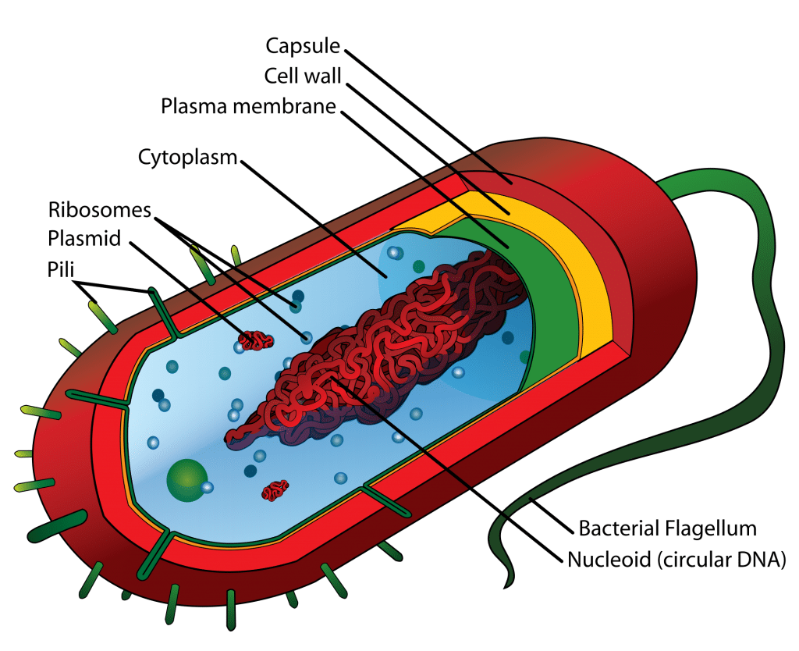
Fig 1.1 — Prokaryotic (bacterial) cell structure. No nucleus; DNA floats free as a nucleoid loop.

UNIT 2 — AMITOSIS (Direct Cell Division)

What Is It?
Amitosis is the simplest type of cell division. The word means 'without mitosis' (a = without, mitosis = mitosis). The nucleus just splits into two and the cell pinches into two — no fancy structures, no visible chromosomes, no spindle fibres. It is also called 'direct division' because the nucleus divides straight into two with no middle steps.

How It Happens (Super Short Version)
- Step 1 — The nucleus grows longer (like a dumbbell).
- Step 2 — It pinches into two equal halves.
- Step 3 — The whole cell splits, giving two daughter cells that look almost exactly like the parent.

Why It Matters
It's fast and cheap, but the two daughters are almost identical copies and it offers no way to mix genes or fix errors. It's mostly used in one-celled organisms (like amoeba and some parasites) and rarely in normal human cells.

Mnemonic
'Amitosis = the LAZY split'
No preparation, no line-up, no spindle — just snap in two. Mitosis and meiosis are the hard-working ones; amitosis is the lazy one.
Word breakdown: A = without, MITOSIS = mitosis. So amitosis = 'without mitosis'.

Quick Test
- Q1. What does 'amitosis' literally mean? → Division without mitosis (no visible chromosomes).
- Q2. In which cells is it common? → Simple one-celled organisms (amoeba, some protozoans/parasites).
- Q3. Are the two daughter cells genetically identical? → Yes, almost exact copies of the parent.
- Q4. What is the main disadvantage of amitosis? → No error correction; mutations pass straight through to both daughters.
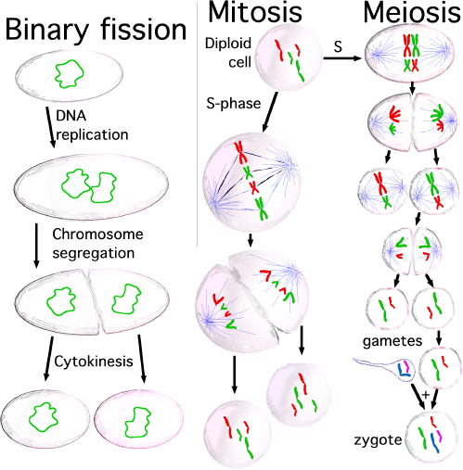
Fig 2.1 — Amitosis (direct division): nucleus elongates then pinches into two. No spindle, no chromosomes.

UNIT 3 — MITOSIS (Equational Division)

What Is It?
Mitosis is the main way your body makes new body cells. One parent cell (2n = diploid, 46 chromosomes in humans) divides to make two identical daughter cells, each with 2n = 46 chromosomes. It's called 'equational division' because each daughter gets an equal share of the DNA.

The 5 Stages of Mitosis
Mnemonic: 'Please Make A Toast + Cake' → P-M-A-T + C
That's the 4 stages of the nucleus (PMAT) plus cytokinesis (C) when the cell actually splits.
- P — Prophase — The DNA (two sister chromatids joined at the centromere) coils up into visible X-shaped chromosomes. The nuclear membrane breaks down. Spindle fibres start forming from the two centrosomes.
- M — Metaphase — All chromosomes line up in the MIDDLE of the cell (the metaphase plate). This is the best time to see all 46 chromosomes clearly. Mnemonic: 'M for Middle'.
- A — Anaphase — Sister chromatids separate and are pulled to opposite poles by the spindle fibres. Each chromatid is now called a chromosome. Mnemonic: 'A for Apart' — the chromatids go apart.
- T — Telophase — Two new nuclei form around the separated chromosomes at each pole. The nuclear membrane rebuilds. Chromosomes uncoil back into chromatin. Mnemonic: 'T for Two new nuclei'.
- C — Cytokinesis — The cytoplasm divides. The cell pinches into two. In animal cells: a 'cleavage furrow' pinches the middle. In plant cells: a 'cell plate' builds a new wall between them. Mnemonic: 'C for Cut — the cell is cut in two'.

Why It Matters
- Growth — you grow from 1 cell (zygote) to trillions via mitosis.
- Repair — every cut, bruise, and broken bone heals via mitosis.
- Cell replacement — skin, gut lining, and blood cells are constantly replaced via mitosis.

Mnemonic for the 5 Stages
'Please Meet Anna, Tell Charlie'
- P — Prophase
- M — Metaphase
- A — Anaphase
- T — Telophase
- C — Cytokinesis
Or even simpler: 'PMAT + C' — Please Make A Toast + Cake.

Quick Test
- Q1. How many chromosomes in a human mitotic daughter cell? → 46 (diploid, 2n).
- Q2. In which stage do chromosomes line up in the middle? → Metaphase.
- Q3. What separates in anaphase? → Sister chromatids (each becomes its own chromosome).
- Q4. What is cytokinesis? → Division of the cytoplasm into two daughter cells.
- Q5. Where does mitosis NOT happen? → In germ cells (sperm/egg formation uses meiosis).
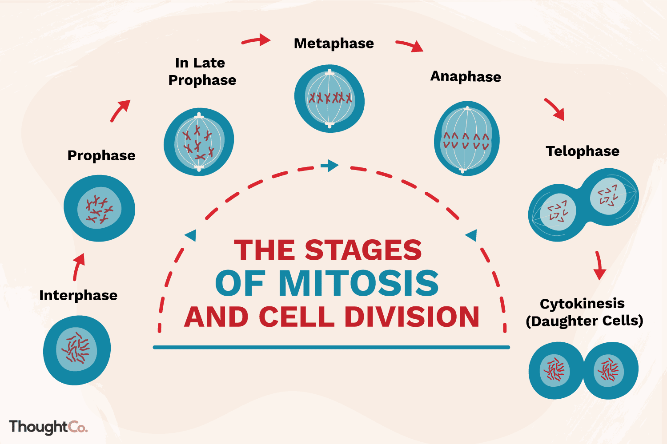
Fig 3.1 — The 5 stages of mitosis: Prophase → Metaphase → Anaphase → Telophase → Cytokinesis.

UNIT 4 — MEIOSIS (Reduction Division)

What Is It?
Meiosis is the special type of cell division that makes sperm and egg cells (gametes). One parent cell (2n = 46) divides TWICE to make four haploid daughter cells (n = 23). It's called 'reduction division' because the chromosome number is halved — this is essential so that when sperm + egg fuse, the zygote gets back to 46.

The Two Divisions
Meiosis I (Reduction Division) — 5 stages:
- Prophase I — Homologous chromosomes PAIR UP (synapsis) and exchange DNA (crossing over). This is where genetic variation is created. Mnemonic: 'P1 = PAIR UP'.
- Metaphase I — Homologous PAIRS line up in the middle (not individual chromosomes like mitosis). Mnemonic: 'M1 = pairs in the MIDDLE'.
- Anaphase I — The PAIRS separate — one of each pair goes to each pole. Sister chromatids stay together. Mnemonic: 'A1 = Apart, but still in pairs'.
- Telophase I — Two cells form, each with n = 23 chromosomes (but each chromosome still has 2 chromatids).
- Cytokinesis I — Cell splits into two haploid cells.

Meiosis II (Equational Division) — almost identical to mitosis:
- Prophase II — Chromosomes condense again; spindle reforms.
- Metaphase II — Individual chromosomes line up in the middle (not pairs).
- Anaphase II — Sister chromatids separate (just like mitosis anaphase).
- Telophase II — Four haploid cells form; nuclear membranes rebuild.
- Cytokinesis II — Final split → 4 single-chromatid gametes (n = 23).

Why It Matters
- Sexual reproduction — without meiosis, chromosome number would double every generation.
- Genetic variation — crossing over in Prophase I shuffles genes, so no two gametes (and no two siblings) are identical.
- Independent assortment — which homologous pair goes to which pole is random, adding more variation.

Mnemonic
'M1 = Pairs Apart, M2 = chromatids Apart'
Meiosis I separates PAIRS (homologous chromosomes). Meiosis II separates chromatids (just like mitosis).
Memory: 'I = one pair, II = two chromatids apart'

Key Difference: Mitosis vs Meiosis (for this unit)
- Mitosis: 1 division → 2 identical diploid cells (body cells).
- Meiosis: 2 divisions → 4 different haploid cells (gametes).
- Crossing over happens ONLY in meiosis (Prophase I) — not in mitosis.

Quick Test
- Q1. How many divisions does meiosis have? → Two (Meiosis I and Meiosis II).
- Q2. How many daughter cells does one meiosis produce? → Four, each haploid (n = 23 in humans).
- Q3. When does crossing over happen? → Prophase I (homologous chromosomes exchange segments).
- Q4. What is independent assortment? → The random orientation of homologous pairs in Metaphase I.
- Q5. Why is meiosis essential for sexual reproduction? → It halves the chromosome number so fertilisation restores 2n.
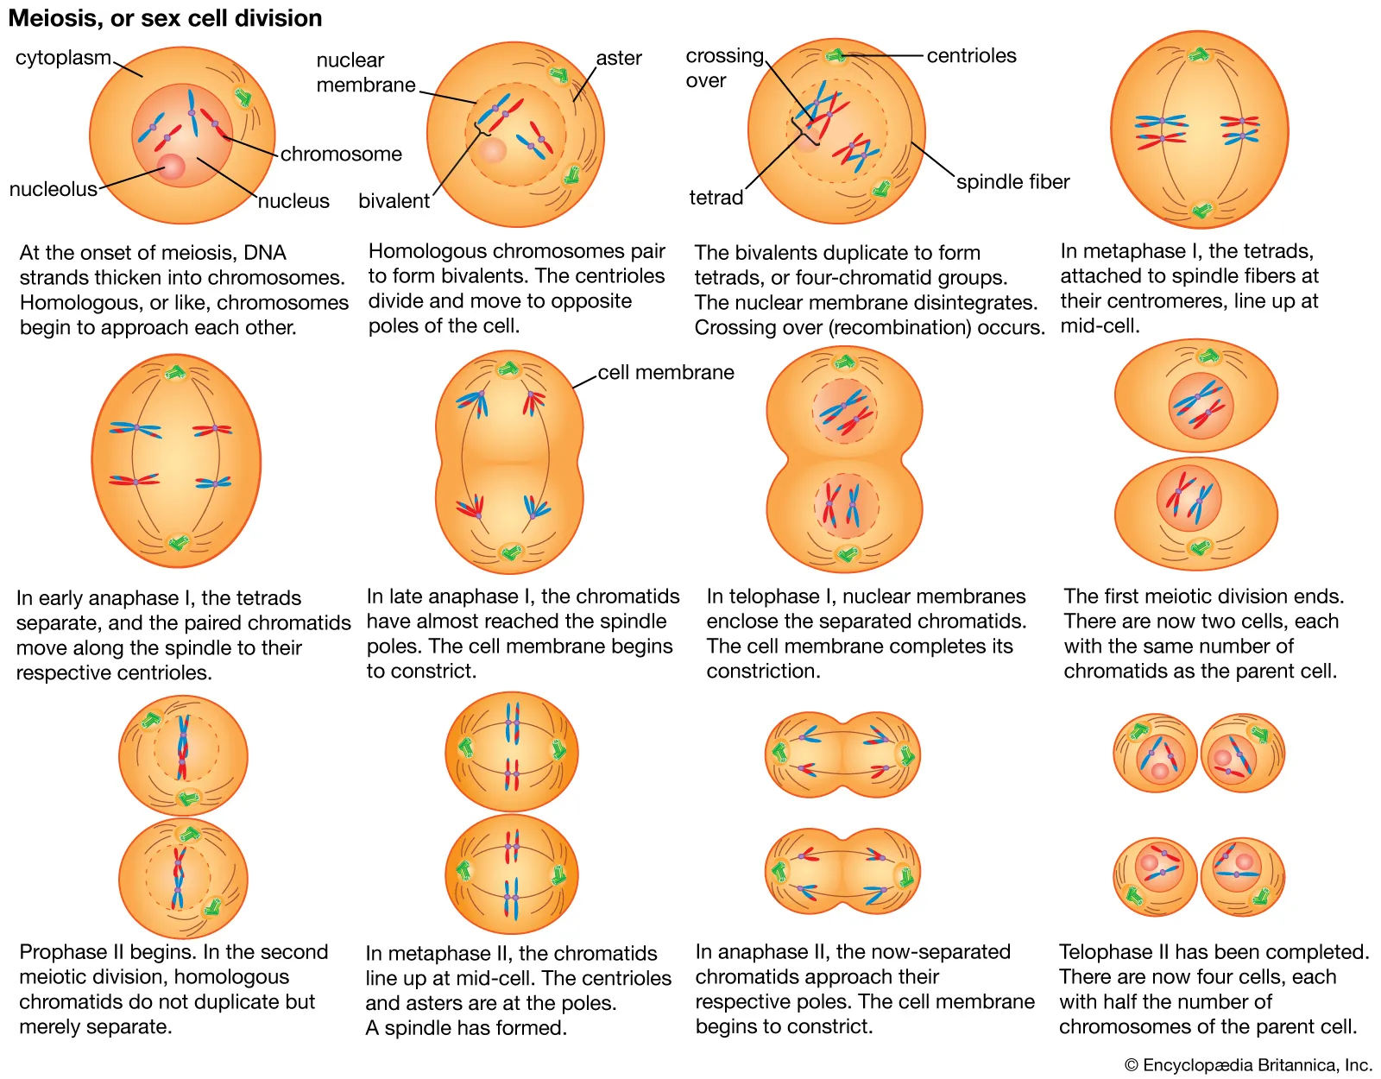
Fig 4.1 — Meiosis: two divisions producing four haploid gametes with genetic variation.

UNIT 5 — MITOSIS vs MEIOSIS (Mastery Unit)

Why This Unit?
Exams love comparing mitosis and meiosis. This unit pulls everything together with a clear comparison table and a master mnemonic to lock it in.

The Master Comparison Table
Feature | Mitosis | Meiosis
Cell type | Somatic (body) cells | Germ cells (make gametes)
Divisions | One | Two (Meiosis I + II)
Daughter cells | 2 identical diploid (2n) | 4 different haploid (n)
Chromosome number | 2n → 2n (stays same) | 2n → n (halved)
Crossing over? | No | Yes (Prophase I)
Homologous pairing? | No | Yes (synapsis in Prophase I)
Genetic variation? | No — identical | Yes — crossing over + independent assortment
Purpose | Growth, repair, asexual reproduction | Sexual reproduction, gamete formation

Master Mnemonic — 'M = Mitosis, M = Meiosis' (two M's)
MITOSIS = 'MIT = Makes Identical Twins'
- One division → two identical diploid daughters
- No crossing over, no pairing
- Purpose: growth + repair
MEOISIS = 'MEO = Makes Extraordinary Offspring' (different gametes)
- Two divisions → four different haploid gametes
- Crossing over in Prophase I + independent assortment in Metaphase I
- Purpose: sexual reproduction + genetic variation

The Ultimate Memory Hook
Think of mitosis as a PHOTOCOPIER (exact copies). Think of meiosis as a SHUFFLE DECK (new combinations every time). Photocopy = identical = mitosis. Shuffle = varied = meiosis.

Final Quick Test (Mastery)
- Q1. What is the ploidy of mitosis daughter cells? → Diploid (2n).
- Q2. What is the ploidy of meiosis daughter cells? → Haploid (n).
- Q3. Which division has crossing over? → Meiosis only (Prophase I).
- Q4. How many cells does mitosis produce? → 2. Meiosis? → 4.
- Q5. If a human cell has 46 chromosomes, how many in a gamete after meiosis? → 23.
- Q6. In which stage of meiosis do homologous pairs line up? → Metaphase I.
- Q7. What is synapsis? → Pairing of homologous chromosomes in Prophase I.
- Q8. Why is amitosis not used in human body cells? → Too error-prone; mitosis corrects alignment errors.
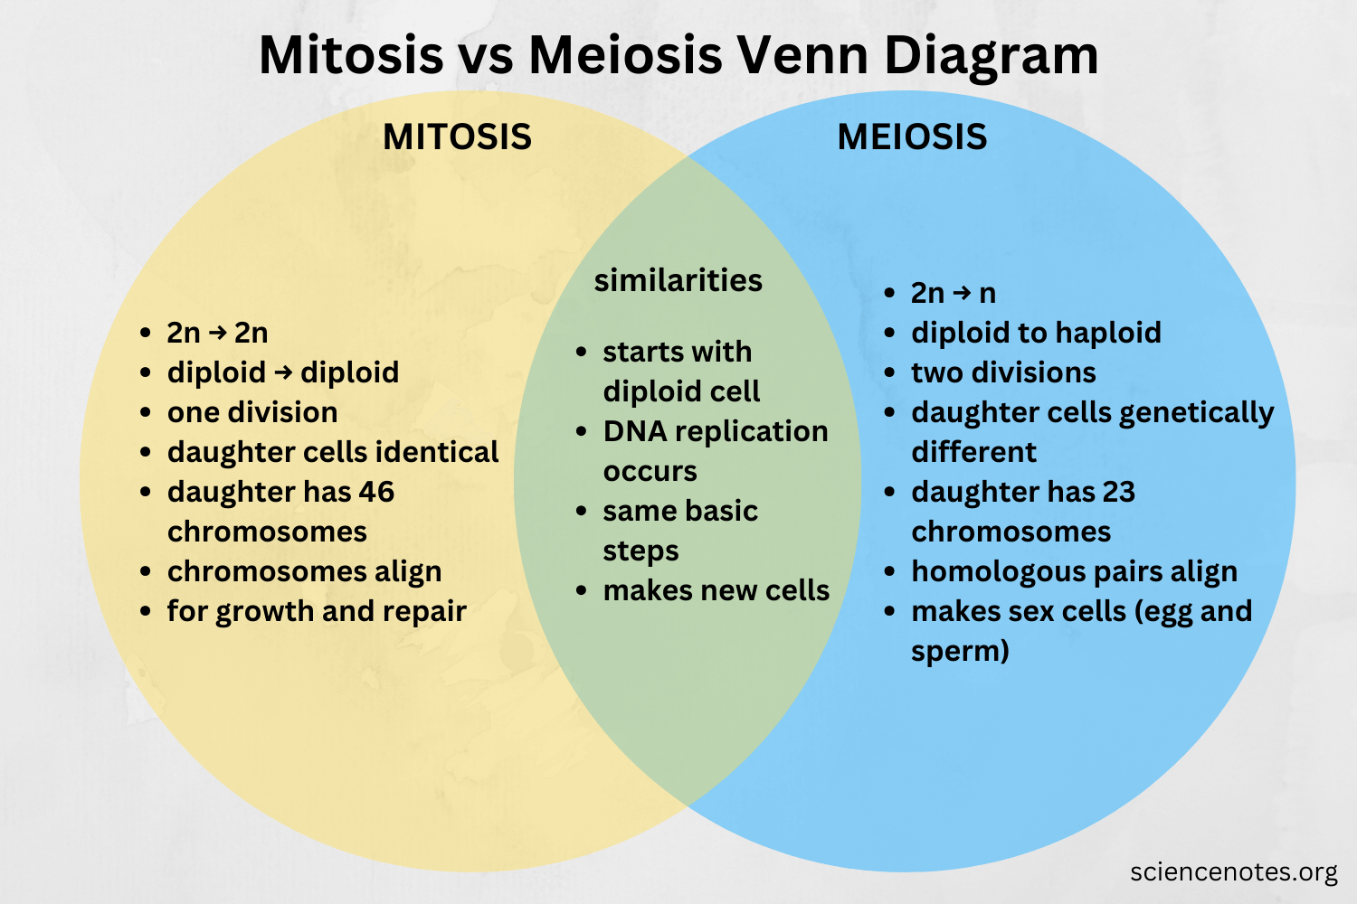
Fig 5.1 — Mitosis vs Meiosis: side-by-side comparison.

All 5 Units at a Glance
Unit | Topic | Key Idea
Unit 1 | Bacteria | Prokaryotic cell structure; no nucleus; 6 must-know parts
Unit 2 | Amitosis | Lazy direct division; one step; used in amoeba
Unit 3 | Mitosis | 5 stages; 2 identical diploid daughters; growth & repair
Unit 4 | Meiosis | 2 divisions; 4 different haploid gametes; crossing over
Unit 5 | Comparison | Mitosis vs Meiosis; master mnemonic; final test

You've now covered all 5 units. Read the mnemonics out loud, look at each diagram once, and do the quick tests. That's it — you're ready.

