BIOLOGY — Mindmap Architecture Study Material
Units 1 to 5: Bacteria | Amitosis | Mitosis | Meiosis | Mitosis vs Meiosis

Optimized Classification • Types • Differences • Boundaries & Limits
All concepts rebuilt with expanded internet-sourced classification for deeper understanding.

At-a-Glance: 5 Units
Unit | Topic | Core Question | Result | Genetic Output
1 | Bacteria (Kingdom Monera) | What are prokaryotes? | One cell → two identical daughter cells | Asexual (no variation)
2 | Amitosis (Direct Division) | Simplest division? | One cell → two (no spindle) | Asexual (no recombination)
3 | Mitosis (Indirect Division) | How do somatic cells divide? | One cell → two identical 2n cells | Clonal (2n → 2n)
4 | Meiosis (Reductional) | How are gametes made? | One cell → four haploid gametes | Sexual (2n → n, variation)
5 | Mitosis vs Meiosis | What separates them? | Two systems side-by-side | Comparison matrix

UNIT 1 — BACTERIA & Kingdom Monera
The most primitive and widespread life forms on Earth — prokaryotic, unicellular, and capable of living in nearly every habitat. Understanding bacteria is the foundation for all of microbiology.

1.1 Mindmap Architecture
🗂 BACTERIA — Full Classification Tree — Mindmap Architecture
▶ Kingdom MONERA
● Domain
– Bacteria
– Archaea (ancient prokaryotes)
● Size
– 0.2 – 10 µm (most: 1–5 µm)
– Smallest: Mycoplasma (~0.2 µm)
● Structure
– Prokaryotic — no true nucleus
– No membrane-bound organelles (no mitochondria, no Golgi, no ER)
– Circular DNA, no histones
– 70S ribosomes (30S + 50S)
– Cell wall: peptidoglycan (murein) — NAG + NAM
– No true vacuole; gas vacuoles in some aquatic forms
● Shape (Morphology)
– Coccus (round) — single / diplococcus / streptococcus / staphylococcus
– Bacillus (rod) — single / diplobacillus / streptobacillus
– Spirilla (spiral) — Vibrio (comma) / Spirillum (rigid spiral) / Spirochaete (flexible)
– Irregular — Mycoplasma (no wall, pleomorphic)
● Energy / Nutrition
– Photoautotrophs — cyanobacteria (blue-green algae)
– Chemoautotrophs — nitrifying, sulfur-oxidizing bacteria
– Photo-heterotrophs — some purple bacteria
– Chemo-heterotrophs — most pathogenic bacteria
● Cell Wall / Staining
– Gram-positive: thick peptidoglycan (20–80 nm) + teichoic acids
– Gram-negative: thin peptidoglycan (5–10 nm) + outer LPS membrane
– Mycobacteria: thick mycolic acid layer (acid-fast)
– Mycoplasma: NO cell wall (pleomorphic)
● Reproduction
– Asexual: Binary Fission (primary), Spore Formation
– Sexual (genetic recombination): Conjugation, Transformation, Transduction
– Spores (endospores): Bacillus, Clostridium — extreme survival

1.2 Bacterial Cell Structure (Diagram)
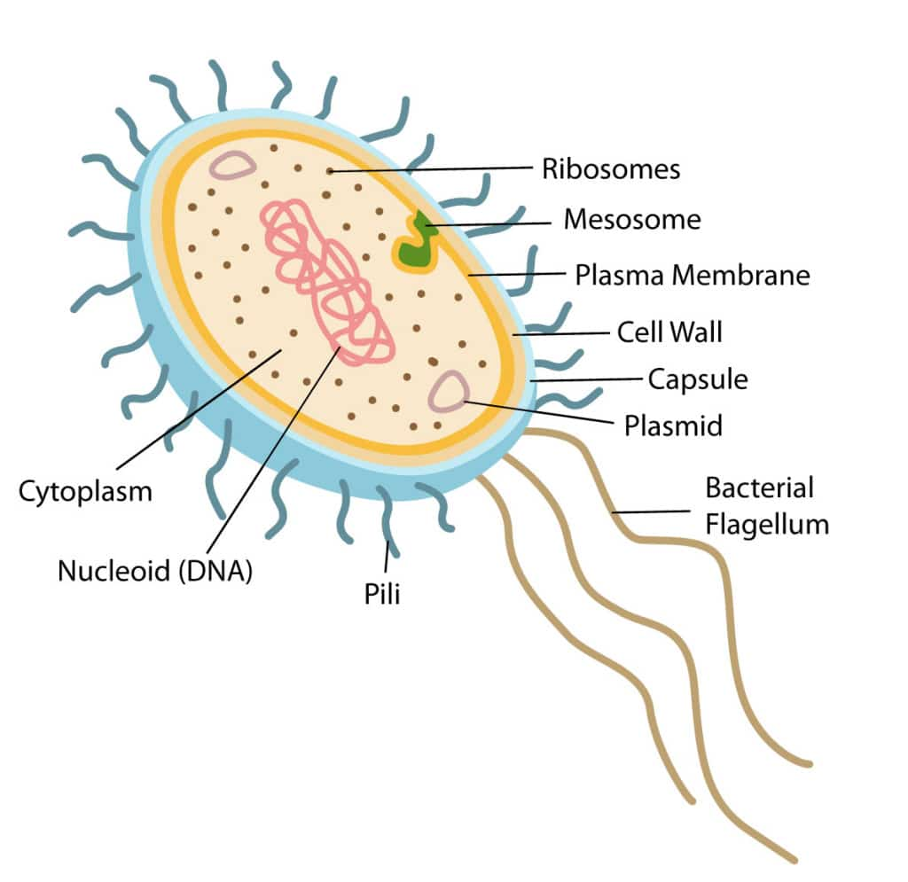
Bacterial cell structure: capsule, cell wall (peptidoglycan), plasma membrane, cytoplasm, nucleoid (circular DNA), 70S ribosomes, flagella, pili

1.3 Shape Classification — Cohn's System (Expanded)
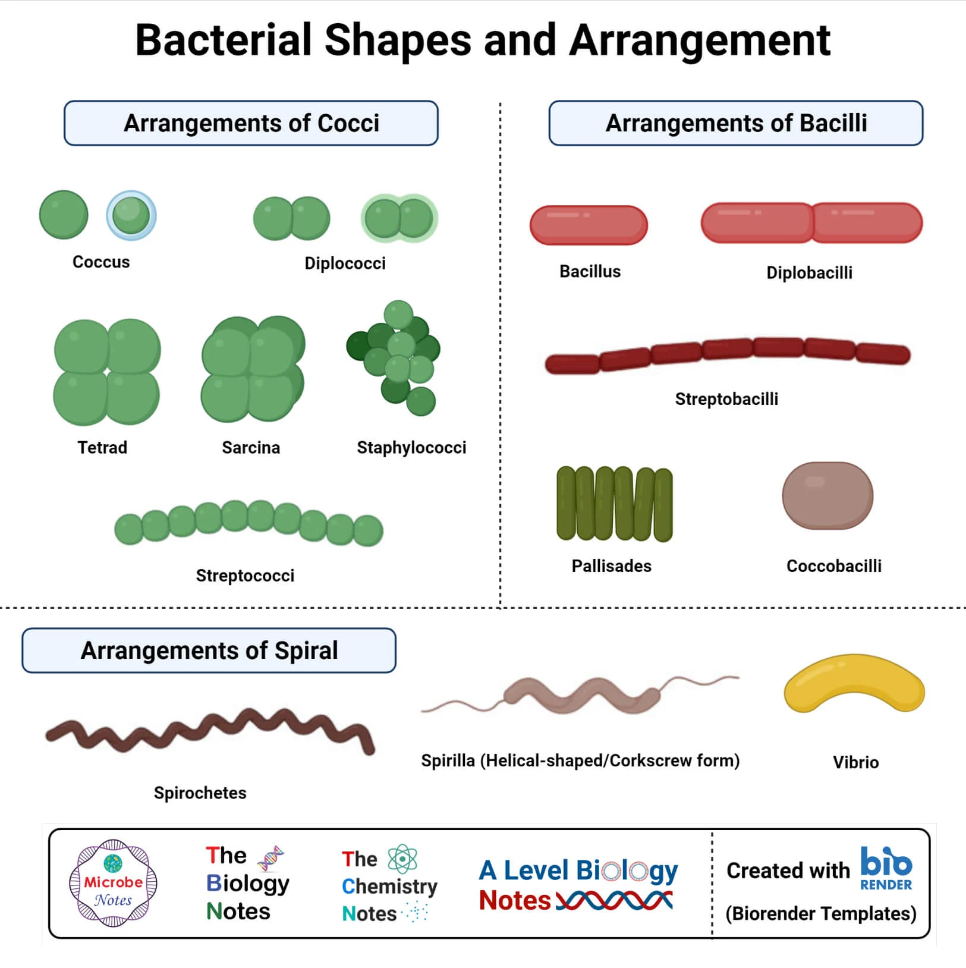
Bacteria shape classification: cocci, bacilli, vibrios, spirilla, spirochaetes, mycoplasma
Shape Class | Single Term | Arrangement Terms | Examples | Key Feature
Coccus (round) | Coccus | Diplococcus (pair) | Neisseria meningitidis | Spherical
 |  | Streptococcus (chain) | Streptococcus pneumoniae | End-to-end chain
 |  | Staphylococcus (cluster) | Staphylococcus aureus | Grape-like clusters
 |  | Tetrads / Sarcina (cubes) | Sarcina | Groups of 4 or 8
Bacillus (rod) | Bacillus | Diplobacillus (pair) | Bacillus anthracis | Cylindrical
 |  | Streptobacillus (chain) | Diplobacillus | Linked chain
Spiral | Spirillum | Rigid spiral | Spirillum volutans | Multiple rigid coils
 | Vibrio | Comma / crescent | Vibrio cholerae | Single curved segment
 | Spirochaete | Flexible helix | Treponema pallidum | Endospore-like flexibility
Irregular | Mycoplasma | Pleomorphic | Mycoplasma pneumoniae | NO cell wall

🧠 Mnemonic to Remember: C-D-S-T = Coccus → Diplococcus → Streptococcus → Staphylococcus (chain to cluster)

1.4 Reproduction & Genetic Recombination (Diagram)
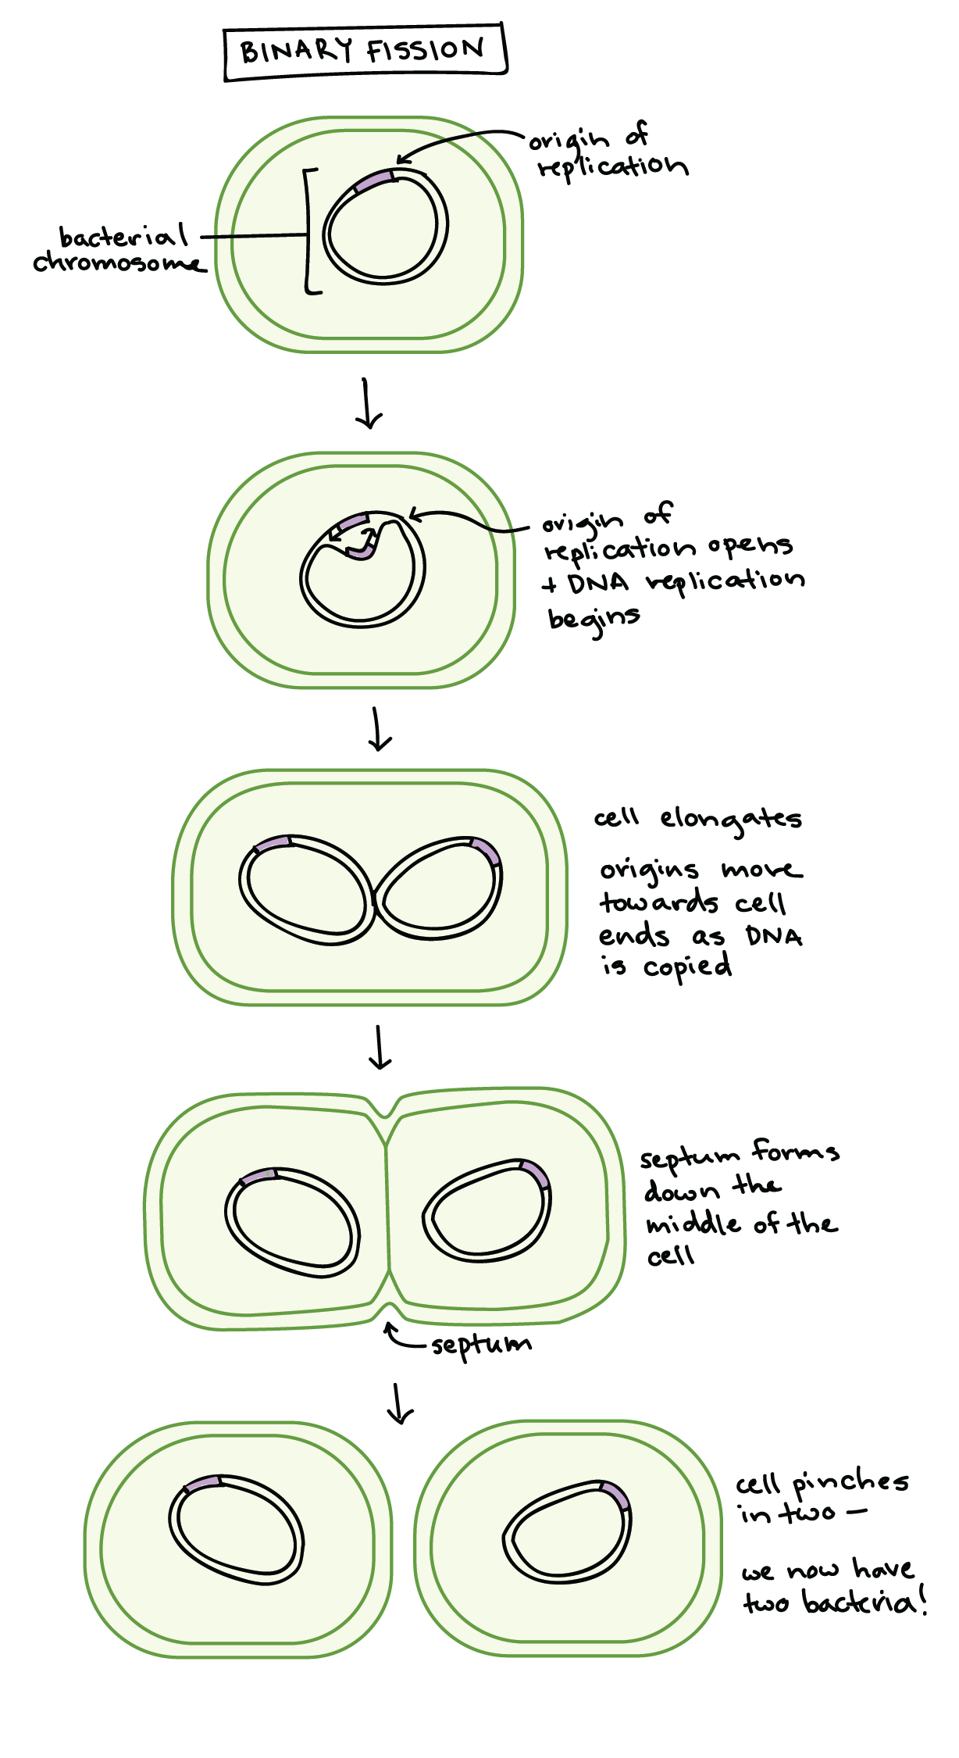
Binary fission in bacteria: DNA replication → cell elongation → septum → two identical cells
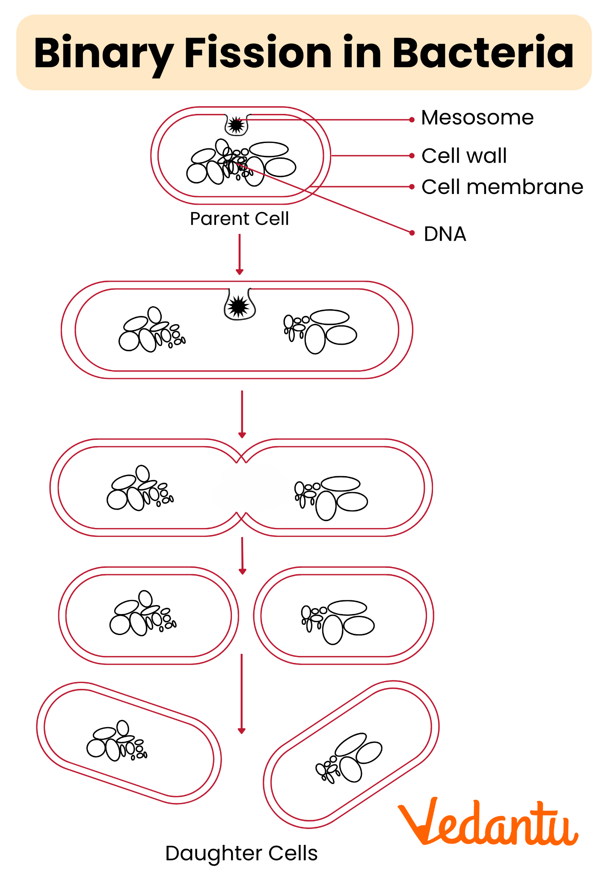
Bacterial genetic recombination: conjugation (plasmid transfer), transformation (free DNA), transduction (phage-mediated)
Method | Type | Mechanism | Requirement | Outcome
Binary Fission | Asexual | DNA replicates → septum forms → two cells | Nutrients, energy | Genetically identical clones (exponential growth: 1→2→4→8...)
Endospore Formation | Survival | Cell dehydrates → keratin coat → dormant spore | Stress (heat, drought, chemicals) | No new cells — survival only; germinates when conditions improve
Conjugation | Sexual (recombination) | F+ donor connects to F− recipient via sex pilus → F plasmid transfers | Cell-to-cell contact | Recipient gains new genes (e.g. antibiotic resistance)
Transformation | Sexual (recombination) | Bacterium takes up free DNA from environment → integrates into chromosome | Free DNA in medium + competent cell | New genetic traits (e.g. Griffith's S strain)
Transduction | Sexual (recombination) | Bacteriophage (virus) carries donor DNA → injects into new host | Bacteriophage + two compatible bacteria | Gene transfer via viral vector

🧠 Mnemonic to Remember: CTC = Conjugation (cell-to-cell), Transformation (takes up DNA), Transduction (Transit of phage DNA) — the three C's of recombination

1.5 Bacteria vs Archaea (Key Distinction)
Feature | Bacteria | Archaea
Cell wall | Peptidoglycan (murein) | Pseudopeptidoglycan (no murein)
Membrane lipids | Fatty acids (ester bonds) | Isoprenoids (ether bonds)
rRNA (16S) | Bacterial-type 16S rRNA | Archaean-type 16S rRNA
Methanogens? | No | Yes (methane producers)
Extremophiles? | Rare | Common (thermophiles, halophiles, acidophiles)
Antibiotic sensitivity | Yes (cell wall target) | Generally resistant

⚠ BOUNDARY & LIMIT: Bacteria are PROKARYOTES: no nucleus, no mitochondria, no Golgi. Mycoplasma is the smallest known bacterium (~200 nm) and has NO cell wall. Murein is the definitive bacterial cell-wall marker; its absence defines mycoplasma. Bacteria have 70S ribosomes (30S+50S); all eukaryotic cytoplasmic ribosomes are 80S (40S+60S). Prokaryotic DNA is circular and lacks histones (unlike archaea which do have histone-like proteins). Gram staining boundary: Gram-positive = thick wall (20–80 nm); Gram-negative = thin wall (5–10 nm) + outer LPS membrane. Mycobacteria are acid-fast — waxy mycolic acid wall makes them resistant to Gram stain and most antibiotics. Binary fission = asexual; sexual recombination only via conjugation/transformation/transduction (never true meiosis or syngamy in bacteria).
Quick Test — Unit 1:
- How many bacteria double in 20 min if starting from 1 cell in 2 hours? (Answer: 2^6 = 64)
- Which bacterium has NO cell wall? (Answer: Mycoplasma)
- What is the key molecular difference between Gram-positive and Gram-negative? (Answer: wall thickness + outer LPS membrane)
- What are the 3 methods of genetic recombination in bacteria? (Answer: Conjugation, Transformation, Transduction — CTC)

UNIT 2 — AMITOSIS (Direct Cell Division)
The simplest form of cell division: the nucleus and cytoplasm simply divide without a spindle apparatus, without chromosome condensation, and without visible stages. It is fast but offers no genetic reassurance.

2.1 Mindmap Architecture
🗂 AMITOSIS — Direct Division Tree — Mindmap Architecture
▶ AMITOSIS (Direct Division)
● What it is
– Nucleus elongates → constricts → two nuclei
– No spindle fibres
– No prophase / metaphase / anaphase / telophase
– No chromosome condensation or segregation
– Simplest, fastest division
● Where it occurs
– Mature red blood cells (anucleate in mammals — exception: RBCs don't divide)
– Liver cells (regeneration)
– Some protists (e.g., Amoeba)
– Certain pathogenic fungi and protozoa
– Some plant cells under stress
– Cancerous/malignant cells (often amitotic — uncontrolled)
● Types of Direct Division
– Binary fission (eukaryotes — simple pinch)
– Budding (yeast, Hydra — small daughter forms on parent)
– Fragmentation (some multicellular organisms break into pieces)
– Multiple fission (sporozoans — one nucleus divides many times before cytoplasm splits)
● Mechanism (step-by-step)
– Step 1: Nucleus elongates and divides (cleavage — no chromosomes visible)
– Step 2: Cytoplasm divides by simple constriction
– Step 3: Two daughter cells form — genetically similar but not necessarily identical

2.2 Diagram — Amitosis vs Binary Fission
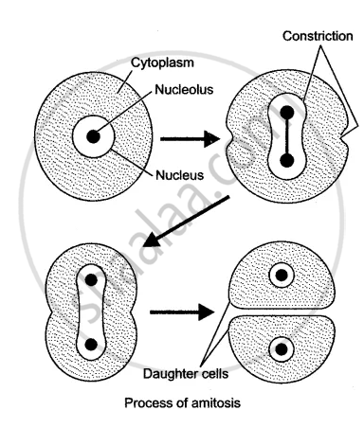
Amitosis (direct division): nucleus elongates and constricts without visible chromosome condensation or spindle formation

2.3 Amitosis — Classification Table
Feature | Amitosis | Notes
Spindle | Absent | No kinetochores, no mitotic apparatus
Chromosome behaviour | No condensation / alignment | DNA just splits roughly
Stages visible | None (no P/M/A/T) | Simply constriction
Genetic accuracy | Low — can produce unequal division | No proofreading checkpoints
Occurrence | Mammalian liver, some protists, cancer cells | Rare in normal adult eukaryotes
Daughter cell ploidy | Usually same as parent (2n → 2n) | Can be uneven
Speed | Fastest form of division | No interphase checkpoint needed
Reproductive significance | None in humans | No meiosis, no crossing over

2.4 Direct Division Types — Expanded
Type | Organism | Mechanism | Daughter Cells
Binary Fission | Amoeba, most protists | Cell constricts at midline after nucleus divides | 2 identical cells
Budding | Saccharomyces (yeast), Hydra | Small vesicle (bud) grows on parent → detaches | 1 large parent + 1 small daughter
Fragmentation | Some fungi, flatworms, some plants | Body breaks into fragments → each regenerates | Multiple new individuals
Multiple Fission | Plasmodium (malaria parasite) | One nucleus divides repeatedly before cytoplasm divides | Many merozoites from one cell

🧠 Mnemonic to Remember: B-F-M-B = Binary fission (Amoeba), Fragmentation (fungi), Multiple fission (Plasmodium), Budding (yeast)

2.5 Where Amitosis Is Biologically Important
- Liver regeneration: hepatocytes divide amitotically after partial liver resection — fast repair without full mitosis.
- Malignant transformation: many cancer cells divide by amitosis — genetic instability drives tumour heterogeneity.
- Red blood cell maturation: mammalian RBCs lose the nucleus entirely (anucleate) — they cannot divide by any method.
- Protozoan life cycles: Plasmodium multiple fission produces merozoites that invade red blood cells.
⚠ BOUNDARY & LIMIT: Amitosis has NO spindle, NO chromosome alignment, and NO genetic checkpoints. It is not a reliable method for passing hereditary information. In humans it is limited to liver regeneration and is associated with malignancy. True mitosis always uses a spindle; true meiosis always involves homologous pairing. Mammalian mature RBCs are ANULEATE — they do not divide at all (no nucleus). Amitosis ≠ binary fission: binary fission in prokaryotes (bacteria) is a specific, regulated process with a septum; amitosis in eukaryotes is an unstructured constriction of the whole cell.
Quick Test — Unit 2:
- What makes amitosis 'direct' division? (No spindle, no chromosome condensation, no visible stages)
- Name two cells in the human body where amitosis occurs. (Liver cells, some cancer cells)
- What is multiple fission and where is it seen? (Plasmodium — one nucleus divides many times before cytoplasm divides)

UNIT 3 — MITOSIS (Indirect / Dividing Cell Division)
The standard mechanism by which every somatic (body) cell divides in eukaryotes. One parent cell → two genetically identical daughter cells (2n → 2n). Driven by the mitotic spindle, with strict genetic checkpoints.

3.1 Mindmap Architecture
🗂 MITOSIS — Full Stages & Context — Mindmap Architecture
▶ CELL CYCLE (Interphase)
● G1
– Cell grows, makes proteins, checks for damage
– Duration: variable (hours to years)
● S (Synthesis)
– DNA replication — each chromosome → 2 sister chromatids
– Centrosome duplicates
– Cell now has 4C DNA
● G2
– Final growth, spindle proteins made, checkpoint: 'ready to divide?'
– G1 + S + G2 = INTERPHASE (~90% of cell cycle time)
▶ MITOTIC PHASE (M phase)
● Prophase
– Chromosomes condense (visible X-shape)
– Spindle fibres form from centrosomes
– Nuclear envelope breaks down
– Prometaphase: spindle attaches to kinetochores
● Metaphase
– All chromosomes line up at the cell equator (metaphase plate)
– Spindle tension confirmed by checkpoint (SAC – spindle assembly checkpoint)
● Anaphase
– Sister chromatids pulled apart by kinetochore microtubules
– Shortened spindles pull each set to opposite poles
– Each chromatid is now an independent chromosome
● Telophase
– Nuclear envelopes reform around each set
– Chromosomes decondense
– Cytokinesis begins
● Cytokinesis
– Animal: cleavage furrow (actin ring)
– Plant: cell plate (Golgi-derived vesicles)
– Result: two independent 2n cells
▶ PURPOSE OF MITOSIS
● Growth
– Embryonic development, organ growth
– 1 cell → trillions
● Repair
– Wound healing, tissue regeneration
– Skin, gut lining, blood cells
● Asexual Reproduction
– Regeneration in Hydra, Planaria, starfish
– Yeast budding
– Bacterial binary fission (prokaryotic equivalent)

3.2 Diagram — Mitosis Stages
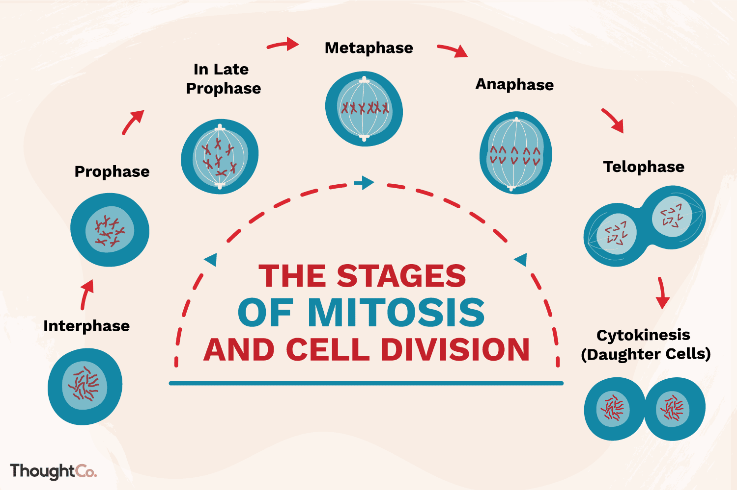
The 5 stages of mitosis: Prophase → Metaphase → Anaphase → Telophase → Cytokinesis

3.3 Diagram — Cell Cycle (Interphase + M)
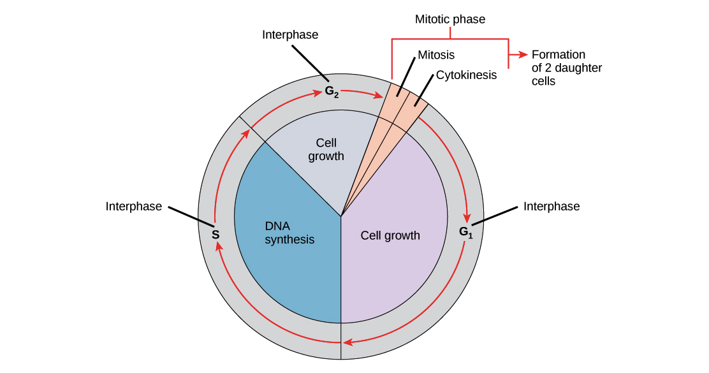
Cell cycle: G1 (growth) → S (DNA replication) → G2 (preparation) → M (mitosis) → daughter cells

3.4 Stage-by-Stage Detail
Stage | Key Events | Chromosome Count | DNA Amount
G1 | Cell grows, proteins made, checkpoints run | 46 chromosomes (human) | 2C
S | Each chromosome replicates → 2 sister chromatids | 46 chromosomes (each has 2 chromatids) | 4C
G2 | Final preparation, centrosome duplication complete | 46 chromosomes (4C DNA) | 4C
Prophase | Condensation begins, spindle nucleates, NEBD | 46 chromosomes | 4C
Metaphase | Equatorial alignment, SAC checkpoint | 46 chromosomes (each X-shaped) | 4C
Anaphase | Sister chromatids pulled to poles (now independent chromosomes) | 92 chromosomes (one chromatid each) | 4C
Telophase | NEBD, decondensation | 46 chromosomes in each daughter region | 4C → 2C each
Daughter cell | Normal somatic cell | 46 chromosomes, 2C DNA | 2C

🧠 Mnemonic to Remember: P-M-A-T + C = 'Please Make A Toast + Cake' — Prophase, Metaphase, Anaphase, Telophase, Cytokinesis

3.5 Mitosis vs Amitosis — Clear Boundary
Feature | Mitosis | Amitosis
Spindle | Present (kinetochore + polar microtubules) | Absent
Stages | Visible: P, M, A, T, C | No visible stages
Chromosome behaviour | Condensation, alignment, separation | No visible condensation or alignment
Genetic accuracy | High — sister chromatids are identical | Low — can be unequal
Cell size control | Yes — daughter cells same size as parent | No — size can vary
Occurrence | All somatic eukaryotic cells | Limited: liver, some protists, cancer
Evolutionary age | Ancient, highly conserved | Simple, primitive

⚠ BOUNDARY & LIMIT: Mitosis produces two GENETICALLY IDENTICAL daughter cells — no crossing over, no recombination. The boundary between mitosis and meiosis: mitosis has ONE division (2n→2n); meiosis has TWO (2n→n). Mitosis occurs in somatic cells; meiosis occurs only in germ cells (gonads). The spindle assembly checkpoint (SAC) at metaphase ensures all kinetochores attach correctly before anaphase begins — this is the key safety mechanism absent in amitosis. In plants, cytokinesis uses a cell plate (Golgi-derived); in animals it uses a cleavage furrow. Mammalian RBCs cannot undergo mitosis (anucleate). Cells that have stopped dividing exit the cell cycle into G0 (e.g. mature neurons, muscle cells).
Quick Test — Unit 3:
- At which stage do chromosomes align at the equator? (Metaphase)
- What is the key difference between metaphase of mitosis and metaphase of meiosis I? (Mitosis: individual chromosomes align. Meiosis I: homologous PAIRS align at the equator.)
- A human cell in S phase has how many chromosomes and how many chromatids? (46 chromosomes, 92 chromatids — each chromosome = 2 sister chromatids)

UNIT 4 — MEIOSIS (Reductional Division)
The specialised cell division that produces gametes (sperm, egg, pollen, ovule) and reduces chromosome number by half (2n → n). It is the source of all genetic variation in sexually reproducing organisms. Two divisions (Meiosis I + Meiosis II) from one DNA replication.

4.1 Mindmap Architecture
🗂 MEIOSIS — Complete Architecture — Mindmap Architecture
▶ BEFORE MEIOSIS
● Interphase
– DNA replication in S phase (once, shared by both divisions)
– Homologous chromosomes now have 2 sister chromatids each
▶ MEIOSIS I (REDUCTIONAL DIVISION)
● Prophase I (longest, most complex)
– Leptotene: chromosomes begin condensing
– Zygotene: homologous chromosomes pair (SYNAPSIS → bivalents / tetrads)
– Pachytene: crossing over (exchange of chromosome segments between non-sister chromatids)
– Diplotene: chiasmata (visible crossover points) hold homologues
– Diakinesis: chromosomes fully condensed, spindle attached
● Metaphase I
– HOMOLOGOUS PAIRS align at equator
– Sister chromatids stay together
– Independent orientation: each pair flips randomly (source of variation #1)
● Anaphase I
– Homologous chromosomes separate (one of each pair goes to each pole)
– Sister chromatids DO NOT separate yet
– Chiasmata break
● Telophase I + Cytokinesis
– Two haploid (n) cells form
– Each cell still has sister chromatids joined
▶ INTERKINESE (short rest)
● No DNA replication
– Cells rest briefly before Meiosis II
▶ MEIOSIS II (EQUATIONAL DIVISION)
● Prophase II
– Chromosomes re-condense, spindle reforms
– Nuclear envelope re-forms and breaks down
● Metaphase II
– Chromosomes (each with 2 chromatids) align individually at equator
● Anaphase II
– Sister chromatids finally separate (like mitosis anaphase)
– Genetic variation source #2: random chromatid assortment
● Telophase II + Cytokinesis
– Four haploid daughter cells (each n, each with 1 chromatid per chromosome)
▶ SOURCES OF GENETIC VARIATION
● Crossing Over
– Pachytene of Prophase I — exchange between non-sister chromatids
● Independent Assortment
– Metaphase I — random orientation of each bivalent
● Random Fertilisation
– 23^2 = 4.7 million possible zygote combinations
▶ GAMETOGENESIS
● Spermatogenesis
– One diploid cell → 4 functional sperm (all equally sized)
● Oogenesis
– One diploid cell → 1 egg + 3 polar bodies (unequal cytokinesis)

4.2 Diagram — Meiosis I and Meiosis II
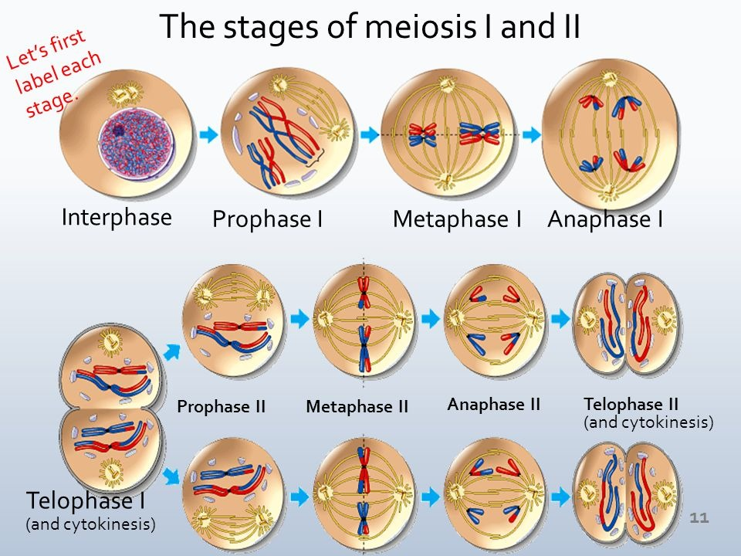
Meiosis I (reductional: homologues separate) and Meiosis II (equational: sister chromatids separate)

4.3 Diagram — All Meiosis Phases
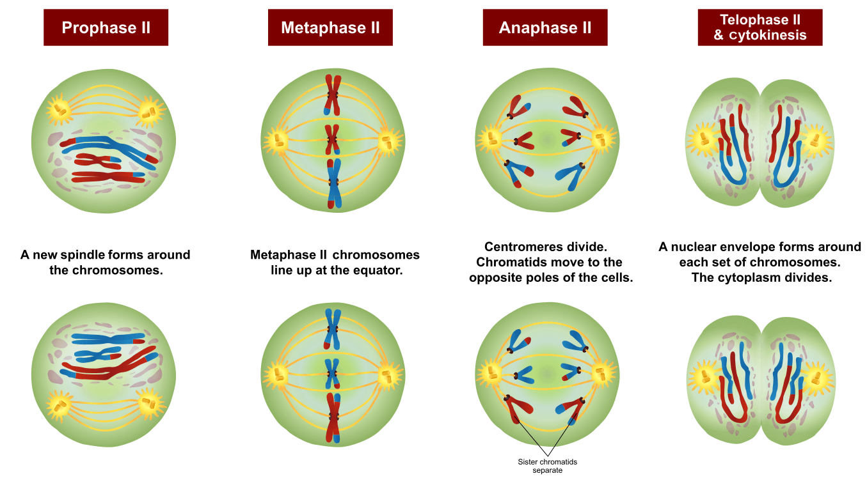
All phases of meiosis: Prophase I (Leptotene → Diakinesis), Metaphase I, Anaphase I, Telophase I, Prophase II, Metaphase II, Anaphase II, Telophase II

4.4 Meiosis I vs Meiosis II
Feature | Meiosis I (Reductional) | Meiosis II (Equational)
What separates? | Homologous PAIRS (bivalents) | Sister CHROMATIDS
Source of variation? | Yes (crossing over + independent assortment) | No (just equal split)
Cytokinesis | After Telophase I | After Telophase II
Starting cell | 2n (one full set of homologous pairs) | n (but chromatids still joined)
Ending cells | Two haploid cells (n) | Four haploid cells (n)
DNA replicated? | Before Meiosis I (shared by both divisions) | No — no replication between M I and M II
Analogous to | No mitotic equivalent | Resembles mitosis (individual chromatids align & separate)

🧠 Mnemonic to Remember: L-Z-P-D-D = Leptotene, Zygotene, Pachytene, Diplotene, Diakinesis (Prophase I sub-phases — 'Lonely Zombies Paint Diploma Days')

🧠 Core Rule: M I pairs apart • M II chromatids apart (The single sentence that separates Meiosis I from Meiosis II)

🧠 Mnemonic to Remember: 2 → 4 = One diploid cell → Four haploid gametes after meiosis completes

4.5 Gametogenesis Comparison
Feature | Spermatogenesis (Males) | Oogenesis (Females)
Starting cell | Primary spermatocyte (2n) | Primary oocyte (2n, arrested in Prophase I at birth)
Completion trigger | Puberty → continuous | One per month → ovulation cycle
Cytokinesis | Equal (no polar bodies) | Unequal (large egg + small polar bodies)
Functional gametes | 4 sperm per primary spermatocyte | 1 egg + 2–3 polar bodies per primary oocyte
Cell motility | Motile (flagellum) | Immotile (needs sperm for activation)
Energy storage | Minimal | Large yolk (nutrient reserve)
Lifespan | Continuous production from puberty | All oocytes formed in fetal life; ~400 ovulated in lifetime

⚠ BOUNDARY & LIMIT: Meiosis I is REDUCTIONAL: it halves the chromosome number (2n → n) by separating homologous PAIRS. Meiosis II is EQUATIONAL: it separates sister CHROMATIDS (like mitosis). The boundary: in Meiosis I, sister chromatids stay together; in Meiosis II, they separate. Crossing over happens ONLY in Prophase I (Pachytene stage) — never in Meiosis II or mitosis. Independent assortment happens ONLY at Metaphase I. In humans: n = 23, so 2^n = 8.4 million possible gamete combinations from one individual. Meiosis errors → aneuploidy (Down syndrome, Turner syndrome, etc.) — especially in oogenesis as maternal age increases. Meiosis in males: 1 primary → 4 functional sperm (all motile). In females: 1 primary → 1 egg + polar bodies (non-functional). Meiosis does NOT occur in prokaryotes (no homologous chromosome pairing in bacteria).
Quick Test — Unit 4:
- What is the most important source of genetic variation in meiosis and when does it occur? (Crossing over, Pachytene of Prophase I; independent assortment at Metaphase I)
- In Meiosis I anaphase, what separates — sister chromatids or homologous pairs? (Homologous pairs; sister chromatids stay joined until Meiosis II)
- How many functional gametes are produced from one primary spermatocyte? (4)
- How many functional gametes are produced from one primary oocyte? (1 egg + polar bodies)

UNIT 5 — MITOSIS vs MEIOSIS (Complete Comparison)
The final, most exam-critical unit: the full side-by-side comparison of the two types of indirect cell division. Every feature is listed so no point is missed.

5.1 Diagram — Mitosis vs Meiosis
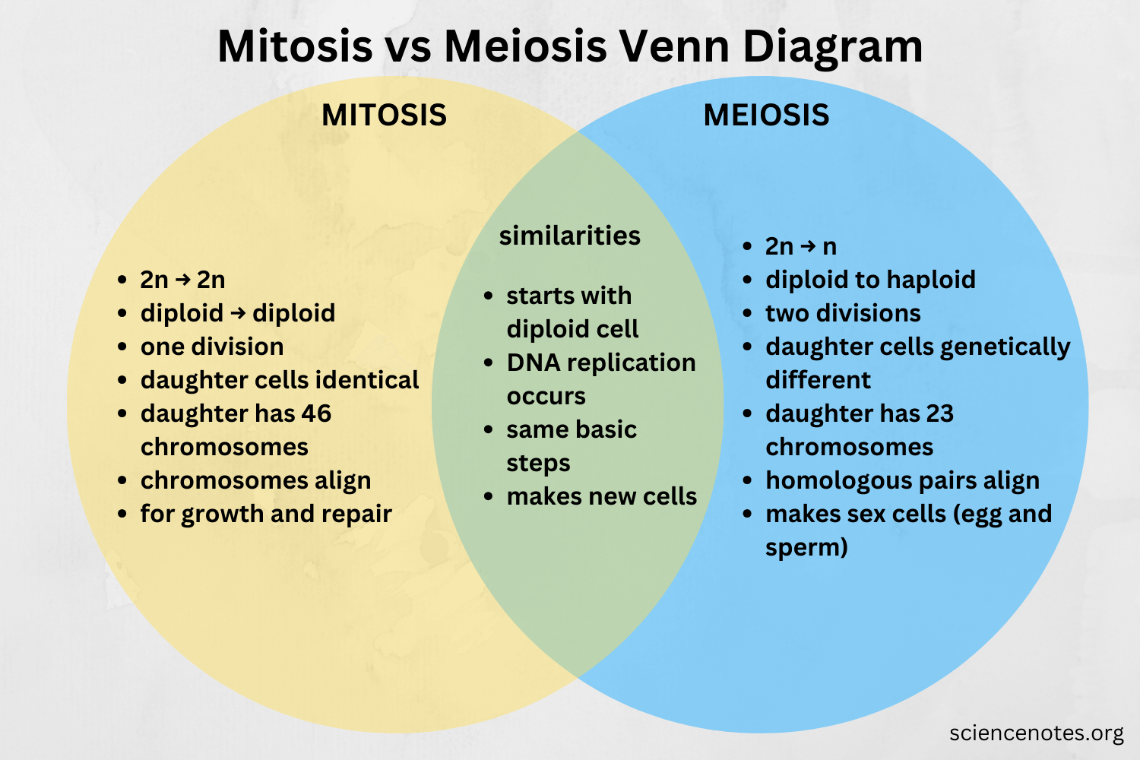
Mitosis vs Meiosis side-by-side comparison: ploidy, number of divisions, genetic variation, and daughter cell outcomes

5.2 Complete Comparison Table
Feature | MITOSIS | MEIOSIS
Cell type | Somatic cells | Germ cells (gonads only)
Number of divisions | 1 division | 2 consecutive divisions (M I + M II)
DNA replication | Once (before the single division) | Once (shared across both divisions)
Ploidy change | 2n → 2n (diploid preserved) | 2n → n (haploid produced)
Daughter cells | 2 diploid cells, genetically identical | 4 haploid cells, genetically different
Crossing over | Never | Yes — Pachytene of Prophase I only
Independent assortment | No (chromosomes align individually) | Yes — Metaphase I (bivalents align randomly)
Genetic variation in daughters? | None (clones) | Yes — unique in every cell
Metaphase alignment | Individual chromosomes align at equator | Homologous PAIRS (bivalents) align at equator
Anaphase separation | Sister chromatids separate | M I: homologues separate; M II: chromatids separate
Spindle behaviour | Single spindle | Two spindles (one per division)
Cytokinesis | Once → 2 cells | Twice → 4 cells
Chromosome count (human) | 46 → 46 | 46 → 23 → 23 × 4
Occurrence in life | Throughout life (growth, repair) | Only during reproduction (puberty onwards)
Evolutionary role | Maintains somatic integrity | Drives genetic diversity
Errors cause | Cancer (uncontrolled mitosis) | Aneuploidy (Down, Turner, Klinefelter)

5.3 Where Each Occurs in the Human Body
Process | Site | Daughter Cells
Mitosis — bone marrow | Bone marrow stem cells → blood cells | 2 identical 2n cells
Mitosis — skin | Basal layer of epidermis | 2 new skin cells (shed every ~40 days)
Mitosis — liver | Hepatocyte regeneration | New hepatocytes
Mitosis — gut | Intestinal epithelium (replaces every 3–5 days) | New intestinal cells
Meiosis — testes | Spermatogenesis (continuous from puberty) | 4 sperm per primary spermatocyte
Meiosis — ovaries | Oogenesis (1 oocyte/month; all made prenatally) | 1 egg + polar bodies
Meiosis — seed plants | Pollen mother cell → microspores | 4 pollen grains per diploid mother cell

5.4 Chromosome Number Tracking (Human 2n=46)
Stage | Chromosomes | Chromatids | DNA (C value)
G1 of mitosis | 46 | 46 | 2C
After S (G2) | 46 | 92 | 4C
Metaphase of mitosis | 46 (each with 2 chromatids) | 92 | 4C
Anaphase of mitosis | 92 (each is now 1 chromatid) | 92 | 4C
Daughter cells of mitosis | 46 | 46 | 2C
Start of meiosis I | 46 (each with 2 chromatids) | 92 | 4C
After Meiosis I (2 cells) | 23 per cell | 46 total (23 pairs) | 2C per cell
After Meiosis II (4 cells) | 23 per cell | 23 per cell | 1C per cell

5.5 Master Mindmap — All Three Division Types
🗂 CELL DIVISION — Master Map (Amitosis + Mitosis + Meiosis) — Mindmap Architecture
▶ CELL DIVISION
● DIRECT (Amitosis)
– No spindle, no stages, no checkpoints
– Liver, some protists, cancer cells
– Fast but genetically unreliable
● INDIRECT (Mitosis)
– 1 division, 2n → 2n, 2 identical cells
– Growth, repair, asexual reproduction
– No crossing over, no variation
– P → M → A → T → C (Please Make A Toast + Cake)
● REDUCTIONAL (Meiosis)
– 2 divisions, 2n → n, 4 different cells
– Gamete production only
– Crossing over (Pachytene) + independent assortment (M I)
– M I: pairs apart | M II: chromatids apart
– Sources of variation: CO, IA, random fertilisation
🧠 All Mnemonics in One Place: Mitosis: P-M-A-T+C • Meiosis: L-Z-P-D-D (Prophase I) • 'I pairs apart' = Meiosis I • 'II chromatids apart' = Meiosis II

🧠 Mnemonic to Remember: 2C vs 4C: '2 cells = 2 C; 4 chromatids = 4 C' (C value = DNA content per cell; 2C = one copy of each chromosome, 4C = two copies)

5.6 Key Boundaries & Limits — All Units Combined
- **Prokaryotes vs Eukaryotes:** Bacteria divide by binary fission — no spindle, no meiosis, no homologous pairing. Meiosis and mitosis are exclusive to eukaryotes.
- **Mammalian RBCs:** Mature mammalian RBCs are anucleate — they cannot divide by ANY method.
- **Mycoplasma:** No cell wall (the only eubacteria without one) — resistant to cell-wall-targeting antibiotics like penicillin.
- **Mycobacteria:** Acid-fast wall (mycolic acid) — survives Gram stain failure, resistant to many antibiotics; requires specific staining (Ziehl-Neelsen).
- **Amitosis in humans:** Limited to liver regeneration and malignant cells; not a normal reproductive pathway.
- **Meiosis timing:** In humans, all oogonia divide to primary oocytes BEFORE BIRTH. No new oocytes are made after that. The meiotic count is fixed at birth (~1–2 million, most degenerate).
- **Crossing over frequency:** Varies between chromosome pairs — the centromere (middle) has the lowest crossover rate; telomeres have the highest.
- **Aneuploidy risk:** Increases with maternal age because oocytes are arrested in Prophase I for decades, weakening the spindle and checkpoint systems.
⚠ BOUNDARY & LIMIT: The complete boundary map: (1) Bacteria = prokaryotes — no nucleus, 70S ribosomes, binary fission only. (2) Amitosis = direct eukaryotic division — no spindle, unreliable. (3) Mitosis = indirect division for somatic cells — 1 division, 2n→2n, no variation. (4) Meiosis = reductional division for gametes — 2 divisions, 2n→n, full variation. (5) Cross over ONLY in Pachytene; independent assortment ONLY at Metaphase I. (6) Mammalian RBCs never divide; sperm are motile, eggs are not; (7) 4 functional sperm vs 1 functional egg per meiosis. (8) G0 = permanent exit from cell cycle (mature neurons, cardiomyocytes).
Final Quick Test — Unit 5:
- What is the single most important difference between Meiosis I and Meiosis II? (M I: homologous PAIRS separate → reduction. M II: sister CHROMATIDS separate → like mitosis.)
- A human cell entering Meiosis I has 46 chromosomes and 92 chromatids. After Meiosis I, how many chromatids are in each daughter cell? (23 chromosomes × 2 = 46 chromatids, but each chromosome still has 2 chromatids — so 23 chromosomes, 46 chromatids per cell)
- Why does meiosis produce variation even if crossing over didn't occur? (Independent assortment of bivalents at Metaphase I gives 2^n random combinations from orientation alone, plus random fertilisation)

