LO1 Describe different software development lifecycles.
P1 Describe two iterative and two sequential software lifecycle models.

SDLC Models
Models for the Software Development Life Cycle (SDLC) are methodical approaches or techniques used in the design, development, testing, deployment, and maintenance of information systems. These models give developers a structure to operate within, guaranteeing that software development is methodical and well-organized. There are several approaches to the development process offered by different SDLC models, and each has pros and cons.
Iterative software lifecycle models:
Spiral model:

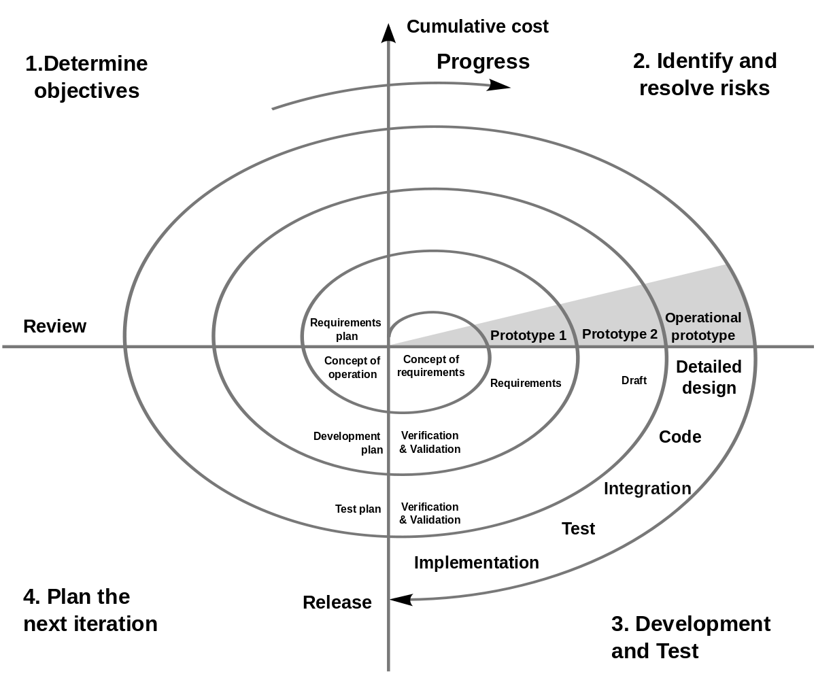
Spiral model an important Software Development Life Cycle (SDLC) technique created for efficient risk management. Each loop on the spiral, which represents different stages of the growth process, represents a stage. This paradigm is flexible and responsive, with the project manager deciding the number of phases based on project risks in real time.

In the Spiral model, the radius represents project expenses, and the angular dimension indicates progress in the ongoing phase. As a meta-model, it combines the iterative nature of the prototyping model with the linearity of the waterfall model.

Its emphasis on proactively managing project risks is a crucial component. Prototyping is used at every stage of the project to address risks, which are characterized as unfavorable circumstances that could affect the project's success. The Spiral model stands out from other SDLC methodologies, such the Prototyping Model, which restricts its capacity to adjust to real-time risk events by requiring comprehensive risk identification prior to development.

Kinds of Risks in Software Development
Schedule risks in a project are problems with time management that have a big influence on the timetables for development and delivery. Schedule hazards are frequently caused by incorrect time estimation, poor resource allocation, scope expansions on a regular basis, and incomplete or incorrectly identified project functions.
Budget risks are the main source of budget overruns, which are related to financial worries. Budget hazards include things like inaccurate or insufficient budget estimates, unforeseen scope extensions for projects, poor budget administration, and instances of cost overruns.
Operational risks result from weak process implementation or external operational factors during regular project development operations. Operational hazards can be caused by a lack of skilled workers, disagreements between duties and employees, unclear roles and responsibilities, poor communication and cooperation, and insufficient training.
Technical risks are the focal point of functional and performance issues; these are typically related to a product's functionality or the performance features of software. Technical risks can arise due to several factors such as infrequent modifications to requirements, restricted adoption of upcoming technologies, insufficient workforce with specialized skills, intricate implementation processes, and inappropriate module integration.
Programmatic risks are those that come from outside sources and are either uncontrollable or external. Programmatic risks can be caused by several things, such as the market's quick development, the availability or scarcity of funding for projects, modifications to government regulations or policies, and contract terminations for a variety of causes.

Spiral Model phases:
Planning Phase of the Spiral model, requirements are gathered, including Business Requirement Specifications (BRS) and System Requirement Specifications (SRS).
Risk Analysis Phase, the process focuses on identifying risks and proposing alternative solutions. At the end of this phase, a prototype is produced. If any risks are identified, corresponding alternate solutions are suggested and implemented.
Engineering Phase involves the development of software, incorporating testing at the phase's conclusion. Both development and testing activities are carried out during this phase.
Evaluation Phase, the customer can assess the project's output to date before deciding whether to proceed to the next spiral.

Advantages of Spiral model
high level of risk analysis to keep things safe.
Excellent for significant and mission-critical tasks.
strong documentation control and approval processes.
Later, further functionality may be added.
Early in the software life cycle, software is developed.

Disadvantages of Spiral model
The use of this model may be expensive.
Risk analysis calls for very specialized knowledge.
The risk analysis step is critical to the project's success.
Not recommended for minor projects.

Agile model:
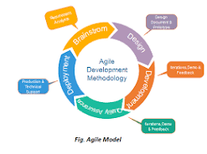
Agile Modeling (AM) is an approach for rapidly modeling and documenting software systems by combining incremental and iterative procedures. Agile Methods divide the product into small, incremental builds and place a heavy focus on adaptability and customer satisfaction through rapid software delivery. These builds, which are completed in brief iterations of one to three weeks, entail cross-functional teams working on different project areas concurrently. Because of its flexibility, the technique is especially well-suited for contexts that undergo rapid change.
Examples of Agile-based approaches include Scrum and the Dynamic Systems Development Method (DSDM).

Agile Model phases:
Requirements Gathering: Start by outlining the project's requirements in detail, outlining the business potential, and estimating the time and effort needed. This first stage aids in assessing viability from an economic and technological standpoint.
Design Requirements: Work with stakeholders to identify the needs for the project and utilize tools such as UML or user flow diagrams to show how new features will fit into the current system.
Development/Iteration: The development team starts the project after requirements are determined. The goal of designers and developers is to release a functional product, with an early focus on simplicity and limited functionality.
Testing/Quality Assurance: The Quality Assurance team thoroughly inspects the functionality of the product, finding and fixing any bugs or issues.
Deployment: The team releases the product into the user's work environment, making it accessible for use.
Feedback: After product release, the final step involves gathering feedback. The team actively receives and processes feedback from users, incorporating improvements based on user insights.
All the phases will loop in each iteration.
Advantages of Agile model
Customer satisfaction through consistent, quick delivery of practical software.
Process and tools are not prioritized over people and interactions.
There is regular communication between customers, developers, and testers.
Functional software is released often, in weeks as opposed to months.
The most effective way to communicate is face-to-face.
Developers and businesspeople working together every day.
Constant focus on high-quality design and technical performance.
adjustment to shifting conditions.
We encourage late modifications to the specifications.

Disadvantages of Agile model
Assessing the work necessary at the start of the software development life cycle can be challenging for certain software deliverables, particularly the larger ones.
The important design and documentation are not given enough attention.
If the client representative does not know exactly what they want out of the project, it might quickly veer off course.
Making the kinds of decisions needed in the development process is only possible for senior programmers.
Unless paired with more seasoned resources, hazardous for novice programmers.

Dynamic Systems Development Method (DSDM).
Rapid Application Development (RAD) is facilitated by the Dynamic Systems Development Method (DSDM), which has also been modified to provide a framework for Agile models. It works particularly well for application development projects were producing intricate business solutions in a short amount of time is necessary.
Project duration is set in stone using DSDM, and resources are distributed as widely as feasible. This method places a higher priority on adjusting to requirements changes while sticking to a set schedule and resource allocation. This approach aids in resolving typical issues including exceeding spending limits, missing deadlines, and guaranteeing user participation.
The DSDM lifecycle comprises seven distinct phases: the Pre-Project Phase, Feasibility Study, Business Case Study, the Functional Model Iteration (FMI), the Design and Build Iteration (DBI), the Implementation Phase, and the Post-Project Phase. This structured approach enables a systematic progression through project development, ensuring comprehensive coverage from initial assessment to post-implementation evaluation.

Scrum
an iterative project management approach, breaks down projects into short sprints lasting one to four weeks, each concluding with a functional draft of the final deliverable. This flexible method is effective for complex projects resulting in tangible products. Scrum in Agile involves key roles: the Product Owner represents customer interests, the Scrum Master facilitates daily meetings and team interactions, and the Development Team, typically self-organized, designs, produces, tests, and releases the product. Together, they form the Scrum Team, collaboratively working towards project goals.
Sequential software lifecycle models:

Waterfall Model:
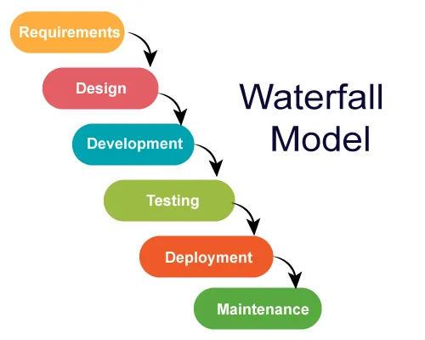
The Waterfall Model, the first process model, is linear and easy to understand. Each phase must be completed before moving to the next. However, it struggles with adapting to changes during the process due to its rigid structure. In principle, a phase must be complete before moving onto the next phase.

Requirement: Gathering and documenting the project requirements to understand what the software needs to achieve.
Design: Developing the system architecture and design based on the gathered requirements.
Development: Writing the actual code for the software, translating the design into a programming language.
Testing: Conducting various levels of testing, including unit testing, integration testing, system testing, and acceptance testing, to identify and fix defects.
Deployment: Releasing the software to the production environment or end-users.
Maintenance: Providing ongoing support, bug fixes, updates, and enhancements to the software after deployment.

Advantages of waterfall model
Simple and user-friendly model
Offers clear structure, which is beneficial for less experienced teams.
Well-defined benchmarks for progress tracking
Establishes stability in requirements.
Effective management control, including planning, staffing, and monitoring.
Suitable when prioritizing quality over cost or schedule constraints.

Disadvantages of waterfall model
requires previous awareness of all prerequisites.
Errors can only be fixed during certain stages.
could give a false impression of progress.
Unsuitable for complex projects with frequent modifications to requirements
Late in the development phase, testing takes place.
It is challenging to include insightful client feedback in continuous development.
Minor modifications or mistakes in finished software can result in serious problems.

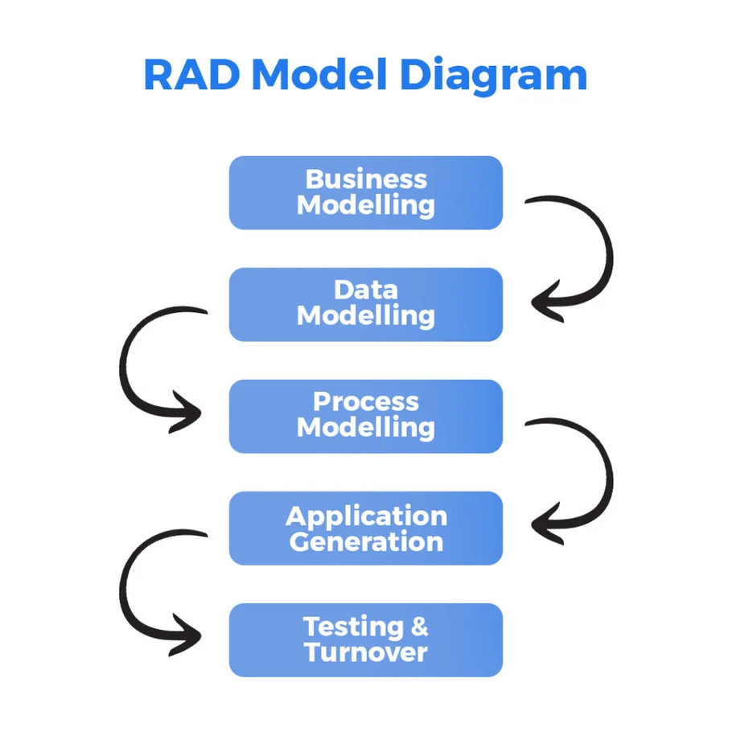 RAD Model:
The Rapid Application Development (RAD) paradigm entails treating individual functionalities or components as mini-projects and developing them concurrently. Time-boxed, delivered, and integrated development phases come together to generate a working prototype.

RAD Model phases:

Business Modeling: Identifying information flow among different business functions.
Data Modeling: Using information obtained from business modeling to define necessary data objects for the business.
Process Modeling: Converting data objects defined in data modeling to achieve the flow of business information for specific objectives. Descriptions are created for CRUD operations on data objects.
Application Generation: Employing automated tools to convert process models into actual code for the system.
Testing and Turnover: Testing new components and interfaces before turnover to ensure functionality and integrity.

Advantages of RAD model
Reduced time needed for development.
Improved component reuse
Quick first assessments
enables client feedback.

Disadvantages of RAD model
depends on excellent individual and team efforts to determine company requirements.
confined to creating modular building systems.
needs designers and developers with advanced skills.
High dependency on modeling skills.
Too expensive for projects where budget is a concern because of automated code production and high modeling charges.

P2 Explain how risk is managed in software lifecycle models.
We have previously mentioned in this report the types of risks in software development, and now we will discuss how risk is managed in software lifecycle models.
Firstly, risk management in software development is the process of identifying, assessing, organizing solutions, keeping an eye on, and responding to possible problems to guarantee project success. Careful analysis and mitigation are required for any threat, no matter how great or tiny, explicit, or implicit, internal, or external, that could compromise the project's success. It is the duty of every team member to identify potential risks and notify the project manager so that appropriate action can be taken. Identification, categorization, prioritization, developing mitigation strategies, ongoing project monitoring, and action plan implementation if a danger materializes are critical responsibilities in software development risk management. It takes regular team communication to identify and counter emerging threats.
Effective risk management in software development is paramount for project success. Despite being perceived as additional effort and cost, neglecting risk management can prove costly.

Risk Assessment and Prioritization in project management involve several key steps. Firstly, identify issues causing risks in projects. Then, determine how likely a problem is to occur and assess its impact, assigning probability and impact values from 1 to 10.
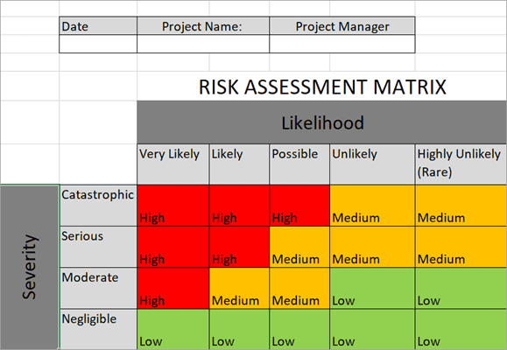
For Risk Avoidance and Mitigation, the goal is to eliminate risks. This includes cutting down project scope by removing non-essential requirements, identifying, and eliminating potential risks, or minimizing their impact.

In Risk Transfer, when a project is too large for one team, external companies can take on specific parts of the project to reduce overall risk.

On the other hand, Risk Acceptance involves deliberately taking on some risks to complete the project. This allows time to understand project requirements and estimate the necessary effort, and its success is determined through trial and evaluation.

Lastly, Risk Monitoring is an ongoing process of regularly evaluating risks, their impact, and likelihood. This ensures that risks are consistently identified, reduced, and their magnitude and impact are assessed to keep the project resilient.

Let's discuss how risk management is incorporated into each phase of the Software Development Life Cycle (SDLC):
Project Planning: Determine and evaluate the risks related to scheduling and resource allocation throughout the project planning phase. Create backup plans in case there are delays or resource shortages.
Requirements & Analysis: Determine the risks associated with misinterpreted specifications or shifting expectations from stakeholders. Create mechanisms for change management, carry out in-depth requirements analysis, and establish clear lines of communication.
Design: Take into consideration any dangers associated with your selections in technology. Reduce risks by thinking about prototypes and doing design reviews.
Coding or Implementation: Control the risks related to coding mistakes and integration difficulties. To find issues early, employ automated testing, code reviews, and the implementation of coding standards.
Testing: Pay attention to the risks associated with insufficient test coverage or unforeseen problems that arise. Use thorough test plans, a variety of testing techniques, and automated testing to reduce risks.
Deployment: Talk about the potential for problems with data migration or unforeseen system behavior. Reduce risks by using careful planning, phased implementations, and rollback strategies.
Maintenance: Recognize potential dangers in continuing system upkeep, such as compatibility problems or security holes. Reduce risks by applying security patches on a regular basis, keeping an eye on performance, and organizing future updates.

M1 Discuss using an example, why a particular lifecycle model is selected for a development environment.
The success of the project depends critically on the selection of a suitable Software Development Life Cycle (SDLC) model in the dynamic world of mobile application development. The Agile SDLC approach was purposefully chosen for the development of FitPro, a feature-rich fitness program intended to adapt to shifting user demands, technology developments, and industry trends. This choice was made because FitPro's goals are perfectly aligned with the model's dynamic nature and innate ability to navigate uncertainty. This introduction will explore the reasoning behind the choice of the Agile model, highlighting its benefits for collaboration, flexibility, speedy delivery, and iterative, customer-centric approach. Agile is the best framework for accomplishing the objectives of developing a dynamic, user-friendly for FitPro. Here's a closer look at why Agile outshines other models for the development of FitPro:

Adaptability and Flexibility:
Agile approaches are excellent at being flexible and adaptive to the needs of evolving projects. Given how dynamic the fitness sector is and how consumer wants can change, this is important in the context of FitPro. Agile development facilitates real-time adjustments, so FitPro may quickly add new features, alter current ones, and keep up with the quickly evolving fitness technology market.
Decreased Risk and Early Validation:
The iterative nature of agile development reduces the risks that come with protracted development cycles. FitPro can be evaluated and validated at an early stage of the development process by segmenting the work into smaller steps. As a result, there is a decreased chance that significant flaws will remain hidden until far later, guaranteeing a more dependable and durable training program.
User-Centric Attention:
Agile gives consumer input and cooperation a lot of weight. A user-centric approach is crucial for FitPro, as the company strives to improve user fitness and enjoyment. Agile's iterative releases facilitate ongoing feedback loops, guaranteeing that decisions are made with user preferences and expectations front and center. This methodology facilitates the development of a fitness application that strikes a chord with its intended user base.
Improved Team Cooperation and Communication:
Agile approaches encourage team members to communicate and work together often. Effective teamwork is crucial in the development of FitPro, as different components like diet planning, exercise programs, community features, and live workouts need to be seamlessly integrated. Agile places a strong focus on regular team meetings and daily communication, which encourages collaboration and makes sure that every part of FitPro is cohesive and well-integrated.
Scalability and Continuous Improvement: FitPro's capacity to grow along with the needs of its users and the trend in the market is essential to its success. FitPro may continue to improve its features and functionalities because of agile's emphasis on continuous improvement. Agile's scalability guarantees that FitPro can quickly and easily adjust to growing user numbers, new content, and changing technological landscapes.
FitPro has chosen Agile Software Development Life Cycle (SDLC) over other methods, such as Waterfall or Rapid Application Development, because of its inherent flexibility, customer-centric approach, and adaptability to change. Agile is the perfect framework for FitPro success in the fast-paced, cutthroat world of fitness application development.

D1 Assess the merits of applying the Waterfall lifecycle model to a large software development project.
The Waterfall lifecycle model, which divides the entire process into discrete phases that occur sequentially, has long been recognized as a standard and systematic method to software development. This approach, which is like a cascading waterfall, goes through phases that include requirements collection, design, implementation, testing, deployment, and maintenance. Each step builds on the last one's accomplishment. Examining how the Waterfall model fits in with the overall objectives of a big software development project as well as the experiences and viewpoints of the developers involved in its implementation is crucial in this context.
When used on big projects, the Waterfall lifecycle model—a conventional, structured method of developing software—has advantages and disadvantages that affect developers as well as project managers. The model offers planning advantages and predictability, offering a well-defined framework with milestones. Precise documentation facilitates progress monitoring and is in perfect harmony with stakeholder participation, especially during critical phases such as requirements definition and user acceptability testing.
The early clarity of requirements reduces uncertainty for developers and enables targeted development through clearly defined phases. Differential specialization can produce better results that match the skill of developers.
However, certain obstacles emerge, such as restricted adaptability for project supervisors and postponed user input. If requirements are not precisely recorded at the outset, the linear aspect of the Waterfall methodology may result in a lengthy time to market and a risk of misalignment with user wants. The rigidity of the model may feel restrictive to developers, particularly when dealing with adjustments at the end of the process, which can affect productivity and creativity.
In conclusion, the Waterfall model offers predictability and clarity, but it also has shortcomings that make project management and development difficult, like inflexibility and delayed feedback. The needs of the project, industry standards, and the fluid nature of software development should all be considered while selecting a development methodology. Agile approaches are preferred by many modern teams because they are more flexible.

P3 Explain the purpose of a feasibility report.
Feasibility study
A feasibility study is a thorough examination that considers every important factor related to a project to assess its chances of success.
The purpose
A feasibility study examines several factors to ascertain whether a concept is feasible, serving as a project's practical review. The first step is determining if the project can be completed, considering all relevant technical, financial, legal, operational, and market factors. It creates solutions and foresees possible problems. The report makes sure the project has adequate funding, personnel, and technology. To determine whether there is interest in the project, it evaluates the market. It makes financial estimates of expenses and earnings. It guarantees adherence to laws and regulations. From a technical standpoint, it looks at whether the project can be completed with the tools and resources already in place. It looks at how the project fits within the current structure of the business. To make sure the project fits with market trends, timing is evaluated. In the end, decision-makers use this data to determine whether to move forward with the project, make changes, or put it on hold.

The feasibility report's objective is to present the project's specifics and suggest possible fixes for the identified issue, demand, or opportunity. The project team investigates several choices and then submits comprehensive data, including initial cost estimates, to the project leader so that the latter can suggest workable options to the approving authority. In the following stage, referred to as the Business Case, these suggested solutions are then examined in more detail. Project limitations and budgetary restrictions are two examples of variables that affect viability and impact decision-making.

P4 Describe how technical solutions can be compared.

Factor | Dart | Adalo
Purpose and Use Case | Programming language with broad applicability for web, server, and mobile platforms. | Low-code/no-code platform for quickly creating web and mobile applications.
Development Complexity | More complex, suitable for complex applications with specific requirements. | Less complex, better suited for prototypes and smaller applications.
Learning Curve | Requires knowledge of best practices and the syntax of the Dart programming language. | Easy and suitable for people without a lot of programming knowledge.
Speed of Development | It can take longer to develop and test. | Designed for quick development without substantial code.
Scalability | Greater control and flexibility, appropriate for intricate and large-scale applications. | Ideal for tasks that are modest to medium in scope.
Community and Support | Active community and support from Google. | Support through the Adalo platform and community forums.
Cost Considerations | Open-source and free, with potential costs for hosting and infrastructure. | Subscription-based pricing, additional costs for specific features or integrations.
Maintainability | Gives the source code further adaptability and control for long-term maintenance. | simplifies development, but futureproofing and customization options could be limited.

M2 Discuss the components of a feasibility report.
- Legal Feasibility study
One of the most important aspects of project management is legal feasibility, which is studied in detail. The project's legal execution depends on compliance with national regulations, even if finance is obtained. It is necessary to carefully evaluate several legal factors, including data protection laws, social media policies, zoning rules, and other legal requirements. Certain places have certain limitations on the kinds of jobs that are permitted. For example, determining the app's legal viability becomes crucial after creation. Ensuring compliance with all applicable rules and regulations and resolving potential legal repercussions are critical steps towards the overall success and longevity of the project.
- Economic feasibility study
The process of determining the financial advantages and disadvantages of a development project is known as economic feasibility. Commonly known as a cost-benefit analysis.
Let's now look at some benefits of the project's development that we should consider:
Tangible benefits
Tangible benefits in a project context are quantifiable and certain, measured in dollars. They include concrete examples such as reduced personnel expenses, lower transaction costs, and higher profit margins. Generally falling into categories such as cost reduction, error reduction, increased flexibility, improved speed of activity, enhanced management planning and control, and the opening of new markets, tangible benefits provide measurable and financially tangible advantages that contribute to the overall success and efficiency of the project.
Intangible benefits
Intangible benefits of an information system that are difficult to quantify in monetary terms include raises in staff morale and wider social effects like lower resources and waste usage. These intangible gains add a substantial amount to the overall value of the system, despite being difficult to measure.

Let's now look at the project development cost, which is something we must consider:
Tangible costs
Costs that may be precisely evaluated in money are referred to as tangible costs in the context of information systems. Tactical costs include labor, hardware, and operating costs (such as facility modifications and employee training) associated with system development. These expenses, which are specific and quantifiable, are a crucial component of the financial factors involved in the creation of information systems.
Intangible costs
The intangible costs of an information system, which are difficult to quantify in monetary terms, can include things like diminished client loyalty, effects on staff morale, and inefficiencies in operations. These expenses are essential to determining the system's total impact on the company, although being difficult to quantify.
One-time costs
In the context of a project, one-time costs are those associated with the beginning and development stage or system startup. These expenses cover a range of tasks including system development, new hardware and software purchases, user training, site preparation, and data or system conversion. These are essentially up-front costs that are incurred in the early phases of a project or system deployment.
Recurring costs
Recurring costs, stemming from the continuous evolution and use of a system, include ongoing expenses like software maintenance, data storage, communications, and supplies. These costs persist throughout the system's lifecycle, reflecting the sustained requirements for its ongoing operation and development.

Cash Flow Analysis and Measures
The purpose of a cash flow analysis is to create a project's working budget. When determining if a company can successfully pay its bills and make enough money to maintain operations, this study is essential. It is crucial to have a positive cash flow as it frequently signifies the viability and upward direction of the organization. Long-term negative cash flow circumstances may suggest probable bankruptcy threats.

Types of Cash Flow
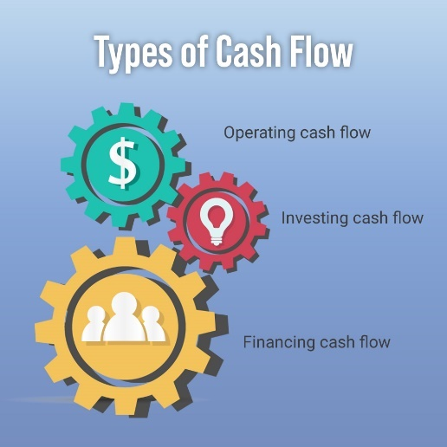
Cash Flows From Operations (CFO)
Operating cash flow, also known as cash flow from operations (CFO), is the term used to characterize financial flows that are directly related to the manufacture and sale of items from regular activities. A company's CFO can tell you if it has enough money flowing in to cover its running costs and debts.
Operating cash flow = cash received from sales - operating expenses.
Operating cash flow is reported on a business's cash flow statement. It reveals when a business could require outside funding for capital development as well as if a business can produce enough cash flow to sustain and grow operations.

Cash Flows From Investing (CFI)
The cash created or spent from various investment-related activities over a given time is reported in the cash flow from investing (CFI) or investing cash flow.
Buying speculative assets, making investments in securities, and selling assets or securities are examples of investing activities.

Cash Flows From Financing (CFF)
Cash flow from financing operations gives investors insight into a business's financial strength and how well its capital structure is handled.
Cash flows from financing (CFF), also known as financing cash flow, displays the net flows of cash used to fund the firm and its capital.

We can assess the monetary value of our project by employing a calculation known as
Return on Investment (ROI)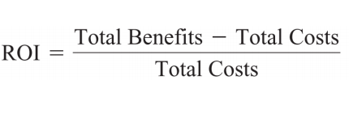
The term ROI refers to a computation that expresses the average rate of return obtained on the capital spent in a project. The project's net benefits (total benefits minus total expenses) are divided by the total costs to get the ROI.

- Technical feasibility study
Examines and assesses the project's present hardware, software, and technical needs in addition to the system's specifications.
A technical feasibility assessment reports on the availability of new technology and resources needed for the planned software development.
The technical expertise of the software development team, the practicality of utilizing the available technology, the simplicity of upkeep and upgrades, and other aspects are all examined in a technical feasibility study.
Aspects of technical viability, especially in the creation of software projects, must be examined since they are essential to their successful completion.

Technical feasibility assessments yield four general rules:

1-Smaller projects tend to be less risky than larger ones.
2-Systems with easily obtained and highly structured requirements are less risky than those with messy, ill-structured, or judgment-dependent requirements.
3-Projects using commonly used or standard technology are less risky than those employing novel or nonstandard technology.
4-Familiarity with the systems development process and application area among the user group reduces project risk compared to situations where the user group is unfamiliar.

- Operational feasibility study

Operational feasibility investigates how a new project will impact regular business operations, what policies should be put in place, and what has to be done to keep the business going.
Let's say you are introducing a worldwide e-commerce website. Next, you need local service teams, warehouses, and sometimes even websites in each nation.
Even if the original concept seems technically and financially viable, it is very difficult to implement operationally and might not even make sense.
- Scheduling feasibility study

Project success depends on scheduling feasibility since timely completion is crucial. As part of this evaluation, the time required to complete the project is estimated, acknowledging the significance of efficient time management.
D2 Assess the impact of different feasibility criteria on a software investigation.
Let's evaluate how several feasibility factors affect the software for the FitPro fitness app:
Legal Feasibility Study:
Impact: To prevent any legal problems throughout FitPro's growth and operation, it is imperative to ensure legal viability. This involves assessing compliance with data protection laws, intellectual property regulations, and any industry-specific legal requirements. Ignoring legal issues may result in penalties, legal action, or the app being blocked in some areas. To reduce hazards, legal specialists must be consulted from the beginning of development.

Economic Feasibility Study:
Impact: Economic feasibility evaluates the financial viability of FitPro. Estimating the expenses of development, upkeep, prospective income sources, and return on investment (ROI) are all included in this. A comprehensive economic feasibility analysis is necessary to make sure that the expenditures of construction and upkeep match the anticipated income. If the costs outweigh the benefits, it may not be economically feasible to proceed with the project.

Technical Feasibility Study:
Impact: Technical viability evaluates if the suggested FitPro app can be created given the limitations and the technology at hand. It takes into account elements including the development team's technical proficiency, development tools, and hardware and software needs. Project delays, higher development costs, or even project collapse might result from decreased technical viability. Updating and evaluating developing technologies on a regular basis is required to keep the project technically feasible.
Operational Feasibility Study:
Impact: FitPro's operational viability assesses how well it will perform in the planned setting. This entails evaluating the effect on current procedures and systems as well as users' capacity to adjust to the new fitness app. FitPro could encounter opposition and the project might be declared operationally unfeasible if it interferes with current business processes or is difficult for users to incorporate into their daily schedules. To guarantee operational viability, user acceptability testing and feedback are essential.

Scheduling Feasibility Study:
Impact: Whether FitPro can be built and delivered in the allotted time is the main consideration in scheduling feasibility. Developmental delays might lead to lost business opportunities or more competition. Investor trust may also be impacted by missing deadlines. Maintaining schedule feasibility requires effective project management, which includes risk management, resource allocation, and realistic scheduling. To guarantee on-time delivery, the project timetable must be regularly reviewed and adjusted.

For the FitPro fitness app to be successful, a thorough feasibility analysis that covers the technological, operational, legal, financial, and scheduling issues is necessary. Efficient decision-making and risk minimization need thorough analysis of the many feasibility criteria, each of which has a unique influence on the project.

P6 Use appropriate software analysis tools/techniques to carry out a software investigation and create supporting documentation.
Adalo:
https://aon-tarawnehs-team.adalo.com/fitpro-1
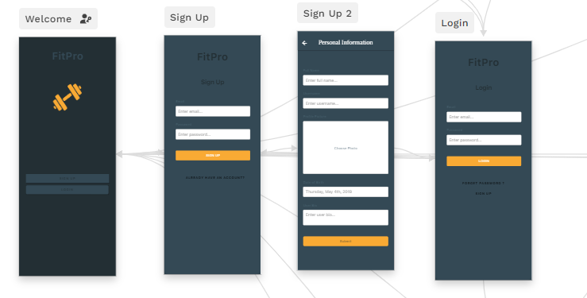

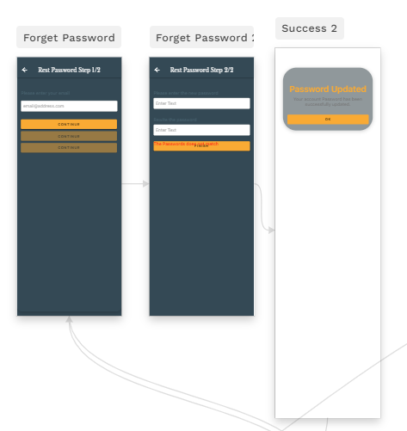
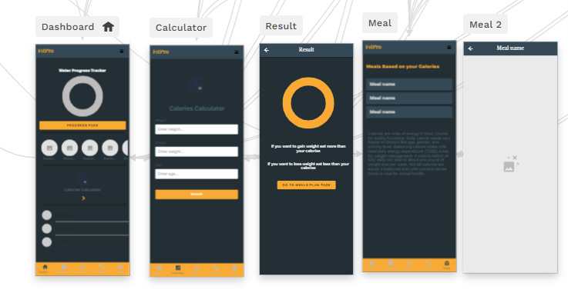
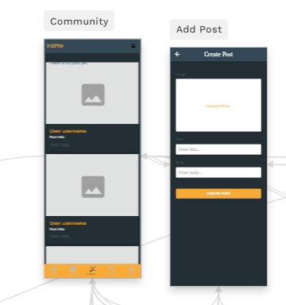

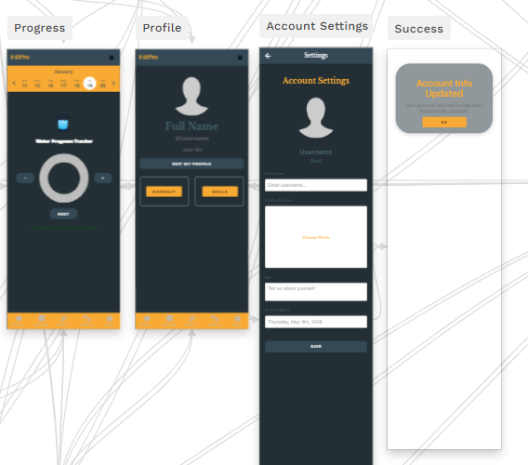

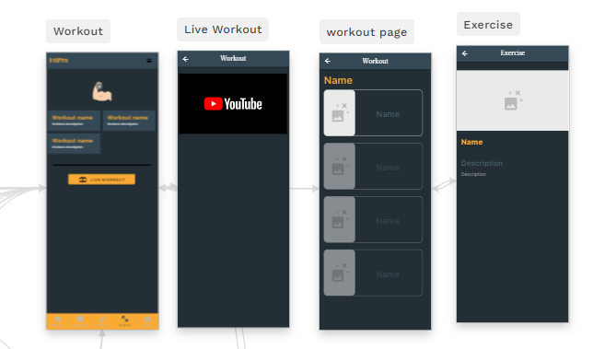

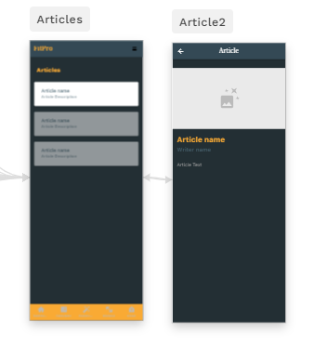
Documentation:
You may use FitPro with ease by reading this documentation. Everything is covered, including how to use the features, get started, and to troubleshooting common issues.

User Registration:
A welcome screen with buttons to "Sign up" and "Log in" will appear when you first run the app. Entering your email address and password on the "Sign up" page is the next step. Your entire name, username, profile picture, birthdate, and a brief bio will then be shared, along with a few other facts. The app takes you to the login screen and establishes your account.

User Login:
After selecting "Log in," a window asking for your password and email address will appear. When the app verifies that your login information matches, you are logged in. In the event of a problem, an error message will appear.

Account Management:
All of your information is visible on your profile page. Accessing "Edit profile," "Workout," and "Meals" is simple. By editing your profile, you may change your username, image, bio, and birthdate under the account settings. You return to your profile after the update is confirmed with a message after saving.

Application Features:
Your primary hub, the dashboard features buttons for "Progress," pictures, arrows, and posts. The useful navbar provides easy access to the following functions: "Workout," "Community," "Calculator," "Dashboard," and "Meals." Additional choices are shown by a menu button.

Calculator Page:
Here, you input your height, weight, and age. The app calculates calories based on this info, and you're taken to a result page.

Result Page:
This page shows your calculated calories. You can go back to the calculator or go to the page with the meal plans.

Community Page:
Check out posts . If there are none, it tells you. Otherwise, scroll through the posts.

Workout Page:
Explore workout categories and join live sessions. Clicking a category takes you to specific exercises, and the live workout button leads to a live session.

Meals Page:
Pick different calorie options, and each click takes you to a detailed meal plan.

Troubleshooting:
Click "Forgot password," enter your email address, and the app will walk you through changing your password if you lose it. It alerts you if there is a problem.

M3 Analyse how software requirements can be traced throughout the software lifecycle.
M4 Discuss two approaches to improving software quality.
Test at an early stage
Early testing is critical to ensuring program functionality. It assists in identifying and resolving concerns early in the design process, preventing more serious problems down the road.
Early testing also results in cost savings. A $100 fix for an issue discovered during the planning stage can wind up costing $10,000 or more if the problem is discovered later on during construction.

Communication
Effective communication is essential for healthy relationships in both personal and professional contexts. Effective communication among all parties engaged in software development is essential to improving the program.

Every stage of the software development process, from planning and design to coding, testing, and deployment, is monitored for quality. By doing this, we can identify problems early on and address them to ensure a high-quality final result.

Feedback and ideas may be shared by team members, vendors, and users alike. This aids the group in making the required modifications to satisfy everyone's expectations.

Keeping team members informed and not separating them from suppliers or users is crucial. Everyone will be aware of what is going on throughout the software development process thanks to this open communication.

D3 Evaluate the process of undertaking a systems investigation with regard to its effectiveness in improving software quality.
The process of investigating systems is crucial for making better-quality software. Let's evaluate how effective this process is at different stages of software development.
The Requirement Gathering and Analysis phase involves collaboration between developers and testers. Testers ensure that the program satisfies user demands by assisting in the early detection of any issues.
As we go into the System Design phase, teamwork is essential. To ensure that the system is ready for success, testers apply their expertise to spot design flaws. Teamwork is essential to the overall quality of the software.
Developers and testers work closely together during the Coding Phase. Testing each section of the code allows testers to identify and address problems early on. Collaboration is essential to producing software of the highest quality.
Throughout the System Testing stage, developers and testers collaborate continually. To make sure the program functions properly, testers analyze different scenarios. Working together is essential to having a robust quality assurance procedure.
Developers produce updates and address issues during the maintenance phase. After modifications are done, testers verify that everything functions as intended. Even after deployment, the software quality is preserved by this continuous sharing.
It's critical to comprehend and value the differences between the mindsets of developers and testers. This promotes clear communication and ensures that the two roles work well together, which improves the quality of the program in the end.
In conclusion, the process of investigating systems, with collaboration between developers and testers, is highly effective in making better-quality software. Continuous feedback, proactive testing, and clear communication all contribute to identifying and fixing issues, resulting in higher-quality software.

P7 Discuss, using examples, the suitability of software behavioural design techniques.
M5 Analyse a range of software behavioural tools and techniques.
Let's discuss the two techniques now.

Flowcharts:
A flowchart, often referred to as a process map or flow diagram, is a graphic depiction that shows the connections between the logical processes needed to accomplish a job. Flowcharts come in two primary varieties:

High-Level Flowchart:
-Offers a summary with six to ten main steps.
-Highlights important system components or activity building pieces inside a process.

Detailed Flowchart:
-Useful for identifying complexity, excessive steps, and areas for standardization or improvement.
-It provides a close-up perspective, displaying several steps.

We use Flowcharts for defining or analyzing existing processes, standardizing, or redesigning workflows, and pinpointing areas for improvement by identifying unnecessary steps or potential barriers.
Constructing Flowcharts:
- Define Purpose and Detail Level:
  - Clarify the goal and decide the required level of detail (high or detailed).
- Gather Expert Input:
  - Assemble individuals familiar with the process to outline the steps.
- Identify First and Last Steps:
  - Define the initial and concluding steps in the process.
- Document Steps Sequentially:
  - Record the process steps in sequence, acknowledging parallel steps.
- Realistic Representation:
  - Describe the process as it truly exists, not an idealized version.
- Sequence Actions and Decisions:
  - Illustrate actions and decisions in the order they occur, connecting them with arrows to display the process flow.
- Handle Decision Points:
  - At decision symbols, select the most natural branch and proceed to the end.
- Address Unfamiliar Steps:
  - Use notes for unfamiliar steps and then continue to the end.
- Complete Branches:
  - Return to fill in any incomplete branches at the last step.
- Validation:
  - Verify the accuracy of the flowchart by working step by step and consulting others.
- Continuous Improvement:
  - Identify areas for improvement and redesign the process accordingly.
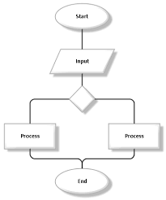
FitPro FlowChart
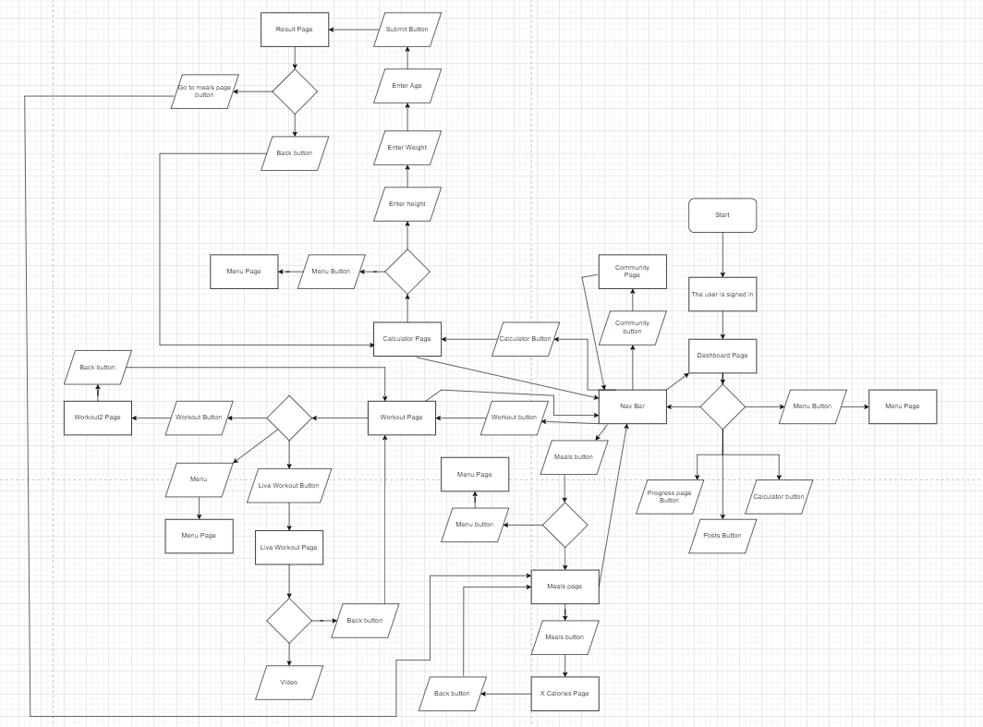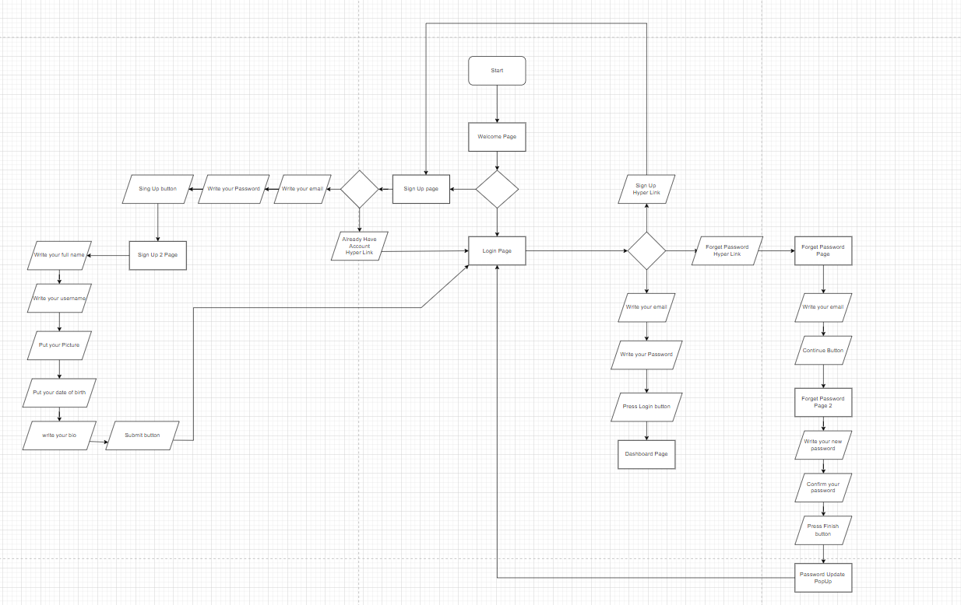
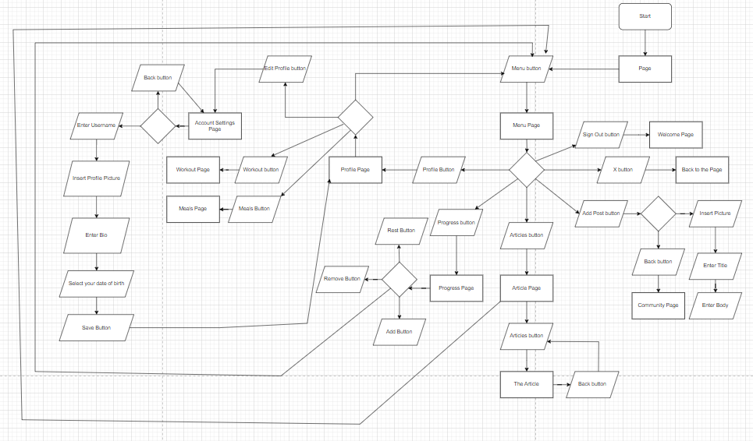
Pseudocode
A technique for explaining computer algorithms that combines plain language with programming language is called pseudocode.
In essence, it is a sporadic step toward the creation of the real code. It enables programmers to express their ideas about how a computer algorithm should be organized and sequenced without having to adhere to precise coding syntax.
Despite being widely used, there are no clear guidelines for the precise implementation of pseudocode.
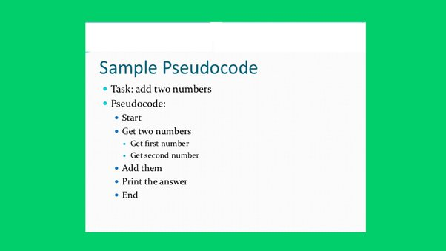

Pseudocode For FitPro
START

DISPLAY welcome page with buttons:
- "Sign up"
- "Log in"

WHEN "Sign up" button clicked:
DISPLAY sign up page with fields for:
- Email
- Password

GET user input for email and password

GET:
CREATE new user account in database with email and password
DISPLAY page to collect additional information:
- Full name
- Username
- Profile picture
- Date of birth
- Bio
GET user input for additional information
STORE additional information in database
GO TO login page

WHEN "Log in" button clicked:
DISPLAY login page with fields for:
- Email
- Password

GET user input for email and password

IF email and password match an account in database:
LOG user in to the app
ELSE:
DISPLAY error message "Invalid email or password"

WHEN "Forgot password" button clicked on login page:
DISPLAY forget password page with field for:
- Email

GET user input for email

IF email exists in database:
SEND password reset email to user
DISPLAY message "Password reset email sent"
ELSE:
DISPLAY error message "Email not found"

WHEN user clicks link in password reset email:
DISPLAY forget password 2 page with fields for:
- New password
- Confirm new password

GET user input for new password and confirm new password

IF new password and confirm new password match:
UPDATE user's password in database
DISPLAY message "Password updated successfully"
GO TO login page
ELSE:
DISPLAY error message "Passwords do not match"

AFTER user logs in:
DISPLAY dashboard page

ON dashboard page:
IF "Progress page" button clicked:
GO TO progress page
ELSE IF image clicked:
GO TO workout page
ELSE IF arrow clicked:
GO TO calculator page
ELSE IF post clicked:
GO TO community page

DISPLAY navbar with buttons for:
- Dashboard
- Calculator
- Community
- Workout
- Meals

WHEN navbar button clicked, GO TO page

DISPLAY menu button

WHEN menu button clicked:
DISPLAY menu page with options for:
- Profile
- Progress
- Articles
- Add post

WHEN menu option clicked, GO TO page

**Calculator Page:**
DISPLAY fields for height, weight, and age
GET user input for height, weight, and age
CALCULATE calories based on user input
GO TO result page

**Result Page:**
DISPLAY calculated calories
DISPLAY "Back" button
IF "Back" button clicked:
GO TO calculator page
DISPLAY "Go to meals plan page" button
IF "Go to meals plan page" button clicked:
GO TO meals page

**Community Page:**
RETRIEVE posts from database
IF no posts found:
DISPLAY message "There is no post yet."
ELSE:
DISPLAY posts

**Workout Page:**
DISPLAY workout categories buttons
DISPLAY live workout button
IF workout category button clicked:
GO TO corresponding workout page
IF live workout button clicked:
GO TO live workout page

**Workout Page (for specific category):**
DISPLAY exercises for the selected category
IF exercise clicked:
DISPLAY image and description of exercise
DISPLAY "Back" button
IF "Back" button clicked:
GO TO workout page

**Live Workout Page:**
DISPLAY live workout video
DISPLAY "Back" button
IF "Back" button clicked:
GO TO workout page

**Meals Page:**
DISPLAY buttons for different calorie options
IF calorie button clicked:
GO TO meal 2 page

**Meal 2 Page:**
DISPLAY meal plan based on selected calorie option
DISPLAY "Back" button
IF "Back" button clicked:
GO TO meals page

Profile Page:
DISPLAY user's profile information
DISPLAY "Edit profile" button
DISPLAY "Workout" button
DISPLAY "Meals" button
IF "Edit profile" button clicked:
GO TO account setting page
IF "Workout" button clicked:
GO TO workout page
IF "Meals" button clicked:
GO TO meals page
Account Setting Page:
DISPLAY fields for username, picture, bio, and date of birth
GET user input for username, picture, bio, and date of birth
SAVE updated profile information to database
DISPLAY popup message "Account info updated"
GO TO profile page

Progress Page:
DISPLAY water intake chart
DISPLAY "+", "-", and "Reset" buttons
IF "+" button clicked:
ADD 1 cup to water intake chart
IF "-" button clicked:
REMOVE 1 cup from water intake chart
IF "Reset" button clicked:
RESET water intake chart to zero

Article Page:
DISPLAY article buttons
IF article button clicked:
GO TO article 2 page for the selected article

Article 2 Page:
DISPLAY article name
DISPLAY writer name
DISPLAY article content

Add Post Page:
DISPLAY fields for post image, title, and body
GET user input for post image, title, and body
CREATE new post in database
GO TO community page

Community Page:
RETRIEVE posts from database (including the newly added post) DISPLAY posts

Let's discuss the two tools now.

Draw io.
A free, open-source online diagramming tool called Draw.io enables users to generate a large range of diagrams, including flowcharts, organizational charts, process diagrams, network diagrams, and more. Being accessible straight from a web browser, this tool is simple to use and straightforward, and it doesn't require the installation of any software.

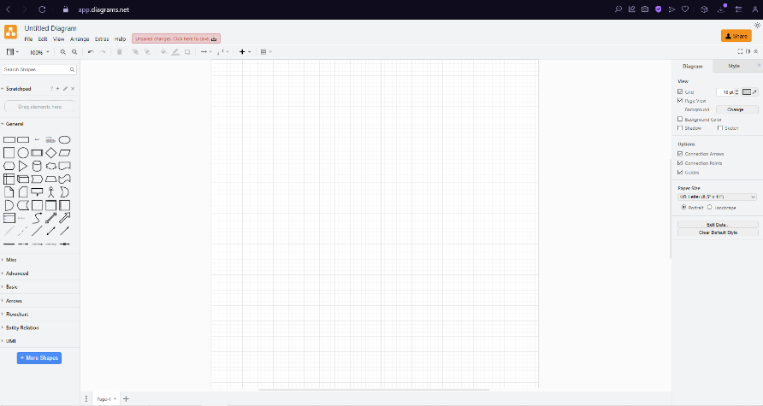

Online Pseudo Code Editors
Tools and platforms are available online that are especially made for creating and exchanging pseudo code. These platforms let you share your pseudo code with others and frequently indicate syntax for basic programming constructs. Websites such as codepad.org, repl.it, and even some online IDEs are a few examples.

M6 Differentiate between a finite state machine (FSM) and an extended FSM, providing an application of use for both.
State machine
A state machine diagram describes the series of actions that an item does in response to events, modeling the behavior of a single object across its existence.
State machine types:
• Finite state machine (FSM): a set of input Boolean conditions and a related set of output Boolean functions correspond to the transition.
• Extended finite state machine (EFSM) model, the transition can be described by a “if statement” consisting of a series of trigger conditions. The transition is initiated, moving the machine from the current state to the next state, if all trigger conditions are met.

State Machine symbols:
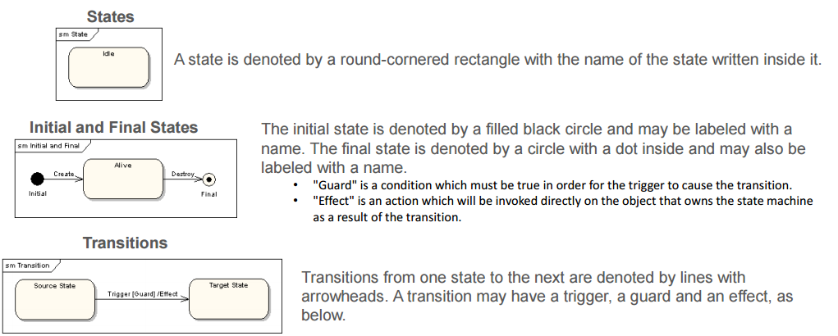
Application of (FSM)
Let's look at a basic illustration of a finite state machine that simulates a metro station turnstile. There are two states for the turnstile: "Locked" and "Unlocked."
States:
Locked: The turnstile is locked in this position, making it impossible for someone to pass through.
Unlocked: The turnstile is unlocked in this position, making it possible for someone to pass through.
Initial and Final States:
The initial state is "Locked."
The final state is "Unlocked."
Transitions:
When a coin is inserted, the turnstile transitions from the "Locked" state to the "Unlocked" state. This represents a successful coin payment.

Application of (EFSM)
Let's look at a basic illustration of an Extended finite state machine that simulates a metro station turnstile. There are two states for the turnstile: "Locked" and "Unlocked."
States:
Locked: The turnstile is locked in this position, making it impossible for someone to pass through.
Unlocked: The turnstile is unlocked in this position, making it possible for someone to pass through.
if statement (the Action):
Payment Made - Represents whether the payment has been made or not.

Current State | Input | Next State | Action (if any) | Condition (IF STATEMENT)
Locked | Coin Inserted | Unlocked | Allow Pass Through | Payment Made is true
Locked | No Coin Inserted | Locked | (No action) | Payment Made is false

D4 Present justifications of how data-driven software can improve the reliability and effectiveness of software.
What is Data-driven
Making strategic decisions in a company through in-depth data analysis and interpretation is known as a data-driven strategy. With the ultimate goal of improving customer and consumer happiness, this approach enables businesses to methodically analyze and arrange their data. The use of precise, unbiased, and unambiguous metrics—like Objectives and Key Results (OKRs) or Key Performance Indicators (KPIs)—incentives development teams to match their daily work with long-term strategic goals and the total commercial value of each project. These teams can see how their efforts are supporting the accomplishment of important objectives and the success of the company by using data visualization. To sum up, solid metrics are essential to data-driven software development since they direct and track development.

Data-driven software manages data that comes from many sources and automates procedures, solves issues, and takes advantage of possibilities. As users search, query, and gather data, it automatically creates master data, metadata, models, schema, and graphs to provide universal accessibility to information inside a single application. Furthermore, the program offers a dynamic and all-inclusive approach to data management by continually correlating data elements.

What is KPI?
Key performance indicators, or KPIs, are measurable metrics that businesses use to monitor and evaluate performance areas. This helps with goal assessment and strategic decision-making. Metrics like traffic, traffic sources, sessions, and transactions provide information on overall performance, user engagement, and transaction success in website KPIs.

What is OKRs?
Objectives and Key Results, or OKRs, are a useful tool for performance monitoring and team management. They facilitate teams' ability to identify priorities, assess their progress toward those targets, and identify areas for improvement. In essence, OKRs give teams an organized method for establishing objectives and tracking their progress. When it comes to assisting data teams in developing their own OKRs for efficient planning and achieving objectives, they are very helpful.

What is Decision support system (DSS)
A computer software called a decision support system (DSS) analyzes a large amount of data and recommends the best solutions to assist an organization make better decisions. To give customers with more than simply routine reports, it compiles data from several sources in an effort to support them in making wise decisions.

Data-driven DSS
A computer software called a data-driven decision support system (DSS) makes choices by utilizing data from databases. By examining data patterns, it frequently forecasts future trends. Companies use it to make judgments about sales and inventories.

Data Driven role in requirement gathering
Data-driven approaches to requirement gathering helps in the development of software that more effectively satisfies customer needs, ensuring a positive user experience and overall success. This entails conducting user interviews in addition to assessing data from several sources, such as website statistics and customer reviews. Data-driven approaches also help confirm initial assumptions, reducing the risk of building features that users may not find valuable and improving the chances of project success.

Data Driven role in Design stage
A data-driven approach is essential for designing the information architecture and improving user experience throughout the design phase. Data-driven design allows designers to identify and rate the features and content that consumers will find most important, then organize the information architecture to best present these components. Users are also empowered with insights and trends linked to their work and goals when data visualization is integrated directly into the application interface through dashboards and charts. This encourages users to make decisions based on data offered in the application, a process known as data-driven decision-making.

Data Driven role in Development stage
Using data-driven methodologies throughout the development phase is essential to creating software that is user-centric, performant, and efficient. Higher user happiness and better company results are the results of this. Development teams may prioritize high-impact additions that greatly increase user pleasure and engagement by using data, which helps them stay in line with broader corporate objectives. By measuring performance, spotting bottlenecks, and optimizing code for quicker and more responsive apps based on user interaction patterns, data-driven approaches also help with code optimization.

Data Driven role in testing stage
Using data-driven strategies throughout the testing phase has several advantages. It facilitates earlier defect discovery, comprehensive test coverage, and testing process optimization. Software quality is further improved by improving the analysis of test findings. Additionally, by enabling quicker release cycles, this strategy eventually raises user happiness.

references.
https://www.rezaid.co.uk/post/sdlc-waterfall-model-the-6-phases-you-need-to-know-about
https://www.door3.com/blog/understanding-risk-management-in-software-development-7-common-risks#:~:text=Risk%20management%20in%20software%20development%20is%20the%20process%20of%20identifying,them%20to%20ensure%20project%20success.
https://www.softwaretestinghelp.com/types-of-risks-in-software-projects/
https://www.tpsgc-pwgsc.gc.ca/biens-property/sngp-npms/ti-it/etivcarftp-idsfvfrmd-eng.html
Feasibility study
Executive Summary:

FitPro, a revolutionary fitness app, aims to empower users in their fitness journey by offering personalized fitness plans, nutrition guidance, and a vibrant community for support. The feasibility study reveals that FitPro holds significant potential for success. The app combines tailored exercise and meal plans, community engagement, progress tracking, live workouts, and expert articles. This comprehensive approach sets FitPro apart in the competitive fitness app market.

Introduction:

Welcome to FitPro, your go-to fitness app on a mission to make getting fit simple and personalized. We're here to help you improve your fitness with easy-to-follow workout and meal plans tailored just for you. But FitPro is more than just exercises and recipes – it's about creating a supportive community where everyone cheers for your success.

At FitPro, we believe in progress, not perfection. Our app lets you track your achievements, join live workouts, and read expert articles to keep you motivated. It's not about being a fitness expert; it's about enjoying the journey to a healthier you.

Join our vibrant FitPro community, where you can connect with people on similar journeys, share your experiences, and celebrate victories together. With FitPro, you're not alone – you're part of a fitness family.

So, let's make fitness fun and achievable. Whether you're a beginner or a fitness enthusiast, FitPro is here to support you. Get ready to embark on a simple, personalized, and exciting fitness adventure with us!

Project Description:

FitPro, your ultimate fitness companion, is designed to revolutionize your fitness journey with a range of features that cater to your unique needs and aspirations. Here's a breakdown of what FitPro has to offer:

Tailored Exercise and Meal Plans:
FitPro doesn't believe in one-size-fits-all. Our app creates personalized exercise routines and meal plans crafted specifically for you. Whether you're a beginner or a fitness enthusiast, FitPro adapts to your fitness level and goals.

User Community:
Fitness is more enjoyable when you're not alone. FitPro's vibrant user community provides a space for users to connect, share experiences, and support each other. It's a community-driven platform where everyone is working towards their fitness goals together.

Progress Tracking:
Celebrate your victories, big and small, with FitPro's progress tracking feature. Monitor your fitness milestones, track your workouts, and see the positive changes as you make progress on your fitness journey.

Live Workouts:
Say goodbye to boring workout routines. FitPro brings you live workouts that add an element of fun and excitement to your exercise routine. Join in real-time workouts led by fitness experts, keeping you motivated and engaged.

Expert Articles:
Knowledge is power. FitPro offers a library of expert articles covering various aspects of fitness, nutrition, and well-being. Stay informed, learn new tips and tricks, and make informed decisions on your path to a healthier lifestyle.

Background Information on the Fitness App Industry:

The fitness app industry has witnessed significant growth in recent years, driven by an increasing awareness of health and wellness. People are now looking for convenient and personalized solutions to achieve their fitness goals. FitPro positions itself in this dynamic landscape by offering a comprehensive approach that combines personalized plans, community engagement, progress tracking, live workouts, and expert insights. As more individuals seek accessible and engaging ways to improve their fitness, FitPro stands out as a user-centric and innovative solution in the competitive fitness app market.

Market Analysis
Demand for Personalized Fitness Solutions:

There's a rising trend among users who want fitness plans tailored to their unique needs, goals, and preferences. Factors driving this trend include increased health awareness, technological advancements (like wearables and AI), higher disposable incomes, and busy lifestyles.

Competition:

The fitness app market is competitive, with big players like MyFitnessPal, Peloton, Strava, and Nike Training Club. FitPro needs to stand out by offering superior personalization, engaging community features, expert guidance, and unique elements like live workouts and nutrition advice.

Potential Users:

FitPro appeals to a diverse audience, from millennials to older adults, who are comfortable using mobile apps and wearables. The app attracts tech-savvy individuals and health-conscious consumers willing to invest in apps that deliver tangible results and improve overall well-being.

Market Trends:

Current trends in fitness apps include AI-powered personalization, seamless integration with wearables, gamification, and diverse content options. FitPro aligns with these trends by offering AI-driven plans, wearable compatibility, engaging community features, and a variety of workout choices.

User Preferences:

Users prioritize convenience, accessibility, a simple interface, and offline functionality for workouts. Ensuring robust data privacy and security is crucial for gaining user trust.

Growth Projections for Fitness Apps:

The future looks promising for fitness apps, with the global market projected to reach $120.37 billion by 2030. Driving factors include increasing smartphone use, growing health awareness, and a demand for convenient and personalized fitness solutions.

Legal feasibility study:

Developing and operating FitPro involves navigating various legal and regulatory considerations to ensure a secure and compliant user experience.

Data Privacy:

FitPro must adhere to strict data privacy regulations to protect user information. Implementing robust data encryption, secure storage practices, and ensuring compliance with international data protection laws, such as GDPR or CCPA, is essential. Clear privacy policies should be communicated to users, detailing how their data will be used, stored, and shared.

User Consent:

Obtaining explicit user consent is crucial for FitPro. Users should be informed about the app's data collection practices, including the types of data collected, the purpose of collection, and how it will be used. Consent mechanisms should be clear, easily accessible, and allow users to opt-in or opt-out of specific data processing activities.

Compliance with Health and Fitness Regulations:

FitPro should comply with relevant health and fitness regulations to ensure the accuracy and safety of its fitness plans and nutritional guidance. Collaborating with qualified fitness and nutrition experts to develop content, and staying informed about any industry-specific regulations, helps ensure that FitPro's offerings meet established standards.

Intellectual Property Rights:

Ensure that FitPro's content, including workout plans, articles, and other materials, does not infringe on intellectual property rights. This includes obtaining necessary licenses for any third-party content and protecting FitPro's intellectual property through trademarks or copyrights.

Economic Feasibility study:
Benefits:

Tangible Benefits:
Attracting a significant user base enhances the company's market presence.
Intangible Benefits:
Developing a popular fitness app positively impacts the company's overall brand reputation. Providing a valuable and personalized fitness experience fosters user loyalty.
Costs:

Tangible Costs:
Development costs include expenses related to coding, design, testing, and system development. Operational costs involve ongoing expenses for server maintenance, software leases, and supplies.
Intangible Costs:
Potential loss of customer goodwill due to system failures and impacts on employee morale from operational inefficiencies.
One-Time Costs:
Initial investment in systems development, acquiring necessary hardware and software, user training, site preparation, and data/system conversion.

Recurring Costs:
Regular upkeep of the FitPro app, costs associated with storing user data, communication expenses, ongoing leasing costs for software and hardware, and miscellaneous costs like supplies.

Cash Flow Analysis and Measures:

CFO (Cash Flow from Operations): Measures FitPro's ability to generate cash through regular business operations.
CFI (Cash Flow from Investing): Represents cash transactions from investments, such as systems development and new hardware.
CFF (Cash Flow from Financing): Captures cash transactions related to financing activities, like loans or equity investments.
Cost Estimates:
Development costs are a one-time investment (denoted as $X), while operational costs are ongoing monthly expenses (denoted as $Y). One-time costs encompass systems development, acquiring hardware/software, user training, site preparation, and data/system conversion. Recurring costs include application software maintenance, data storage, communications, new software/hardware leases, and miscellaneous supplies.

Revenue Projections:
Revenue sources include subscription fees from projected premium subscribers, income from in-app purchases, and potential partnerships with fitness brands or wellness companies.

Return on Investment (ROI):
The ROI formula, represented as (Total Benefits - Total Costs) / Total Costs, will provide insights into the financial success and profitability of the FitPro project.

Technical Feasibility study:

App Development:
FitPro's development will require expertise in mobile app development, incorporating features such as tailored exercise and meal plans, community engagement, and progress tracking. Leveraging modern app development frameworks and programming languages will be essential.

Server Infrastructure:
FitPro's server infrastructure must handle user data securely, ensuring data privacy and reliability. Consideration should be given to scalable cloud solutions to accommodate potential user growth and dynamic workloads, promoting optimal performance.

Challenges and Solutions:

Scalability: The challenge lies in accommodating a growing user base. Implementing cloud-based solutions, like AWS or Azure, can ensure scalability and flexibility.

Data Security: Protecting user data is critical. Implementing robust encryption, regular security audits, and compliance with data protection regulations will address this concern.

Maintenance and Updates:
FitPro's success depends on regular maintenance and updates. A structured maintenance plan should include bug fixes, security updates, and feature enhancements to keep the app current and competitive.

Testing:
Rigorous testing is crucial to ensure FitPro's functionality across various devices and scenarios. Implementing automated testing tools can enhance efficiency and accuracy in identifying and fixing potential issues.

Operational Feasibility Study:

User Engagement Processes:

Implement procedures for maintaining a vibrant user community, encouraging engagement and support among users.
Establish mechanisms for handling user queries, feedback, and community moderation.
Personalized Fitness Plans and Nutrition Guidance:

Develop a streamlined process for creating and delivering personalized exercise and meal plans to users.
Implement procedures to regularly update and refine plans based on user progress and feedback.
Progress Tracking:

Establish a user-friendly progress tracking system within the app.
Implement procedures for data accuracy and user privacy in progress tracking.
Live Workouts and Expert Articles:

Ensure seamless integration of live workouts and expert articles into the app.
Establish a content management system for regular updates and quality control.
Technical Infrastructure:

Implement robust server infrastructure to handle user data, live workout streaming, and content delivery.
Develop procedures for continuous monitoring and maintenance of the technical infrastructure.
Customer Support:

Set up a dedicated customer support team to address user inquiries, technical issues, and provide assistance.
Establish communication channels for users to reach support easily.
Security and Data Privacy:

Implement stringent security measures to protect user data.
Develop procedures to comply with data privacy regulations and standards.
Scalability Planning:

Assess the scalability of the app to accommodate a growing user base.
Develop strategies to handle increased demand for personalized plans, community engagement, and features.
Collaboration with Fitness Experts:

Establish procedures for collaboration with fitness experts providing content for live workouts and articles.
Ensure a seamless process for vetting and onboarding new experts.
Community Building Efforts:

Develop strategies for ongoing community building and user retention.
Implement procedures for community events, challenges, and promotions.

FitPro Project Schedule and Timeline (8 Weeks):

Weeks 1-2: Project Initiation and Planning

Define project scope, objectives, and deliverables.
Assemble project team and assign roles and responsibilities.
Conduct a detailed market analysis to inform app features and user requirements.
Develop a comprehensive project plan, including budget and resource allocation.
Weeks 3-4: Design and Development Phase

Design the user interface (UI) and user experience (UX) of the FitPro app.
Begin app development, focusing on the core features: personalized fitness plans, nutrition guidance, and user community.
Identify and initiate collaboration with fitness experts for live workouts and expert articles.
Weeks 5-6: Feature Implementation and Testing

Implement tailored exercise and meal plans functionality.
Develop and integrate progress tracking features.
Incorporate live workout streaming and expert articles into the app.
Begin internal testing of the app's functionalities to identify and resolve bugs.
Weeks 7-8: Finalization and Launch Preparation

Refine the user community features and engagement mechanisms.
Conduct extensive testing to ensure a seamless user experience.
Finalize content for live workouts and expert articles.
Prepare marketing and promotional materials for the FitPro launch.
Conduct a comprehensive review of legal and regulatory compliance.
Develop a customer support system for inquiries and troubleshooting.
Launch FitPro to the public, initiate marketing campaigns, and engage with the user community.

Risk Analysis and Mitigation Plan for FitPro:

Technical Challenges:

Risk: Unforeseen technical issues during app development or integration of live workout streaming.
Mitigation: Regularly engage with the development team, conduct thorough testing phases, and have contingency plans for technical troubleshooting.
User Adoption:

Risk: Slower-than-expected user adoption due to competition or lack of initial awareness.
Mitigation: Implement a robust marketing strategy, including influencer partnerships, social media campaigns, and promotional events. Continuously assess and adjust marketing efforts based on user feedback.
Data Security and Privacy:

Risk: Breach of user data or non-compliance with data privacy regulations.
Mitigation: Prioritize robust security measures, conduct regular security audits, and ensure compliance with relevant data protection laws. Clearly communicate the app's privacy policy to users.
Market Saturation:

Risk: Saturated market with numerous fitness apps, leading to difficulties in differentiating FitPro.
Mitigation: Focus on unique selling points, such as personalized plans, a vibrant community, and innovative features. Regularly analyze market trends to adapt and stay ahead of competitors.
Content Quality:

Risk: Inconsistency or poor quality in live workouts and expert articles.
Mitigation: Establish stringent content guidelines for fitness experts, conduct quality checks, and gather user feedback for continuous improvement. Engage in ongoing communication with experts to ensure alignment with FitPro's standards.
Community Management:

Risk: Challenges in moderating the user community, potential conflicts, or inappropriate content.
Mitigation: Implement community guidelines, have a dedicated moderation team, and foster a positive community culture. Swiftly address any issues to maintain a supportive environment.
Legal and Regulatory Compliance:

Risk: Changes in health and fitness regulations or legal requirements affecting the app's operations.
Mitigation: Regularly update legal assessments, stay informed about changes in regulations, and adapt the app's policies and procedures accordingly.
Dependency on Fitness Experts:

Risk: Reliance on a limited pool of fitness experts for live workouts and articles.
Mitigation: Diversify partnerships with a broader range of fitness experts, ensuring a consistent flow of quality content. Have contingency plans in case of unforeseen unavailability.
Operational Scaling Challenges:

Risk: Difficulties in scaling operations to meet increasing user demand.
Mitigation: Continuously assess scalability needs, invest in robust infrastructure, and plan for operational scaling well in advance based on user growth patterns.
User Engagement:

Risk: Low user engagement leads to dissatisfaction and attrition.
Mitigation: Implement gamification elements, challenges, and incentives to boost engagement. Regularly analyze user feedback to identify and address issues promptly.

RTM
Case ID | Test Description | Test Input | Outcome | Expected  result | Actual Result | Status
1 | Click "Sign up" button in welcome page | Valid Button | Display Sign up page | Sign-up page displayed with fields for Email and Password | Sign-up page displayed with fields for Email and Password | Pass
2 | Click "Login " button in welcome page | Valid Button | Display login page | Login page displayed with fields for Email and Password | Login page displayed with fields for Email and Password | Pass
3 | Enter email and password for sign-up | Valid email and password | Display Sign up2 page | User account created in the database | User account created in the database | Pass
4 | Enter additional information for sign-up | Valid full name, username, profile picture, date of birth, bio | Display Login Page | Additional information stored in the database | Additional information stored in the database | Pass
5 | Enter email and password for login | Valid email and password | User logged in | User successfully logged in | User successfully logged in | Pass
6 | Enter invalid email or password for login | Invalid email or password | Invalid email or password | Error message "Invalid email or password" displayed | Error message "Invalid email or password" displayed | Pass
7 | Enter email for password reset | Valid email | Display continue button | Display Forget password 2 Page | Display Forget password 2 Page | Pass
8 | Enter invalid email for password reset | Invalid email | Error | Does not Display continue button | Does not Display continue button | Pass
9 | Enter new password and confirm new password | Valid new password and confirmation | Password updated | Pop-up "Password updated " displayed | Pop-up "Password updated " displayed | Pass
10 | Enter mismatched passwords | Mismatched passwords | Error message displayed | Error message " The Passwords does not match " displayed | Error message " The Passwords does not match " displayed | Pass
11 | Display navbar with buttons | Navbar | Navbar Displayed | Navbar displayed with buttons | Navbar displayed with buttons | Pass
12 | Click on "Dashboard" button in the navbar | "Dashboard" button | Redirect to Dashboard page | Dashboard page displayed | Dashboard page displayed | Pass
13 | Click on "Calculator" button in the navbar | "Calculator" button | Redirect to Calculator page | Calculator page displayed | Calculator page displayed | Pass
14 | Click on "Community" button in the navbar | "Community" button | Redirect to Community page | Community page displayed | Community page displayed | Pass
15 | Click on "Workout" button in the navbar | "Workout" button | Redirect to Workout page | Workout page displayed | Workout page displayed | Pass
16 | Click on "Meals" button in the navbar | "Meals" button | Redirect to Meals page | Meals page displayed | Meals page displayed | Pass
17 | Display menu button | Menu button | Menu page displayed | Menu button displayed | Menu button displayed | Pass
18 | Click on "Profile" option in the menu | "Profile" option | Redirect to Profile page | Profile page displayed | Profile page displayed | Pass
19 | Click on "Progress" option in the menu | "Progress" option | Redirect to Progress page | Progress page displayed | Progress page displayed | Pass
20 | Click on "Articles" option in the menu | "Articles" option | Redirect to Articles page | Articles page displayed | Articles page displayed | Pass
21 | Click on "Add post" option in the menu | “Add post" option | Redirect to Add post page | Add post page displayed | Add post page displayed | Pass
22 | Click "Progress page" button on the dashboard page | "Progress page" button | Progress page | Redirect to the Progress page | Redirect to the Progress page | Pass
23 | Click on an image on the dashboard page | Click on an image on the dashboard page | Workout page | Redirect to the Workout page | Redirect to the Workout page | Pass
24 | Click on an arrow on the dashboard page | Click on an arrow on the dashboard page | Calculator page | Redirect to the Calculator page | Redirect to the Calculator page | Pass
25 | Click on a post on the dashboard page | Click on a post on the dashboard page | Community Page | Redirect to the Community page | Redirect to the Community page | Pass
26 | Enter height, weight, and age on the Calculator Page | Valid height, weight, and age | Result Page | height, weight, and age stored in the database | height, weight, and age stored in the database | Pass
27 | Result Page | Result Page | Calculated Calories | Result page displayed with calculated calories | Result page displayed with calculated calories | Pass
28 | Click "Back" button on the Result Page | "Back" button | Redirect to Calculator page | calculator page displayed | calculator page displayed | Pass
29 | Click "Go to meals plan page" button on the Result Page | "Go to meals plan page" button | Redirect to Meals page | Meals page displayed | Meals page displayed | Pass
30 | Retrieve posts from the database on the Community Page | Posts from the database | Posts displayed or error massage | Posts displayed, or message "There is no post yet." shown if no posts | Posts displayed, or message "There is no post yet." shown if no posts | Pass
31 | Click workout category button on the Workout Page | Click workout category button | Redirect to workout page | workout page displayed | workout page displayed | Pass
32 | Click live workout button on the Workout Page | Click live workout button | Redirect to Live Workout page | Live Workout page displayed | Live Workout page displayed | Pass
33 | Click on an exercise on the Workout Page | Click on an exercise | Redirect to exercise page | Exercise details page displayed with image, description, and "Back" button | Exercise details page displayed with image, description, and "Back" button | Pass
34 | Click "Back" button on the Exercise Page | "Back" button | Redirect to Workout2 Page | Workout2 Page | Workout2 Page Displayed | Pass
35 | Click "Back" button on the Live Workout Page | "Back" button | Redirect to Workout Page | Workout Page Displayed | Workout Page Displayed | Pass
36 | Click calorie button on the Meals Page | calorie button | Redirect to Meal 2 page | Meal 2 page displayed | Meal 2 page displayed | Pass
37 | Click "Back" button on the Meal 2 Page | Click "Back" button | Redirect to Meals Page | Meals Page displayed | Meals Page displayed | Pass
38 | Click "Edit profile" button on the Profile Page | "Edit profile" button | Redirect to Account Setting page | Account Setting page displayed | Account Setting page displayed | Pass
39 | Click "Workout" button on the Profile Page | “Workout" button | Redirect to Workout page | Workout page displayed | Workout page displayed | Pass
40 | Click "Meals" button on the Profile Page | "Meals" button | Redirect to Meals page | Meals page displayed | Meals page displayed | Pass
41 | Enter username, picture, bio, and date of birth on the Account Setting Page | Valid inputs | popup message "Account info updated" displayed, and redirected to Profile page | Updated profile information saved to the database | Updated profile information saved to the database | Pass
42 | Click "+" button on the Progress Page | "+" button | 1 cup added to water intake chart | Water intake chart updated | Water intake chart updated | Pass
43 | Click "-" button on the Progress Page | "-" button | 1 cup removed from water intake chart | Water intake chart updated | Water intake chart updated | Pass
44 | Click "Reset" button on the Progress Page | "Reset" button | Water intake chart reset to zero | Water intake chart reset to zero | Water intake chart reset to zero | Pass
45 | Enter post image, title, and body on the Add Post Page | Valid inputs | Posted | New post created in the database, and redirected to Community page | New post created in the database, and redirected to Community page | Pass

