FITPRO

SDLC
REPORT

2024

Prepared By:
Aon Tarawneh
Prepared For:
Laheeb Alselehat


Software Development Life Cycle

Introduction
In the ever-evolving field of health and fitness, technology is essential to people reaching their wellness objectives. I'm excited to be contributing to "FitPro," our newest fitness app, as a software developer at App Tech. FitPro is a tailored health guide for people seeking to enhance their well- being, not just an app. Customized workout and food programs are available, along with progress tracking, live workouts, and expert articles. Users may also interact with a supportive community. The development of FitPro, its salient characteristics, and its influence on the digital fitness scene will all be examined in this paper.

SDLC Models

Models for the Software Development Life Cycle (SDLC) are methodical approaches or techniques used in the design, development, testing, deployment, and maintenance of information systems. These models give developers a structure to operate within, guaranteeing that software development is methodical and well-organized. There are several approaches to the development process offered by different SDLC models, and each has pros and cons.
The topics of sequential and iterative software lifecycle models will be covered next.

01

Iterative software lifecycle models:

Spiral model
Spiral model an important Software Development Life Cycle (SDLC) technique created for efficient risk management. Each loop on the spiral, which represents different stages of the growth process, represents a stage. This paradigm is flexible and responsive, with the project manager deciding the number of phases based on project risks in real time.


In the Spiral model, the radius represents project expenses, and the angular dimension indicates progress in the ongoing phase. As a meta-model, it combines the iterative nature of the prototyping model with the linearity of the waterfall model.

Spiral Model phases:

01 Planning Phase

of the Spiral model, requirements are gathered, including Business Requirement Specifications (BRS) and System Requirement Specifications (SRS).
the process focuses on identifying risks and proposing alternative solutions. At the end of this phase, a prototype is produced. If any risks are identified, corresponding alternate solutions are suggested and implemented.
Risk Analysis Phase
02
involves the development of software, incorporating testing at the phase's conclusion. Both development and testing activities are carried out during this phase.
Engineering Phase
03
, the customer can assess the project's output to date before deciding whether to proceed to the next spiral.
Evaluation Phase
04

02

Iterative software lifecycle models:
Spiral model

Its emphasis on proactively managing project risks is a crucial component. Prototyping is used at every stage of the project to address risks, which are characterized as unfavorable circumstances that could affect the project's success. The Spiral model stands out from other SDLC methodologies, such the Prototyping Model, which restricts its capacity to adjust to real-time risk events by requiring comprehensive risk identification prior to development.

Kinds of Risks in Software Development

Schedule risks in a project are problems with time management that have a big influence on the timetables for development and delivery. Schedule hazards are frequently caused by incorrect time estimation, poor resource allocation, scope expansions on a regular basis, and incomplete or incorrectly identified project functions.

Budget risks are the main source of budget overruns, which are related to financial worries. Budget hazards include things like inaccurate or insufficient budget estimates, unforeseen scope extensions for projects, poor budget administration, and instances of cost overruns.

Operational risks result from weak process implementation or external operational factors during regular project development operations. Operational hazards can be caused by a lack of skilled workers, disagreements between duties and employees, unclear roles and responsibilities, poor communication and cooperation, and insufficient training.

Technical risks are the focal point of functional and performance issues; these are typically related to a product's functionality or the performance features of software. Technical risks can arise due to several factors such as infrequent modifications to requirements, restricted adoption of upcoming technologies, insufficient workforce with specialized skills, intricate implementation processes, and inappropriate module integration.

Programmatic risks are those that come from outside sources and are either uncontrollable or external. Programmatic risks can be caused by several things, such as the market's quick development, the availability or scarcity of funding for projects, modifications to government regulations or policies, and contract terminations for a variety of causes.

03

Iterative software lifecycle models:

Spiral model
Advantages of Spiral model
high level of risk analysis to keep things safe. Excellent for significant and mission-critical tasks.

strong documentation control and approval processes. Later, further functionality may be added.
Early in the software life cycle, software is developed.

Disadvantages of Spiral model
The use of this model may be expensive.
Risk analysis calls for very specialized knowledge.
The risk analysis step is critical to the project's success. Not recommended for minor projects.

When to use Spiral Model
For projects where costs and risks need to be carefully considered, the Spiral Model works well. It works effectively for initiatives that range from medium to high risk, particularly when making long-term commitments might be foolish given possible shifts in the economy's priorities. This paradigm allows for adaptation and continual improvement and works well when handling complicated requirements, unclear customer requests, and the creation of a new product line.

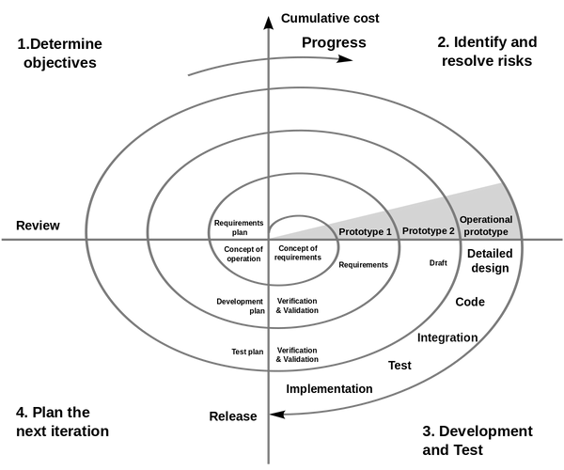

04

Iterative software lifecycle models:

Agile model

SAgile Modeling (AM) is an approach for rapidly modeling and documenting software systems by combining incremental and iterative procedures. Agile Methods divide the product into small, incremental builds and place a heavy focus on adaptability and customer satisfaction through rapid software delivery. These builds, which are completed in brief iterations of one to three weeks, entail cross-functional teams working on different project areas concurrently. Because of its flexibility, the technique is especially well-suited for contexts that undergo rapid change.

Examples of Agile-based approaches include Scrum and the Dynamic Systems Development Method (DSDM).

Agile Model phases:

01 Planning Phase
Start by outlining the project's requirements in detail, outlining the business potential, and estimating the time and effort needed. This first stage aids in assessing viability from an economic and technological standpoint.
Work with stakeholders to identify the needs for the project and utilize tools such as UML or user flow diagrams to show how new features will fit into the current system.
Design Requirements
02
The development team starts the project after requirements are determined. The goal of designers and developers is to release a functional product, with an early focus on simplicity and limited functionality.
Development/ Iteration
03
The Quality Assurance team thoroughly inspects the functionality of the product, finding and fixing any bugs or issues.
Testing/Quality Assurance
04
The team releases the product into the user's work environment, making it accessible for use.
Deployment
05
After product release, the final step involves gathering feedback. The team actively receives and processes feedback from users, incorporating improvements based on user insights.
Feedback
06

All the phases will loop in each iteration.
05

Iterative software lifecycle models:

Agile model
Dynamic Systems Development Method (DSDM)


Rapid Application Development (RAD) is facilitated by the Dynamic Systems Development Method (DSDM), which has also been modified to provide a framework for Agile models. It works particularly well for application development projects were producing intricate business solutions in a short amount of time is necessary.
Project duration is set in stone using DSDM, and resources are distributed as widely as feasible. This method places a higher priority on adjusting to requirements changes while sticking to a set schedule and resource allocation. This approach aids in resolving typical issues including exceeding spending limits, missing deadlines, and guaranteeing user participation.
The DSDM lifecycle comprises seven distinct phases: the Pre-Project Phase, Feasibility Study, Business Case Study, the Functional Model Iteration (FMI), the Design and Build Iteration (DBI), the Implementation Phase, and the Post-Project Phase. This structured approach enables a systematic progression through project development, ensuring comprehensive coverage from initial assessment to post-implementation evaluation.

Scrum

an iterative project management approach, breaks down projects into short sprints lasting one to four weeks, each concluding with a functional draft of the final deliverable. This flexible method is effective for complex projects resulting in tangible products. Scrum in Agile involves key roles: the Product Owner represents customer interests, the Scrum Master facilitates daily meetings and team interactions, and the Development Team, typically self- organized, designs, produces, tests, and releases the product. Together, they form the Scrum Team, collaboratively working towards project goals.

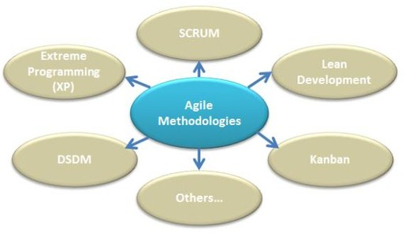

06

Iterative software lifecycle models:

Agile model
Advantages of Agile model
Customer satisfaction through consistent, quick delivery of practical software. Process and tools are not prioritized over people and interactions.

There is regular communication between customers, developers, and testers. Functional software is released often, in weeks as opposed to months.
The most effective way to communicate is face-to-face. Developers and businesspeople working together every day. Constant focus on high-quality design and technical performance. adjustment to shifting conditions.
We encourage late modifications to the specifications.

Disadvantages of Agile model
Assessing the work necessary at the start of the software development life cycle can be challenging for certain software deliverables, particularly the larger ones.
The important design and documentation are not given enough attention.
If the client representative does not know exactly what they want out of the project, it might quickly veer off course.
Making the kinds of decisions needed in the development process is only possible for senior programmers.
Unless paired with more seasoned resources, hazardous for novice programmers.

When touse the Agile Model
Agile's regular release of increments makes it ideal for introducing new changes quickly and affordably. Within a few days or even hours, developers may swiftly roll back and add new functionality. This model embraces the changing nature of end users' demands in the business and IT domains, which makes it excellent at handling vague requirements. In order to make sure the client receives the system they actually need or want, changes might be considered and features added or withdrawn in response to input.



07

Sequential software lifecycle models:

Waterfall Model:


The Waterfall Model, the first process model, is linear and easy to understand. Each phase must be completed before moving to the next. However, it struggles with adapting to changes during the process due to its rigid structure. In principle, a phase must be complete before moving onto the next phase.

Waterfall Model phases:

01 Requirement
Gathering and documenting the project requirements to understand what the software needs to achieve.
Developing the system architecture and design based on the gathered requirements.
Design
02
Writing the actual code for the software, translating the design into a programming language.
Development
03
Conducting various levels of testing, including unit testing, integration testing, system testing, and acceptance testing, to identify and fix defects.
Testing
04
Releasing the software to the production environment or end-users.
Deployment
05
Providing ongoing support, bug fixes, updates, and enhancements to the software after deployment.
Maintenance
06

08

Sequential software lifecycle models:
Waterfall Model:

Advantages of waterfall model


Simple and user-friendly model
Offers clear structure, which is beneficial for less experienced teams. Well-defined benchmarks for progress tracking
Establishes stability in requirements.
Effective management control, including planning, staffing, and monitoring. Suitable when prioritizing quality over cost or schedule constraints.

Disadvantages of waterfall model

requires previous awareness of all prerequisites. Errors can only be fixed during certain stages. could give a false impression of progress.
Unsuitable for complex projects with frequent modifications to requirements Late in the development phase, testing takes place.
It is challenging to include insightful client feedback in continuous development. Minor modifications or mistakes in finished software can result in serious problems.

When to Apply the Waterfall Model:
- New Version of an Existing Product 2. Porting an Existing Product to a New Platform 3. Stable Product Definition 4. Technological Understanding 5.

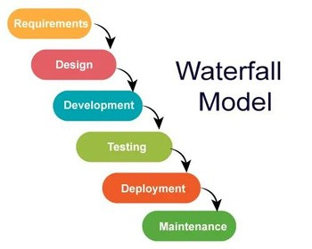

09

Sequential software lifecycle models:

RAD Model


The Rapid Application Development (RAD) paradigm entails treating individual functionalities or components as mini-projects and developing them concurrently. Time- boxed, delivered, and integrated development phases come together to generate a working prototype.

RAD Model phases:

Business Modeling
Identifying information flow among different business functions.
01

Data Modeling
Using information obtained from business modeling to define necessary data objects for the business.
02
Converting data objects defined in data modeling to achieve the flow of business information for specific objectives. Descriptions are created for CRUD operations on data objects.
Process Modeling
03
Employing automated tools to convert process models into actual code for the system.
Application Generation
04

Testing and Turnover

Testing new components and interfaces before turnover to ensure functionality and integrity.
05

10

Sequential software lifecycle models:
RAD Model

Advantages of RAD model

Reduced time needed for development. Improved component reuse
Quick first assessments enables client feedback.

Disadvantages of RAD model
depends on excellent individual and team efforts to determine company requirements. confined to creating modular building systems.
needs designers and developers with advanced skills. High dependency on modeling skills.
Too expensive for projects where budget is a concern because of automated code production and high modeling charges.

When to Use RAD model
When a modular system is needed in two to three months, RAD is appropriate. It's best if there are many of designers available, a substantial budget to pay for them, and automated code generation technologies. When personnel with in-depth business expertise are available and the system has to be delivered fast—typically in two to three months—this strategy works well.

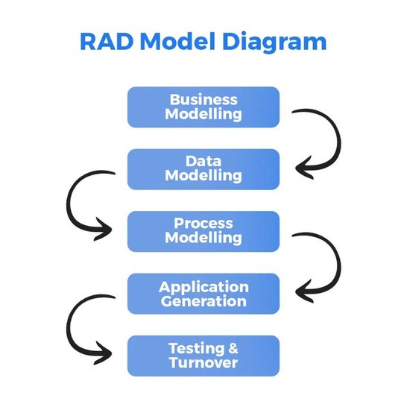

11

models
We have previously mentioned in this report the types of risks in software development, and now we will discuss how risk is managed in software lifecycle models.

Firstly, risk management in software development is the process of identifying, assessing, organizing solutions, keeping an eye on, and responding to possible problems to guarantee project success.
Careful analysis and mitigation are required for any threat, no matter how great or tiny, explicit, or implicit, internal, or external, that could compromise the project's success. It is the duty of every team member to identify potential risks and notify the project manager so that appropriate action can be taken. Identification, categorization, prioritization, developing mitigation strategies, ongoing project monitoring, and action plan implementation if a danger materializes are critical responsibilities in software development risk management. It takes regular team communication to identify and counter emerging threats.

Effective risk management in software development is paramount for project success. Despite being perceived as additional effort and cost, neglecting risk management can prove costly.

For Risk Avoidance and Mitigation, the goal is to eliminate risks. This includes cutting down project scope by removing non-essential requirements, identifying, and eliminating potential risks, or minimizing their impact.

In Risk Transfer, when a project is too large for one team, external companies can take on specific parts of the project to reduce overall risk.

On the other hand, Risk Acceptance involves deliberately taking on some risks to complete the project. This allows time to understand project requirements and estimate the necessary effort, and its success is determined through trial and evaluation.


Lastly, Risk Monitoring is an ongoing process of regularly evaluating risks, their impact, and likelihood. This ensures that risks are consistently identified, reduced, and their magnitude and impact are assessed to keep the project resilient.

12

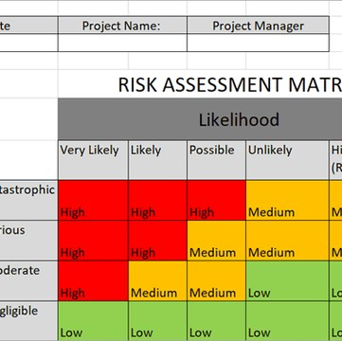
lifecycle models
Risk Assessment and Prioritization
in project management involve several key steps. Firstly, identify issues causing risks in projects. Then, determine how likely a problem is to occur and assess its impact, assigning probability and impact values from 1 to 10.
Let's discuss how risk management is incorporated into each phase of the Software Development Life Cycle (SDLC):

Project Planning: Determine and evaluate the risks related to scheduling and resource allocation throughout the project planning phase. Create backup plans in case there are delays or resource shortages.

Requirements & Analysis: Determine the risks associated with misinterpreted specifications or shifting expectations from stakeholders. Create mechanisms for change management, carry out in-depth requirements analysis, and establish clear lines of communication.

Design: Take into consideration any dangers associated with your selections in technology. Reduce risks by thinking about prototypes and doing design reviews.

Coding or Implementation: Control the risks related to coding mistakes and integration difficulties. To find issues early, employ automated testing, code reviews, and the implementation of coding standards.

Testing: Pay attention to the risks associated with insufficient test coverage or unforeseen problems that arise. Use thorough test plans, a variety of testing techniques, and automated testing to reduce risks.

Deployment: Talk about the potential for problems with data migration or unforeseen system behavior. Reduce risks by using careful planning, phased implementations, and rollback strategies.

Maintenance: Recognize potential dangers in continuing system upkeep, such as compatibility problems or security holes. Reduce risks by applying security patches on a regular basis, keeping an eye on performance, and organizing future updates.
13

01.

The success of the project depends critically on the selection of a suitable Software Development Life Cycle (SDLC) model in the dynamic world of mobile application development. The Agile SDLC approach was purposefully chosen for the development of FitPro, a feature-rich fitness program intended to adapt to shifting user demands, technology developments, and industry trends. This choice was made because FitPro's goals are perfectly aligned with the model's dynamic nature and innate ability to navigate uncertainty. This introduction will explore the reasoning behind the choice of the Agile model, highlighting its benefits for collaboration, flexibility, speedy delivery, and iterative, customer-centric approach. Agile is the best framework for accomplishing the objectives of developing a dynamic, user-friendly for FitPro. Here's a closer look at why Agile outshines other models for the development of FitPro:

Adaptability and Flexibility:

Agile approaches are excellent at being flexible and adaptive to the needs of evolving projects. Given how dynamic the fitness sector is and how consumer wants can change, this is important in the context of FitPro. Agile development facilitates real-time adjustments, so FitPro may quickly add new features, alter current ones, and keep up with the quickly evolving fitness technology market.

02.

Decreased Risk and Early Validation:

The iterative nature of agile development reduces the risks that come with protracted development cycles. FitPro can be evaluated and validated at an early stage of the development process by segmenting the work into smaller steps. As a result, there is a decreased chance that significant flaws will remain hidden until far later, guaranteeing a more dependable and durable training program.

03.

User-Centric Attention:

Agile gives consumer input and cooperation a lot of weight. A user-centric approach is crucial for FitPro, as the company strives to improve user fitness and enjoyment. Agile's iterative releases facilitate ongoing feedback loops, guaranteeing that decisions are made with user preferences and expectations front and center. This methodology facilitates the development of a fitness application that strikes a chord with its intended user base.

14

04.

Improved Team Cooperation and Communication:

Agile approaches encourage team members to communicate and work together often. Effective teamwork is crucial in the development of FitPro, as different components like diet planning, exercise programs, community features, and live workouts need to be seamlessly integrated. Agile places a strong focus on regular team meetings and daily communication, which encourages collaboration and makes sure that every part of FitPro is cohesive and well-integrated.

05.

Scalability and Continuous Improvement:

FitPro's capacity to grow along with the needs of its users and the trend in the market is essential to its success. FitPro may continue to improve its features and functionalities because of agile's emphasis on continuous improvement. Agile's scalability guarantees that FitPro can quickly and easily adjust to growing user numbers, new content, and changing technological landscapes.

In Conclusion
FitPro has chosen Agile Software Development Life Cycle (SDLC) over other methods, such as Waterfall or Rapid Application Development, because of its inherent flexibility, customer-centric approach, and adaptability to change. Agile is the perfect framework for FitPro success in the fast- paced, cutthroat world of fitness application development.
Example for particular lifecycle mode l for design a new social networking application

Suppose you are working on a software development project and your team is assigned to design a new social networking application that aims to link individuals who share interests and hobbies. By using sophisticated matchmaking algorithms to propose possible friends and activity partners based on users' choices, the app seeks to offer a distinctive user experience.

Because of its adaptability to changing needs, flexibility, and emphasis on user input, the Iterative Model is a good fit for the social networking application situation. This model guarantees that the finished result satisfies user expectations and market demands since it is well-suited to the project's iterative and dynamic character.

15


Assess the merits of applying the Waterfall lifecycle model to a large software development project.

The Waterfall lifecycle model, which divides the entire process into discrete phases that occur sequentially, has long been recognized as a standard and systematic method to software development. This approach, which is like a cascading waterfall, goes through phases that include requirements collection, design, implementation, testing, deployment, and maintenance. Each step builds on the last one's accomplishment. Examining how the Waterfall model fits in with the overall objectives of a big software development project as well as the experiences and viewpoints of the developers involved in its implementation is crucial in this context.

When used on big projects, the Waterfall lifecycle model—a conventional, structured method of developing software—has advantages and disadvantages that affect developers as well as project managers. The model offers planning advantages and predictability, offering a well-defined framework with milestones. Precise documentation facilitates progress monitoring and is in perfect harmony with stakeholder participation, especially during critical phases such as requirements definition and user acceptability testing.

The early clarity of requirements reduces uncertainty for developers and enables targeted development through clearly defined phases. Differential specialization can produce better results that match the skill of developers.

However, certain obstacles emerge, such as restricted adaptability for project supervisors and postponed user input. If requirements are not precisely recorded at the outset, the linear aspect of the Waterfall methodology may result in a lengthy time to market and a risk of misalignment with user wants. The rigidity of the model may feel restrictive to developers, particularly when dealing with adjustments at the end of the process, which can affect productivity and creativity.

Waterfall projects, like building airplanes, require detailed upfront planning because they have a long history and share a lot of common elements. About 80% of the design can rely on established components. In contrast, non-standard projects, like unique houses or software, often need innovation in about 80% of the design. For these, agile methodologies are better as they allow for mistakes and adjustments, acknowledging that only 20% of the solution is known upfront. Standard projects, like cookie-cutter houses or CMS-managed websites, may be more suited for a waterfall approach due to their predictability.

In conclusion, the Waterfall model offers predictability and clarity, but it also has shortcomings that make project management and development difficult, like inflexibility and delayed feedback. The needs of the project, industry standards, and the fluid nature of software development should all be considered while selecting a development methodology. Agile approaches are preferred by many modern teams because they are more flexible.

16

FEASIBILITY STUDY
A feasibility study is a thorough examination that considers every important factor related to a project to assess its chances of success.

THE PURPOSE
A feasibility study examines several factors to ascertain whether a concept is feasible, serving as a project's practical review. The first step is determining if the project can be completed, considering all relevant technical, financial, legal, operational, and market factors. It creates solutions and foresees possible problems. The report makes sure the project has adequate funding, personnel, and technology. To determine whether there is interest in the project, it evaluates the market. It makes financial estimates of expenses and earnings. It guarantees adherence to laws and regulations. From a technical standpoint, it looks at whether the project can be completed with the tools and resources already in place. It looks at how the project fits within the current structure of the business. To make sure the project fits with market trends, timing is evaluated. In the end, decision-makers use this data to determine whether to move forward with the project, make changes, or put it on hold.

The feasibility report's objective is to present the project's specifics and suggest possible fixes for the identified issue, demand, or opportunity. The project team investigates several choices and then submits comprehensive data, including initial cost estimates, to the project leader so that the latter can suggest workable options to the approving authority. In the following stage, referred to as the Business Case, these suggested solutions are then examined in more detail. Project limitations and budgetary restrictions are two examples of variables that affect viability and impact decision-making.

17

Compare between Two Technical Soluations
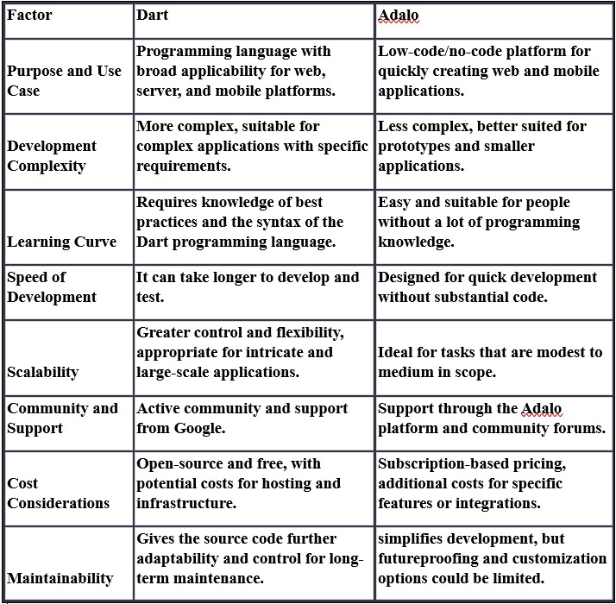

18

FEASIBILITY STUDY
A feasibility study is a thorough examination that considers every important factor related to a project to assess its chances of success.

COMPONENTS OF A FEASIBILITY REPORT.

  - LEGAL FEASIBILITY STUDY
One of the most important aspects of project management is legal feasibility, which is studied in detail. The project's legal execution depends on compliance with national regulations, even if finance is obtained. It is necessary to carefully evaluate several legal factors, including data protection laws, social media policies, zoning rules, and other legal requirements. Certain places have certain limitations on the kinds of jobs that are permitted. For example, determining the app's legal viability becomes crucial after creation. Ensuring compliance with all applicable rules and regulations and resolving potential legal repercussions are critical steps towards the overall success and longevity of the project.

  - ECONOMIC FEASIBILITY STUDY
The process of determining the financial advantages and disadvantages of a development project is known as economic feasibility. Commonly known as a cost-benefit analysis.
Let's now look at some benefits of the project's development that we should consider:

Tangible benefits
Tangible benefits in a project context are quantifiable and certain, measured in dollars. They include concrete examples such as reduced personnel expenses, lower transaction costs, and higher profit margins. Generally falling into categories such as cost reduction, error reduction, increased flexibility, improved speed of activity, enhanced management planning and control, and the opening of new markets, tangible benefits provide measurable and financially tangible advantages that contribute to the overall success and efficiency of the project.

Intangible benefits
Intangible benefits of an information system that are difficult to quantify in monetary terms include raises in staff morale and wider social effects like lower resources and waste usage. These intangible gains add a substantial amount to the overall value of the system, despite being difficult to measure.

19

FEASIBILITY STUDY
A feasibility study is a thorough examination that considers every important factor related to a project to assess its chances of success.

COMPONENTS OF A FEASIBILITY REPORT.

02 ECONOMIC FEASIBILITY STUDY
Let's now look at the project development cost, which is something we must consider:

Tangible costs
Costs that may be precisely evaluated in money are referred to as tangible costs in the context of information systems. Tactical costs include labor, hardware, and operating costs (such as facility modifications and employee training) associated with system development. These expenses, which are specific and quantifiable, are a crucial component of the financial factors involved in the creation of information systems.

Intangible costs
The intangible costs of an information system, which are difficult to quantify in monetary terms, can include things like diminished client loyalty, effects on staff morale, and inefficiencies in operations. These expenses are essential to determining the system's total impact on the company, although being difficult to quantify.

One-time costs
In the context of a project, one-time costs are those associated with the beginning and development stage or system startup. These expenses cover a range of tasks including system development, new hardware and software purchases, user training, site preparation, and data or system conversion. These are essentially up- front costs that are incurred in the early phases of a project or system deployment.

Recurring costs
Recurring costs, stemming from the continuous evolution and use of a system, include ongoing expenses like software maintenance, data storage, communications, and supplies. These costs persist throughout the system's lifecycle, reflecting the sustained requirements for its ongoing operation and development.

Cash Flow Analysis and Measures
The purpose of a cash flow analysis is to create a project's working budget. When determining if a company can successfully pay its bills and make enough money to maintain operations, this study is essential. It is crucial to have a positive cash flow as it frequently signifies the viability and upward direction of the organization. Long-term negative cash flow circumstances may suggest probable bankruptcy threats.

20

FEASIBILITY STUDY
A feasibility study is a thorough examination that considers every important factor related to a project to assess its chances of success.

COMPONENTS OF A FEASIBILITY REPORT.

- ECONOMIC FEASIBILITY STUDY

Cash Flows From Operations (CFO)
Operating cash flow, also known as cash flow from operations (CFO), is the term used to characterize financial flows that are directly related to the manufacture and sale of items from regular activities. A company's CFO can tell you if it has enough money flowing in to cover its running costs and debts.
Operating cash flow = cash received from sales - operating expenses.
Operating cash flow is reported on a business's cash flow statement. It reveals when a business could require outside funding for capital development as well as if a business can produce enough cash flow to sustain and grow operations.

Cash Flows From Investing (CFI)
The cash created or spent from various investment-related activities over a given time is reported in the cash flow from investing (CFI) or investing cash flow.
Buying speculative assets, making investments in securities, and selling assets or securities are examples of investing activities.

Cash Flows From Financing (CFF)
Cash flow from financing operations gives investors insight into a business's financial strength and how well its capital structure is handled.
Cash flows from financing (CFF), also known as financing cash flow, displays the net flows of cash used to fund the firm and its capital.

We can assess the monetary value of our project by employing a calculation known as

Return on Investment (ROI)
The term ROI refers to a computation that expresses the average rate of return obtained on the capital spent in a project. The project's net benefits (total benefits minus total expenses) are divided by the total costs to get the ROI.

21

FEASIBILITY STUDY
A feasibility study is a thorough examination that considers every important factor related to a project to assess its chances of success.

COMPONENTS OF A FEASIBILITY REPORT.

- TECHNICAL FEASIBILITY STUDY

Examines and assesses the project's present hardware, software, and technical needs in addition to the system's specifications.
A technical feasibility assessment reports on the availability of new technology and resources needed for the planned software development.
The technical expertise of the software development team, the practicality of utilizing the available technology, the simplicity of upkeep and upgrades, and other aspects are all examined in a technical feasibility study.
Aspects of technical viability, especially in the creation of software projects, must be examined since they are essential to their successful completion.

Technical feasibility assessments yield four general rules:

- Smaller projects tend to be less risky than larger ones.
- Systems with easily obtained and highly structured requirements are less risky than those with messy, ill- structured, or judgment-dependent requirements.
- Projects using commonly used or standard technology are less risky than those employing novel or nonstandard technology.
- Familiarity with the systems development process and application area among the user group reduces project risk compared to situations where the user group is unfamiliar.

22

FEASIBILITY STUDY
A feasibility study is a thorough examination that considers every important factor related to a project to assess its chances of success.

COMPONENTS OF A FEASIBILITY REPORT.

- OPERATIONAL FEASIBILITY STUDY

Operational feasibility investigates how a new project will impact regular business operations, what policies should be put in place, and what has to be done to keep the business going.
Let's say you are introducing a worldwide e-commerce website. Next, you need local service teams, warehouses, and sometimes even websites in each nation.
Even if the original concept seems technically and financially viable, it is very difficult to implement operationally and might not even make sense.

- SCHEDULING FEASIBILITY STUDY

Project success depends on scheduling feasibility since timely completion is crucial. As part of this evaluation, the time required to complete the project is estimated, acknowledging the significance of efficient time management.

23

FEASIBILITY STUDY
A feasibility study is a thorough examination that considers every important factor related to a project to assess its chances of success.

IMPACT OF DIFFERENT FEASIBILITY CRITERIA ON A SOFTWARE INVESTIGATION

Let's evaluate how several feasibility factors affect the software for the FitPro fitness app:

Legal Feasibility Study:
Impact: To prevent any legal problems throughout FitPro's growth and operation, it is imperative to ensure legal viability. This involves assessing compliance with data protection laws, intellectual property regulations, and any industry-specific legal requirements. Ignoring legal issues may result in penalties, legal action, or the app being blocked in some areas. To reduce hazards, legal specialists must be consulted from the beginning of development.

Economic Feasibility Study:
Impact: Economic feasibility evaluates the financial viability of FitPro.Estimating the expenses of development, upkeep, prospective income sources, and return on investment (ROI) are all included in this. A comprehensive economic feasibility analysis is necessary to make sure that the expenditures of construction and upkeep match the anticipated income. If the costs outweigh the benefits, it may not be economically feasible to proceed with the project.

Technical Feasibility Study:
Impact: Technical viability evaluates if the suggested FitPro app can be created given the limitations and the technology at hand. It takes into account elements including the development team's technical proficiency, development tools, and hardware and software needs. Project delays, higher development costs, or even project collapse might result from decreased technical viability. Updating and evaluating developing technologies on a regular basis is required to keep the project technically feasible.

24

FEASIBILITY STUDY
A feasibility study is a thorough examination that considers every important factor related to a project to assess its chances of success.

IMPACT OF DIFFERENT FEASIBILITY CRITERIA ON A SOFTWARE INVESTIGATION

Operational Feasibility Study:
Impact: FitPro's operational viability assesses how well it will perform in the planned setting. This entails evaluating the effect on current procedures and systems as well as users' capacity to adjust to the new fitness app. FitPro could encounter opposition and the project might be declared operationally unfeasible if it interferes with current business processes or is difficult for users to incorporate into their daily schedules. To guarantee operational viability, user acceptability testing and feedback are essential.

Scheduling Feasibility Study:
Impact: Whether FitPro can be built and delivered in the allotted time is the main consideration in scheduling feasibility. Developmental delays might lead to lost business opportunities or more competition. Investor trust may also be impacted by missing deadlines. Maintaining schedule feasibility requires effective project management, which includes risk management, resource allocation, and realistic scheduling. To guarantee on-time delivery, the project timetable must be regularly reviewed and adjusted.

For the FitPro fitness app to be successful, a thorough feasibility analysis that covers the technological, operational, legal, financial, and scheduling issues is necessary. Efficient decision- making and risk minimization need thorough analysis of the many feasibility criteria, each of which has a unique influence on the project.

25

FitPro Feasibility study

Executive Summary:

FitPro is a modern fitness program that provides users with individualized training routines, dietary advice, and a strong community to encourage them on their fitness journey.
According to the feasibility assessment, FitPro has a lot of room to grow. The app includes personalized diet and fitness programs, live exercises, progress tracking, community interaction, and professional publications. FitPro distinguishes itself in the crowded fitness app industry with its all-encompassing strategy.

Introduction:
Our dream fitness software at app Tech, "FitPro," promises to transform people's approach to fitness adventures in a time when health and well-being have become paramount. I am excited to offer a thorough feasibility analysis detailing the potential, obstacles, and tactics for making FitPro a top option for fitness fans as a committed software engineer guiding the FitPro development.

Introduction:

FitPro is the ideal exercise partner, offering a plethora of features tailored to meet your specific requirements and goals to transform your fitness experience. This is an overview of FitPro's features:

Customized Meal and Exercise Plans: FitPro doesn't think there is a one-size-fits-all approach. Our software generates customized nutrition planning and workout schedules just for you. FitPro adjusts to your fitness level and objectives, regardless of your experience level.

User Community: Social interaction enhances the enjoyment of exercise. FitPro's thriving user base offers a forum for interaction, experience sharing, and mutual assistance.
Everyone uses this community-driven platform to work together to achieve their fitness objectives.
26

FitPro Feasibility study

Executive Summary:

Progress monitoring: FitPro's progress monitoring function lets you recognize and celebrate all of your accomplishments, no matter how minor. Track your exercises, keep an eye on your fitness goals, and notice the improvements you make as you go.

Live Workouts: Bid farewell to monotonous exercise regimens. FitPro offers live exercises to infuse excitement and pleasure into your fitness regimen. Engage in live exercise classes with fitness professionals to stay inspired and motivated.

Articles by experts: Information is power. FitPro provides a vast collection of knowledgeable articles addressing a range of topics related to health, wellness, and diet. Make wise judgments, keep yourself informed, and pick up new skills and advice along the way to a healthier living.

Background Information on the Fitness App Industry:

The fitness app industry has witnessed significant growth in recent years, driven by an increasing awareness of health and wellness. People are now looking for convenient and personalized solutions to achieve their fitness goals. FitPro positions itself in this dynamic landscape by offering a comprehensive approach that combines personalized plans, community engagement, progress tracking, live workouts, and expert insights. As more individuals seek accessible and engaging ways to improve their fitness, FitPro stands out as a user-centric and innovative solution in the competitive fitness app market.

27

FitPro Feasibility study

Market Analysis:
A growing number of people are in need of individualized fitness solutions due to busy lifestyles, more disposable cash, health consciousness, and technology improvements. Giants like MyFitnessPal and Peloton compete with FitPro, but FitPro stands out with more customization, fun community features, professional advice, live exercises, and dietary assistance. FitPro, created for a broad user base used to mobile applications, follows the current trends in fitness apps by emphasizing solid data protection, accessibility, and ease of use. FitPro is ideally positioned to profit from the rising demand for easy and customized fitness solutions, with the worldwide fitness app industry expected to reach $120.37 billion by 2030.

Legal feasibility study:
Developing and operating FitPro involves navigating various legal and regulatory considerations to ensure a secure and compliant user experience.

Data Privacy:
FitPro is required to abide by strict data privacy laws in order to safeguard user data. It's critical to put strong data encryption, safe storage procedures, and compliance with international data protection laws—like the CCPA and GDPR—into place. Users should be informed in clear terms of the privacy rules that govern the use, storage, and sharing of their data.

User Consent:
FitPro has to have clear consent from users. Users need to be aware of the app's data collection policies, which include the kinds of data that are gathered, why they are collected, and how they will be used. Users should be able to readily opt-in or opt-out of particular data processing activities using transparent consent channels.

Intellectual Property Rights:
Make sure that none of FitPro's content—workout regimens, publications, and other materials—violates any intellectual property rights. This entails securing the required permissions for any content created by other parties and safeguarding FitPro's intellectual property with copyrights or trademarks.
28

FitPro Feasibility study

Economic Feasibility study:

Benefits:

Tangible Benefits:
Gaining a sizable user base helps the business become more visible in the marketplace.

Intangible Benefits:
Creating a well-liked fitness app enhances the company's reputation as a whole. User loyalty is increased when a useful and customized fitness experience is offered.

Costs:

Tangible Costs:
Coding, design, testing, and system development expenditures are all included in the development costs. Operational costs include recurring expenditures for consumables, software rentals, and server upkeep.

Intangible Costs:
The possible loss of client loyalty as a result of system malfunctions and the effects of operational inefficiencies on staff morale.

One-Time Costs:
The initial outlay for developing the systems, purchasing the required gear and software, educating the users, setting up the location, and converting the data/system.

Recurring Costs:
Regular upkeep of the FitPro app, fees related with storing user data, communication charges, continuous lease costs for software and hardware, and additional costs like materials.

29

FitPro Feasibility study

Economic Feasibility study:

Cash Flow Analysis and Measures:

CFO (Cash Flow from Operations): evaluates FitPro's capacity to make money from routine business activities.

CFI (Cash Flow from Investing): represents financial transactions related to investments, such as the creation of new hardware and systems.

CFF (Cash Flow from Financing): records financial transactions for loans and stock investments, among other financing-related operations.

Revenue Projections:
Potential collaborations with health or fitness brands, in-app purchases, and subscription fees from anticipated premium users are some of the revenue streams.

Return on Investment (ROI):
The ROI formula, represented as (Total Benefits - Total Costs) / Total Costs, will provide insights into the financial success and profitability of the FitPro project.

30

FitPro Feasibility study

Technical Feasibility study:

Platform and Compatibility:
FitPro is going to be created as a cross-platform program, meaning that it will work with devices running both iOS and Android. Frameworks for effective code exchange and maintenance will be used to achieve this.

Database Management:
It will be possible to store user profiles, customized plans, community interactions, and progress data in a scalable and resilient database system. You could think about Firebase or MongoDB because of their scalability and versatility.

Security:
FitPro will employ industry-standard security mechanisms, such as end-to-end encryption for user communication, secure user information storage, and secure API endpoints, in light of the sensitivity of user data. To handle new threats, regular security assessments and upgrades will be carried out.

Cloud Services:
Scalability, dependability, and effective data management may be ensured by using cloud services (Google Cloud), particularly as the user base expands. Additionally, this will make services like content distribution and live exercises possible.

User Interface (UI) and User Experience (UX):
A primary focus of the development process will be a UI/UX design that is easy to use and intuitive. To improve user happiness, the app's design will place a high priority on responsiveness, accessibility, and an interesting user interface.

31

FitPro Feasibility study

Operational Feasibility Study:

Organizational Readiness:
Assessing the organization's readiness comprises examining the present infrastructure, skill sets of the personnel, and general ability to take on the FitPro project. App Tech should make sure that its personnel have the required understanding of the fitness industry, cloud services, and mobile app development.

Stakeholder Alignment:
Key stakeholders, including as management, development teams, marketing, and support personnel, must be in sync. Establishing a collaborative atmosphere and ensuring everyone is in agreement may be achieved by clear communication of project goals, timetables, and expectations.

Scalability Planning:
Scalability should be taken into account while designing and implementing the FitPro app, given the anticipated increase in user numbers. To make sure the app can manage more user traffic, load testing and performance evaluations will be carried out on a regular basis.

32

FitPro Feasibility study
Scheduling Feasibility Study:
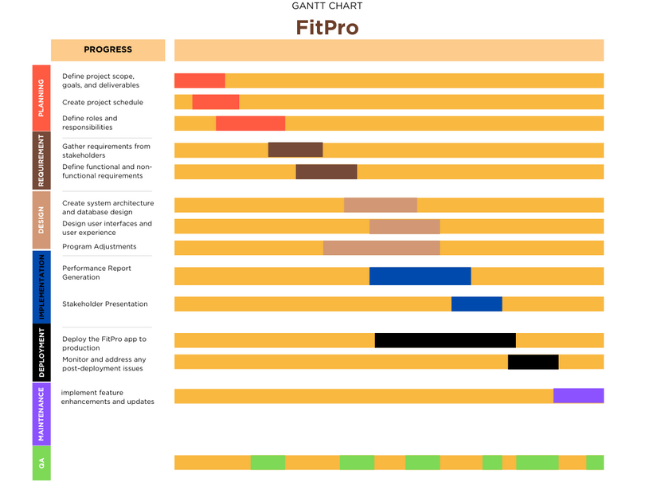

The goal of the schedule feasibility study for App Tech's FitPro fitness application is to evaluate the project's time needs and viability in relation to the deadlines. This research takes into account a number of scheduling factors to guarantee that the project remains on course and is completed on time.

34

FitPro Feasibility study
Impact of feasibility study on FitPro
To sum up, App Tech needs the FitPro feasibility study to help them make judgments on the fitness app's practicality, hazards, and future prospects. It offers a thorough analysis that directs the project's development and guarantees that it is in line with the aims and objectives of the business.

35

Inter View

Stakeholder: Fitness Trainer

Structured Interview:

What are the key elements of an effective fitness plan?

An effective fitness plan includes a balance of cardiovascular exercise, strength training, flexibility exercises, and proper nutrition.

From your experience, what common challenges do individuals face when trying to adopt a healthier lifestyle?

Common challenges include lack of motivation, time constraints, and difficulties in maintaining a consistent workout routine.

How can personalized exercise routines benefit users with different fitness levels and goals?

Individual requirements are taken into account while creating personalized workout plans, which guarantee that activities match objectives and fitness levels and improve overall participation and outcomes.



36

Inter View

Stakeholder: Fitness Trainer

Unstructured Interview:

Can you share specific instances where personalized fitness plans have led to significant improvements in an individual's health?

Certainly, I've seen cases where tailored plans helped in weight loss, increased energy levels, and improved overall well-being.

In your opinion, what features would make FitPro stand out as a preferred fitness app?

A strong community engagement platform, live workouts for real-time guidance, and regularly updated expert articles on fitness trends and nutrition.

Are there any overlooked issues in existing fitness apps that, if addressed, could greatly enhance user experience?

Some apps lack flexibility in adjusting workout plans, and there's often a gap in providing real-time interaction with fitness experts during workouts.



37

SRS
Table of contant

Table of Contents

- Introduction
  - Purpose
  - Project Scope
  - Intended Audience

- Overall Description
  - Product Perspective
  - Product Features
  - Operating Environment
  - Assumptions and Dependencies

- System Features
  - User Registration and Profile Setup
  - Fitness Plans
  - Progress Reports
  - User Community
  - Expert Articles

- Nonfunctional Requirements
  - Performance Requirements
  - Security and Safety Requirements

Appendix A: Glossary

Appendix B: Analysis Models

Appendix C: Data Dictionary

38

The purpose of this document is to establish the Software Requirements Specification (SRS) for FitPro, a mobile fitness software that offers individualized programs, nutrition guidance, and a community of support to assist users reach their goals for fitness.
1.1 Purpose
1.2 Scope

FitPro's software offers exercise plans depending on customer goals and preferences in an effort to provide consumers a personalized fitness experience. The site includes capabilities for meal planning, calorie tracking, and customized nutrition guidance in addition to workouts.

A wealth of articles covering fitness and nutrition subjects, live workout sessions with certified trainers, and progress monitoring for many fitness indicators are some of the key features. FitPro promotes user connection, creating a friendly environment where people may exchange support and experiences.

Aligning with business aims, the platform's main purpose is to encourage a balanced lifestyle. As a go-to resource for individualized fitness and well-being, FitPro hopes to develop into a comprehensive wellness platform that caters to a range of customer needs.

39

The FitPro fitness app's development and implementation stakeholders are the target audience for this Software Requirements Specification (SRS) document. Among the intended audience are:
1.3 Intended Audience

Project managers: As the primary managers of the FitPro project, they will find information in this document to assist them in managing expectations, working with stakeholders, and solving any possible problems.

Product Owner: he will obtain an understanding of the specific specifications, features, and functions anticipated in FitPro. The Product Owner is in charge of outlining the needs and vision for the product.

Development Team (Testers, Developers, and Designers): The technical group responsible for developing and overseeing the FitPro application is served by this department. The FitPro app's features, functionality, and performance requirements are explained in depth for designers, developers, and testers.

Users: FitPro's end users, who are those looking to increase their level of fitness, will get information about the app's advantages.

Documentation Writers: This section contains important details on the functional features of FitPro that need to be explained to end users for those in charge of writing user manuals, help guides, and other supporting documentation.

Document Organization:
This document is designed to serve different readers involved in the FitPro fitness app project. Start with the introductory sections for a general overview. Project Managers then dive into project management details, Product Owners explore product vision and requirements, and the Development Team find technical specifications. Users will discover information about FitPro's benefits and features, while Documentation Writers can focus on user communication. Following this sequence helps each reader grasp the relevant information for their role, making the document accessible and user-friendly.
40

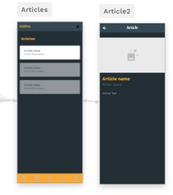
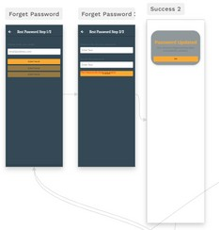

FitPro is a brand-new fitness software that provides consumers with a comprehensive solution rather than replacing anything. It all comes down to exercise, individualized nutration advice, and an active user base. Users receive personalized training schedules according to their objectives, degree of fitness, and equipment availability. The software offers nutration guidance, aids with meal planning, and tracks calories. The calories calculator's statistics make it simple for users to monitor their progress.
2.1 Product Perspective
For a variety of interests and fitness levels, FitPro offers live sessions with professional instructors, going beyond solitary exercises. Expert articles on diet and exercise are also available to users. Users may interact through forums, chat, and experience sharing inside the app's supportive community.
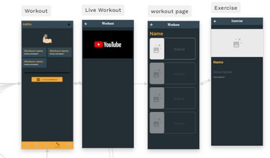
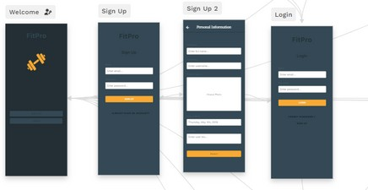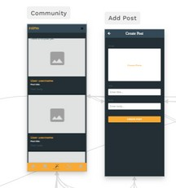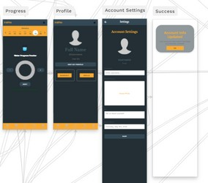Here's a quick look at our simple diagram. It shows the main parts, how they connect. Let's dive in!

41

FitPro's user-friendly foundation makes your fitness journey simpler. Onboarding is the first step; start by configuring your profile and fitness preferences. FitPro will provide customized food and exercise suggestions.
2.2 Product Features

Workout Plans: Get access to exercise schedules that include descriptions for simple implementation.

Calorie Counter: Use the nutrition function to create personalized meal plans that are in line with your fitness objectives.

Progress Tracking: Use an all-inclusive progress tracking tool to monitor your drinking water level.

Live Workouts: For an engaging fitness experience, work out in real time with certified instructors.

Expert Articles: Read through a selection of regularly updated instructional articles about fitness and nutrition.

Community: In the forum or chat room, interact with other people to get support and encouragement.
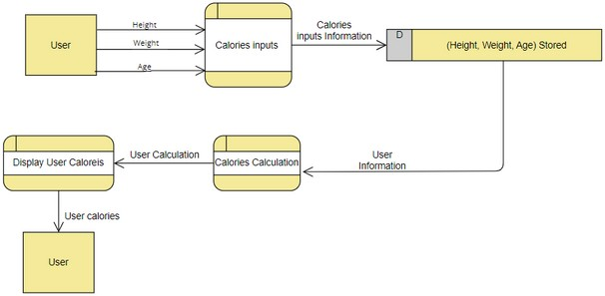

42

Data Flow Diagram (DFD):
2.2 Product Features


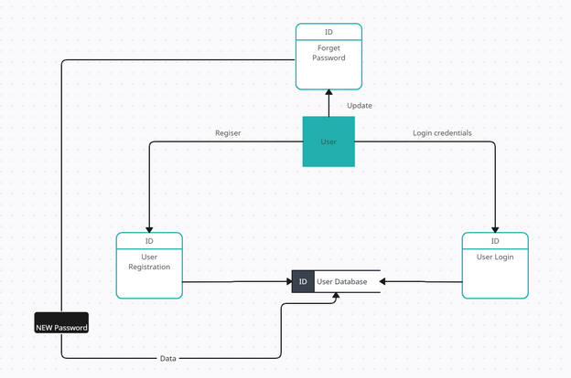
43

In order to provide accessibility for a wide range of users, the program is designed to be compatible with several platforms and settings. Among the essential elements of the operating environment are:
2.3 Operating Environment

Hardware Platform: FitPro is designed to work with a variety of hardware configurations, such as tablets, smartphones, and other handheld electronic devices. It makes use of contemporary hardware's capabilities to provide a snappy and responsive user experience.

Operating System: FitPro was designed to work with the most popular mobile operating systems, including Android and iOS.

Internet connectivity: To access live workouts, update information, and promote community interactions, FitPro needs internet connectivity for certain of its functions. The program is designed to run smoothly on a variety of network configurations.

FitPro's operating environment is flexible, allowing it to adjust to changes in technology while still offering a well-rounded and user-friendly workout experience.

44

Many things could affect how FitPro works, like the kinds of devices it can be used on, such as phones, tablets, and smartwatches. For FitPro to stay compatible with these devices, it needs to adjust when devices change or new ones come out. FitPro's design also considers rules about keeping your data safe and private. If these rules change, FitPro might need to change too.
2.4 Assumptions and Dependencies

FitPro also needs a good internet connection, especially for features like live workouts. If the internet isn't stable, it might affect how well live workouts work. The app also includes expert articles and other content, and whether these are available can depend on certain agreements. If those agreements change, the content in FitPro might need to change too.

The part of FitPro that stores and manages information (like your workout plans) should be able to handle more users and changing usage patterns. But if a lot of people start using FitPro differently, the way it stores information might need to be adjusted. FitPro will make money in future through things like ads or if people buy special features. The way it makes money might need to change if more people start using FitPro or if people's preferences change.

FitPro also relies on other things to make it better. For example, we will use special tools to connect with smartwatches and other devices. FitPro will also relies on certain systems to let people buy special features. If these tools or systems change, FitPro might need to change too. FitPro will use social media to let people log in and share their achievements. All these things are important to think about when making FitPro and keeping it working well.

45

  - Account Creation
1 User Registration and Profile Setup
Users can create accounts using email. (High priority).

    - Description and Priority
FitPro places a high priority on the User Registration and Account Creation function since it is the first step towards allowing users to interact with the platform. Users may easily create FitPro accounts with their email addresses thanks to this capability. Users are required to enter some details during the registration process, such as their email address, full name, username, age, height, and weight. The system enforces strict password rules to guarantee user account security.

User Registration and Account Creation is crucial (Benefit: 9) for personalizing fitness journeys, accessing tailored plans, and engaging with the FitPro community. It's generally straightforward (Penalty: 2), but complexity could deter some users. The moderate (cost:5) involves resources for account management and security. Mitigating a moderate (risk :6) requires robust password policies and security measures for user data protection.

    - Functional Requirements:
Req.1: Collect user information (email, Full-Name, Username, age, weight, height). Req.2: Enforce strong password for account security.

    - Error Handling:
Provide users with obvious error messages during registration to remind them to fill up any missing fields if any are required.
Notify the user of the password requirements in the event that their password is weak and provide assistance in coming up with a strong one.

46

  - Profile Management
User Registration and Profile Setup
Users can update personal information, fitness goals, and preferences. High priority.

    - Description and Priority
With the help of this high-priority feature, FitPro users may easily change their name, age, and other personal information, resulting in a more customized and personalized workout experience.

This feature's high benefit rating (9) stems from the enhanced personalization it offers, positively impacting user engagement and satisfaction. While the potential penalty (3) is low, any issues in the updating process should be swiftly addressed to minimize inconvenience. With a moderate implementation cost (5), the development effort is reasonable, and a well- executed solution can effectively manage the associated risks (4), ensuring accurate and secure profile management.

    - Functional Requirements:
Req.1: Allow users to update profile information.
Req.2: Enable customization with profile pictures and fitness tracker integration.

    - Error Handling:
If the update request contains erroneous data (such as an age that is not a number or an improper profile image), error messages should be sent to direct the user to enter valid data. To avoid unauthorized alterations, make sure that any changes made to sensitive information (such email addresses) are validated by extra authentication.

47

  - Workout Plan

2 Fitness Plans
FitPro generates workout plans tailored to goals. High priority.

  - Description and Priority:
Personalized fitness programs are a high-priority element of FitPro that are designed to give consumers workout routines that are exactly matched to their unique fitness objectives.

The substantial benefit rating (9) underscores the positive impact of this feature on user engagement and motivation. With a low associated penalty (2), the core functionality of generating personalized workout plans is seen as a valuable asset for users. While the implementation cost is moderate (6), reflecting the necessary development resources, the manageable risk (4) is primarily related to ensuring the accuracy of goal-tailored plans. Robust algorithms and validation processes are essential to mitigate potential risks and enhance the overall reliability of the generated workout plans.

  - Functional Requirements:
Req.1: Consider user goals, fitness level, and preferences for plan generation. Req.2: Provide flexibility in workout duration and intensity.
Req.3: Include clear instructions.

  - Error Handling:
In case of unavailable equipment for a particular exercise, suggest alternative exercises or provide equipment substitution options.

48

  - drinking water tracking

3 Progress Reports
FitPro introduces a low-priority Progress Reports feature, enabling users to log drinking wate intake.

  - Description and Priority:
FitPro has a low-priority Progress Reports tool that lets customers track how much water they drink each day. Although it isn't a top priority function, customers may check and manage their hydration levels with the help of this feature.

FitPro's integration of water tracking (Benefit: 4) raises user awareness of hydration, which improves user well-being. The simple feature eliminates possible downsides with a low development cost (3) and negligible penalty (1). Standard validation procedures are permitted due to the minimal risk (2), guaranteeing correctness.

  - Functional Requirements:
Req.1: Enable drinking water tracking.

  - Error Handling:
Water Tracking: Ensure that users input valid water consumption data.

49

  - Posts Platform

4 User Community
Users connect with the FitPro community. Medium priority.

  - Description and Priority:
FitPro emphasizes community involvement inside the FitPro platform by launching the User Community feature, which allows users to interact with one another. This feature is given a medium priority, emphasizing its value in building relationships and community among FitPro users without being considered an essential component of the FitPro experience as a whole.

In comparison to items that are higher on the priority list, the User Community feature (Benefit: 5) has a moderate influence on fostering a feeling of community and support among FitPro members. Given that community interaction is often favorable, the potential penalty (2) is minimal. It has a medium priority and is not as important to the full FitPro functionality. The moderate implementation cost (4) pays for the materials needed to create and manage an interactive platform for users. With an emphasis on content management and maintaining a welcoming community, the related risk (3) is likewise moderate.

  - Functional Requirements:
Req.1: Create posts and share fitness experiences. Req.2: Provide a platform for questions and support.

  - Error Handling:
Put in place content moderation to stop offensive or community guidelines-violating posts. Inform users of any problems or interruptions in the chat platform's functionality and provide them with information on when service will be restored.

50

  - Library of Articles

5 Expert Articles
Explore expert-written articles on fitness and nutrition. Medium priority.

  - Description and Priority:
FitPro launches the Expert Articles service, which lets customers read articles written by qualified nutritionists and exercise professionals. This feature, which has a medium priority, provides insightful information without being seen as essential to the fundamental FitPro experience.

Expert Articles (Benefit: 6) offers insightful advice on diet and exercise from licensed professionals. Although it has a moderate priority and is impactful, it is not a high priority. Positive interaction with expert information is indicated by the low potential penalty (2). It has a medium priority and is not as important to FitPro's overall operation. The modest implementation cost (3) includes resources for keeping the article library up to date. The danger associated with (4) emphasizes how crucial material quality management is to improve the fitness and nutrition user experience.

  - Functional Requirements:
Req.1: Organize articles into categories for easy access.

  - Error Handling:
A helpful error notice should appear and you should be advised to try again later if there are server problems or the material cannot be loaded.
Each functionality's unique functional needs are broken out here, and error handling strategies for expected error situations or invalid inputs are also considered.

51

FitPro places a high value on a seamless and quick user experience. Exercise routines, and community interactions are among the features that are made to load quickly. We guarantee high availability, reducing server outages or maintenance periods, to reduce downtime. FitPro also improves data efficiency to meet the needs of customers with restricted data plans, particularly for video streaming and content delivery. For everyday actions, the FitPro app must react in a matter of seconds to provide a seamless user experience.
Performance Requirements
Security and Safety Requirements

Our user authentication system's safety standards place a high priority on preventing loss, illegal access, and potential injury from product use. To do this, we will impose the need for multi-factor authentication for more thorough user identity verification and the establishment of strong password regulations. Encryption protects sensitive user data while it is in transit and at rest, including financial information, health data, and personal information. Frequent security audits are carried out to find and fix vulnerabilities, and if sensitive data is accessed by unauthorized parties, prompt action is taken.

The system is built to abide with laws and regulations from outside sources, such as GDPR, and a dedicated compliance officer makes sure that compliance is always maintained. Furthermore, it's critical to achieve and maintain safety certifications like ISO 27001, and industry-specific security requirements need to be properly followed. Clear rules on managing sensitive information are supported by a thorough user education program that is undertaken to improve knowledge and adherence to security best practices. By taking these precautions, our user authentication system aims to reduce risks for users and their sensitive data while offering a safe and compliant environment.

52

Personalized fitness plan: A workout routine generated specifically for the user's individual needs and goals.
A:: Gllossarry

Nutritional guidance: Suggestions for wholesome eating practices and meal plans customized to the individual's dietary requirements and objectives.

Tracking progress: keeping an eye on and documenting fitness data to gauge progress over time.

Live workout: A workout conducted in real time via the app's video interface under the guidance of a licensed trainer.

Expert article: Well-informed writing by licensed experts on diet, exercise, and related subjects.

53

B: Analysis Models

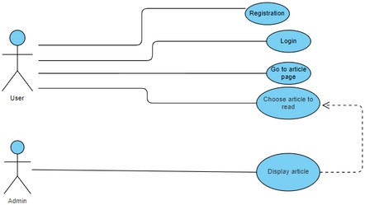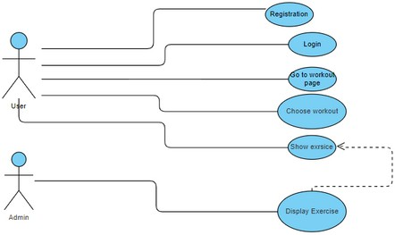

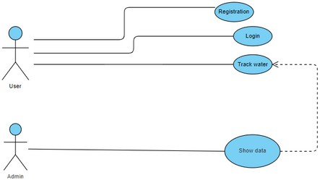
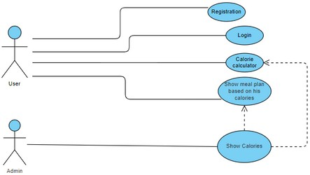

54

C: Data Dictionary

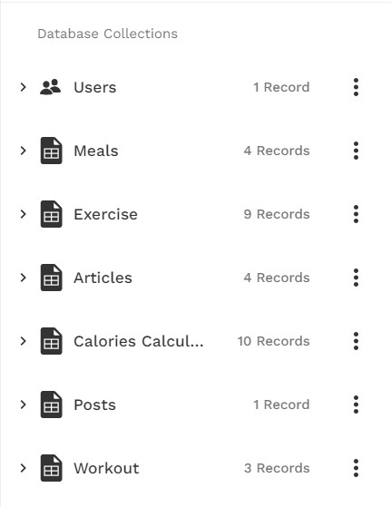

55

HOW SOFTWARE REQUIREMENTS CAN BE TRACED THROUGHOUT THE SOFTWARE LIFECYCLE.
RTM
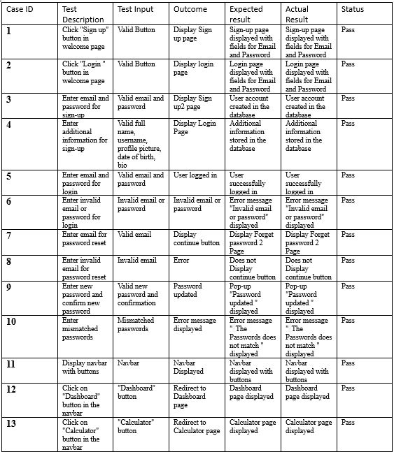
56

HOW SOFTWARE REQUIREMENTS CAN BE TRACED THROUGHOUT THE SOFTWARE LIFECYCLE.
RTM
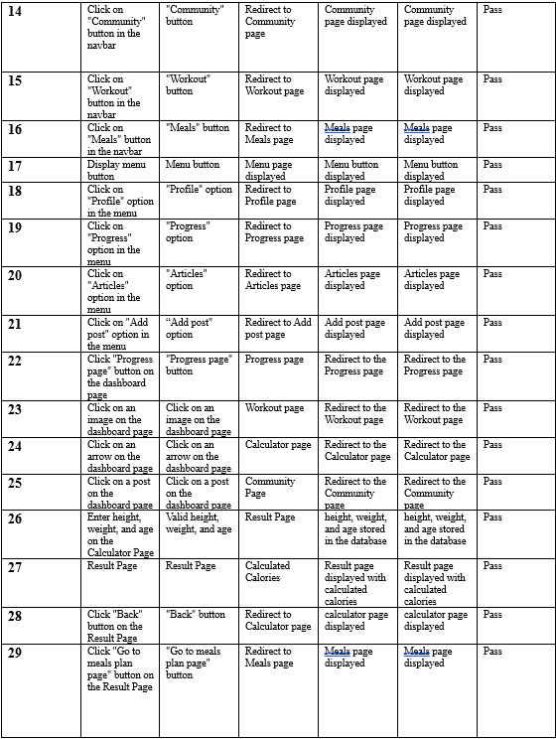

57

HOW SOFTWARE REQUIREMENTS CAN BE TRACED THROUGHOUT THE SOFTWARE LIFECYCLE.
RTM
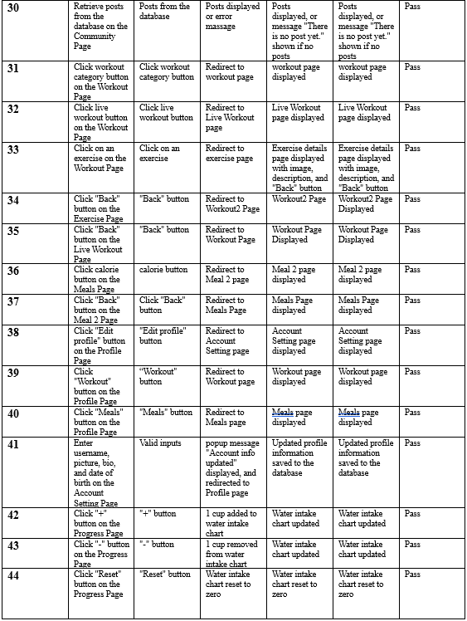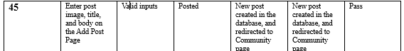

58

DISCUSS TWO APPROACHES TO IMPROVING SOFTWARE QUALITY

Test at an early stage
Early testing is critical to ensuring program functionality. It assists in identifying and resolving concerns early in the design process, preventing more serious problems down the road.
Early testing also results in cost savings. A $100 fix for an issue discovered during the planning stage can wind up costing
$10,000 or more if the problem is discovered later on during
construction.
01

Communication
02
Effective communication is essential for healthy relationships in both personal and professional contexts. Effective communication among all parties engaged in software development is essential to improving the program.

Every stage of the software development process, from planning and design to coding, testing, and deployment, is monitored for quality. By doing this, we can identify problems early on and address them to ensure a high-quality final result.

Feedback and ideas may be shared by team members, vendors, and users alike. This aids the group in making the required modifications to satisfy everyone's expectations.

Keeping team members informed and not separating them from suppliers or users is crucial. Everyone will be aware of what is going on throughout the software development process thanks to this open communication.

59

THE PROCESS
OF UNDERTAKING A SYSTEMS INVESTIGATION WITH REGARD TO ITS EFFECTIVENESS IN IMPROVING SOFTWARE QUALITY.
Interviewing people during the requirements gathering stage offers advantages and disadvantages. Positively, interviews offer a thorough grasp of the requirements and preferences of stakeholders. The development team and stakeholders can clarify unclear topics and build a cooperative connection through direct engagement. The introduction of prejudice and a narrow perspective, however, might have a detrimental effect since the expressed points of view would not fully reflect those of all stakeholders. Furthermore, conducting interviews can take a lot of time, particularly when there are many parties involved.

Even though interviews can yield insightful information, it is frequently insufficient on its own. If you only use interviews, you can miss certain important details or viewpoints. For a more thorough covering of needs, it becomes important to augment with additional ways.

Alternatives for Gathering Requirements:
Various different ways can supplement the interview process:

Conducting interviews during the requirements gathering phase has both positive and negative impacts. On the positive side, interviews provide an in-depth understanding of stakeholders' needs and preferences. The direct interaction allows for clarification of ambiguous points and fosters a collaborative relationship between the development team and stakeholders. However, a potential negative impact is the introduction of bias and a limited perspective, as the viewpoints expressed may not represent the opinions of all stakeholders. Additionally, interviews can be time-consuming, especially when dealing with a large number of stakeholders.

Despite the valuable insights gained from interviews, it is often not enough on its own. Relying solely on interviews may result in overlooking certain aspects or perspectives. Therefore, supplementing with other methods becomes necessary for a more comprehensive coverage of requirements.

60

THE PROCESS
OF UNDERTAKING A SYSTEMS INVESTIGATION WITH REGARD TO ITS EFFECTIVENESS IN IMPROVING SOFTWARE QUALITY.
Other Options of Requirement Gathering:
Various alternative methods can complement the interview process:

Background Study: Understanding the market, the industry, and the solutions that are currently available is aided by background research. This more comprehensive background improves decision-making and guarantees that the software is designed in accordance with user expectations and industry standards.

Questionnaires: Questionnaires are a useful tool for gathering quantitative information from a wide range of stakeholders. This technique is helpful for getting feedback on certain attributes or preferences, giving the qualitative insights gleaned from interviews a quantitative component.

It is essential to combine these techniques to provide thorough coverage. Cross-verification is made possible by the range of techniques, which raises the precision and dependability of requirements that are obtained. Additionally, utilizing a variety of approaches satisfies the requirements of many stakeholders by accommodating differing communication preferences. To put it briefly, a good requirements collecting process builds a solid set of needs for successful software development by utilizing a variety of methodologies in a balanced manner.

61

THE PROCESS
OF UNDERTAKING A SYSTEMS INVESTIGATION WITH REGARD TO ITS EFFECTIVENESS IN IMPROVING SOFTWARE QUALITY.
The process of investigating systems is crucial for making better-quality software. Let's evaluate how effective this process is at different stages of software development.

The Requirement Gathering and Analysis phase involves collaboration between developers and testers. Testers ensure that the program satisfies user demands by assisting in the early detection of any issues.

As we go into the System Design phase, teamwork is essential. To ensure that the system is ready for success, testers apply their expertise to spot design flaws. Teamwork is essential to the overall quality of the software.

Developers and testers work closely together during the Coding Phase. Testing each section of the code allows testers to identify and address problems early on. Collaboration is essential to producing software of the highest quality.

Throughout the System Testing stage, developers and testers collaborate continually. To make sure the program functions properly, testers analyze different scenarios. Working together is essential to having a robust quality assurance procedure.

Developers produce updates and address issues during the maintenance phase. After modifications are done, testers verify that everything functions as intended. Even after deployment, the software quality is preserved by this continuous sharing.
It's critical to comprehend and value the differences between the mindsets of developers and testers. This promotes clear communication and ensures that the two roles work well together, which improves the quality of the program in the end.
In conclusion, the process of investigating systems, with collaboration between developers and testers, is highly effective in making better-quality software. Continuous feedback, proactive testing, and clear communication all contribute to identifying and fixing issues, resulting in higher-quality software.

62

SOFTWARE BEHAVIORAL
Let's discuss the two techniques now.
Flowcharts:
A flowchart, often referred to as a process map or flow diagram, is a graphic depiction that shows the connections between the logical processes needed to accomplish a job. Flowcharts come in two primary varieties:

High-Level Flowchart:
-Offers a summary with six to ten main steps.
-Highlights important system components or activity building pieces inside a process.

Detailed Flowchart:
-Useful for identifying complexity, excessive steps, and areas for standardization or improvement.
-It provides a close-up perspective, displaying several steps.

We use Flowcharts for defining or analyzing existing processes, standardizing, or redesigning workflows, and pinpointing areas for improvement by identifying unnecessary steps or potential barriers.
Constructing Flowcharts:
- Define Purpose and Detail Level:
Clarify the goal and decide the required level of detail (high or detailed).
- Gather Expert Input:
Assemble individuals familiar with the process to outline the steps.
- Identify First and Last Steps:
Define the initial and concluding steps in the process.
- Document Steps Sequentially:
Record the process steps in sequence, acknowledging parallel steps.
- Realistic Representation:
Describe the process as it truly exists, not an idealized version.
- Sequence Actions and Decisions:
Illustrate actions and decisions in the order they occur, connecting them with arrows to display the process flow.
- Handle Decision Points:
At decision symbols, select the most natural branch and proceed to the end.
- Address Unfamiliar Steps:
Use notes for unfamiliar steps and then continue to the end.
- Complete Branches:
Return to fill in any incomplete branches at the last step.
- Validation:
Verify the accuracy of the flowchart by working step by step and consulting others.
- Continuous Improvement:
Identify areas for improvement and redesign the process accordingly.
63

SOFTWARE BEHAVIORAL
Let's discuss the two techniques now.
FitPro Flowcharts:

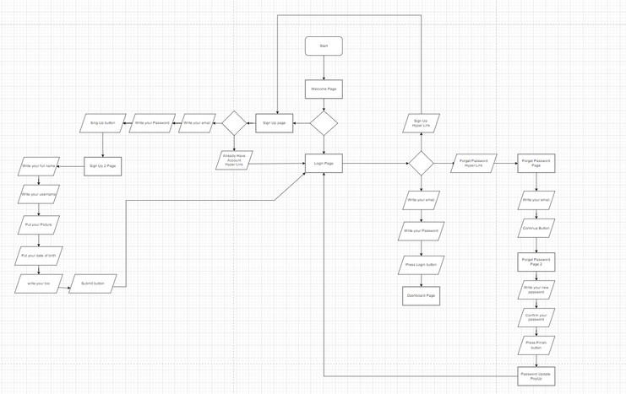

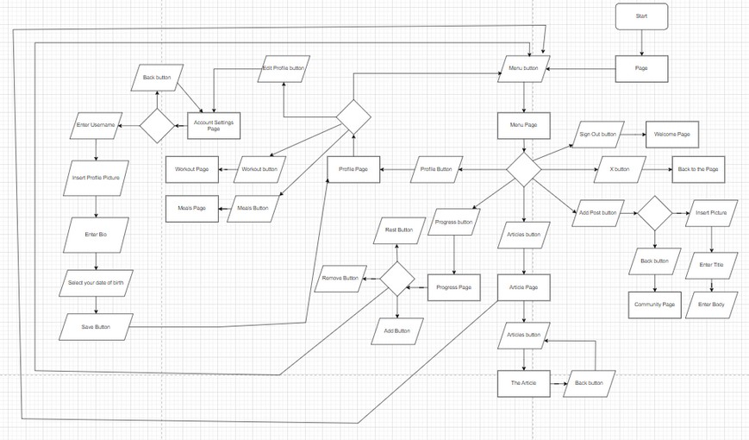
64

SOFTWARE BEHAVIORAL
Let's discuss the two techniques now.
FitPro Flowcharts:

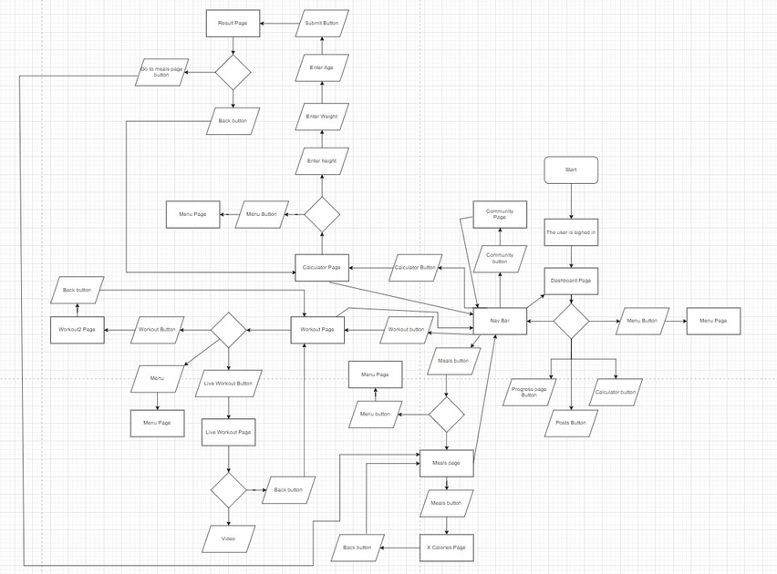

65

Pseudocode
A technique for explaining computer algorithms that combines plain language with programming language is called pseudocode.
In essence, it is a sporadic step toward the creation of the real code. It enables programmers to express their ideas about how a computer algorithm should be organized and sequenced without having to adhere to precise coding syntax.
Despite being widely used, there are no clear guidelines for the precise implementation of pseudocode.

Pseudocode For FitPro
START

DISPLAY welcome page with buttons:
- "Sign up"
- "Log in"

WHEN "Sign up" button clicked:
DISPLAY sign up page with fields for:
- Email
- Password
GET user input for email and password GET:
CREATE new user account in database with email and password DISPLAY page to collect additional information:
- Full name
- Username
- Profile picture
- Date of birth
- Bio
GET user input for additional information STORE additional information in database GO TO login page

WHEN "Log in" button clicked: DISPLAY login page with fields for:
- Email
- Password

GET user input for email and password
66

Pseudocode
IF email and password match an account in database: LOG user in to the app
ELSE:
DISPLAY error message "Invalid email or password"

WHEN "Forgot password" button clicked on login page: DISPLAY forget password page with field for:
- Email

GET user input for email

IF email exists in database:
SEND password reset email to user
DISPLAY message "Password reset email sent" ELSE:
DISPLAY error message "Email not found"

WHEN user clicks link in password reset email: DISPLAY forget password 2 page with fields for:
- New password
- Confirm new password
GET user input for new password and confirm new password IF new password and confirm new password match:
UPDATE user's password in database
DISPLAY message "Password updated successfully" GO TO login page
ELSE:
DISPLAY error message "Passwords do not match"

AFTER user logs in: DISPLAY dashboard page

67

Pseudocode
ON dashboard page:
IF "Progress page" button clicked: GO TO progress page
ELSE IF image clicked:
GO TO workout page ELSE IF arrow clicked:
GO TO calculator page ELSE IF post clicked:
GO TO community page

DISPLAY navbar with buttons for:
- Dashboard
- Calculator
- Community
- Workout
- Meals

WHEN navbar button clicked, GO TO page DISPLAY menu button
WHEN menu button clicked:
DISPLAY menu page with options for:
- Profile
- Progress
- Articles
- Add post

WHEN menu option clicked, GO TO page

**Calculator Page:**
DISPLAY fields for height, weight, and age GET user input for height, weight, and age CALCULATE calories based on user input GO TO result page

68

Pseudocode
**Result Page:**
DISPLAY calculated calories DISPLAY "Back" button
IF "Back" button clicked:
GO TO calculator page
DISPLAY "Go to meals plan page" button IF "Go to meals plan page" button clicked: GO TO meals page

**Community Page:** RETRIEVE posts from database IF no posts found:
DISPLAY message "There is no post yet." ELSE:
DISPLAY posts

**Workout Page:**
DISPLAY workout categories buttons DISPLAY live workout button
IF workout category button clicked: GO TO corresponding workout page IF live workout button clicked:
GO TO live workout page

**Workout Page (for specific category):** DISPLAY exercises for the selected category IF exercise clicked:
DISPLAY image and description of exercise DISPLAY "Back" button
IF "Back" button clicked: GO TO workout page

**Live Workout Page:** DISPLAY live workout video DISPLAY "Back" button
IF "Back" button clicked: GO TO workout page

69

Pseudocode
**Meals Page:**
DISPLAY buttons for different calorie options IF calorie button clicked:
GO TO meal 2 page

**Meal 2 Page:**
DISPLAY meal plan based on selected calorie option DISPLAY "Back" button
IF "Back" button clicked:
GO TO meals page

Profile Page:
DISPLAY user's profile information DISPLAY "Edit profile" button DISPLAY "Workout" button DISPLAY "Meals" button
IF "Edit profile" button clicked:
GO TO account setting page IF "Workout" button clicked:
GO TO workout page
IF "Meals" button clicked:
GO TO meals page Account Setting Page:
DISPLAY fields for username, picture, bio, and date of birth GET user input for username, picture, bio, and date of birth SAVE updated profile information to database
DISPLAY popup message "Account info updated" GO TO profile page

Progress Page:
DISPLAY water intake chart
DISPLAY "+", "-", and "Reset" buttons IF "+" button clicked:
ADD 1 cup to water intake chart IF "-" button clicked:
REMOVE 1 cup from water intake chart IF "Reset" button clicked:
RESET water intake chart to zero
70

Pseudocode
Article Page:
DISPLAY article buttons IF article button clicked:
GO TO article 2 page for the selected article

Article 2 Page:
DISPLAY article name DISPLAY writer name DISPLAY article content

Add Post Page:
DISPLAY fields for post image, title, and body GET user input for post image, title, and body CREATE new post in database
GO TO community page

Community Page:
RETRIEVE posts from database (including the newly added post) DISPLAY posts

71

Let's discuss the two tools now.
Draw io.
A free, open-source online diagramming tool called Draw.io enables users to generate a large range of diagrams, including flowcharts, organizational charts, process diagrams, network diagrams, and more. Being accessible straight from a web browser, this tool is simple to use and straightforward, and it doesn't require t installation of any software.
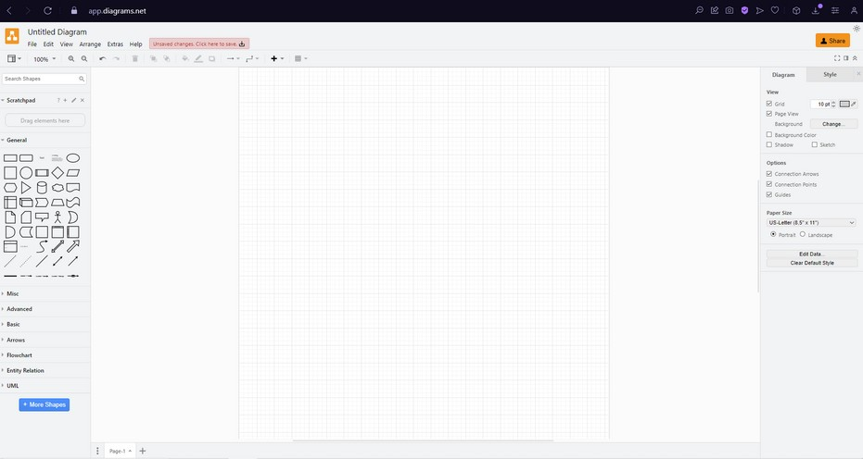

Online Pseudo Code Editors
Tools and platforms are available online that are especially made for creating and exchanging pseudo code. These platforms let you share your pseudo code with others and frequently indicate syntax for basic programming constructs. Websites such as codepad.org, repl.it, and even some online IDEs are a few examples.

72

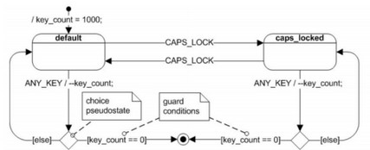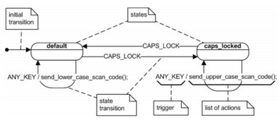State machine
A state machine diagram describes the series of actions that an item does in response to events, modeling the behavior of a single object across its existence.

State machine types:
Finite state machine (FSM): a set of input Boolean conditions and a related set of output Boolean functions correspond to the transition.
Extended finite state machine (EFSM) model, the transition can be described by a “if statement” consisting of a series of trigger conditions. The transition is initiated, moving the machine from the current state to the next state, if all trigger conditions are met.

State Machine symbols:
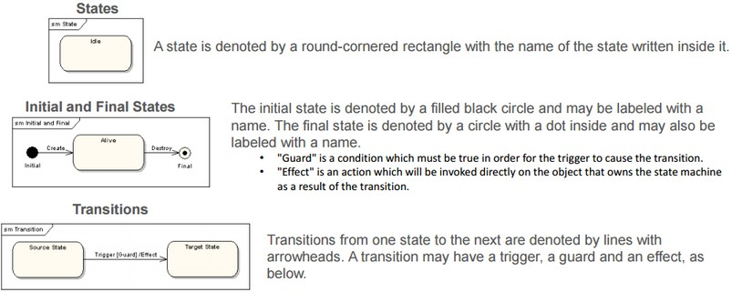

73

Application of (FSM)
Let's look at a basic illustration of a finite state machine that simulates a metro station turnstile. There are two states for the turnstile: "Locked" and "Unlocked."
States:
Locked: The turnstile is locked in this position, making it impossible for someone to pass through.
Unlocked: The turnstile is unlocked in this position, making it possible for someone to pass through.

Initial and Final States:
The initial state is "Locked." The final state is "Unlocked."

Transitions:
When a coin is inserted, the turnstile transitions from the "Locked" state to the "Unlocked" state. This represents a successful coin payment.

Application of (EFSM)
Let's look at a basic illustration of an Extended finite state machine that simulates a metro station turnstile. There are two states for the turnstile: "Locked" and "Unlocked."

States:
Locked: The turnstile is locked in this position, making it impossible for someone to pass through.
Unlocked: The turnstile is unlocked in this position, making it possible for someone to pass through.

if statement (the Action):
Payment Made - Represents whether the payment has been made or not.
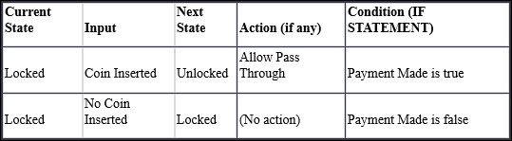

74

How data-driven software can improve the reliability and effectiveness of software.

What is Data-driven

Making strategic decisions in a company through in-depth data analysis and interpretation is known as a data-driven strategy. With the ultimate goal of improving customer and consumer happiness, this approach enables businesses to methodically analyze and arrange their data. The use of precise, unbiased, and unambiguous metrics—like Objectives and Key Results (OKRs) or Key Performance Indicators (KPIs)—incentives development teams to match their daily work with long-term strategic goals and the total commercial value of each project. These teams can see how their efforts are supporting the accomplishment of important objectives and the success of the company by using data visualization. To sum up, solid metrics are essential to data-driven software development since they direct and track development.

Data-driven software manages data that comes from many sources and automates procedures, solves issues, and takes advantage of possibilities. As users search, query, and gather data, it automatically creates master data, metadata, models, schema, and graphs to provide universal accessibility to information inside a single application. Furthermore, the program offers a dynamic and all-inclusive approach to data management by continually correlating data elements.

What is KPI?
Key performance indicators, or KPIs, are measurable metrics that businesses use to monitor and evaluate performance areas. This helps with goal assessment and strategic decision- making. Metrics like traffic, traffic sources, sessions, and transactions provide information on overall performance, user engagement, and transaction success in website KPIs.

What is OKRs?
Objectives and Key Results, or OKRs, are a useful tool for performance monitoring and team management. They facilitate teams' ability to identify priorities, assess their progress toward those targets, and identify areas for improvement. In essence, OKRs give teams an organized method for establishing objectives and tracking their progress. When it comes to assisting data teams in developing their own OKRs for efficient planning and achieving objectives, they are very helpful.

What is Decision support system (DSS)
A computer software called a decision support system (DSS) analyzes a large amount of data and recommends the best solutions to assist an organization make better decisions. To give customers with more than simply routine reports, it compiles data from several sources in an effort to support them in making wise decisions.

Data-driven DSS
A computer software called a data-driven decision support system (DSS) makes choices by utilizing data from databases. By examining data patterns, it frequently forecasts future trends. Companies use it to make judgments about sales and inventories.
75

How data-driven software can improve the reliability and effectiveness of software.

Data Driven role in requirement gathering

Data-driven approaches to requirement gathering helps in the development of software that more effectively satisfies customer needs, ensuring a positive user experience and overall success. This entails conducting user interviews in addition to assessing data from several sources, such as website statistics and customer reviews. Data-driven approaches also help confirm initial assumptions, reducing the risk of building features that users may not find valuable and improving the chances of project success.

Data Driven role in Design stage
A data-driven approach is essential for designing the information architecture and improving user experience throughout the design phase. Data-driven design allows designers to identify and rate the features and content that consumers will find most important, then organize the information architecture to best present these components. Users are also empowered with insights and trends linked to their work and goals when data visualization is integrated directly into the application interface through dashboards and charts. This encourages users to make decisions based on data offered in the application, a process known as data-driven decision-making.

Data Driven role in Development stage
Using data-driven methodologies throughout the development phase is essential to creating software that is user-centric, performant, and efficient. Higher user happiness and better company results are the results of this. Development teams may prioritize high-impact additions that greatly increase user pleasure and engagement by using data, which helps them stay in line with broader corporate objectives. By measuring performance, spotting bottlenecks, and optimizing code for quicker and more responsive apps based on user interaction patterns, data-driven approaches also help with code optimization.

Data Driven role in testing stage
Using data-driven strategies throughout the testing phase has several advantages. It facilitates earlier defect discovery, comprehensive test coverage, and testing process optimization. Software quality is further improved by improving the analysis of test findings. Additionally, by enabling quicker release cycles, this strategy eventually raises user happiness.

76



Software Design Specification


MY Adalo

https://aon-tarawnehs-team.adalo.com/fitpro-1

77

Documentation

You may use FitPro with ease by reading this documentation. Everything is covered, including how to use the features, get started, and to troubleshooting common issues.

User Registration:
A welcome screen with buttons to "Sign up" and "Log in" will appear when you first run the app. Entering your email address and password on the "Sign up" page is the next step. Your entire name, username, profile picture, birthdate, and a brief bio will then be shared, along with a few other facts. The app takes you to the login screen and establishes your account.

User Login:
After selecting "Log in," a window asking for your password and email address will appear. When the app verifies that your login information matches, you are logged in. In the event of a problem, an error message will appear.

Account Management:
All of your information is visible on your profile page. Accessing "Edit profile," "Workout," and "Meals" is simple. By editing your profile, you may change your username, image, bio, and birthdate under the account settings. You return to your profile after the update is confirmed with a message after saving.

Application Features:
Your primary hub, the dashboard features buttons for "Progress," pictures, arrows, and posts. The useful navbar provides easy access to the following functions: "Workout," "Community," "Calculator," "Dashboard," and "Meals." Additional choices are shown by a menu button.

Calculator Page:
Here, you input your height, weight, and age. The app calculates calories based on this info, and you're taken to a result page.

Result Page:
This page shows your calculated calories. You can go back to the calculator or go to the page with the meal plans.

Community Page:
Check out posts . If there are none, it tells you. Otherwise, scroll through the posts.

Workout Page:
Explore workout categories and join live sessions. Clicking a category takes you to specific exercises, and the live workout button leads to a live session.

Meals Page:
Pick different calorie options, and each click takes you to a detailed meal plan.

Troubleshooting:
Click "Forgot password," enter your email address, and the app will walk you through changing your password if you lose it. It alerts you if there is a problem.
78

references.
https://www.rezaid.co.uk/post/sdlc-waterfall-model-the-6-phases-you-need-to-know-about

https://www.door3.com/blog/understanding-risk-management-in-software-development-7-common-risks#:~:text=Risk%20management%20in%20software%20development%20is%20the%20process%20of%20identifying,them%20to%20ensure%20project%20success.

https://www.softwaretestinghelp.com/types-of-risks-in-software-projects/

https://www.tpsgc-pwgsc.gc.ca/biens-property/sngp-npms/ti-it/etivcarftp-idsfvfrmd-eng.html

Thank You

