


Document Reference Code: DP-01
V1.1.1 Power board
Full editable documents and source files are available at the following URL: https://gitlab.laas.fr/owntech/1leg/-/tree/V1.1.1

Definition Package

Power board

Document summary:
This document contains the general PCB layers arrangement, the drill map and the components layout of this electronic board.
Diffusion : External
Date | Revision | Creator | Reviewer | Approver | Document status
 | D
 | C
 | B
 | A
07/06/2021 | - | Benmouffok Amine | Alinei Jean | Villa Luiz
Preliminary PREL, Good For Execution GFE, As Built ASB

Table of content
Board Scheme : 3
Layers Arrangement : 4
Top Components Layout : 5
Bottom Components Layout : 6
Non-Plated Holes Layout : 7
Plated Holes Layout : 8
Top Copper Layer : 9
First Intern Copper Layer : 10
Second Intern Copper Layer : 11
Bottom Copper Layer : 12
Top Mask Layer : 13
Bottom Mask Layer : 14
Bill of materials : 15

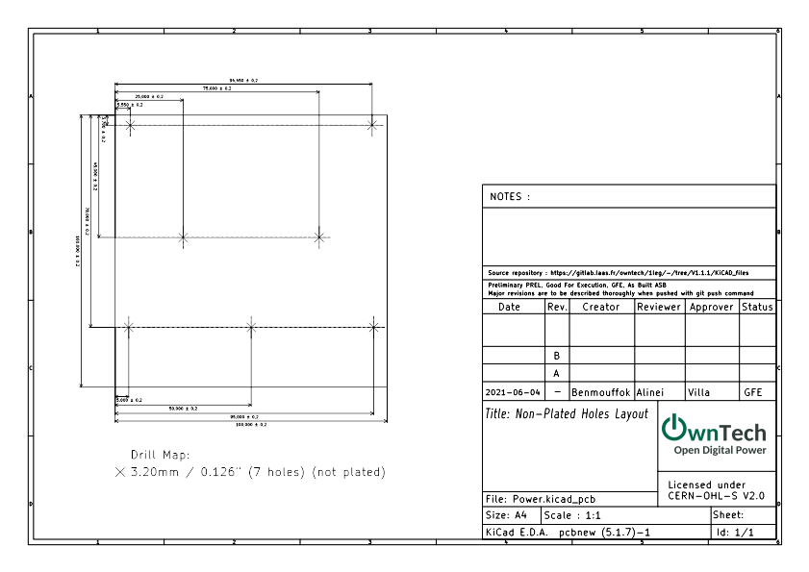
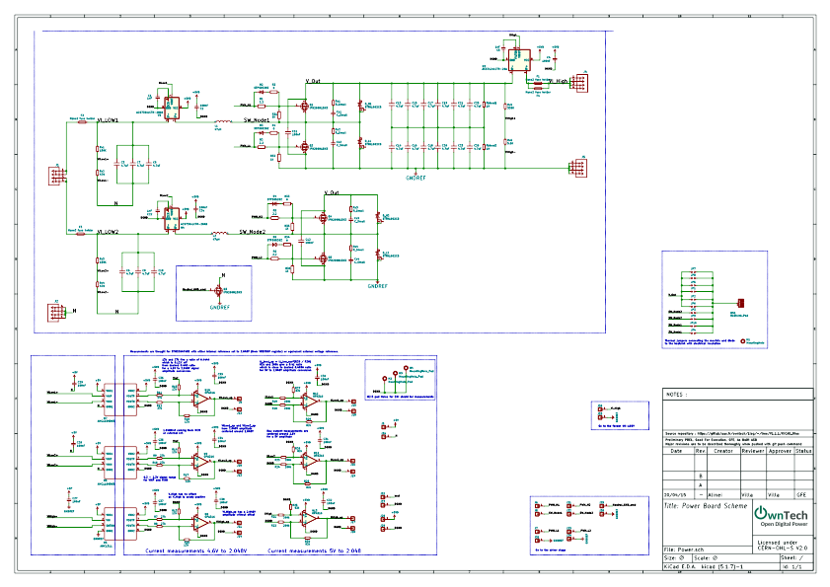
Board Scheme :

Layers Arrangement :

Top layer - Top View

First Intern Layer - Top View

Second Intern Layer - Top View

Bottom Layer - Behind View

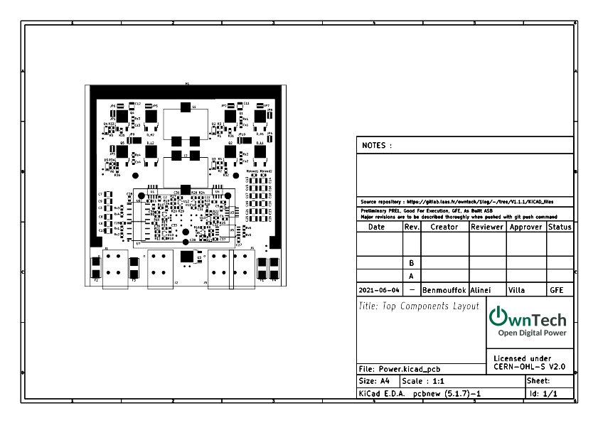
Top Components Layout :

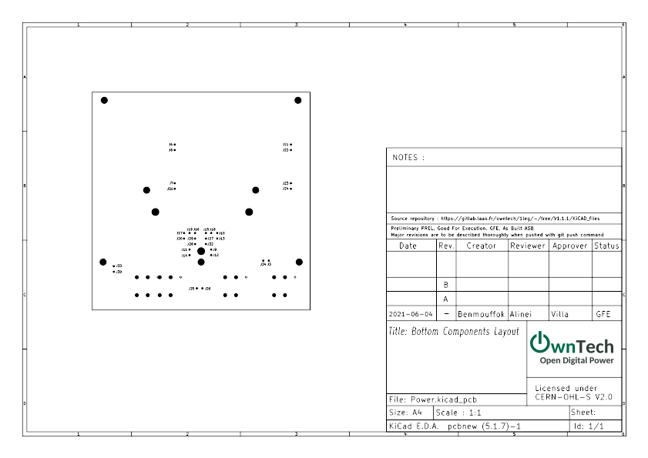
Bottom Components Layout :

Non-Plated Holes Layout :

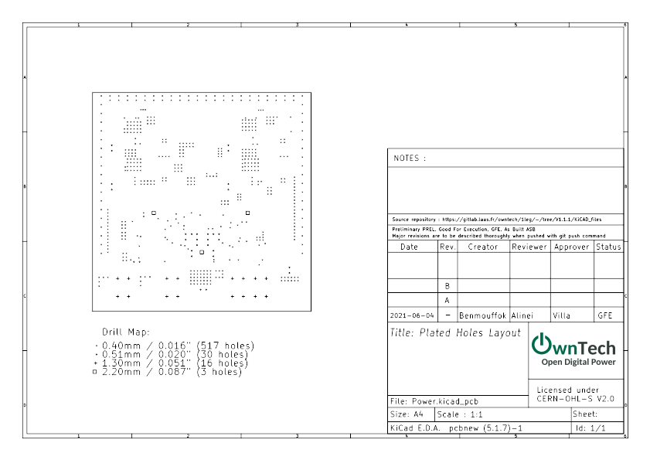

Plated Holes Layout :

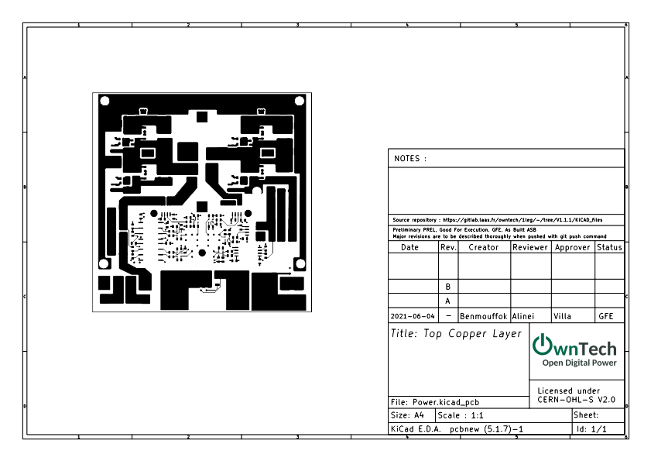

Top Copper Layer :

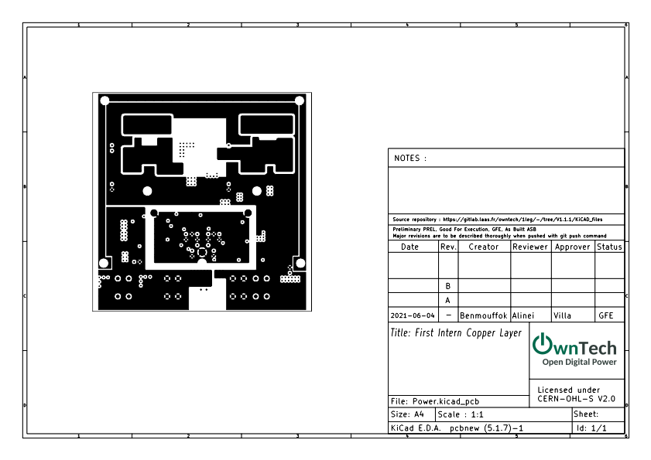

First Intern Copper Layer :

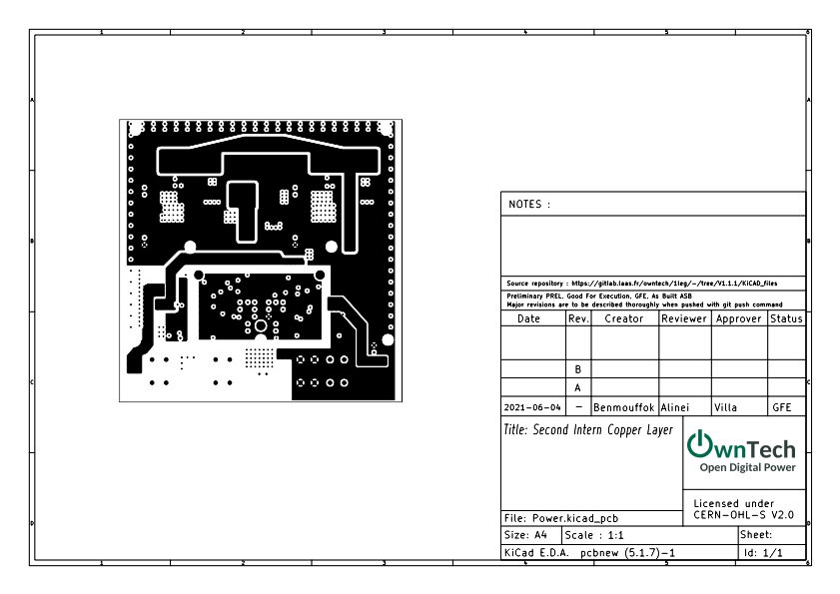

Second Intern Copper Layer :

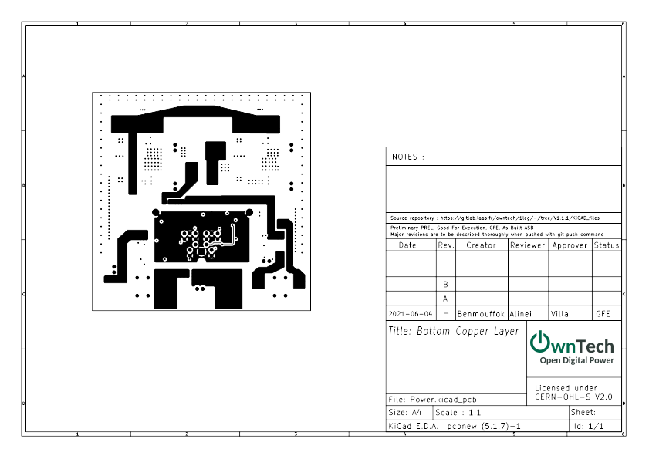

Bottom Copper Layer :

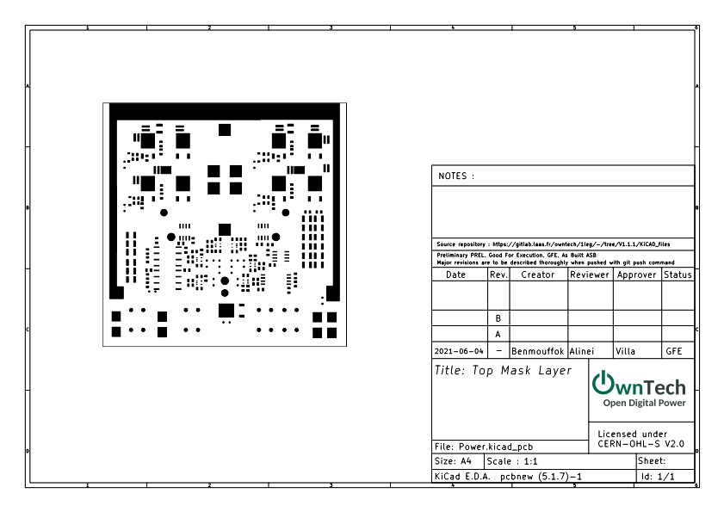

Top Mask Layer :

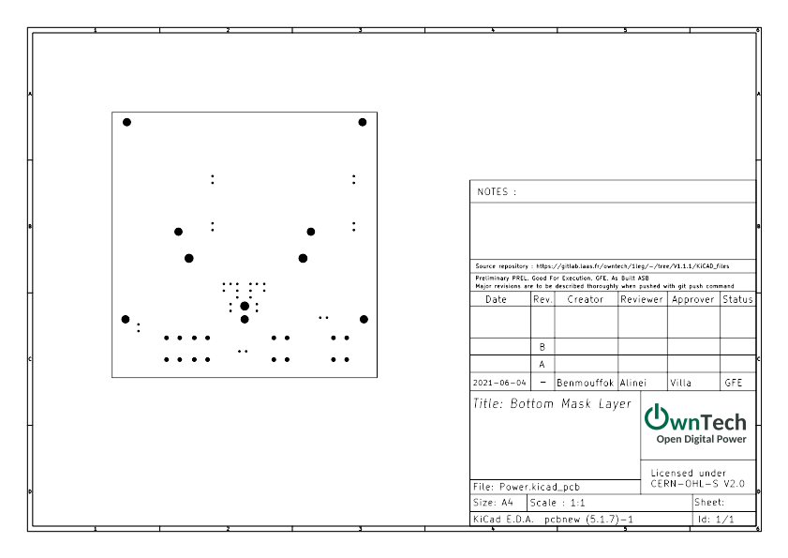

Bottom Mask Layer :

Bill of materials :
Reference | Value | Footprint | Datasheet | Manf#(Manufacturer Reference)
Q1 | IPD200N15N3 | Package_TO_SOT_SMD:TO-252-2 | https://www.infineon.com/dgdl/Infineon-IPD200N15N3%20G-DS-v02_07-EN.pdf?fileId=5546d4624fb7fef2014ff59238932dbf | IPD200N15N3GATMA1
Q2 | IPD200N15N3 | Package_TO_SOT_SMD:TO-252-2 | https://www.infineon.com/dgdl/Infineon-IPD200N15N3%20G-DS-v02_07-EN.pdf?fileId=5546d4624fb7fef2014ff59238932dbf | IPD200N15N3GATMA1
R2 | 2,2 | Resistor_SMD:R_0805_2012Metric | ~ | CR0805AF/-2R20EAS
R1 | 2,2 | Resistor_SMD:R_0805_2012Metric | ~ | CR0805AF/-2R20EAS
R32 | 1k | Resistor_SMD:R_0805_2012Metric | ~ | RC0805FR-071KL
Rs1 | R_Small | Resistor_SMD:R_0805_2012Metric | ~ | x
Rs2 | R_Small | Resistor_SMD:R_0805_2012Metric | ~ | x
Cs2 | C_Small | Capacitor_SMD:C_0805_2012Metric | ~ | x
Cs1 | C_Small | Capacitor_SMD:C_0805_2012Metric | ~ | x
D_H1 | STTH1002CB | Package_TO_SOT_SMD:TO-252-2 | https://www.st.com/resource/en/datasheet/stth1002c.pdf | STTH1002CB
D_L1 | STTH1002CB | Package_TO_SOT_SMD:TO-252-2 | https://www.st.com/resource/en/datasheet/stth1002c.pdf | STTH1002CB
U3 | ACS712xLCTR-20A | Package_SO:SOIC-8_3.9x4.9mm_P1.27mm | http://www.allegromicro.com/~/media/Files/Datasheets/ACS712-Datasheet.ashx?la=en | ACS712ELCTR-20A-T
C2 | 100nF | Capacitor_SMD:C_0805_2012Metric | ~ | CC0805KRX7R9BB104
C5 | 1nF | Capacitor_SMD:C_0805_2012Metric | ~ | 885382207004
D3 | STPS0520Z | Diode_SMD:D_SOD-123 | https://www.st.com/resource/en/datasheet/stps0520z.pdf | STPS0520Z
D2 | STPS0520Z | Diode_SMD:D_SOD-123 | https://www.st.com/resource/en/datasheet/stps0520z.pdf | STPS0520Z
C13 | 4.7uF | Capacitor_SMD:C_1210_3225Metric |  | 12101C475K4Z2A
C11 | 100nF | Capacitor_SMD:C_1210_3225Metric | ~ | 1210PC104KAT1A
L2 | 47uH | Footprints:WE-HCF-2013 | https://www.we-online.com/catalog/datasheet/7443634700.pdf | 7443634700
C24 | 100nF | Capacitor_SMD:C_0805_2012Metric | ~ | CC0805KRX7R9BB104
C22 | 1nF | Capacitor_SMD:C_0805_2012Metric | ~ | 885382207004
L1 | 47uH | Footprints:WE-HCF-2013 | https://www.we-online.com/catalog/datasheet/7443634700.pdf | 7443634700
R4 | 0 | Resistor_SMD:R_0805_2012Metric | ~ | RC0805FR-070RL
R3 | 0 | Resistor_SMD:R_0805_2012Metric | ~ | RC0805FR-070RL
C1 | 1nF | Capacitor_SMD:C_0805_2012Metric | ~ | 885382207004
U4 | ACS730xLCTR-20AB | Package_SO:SOIC-8_3.9x4.9mm_P1.27mm | http://www.allegromicro.com/~/media/Files/Datasheets/ACS730-Datasheet.ashx?la=en | ACS730KLCTR-20AB-T
Rv1 | 150K | Resistor_SMD:R_0805_2012Metric | ~ | PCF-W0805LF-03-1503-B-P-LT
Rv3 | 150K | Resistor_SMD:R_0805_2012Metric | ~ | PCF-W0805LF-03-1503-B-P-LT
Rv4 | 470 | Resistor_SMD:R_0805_2012Metric | ~ | TNPW0805470RDEEA
Rv2 | 470 | Resistor_SMD:R_0805_2012Metric | ~ | TNPW0805470RDEEA
Rv6 | 5.6K | Resistor_SMD:R_0805_2012Metric |  | ERA-6AEB562V
Rv5 | 330K | Resistor_SMD:R_0805_2012Metric | ~ | RG2012P-334-B-T5
R33 | 0 | Resistor_SMD:R_0805_2012Metric | ~ | RC0805FR-070RL
R35 | 1k | Resistor_SMD:R_0805_2012Metric | ~ | RC0805FR-071KL
C12 | 100nF | Capacitor_SMD:C_1210_3225Metric | ~ | 1210PC104KAT1A
D4 | STPS0520Z | Diode_SMD:D_SOD-123 | https://www.st.com/resource/en/datasheet/stps0520z.pdf | STPS0520Z
D_L2 | STTH1002CB | Package_TO_SOT_SMD:TO-252-2 | https://www.st.com/resource/en/datasheet/stth1002c.pdf | STTH1002CB
D_H2 | STTH1002CB | Package_TO_SOT_SMD:TO-252-2 | https://www.st.com/resource/en/datasheet/stth1002c.pdf | STTH1002CB
Cs3 | C_Small | Capacitor_SMD:C_0805_2012Metric | ~ | x
Cs4 | C_Small | Capacitor_SMD:C_0805_2012Metric | ~ | x
Rs4 | R_Small | Resistor_SMD:R_0805_2012Metric | ~ | x
Rs3 | R_Small | Resistor_SMD:R_0805_2012Metric | ~ | x
R5 | 2,2 | Resistor_SMD:R_0805_2012Metric | ~ | CR0805AF/-2R20EAS
Q5 | IPD200N15N3 | Package_TO_SOT_SMD:TO-252-2 | https://www.infineon.com/dgdl/Infineon-IPD200N15N3%20G-DS-v02_07-EN.pdf?fileId=5546d4624fb7fef2014ff59238932dbf | IPD200N15N3GATMA1
Q4 | IPD200N15N3 | Package_TO_SOT_SMD:TO-252-2 | https://www.infineon.com/dgdl/Infineon-IPD200N15N3%20G-DS-v02_07-EN.pdf?fileId=5546d4624fb7fef2014ff59238932dbf | IPD200N15N3GATMA1
J1 | 2604-1102 | Footprints:WAGO-2604-1102 | https://www.wago.com/fr/connexion-de-circuits-imprim%C3%A9s/borne-pour-circuits-imprim%C3%A9s/p/2604-1102 | 2604-1102
J4 | 2604-1102 | Footprints:WAGO-2604-1102 | https://www.wago.com/fr/connexion-de-circuits-imprim%C3%A9s/borne-pour-circuits-imprim%C3%A9s/p/2604-1102 | 2604-1102
Rbleed1 | 1M | Resistor_SMD:R_0805_2012Metric | ~ | CMP0805-FX-1004ELF
Rbleed2 | 1M | Resistor_SMD:R_0805_2012Metric | ~ | CMP0805-FX-1004ELF
R6 | 2,2 | Resistor_SMD:R_0805_2012Metric | ~ | CR0805AF/-2R20EAS
R36 | 1k | Resistor_SMD:R_0805_2012Metric | ~ | RC0805FR-071KL
D5 | STPS0520Z | Diode_SMD:D_SOD-123 | https://www.st.com/resource/en/datasheet/stps0520z.pdf | STPS0520Z
R34 | 0 | Resistor_SMD:R_0805_2012Metric | ~ | RC0805FR-070RL
C15 | 4.7uF | Capacitor_SMD:C_1210_3225Metric | ~ | 12101C475K4Z2A
C17 | 4.7uF | Capacitor_SMD:C_1210_3225Metric | ~ | 12101C475K4Z2A
C19 | 4.7uF | Capacitor_SMD:C_1210_3225Metric | ~ | 12101C475K4Z2A
C21 | 4.7uF | Capacitor_SMD:C_1210_3225Metric | ~ | 12101C475K4Z2A
C25 | 4.7uF | Capacitor_SMD:C_1210_3225Metric | ~ | 12101C475K4Z2A
C14 | 4.7uF | Capacitor_SMD:C_1210_3225Metric | ~ | 12101C475K4Z2A
C16 | 4.7uF | Capacitor_SMD:C_1210_3225Metric | ~ | 12101C475K4Z2A
C18 | 4.7uF | Capacitor_SMD:C_1210_3225Metric | ~ | 12101C475K4Z2A
C20 | 4.7uF | Capacitor_SMD:C_1210_3225Metric | ~ | 12101C475K4Z2A
C23 | 4.7uF | Capacitor_SMD:C_1210_3225Metric | ~ | 12101C475K4Z2A
C26 | 4.7uF | Capacitor_SMD:C_1210_3225Metric | ~ | 12101C475K4Z2A
C7 | 4.7uF | Capacitor_SMD:C_1210_3225Metric | ~ | 12101C475K4Z2A
C9 | 4.7uF | Capacitor_SMD:C_1210_3225Metric | ~ | 12101C475K4Z2A
C6 | 4.7uF | Capacitor_SMD:C_1210_3225Metric | ~ | 12101C475K4Z2A
C8 | 4.7uF | Capacitor_SMD:C_1210_3225Metric | ~ | 12101C475K4Z2A
C10 | 4.7uF | Capacitor_SMD:C_1210_3225Metric | ~ | 12101C475K4Z2A
C3 | 4.7uF | Capacitor_SMD:C_1210_3225Metric | ~ | 12101C475K4Z2A
U1 | ACS730xLCTR-20AB | Package_SO:SOIC-8_3.9x4.9mm_P1.27mm | http://www.allegromicro.com/~/media/Files/Datasheets/ACS730-Datasheet.ashx?la=en | ACS730KLCTR-20AB-T
R31 | 1k | Resistor_SMD:R_0805_2012Metric | ~ | RC0805FR-071KL
HS1 | Heatsink_Pad | Footprints:custom_heatsink | ~ | x
JP1 | THJP0612AST | Resistor_SMD:R_0612_1632Metric | https://www.vishay.com/docs/60157/thjp.pdf | THJP0612AST1
JP3 | THJP0612AST | Resistor_SMD:R_0612_1632Metric | https://www.vishay.com/docs/60157/thjp.pdf | THJP0612AST1
JP4 | THJP0612AST | Resistor_SMD:R_0612_1632Metric | https://www.vishay.com/docs/60157/thjp.pdf | THJP0612AST1
J6 | Conn_01x01 | Footprints:0906_millmax | https://www.mill-max.com/products/pin/0906/0906-0-15-20-76-14-11-0?s_term=0906-0-15-20-76-14-11-0&s_type=Quick%2FProduct%2FPart+Number+Search | 0906-0-15-20-76-14-11-0
J7 | Conn_01x01 | Footprints:0906_millmax | https://www.mill-max.com/products/pin/0906/0906-0-15-20-76-14-11-0?s_term=0906-0-15-20-76-14-11-0&s_type=Quick%2FProduct%2FPart+Number+Search | 0906-0-15-20-76-14-11-0
J8 | Conn_01x01 | Footprints:0906_millmax | https://www.mill-max.com/products/pin/0906/0906-0-15-20-76-14-11-0?s_term=0906-0-15-20-76-14-11-0&s_type=Quick%2FProduct%2FPart+Number+Search | 0906-0-15-20-76-14-11-0
J20 | Conn_01x01 | Footprints:0906_millmax | https://www.mill-max.com/products/pin/0906/0906-0-15-20-76-14-11-0?s_term=0906-0-15-20-76-14-11-0&s_type=Quick%2FProduct%2FPart+Number+Search | 0906-0-15-20-76-14-11-0
J21 | Conn_01x01 | Footprints:0906_millmax | https://www.mill-max.com/products/pin/0906/0906-0-15-20-76-14-11-0?s_term=0906-0-15-20-76-14-11-0&s_type=Quick%2FProduct%2FPart+Number+Search | 0906-0-15-20-76-14-11-0
J23 | Conn_01x01 | Footprints:0906_millmax | https://www.mill-max.com/products/pin/0906/0906-0-15-20-76-14-11-0?s_term=0906-0-15-20-76-14-11-0&s_type=Quick%2FProduct%2FPart+Number+Search | 0906-0-15-20-76-14-11-0
J22 | Conn_01x01 | Footprints:0906_millmax | https://www.mill-max.com/products/pin/0906/0906-0-15-20-76-14-11-0?s_term=0906-0-15-20-76-14-11-0&s_type=Quick%2FProduct%2FPart+Number+Search | 0906-0-15-20-76-14-11-0
J24 | Conn_01x01 | Footprints:0906_millmax | https://www.mill-max.com/products/pin/0906/0906-0-15-20-76-14-11-0?s_term=0906-0-15-20-76-14-11-0&s_type=Quick%2FProduct%2FPart+Number+Search | 0906-0-15-20-76-14-11-0
J25 | Conn_01x01 | Footprints:0906_millmax | https://www.mill-max.com/products/pin/0906/0906-0-15-20-76-14-11-0?s_term=0906-0-15-20-76-14-11-0&s_type=Quick%2FProduct%2FPart+Number+Search | 0906-0-15-20-76-14-11-0
J26 | Conn_01x01 | Footprints:0906_millmax | https://www.mill-max.com/products/pin/0906/0906-0-15-20-76-14-11-0?s_term=0906-0-15-20-76-14-11-0&s_type=Quick%2FProduct%2FPart+Number+Search | 0906-0-15-20-76-14-11-0
J9 | Conn_01x01 | Footprints:0906_millmax | https://www.mill-max.com/products/pin/0906/0906-0-15-20-76-14-11-0?s_term=0906-0-15-20-76-14-11-0&s_type=Quick%2FProduct%2FPart+Number+Search | 0906-0-15-20-76-14-11-0
J10 | Conn_01x01 | Footprints:0906_millmax | https://www.mill-max.com/products/pin/0906/0906-0-15-20-76-14-11-0?s_term=0906-0-15-20-76-14-11-0&s_type=Quick%2FProduct%2FPart+Number+Search | 0906-0-15-20-76-14-11-0
J11 | Conn_01x01 | Footprints:0906_millmax | https://www.mill-max.com/products/pin/0906/0906-0-15-20-76-14-11-0?s_term=0906-0-15-20-76-14-11-0&s_type=Quick%2FProduct%2FPart+Number+Search | 0906-0-15-20-76-14-11-0
J12 | Conn_01x01 | Footprints:0906_millmax | https://www.mill-max.com/products/pin/0906/0906-0-15-20-76-14-11-0?s_term=0906-0-15-20-76-14-11-0&s_type=Quick%2FProduct%2FPart+Number+Search | 0906-0-15-20-76-14-11-0
J13 | Conn_01x01 | Footprints:0906_millmax | https://www.mill-max.com/products/pin/0906/0906-0-15-20-76-14-11-0?s_term=0906-0-15-20-76-14-11-0&s_type=Quick%2FProduct%2FPart+Number+Search | 0906-0-15-20-76-14-11-0
J14 | Conn_01x01 | Footprints:0906_millmax | https://www.mill-max.com/products/pin/0906/0906-0-15-20-76-14-11-0?s_term=0906-0-15-20-76-14-11-0&s_type=Quick%2FProduct%2FPart+Number+Search | 0906-0-15-20-76-14-11-0
J15 | Conn_01x01 | Footprints:0906_millmax | https://www.mill-max.com/products/pin/0906/0906-0-15-20-76-14-11-0?s_term=0906-0-15-20-76-14-11-0&s_type=Quick%2FProduct%2FPart+Number+Search | 0906-0-15-20-76-14-11-0
J16 | Conn_01x01 | Footprints:0906_millmax | https://www.mill-max.com/products/pin/0906/0906-0-15-20-76-14-11-0?s_term=0906-0-15-20-76-14-11-0&s_type=Quick%2FProduct%2FPart+Number+Search | 0906-0-15-20-76-14-11-0
J17 | Conn_01x01 | Footprints:0906_millmax | https://www.mill-max.com/products/pin/0906/0906-0-15-20-76-14-11-0?s_term=0906-0-15-20-76-14-11-0&s_type=Quick%2FProduct%2FPart+Number+Search | 0906-0-15-20-76-14-11-0
J18 | Conn_01x01 | Footprints:0906_millmax | https://www.mill-max.com/products/pin/0906/0906-0-15-20-76-14-11-0?s_term=0906-0-15-20-76-14-11-0&s_type=Quick%2FProduct%2FPart+Number+Search | 0906-0-15-20-76-14-11-0
J19 | Conn_01x01 | Footprints:0906_millmax | https://www.mill-max.com/products/pin/0906/0906-0-15-20-76-14-11-0?s_term=0906-0-15-20-76-14-11-0&s_type=Quick%2FProduct%2FPart+Number+Search | 0906-0-15-20-76-14-11-0
J31 | Conn_01x01 | Footprints:0906_millmax | https://www.mill-max.com/products/pin/0906/0906-0-15-20-76-14-11-0?s_term=0906-0-15-20-76-14-11-0&s_type=Quick%2FProduct%2FPart+Number+Search | 0906-0-15-20-76-14-11-0
J29 | Conn_01x01 | Footprints:0906_millmax | https://www.mill-max.com/products/pin/0906/0906-0-15-20-76-14-11-0?s_term=0906-0-15-20-76-14-11-0&s_type=Quick%2FProduct%2FPart+Number+Search | 0906-0-15-20-76-14-11-0
J28 | Conn_01x01 | Footprints:0906_millmax | https://www.mill-max.com/products/pin/0906/0906-0-15-20-76-14-11-0?s_term=0906-0-15-20-76-14-11-0&s_type=Quick%2FProduct%2FPart+Number+Search | 0906-0-15-20-76-14-11-0
JP5 | THJP0612AST | Resistor_SMD:R_0612_1632Metric | https://www.vishay.com/docs/60157/thjp.pdf | THJP0612AST1
JP2 | THJP0612AST | Resistor_SMD:R_0612_1632Metric | https://www.vishay.com/docs/60157/thjp.pdf | THJP0612AST1
JP6 | THJP0612AST | Resistor_SMD:R_0612_1632Metric | https://www.vishay.com/docs/60157/thjp.pdf | THJP0612AST1
U6 | AMC1100DUB | Footprints:SOP-8_6.62x9.15mm_P2.54mm | https://www.ti.com/lit/ds/symlink/amc1100.pdf?ts=1622519237932&ref_url=https%253A%252F%252Fwww.google.com%252F | AMC1100DUB
U7 | AMC1100DUB | Footprints:SOP-8_6.62x9.15mm_P2.54mm | https://www.ti.com/lit/ds/symlink/amc1100.pdf?ts=1622519237932&ref_url=https%253A%252F%252Fwww.google.com%252F | AMC1100DUB
R11 | 27k | Resistor_SMD:R_0805_2012Metric | ~ | RC0805FR-0727KL
R12 | 27k | Resistor_SMD:R_0805_2012Metric | ~ | RC0805FR-0727KL
U10 | OPA316 | Package_TO_SOT_SMD:SOT-353_SC-70-5 | https://www.ti.com/lit/ds/symlink/opa316.pdf?ts=1622530692356&ref_url=https%253A%252F%252Fwww.ti.com%252Fproduct%252FOPA316 | OPA316IDCKT
R15 | 12k | Resistor_SMD:R_0805_2012Metric | ~ | RC0805FR-0712KL
R18 | 12k | Resistor_SMD:R_0805_2012Metric | ~ | RC0805FR-0712KL
R7 | 27k | Resistor_SMD:R_0805_2012Metric | ~ | RC0805FR-0727KL
R8 | 27k | Resistor_SMD:R_0805_2012Metric | ~ | RC0805FR-0727KL
U8 | OPA316 | Package_TO_SOT_SMD:SOT-353_SC-70-5 | https://www.ti.com/lit/ds/symlink/opa316.pdf?ts=1622530692356&ref_url=https%253A%252F%252Fwww.ti.com%252Fproduct%252FOPA316 | OPA316IDCKT
R13 | 12k | Resistor_SMD:R_0805_2012Metric | ~ | RC0805FR-0712KL
R16 | 12k | Resistor_SMD:R_0805_2012Metric | ~ | RC0805FR-0712KL
C35 | 100nF | Capacitor_SMD:C_0805_2012Metric | ~ | CC0805KRX7R9BB104
R9 | 27k | Resistor_SMD:R_0805_2012Metric | ~ | RC0805FR-0727KL
R10 | 27k | Resistor_SMD:R_0805_2012Metric | ~ | RC0805FR-0727KL
U9 | OPA316 | Package_TO_SOT_SMD:SOT-353_SC-70-5 | https://www.ti.com/lit/ds/symlink/opa316.pdf?ts=1622530692356&ref_url=https%253A%252F%252Fwww.ti.com%252Fproduct%252FOPA316 | OPA316IDCKT
R14 | 12k | Resistor_SMD:R_0805_2012Metric | ~ | RC0805FR-0712KL
R17 | 12k | Resistor_SMD:R_0805_2012Metric | ~ | RC0805FR-0712KL
C29 | 100nF | Capacitor_SMD:C_0805_2012Metric | ~ | CC0805KRX7R9BB104
C27 | 100nF | Capacitor_SMD:C_0805_2012Metric | ~ | CC0805KRX7R9BB104
C36 | 100nF | Capacitor_SMD:C_0805_2012Metric | ~ | CC0805KRX7R9BB104
C37 | 100nF | Capacitor_SMD:C_0805_2012Metric | ~ | CC0805KRX7R9BB104
J32 | Conn_01x01 | Footprints:0906_millmax | https://www.mill-max.com/products/pin/0906/0906-0-15-20-76-14-11-0?s_term=0906-0-15-20-76-14-11-0&s_type=Quick%2FProduct%2FPart+Number+Search | 0906-0-15-20-76-14-11-0
U11 | OPA316 | Package_TO_SOT_SMD:SOT-353_SC-70-5 | https://www.ti.com/lit/ds/symlink/opa316.pdf?ts=1622530692356&ref_url=https%253A%252F%252Fwww.ti.com%252Fproduct%252FOPA316 | OPA316IDCKT
U13 | OPA316 | Package_TO_SOT_SMD:SOT-353_SC-70-5 | https://www.ti.com/lit/ds/symlink/opa316.pdf?ts=1622530692356&ref_url=https%253A%252F%252Fwww.ti.com%252Fproduct%252FOPA316 | OPA316IDCKT
R24 | 200k | Resistor_SMD:R_0805_2012Metric | ~ | ERJ6RED2003V
R20 | 200k | Resistor_SMD:R_0805_2012Metric | ~ | ERJ6RED2003V
R22 | 200k | Resistor_SMD:R_0805_2012Metric | ~ | ERJ6RED2003V
R28 | 82k | Resistor_SMD:R_0805_2012Metric | ~ | CR0805-FX-8202ELF
R29 | 82k | Resistor_SMD:R_0805_2012Metric | ~ | CR0805-FX-8202ELF
R30 | 82k | Resistor_SMD:R_0805_2012Metric | ~ | CR0805-FX-8202ELF
U12 | OPA316 | Package_TO_SOT_SMD:SOT-353_SC-70-5 | https://www.ti.com/lit/ds/symlink/opa316.pdf?ts=1622530692356&ref_url=https%253A%252F%252Fwww.ti.com%252Fproduct%252FOPA316 | OPA316IDCKT
R19 | 200k | Resistor_SMD:R_0805_2012Metric | ~ | ERJ6RED2003V
R27 | 82k | Resistor_SMD:R_0805_2012Metric | ~ | CR0805-FX-8202ELF
R26 | 82k | Resistor_SMD:R_0805_2012Metric | ~ | CR0805-FX-8202ELF
R25 | 82k | Resistor_SMD:R_0805_2012Metric | ~ | CR0805-FX-8202ELF
R23 | 200k | Resistor_SMD:R_0805_2012Metric | ~ | ERJ6RED2003V
R21 | 200k | Resistor_SMD:R_0805_2012Metric | ~ | ERJ6RED2003V
F1 | Nano2 fuse holder | Footprints:Fuse_holder_omni_blok | https://www.littelfuse.com/~/media/electronics/datasheets/fuses/littelfuse_fuse_154_154t_154l_154tl_datasheet.pdf.pdf | 0154008.DRL
F2 | Nano2 fuse holder | Footprints:Fuse_holder_omni_blok | https://www.littelfuse.com/~/media/electronics/datasheets/fuses/littelfuse_fuse_154_154t_154l_154tl_datasheet.pdf.pdf | 0154008.DRL
F3 | Nano2 fuse holder | Footprints:Fuse_holder_omni_blok | https://www.littelfuse.com/~/media/electronics/datasheets/fuses/littelfuse_fuse_154_154t_154l_154tl_datasheet.pdf.pdf | 0154008.DRL
Q3 | IPD200N15N3 | Package_TO_SOT_SMD:TO-252-2 | https://www.infineon.com/dgdl/Infineon-IPD200N15N3%20G-DS-v02_07-EN.pdf?fileId=5546d4624fb7fef2014ff59238932dbf | IPD200N15N3GATMA1
U5 | AMC1311 | Footprints:SOIC-8_7.5x5.85mm_P1.27mm | ti.com/lit/ds/symlink/amc1311.pdf?ts=1622554434410&ref_url=https%253A%252F%252Fwww.ti.com%252Fproduct%252FAMC1311%253Futm_source%253Dgoogle%2526utm_medium%253Dcpc%2526utm_campaign%253Dasc-dc-null-prodfolderdynamic-cpc-pf-google-wwe%2526utm_content%253Dpro | AMC1311DWVR
C28 | 100nF | Capacitor_SMD:C_0805_2012Metric | ~ | CC0805KRX7R9BB104
C4 | 100nF | Capacitor_SMD:C_0805_2012Metric | ~ | CC0805KRX7R9BB104
J5 | 2604-1102 | Footprints:WAGO-2604-1102 | https://www.wago.com/fr/connexion-de-circuits-imprim%C3%A9s/borne-pour-circuits-imprim%C3%A9s/p/2604-1102 | 2604-1102
J2 | 2604-1102 | Footprints:WAGO-2604-1102 | https://www.wago.com/fr/connexion-de-circuits-imprim%C3%A9s/borne-pour-circuits-imprim%C3%A9s/p/2604-1102 | 2604-1102
J27 | Conn_01x01 | Footprints:0906_millmax | https://www.mill-max.com/products/pin/0906/0906-0-15-20-76-14-11-0?s_term=0906-0-15-20-76-14-11-0&s_type=Quick%2FProduct%2FPart+Number+Search | 0906-0-15-20-76-14-11-0
J30 | Conn_01x01 | Footprints:0906_millmax | https://www.mill-max.com/products/pin/0906/0906-0-15-20-76-14-11-0?s_term=0906-0-15-20-76-14-11-0&s_type=Quick%2FProduct%2FPart+Number+Search | 0906-0-15-20-76-14-11-0
J33 | Conn_01x01 | Footprints:0906_millmax | https://www.mill-max.com/products/pin/0906/0906-0-15-20-76-14-11-0?s_term=0906-0-15-20-76-14-11-0&s_type=Quick%2FProduct%2FPart+Number+Search | 0906-0-15-20-76-14-11-0
J34 | Conn_01x01 | Footprints:0906_millmax | https://www.mill-max.com/products/pin/0906/0906-0-15-20-76-14-11-0?s_term=0906-0-15-20-76-14-11-0&s_type=Quick%2FProduct%2FPart+Number+Search | 0906-0-15-20-76-14-11-0
J3 | Conn_01x01 | Footprints:0906_millmax | https://www.mill-max.com/products/pin/0906/0906-0-15-20-76-14-11-0?s_term=0906-0-15-20-76-14-11-0&s_type=Quick%2FProduct%2FPart+Number+Search | 0906-0-15-20-76-14-11-0
C30 | 100nF | Capacitor_SMD:C_0805_2012Metric | ~ | CC0805KRX7R9BB104
C31 | 100nF | Capacitor_SMD:C_0805_2012Metric | ~ | CC0805KRX7R9BB104
C32 | 100nF | Capacitor_SMD:C_0805_2012Metric | ~ | CC0805KRX7R9BB104
H1 | MountingHole | Footprints:mounting_holes | ~ | x
F4 | Nano2 fuse holder | Footprints:Fuse_holder_omni_blok | https://www.littelfuse.com/~/media/electronics/datasheets/fuses/littelfuse_fuse_154_154t_154l_154tl_datasheet.pdf.pdf | 0154008.DRL
C33 | 100nF | Capacitor_SMD:C_0805_2012Metric | ~ | CC0805KRX7R9BB104
C34 | 100nF | Capacitor_SMD:C_0805_2012Metric | ~ | CC0805KRX7R9BB104
C38 | 100nF | Capacitor_SMD:C_0805_2012Metric | ~ | CC0805KRX7R9BB104
JP8 | THJP0612AST | Resistor_SMD:R_0612_1632Metric | https://www.vishay.com/docs/60157/thjp.pdf | THJP0612AST1
JP7 | THJP0612AST | Resistor_SMD:R_0612_1632Metric | https://www.vishay.com/docs/60157/thjp.pdf | THJP0612AST1
JP10 | THJP0612AST | Resistor_SMD:R_0612_1632Metric | https://www.vishay.com/docs/60157/thjp.pdf | THJP0612AST1
JP9 | THJP0612AST | Resistor_SMD:R_0612_1632Metric | https://www.vishay.com/docs/60157/thjp.pdf | THJP0612AST1
H2 | MountingHole_Pad | MountingHole:MountingHole_2.2mm_M2_ISO7380_Pad | ~ | x
H3 | MountingHole_Pad | MountingHole:MountingHole_2.2mm_M2_ISO7380_Pad | ~ | x
H4 | MountingHole_Pad | MountingHole:MountingHole_2.2mm_M2_ISO7380_Pad | ~ | X

