


Document Reference Code: DP-01
V1.1.1 Shield Nucleo board
Full editable documents and source files are available at the following URL: https://gitlab.laas.fr/owntech/1leg/-/tree/V1.1.1

Definition Package

Shield Nucleo board

Document summary:
This document contains the general PCB layers arrangement, the drill map and the components layout of this electronic board.
Diffusion : External
Date | Revision | Creator | Reviewer | Approver | Document status
 | D
 | C
 | B
 | A
07/06/2021 | - | Benmouffok Amine | Alinei Jean | Villa Luiz
Preliminary PREL, Good For Execution GFE, As Built ASB

Table of content
Board Scheme : 3
Layers Arrangement : 4
Top Components Layout : 5
Bottom Components Layout : 6
Non-Plated Holes Layout : 7
Plated Holes Layout : 8
Top Copper Layer : 9
First Intern Copper Layer : 10
Second Intern Copper Layer : 11
Bottom Copper Layer : 12
Top Mask Layer : 13
Bottom Mask Layer : 14
Bill of materials : 15

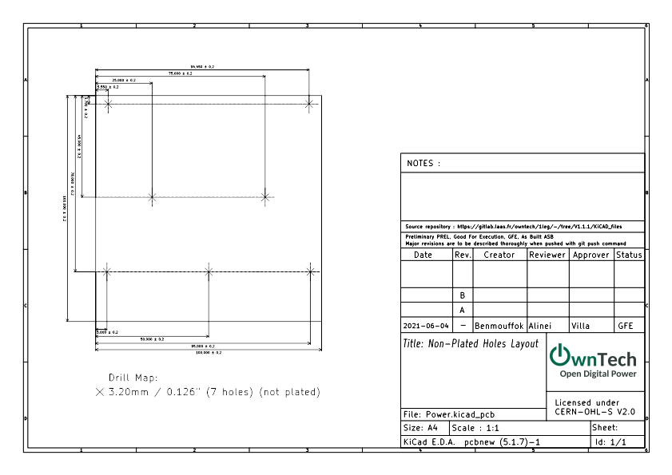
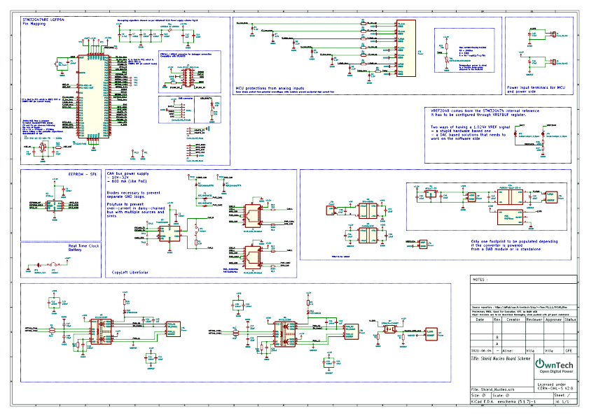
Board Scheme :

Layers Arrangement :

Top layer - Top View

First Intern Layer - Top View

Second Intern Layer - Top View

Bottom Layer - Behind View

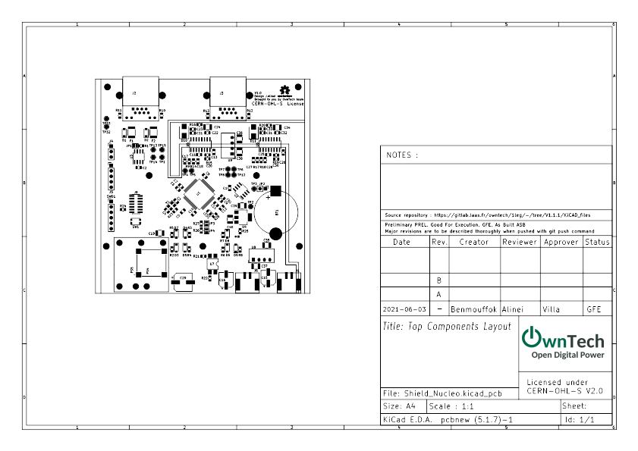
Top Components Layout :

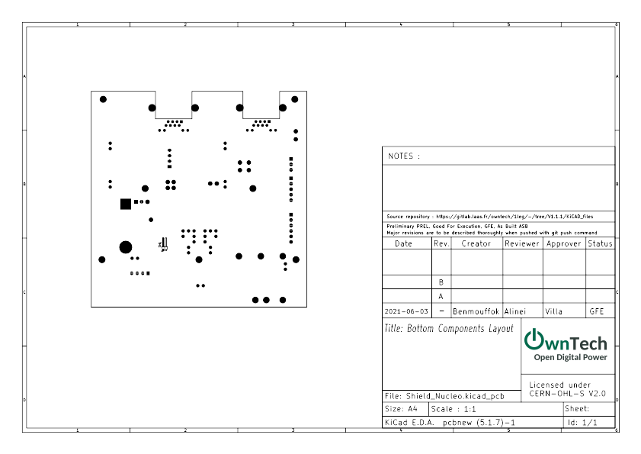
Bottom Components Layout :

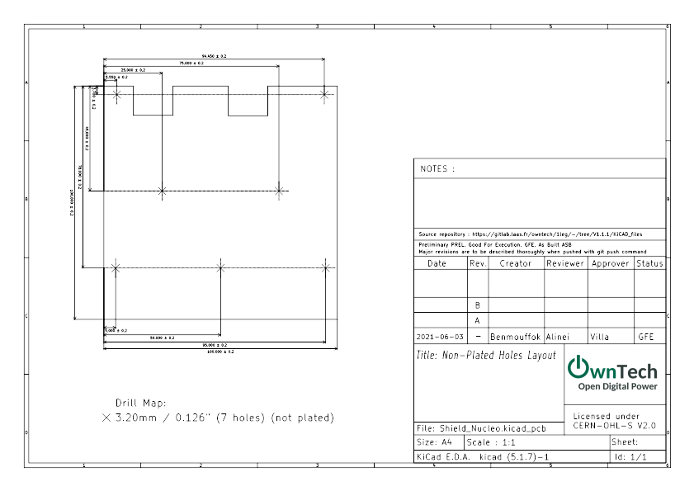

Non-Plated Holes Layout :

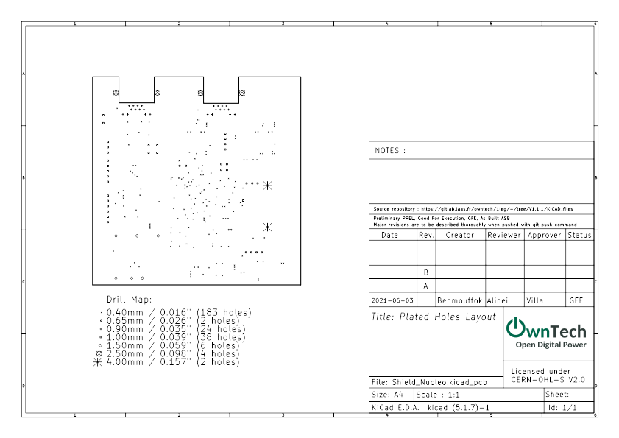

Plated Holes Layout :

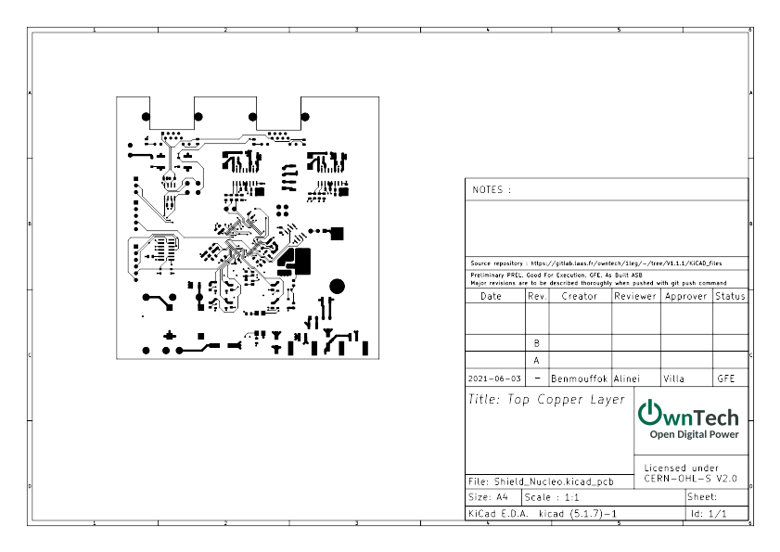

Top Copper Layer :

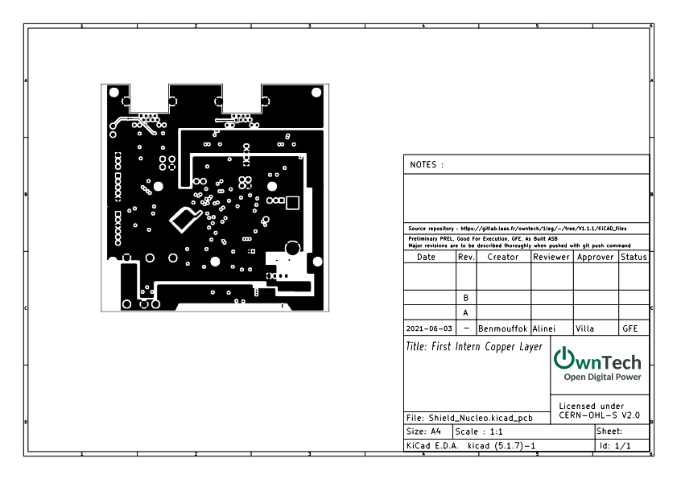

First Intern Copper Layer :

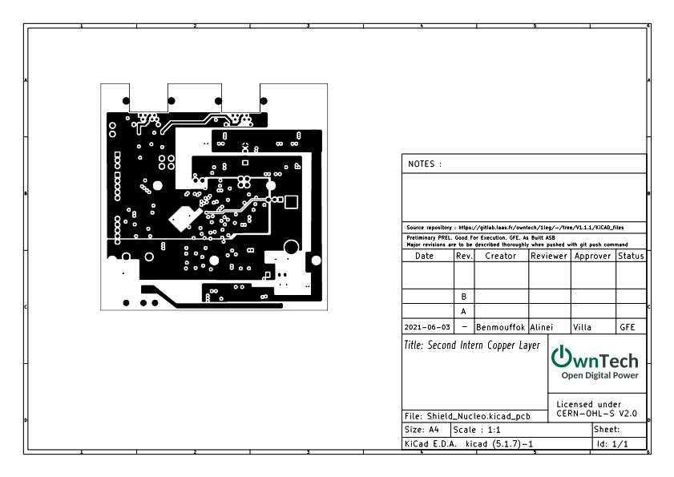

Second Intern Copper Layer :

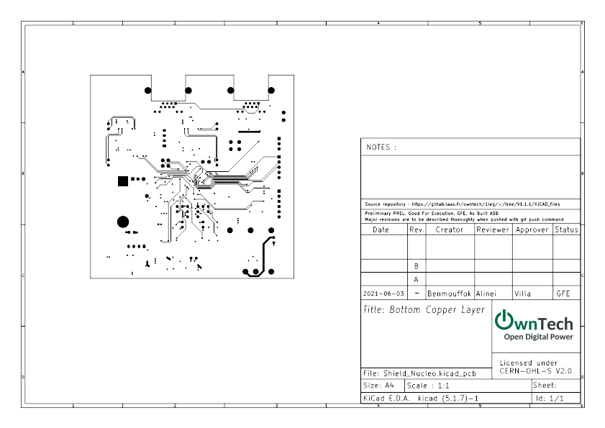

Bottom Copper Layer :

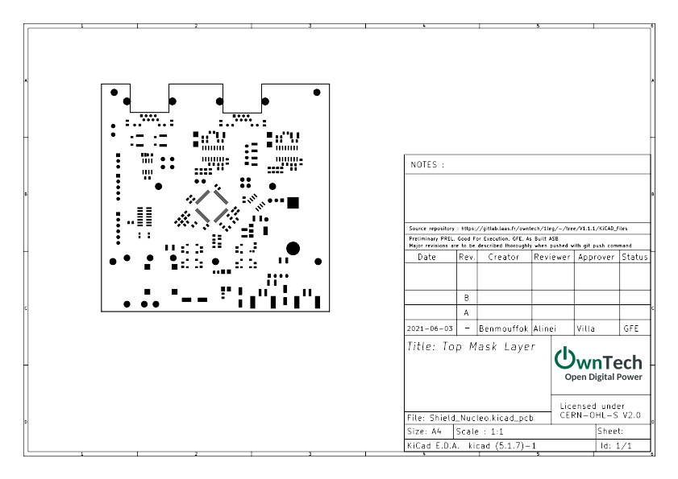

Top Mask Layer :

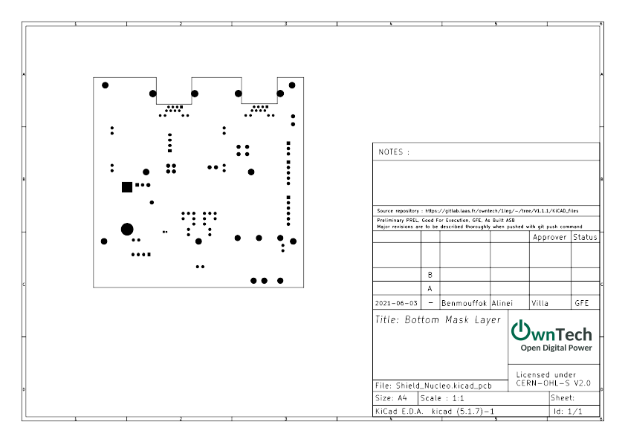

Bottom Mask Layer :

Bill of materials :
Reference | Value | Footprint | Datasheet | Manf#( Manufacturer Reference)
BT1 | Battery_Cell | Footprints:CR2032 | https://www.murata.com/-/media/webrenewal/products/batteries/micro/cr/test_summary/test_summary_pdf/tab-high-drain/test-summary-un38-3-cr2032r-ho6aaww-97384199.ashx?la=en-gb&cvid=20210218001039000000 | 97384199
U3 | TCAN334GDR | Footprints:SOIC-8_3.9x4.9mm_P1.27mm | https://www.ti.com/lit/ds/symlink/tcan334g.pdf?ts=1622552431960&ref_url=https%253A%252F%252Fwww.ti.com%252Fproduct%252FTCAN334G | TCAN334GDR
R1 | 120 | Resistor_SMD:R_0805_2012Metric | ~ | CR0805-FX-1200ELF
C2 | 100nF | Capacitor_SMD:C_0805_2012Metric | ~ | CC0805KRX7R9BB104
JP1 | Jumper | Jumper:SolderJumper-2_P1.3mm_Open_Pad1.0x1.5mm | ~ | x
D1 | RBR2MM60ATFTR | Diode_SMD:D_SOD-123 | https://fscdn.rohm.com/en/products/databook/datasheet/discrete/diode/schottky_barrier/rbr2mm60atftr-e.pdf | RBR2MM60ATFTR
D2 | RBR2MM60ATFTR | Diode_SMD:D_SOD-123 | https://fscdn.rohm.com/en/products/databook/datasheet/discrete/diode/schottky_barrier/rbr2mm60atftr-e.pdf | RBR2MM60ATFTR
F1 | 0ZCJ0050AF2E | Fuse:Fuse_1812_4532Metric | https://www.belfuse.com/resources/datasheets/circuitprotection/ds-cp-0zcj-series.pdf | 0ZCJ0050AF2E
F2 | 0ZCJ0050AF2E | Fuse:Fuse_1812_4532Metric | https://www.belfuse.com/resources/datasheets/circuitprotection/ds-cp-0zcj-series.pdf | 0ZCJ0050AF2E
TP13 | TestPoint | TestPoint:TestPoint_THTPad_D2.0mm_Drill1.0mm | https://www.keyelco.com/product.cfm/product_id/1310 | 5001
TP14 | TestPoint | TestPoint:TestPoint_THTPad_D2.0mm_Drill1.0mm | https://www.keyelco.com/product.cfm/product_id/1310 | 5001
TP15 | TestPoint | TestPoint:TestPoint_THTPad_D2.0mm_Drill1.0mm | https://www.keyelco.com/product.cfm/product_id/1310 | 5001
TP2 | TestPoint | TestPoint:TestPoint_THTPad_D2.0mm_Drill1.0mm | https://www.keyelco.com/product.cfm/product_id/1310 | 5001
TP3 | TestPoint | TestPoint:TestPoint_THTPad_D2.0mm_Drill1.0mm | https://www.keyelco.com/product.cfm/product_id/1310 | 5001
U2 | AT25xxx | Footprints:SOIC-8_3.9x4.9mm_P1.27mm | https://ww1.microchip.com/downloads/en/DeviceDoc/AT25128B-AT25256B-SPI-Serial-EEPROM-Data-Sheet-20006193A.pdf | AT25256B-SSPDGV-T
C1 | 100nF | Capacitor_SMD:C_0805_2012Metric | ~ | CC0805KRX7R9BB104
JP2 | Jumper | Connector_PinHeader_2.54mm:PinHeader_1x02_P2.54mm_Vertical | https://www.samtec.com/products/tsw-102-07-t-s | TSW-102-07-T-S
TP1 | TestPoint | TestPoint:TestPoint_THTPad_D2.0mm_Drill1.0mm | https://www.keyelco.com/product.cfm/product_id/1310 | 5001
TP12 | TestPoint | TestPoint:TestPoint_THTPad_D2.0mm_Drill1.0mm | https://www.keyelco.com/product.cfm/product_id/1310 | 5001
TP7 | TestPoint | TestPoint:TestPoint_THTPad_D2.0mm_Drill1.0mm | https://www.keyelco.com/product.cfm/product_id/1310 | 5001
TP6 | TestPoint | TestPoint:TestPoint_THTPad_D2.0mm_Drill1.0mm | https://www.keyelco.com/product.cfm/product_id/1310 | 5001
TP5 | TestPoint | TestPoint:TestPoint_THTPad_D2.0mm_Drill1.0mm | https://www.keyelco.com/product.cfm/product_id/1310 | 5001
TP4 | TestPoint | TestPoint:TestPoint_THTPad_D2.0mm_Drill1.0mm | https://www.keyelco.com/product.cfm/product_id/1310 | 5001
TP32 | TestPoint | TestPoint:TestPoint_THTPad_D2.0mm_Drill1.0mm | https://www.keyelco.com/product.cfm/product_id/1310 | 5001
TP33 | TestPoint | TestPoint:TestPoint_THTPad_D2.0mm_Drill1.0mm | https://www.keyelco.com/product.cfm/product_id/1310 | 5001
J2 | RJ45_LED_Shielded | Footprints:ethernet_RJE721881411 | https://cdn.amphenol-icc.com/media/wysiwyg/files/documentation/datasheet/inputoutput/io-modjack-rje72.pdf | RJE721881411
J3 | RJ45_LED_Shielded | Footprints:ethernet_RJE721881411 | https://cdn.amphenol-icc.com/media/wysiwyg/files/documentation/datasheet/inputoutput/io-modjack-rje72.pdf | RJE721881411
R10 | 330 | Resistor_SMD:R_0805_2012Metric | ~ | CRCW0805330RFKEAC
R11 | 3000 | Resistor_SMD:R_0805_2012Metric | ~ | CR0805-FX-3001ELF
R12 | 330 | Resistor_SMD:R_0805_2012Metric | ~ | CRCW0805330RFKEAC
R13 | 3000 | Resistor_SMD:R_0805_2012Metric | ~ | CR0805-FX-3001ELF
C6 | 4,7uF | Capacitor_SMD:C_0805_2012Metric | ~ | CGA4J1X7R1H475K125AE
C10 | 100nF | Capacitor_SMD:C_0805_2012Metric | ~ | CC0805KRX7R9BB104
C9 | 100nF | Capacitor_SMD:C_0805_2012Metric | ~ | CC0805KRX7R9BB104
C8 | 100nF | Capacitor_SMD:C_0805_2012Metric | ~ | CC0805KRX7R9BB104
C7 | 100nF | Capacitor_SMD:C_0805_2012Metric | ~ | CC0805KRX7R9BB104
C14 | 10nF | Capacitor_SMD:C_0805_2012Metric | ~ | C0805X103K5RAC3316
C12 | 1ÂµF | Capacitor_SMD:C_0805_2012Metric | ~ | CL21B105KBFNFNE
FB1 | 100Ohm @Â 100MHz | Resistor_SMD:R_0805_2012Metric | https://www.vishay.com/docs/34025/ilbb0805.pdf | ILBB0805ER101V
C3 | 12pF | Capacitor_SMD:C_0805_2012Metric | ~ | C0805C120K5HACTU
C4 | 12pF | Capacitor_SMD:C_0805_2012Metric | ~ | C0805C120K5HACTU
C5 | 100nF | Capacitor_SMD:C_0805_2012Metric | ~ | CC0805KRX7R9BB104
SW1 | SW_Push | Button_Switch_SMD:SW_Push_1P1T_NO_CK_KMR2 | https://www.ckswitches.com/media/1479/kmr2.pdf | KMR241NGLFS
U1 | STM32G474RE | Package_QFP:LQFP-64_10x10mm_P0.5mm | https://my2.st.com/resource/en/datasheet/stm32g474re.pdf | STM32G474RET6
D8 | 3.3V | Diode_SMD:D_SOD-123 | https://www.vishay.com/docs/85774/mmsz5225.pdf | MMSZ5226C-HE3-08
D7 | 3.3V | Diode_SMD:D_SOD-123 | https://www.vishay.com/docs/85774/mmsz5225.pdf | MMSZ5226C-HE3-08
D4 | 3.3V | Diode_SMD:D_SOD-123 | https://www.vishay.com/docs/85774/mmsz5225.pdf | MMSZ5226C-HE3-08
J6 | Conn_01x02 | Footprints:PTSM-0,5-2-HH0-SMD | https://www.phoenixcontact.com/online/portal/fr?uri=pxc-oc-itemdetail:pid=1814919&library=frfr&tab=1 | 1814919
C16 | 47uF | Capacitor_SMD:CP_Elec_6.3x7.7 | ~ | 865080645012
J1 | Conn_01x02 | Footprints:PTSM-0,5-2-HH0-SMD | https://www.phoenixcontact.com/online/portal/fr?uri=pxc-oc-itemdetail:pid=1814919&library=frfr&tab=1 | 1814919
C15 | 47uF | Capacitor_SMD:CP_Elec_6.3x7.7 | ~ | 865080645012
PS4 | PQDE6W-Q110-S5-D | Footprints:PQDE6W-Q110-S5-D | https://www.cui.com/product/resource/pqde6w-q110-d.pdf | PQDE6W-Q110-S5-D
PS5 | VXO78xxx | Footprints:CONV_VXO78012-500-M | https://www.cui.com/product/resource/vxo78-500-m.pdf | VXO78012-500-M-TR
U4 | AP1117-33 | Package_TO_SOT_SMD:SOT-223-3_TabPin2 | https://www.diodes.com/assets/Datasheets/AP1117.pdf | AP1117E33G-13
U5 | UCC21222DR | Footprints:SOIC-16_3.9x9.9mm_P1.27mm | https://www.ti.com/lit/ds/symlink/ucc21222.pdf?ts=1622551800777&ref_url=https%253A%252F%252Fwww.ti.com%252Fproduct%252FUCC21222 | UCC21222DR
C17 | 33pF | Capacitor_SMD:C_0805_2012Metric | ~ | C0805C330J5GACTU
C18 | 33pF | Capacitor_SMD:C_0805_2012Metric | ~ | C0805C330J5GACTU
R9 | 51 | Resistor_SMD:R_0805_2012Metric | ~ | RT0805FRE0751RL
R14 | 51 | Resistor_SMD:R_0805_2012Metric | ~ | RT0805FRE0751RL
R15 | 20k | Resistor_SMD:R_0805_2012Metric | ~ | PCF-W0805LF-03-2002-B-P-LT
C20 | 100nF | Capacitor_SMD:C_0805_2012Metric | ~ | CC0805KRX7R9BB104
C13 | 100nF | Capacitor_SMD:C_0805_2012Metric | ~ | CC0805KRX7R9BB104
C11 | 100nF | Capacitor_SMD:C_0805_2012Metric | ~ | CC0805KRX7R9BB104
D10 | STTH4R02U | Diode_SMD:D_SMB | https://www.st.com/resource/en/datasheet/stth4r02.pdf | STTH4R02U
R16 | 2.2 | Resistor_SMD:R_0805_2012Metric | ~ | CR0805AF/-2R20EAS
C24 | 10uF | Capacitor_SMD:C_1210_3225Metric | ~ | CL32B106KBJZW6E
C22 | 100nF | Capacitor_SMD:C_0805_2012Metric | ~ | CC0805KRX7R9BB104
C23 | 1uF | Capacitor_SMD:C_0805_2012Metric | ~ | CL21B105KBFNFNE
C21 | 100nF | Capacitor_SMD:C_0805_2012Metric | ~ | CC0805KRX7R9BB104
U6 | UCC21222DR | Footprints:SOIC-16_3.9x9.9mm_P1.27mm | https://www.ti.com/lit/ds/symlink/ucc21222.pdf?ts=1622551800777&ref_url=https%253A%252F%252Fwww.ti.com%252Fproduct%252FUCC21222 | UCC21222DR
C27 | 33pF | Capacitor_SMD:C_0805_2012Metric | ~ | C0805C330J5GACTU
C28 | 33pF | Capacitor_SMD:C_0805_2012Metric | ~ | C0805C330J5GACTU
R17 | 51 | Resistor_SMD:R_0805_2012Metric | ~ | RT0805FRE0751RL
R18 | 51 | Resistor_SMD:R_0805_2012Metric | ~ | RT0805FRE0751RL
R19 | 20k | Resistor_SMD:R_0805_2012Metric | ~ | PCF-W0805LF-03-2002-B-P-LT
C30 | 100nF | Capacitor_SMD:C_0805_2012Metric | ~ | CC0805KRX7R9BB104
C26 | 100nF | Capacitor_SMD:C_0805_2012Metric | ~ | CC0805KRX7R9BB104
C25 | 100nF | Capacitor_SMD:C_0805_2012Metric | ~ | CC0805KRX7R9BB104
D11 | STTH4R02U | Diode_SMD:D_SMB | https://www.st.com/resource/en/datasheet/stth4r02.pdf | STTH4R02U
R20 | 2.2 | Resistor_SMD:R_0805_2012Metric | ~ | CR0805AF/-2R20EAS
C34 | 10uF | Capacitor_SMD:C_1210_3225Metric | ~ | CL32B106KBJZW6E
C32 | 100nF | Capacitor_SMD:C_0805_2012Metric | ~ | CC0805KRX7R9BB104
C33 | 1uF | Capacitor_SMD:C_0805_2012Metric | ~ | CL21B105KBFNFNE
C31 | 100nF | Capacitor_SMD:C_0805_2012Metric | ~ | CC0805KRX7R9BB104
U7 | SFH617A-2X009T | Package_DIP:SMDIP-4_W7.62mm | http://www.vishay.com/docs/83740/sfh617a.pdf | SFH617A-2X009T
R21 | 51 | Resistor_SMD:R_0805_2012Metric | ~ | RT0805FRE0751RL
R22 | 1k | Resistor_SMD:R_0805_2012Metric | ~ | RC0805FR-071KL
Y1 | ECS-240-10-33-AGM-TR - 24MHz | Crystal:Crystal_SMD_3225-4Pin_3.2x2.5mm | https://ecsxtal.com/store/pdf/ecx-32.pdf | ECS-240-10-33-AGM-TR
R23 | 220 | Resistor_SMD:R_0805_2012Metric | ~ | CRCW0805220RFKEAC
SWD1 | Conn_01x06_Female | Connector_PinHeader_2.54mm:PinHeader_1x06_P2.54mm_Vertical | https://www.samtec.com/products/tsw-106-07-t-s | TSW-106-07-T-S
R24 | 100 | Resistor_SMD:R_0805_2012Metric | ~ | CR0805-FX-1000ELF
J8 | Conn_02x07_Odd_Even | Connector_PinHeader_1.27mm:PinHeader_2x07_P1.27mm_Vertical_SMD | https://www.samtec.com/products/ftsh-107-01-f-dv-k | FTSH-107-01-F-DV-K
R25 | 20k | Resistor_SMD:R_0805_2012Metric | ~ | PCF-W0805LF-03-2002-B-P-LT
TH1 | NXFT15XH103FA2B100 | Connector_PinHeader_1.27mm:PinHeader_1x02_P1.27mm_Horizontal | https://www.murata.com/en-eu/products/productdetail?partno=NXFT15XH103FA2B100 | NXFT15XH103FA2B100
C29 | 10uF | Capacitor_SMD:CP_Elec_8x11.9 | ~ | EEE-FN2A100P
C19 | 10uF | Capacitor_SMD:C_1210_3225Metric | ~ | CL32B106KBJZW6E
C35 | 10uF | Capacitor_SMD:C_1210_3225Metric | ~ | CL32B106KBJZW6E
C38 | 10uF | Capacitor_SMD:C_1210_3225Metric | ~ | CL32B106KBJZW6E
C37 | 10uF | Capacitor_SMD:C_1210_3225Metric | ~ | CL32B106KBJZW6E
C36 | 10uF | Capacitor_SMD:C_1210_3225Metric | ~ | CL32B106KBJZW6E
C40 | 10uF | Capacitor_SMD:C_1210_3225Metric | ~ | CL32B106KBJZW6E
C39 | 10uF | Capacitor_SMD:C_1210_3225Metric | ~ | CL32B106KBJZW6E
J7 | Power | Footprints:3D_Footprint_Power |  | x
D3 | 3.3V | Diode_SMD:D_SOD-123 | https://www.vishay.com/docs/85774/mmsz5225.pdf | MMSZ5226C-HE3-08
D9 | 3.3V | Diode_SMD:D_SOD-123 | https://www.vishay.com/docs/85774/mmsz5225.pdf | MMSZ5226C-HE3-08
R8 | 20k | Resistor_SMD:R_0805_2012Metric | ~ | PCF-W0805LF-03-2002-B-P-LT
TP8 | TestPoint | TestPoint:TestPoint_THTPad_D2.0mm_Drill1.0mm | https://www.keyelco.com/product.cfm/product_id/1310 | 5001
R26 | 100K | Resistor_SMD:R_0805_2012Metric | ~ | APC0805B100KN
R27 | 100K | Resistor_SMD:R_0805_2012Metric | ~ | APC0805B100KN
JP4 | SolderJumper_2_Open | Jumper:SolderJumper-2_P1.3mm_Open_Pad1.0x1.5mm | ~ | x
JP3 | SolderJumper_2_Open | Jumper:SolderJumper-2_P1.3mm_Open_Pad1.0x1.5mm | ~ | x
U8 | RFM-0505s | Converter_DCDC:Converter_DCDC_muRata_CRE1xxxxxx3C_THT | https://recom-power.com/pdf/Econoline/ROE.pdf | ROE0505S
U9 | CME0512S3C | Converter_DCDC:Converter_DCDC_muRata_CRE1xxxxxx3C_THT | https://www.murata.com/products/productdata/8807029342238/kdc-cme.pdf?1614569448000 | CME0512S3C
J4 | Conn_01x03_Male | Connector_PinHeader_2.54mm:PinHeader_1x03_P2.54mm_Vertical | https://www.samtec.com/products/tsw-103-07-t-s | TSW-103-07-T-S
J5 | Conn_01x05_Male | Connector_PinHeader_2.54mm:PinHeader_1x05_P2.54mm_Vertical | https://www.samtec.com/products/tsw-105-07-t-s | TSW-105-07-T-S
R28 | 330 | Resistor_SMD:R_0805_2012Metric | ~ | CRCW0805330RFKEAC
LED1 | LED | LED_SMD:LED_0805_2012Metric | https://www.we-online.com/catalog/datasheet/150080RS75000.pdf | 150080RS75000
D5 | 3.3V | Diode_SMD:D_SOD-123 | https://www.vishay.com/docs/85774/mmsz5225.pdf | MMSZ5226C-HE3-08
R4 | 20k | Resistor_SMD:R_0805_2012Metric | ~ | PCF-W0805LF-03-2002-B-P-LT
D6 | 3.3V | Diode_SMD:D_SOD-123 | https://www.vishay.com/docs/85774/mmsz5225.pdf | MMSZ5226C-HE3-08
R3 | 20k | Resistor_SMD:R_0805_2012Metric | ~ | PCF-W0805LF-03-2002-B-P-LT
R5 | 20k | Resistor_SMD:R_0805_2012Metric | ~ | PCF-W0805LF-03-2002-B-P-LT
R7 | 20k | Resistor_SMD:R_0805_2012Metric | ~ | PCF-W0805LF-03-2002-B-P-LT
R6 | 20k | Resistor_SMD:R_0805_2012Metric | ~ | PCF-W0805LF-03-2002-B-P-LT
R2 | 20k | Resistor_SMD:R_0805_2012Metric | ~ | PCF-W0805LF-03-2002-B-P-LT

