Feedback and participation: synthetic review fixture
This is a public software test manuscript. It reports no real study or participant data.
The abstract reports 52 students. The methods and Table 1 report 48 students.

Methods and findings
Feedback supports learning in important ways. The intended meaning of participation is not specified here.
The study included 48 students. We have not supplied a record of when the analysis plan was fixed.
Group | n
A | 24
B | 24
Total | 48
Table 1. Synthetic participant counts. Total: 48.
The table provides counts only; the basis for selecting the groups needs verification.
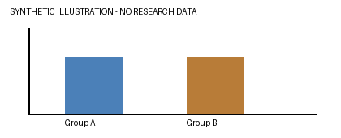
Figure 1. Synthetic illustration; no measured effect is depicted.
Existing author note: keep this original comment and green highlight
Existing revision: revised wording
Citation field: [1]
[1] Demonstration placeholder, not a real bibliographic reference.

