
ACCENTTECH, LLC
CONSULTING . TECHNOLOGY . OUTSOURCING
Hybrid Cloud Infrastructure, Data & Security, Network Architecture and Automation
Website: http://www.accenttechs.com Telephone: +1-443-565-2422
Accenttech, LLC is one of the world’s leading providers of information technology consulting, business process management, infrastructure services and marketer of high-tech products. We are holding company composed of the following operating units: Accenttech Consulting Group, Accenttech Business Group, Accenttech Direct Worldwide Group, and Accenttech Retail Group. Accenttech is a limited liability company registered in Baltimore, Maryland, USA.
OPEN SOURCE INNOVATION CONSULTANTS

Agile Integration, Automated and Optimized Business ProcessesOur full-service IT consulting and business process management provides credible information regarding any signs of a problem that might put your investment at risk. We are a consulting firm that is practical and straightforward. We serve the information systems needs of the business enterprise – integrated business systems, public and private organizations, small medium enterprises, and agencies.
We are industry leading suppliers of hardware and software products and solutions to address risks and performance management. We provide a full complement of network technologies as well as outsourcing services for managing business offices, retail stores and outlets, warehouses and hospitality centers. Our commitment as a leader in information technology consulting has been to continually update our knowledge to give the best professional advice.

We help our clients achieve
- Hybrid Cloud Infrastructure, Security Services, Network Architecture and Automation
- Legacy Modernization and IT Optimization
- Cloud-native Application Development
- Improved Operational Efficiency
- Agile Integration, Automated and Optimized Business Processes
- Customer, Products And Services
- Data Migration and Cloud Migration

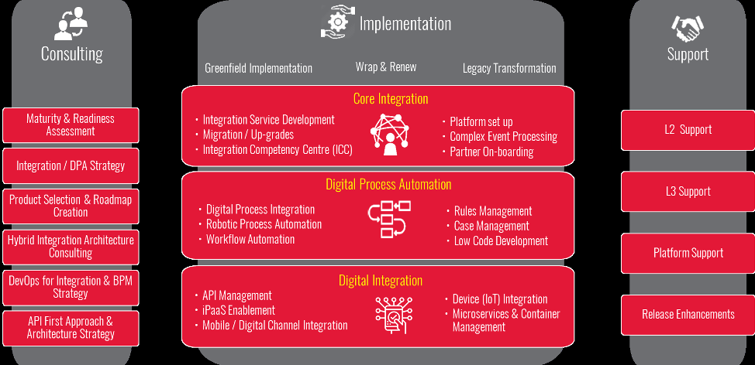
Enterprise Integration
Harnessing the power of Digital for growth is the new-age survival mantra in the business world. With a myriad of internal enterprise applications and the explosive growth of mobile and cloud apps, those who do not embark on the digital transformation journey will only become the Enterprises of the Past. Enterprise today take multiple initiatives to achieve their digital transformation goals. However, the burden of Legacy IT, fragmented systems and siloed data act as brakes slowing down the pace of this journey. This is where Enterprise Integration comes to rescue by unleashing its power to connect anything and everything.
Enterprise Solutions
Accenttech, LLC has been delivering projects in the areas of Core Integration, Partner Integration, Digital Process Automation and Digital Integration, to transform our clients’ businesses and make them digital ready. We have delivered end-to-end solutions in the areas of Integration and BPM Consultation, Maturity Assessment, API management, Product Roadmap Strategy, Rapid Application Development, Microservices and Containerization, iPaaS Enablement, Device Integration, Partner on-boarding and Robotic Process Automation. Our strong experience of over two decades has earned us critical acclaim amongst leading analysts, and many awards from our customers and alliance partners alike.
Contact information:
Attention: Director of Technology & Professional Services,
Accenttech, LLC
Reisterstown, MD 21136
Main telephone: +1-443-565-2422
Emai: info@accenttechs.com

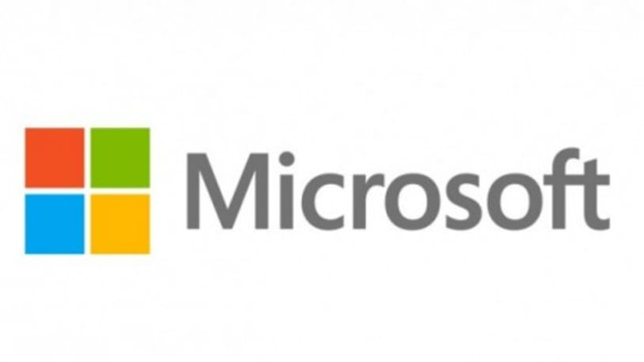

Business Partners:

