Fashion-MNIST Image Classification
CSC2042S Assignment 3 — Neural Networks
Student: Owen Mboma | Student number: MBMCHA003

1. Aim and method
The aim was to train a multi-layer perceptron (MLP) to classify Fashion-MNIST clothing images and test how optimizer, learning rate, and batch size affect performance. Fashion-MNIST contains 28 × 28 grayscale images in 10 clothing categories. I divided its 60,000-image training partition into 50,000 training images and 10,000 validation images using a seeded random split (seed 42). The separate 10,000-image test partition was not used for these results.
Images were converted to tensors, scaled to [0, 1], then standardized using the mean and standard deviation computed from the 50,000 training images (0.2857 and 0.3529). The same statistics were applied to validation and test images. The fixed MLP has 784 input features, hidden layers of 128 and 64 ReLU units, and 10 output logits; it was trained with cross-entropy loss.
The baseline used Adam (learning rate 0.001), batch size 64, and 10 epochs. Its measured accuracy was 92.20% on training data and 88.52% on validation data. Training and validation loss were recorded each epoch. The original baseline is reported separately from Run 5, which repeats its hyperparameters within the later search.

2. Experiment design and results
I tested three variables in eight 10-epoch configurations: optimizer (SGD or Adam), learning rate (0.01/0.10 for SGD; 0.001/0.003 for Adam), and batch size (64 or 128). Run 5 is a separate repeat of the original baseline configuration. In this rerun, it reached the same reported training and validation accuracies as the original baseline.
Table 1 — Training accuracy
Model / run | Optimizer | Learning rate | Batch size | Training accuracy
Original baseline | Adam | 0.001 | 64 | 92.20%
Run 1 | SGD | 0.01 | 64 | 86.94%
Run 2 | SGD | 0.01 | 128 | 85.97%
Run 3 | SGD | 0.10 | 64 | 88.47%
Run 4 | SGD | 0.10 | 128 | 91.05%
Run 5 (baseline repeat) | Adam | 0.001 | 64 | 92.20%
Run 6 | Adam | 0.001 | 128 | 92.42%
Run 7 | Adam | 0.003 | 64 | 90.47%
Run 8 | Adam | 0.003 | 128 | 91.61%
Table 2 — Validation accuracy
Model / run | Optimizer | Learning rate | Batch size | Validation accuracy
Original baseline | Adam | 0.001 | 64 | 88.52%
Run 1 | SGD | 0.01 | 64 | 85.90%
Run 2 | SGD | 0.01 | 128 | 84.99%
Run 3 | SGD | 0.10 | 64 | 86.00%
Run 4 | SGD | 0.10 | 128 | 88.33%
Run 5 (baseline repeat) | Adam | 0.001 | 64 | 88.52%
Run 6 | Adam | 0.001 | 128 | 89.04%
Run 7 | Adam | 0.003 | 64 | 87.65%
Run 8 | Adam | 0.003 | 128 | 88.16%

3. Hyperparameter results
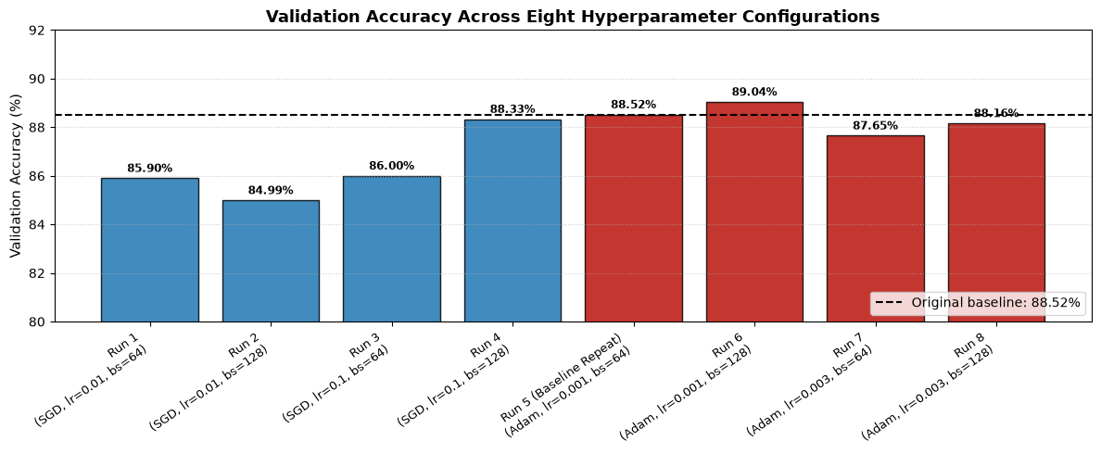
Figure 1. Validation accuracy for all eight tested configurations. The dashed line marks the original baseline.
The best tested configuration was Adam, learning rate 0.001, batch size 128 (Run 6), with 89.04% validation accuracy. This is a modest gain of 0.52 percentage points over the 88.52% baseline. Comparisons of learning rate should be made within each optimizer because the SGD and Adam rate ranges differ. For SGD, changing 0.01 to 0.10 moved accuracy from 85.90% to 86.00% at batch size 64, and from 84.99% to 88.33% at batch size 128. For Adam, changing 0.001 to 0.003 reduced accuracy by 0.87 points at batch size 64 and 0.88 points at batch size 128.
Batch-size effects were not uniform: increasing 64 to 128 helped both Adam settings by about half a point, while SGD at 0.01 declined by 0.91 points and SGD at 0.10 improved by 2.33 points. The tested Adam configurations scored higher overall, but because the learning rates were not matched, this grid does not isolate an optimizer-only effect.

4. Loss curves and overfitting
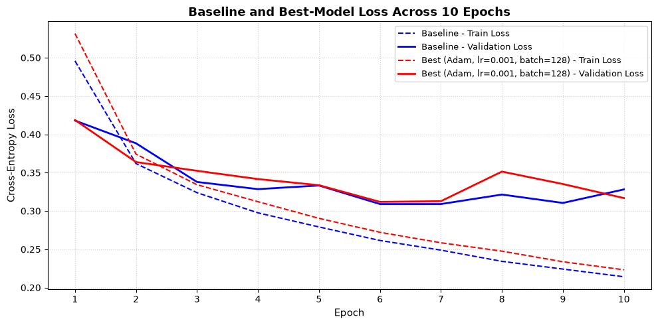
Figure 2. Training and validation cross-entropy loss for the original baseline and best configuration across 10 epochs.
Training loss decreases across all 10 epochs for both models. Validation loss drops rapidly early in training, reaches its lowest region around epochs 6–7, then levels off and fluctuates. The best model has a noticeable validation-loss rise around epoch 8 before finishing at 0.3168; the baseline finishes at 0.3281. At the end, training accuracy exceeds validation accuracy by 3.68 points for the baseline (92.20% versus 88.52%) and 3.38 points for Run 6 (92.42% versus 89.04%). These gaps and the late separation of the loss curves suggest some overfitting. Run 6 generalizes slightly better by the final validation metrics, but the curves do not show that tuning removed overfitting or that larger batches caused regularization.

5. Confusion matrix and conclusion
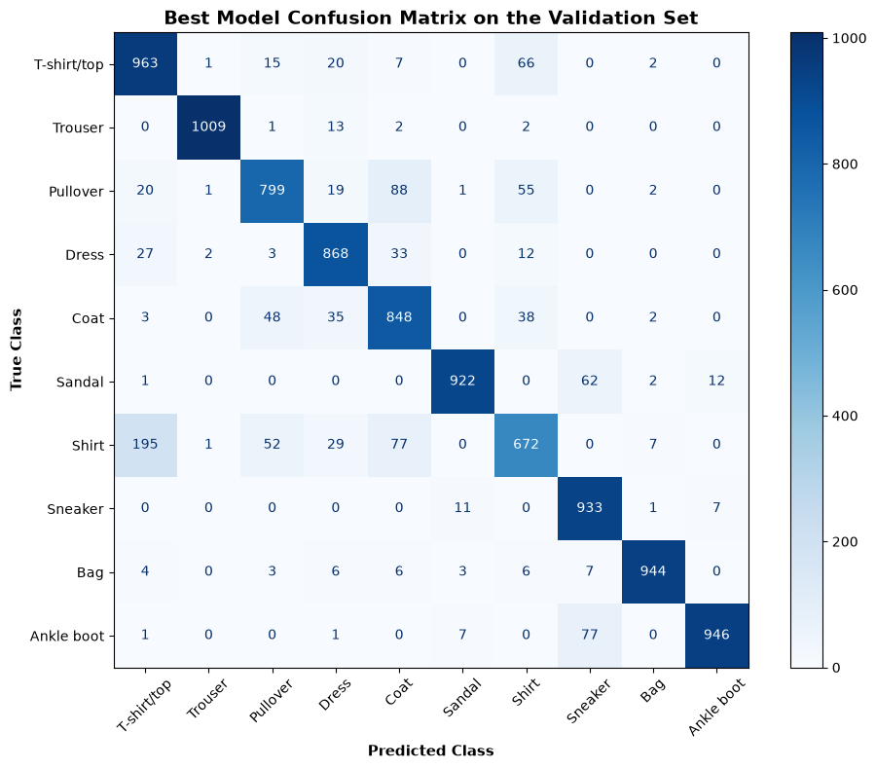
Figure 3. Validation confusion matrix for the best model (Run 6). Rows are true classes and columns are predicted classes.
The largest directional error is a Shirt classified as T-shirt/top (195 validation images). In the reverse direction, 66 T-shirts/tops are classified as shirts, so the pair accounts for 261 errors across both directions. To me, this is understandable because both categories are upper-body garments and their silhouettes can look alike in small 28 × 28 grayscale images; fine cues such as collars and sleeve shapes occupy very few pixels. Flattening pixels for an MLP also gives the model no built-in way to preserve local two-dimensional patterns.
The main limitation is the narrow experiment: eight configurations on one seeded split, with only 10 epochs and no repeated-seed comparison. A useful next step would be to repeat promising configurations across several seeds and compare them with a small CNN, which can learn local image features directly.

