JSS1
DIGITAL TECHNOLOGY
A Practical Guide to Digital Skills, Computing, Communication, Media and Visual Programming
COMPUTING

DATA

MEDIA

NETWORKS

CODING

DIGITAL CITIZENSHIP

Author: ______________________________
Publisher: ____________________________
Edition: ______________________________
ISBN: _________________________________

Title Page
JSS1 Digital Technology
A Practical Guide to Digital Skills, Computing, Communication, Media and Visual Programming
Prepared for Nigerian Junior Secondary School learners
Author: ______________________________
Publisher: ____________________________
Edition: ______________________________

Copyright and Publication Information
© ____________________
All rights reserved. No part of this publication may be reproduced, stored or transmitted in any form without written permission of the publisher, except as allowed by applicable educational and copyright law.
ISBN: _________________________________
First publication: ______________________
Printed in Nigeria

Dedication
Dedicated to Nigerian learners who explore, create, solve problems, ask questions and use technology to make their schools and communities better.

Acknowledgements
The preparation of a practical Digital Technology textbook requires contributions from classroom teachers, curriculum specialists, technology practitioners, illustrators, editors and reviewers. The final publication should include the names of the editorial, illustration, production and review teams appointed by the publisher.

Foreword
Digital Technology has become part of how people learn, communicate, create, work and solve problems. The revised Nigerian curriculum places strong emphasis on practical competence and meaningful use of technology. This book therefore teaches JSS1 learners through explanation, demonstration, practice and projects.
Students are introduced to digital devices, hardware, software, documents, presentations, 3D modelling, data processing, communication, networks, Internet research, digital safety, digital media, algorithms and visual programming. The book also introduces careers and emerging technologies so that learners can begin to see pathways for future learning.

Introduction to the Textbook
This textbook follows the practical spirit of the new JSS1 Digital Technologies curriculum. The NERDC Digital Technologies JSS1 material identifies learning areas including the history and uses of digital devices, hardware and storage, application software, data processing, computer communication, networks, digital media and visual programming. The book expands those areas into classroom-ready chapters and projects.
Software names and interfaces can change across versions. Examples use Microsoft Word, Microsoft PowerPoint and beginner visual-programming tools where appropriate, but equivalent permitted software may be substituted when the school uses a different platform. Teacher demonstrations should always match the software installed in the laboratory.

How to Use This Book
Each chapter begins with learning objectives and key terms, moves from explanation to worked examples, and ends with practical work and assessment. Students should read the explanation before attempting a practical task. During practical lessons, follow teacher instructions and laboratory rules. Save work regularly, use meaningful filenames and report equipment faults promptly.
The recurring boxes KEY IDEA, DID YOU KNOW?, TECH TIP, THINK ABOUT IT, WATCH OUT!, TRY THIS and REAL-LIFE CONNECTION are designed to highlight important ideas without replacing the main explanation.

General Learning Objectives
By the end of JSS1 Digital Technology, learners should be able to recognise major digital devices and components, use common productivity applications, process simple data, communicate safely through networks and online services, create basic digital media, solve problems using algorithms, build visual programs and demonstrate responsible digital citizenship. Learners should also understand that technology skills are developed through continuous practice.

Table of Contents
FRONT MATTER
Title Page
Copyright and Publication Information
Dedication
Acknowledgements
Foreword
Introduction to the Textbook
How to Use This Book
General Learning Objectives
PART ONE: DIGITAL FOUNDATIONS
Chapter 1 — Digital Technology Foundations and the History of Digital Devices
Chapter 2 — Digital Careers and Skills for the Future
Chapter 3 — Computer Hardware Components and Storage Units
Chapter 4 — Software, Operating Systems, Booting and Shutdown
Chapter 5 — Introduction to Microsoft Word: Creating Digital Documents
Chapter 6 — Presentation Software with Microsoft PowerPoint
Chapter 7 — 3D Modelling with Paint 3D and Introductory Digital Media
Chapter 8 — Data Processing and Information
Chapter 9 — Basic Computer Communication and Networks
Chapter 10 — Internet Basics, Web Browsing and Online Research
Chapter 11 — Digital Safety, Privacy, Ethics and Responsible Internet Use
Chapter 12 — Digital Media: Images, Audio, Video and Multimedia
Chapter 13 — Algorithms and Problem-Solving for Beginners
Chapter 14 — Visual Programming: Variables, Conditions and Loops
Chapter 15 — Game Development, Debugging and Integrated Programming Project
Chapter 16 — Emerging Technologies: AI, Robotics, IoT and Smart Services
END MATTER
Comprehensive Revision
Practical Examination
Theory Examination
Objective Examination
Integrated Projects
Glossary
Index
References
Front Cover and Back Cover Copy

Major Themes
- Digital foundations and history
- Digital careers
- Hardware, storage and software
- Word processing and presentations
- 3D modelling and digital media
- Data processing
- Communication, networks and Internet
- Digital safety and ethics
- Algorithms and visual programming
- Game development and debugging
- Emerging technologies

PART ONE: DIGITAL FOUNDATIONS

CHAPTER 1: Digital Technology Foundations and the History of Digital Devices
Learning Objectives
- explain the meaning of digital technology and distinguish digital from analogue information;
- describe why digital technology matters in school, home, work and society;
- identify major milestones in the development of computing devices;
- recognise examples of modern digital devices and explain their uses;
- demonstrate responsible and careful handling of digital equipment.
Key Terms: Digital Technology Foundations and the History of Digital Devices
Introduction: This chapter connects the topic to everyday school and community experiences. Read the explanations carefully, then complete the practical tasks with teacher supervision.

1.1 What Is Digital Technology?
Digital technology refers to electronic technology that represents, stores, processes or communicates information using discrete values. In many modern systems, these values are represented using binary digits, commonly written as 0 and 1. A smartphone, school computer, digital camera, tablet, smart television and many medical devices are examples of systems that use digital technology.
Digital technology is not simply the same thing as “using a computer”. A computer is one kind of digital device. Digital technology also includes the software, networks, communication services and embedded systems that allow devices to collect information, make decisions, store files and exchange messages.
At JSS1 level, the most useful question is not only “What is this device?” but also “What problem does this technology help people solve?” A calculator helps with calculations, a word processor helps create documents, a network allows devices to exchange information, and a digital camera captures images in electronic form.
KEY IDEA
Digital technology combines devices, software, data and communication processes to help people perform tasks more effectively.

- School: writing assignments, searching for information, preparing presentations and practising skills.
- Home: communication, entertainment, record keeping and access to services.
- Business: sales records, payment processing, advertising and communication.
- Health: storing patient information, medical imaging and communication.
- Agriculture: weather information, farm records, mapping and smart equipment.

1.2 Digital and Analogue Information
Analogue systems represent information as continuously varying values. A traditional mercury thermometer, for example, uses the continuous movement of a liquid column to indicate temperature. Digital systems represent information in discrete states. A digital thermometer may show a numerical value such as 36.8 °C.
The distinction matters because digital systems can copy, store and process information in ways that are very different from many traditional analogue systems. Digital files can be duplicated without the physical medium having to be recreated in exactly the same way.
Students should not conclude that analogue technology is “bad” and digital technology is always “better”. Different technologies are designed for different purposes. The important skill is choosing an appropriate tool for a particular task.
THINK ABOUT IT
Why might a hospital choose digital equipment for one task but still use a traditional physical tool for another?

Table 1.1: Digital and analogue examples
Situation | Analogue example | Digital example
Clock | Hands moving continuously | Numerical display
Temperature | Liquid thermometer | Electronic temperature sensor
Music | Vinyl groove / tape signal | Audio file
Photography | Film | Digital image file

1.3 Early Calculating and Computing Devices
People have used tools for calculation for thousands of years. The abacus is one of the best-known early calculating devices. It uses beads arranged on rods or grooves to represent numbers and support arithmetic operations.
Later developments included logarithmic calculation tools, mechanical calculators and punched-card systems. These inventions did not all work like modern computers, but they contributed ideas such as mechanical processing, storing patterns of information and automating repeated operations.
A useful way to understand history is to focus on the problem each invention addressed. When calculations became too large or repetitive for people to manage comfortably, inventors created tools to reduce effort and improve accuracy.
DID YOU KNOW?
The history of computing is not a single straight line. Many inventions from different places and periods contributed to the technologies used today.

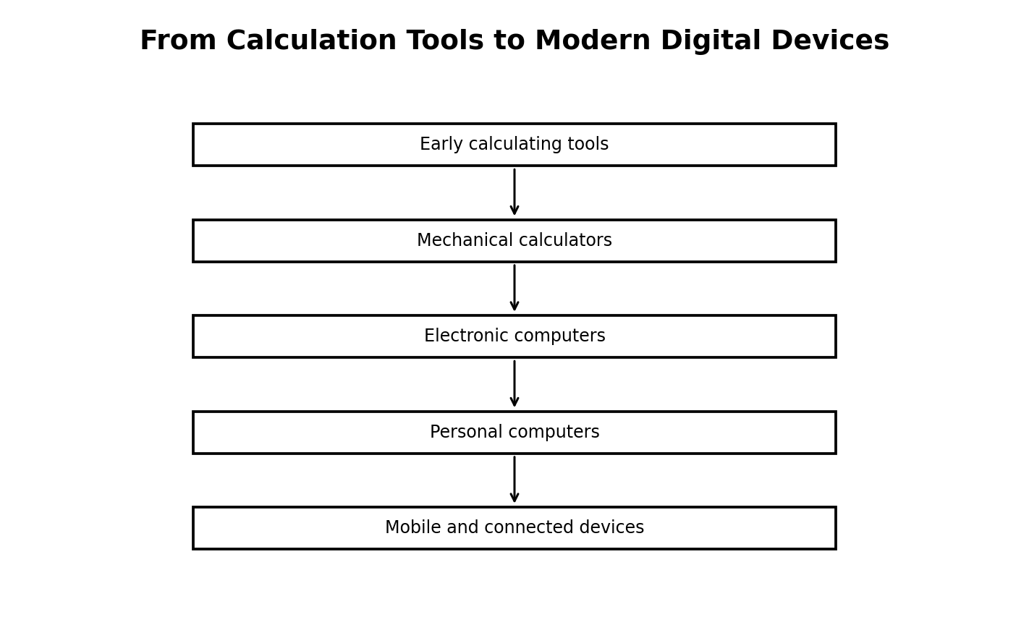
Figure 1.3: the development path from early tools to modern connected devices
Illustration description: A simple chronological flow showing how computing developed through several stages.

1.4 Generations and Changing Computer Technology
Computer generations are broad historical groupings used to describe major changes in computer technology. Early electronic computers relied on large electronic components and consumed much more physical space and power than today’s personal devices. Later developments produced smaller, faster and more reliable systems.
The move from large central computers to personal computers changed who could use computing. The growth of the Internet and mobile technology then made communication and access to information more widespread.
Modern devices often combine functions that previously required separate machines. A smartphone can act as a camera, music player, navigation tool, communication device and small computer. This is an example of technological convergence.
TECH TIP
When comparing old and new devices, consider size, speed, storage, connectivity, power consumption and the tasks each device can perform.

- smaller components and greater processing capability;
- portable devices and wireless communication;
- cloud-based services and online collaboration;
- embedded computing inside vehicles, appliances and machines.

1.5 Modern Digital Devices
A digital device is an electronic device that processes digital information. Devices differ in their input methods, processing capabilities, storage capacity, operating systems and communication features.
Examples include desktop computers, laptops, tablets, smartphones, smart watches, game consoles, printers, cameras, routers and many embedded devices. Some devices are general-purpose, meaning they can perform many different tasks. Others are designed for a narrower purpose.
Knowing the purpose of a device helps students select and use equipment safely. A printer is used mainly to produce hard copies, while a scanner converts physical documents or images into digital data. A router directs network traffic between devices or networks.
TRY THIS
Look around your school or home and list ten digital devices. For each one, write one problem it solves and one type of information it handles.

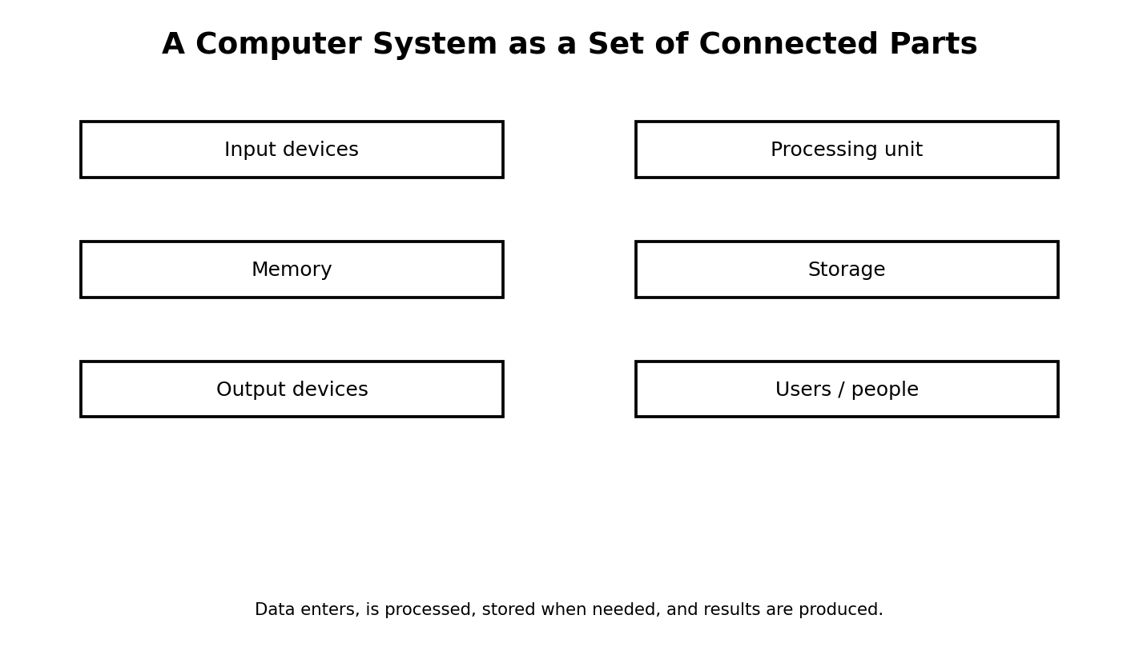
Figure 1.5: major parts of a computer system
Illustration description: Boxes showing input, processing, memory, storage, output and the role of users.

1.6 Responsible Use and Care of Digital Devices
Digital devices are valuable resources. Good care reduces damage, improves reliability and protects the information stored on the equipment. Students should keep liquids away from computers, use clean hands, handle connectors gently and follow laboratory instructions.
Responsible use also includes using equipment only for approved school activities, respecting other people’s files and avoiding unauthorised changes to settings. Where a computer laboratory assigns a particular system to a student, the student should use that assigned system and report faults promptly rather than attempting unsafe repairs.
Care includes physical handling and digital responsibility. Students should close applications properly, shut down computers according to instructions, keep passwords private and avoid downloading unknown files.
WATCH OUT!
Never pull a cable by the wire. Hold the connector firmly when disconnecting a peripheral.

- Inspect the work area before switching on a device.
- Check that cables are connected correctly and safely.
- Use the correct login or class account.
- Save work regularly using meaningful filenames.
- Shut down or sign out using the approved procedure.

Practical Activity
Objective: Apply the main skill from this chapter in a controlled classroom task.
Materials/software: Use the school laboratory, permitted software, exercise files and teacher-approved resources.
Procedure: Review the relevant worked example, perform the task step by step, save your work, then check the expected result.
Expected result: A complete and correctly saved practical product that demonstrates the skill taught in this chapter.
Reflection: What step was easiest? What step was most difficult? What would you improve after receiving feedback?

Guided Practice
- Repeat the main skill with a new example.
- Compare your result with a partner or model answer.
- Correct one error you found.

Student Practice
- Complete a similar task independently.
- Explain the result in your own words.
- Save the work using a clear filename.

Challenge Activity
Adapt the practical task to a new situation in your school or community. Explain why your solution is appropriate and identify one limitation.

Project
Project title: Chapter 1 Applied Digital Project
Problem statement: Use the chapter skill to create a useful digital product or solution for a school-related need.
Requirements: clear objective, appropriate tools, correct procedure, saved output and a short explanation.
Assessment criteria: accuracy, completeness, presentation, responsible use of technology and ability to explain the work.
Extension: Add one improvement that makes the solution more useful or accessible.

Chapter Summary
This chapter introduced the main concepts, showed how they work in practical situations and provided opportunities to apply them. Review the key terms and repeat the practical activity until you can perform it with minimal assistance.

Worked Example and Extended Practice
Worked Example: Imagine a Nigerian school where a practical problem related to digital technology foundations and the history of digital devices has been identified. The teacher first states the goal in simple language, lists the available resources and decides what a successful result should look like. Students then carry out the task in small stages, checking their work after each stage. This approach reduces errors and makes it easier to improve the final product.
Step 1 — Understand the task: underline the important words in the question and identify what must be produced. Step 2 — Plan: choose the appropriate tool, information and sequence. Step 3 — Perform: work carefully and save at sensible points. Step 4 — Check: compare the result with the requirements. Step 5 — Improve: correct mistakes and make one useful improvement.
COMMON MISTAKES
Typical beginner errors include skipping instructions, choosing a tool before understanding the task, failing to save work, using unclear filenames, ignoring a safety rule, and submitting a result without checking it. A strong learner learns to notice these mistakes early and correct them.

Practice Scenario: Your teacher gives you a new task related to this chapter but does not tell you every button to press. Explain what you would do before asking for help. A good response should include identifying the goal, recalling a similar procedure, checking available menus or help resources, trying a safe first step, and asking a clear question if the problem remains.
Table 1.X: Skills checklist
Skill | Beginning | Developing | Independent
I can explain the main idea | Need help | Can explain with prompts | Can explain clearly
I can perform the basic task | Need step-by-step help | Can complete most steps | Can work independently
I can check my result | Rarely checks | Checks when reminded | Always checks and corrects
I can work responsibly | Needs reminders | Usually follows rules | Consistently follows rules

Discussion and Critical Thinking
- Why is planning useful before starting a digital task?
- What could happen if a person uses the right tool but follows the wrong procedure?
- Which part of this chapter would be most useful in your school, and why?
- How could you teach one skill from this chapter to a younger learner?
- What change would make the practical activity easier to understand without making it too easy?

Independent Mini-Task
Design a small personal practice task based on this chapter. Write the objective, materials or software, five to eight steps, the expected result and one way to test the result. Complete the task, save the evidence of your work and write three sentences describing what you improved after testing.

Teacher Demonstration Prompt
Demonstrate one complete task without performing unrelated steps. Pause at the points where students must make a decision, ask a prediction question, then continue. End by showing how the final result is checked.

ASSESSMENT
Complete the objective, theory and practical tasks below. Your teacher may select some items for continuous assessment.

A. Objective Questions
1. Which statement best describes the main purpose of the topic in this chapter? (A) Option A (B) Option B (C) Option C (D) Option D
2. Which option is an example rather than a definition of the concept studied? (A) Option A (B) Option B (C) Option C (D) Option D
3. Which action is the safest or most effective procedure in the practical activity? (A) Option A (B) Option B (C) Option C (D) Option D
4. Which pair is correctly matched? (A) Option A (B) Option B (C) Option C (D) Option D
5. Which sequence shows the correct order of the process? (A) Option A (B) Option B (C) Option C (D) Option D
6. What would most likely happen if an important step were skipped? (A) Option A (B) Option B (C) Option C (D) Option D
7. Which statement shows responsible use of digital technology? (A) Option A (B) Option B (C) Option C (D) Option D
8. Which result would you expect after completing the practical task? (A) Option A (B) Option B (C) Option C (D) Option D
B. Theory Questions
- Define two important terms from this chapter in your own words.
- Explain one real-life use of the main skill learned in this chapter.
- Describe the steps you would follow to complete the practical activity safely.
- State two common mistakes and explain how to avoid them.
C. Practical Questions
- Perform the main practical task from the chapter using the software available in your laboratory.
- Save your work with a meaningful filename and show the finished result to your teacher.
- Explain one improvement you would make to your work after testing it.
CHAPTER REVIEW
- Write five facts you remember from the chapter.
- Write three things you can now do that you could not do before the lesson.
- Choose one idea from the chapter and explain how it could help a Nigerian school or community.
- What question do you still have about the topic?

CHAPTER 2: Digital Careers and Skills for the Future
Learning Objectives
- identify major careers related to digital technology;
- describe the tasks performed in selected technology careers;
- recognise technical, creative and personal skills needed for digital work;
- develop a simple personal technology-skill plan;
- connect school activities with future career opportunities.
Key Terms: Digital Careers and Skills for the Future
Introduction: This chapter connects the topic to everyday school and community experiences. Read the explanations carefully, then complete the practical tasks with teacher supervision.

2.1 What Is a Digital Technology Career?
A digital technology career is work that uses computing, information, communication or digital tools as a major part of the job. Some careers involve creating technology, some involve analysing information, some involve protecting systems and others use technology to support a different profession.
A person does not need to become a programmer to have a digital career. Teachers, accountants, designers, farmers, engineers, health workers and entrepreneurs increasingly use digital tools. Technology skills therefore support many careers.
Career exploration at JSS1 is about awareness rather than choosing a permanent profession. Students should learn what different professionals do and begin developing habits of curiosity, problem-solving, communication and responsible technology use.
REAL-LIFE CONNECTION
A student who enjoys creating posters may discover an interest in graphic design. Another student who enjoys solving puzzles may enjoy programming or cybersecurity.

2.2 Major Digital Careers
Software developers design and build computer programs. Web developers create and maintain websites and web applications. Data analysts organise and interpret data to help people make decisions. Network professionals design and maintain connected systems.
Graphic designers create visual communication. Digital marketers use online channels to promote products or services. Cybersecurity professionals help protect systems and information. Technical support professionals help users solve hardware and software problems.
There are also careers in animation, video production, cloud services, user-interface design, database administration, artificial intelligence, robotics and digital education. The field continues to change as new tools appear.
Table 2.1: Examples of digital careers
Career | Typical work | Useful school skills
Software developer | Builds programs | Logic, programming, persistence
Graphic designer | Creates visual communication | Creativity, layout, digital tools
Data analyst | Finds patterns in data | Mathematics, spreadsheets, reasoning
Network professional | Connects and supports systems | Problem-solving, communication
Cybersecurity professional | Protects systems and data | Carefulness, security awareness
Digital marketer | Promotes products or services | Communication, creativity, analysis

2.3 Technical Skills and Human Skills
Technology careers require both technical and human skills. Technical skills are abilities connected directly to tools and processes, such as typing, using spreadsheets, programming, designing graphics or troubleshooting a device. Human skills include communication, teamwork, creativity, time management and ethical judgement.
Students can develop these skills through ordinary classroom work. A group presentation builds communication and teamwork. A Scratch project develops logic and persistence. A spreadsheet activity develops accuracy. A research project develops information literacy.
One of the most valuable habits is learning how to learn. Software changes, so a successful technology worker must be willing to read instructions, practise new tools and solve unfamiliar problems.
- Ask clear questions.
- Break difficult tasks into smaller steps.
- Check your work before submitting it.
- Keep useful notes and organise files.
- Accept feedback and improve your work.

2.4 Career Stories and Nigerian Opportunities
Across Nigeria, digital work is found in schools, banks, telecommunications, media organisations, technology companies, public institutions, hospitals and small businesses. Many people also work independently by offering services such as web design, graphics, repairs, photography, digital marketing and training.
A student can begin building a portfolio early. A portfolio is a collection of work that demonstrates ability. For example, a student interested in design might keep selected posters. A student interested in programming might keep small games and animations. A student interested in data might keep well-designed spreadsheet projects.
Career growth is not only about having expensive equipment. It is also about skill, reliability, problem-solving, responsible behaviour and the ability to explain your work clearly.
THINK ABOUT IT
Which digital service is needed in your community? What simple skill could help you provide that service in the future?

2.5 Building a Personal Skills Plan
A simple skills plan identifies a goal, the current ability level, the resources available for practice and a way to measure progress. Students should choose small, realistic goals rather than attempting to master everything at once.
For example, a learner may set the goal: “By the end of the term I will create and present a five-slide PowerPoint presentation without help.” The student can divide the goal into smaller tasks: learn slide layouts, insert images, apply a theme, practise transitions, rehearse the speech and review the final presentation.
The same approach can be used for typing, spreadsheet work, image editing or programming.
Table 2.2: Personal skills plan
Goal | Practice | Evidence of progress
Create better documents | One document every two weeks | Before/after comparison
Improve presentation | Practise speaking for five minutes | Recorded rehearsal or teacher feedback
Learn programming | Build one small Scratch project monthly | Saved project files
Improve digital safety | Study one safety topic weekly | Completed safety checklist

2.6 Mini Career Project
Choose one digital career that interests you. Research what the worker does, what tools may be used, which school subjects can help, and what personal qualities are useful. Present your findings as a one-page career poster or a three-slide presentation.
Your project should distinguish facts from assumptions. If you use an online source, record the website title and date you accessed the information. Avoid copying long passages. Summarise the information in your own words and give credit to the source.
Finally, add a “My first step” section stating one small skill you can begin practising now.
- Choose a career.
- Gather at least three reliable pieces of information.
- Organise the information into headings.
- Create the poster or slides.
- Check spelling and source credits.
- Present to the class and answer questions.

Practical Activity
Objective: Apply the main skill from this chapter in a controlled classroom task.
Materials/software: Use the school laboratory, permitted software, exercise files and teacher-approved resources.
Procedure: Review the relevant worked example, perform the task step by step, save your work, then check the expected result.
Expected result: A complete and correctly saved practical product that demonstrates the skill taught in this chapter.
Reflection: What step was easiest? What step was most difficult? What would you improve after receiving feedback?

Guided Practice
- Repeat the main skill with a new example.
- Compare your result with a partner or model answer.
- Correct one error you found.

Student Practice
- Complete a similar task independently.
- Explain the result in your own words.
- Save the work using a clear filename.

Challenge Activity
Adapt the practical task to a new situation in your school or community. Explain why your solution is appropriate and identify one limitation.

Project
Project title: Chapter 2 Applied Digital Project
Problem statement: Use the chapter skill to create a useful digital product or solution for a school-related need.
Requirements: clear objective, appropriate tools, correct procedure, saved output and a short explanation.
Assessment criteria: accuracy, completeness, presentation, responsible use of technology and ability to explain the work.
Extension: Add one improvement that makes the solution more useful or accessible.

Chapter Summary
This chapter introduced the main concepts, showed how they work in practical situations and provided opportunities to apply them. Review the key terms and repeat the practical activity until you can perform it with minimal assistance.

Worked Example and Extended Practice
Worked Example: Imagine a Nigerian school where a practical problem related to digital careers and skills for the future has been identified. The teacher first states the goal in simple language, lists the available resources and decides what a successful result should look like. Students then carry out the task in small stages, checking their work after each stage. This approach reduces errors and makes it easier to improve the final product.
Step 1 — Understand the task: underline the important words in the question and identify what must be produced. Step 2 — Plan: choose the appropriate tool, information and sequence. Step 3 — Perform: work carefully and save at sensible points. Step 4 — Check: compare the result with the requirements. Step 5 — Improve: correct mistakes and make one useful improvement.
COMMON MISTAKES
Typical beginner errors include skipping instructions, choosing a tool before understanding the task, failing to save work, using unclear filenames, ignoring a safety rule, and submitting a result without checking it. A strong learner learns to notice these mistakes early and correct them.

Practice Scenario: Your teacher gives you a new task related to this chapter but does not tell you every button to press. Explain what you would do before asking for help. A good response should include identifying the goal, recalling a similar procedure, checking available menus or help resources, trying a safe first step, and asking a clear question if the problem remains.
Table 2.X: Skills checklist
Skill | Beginning | Developing | Independent
I can explain the main idea | Need help | Can explain with prompts | Can explain clearly
I can perform the basic task | Need step-by-step help | Can complete most steps | Can work independently
I can check my result | Rarely checks | Checks when reminded | Always checks and corrects
I can work responsibly | Needs reminders | Usually follows rules | Consistently follows rules

Discussion and Critical Thinking
- Why is planning useful before starting a digital task?
- What could happen if a person uses the right tool but follows the wrong procedure?
- Which part of this chapter would be most useful in your school, and why?
- How could you teach one skill from this chapter to a younger learner?
- What change would make the practical activity easier to understand without making it too easy?

Independent Mini-Task
Design a small personal practice task based on this chapter. Write the objective, materials or software, five to eight steps, the expected result and one way to test the result. Complete the task, save the evidence of your work and write three sentences describing what you improved after testing.

Teacher Demonstration Prompt
Demonstrate one complete task without performing unrelated steps. Pause at the points where students must make a decision, ask a prediction question, then continue. End by showing how the final result is checked.

Extended Practice Workshop
Case Study: A student is asked to complete a new task involving digital careers and skills for the future. The student has the basic tools but no step-by-step answer. Before touching the computer, the student identifies the goal, chooses the most suitable resource, predicts the result and lists the checks that will prove the work is correct. This is the habit of an independent digital learner.
Worked practice: 1) Read the task twice. 2) Circle the important requirements. 3) Separate the task into smaller actions. 4) Complete one action at a time. 5) Save after important changes. 6) Test the result using at least one example. 7) Correct any error. 8) Explain what you learned.
Application task: Rewrite the chapter activity for a different school situation. For example, a document skill can be applied to a club notice, a data skill to a class survey, a network skill to a laboratory diagram, an algorithm skill to a school routine, or a programming skill to an educational quiz. Your version should keep the same learning objective while changing the context.
Table 2.Y: Practice quality checklist
Question | Yes / Not yet | Evidence
Did I understand the task? |  | Written plan
Did I use an appropriate tool? |  | Tool selected
Did I follow a safe procedure? |  | Safety check
Did I test the result? |  | Test example
Did I improve the work? |  | Change made
REFLECT
The most important improvement you can make as a digital learner is to become comfortable with testing. A first attempt does not need to be perfect. What matters is that you can identify what happened, explain why it happened and make a sensible improvement.

ASSESSMENT
Complete the objective, theory and practical tasks below. Your teacher may select some items for continuous assessment.

A. Objective Questions
1. Which statement best describes the main purpose of the topic in this chapter? (A) Option A (B) Option B (C) Option C (D) Option D
2. Which option is an example rather than a definition of the concept studied? (A) Option A (B) Option B (C) Option C (D) Option D
3. Which action is the safest or most effective procedure in the practical activity? (A) Option A (B) Option B (C) Option C (D) Option D
4. Which pair is correctly matched? (A) Option A (B) Option B (C) Option C (D) Option D
5. Which sequence shows the correct order of the process? (A) Option A (B) Option B (C) Option C (D) Option D
6. What would most likely happen if an important step were skipped? (A) Option A (B) Option B (C) Option C (D) Option D
7. Which statement shows responsible use of digital technology? (A) Option A (B) Option B (C) Option C (D) Option D
8. Which result would you expect after completing the practical task? (A) Option A (B) Option B (C) Option C (D) Option D
B. Theory Questions
- Define two important terms from this chapter in your own words.
- Explain one real-life use of the main skill learned in this chapter.
- Describe the steps you would follow to complete the practical activity safely.
- State two common mistakes and explain how to avoid them.
C. Practical Questions
- Perform the main practical task from the chapter using the software available in your laboratory.
- Save your work with a meaningful filename and show the finished result to your teacher.
- Explain one improvement you would make to your work after testing it.
CHAPTER REVIEW
- Write five facts you remember from the chapter.
- Write three things you can now do that you could not do before the lesson.
- Choose one idea from the chapter and explain how it could help a Nigerian school or community.
- What question do you still have about the topic?

CHAPTER 3: Computer Hardware Components and Storage Units
Learning Objectives
- define computer hardware and identify common components;
- classify devices as input, output, storage or processing components;
- explain the basic roles of the processor and memory;
- distinguish primary and secondary storage;
- interpret common storage units such as byte, KB, MB, GB and TB;
- apply simple hardware care practices.
Key Terms: Computer Hardware Components and Storage Units
Introduction: This chapter connects the topic to everyday school and community experiences. Read the explanations carefully, then complete the practical tasks with teacher supervision.

3.1 Meaning of Computer Hardware
Hardware means the physical parts of a computer system that can be seen and touched. Examples include the keyboard, mouse, monitor, system unit, speakers, printer, motherboard and storage devices.
Hardware works together with software. A keyboard can physically send a signal, but software is needed to interpret that signal and place the corresponding character in a document. The complete system therefore depends on cooperation between physical equipment and programs.
Students should learn to identify components not only by name but by function. Asking “What does this part do?” is a better starting point than memorising names alone.
Figure 3.1: the main parts of a computer system
Illustration description: The diagram groups the system into input, processing, memory, storage and output, with people using the system.

3.2 Input and Output Devices
Input devices send data or instructions into a computer. Common examples include the keyboard, mouse, scanner, microphone, webcam and touch screen. Output devices present results from a computer to a user or another system. Examples include monitors, printers, speakers, projectors and some display panels.
Some modern devices can act as both input and output. A touch screen displays information and also detects touch. A multifunction printer may print, scan and copy.
When identifying a device, focus on the direction of information flow. If information moves from the user into the computer, it is functioning as an input device. If the system presents information to the user, it is functioning as an output device.
Table 3.1: Common hardware devices
Category | Examples | Main role
Input | Keyboard, mouse, scanner | Enter data or instructions
Output | Monitor, printer, speakers | Present results
Storage | SSD, hard disk, flash drive | Keep data for later use
Processing | CPU | Carries out instructions

3.3 Processor and Memory
The processor, commonly called the CPU, carries out instructions and performs calculations. It works with other components to transform input data into useful results. The CPU is not the same thing as the entire computer; it is one important part of the system.
Memory and storage are related but different. Random Access Memory (RAM) provides temporary working space for programs and data currently in use. When power is removed, the contents of ordinary RAM are not retained. Storage devices such as SSDs and hard disk drives are used to keep files for longer periods.
A useful analogy is a student’s desk. The desk is where current work is arranged and easily reached, while a cupboard can keep materials for later. RAM is like the active workspace; storage is like the longer-term place for keeping files.
KEY IDEA
RAM supports active work. Storage keeps information for later use. Both are important, but they perform different roles.

3.4 Storage Devices
Storage devices keep digital information such as documents, pictures, music, videos and programs. Common storage technologies include solid-state drives, hard disk drives, USB flash drives, memory cards and optical discs. Different devices offer different capacities, speeds, durability and portability.
A flash drive is convenient for moving files between compatible computers. A solid-state drive has no spinning magnetic platter and generally provides fast access. A hard disk drive uses magnetic storage and can offer large capacities at relatively low cost in many contexts.
Students should treat storage devices carefully. Files may be lost not only because a device is damaged but also because files are accidentally deleted, overwritten or corrupted. Good file organisation and backup habits are therefore part of responsible storage management.
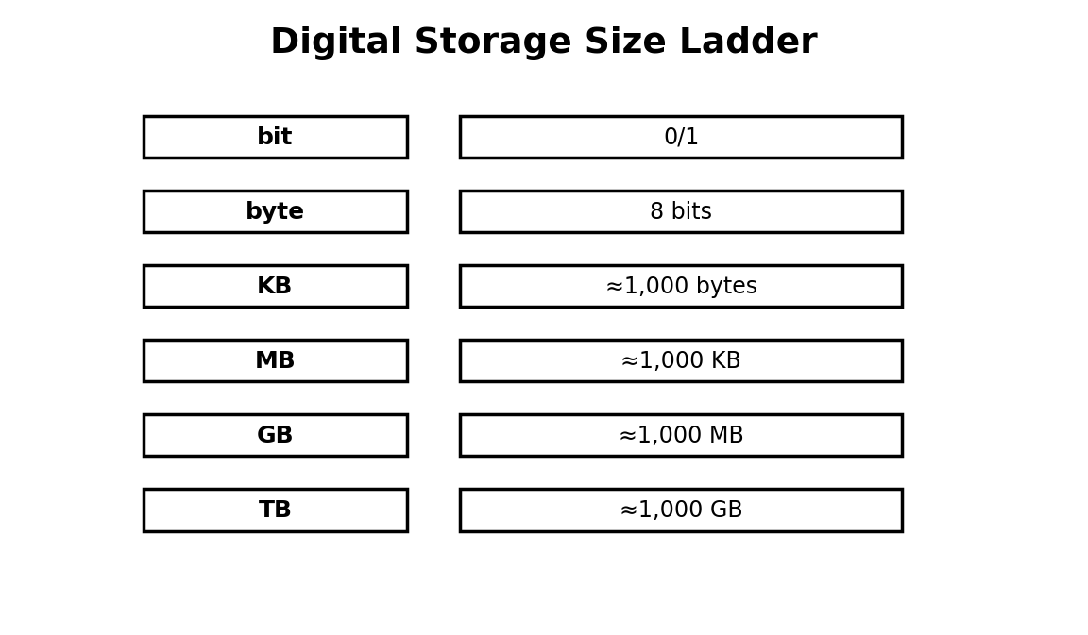
Figure 3.4: storage size units
Illustration description: A ladder showing the progression from bit and byte through larger commonly used storage units.

3.5 Storage Units
A bit is a binary digit and can represent one of two basic states. A byte is commonly treated as eight bits. Larger units are used because modern files can contain much more information than can conveniently be measured in individual bytes.
In everyday computing, prefixes such as KB, MB, GB and TB are used to communicate approximate storage sizes. Exact values may vary depending on whether decimal or binary measurement conventions are being used, but the important JSS1 skill is understanding the relative scale.
For example, a plain-text note may require very little storage, a high-resolution photograph usually requires more, and a long high-quality video can require much more again.
TRY THIS
Compare the sizes of three files on a computer. Which file type is largest, and what might explain the difference?

- 8 bits make 1 byte.
- About 1,000 bytes are commonly described as 1 KB in decimal usage.
- About 1,000 KB make 1 MB.
- About 1,000 MB make 1 GB.
- About 1,000 GB make 1 TB.

3.6 Hardware Identification and Care Activity
In the laboratory, work in small groups. Identify as many computer components as your teacher allows. Record the name, category, purpose and one care instruction for each component.
Do not open a system unit or disconnect internal components unless your teacher specifically authorises the activity. The goal at JSS1 is safe identification, not unsupervised repair.
After completing the identification, arrange the devices into input, output, storage and processing categories. Discuss any device that seems to belong to more than one category because it can perform multiple roles.
WATCH OUT!
Electric equipment can be damaged by moisture, rough handling and incorrect connections. Report faults instead of forcing a connector or opening equipment without permission.

- Prepare a four-column observation table.
- Move around the laboratory with teacher permission.
- Identify at least eight components.
- Record one safety or maintenance point for each.
- Compare group answers and correct disagreements.

Practical Activity
Objective: Apply the main skill from this chapter in a controlled classroom task.
Materials/software: Use the school laboratory, permitted software, exercise files and teacher-approved resources.
Procedure: Review the relevant worked example, perform the task step by step, save your work, then check the expected result.
Expected result: A complete and correctly saved practical product that demonstrates the skill taught in this chapter.
Reflection: What step was easiest? What step was most difficult? What would you improve after receiving feedback?

Guided Practice
- Repeat the main skill with a new example.
- Compare your result with a partner or model answer.
- Correct one error you found.

Student Practice
- Complete a similar task independently.
- Explain the result in your own words.
- Save the work using a clear filename.

Challenge Activity
Adapt the practical task to a new situation in your school or community. Explain why your solution is appropriate and identify one limitation.

Project
Project title: Chapter 3 Applied Digital Project
Problem statement: Use the chapter skill to create a useful digital product or solution for a school-related need.
Requirements: clear objective, appropriate tools, correct procedure, saved output and a short explanation.
Assessment criteria: accuracy, completeness, presentation, responsible use of technology and ability to explain the work.
Extension: Add one improvement that makes the solution more useful or accessible.

Chapter Summary
This chapter introduced the main concepts, showed how they work in practical situations and provided opportunities to apply them. Review the key terms and repeat the practical activity until you can perform it with minimal assistance.

Worked Example and Extended Practice
Worked Example: Imagine a Nigerian school where a practical problem related to computer hardware components and storage units has been identified. The teacher first states the goal in simple language, lists the available resources and decides what a successful result should look like. Students then carry out the task in small stages, checking their work after each stage. This approach reduces errors and makes it easier to improve the final product.
Step 1 — Understand the task: underline the important words in the question and identify what must be produced. Step 2 — Plan: choose the appropriate tool, information and sequence. Step 3 — Perform: work carefully and save at sensible points. Step 4 — Check: compare the result with the requirements. Step 5 — Improve: correct mistakes and make one useful improvement.
COMMON MISTAKES
Typical beginner errors include skipping instructions, choosing a tool before understanding the task, failing to save work, using unclear filenames, ignoring a safety rule, and submitting a result without checking it. A strong learner learns to notice these mistakes early and correct them.

Practice Scenario: Your teacher gives you a new task related to this chapter but does not tell you every button to press. Explain what you would do before asking for help. A good response should include identifying the goal, recalling a similar procedure, checking available menus or help resources, trying a safe first step, and asking a clear question if the problem remains.
Table 3.X: Skills checklist
Skill | Beginning | Developing | Independent
I can explain the main idea | Need help | Can explain with prompts | Can explain clearly
I can perform the basic task | Need step-by-step help | Can complete most steps | Can work independently
I can check my result | Rarely checks | Checks when reminded | Always checks and corrects
I can work responsibly | Needs reminders | Usually follows rules | Consistently follows rules

Discussion and Critical Thinking
- Why is planning useful before starting a digital task?
- What could happen if a person uses the right tool but follows the wrong procedure?
- Which part of this chapter would be most useful in your school, and why?
- How could you teach one skill from this chapter to a younger learner?
- What change would make the practical activity easier to understand without making it too easy?

Independent Mini-Task
Design a small personal practice task based on this chapter. Write the objective, materials or software, five to eight steps, the expected result and one way to test the result. Complete the task, save the evidence of your work and write three sentences describing what you improved after testing.

Teacher Demonstration Prompt
Demonstrate one complete task without performing unrelated steps. Pause at the points where students must make a decision, ask a prediction question, then continue. End by showing how the final result is checked.

ASSESSMENT
Complete the objective, theory and practical tasks below. Your teacher may select some items for continuous assessment.

A. Objective Questions
1. Which statement best describes the main purpose of the topic in this chapter? (A) Option A (B) Option B (C) Option C (D) Option D
2. Which option is an example rather than a definition of the concept studied? (A) Option A (B) Option B (C) Option C (D) Option D
3. Which action is the safest or most effective procedure in the practical activity? (A) Option A (B) Option B (C) Option C (D) Option D
4. Which pair is correctly matched? (A) Option A (B) Option B (C) Option C (D) Option D
5. Which sequence shows the correct order of the process? (A) Option A (B) Option B (C) Option C (D) Option D
6. What would most likely happen if an important step were skipped? (A) Option A (B) Option B (C) Option C (D) Option D
7. Which statement shows responsible use of digital technology? (A) Option A (B) Option B (C) Option C (D) Option D
8. Which result would you expect after completing the practical task? (A) Option A (B) Option B (C) Option C (D) Option D
B. Theory Questions
- Define two important terms from this chapter in your own words.
- Explain one real-life use of the main skill learned in this chapter.
- Describe the steps you would follow to complete the practical activity safely.
- State two common mistakes and explain how to avoid them.
C. Practical Questions
- Perform the main practical task from the chapter using the software available in your laboratory.
- Save your work with a meaningful filename and show the finished result to your teacher.
- Explain one improvement you would make to your work after testing it.
CHAPTER REVIEW
- Write five facts you remember from the chapter.
- Write three things you can now do that you could not do before the lesson.
- Choose one idea from the chapter and explain how it could help a Nigerian school or community.
- What question do you still have about the topic?

CHAPTER 4: Software, Operating Systems, Booting and Shutdown
Learning Objectives
- explain what software is and distinguish system software from application software;
- identify common examples of application software;
- describe the role of an operating system;
- demonstrate correct booting, login, restart and shutdown procedures;
- practise simple file and folder organisation;
Key Terms: Software, Operating Systems, Booting and Shutdown
Introduction: This chapter connects the topic to everyday school and community experiences. Read the explanations carefully, then complete the practical tasks with teacher supervision.

4.1 Software and Its Purpose
Software is a set of instructions that tells a digital device what to do. Unlike hardware, software is not a physical object that can be touched in the same way as a keyboard or monitor. Programs, mobile apps and operating systems are examples of software.
Software makes hardware useful. A printer driver helps a computer communicate with a printer. A word processor helps a user create documents. A media player handles audio or video files. Different programs are designed for different tasks.
KEY IDEA
Hardware provides the physical equipment; software provides the instructions that make the equipment perform useful tasks.

- System software manages or supports the operation of the computer.
- Application software helps users perform particular tasks.
- Utility programs support maintenance, protection or system management.

4.2 System Software and Application Software
The operating system is a major type of system software. It manages hardware resources, provides an interface for the user, helps programs run and organises files. Examples of operating systems include Microsoft Windows, Android, iOS, Linux and ChromeOS.
Application software is designed around user tasks. Examples include word processors, presentation software, drawing tools, web browsers, calculators and educational programs. The exact programs installed on a school computer depend on the school and device.
Table 4.1: System and application software
Type | Example | Purpose
System software | Operating system | Manages the computer and provides core services
Application | Word processor | Creates and edits documents
Application | Presentation software | Creates slideshows
Application | Web browser | Accesses websites
Utility | Antivirus / security tool | Helps protect and maintain a system

4.3 Starting a Computer
Booting is the process of starting a computer and loading the software needed for operation. A cold boot starts a computer from a powered-off state. A restart, sometimes called a warm boot, starts the operating system again without beginning from a completely powered-off state.
A normal start involves switching on the equipment, allowing the system to load, signing in when required and waiting for the desktop or home screen to become ready. Students should never repeatedly press the power button simply because the screen takes time to load.
WATCH OUT!
Do not interrupt an important startup or update process unless your teacher or system instructions tell you to do so.

- Check that the computer and monitor are safely connected.
- Switch on the required equipment.
- Wait for the system to complete its startup process.
- Sign in with the authorised account.
- Check that the desktop is ready before opening programs.

4.4 Shutting Down and Restarting
Closing a computer properly helps the operating system finish necessary tasks and protects unsaved work. Before shutting down, save open files, close programs and follow the approved shutdown procedure.
A restart can be useful when a system needs to reload software or complete an update. A shutdown turns the system off. Students should understand the difference and choose the correct action instead of switching off power at the wall every time.
TECH TIP
Get into the habit of saving before you shut down. The most expensive recovery problem is often the work that was never saved.

4.5 Files, Folders and Good Organisation
A file is a stored unit of information, such as a document, image or presentation. A folder is a container used to organise files. Meaningful names make work easier to find. Instead of “New Document 7”, a better name may be “JSS1_Science_Assignment_Week4”.
Students should create a simple class folder structure and save work in the correct place. Good organisation reduces lost work and makes submission easier.
- Create a folder named with your class and subject.
- Create subfolders for Documents, Presentations and Projects.
- Save one practice file in each folder.
- Rename files with clear names.
- Open the files again to confirm that they were saved correctly.

4.6 Practical Boot-and-Manage Activity
Work under the teacher’s supervision. Start the computer correctly, open a permitted application, create a small file, save it in a named folder, close the application and shut down the computer.
The purpose is to develop a complete routine from starting the machine to leaving it ready for the next user.
REAL-LIFE CONNECTION
The same habits used in a school laboratory apply in offices, libraries, computer centres and shared workplaces.

- Boot the computer.
- Log in correctly.
- Open a word processor and type two sentences.
- Save the file to the class folder.
- Close the application.
- Shut down correctly and leave the workspace tidy.

Practical Activity
Objective: Apply the main skill from this chapter in a controlled classroom task.
Materials/software: Use the school laboratory, permitted software, exercise files and teacher-approved resources.
Procedure: Review the relevant worked example, perform the task step by step, save your work, then check the expected result.
Expected result: A complete and correctly saved practical product that demonstrates the skill taught in this chapter.
Reflection: What step was easiest? What step was most difficult? What would you improve after receiving feedback?

Guided Practice
- Repeat the main skill with a new example.
- Compare your result with a partner or model answer.
- Correct one error you found.

Student Practice
- Complete a similar task independently.
- Explain the result in your own words.
- Save the work using a clear filename.

Challenge Activity
Adapt the practical task to a new situation in your school or community. Explain why your solution is appropriate and identify one limitation.

Project
Project title: Chapter 4 Applied Digital Project
Problem statement: Use the chapter skill to create a useful digital product or solution for a school-related need.
Requirements: clear objective, appropriate tools, correct procedure, saved output and a short explanation.
Assessment criteria: accuracy, completeness, presentation, responsible use of technology and ability to explain the work.
Extension: Add one improvement that makes the solution more useful or accessible.

Chapter Summary
This chapter introduced the main concepts, showed how they work in practical situations and provided opportunities to apply them. Review the key terms and repeat the practical activity until you can perform it with minimal assistance.

Worked Example and Extended Practice
Worked Example: Imagine a Nigerian school where a practical problem related to software, operating systems, booting and shutdown has been identified. The teacher first states the goal in simple language, lists the available resources and decides what a successful result should look like. Students then carry out the task in small stages, checking their work after each stage. This approach reduces errors and makes it easier to improve the final product.
Step 1 — Understand the task: underline the important words in the question and identify what must be produced. Step 2 — Plan: choose the appropriate tool, information and sequence. Step 3 — Perform: work carefully and save at sensible points. Step 4 — Check: compare the result with the requirements. Step 5 — Improve: correct mistakes and make one useful improvement.
COMMON MISTAKES
Typical beginner errors include skipping instructions, choosing a tool before understanding the task, failing to save work, using unclear filenames, ignoring a safety rule, and submitting a result without checking it. A strong learner learns to notice these mistakes early and correct them.

Practice Scenario: Your teacher gives you a new task related to this chapter but does not tell you every button to press. Explain what you would do before asking for help. A good response should include identifying the goal, recalling a similar procedure, checking available menus or help resources, trying a safe first step, and asking a clear question if the problem remains.
Table 4.X: Skills checklist
Skill | Beginning | Developing | Independent
I can explain the main idea | Need help | Can explain with prompts | Can explain clearly
I can perform the basic task | Need step-by-step help | Can complete most steps | Can work independently
I can check my result | Rarely checks | Checks when reminded | Always checks and corrects
I can work responsibly | Needs reminders | Usually follows rules | Consistently follows rules

Discussion and Critical Thinking
- Why is planning useful before starting a digital task?
- What could happen if a person uses the right tool but follows the wrong procedure?
- Which part of this chapter would be most useful in your school, and why?
- How could you teach one skill from this chapter to a younger learner?
- What change would make the practical activity easier to understand without making it too easy?

Independent Mini-Task
Design a small personal practice task based on this chapter. Write the objective, materials or software, five to eight steps, the expected result and one way to test the result. Complete the task, save the evidence of your work and write three sentences describing what you improved after testing.

Teacher Demonstration Prompt
Demonstrate one complete task without performing unrelated steps. Pause at the points where students must make a decision, ask a prediction question, then continue. End by showing how the final result is checked.

ASSESSMENT
Complete the objective, theory and practical tasks below. Your teacher may select some items for continuous assessment.

A. Objective Questions
1. Which statement best describes the main purpose of the topic in this chapter? (A) Option A (B) Option B (C) Option C (D) Option D
2. Which option is an example rather than a definition of the concept studied? (A) Option A (B) Option B (C) Option C (D) Option D
3. Which action is the safest or most effective procedure in the practical activity? (A) Option A (B) Option B (C) Option C (D) Option D
4. Which pair is correctly matched? (A) Option A (B) Option B (C) Option C (D) Option D
5. Which sequence shows the correct order of the process? (A) Option A (B) Option B (C) Option C (D) Option D
6. What would most likely happen if an important step were skipped? (A) Option A (B) Option B (C) Option C (D) Option D
7. Which statement shows responsible use of digital technology? (A) Option A (B) Option B (C) Option C (D) Option D
8. Which result would you expect after completing the practical task? (A) Option A (B) Option B (C) Option C (D) Option D
B. Theory Questions
- Define two important terms from this chapter in your own words.
- Explain one real-life use of the main skill learned in this chapter.
- Describe the steps you would follow to complete the practical activity safely.
- State two common mistakes and explain how to avoid them.
C. Practical Questions
- Perform the main practical task from the chapter using the software available in your laboratory.
- Save your work with a meaningful filename and show the finished result to your teacher.
- Explain one improvement you would make to your work after testing it.
CHAPTER REVIEW
- Write five facts you remember from the chapter.
- Write three things you can now do that you could not do before the lesson.
- Choose one idea from the chapter and explain how it could help a Nigerian school or community.
- What question do you still have about the topic?

PART TWO: DIGITAL PRODUCTIVITY AND MEDIA

CHAPTER 5: Introduction to Microsoft Word: Creating Digital Documents
Learning Objectives
- open and identify the main working areas of a word processor;
- create, edit and save a document;
- apply basic text and paragraph formatting;
- insert pictures and simple tables;
- prepare a basic school document for printing or digital sharing;
Key Terms: Introduction to Microsoft Word, Creating Digital Documents
Introduction: This chapter connects the topic to everyday school and community experiences. Read the explanations carefully, then complete the practical tasks with teacher supervision.

5.1 What Is a Word Processor?
A word processor is application software used to create, edit, format, save and print text-based documents. Microsoft Word is a widely used example, while LibreOffice Writer and other programs provide similar core functions.
Word processing differs from typing into a plain text box because the document can be formatted, organised and combined with other elements such as tables and images.
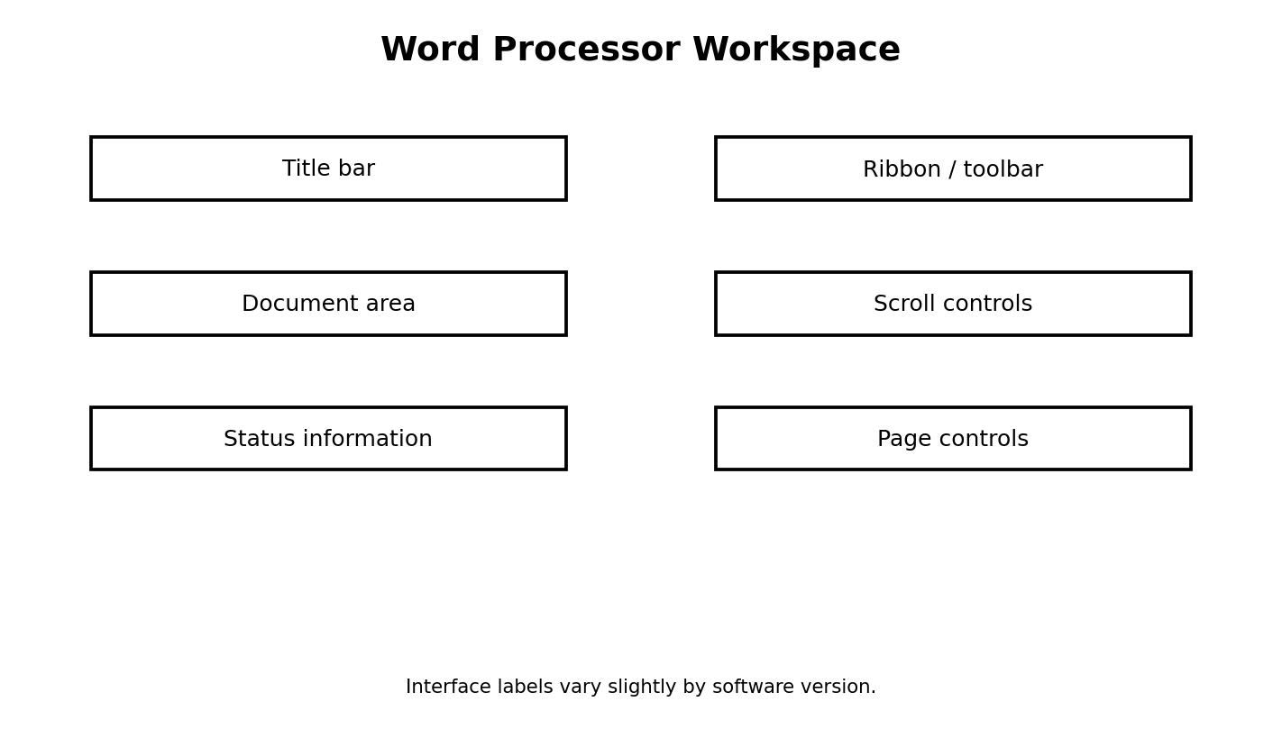
Figure 5.1: basic parts of a word-processing workspace
Illustration description: A labelled mock interface showing title bar, toolbar, document area, scroll controls and status information.

5.2 Creating and Saving a Document
Begin with a clear filename and save the document in an appropriate folder. Save frequently as you work. When a document contains important school work, keep a second copy where permitted.
Editing means changing existing content. You can insert text, delete text, copy, cut, paste and undo mistakes. These operations are basic building blocks for efficient document creation.
- Open Word or a compatible word processor.
- Create a blank document.
- Type a short paragraph about your school.
- Save it as “JSS1_School_Introduction”.
- Continue editing and save again.

5.3 Formatting Text
Formatting changes the appearance of content without changing its meaning. Common text formatting includes font family, size, bold, italic, underline and font colour. Students should use formatting to improve communication rather than decorate every line.
A professional document uses a limited set of consistent choices. Headings should be easy to notice, body text should be comfortable to read, and emphasis should be used only where it is useful.
WATCH OUT!
Avoid using many fonts, colours and special effects in a single school document. Too much formatting can make an important message harder to read.

5.4 Paragraphs, Alignment and Spacing
Paragraph formatting controls how blocks of text are arranged. Alignment may be left, centred, right or justified. Line spacing controls the vertical space between lines, while paragraph spacing controls space before or after paragraphs.
Indentation can move a paragraph inward from the margin. Bullets and numbered lists help organise information clearly.
Table 5.1: Useful paragraph tools
Tool | Typical use
Left alignment | General body text
Centre alignment | Titles or short labels
Justification | Formal text in some documents
Bullets | Unordered points
Numbering | Steps or ranked items
Indentation | Quotations or nested information

5.5 Pictures, Tables and Page Setup
Pictures can make documents more informative when they explain or support the text. Insert an image, resize it proportionally and choose an appropriate text-wrapping option. Avoid stretching pictures until they look distorted.
Tables organise information into rows and columns. Page setup controls paper size, orientation and margins. These choices matter when a document will be printed.
- Insert a suitable school photograph or permitted illustration.
- Add a two-column table containing three school rules and their reasons.
- Adjust the page margins if instructed.
- Insert a footer containing your name and class.

5.6 Practical Project: School Notice
Create a one-page school notice titled “Digital Laboratory Safety Week”. Include a clear heading, short introduction, five safety rules, one relevant image, a small table and your name/class at the bottom.
Review the document using spelling tools and read it aloud before printing or submitting it.
CREATE
Your teacher may display strong examples in the laboratory. Explain which design choices made the best notice easy to read.

- Plan the content before typing.
- Create the heading and body text.
- Use consistent formatting.
- Insert the image and table.
- Proofread carefully.
- Save using a meaningful filename.

Practical Activity
Objective: Apply the main skill from this chapter in a controlled classroom task.
Materials/software: Use the school laboratory, permitted software, exercise files and teacher-approved resources.
Procedure: Review the relevant worked example, perform the task step by step, save your work, then check the expected result.
Expected result: A complete and correctly saved practical product that demonstrates the skill taught in this chapter.
Reflection: What step was easiest? What step was most difficult? What would you improve after receiving feedback?

Guided Practice
- Repeat the main skill with a new example.
- Compare your result with a partner or model answer.
- Correct one error you found.

Student Practice
- Complete a similar task independently.
- Explain the result in your own words.
- Save the work using a clear filename.

Challenge Activity
Adapt the practical task to a new situation in your school or community. Explain why your solution is appropriate and identify one limitation.

Project
Project title: Chapter 5 Applied Digital Project
Problem statement: Use the chapter skill to create a useful digital product or solution for a school-related need.
Requirements: clear objective, appropriate tools, correct procedure, saved output and a short explanation.
Assessment criteria: accuracy, completeness, presentation, responsible use of technology and ability to explain the work.
Extension: Add one improvement that makes the solution more useful or accessible.

Chapter Summary
This chapter introduced the main concepts, showed how they work in practical situations and provided opportunities to apply them. Review the key terms and repeat the practical activity until you can perform it with minimal assistance.

Worked Example and Extended Practice
Worked Example: Imagine a Nigerian school where a practical problem related to introduction to microsoft word: creating digital documents has been identified. The teacher first states the goal in simple language, lists the available resources and decides what a successful result should look like. Students then carry out the task in small stages, checking their work after each stage. This approach reduces errors and makes it easier to improve the final product.
Step 1 — Understand the task: underline the important words in the question and identify what must be produced. Step 2 — Plan: choose the appropriate tool, information and sequence. Step 3 — Perform: work carefully and save at sensible points. Step 4 — Check: compare the result with the requirements. Step 5 — Improve: correct mistakes and make one useful improvement.
COMMON MISTAKES
Typical beginner errors include skipping instructions, choosing a tool before understanding the task, failing to save work, using unclear filenames, ignoring a safety rule, and submitting a result without checking it. A strong learner learns to notice these mistakes early and correct them.

Practice Scenario: Your teacher gives you a new task related to this chapter but does not tell you every button to press. Explain what you would do before asking for help. A good response should include identifying the goal, recalling a similar procedure, checking available menus or help resources, trying a safe first step, and asking a clear question if the problem remains.
Table 5.X: Skills checklist
Skill | Beginning | Developing | Independent
I can explain the main idea | Need help | Can explain with prompts | Can explain clearly
I can perform the basic task | Need step-by-step help | Can complete most steps | Can work independently
I can check my result | Rarely checks | Checks when reminded | Always checks and corrects
I can work responsibly | Needs reminders | Usually follows rules | Consistently follows rules

Discussion and Critical Thinking
- Why is planning useful before starting a digital task?
- What could happen if a person uses the right tool but follows the wrong procedure?
- Which part of this chapter would be most useful in your school, and why?
- How could you teach one skill from this chapter to a younger learner?
- What change would make the practical activity easier to understand without making it too easy?

Independent Mini-Task
Design a small personal practice task based on this chapter. Write the objective, materials or software, five to eight steps, the expected result and one way to test the result. Complete the task, save the evidence of your work and write three sentences describing what you improved after testing.

Teacher Demonstration Prompt
Demonstrate one complete task without performing unrelated steps. Pause at the points where students must make a decision, ask a prediction question, then continue. End by showing how the final result is checked.

Extended Practice Workshop
Case Study: A student is asked to complete a new task involving introduction to microsoft word: creating digital documents. The student has the basic tools but no step-by-step answer. Before touching the computer, the student identifies the goal, chooses the most suitable resource, predicts the result and lists the checks that will prove the work is correct. This is the habit of an independent digital learner.
Worked practice: 1) Read the task twice. 2) Circle the important requirements. 3) Separate the task into smaller actions. 4) Complete one action at a time. 5) Save after important changes. 6) Test the result using at least one example. 7) Correct any error. 8) Explain what you learned.
Application task: Rewrite the chapter activity for a different school situation. For example, a document skill can be applied to a club notice, a data skill to a class survey, a network skill to a laboratory diagram, an algorithm skill to a school routine, or a programming skill to an educational quiz. Your version should keep the same learning objective while changing the context.
Table 5.Y: Practice quality checklist
Question | Yes / Not yet | Evidence
Did I understand the task? |  | Written plan
Did I use an appropriate tool? |  | Tool selected
Did I follow a safe procedure? |  | Safety check
Did I test the result? |  | Test example
Did I improve the work? |  | Change made
REFLECT
The most important improvement you can make as a digital learner is to become comfortable with testing. A first attempt does not need to be perfect. What matters is that you can identify what happened, explain why it happened and make a sensible improvement.

ASSESSMENT
Complete the objective, theory and practical tasks below. Your teacher may select some items for continuous assessment.

A. Objective Questions
1. Which statement best describes the main purpose of the topic in this chapter? (A) Option A (B) Option B (C) Option C (D) Option D
2. Which option is an example rather than a definition of the concept studied? (A) Option A (B) Option B (C) Option C (D) Option D
3. Which action is the safest or most effective procedure in the practical activity? (A) Option A (B) Option B (C) Option C (D) Option D
4. Which pair is correctly matched? (A) Option A (B) Option B (C) Option C (D) Option D
5. Which sequence shows the correct order of the process? (A) Option A (B) Option B (C) Option C (D) Option D
6. What would most likely happen if an important step were skipped? (A) Option A (B) Option B (C) Option C (D) Option D
7. Which statement shows responsible use of digital technology? (A) Option A (B) Option B (C) Option C (D) Option D
8. Which result would you expect after completing the practical task? (A) Option A (B) Option B (C) Option C (D) Option D
B. Theory Questions
- Define two important terms from this chapter in your own words.
- Explain one real-life use of the main skill learned in this chapter.
- Describe the steps you would follow to complete the practical activity safely.
- State two common mistakes and explain how to avoid them.
C. Practical Questions
- Perform the main practical task from the chapter using the software available in your laboratory.
- Save your work with a meaningful filename and show the finished result to your teacher.
- Explain one improvement you would make to your work after testing it.
CHAPTER REVIEW
- Write five facts you remember from the chapter.
- Write three things you can now do that you could not do before the lesson.
- Choose one idea from the chapter and explain how it could help a Nigerian school or community.
- What question do you still have about the topic?

CHAPTER 6: Presentation Software with Microsoft PowerPoint
Learning Objectives
- explain the purpose of presentation software;
- create and organise slides;
- use themes, layouts, images and simple transitions;
- prepare speaker notes and deliver a short presentation;
- identify common presentation mistakes and correct them;
Key Terms: Presentation Software with Microsoft PowerPoint
Introduction: This chapter connects the topic to everyday school and community experiences. Read the explanations carefully, then complete the practical tasks with teacher supervision.

6.1 What Makes a Good Presentation?
Presentation software allows a speaker to organise ideas into slides for an audience. A good presentation has a clear purpose, suitable structure, readable slides and confident delivery. The computer does not replace the speaker; it supports communication.
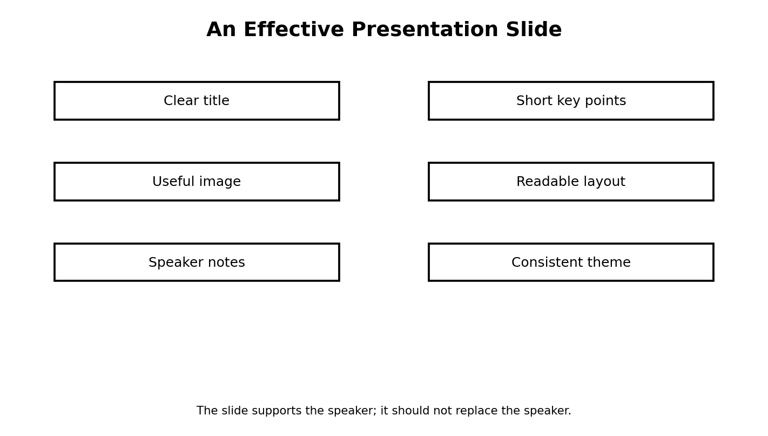
Figure 6.1: parts of an effective presentation slide
Illustration description: A slide diagram highlighting title, short points, image, readable layout, notes and consistent theme.

6.2 Creating Slides
Start with a simple outline: title, introduction, main points, conclusion. Choose a layout that matches the content. A title-and-content layout can support short lists, while an image-based layout can support visual explanation.
Keep the amount of text on each slide limited. The audience should listen to the speaker and use the slide to understand the key idea.
- One main idea per slide when practical.
- Use large, readable text.
- Use images that genuinely support the message.
- Keep design choices consistent.

6.3 Themes, Images and Shapes
A theme provides a coordinated visual style. You can insert pictures, shapes, icons and other elements to support explanation. Images should be clear and relevant. Shapes can be used to build simple diagrams and process illustrations.
When using online images, respect copyright and school rules. Prefer your own images, permitted educational resources or media that can legally be reused.
TECH TIP
Before choosing a picture, ask: Does it help the audience understand the point? If the answer is no, remove it.

6.4 Transitions and Animations
A transition controls how one slide changes to another. An animation affects an object on a slide. Both can be useful, but excessive effects distract the audience.
Use animation to reveal a sequence or focus attention, not simply to make every object spin or fly in.
Table 6.1: Presentation effects
Feature | Best use | Common problem
Transition | Smooth movement between slides | Using a different effect on every slide
Animation | Revealing a process step by step | Excessive movement
Theme | Consistent design | Choosing a theme that reduces readability

6.5 Speaker Notes and Delivery
Speaker notes provide reminders that may not appear on the audience slide. During delivery, maintain eye contact, speak clearly, stand in a balanced position and explain ideas in your own words.
Practise before presenting. Timing matters. A student who knows the content but speaks too quickly may still be difficult to understand.
- Read through your slides without presenting.
- Practise speaking while looking at your notes.
- Time the presentation.
- Reduce any crowded slide.
- Present to a partner and collect feedback.

6.6 Project: Nigeria in Five Slides
Create a five-slide presentation titled “My Nigeria”. Suggested slides: title, location and people, culture, a technology example, and a conclusion about responsible citizenship. Use at least one image and one simple diagram.
Your teacher should assess organisation, accuracy, readability, design, speaking and correct saving of the file.
THINK ABOUT IT
What should a speaker do when the projector stops working? Explain why a good presentation should still be understandable without the technology.

Practical Activity
Objective: Apply the main skill from this chapter in a controlled classroom task.
Materials/software: Use the school laboratory, permitted software, exercise files and teacher-approved resources.
Procedure: Review the relevant worked example, perform the task step by step, save your work, then check the expected result.
Expected result: A complete and correctly saved practical product that demonstrates the skill taught in this chapter.
Reflection: What step was easiest? What step was most difficult? What would you improve after receiving feedback?

Guided Practice
- Repeat the main skill with a new example.
- Compare your result with a partner or model answer.
- Correct one error you found.

Student Practice
- Complete a similar task independently.
- Explain the result in your own words.
- Save the work using a clear filename.

Challenge Activity
Adapt the practical task to a new situation in your school or community. Explain why your solution is appropriate and identify one limitation.

Project
Project title: Chapter 6 Applied Digital Project
Problem statement: Use the chapter skill to create a useful digital product or solution for a school-related need.
Requirements: clear objective, appropriate tools, correct procedure, saved output and a short explanation.
Assessment criteria: accuracy, completeness, presentation, responsible use of technology and ability to explain the work.
Extension: Add one improvement that makes the solution more useful or accessible.

Chapter Summary
This chapter introduced the main concepts, showed how they work in practical situations and provided opportunities to apply them. Review the key terms and repeat the practical activity until you can perform it with minimal assistance.

Worked Example and Extended Practice
Worked Example: Imagine a Nigerian school where a practical problem related to presentation software with microsoft powerpoint has been identified. The teacher first states the goal in simple language, lists the available resources and decides what a successful result should look like. Students then carry out the task in small stages, checking their work after each stage. This approach reduces errors and makes it easier to improve the final product.
Step 1 — Understand the task: underline the important words in the question and identify what must be produced. Step 2 — Plan: choose the appropriate tool, information and sequence. Step 3 — Perform: work carefully and save at sensible points. Step 4 — Check: compare the result with the requirements. Step 5 — Improve: correct mistakes and make one useful improvement.
COMMON MISTAKES
Typical beginner errors include skipping instructions, choosing a tool before understanding the task, failing to save work, using unclear filenames, ignoring a safety rule, and submitting a result without checking it. A strong learner learns to notice these mistakes early and correct them.

Practice Scenario: Your teacher gives you a new task related to this chapter but does not tell you every button to press. Explain what you would do before asking for help. A good response should include identifying the goal, recalling a similar procedure, checking available menus or help resources, trying a safe first step, and asking a clear question if the problem remains.
Table 6.X: Skills checklist
Skill | Beginning | Developing | Independent
I can explain the main idea | Need help | Can explain with prompts | Can explain clearly
I can perform the basic task | Need step-by-step help | Can complete most steps | Can work independently
I can check my result | Rarely checks | Checks when reminded | Always checks and corrects
I can work responsibly | Needs reminders | Usually follows rules | Consistently follows rules

Discussion and Critical Thinking
- Why is planning useful before starting a digital task?
- What could happen if a person uses the right tool but follows the wrong procedure?
- Which part of this chapter would be most useful in your school, and why?
- How could you teach one skill from this chapter to a younger learner?
- What change would make the practical activity easier to understand without making it too easy?

Independent Mini-Task
Design a small personal practice task based on this chapter. Write the objective, materials or software, five to eight steps, the expected result and one way to test the result. Complete the task, save the evidence of your work and write three sentences describing what you improved after testing.

Teacher Demonstration Prompt
Demonstrate one complete task without performing unrelated steps. Pause at the points where students must make a decision, ask a prediction question, then continue. End by showing how the final result is checked.

Extended Practice Workshop
Case Study: A student is asked to complete a new task involving presentation software with microsoft powerpoint. The student has the basic tools but no step-by-step answer. Before touching the computer, the student identifies the goal, chooses the most suitable resource, predicts the result and lists the checks that will prove the work is correct. This is the habit of an independent digital learner.
Worked practice: 1) Read the task twice. 2) Circle the important requirements. 3) Separate the task into smaller actions. 4) Complete one action at a time. 5) Save after important changes. 6) Test the result using at least one example. 7) Correct any error. 8) Explain what you learned.
Application task: Rewrite the chapter activity for a different school situation. For example, a document skill can be applied to a club notice, a data skill to a class survey, a network skill to a laboratory diagram, an algorithm skill to a school routine, or a programming skill to an educational quiz. Your version should keep the same learning objective while changing the context.
Table 6.Y: Practice quality checklist
Question | Yes / Not yet | Evidence
Did I understand the task? |  | Written plan
Did I use an appropriate tool? |  | Tool selected
Did I follow a safe procedure? |  | Safety check
Did I test the result? |  | Test example
Did I improve the work? |  | Change made
REFLECT
The most important improvement you can make as a digital learner is to become comfortable with testing. A first attempt does not need to be perfect. What matters is that you can identify what happened, explain why it happened and make a sensible improvement.

ASSESSMENT
Complete the objective, theory and practical tasks below. Your teacher may select some items for continuous assessment.

A. Objective Questions
1. Which statement best describes the main purpose of the topic in this chapter? (A) Option A (B) Option B (C) Option C (D) Option D
2. Which option is an example rather than a definition of the concept studied? (A) Option A (B) Option B (C) Option C (D) Option D
3. Which action is the safest or most effective procedure in the practical activity? (A) Option A (B) Option B (C) Option C (D) Option D
4. Which pair is correctly matched? (A) Option A (B) Option B (C) Option C (D) Option D
5. Which sequence shows the correct order of the process? (A) Option A (B) Option B (C) Option C (D) Option D
6. What would most likely happen if an important step were skipped? (A) Option A (B) Option B (C) Option C (D) Option D
7. Which statement shows responsible use of digital technology? (A) Option A (B) Option B (C) Option C (D) Option D
8. Which result would you expect after completing the practical task? (A) Option A (B) Option B (C) Option C (D) Option D
B. Theory Questions
- Define two important terms from this chapter in your own words.
- Explain one real-life use of the main skill learned in this chapter.
- Describe the steps you would follow to complete the practical activity safely.
- State two common mistakes and explain how to avoid them.
C. Practical Questions
- Perform the main practical task from the chapter using the software available in your laboratory.
- Save your work with a meaningful filename and show the finished result to your teacher.
- Explain one improvement you would make to your work after testing it.
CHAPTER REVIEW
- Write five facts you remember from the chapter.
- Write three things you can now do that you could not do before the lesson.
- Choose one idea from the chapter and explain how it could help a Nigerian school or community.
- What question do you still have about the topic?

CHAPTER 7: 3D Modelling with Paint 3D and Introductory Digital Media
Learning Objectives
- explain the basic idea of 2D and 3D digital graphics;
- identify common Paint 3D tools and their purposes;
- create simple 3D objects from basic shapes;
- save and export a digital drawing appropriately;
- understand how digital media combines text, images, audio, video and animation;
Key Terms: D Modelling with Paint , D and Introductory Digital Media
Introduction: This chapter connects the topic to everyday school and community experiences. Read the explanations carefully, then complete the practical tasks with teacher supervision.

7.1 Digital Graphics and 3D Modelling
Digital graphics are images created or edited using digital tools. A two-dimensional image has width and height. A three-dimensional model represents width, height and depth. Paint 3D is an example of software that can introduce beginners to 3D objects and digital drawing.
The goal is not to create professional 3D animation at JSS1. The goal is to understand spatial thinking, basic shapes, simple design choices and digital file handling.

7.2 Paint 3D Workspace
Software interfaces may differ by version, but common actions include selecting tools, choosing colours, drawing or placing shapes, resizing objects and saving the result. Teachers should demonstrate the installed version in the laboratory before students begin.
Start with simple objects: a box, cylinder, sphere-like form and combined shapes. Encourage students to think about front, side and top views when appropriate.

7.3 Creating a Simple 3D Object
Choose a basic shape, place it on the canvas, resize it, change its colour and add another shape. The student should observe how overlapping shapes can create more complex forms.
A good beginner project is a simple digital classroom object such as a pencil holder, a computer mouse model or a small house. Keep the design simple enough to finish during a lesson.
- Open the installed 3D drawing application.
- Choose a basic 3D shape.
- Resize and colour the shape.
- Add one more shape.
- Move the shapes to create a simple object.
- Save the work using a meaningful filename.

7.4 Digital Media Elements
Digital media includes text, images, graphics, audio, video and animation. Multimedia combines multiple media types in one communication experience. A short educational presentation containing text, images and audio is a simple multimedia product.
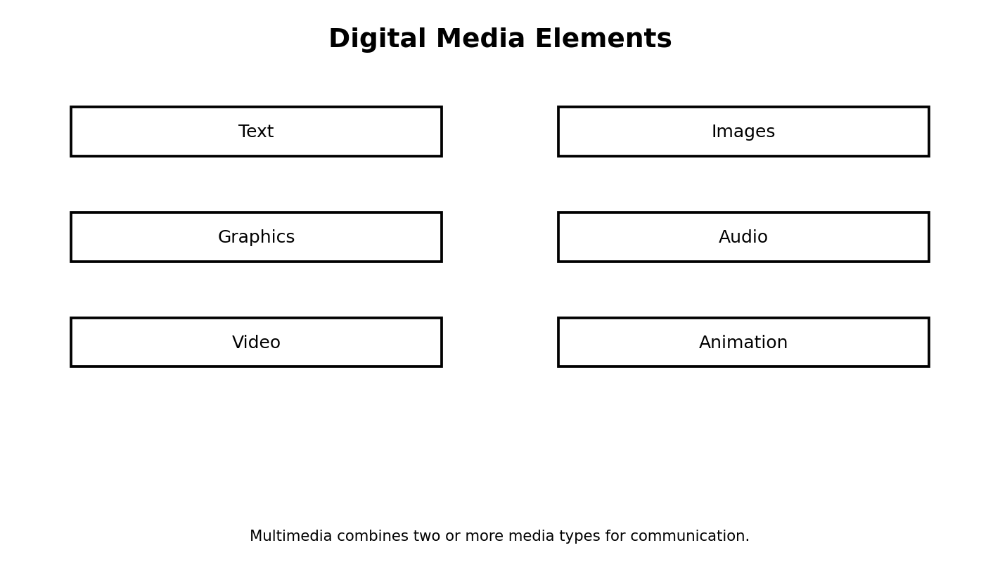
Figure 7.4: digital media elements
Illustration description: A classification diagram showing text, images, graphics, audio, video and animation as major media elements.

7.5 Responsible Media Creation
Good digital media is accurate, respectful and purposeful. Students should avoid using another person’s photo, voice or creative work without permission when permission is required. Personal information should not be displayed unnecessarily.
Before publishing a media product, check spelling, captions, volume, image quality and the accuracy of the message.
WATCH OUT!
Never create or share media that humiliates another person. A joke can become harmful when it is shared without consent.

7.6 Project: Digital Classroom Model
Create a simple 3D model of one classroom object. Add a short title label and export or save the project in the format supported by your software. Then explain the design choices you made.
Students without access to Paint 3D can complete the same learning objective using another permitted beginner 3D drawing tool.
TRY THIS
Make a second version of the object. Change one feature and explain whether the new version is better for its intended purpose.

Practical Activity
Objective: Apply the main skill from this chapter in a controlled classroom task.
Materials/software: Use the school laboratory, permitted software, exercise files and teacher-approved resources.
Procedure: Review the relevant worked example, perform the task step by step, save your work, then check the expected result.
Expected result: A complete and correctly saved practical product that demonstrates the skill taught in this chapter.
Reflection: What step was easiest? What step was most difficult? What would you improve after receiving feedback?

Guided Practice
- Repeat the main skill with a new example.
- Compare your result with a partner or model answer.
- Correct one error you found.

Student Practice
- Complete a similar task independently.
- Explain the result in your own words.
- Save the work using a clear filename.

Challenge Activity
Adapt the practical task to a new situation in your school or community. Explain why your solution is appropriate and identify one limitation.

Project
Project title: Chapter 7 Applied Digital Project
Problem statement: Use the chapter skill to create a useful digital product or solution for a school-related need.
Requirements: clear objective, appropriate tools, correct procedure, saved output and a short explanation.
Assessment criteria: accuracy, completeness, presentation, responsible use of technology and ability to explain the work.
Extension: Add one improvement that makes the solution more useful or accessible.

Chapter Summary
This chapter introduced the main concepts, showed how they work in practical situations and provided opportunities to apply them. Review the key terms and repeat the practical activity until you can perform it with minimal assistance.

Worked Example and Extended Practice
Worked Example: Imagine a Nigerian school where a practical problem related to 3d modelling with paint 3d and introductory digital media has been identified. The teacher first states the goal in simple language, lists the available resources and decides what a successful result should look like. Students then carry out the task in small stages, checking their work after each stage. This approach reduces errors and makes it easier to improve the final product.
Step 1 — Understand the task: underline the important words in the question and identify what must be produced. Step 2 — Plan: choose the appropriate tool, information and sequence. Step 3 — Perform: work carefully and save at sensible points. Step 4 — Check: compare the result with the requirements. Step 5 — Improve: correct mistakes and make one useful improvement.
COMMON MISTAKES
Typical beginner errors include skipping instructions, choosing a tool before understanding the task, failing to save work, using unclear filenames, ignoring a safety rule, and submitting a result without checking it. A strong learner learns to notice these mistakes early and correct them.

Practice Scenario: Your teacher gives you a new task related to this chapter but does not tell you every button to press. Explain what you would do before asking for help. A good response should include identifying the goal, recalling a similar procedure, checking available menus or help resources, trying a safe first step, and asking a clear question if the problem remains.
Table 7.X: Skills checklist
Skill | Beginning | Developing | Independent
I can explain the main idea | Need help | Can explain with prompts | Can explain clearly
I can perform the basic task | Need step-by-step help | Can complete most steps | Can work independently
I can check my result | Rarely checks | Checks when reminded | Always checks and corrects
I can work responsibly | Needs reminders | Usually follows rules | Consistently follows rules

Discussion and Critical Thinking
- Why is planning useful before starting a digital task?
- What could happen if a person uses the right tool but follows the wrong procedure?
- Which part of this chapter would be most useful in your school, and why?
- How could you teach one skill from this chapter to a younger learner?
- What change would make the practical activity easier to understand without making it too easy?

Independent Mini-Task
Design a small personal practice task based on this chapter. Write the objective, materials or software, five to eight steps, the expected result and one way to test the result. Complete the task, save the evidence of your work and write three sentences describing what you improved after testing.

Teacher Demonstration Prompt
Demonstrate one complete task without performing unrelated steps. Pause at the points where students must make a decision, ask a prediction question, then continue. End by showing how the final result is checked.

ASSESSMENT
Complete the objective, theory and practical tasks below. Your teacher may select some items for continuous assessment.

A. Objective Questions
1. Which statement best describes the main purpose of the topic in this chapter? (A) Option A (B) Option B (C) Option C (D) Option D
2. Which option is an example rather than a definition of the concept studied? (A) Option A (B) Option B (C) Option C (D) Option D
3. Which action is the safest or most effective procedure in the practical activity? (A) Option A (B) Option B (C) Option C (D) Option D
4. Which pair is correctly matched? (A) Option A (B) Option B (C) Option C (D) Option D
5. Which sequence shows the correct order of the process? (A) Option A (B) Option B (C) Option C (D) Option D
6. What would most likely happen if an important step were skipped? (A) Option A (B) Option B (C) Option C (D) Option D
7. Which statement shows responsible use of digital technology? (A) Option A (B) Option B (C) Option C (D) Option D
8. Which result would you expect after completing the practical task? (A) Option A (B) Option B (C) Option C (D) Option D
B. Theory Questions
- Define two important terms from this chapter in your own words.
- Explain one real-life use of the main skill learned in this chapter.
- Describe the steps you would follow to complete the practical activity safely.
- State two common mistakes and explain how to avoid them.
C. Practical Questions
- Perform the main practical task from the chapter using the software available in your laboratory.
- Save your work with a meaningful filename and show the finished result to your teacher.
- Explain one improvement you would make to your work after testing it.
CHAPTER REVIEW
- Write five facts you remember from the chapter.
- Write three things you can now do that you could not do before the lesson.
- Choose one idea from the chapter and explain how it could help a Nigerian school or community.
- What question do you still have about the topic?

PART THREE: DATA, COMMUNICATION AND INTERNET

CHAPTER 8: Data Processing and Information
Learning Objectives
- distinguish data from information;
- describe the stages of a basic data-processing cycle;
- identify common ways data are collected and organised;
- perform simple data entry and checking activities;
- explain why accurate data matter in schools and daily life;
Key Terms: Data Processing and Information
Introduction: This chapter connects the topic to everyday school and community experiences. Read the explanations carefully, then complete the practical tasks with teacher supervision.

8.1 Data and Information
Data are recorded facts or observations. A list of student scores, names, dates or temperatures can be data. Information is data that has been processed or organised so that it becomes meaningful for a purpose.
The distinction depends on context. A single number may be data. When the number is interpreted as a score, average or attendance count, it can contribute to useful information.

8.2 The Data-Processing Cycle
Data processing involves collecting data, checking it, entering or encoding it, processing it, interpreting the results and communicating useful findings. Modern computers can perform many of these steps quickly, but human judgement is still needed to decide what data to collect and how the results should be used.
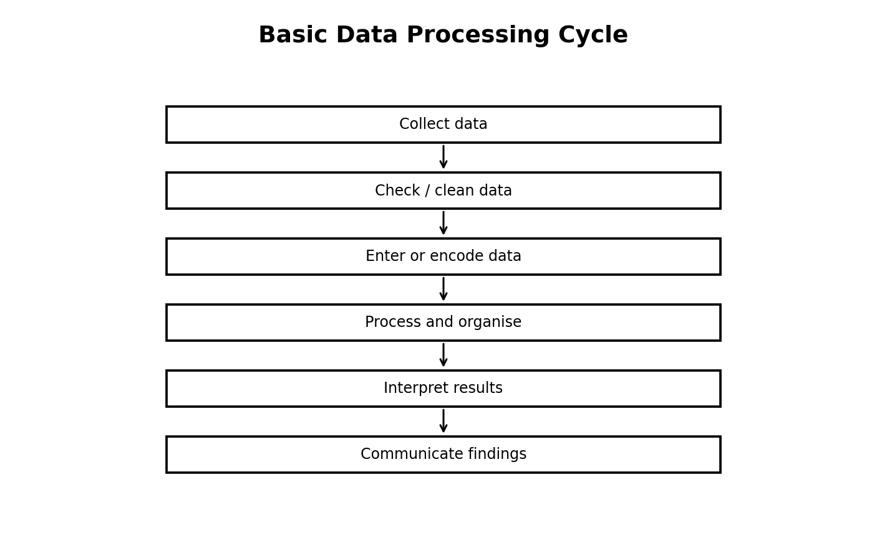
Figure 8.2: the basic data-processing cycle
Illustration description: A flowchart from collection through checking, entry, processing, interpretation and communication.

8.3 Data Collection
Data can be collected by observation, interviews, questionnaires, forms, measurements and existing records. The method should match the question being asked. If a teacher wants to know which transport methods students use to reach school, a simple questionnaire may be useful.
Table 8.1: Example data collection methods
Method | Example use | Strength
Observation | Count how many computers are working | Direct evidence
Questionnaire | Ask students about study habits | Can collect many responses
Measurement | Record temperature or distance | Produces numerical values
Existing records | Review attendance records | Uses information already available

8.4 Data Accuracy and Cleaning
Incorrect data can lead to incorrect decisions. Data cleaning includes checking for missing values, impossible entries, duplicated records and typing mistakes. In a school score sheet, a mark outside the permitted range should be checked before results are calculated.
Students should also think about bias. If a survey asks only one small group, its results may not represent the entire class.
THINK ABOUT IT
Why is “garbage in, garbage out” a useful warning when working with computers?

8.5 Simple Processing Example
Suppose five students obtain the following scores in a short quiz: 8, 6, 9, 7 and 10 out of 10. The data are the individual scores. The class average is a processed result.
Add the scores: 8 + 6 + 9 + 7 + 10 = 40. There are five scores, so the average is 40 ÷ 5 = 8. The average provides a simple summary of the group’s performance.
TRY THIS
Create a small table of ten fictional quiz scores. Calculate the total and average by hand, then verify the answer using a spreadsheet.

Table 8.2: Worked data example
Student | Score
Amina | 8
Bala | 6
Chinedu | 9
Dayo | 7
Efe | 10

8.6 Practical Data Project
Collect a small set of non-sensitive classroom data with your teacher’s approval, such as favourite school club, number of books read in a month or scores in a short practice quiz. Enter the data into a table, check the entries and produce a short summary.
Do not collect passwords, medical information or other private details for a classroom activity. Use only information appropriate for the educational purpose.
- Define the question.
- Choose the data to collect.
- Collect the information fairly.
- Enter it in a simple table.
- Check for mistakes.
- Calculate at least one useful summary.
- Write two conclusions supported by the data.

Practical Activity
Objective: Apply the main skill from this chapter in a controlled classroom task.
Materials/software: Use the school laboratory, permitted software, exercise files and teacher-approved resources.
Procedure: Review the relevant worked example, perform the task step by step, save your work, then check the expected result.
Expected result: A complete and correctly saved practical product that demonstrates the skill taught in this chapter.
Reflection: What step was easiest? What step was most difficult? What would you improve after receiving feedback?

Guided Practice
- Repeat the main skill with a new example.
- Compare your result with a partner or model answer.
- Correct one error you found.

Student Practice
- Complete a similar task independently.
- Explain the result in your own words.
- Save the work using a clear filename.

Challenge Activity
Adapt the practical task to a new situation in your school or community. Explain why your solution is appropriate and identify one limitation.

Project
Project title: Chapter 8 Applied Digital Project
Problem statement: Use the chapter skill to create a useful digital product or solution for a school-related need.
Requirements: clear objective, appropriate tools, correct procedure, saved output and a short explanation.
Assessment criteria: accuracy, completeness, presentation, responsible use of technology and ability to explain the work.
Extension: Add one improvement that makes the solution more useful or accessible.

Chapter Summary
This chapter introduced the main concepts, showed how they work in practical situations and provided opportunities to apply them. Review the key terms and repeat the practical activity until you can perform it with minimal assistance.

Worked Example and Extended Practice
Worked Example: Imagine a Nigerian school where a practical problem related to data processing and information has been identified. The teacher first states the goal in simple language, lists the available resources and decides what a successful result should look like. Students then carry out the task in small stages, checking their work after each stage. This approach reduces errors and makes it easier to improve the final product.
Step 1 — Understand the task: underline the important words in the question and identify what must be produced. Step 2 — Plan: choose the appropriate tool, information and sequence. Step 3 — Perform: work carefully and save at sensible points. Step 4 — Check: compare the result with the requirements. Step 5 — Improve: correct mistakes and make one useful improvement.
COMMON MISTAKES
Typical beginner errors include skipping instructions, choosing a tool before understanding the task, failing to save work, using unclear filenames, ignoring a safety rule, and submitting a result without checking it. A strong learner learns to notice these mistakes early and correct them.

Practice Scenario: Your teacher gives you a new task related to this chapter but does not tell you every button to press. Explain what you would do before asking for help. A good response should include identifying the goal, recalling a similar procedure, checking available menus or help resources, trying a safe first step, and asking a clear question if the problem remains.
Table 8.X: Skills checklist
Skill | Beginning | Developing | Independent
I can explain the main idea | Need help | Can explain with prompts | Can explain clearly
I can perform the basic task | Need step-by-step help | Can complete most steps | Can work independently
I can check my result | Rarely checks | Checks when reminded | Always checks and corrects
I can work responsibly | Needs reminders | Usually follows rules | Consistently follows rules

Discussion and Critical Thinking
- Why is planning useful before starting a digital task?
- What could happen if a person uses the right tool but follows the wrong procedure?
- Which part of this chapter would be most useful in your school, and why?
- How could you teach one skill from this chapter to a younger learner?
- What change would make the practical activity easier to understand without making it too easy?

Independent Mini-Task
Design a small personal practice task based on this chapter. Write the objective, materials or software, five to eight steps, the expected result and one way to test the result. Complete the task, save the evidence of your work and write three sentences describing what you improved after testing.

Teacher Demonstration Prompt
Demonstrate one complete task without performing unrelated steps. Pause at the points where students must make a decision, ask a prediction question, then continue. End by showing how the final result is checked.

Extended Practice Workshop
Case Study: A student is asked to complete a new task involving data processing and information. The student has the basic tools but no step-by-step answer. Before touching the computer, the student identifies the goal, chooses the most suitable resource, predicts the result and lists the checks that will prove the work is correct. This is the habit of an independent digital learner.
Worked practice: 1) Read the task twice. 2) Circle the important requirements. 3) Separate the task into smaller actions. 4) Complete one action at a time. 5) Save after important changes. 6) Test the result using at least one example. 7) Correct any error. 8) Explain what you learned.
Application task: Rewrite the chapter activity for a different school situation. For example, a document skill can be applied to a club notice, a data skill to a class survey, a network skill to a laboratory diagram, an algorithm skill to a school routine, or a programming skill to an educational quiz. Your version should keep the same learning objective while changing the context.
Table 8.Y: Practice quality checklist
Question | Yes / Not yet | Evidence
Did I understand the task? |  | Written plan
Did I use an appropriate tool? |  | Tool selected
Did I follow a safe procedure? |  | Safety check
Did I test the result? |  | Test example
Did I improve the work? |  | Change made
REFLECT
The most important improvement you can make as a digital learner is to become comfortable with testing. A first attempt does not need to be perfect. What matters is that you can identify what happened, explain why it happened and make a sensible improvement.

ASSESSMENT
Complete the objective, theory and practical tasks below. Your teacher may select some items for continuous assessment.

A. Objective Questions
1. Which statement best describes the main purpose of the topic in this chapter? (A) Option A (B) Option B (C) Option C (D) Option D
2. Which option is an example rather than a definition of the concept studied? (A) Option A (B) Option B (C) Option C (D) Option D
3. Which action is the safest or most effective procedure in the practical activity? (A) Option A (B) Option B (C) Option C (D) Option D
4. Which pair is correctly matched? (A) Option A (B) Option B (C) Option C (D) Option D
5. Which sequence shows the correct order of the process? (A) Option A (B) Option B (C) Option C (D) Option D
6. What would most likely happen if an important step were skipped? (A) Option A (B) Option B (C) Option C (D) Option D
7. Which statement shows responsible use of digital technology? (A) Option A (B) Option B (C) Option C (D) Option D
8. Which result would you expect after completing the practical task? (A) Option A (B) Option B (C) Option C (D) Option D
B. Theory Questions
- Define two important terms from this chapter in your own words.
- Explain one real-life use of the main skill learned in this chapter.
- Describe the steps you would follow to complete the practical activity safely.
- State two common mistakes and explain how to avoid them.
C. Practical Questions
- Perform the main practical task from the chapter using the software available in your laboratory.
- Save your work with a meaningful filename and show the finished result to your teacher.
- Explain one improvement you would make to your work after testing it.
CHAPTER REVIEW
- Write five facts you remember from the chapter.
- Write three things you can now do that you could not do before the lesson.
- Choose one idea from the chapter and explain how it could help a Nigerian school or community.
- What question do you still have about the topic?

CHAPTER 9: Basic Computer Communication and Networks
Learning Objectives
- explain computer communication;
- distinguish wired and wireless communication;
- define a computer network and identify common components;
- describe basic network types such as LAN and WAN;
- explain why schools and businesses use networks;
Key Terms: Basic Computer Communication and Networks
Introduction: This chapter connects the topic to everyday school and community experiences. Read the explanations carefully, then complete the practical tasks with teacher supervision.

9.1 Communication with Computers
Communication is the exchange of information between people or devices. Computer communication occurs when digital devices exchange data using a wired or wireless method. Examples include sending a file from one computer to another, printing over a network or sending an email.
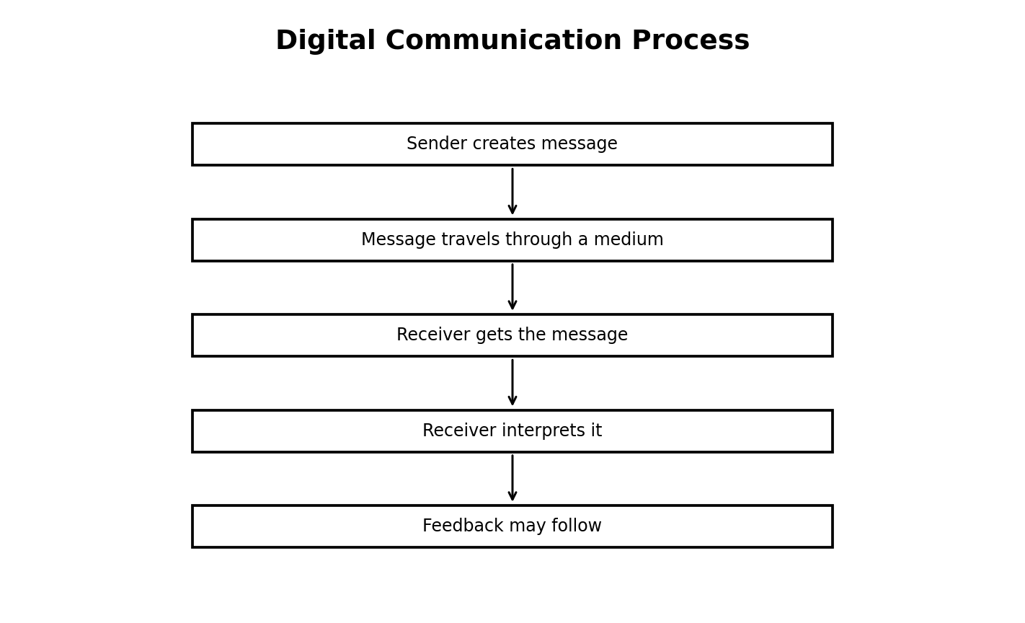
Figure 9.1: a basic digital communication process
Illustration description: Sender, message, communication medium, receiver and feedback are shown as a simple process.

9.2 Wired and Wireless Communication
Wired communication uses a physical connection such as a network cable. Wireless communication uses radio or other wireless methods to exchange data without a direct cable between communicating devices. Wi-Fi and Bluetooth are common examples of wireless technologies.
Each method has advantages and limitations. Cables can provide reliable connections but reduce mobility. Wireless connections are convenient but can be affected by range, interference and security settings.
Table 9.1: Wired and wireless communication
Feature | Wired | Wireless
Connection | Physical cable | Radio / wireless signal
Mobility | Lower | Higher
Typical school use | Desktop network | Wi-Fi access
Main concern | Cable condition | Signal range and security

9.3 What Is a Computer Network?
A computer network is a group of connected devices that can communicate and share resources. The devices may include computers, printers, phones, servers and networking equipment. A school network can allow multiple computers to access a printer or shared service.
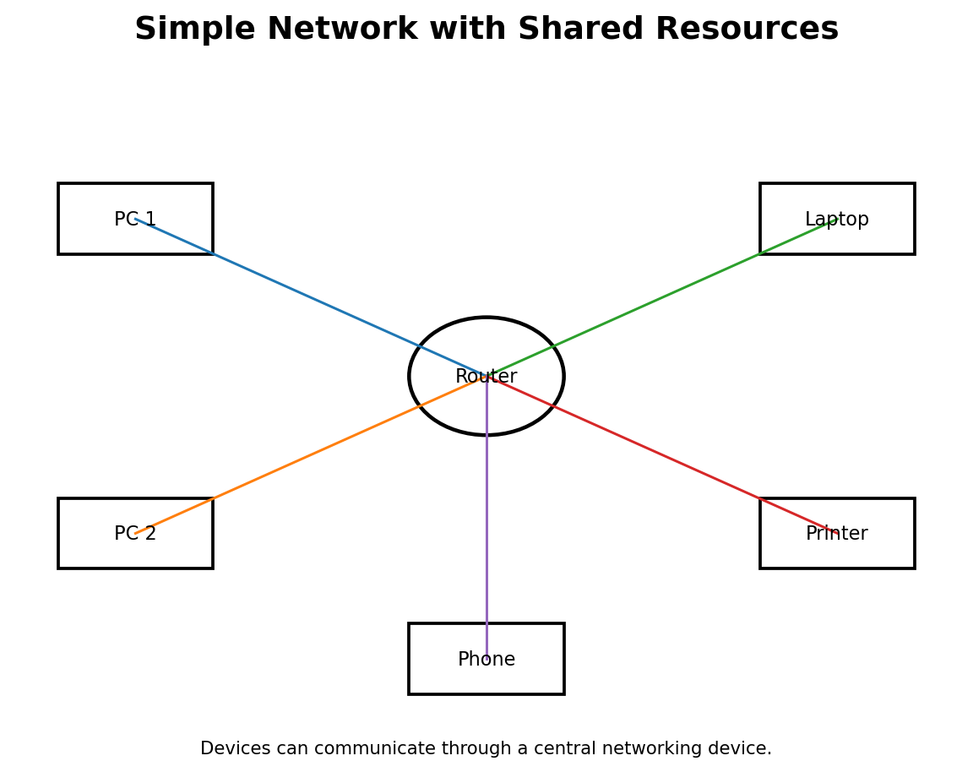
Figure 9.3: a simple network
Illustration description: A central network device connected to computers, a printer and a phone.

9.4 Network Components
Network components include the devices being connected and the equipment used to move data. A router helps direct traffic between networks. A switch can connect multiple devices on a local network. Network cables and wireless access points provide connection methods.
Students do not need to configure enterprise networks at JSS1. The goal is to recognise the parts and understand why they are used.

9.5 Types of Networks
A LAN, or Local Area Network, connects devices in a limited area such as a classroom, office or school building. A WAN, or Wide Area Network, connects networks across a larger geographical area. The Internet can be described as a very large interconnected system of networks.
Table 9.2: Simple network comparison
Type | Coverage | Example
LAN | Small area | School computer laboratory
WAN | Large geographical area | Networks connecting distant offices
Internet | Interconnected networks worldwide | Access to web and online services

9.6 Practical Network Observation
Observe your school laboratory network without changing any settings. Identify computers, printers, networking equipment and visible cables or wireless access points. Draw a simple diagram showing how the devices may be connected.
Do not unplug cables, change router settings or connect unauthorised devices. The activity is observational.
WATCH OUT!
A network problem should be reported. Do not reset networking equipment simply because a website fails to open.

- List the visible devices.
- Classify each by role.
- Draw the central connection point if one is visible.
- Add labels and a title.
- Explain two benefits of the network to your school.

Practical Activity
Objective: Apply the main skill from this chapter in a controlled classroom task.
Materials/software: Use the school laboratory, permitted software, exercise files and teacher-approved resources.
Procedure: Review the relevant worked example, perform the task step by step, save your work, then check the expected result.
Expected result: A complete and correctly saved practical product that demonstrates the skill taught in this chapter.
Reflection: What step was easiest? What step was most difficult? What would you improve after receiving feedback?

Guided Practice
- Repeat the main skill with a new example.
- Compare your result with a partner or model answer.
- Correct one error you found.

Student Practice
- Complete a similar task independently.
- Explain the result in your own words.
- Save the work using a clear filename.

Challenge Activity
Adapt the practical task to a new situation in your school or community. Explain why your solution is appropriate and identify one limitation.

Project
Project title: Chapter 9 Applied Digital Project
Problem statement: Use the chapter skill to create a useful digital product or solution for a school-related need.
Requirements: clear objective, appropriate tools, correct procedure, saved output and a short explanation.
Assessment criteria: accuracy, completeness, presentation, responsible use of technology and ability to explain the work.
Extension: Add one improvement that makes the solution more useful or accessible.

Chapter Summary
This chapter introduced the main concepts, showed how they work in practical situations and provided opportunities to apply them. Review the key terms and repeat the practical activity until you can perform it with minimal assistance.

Worked Example and Extended Practice
Worked Example: Imagine a Nigerian school where a practical problem related to basic computer communication and networks has been identified. The teacher first states the goal in simple language, lists the available resources and decides what a successful result should look like. Students then carry out the task in small stages, checking their work after each stage. This approach reduces errors and makes it easier to improve the final product.
Step 1 — Understand the task: underline the important words in the question and identify what must be produced. Step 2 — Plan: choose the appropriate tool, information and sequence. Step 3 — Perform: work carefully and save at sensible points. Step 4 — Check: compare the result with the requirements. Step 5 — Improve: correct mistakes and make one useful improvement.
COMMON MISTAKES
Typical beginner errors include skipping instructions, choosing a tool before understanding the task, failing to save work, using unclear filenames, ignoring a safety rule, and submitting a result without checking it. A strong learner learns to notice these mistakes early and correct them.

Practice Scenario: Your teacher gives you a new task related to this chapter but does not tell you every button to press. Explain what you would do before asking for help. A good response should include identifying the goal, recalling a similar procedure, checking available menus or help resources, trying a safe first step, and asking a clear question if the problem remains.
Table 9.X: Skills checklist
Skill | Beginning | Developing | Independent
I can explain the main idea | Need help | Can explain with prompts | Can explain clearly
I can perform the basic task | Need step-by-step help | Can complete most steps | Can work independently
I can check my result | Rarely checks | Checks when reminded | Always checks and corrects
I can work responsibly | Needs reminders | Usually follows rules | Consistently follows rules

Discussion and Critical Thinking
- Why is planning useful before starting a digital task?
- What could happen if a person uses the right tool but follows the wrong procedure?
- Which part of this chapter would be most useful in your school, and why?
- How could you teach one skill from this chapter to a younger learner?
- What change would make the practical activity easier to understand without making it too easy?

Independent Mini-Task
Design a small personal practice task based on this chapter. Write the objective, materials or software, five to eight steps, the expected result and one way to test the result. Complete the task, save the evidence of your work and write three sentences describing what you improved after testing.

Teacher Demonstration Prompt
Demonstrate one complete task without performing unrelated steps. Pause at the points where students must make a decision, ask a prediction question, then continue. End by showing how the final result is checked.

Extended Practice Workshop
Case Study: A student is asked to complete a new task involving basic computer communication and networks. The student has the basic tools but no step-by-step answer. Before touching the computer, the student identifies the goal, chooses the most suitable resource, predicts the result and lists the checks that will prove the work is correct. This is the habit of an independent digital learner.
Worked practice: 1) Read the task twice. 2) Circle the important requirements. 3) Separate the task into smaller actions. 4) Complete one action at a time. 5) Save after important changes. 6) Test the result using at least one example. 7) Correct any error. 8) Explain what you learned.
Application task: Rewrite the chapter activity for a different school situation. For example, a document skill can be applied to a club notice, a data skill to a class survey, a network skill to a laboratory diagram, an algorithm skill to a school routine, or a programming skill to an educational quiz. Your version should keep the same learning objective while changing the context.
Table 9.Y: Practice quality checklist
Question | Yes / Not yet | Evidence
Did I understand the task? |  | Written plan
Did I use an appropriate tool? |  | Tool selected
Did I follow a safe procedure? |  | Safety check
Did I test the result? |  | Test example
Did I improve the work? |  | Change made
REFLECT
The most important improvement you can make as a digital learner is to become comfortable with testing. A first attempt does not need to be perfect. What matters is that you can identify what happened, explain why it happened and make a sensible improvement.

ASSESSMENT
Complete the objective, theory and practical tasks below. Your teacher may select some items for continuous assessment.

A. Objective Questions
1. Which statement best describes the main purpose of the topic in this chapter? (A) Option A (B) Option B (C) Option C (D) Option D
2. Which option is an example rather than a definition of the concept studied? (A) Option A (B) Option B (C) Option C (D) Option D
3. Which action is the safest or most effective procedure in the practical activity? (A) Option A (B) Option B (C) Option C (D) Option D
4. Which pair is correctly matched? (A) Option A (B) Option B (C) Option C (D) Option D
5. Which sequence shows the correct order of the process? (A) Option A (B) Option B (C) Option C (D) Option D
6. What would most likely happen if an important step were skipped? (A) Option A (B) Option B (C) Option C (D) Option D
7. Which statement shows responsible use of digital technology? (A) Option A (B) Option B (C) Option C (D) Option D
8. Which result would you expect after completing the practical task? (A) Option A (B) Option B (C) Option C (D) Option D
B. Theory Questions
- Define two important terms from this chapter in your own words.
- Explain one real-life use of the main skill learned in this chapter.
- Describe the steps you would follow to complete the practical activity safely.
- State two common mistakes and explain how to avoid them.
C. Practical Questions
- Perform the main practical task from the chapter using the software available in your laboratory.
- Save your work with a meaningful filename and show the finished result to your teacher.
- Explain one improvement you would make to your work after testing it.
CHAPTER REVIEW
- Write five facts you remember from the chapter.
- Write three things you can now do that you could not do before the lesson.
- Choose one idea from the chapter and explain how it could help a Nigerian school or community.
- What question do you still have about the topic?

CHAPTER 10: Internet Basics, Web Browsing and Online Research
Learning Objectives
- define the Internet and World Wide Web at a basic level;
- identify browsers, websites, web pages, URLs and search engines;
- perform simple web searches using useful keywords;
- evaluate online information before using it;
- save or cite useful sources responsibly;
Key Terms: Internet Basics, Web Browsing and Online Research
Introduction: This chapter connects the topic to everyday school and community experiences. Read the explanations carefully, then complete the practical tasks with teacher supervision.

10.1 The Internet and the Web
The Internet is a large interconnected network of networks. The World Wide Web is a service that uses the Internet to provide linked web pages and other resources. These terms are related but not identical.
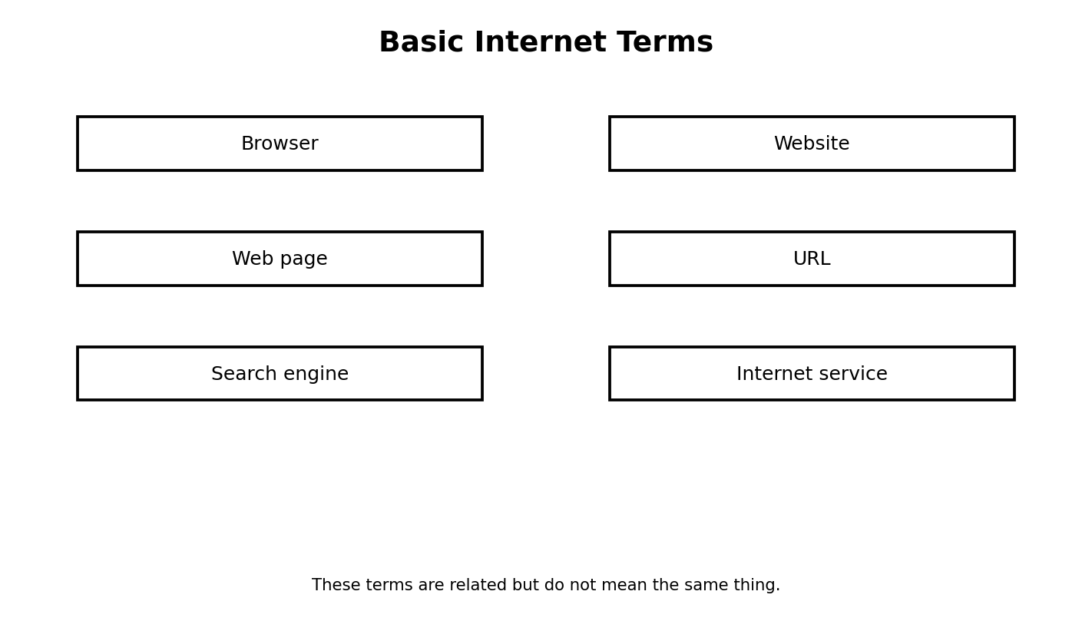
Figure 10.1: basic Internet terms
Illustration description: Boxes showing browser, website, web page, URL, search engine and Internet service.

10.2 Browsers, Websites and URLs
A web browser is software used to access and interact with web pages. A website is a collection of related web pages and resources under a particular web address or domain. A URL is a web address used to locate a resource.
Students should learn to read a web address carefully. A website name in a search result does not automatically mean that the information is accurate.

10.3 Search Engines and Keywords
Search engines help users discover information by matching queries with indexed resources. Effective searching begins with clear keywords. A query such as “benefits of recycling in schools Nigeria” is usually more useful than “recycling”.
Use specific terms, quotation marks where helpful, and additional words to narrow results. Read more than one source when the topic matters.

10.4 Checking Online Information
Online information can be incomplete, outdated, inaccurate or intentionally misleading. Students should consider who published the information, when it was published or updated, what evidence is provided and whether other reliable sources agree.
A page with attractive graphics is not automatically trustworthy. Evidence and source quality matter more than appearance.
- Check the author or organisation.
- Look for a date.
- Compare important claims with another credible source.
- Watch for exaggerated headlines.
- Distinguish fact from opinion or advertising.

10.5 Saving and Citing Sources
When using online information for schoolwork, keep a record of the source title and web address as required by your teacher. Summarise information in your own words and give credit to the source. Copying another person’s words or ideas without acknowledgement can be plagiarism.
KEY IDEA
Research is not the same as copying. Research means finding information, evaluating it, understanding it and using it responsibly.

10.6 Mini Research Project
Choose a simple school topic such as “ways to save electricity in a computer laboratory”. Find information from at least three credible sources. Compare the sources, write a short summary in your own words and create three presentation slides.
Your teacher should check whether the sources are relevant, whether the claims are supported and whether the final work gives credit to sources used.
- Write the research question.
- Search using specific keywords.
- Open several results.
- Record source details.
- Compare the evidence.
- Write a concise summary.
- Create the presentation and rehearse it.

Practical Activity
Objective: Apply the main skill from this chapter in a controlled classroom task.
Materials/software: Use the school laboratory, permitted software, exercise files and teacher-approved resources.
Procedure: Review the relevant worked example, perform the task step by step, save your work, then check the expected result.
Expected result: A complete and correctly saved practical product that demonstrates the skill taught in this chapter.
Reflection: What step was easiest? What step was most difficult? What would you improve after receiving feedback?

Guided Practice
- Repeat the main skill with a new example.
- Compare your result with a partner or model answer.
- Correct one error you found.

Student Practice
- Complete a similar task independently.
- Explain the result in your own words.
- Save the work using a clear filename.

Challenge Activity
Adapt the practical task to a new situation in your school or community. Explain why your solution is appropriate and identify one limitation.

Project
Project title: Chapter 10 Applied Digital Project
Problem statement: Use the chapter skill to create a useful digital product or solution for a school-related need.
Requirements: clear objective, appropriate tools, correct procedure, saved output and a short explanation.
Assessment criteria: accuracy, completeness, presentation, responsible use of technology and ability to explain the work.
Extension: Add one improvement that makes the solution more useful or accessible.

Chapter Summary
This chapter introduced the main concepts, showed how they work in practical situations and provided opportunities to apply them. Review the key terms and repeat the practical activity until you can perform it with minimal assistance.

Worked Example and Extended Practice
Worked Example: Imagine a Nigerian school where a practical problem related to internet basics, web browsing and online research has been identified. The teacher first states the goal in simple language, lists the available resources and decides what a successful result should look like. Students then carry out the task in small stages, checking their work after each stage. This approach reduces errors and makes it easier to improve the final product.
Step 1 — Understand the task: underline the important words in the question and identify what must be produced. Step 2 — Plan: choose the appropriate tool, information and sequence. Step 3 — Perform: work carefully and save at sensible points. Step 4 — Check: compare the result with the requirements. Step 5 — Improve: correct mistakes and make one useful improvement.
COMMON MISTAKES
Typical beginner errors include skipping instructions, choosing a tool before understanding the task, failing to save work, using unclear filenames, ignoring a safety rule, and submitting a result without checking it. A strong learner learns to notice these mistakes early and correct them.

Practice Scenario: Your teacher gives you a new task related to this chapter but does not tell you every button to press. Explain what you would do before asking for help. A good response should include identifying the goal, recalling a similar procedure, checking available menus or help resources, trying a safe first step, and asking a clear question if the problem remains.
Table 10.X: Skills checklist
Skill | Beginning | Developing | Independent
I can explain the main idea | Need help | Can explain with prompts | Can explain clearly
I can perform the basic task | Need step-by-step help | Can complete most steps | Can work independently
I can check my result | Rarely checks | Checks when reminded | Always checks and corrects
I can work responsibly | Needs reminders | Usually follows rules | Consistently follows rules

Discussion and Critical Thinking
- Why is planning useful before starting a digital task?
- What could happen if a person uses the right tool but follows the wrong procedure?
- Which part of this chapter would be most useful in your school, and why?
- How could you teach one skill from this chapter to a younger learner?
- What change would make the practical activity easier to understand without making it too easy?

Independent Mini-Task
Design a small personal practice task based on this chapter. Write the objective, materials or software, five to eight steps, the expected result and one way to test the result. Complete the task, save the evidence of your work and write three sentences describing what you improved after testing.

Teacher Demonstration Prompt
Demonstrate one complete task without performing unrelated steps. Pause at the points where students must make a decision, ask a prediction question, then continue. End by showing how the final result is checked.

Extended Practice Workshop
Case Study: A student is asked to complete a new task involving internet basics, web browsing and online research. The student has the basic tools but no step-by-step answer. Before touching the computer, the student identifies the goal, chooses the most suitable resource, predicts the result and lists the checks that will prove the work is correct. This is the habit of an independent digital learner.
Worked practice: 1) Read the task twice. 2) Circle the important requirements. 3) Separate the task into smaller actions. 4) Complete one action at a time. 5) Save after important changes. 6) Test the result using at least one example. 7) Correct any error. 8) Explain what you learned.
Application task: Rewrite the chapter activity for a different school situation. For example, a document skill can be applied to a club notice, a data skill to a class survey, a network skill to a laboratory diagram, an algorithm skill to a school routine, or a programming skill to an educational quiz. Your version should keep the same learning objective while changing the context.
Table 10.Y: Practice quality checklist
Question | Yes / Not yet | Evidence
Did I understand the task? |  | Written plan
Did I use an appropriate tool? |  | Tool selected
Did I follow a safe procedure? |  | Safety check
Did I test the result? |  | Test example
Did I improve the work? |  | Change made
REFLECT
The most important improvement you can make as a digital learner is to become comfortable with testing. A first attempt does not need to be perfect. What matters is that you can identify what happened, explain why it happened and make a sensible improvement.

ASSESSMENT
Complete the objective, theory and practical tasks below. Your teacher may select some items for continuous assessment.

A. Objective Questions
1. Which statement best describes the main purpose of the topic in this chapter? (A) Option A (B) Option B (C) Option C (D) Option D
2. Which option is an example rather than a definition of the concept studied? (A) Option A (B) Option B (C) Option C (D) Option D
3. Which action is the safest or most effective procedure in the practical activity? (A) Option A (B) Option B (C) Option C (D) Option D
4. Which pair is correctly matched? (A) Option A (B) Option B (C) Option C (D) Option D
5. Which sequence shows the correct order of the process? (A) Option A (B) Option B (C) Option C (D) Option D
6. What would most likely happen if an important step were skipped? (A) Option A (B) Option B (C) Option C (D) Option D
7. Which statement shows responsible use of digital technology? (A) Option A (B) Option B (C) Option C (D) Option D
8. Which result would you expect after completing the practical task? (A) Option A (B) Option B (C) Option C (D) Option D
B. Theory Questions
- Define two important terms from this chapter in your own words.
- Explain one real-life use of the main skill learned in this chapter.
- Describe the steps you would follow to complete the practical activity safely.
- State two common mistakes and explain how to avoid them.
C. Practical Questions
- Perform the main practical task from the chapter using the software available in your laboratory.
- Save your work with a meaningful filename and show the finished result to your teacher.
- Explain one improvement you would make to your work after testing it.
CHAPTER REVIEW
- Write five facts you remember from the chapter.
- Write three things you can now do that you could not do before the lesson.
- Choose one idea from the chapter and explain how it could help a Nigerian school or community.
- What question do you still have about the topic?

CHAPTER 11: Digital Safety, Privacy, Ethics and Responsible Internet Use
Learning Objectives
- explain common digital safety risks;
- create and manage strong passwords responsibly;
- recognise phishing, malware and unsafe links;
- protect privacy and personal information;
- respond appropriately to cyberbullying and harmful content;
- explain basic copyright, plagiarism and ethical-use principles;
Key Terms: Digital Safety, Privacy, Ethics and Responsible Internet Use
Introduction: This chapter connects the topic to everyday school and community experiences. Read the explanations carefully, then complete the practical tasks with teacher supervision.

11.1 Why Digital Safety Matters
Digital tools can help people learn and communicate, but careless use can expose accounts, devices and personal information to harm. Digital safety means taking practical steps to reduce risk when using technology.
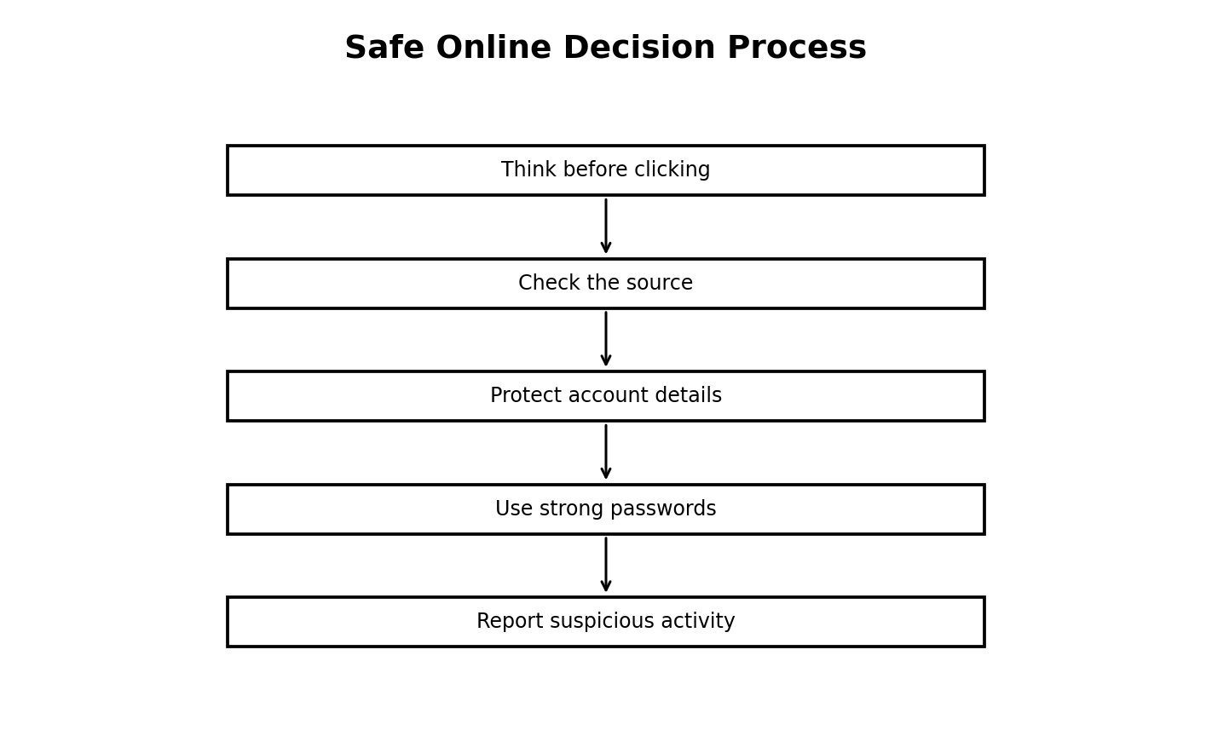
Figure 11.1: a safe online decision process
Illustration description: A sequence showing the habit of thinking, checking, protecting, reporting and responding.

11.2 Password Safety
A password should be difficult for other people to guess. Avoid obvious information such as your name, school, birthday or simple number patterns. Do not share passwords with friends simply because they ask. Where a service supports multi-factor authentication, it can provide an additional layer of protection.
Different important accounts should not all rely on the same password. Students should follow school and family guidance for password management.

11.3 Phishing, Malware and Suspicious Links
Phishing is a deceptive attempt to trick a person into revealing information or taking an unsafe action. The message may appear to come from a trusted organisation. Malware is malicious software designed to damage, disrupt or gain unauthorised access to systems or information.
Students should be cautious when a message demands urgent action, asks for a secret code, or directs them to an unexpected login page.
WATCH OUT!
A familiar logo or name does not prove that a message is genuine. Check the sender and the destination before clicking.

11.4 Privacy and Digital Footprints
Privacy concerns control over personal information. A digital footprint is the trail of information created by activities carried out online or with digital systems. Posts, comments, images and account activity can contribute to a person’s digital reputation.
Students should think before sharing. Not every photograph, location, school detail or personal story belongs on a public platform.

11.5 Cyberbullying and Respectful Communication
Cyberbullying involves repeated harmful or threatening behaviour carried out through digital communication. A responsible response may include saving evidence, blocking the sender, reporting the behaviour and telling a trusted adult or school authority.
Online communication should use the same basic values as face-to-face communication: respect, honesty, self-control and consideration for other people.
THINK ABOUT IT
Why is “I was only joking” not enough to excuse harmful online behaviour?

11.6 Ethics, Copyright and Plagiarism
Ethics concerns principles about what is right and responsible. Copyright gives creators legal rights over many original works. Plagiarism is presenting another person’s words or ideas as your own.
Students can respect creators by using permitted resources, giving credit, asking permission when required and producing original work. Digital technology makes copying easy, but easy copying does not make copying right.
- Name the creator or source when appropriate.
- Use permitted media.
- Paraphrase rather than copying large passages.
- Keep source notes while researching.
- Ask the teacher when you are unsure about permitted use.

Practical Activity
Objective: Apply the main skill from this chapter in a controlled classroom task.
Materials/software: Use the school laboratory, permitted software, exercise files and teacher-approved resources.
Procedure: Review the relevant worked example, perform the task step by step, save your work, then check the expected result.
Expected result: A complete and correctly saved practical product that demonstrates the skill taught in this chapter.
Reflection: What step was easiest? What step was most difficult? What would you improve after receiving feedback?

Guided Practice
- Repeat the main skill with a new example.
- Compare your result with a partner or model answer.
- Correct one error you found.

Student Practice
- Complete a similar task independently.
- Explain the result in your own words.
- Save the work using a clear filename.

Challenge Activity
Adapt the practical task to a new situation in your school or community. Explain why your solution is appropriate and identify one limitation.

Project
Project title: Chapter 11 Applied Digital Project
Problem statement: Use the chapter skill to create a useful digital product or solution for a school-related need.
Requirements: clear objective, appropriate tools, correct procedure, saved output and a short explanation.
Assessment criteria: accuracy, completeness, presentation, responsible use of technology and ability to explain the work.
Extension: Add one improvement that makes the solution more useful or accessible.

Chapter Summary
This chapter introduced the main concepts, showed how they work in practical situations and provided opportunities to apply them. Review the key terms and repeat the practical activity until you can perform it with minimal assistance.

Worked Example and Extended Practice
Worked Example: Imagine a Nigerian school where a practical problem related to digital safety, privacy, ethics and responsible internet use has been identified. The teacher first states the goal in simple language, lists the available resources and decides what a successful result should look like. Students then carry out the task in small stages, checking their work after each stage. This approach reduces errors and makes it easier to improve the final product.
Step 1 — Understand the task: underline the important words in the question and identify what must be produced. Step 2 — Plan: choose the appropriate tool, information and sequence. Step 3 — Perform: work carefully and save at sensible points. Step 4 — Check: compare the result with the requirements. Step 5 — Improve: correct mistakes and make one useful improvement.
COMMON MISTAKES
Typical beginner errors include skipping instructions, choosing a tool before understanding the task, failing to save work, using unclear filenames, ignoring a safety rule, and submitting a result without checking it. A strong learner learns to notice these mistakes early and correct them.

Practice Scenario: Your teacher gives you a new task related to this chapter but does not tell you every button to press. Explain what you would do before asking for help. A good response should include identifying the goal, recalling a similar procedure, checking available menus or help resources, trying a safe first step, and asking a clear question if the problem remains.
Table 11.X: Skills checklist
Skill | Beginning | Developing | Independent
I can explain the main idea | Need help | Can explain with prompts | Can explain clearly
I can perform the basic task | Need step-by-step help | Can complete most steps | Can work independently
I can check my result | Rarely checks | Checks when reminded | Always checks and corrects
I can work responsibly | Needs reminders | Usually follows rules | Consistently follows rules

Discussion and Critical Thinking
- Why is planning useful before starting a digital task?
- What could happen if a person uses the right tool but follows the wrong procedure?
- Which part of this chapter would be most useful in your school, and why?
- How could you teach one skill from this chapter to a younger learner?
- What change would make the practical activity easier to understand without making it too easy?

Independent Mini-Task
Design a small personal practice task based on this chapter. Write the objective, materials or software, five to eight steps, the expected result and one way to test the result. Complete the task, save the evidence of your work and write three sentences describing what you improved after testing.

Teacher Demonstration Prompt
Demonstrate one complete task without performing unrelated steps. Pause at the points where students must make a decision, ask a prediction question, then continue. End by showing how the final result is checked.

Extended Practice Workshop
Case Study: A student is asked to complete a new task involving digital safety, privacy, ethics and responsible internet use. The student has the basic tools but no step-by-step answer. Before touching the computer, the student identifies the goal, chooses the most suitable resource, predicts the result and lists the checks that will prove the work is correct. This is the habit of an independent digital learner.
Worked practice: 1) Read the task twice. 2) Circle the important requirements. 3) Separate the task into smaller actions. 4) Complete one action at a time. 5) Save after important changes. 6) Test the result using at least one example. 7) Correct any error. 8) Explain what you learned.
Application task: Rewrite the chapter activity for a different school situation. For example, a document skill can be applied to a club notice, a data skill to a class survey, a network skill to a laboratory diagram, an algorithm skill to a school routine, or a programming skill to an educational quiz. Your version should keep the same learning objective while changing the context.
Table 11.Y: Practice quality checklist
Question | Yes / Not yet | Evidence
Did I understand the task? |  | Written plan
Did I use an appropriate tool? |  | Tool selected
Did I follow a safe procedure? |  | Safety check
Did I test the result? |  | Test example
Did I improve the work? |  | Change made
REFLECT
The most important improvement you can make as a digital learner is to become comfortable with testing. A first attempt does not need to be perfect. What matters is that you can identify what happened, explain why it happened and make a sensible improvement.

ASSESSMENT
Complete the objective, theory and practical tasks below. Your teacher may select some items for continuous assessment.

A. Objective Questions
1. Which statement best describes the main purpose of the topic in this chapter? (A) Option A (B) Option B (C) Option C (D) Option D
2. Which option is an example rather than a definition of the concept studied? (A) Option A (B) Option B (C) Option C (D) Option D
3. Which action is the safest or most effective procedure in the practical activity? (A) Option A (B) Option B (C) Option C (D) Option D
4. Which pair is correctly matched? (A) Option A (B) Option B (C) Option C (D) Option D
5. Which sequence shows the correct order of the process? (A) Option A (B) Option B (C) Option C (D) Option D
6. What would most likely happen if an important step were skipped? (A) Option A (B) Option B (C) Option C (D) Option D
7. Which statement shows responsible use of digital technology? (A) Option A (B) Option B (C) Option C (D) Option D
8. Which result would you expect after completing the practical task? (A) Option A (B) Option B (C) Option C (D) Option D
B. Theory Questions
- Define two important terms from this chapter in your own words.
- Explain one real-life use of the main skill learned in this chapter.
- Describe the steps you would follow to complete the practical activity safely.
- State two common mistakes and explain how to avoid them.
C. Practical Questions
- Perform the main practical task from the chapter using the software available in your laboratory.
- Save your work with a meaningful filename and show the finished result to your teacher.
- Explain one improvement you would make to your work after testing it.
CHAPTER REVIEW
- Write five facts you remember from the chapter.
- Write three things you can now do that you could not do before the lesson.
- Choose one idea from the chapter and explain how it could help a Nigerian school or community.
- What question do you still have about the topic?

CHAPTER 12: Digital Media: Images, Audio, Video and Multimedia
Learning Objectives
- define digital media and multimedia;
- identify common image formats and basic image-editing actions;
- record and edit simple audio responsibly;
- plan a short educational video;
- combine media elements into a simple digital story;
Key Terms: Digital Media, Images, Audio, Video and Multimedia
Introduction: This chapter connects the topic to everyday school and community experiences. Read the explanations carefully, then complete the practical tasks with teacher supervision.

12.1 Understanding Digital Media
Digital media refers to information represented and communicated in digital form. Common media types include text, images, graphics, audio, video and animation. Multimedia combines two or more of these forms in one product.
Figure 12.1: digital media elements
Illustration description: A visual classification of the major digital media elements.

12.2 Basic Image Editing
Image editing can include cropping, resizing, rotating, adjusting brightness and making simple corrections. The purpose is usually to improve clarity or fit an image to a specific communication task.
Always preserve the original when the image is important. Work on a copy so that mistakes do not destroy the source file.
- Open a permitted image-editing tool.
- Import a practice image.
- Crop unnecessary edges.
- Resize the image for the intended use.
- Apply a simple adjustment.
- Save the edited copy with a clear filename.

12.3 Audio Recording
Audio can be recorded with a phone, computer or other supported device. Good recording practice includes choosing a quiet space, speaking close enough to the microphone, avoiding unnecessary background noise and checking the recording before sharing it.
Students should obtain consent before recording identifiable people for school projects when required by school policy.

12.4 Basic Video Editing
Simple video editing can involve trimming clips, arranging scenes, adding a title, inserting captions and using a small number of transitions. A short educational video should have a clear beginning, middle and end.
TECH TIP
Keep the message simple. A well-planned 60-second educational video can be more effective than a long video with no clear purpose.

12.5 Digital Storytelling
A digital story uses media to communicate a narrative or explanation. Students can combine a few images, short text, recorded narration and background sound where appropriate. A storyboard helps plan the sequence before editing begins.
Table 12.1: Storyboard example
Scene | Visual | Audio / narration
1 | Title card | Project title
2 | School environment | Short explanation
3 | Problem or question | Narration
4 | Solution or action | Key message
5 | Conclusion | Call to action / summary

12.6 Project: One-Minute Educational Media
Create a one-minute product explaining one school technology rule, such as safe charging of devices, careful password use or responsible Internet research. Use at least two media elements and include a clear title.
The project should be original, respectful and suitable for classroom sharing.
- Write the key message in one sentence.
- Create a five-part storyboard.
- Collect or create the media elements.
- Record or assemble the project.
- Review the sound, text and visuals.
- Export or save using the required format.

Practical Activity
Objective: Apply the main skill from this chapter in a controlled classroom task.
Materials/software: Use the school laboratory, permitted software, exercise files and teacher-approved resources.
Procedure: Review the relevant worked example, perform the task step by step, save your work, then check the expected result.
Expected result: A complete and correctly saved practical product that demonstrates the skill taught in this chapter.
Reflection: What step was easiest? What step was most difficult? What would you improve after receiving feedback?

Guided Practice
- Repeat the main skill with a new example.
- Compare your result with a partner or model answer.
- Correct one error you found.

Student Practice
- Complete a similar task independently.
- Explain the result in your own words.
- Save the work using a clear filename.

Challenge Activity
Adapt the practical task to a new situation in your school or community. Explain why your solution is appropriate and identify one limitation.

Project
Project title: Chapter 12 Applied Digital Project
Problem statement: Use the chapter skill to create a useful digital product or solution for a school-related need.
Requirements: clear objective, appropriate tools, correct procedure, saved output and a short explanation.
Assessment criteria: accuracy, completeness, presentation, responsible use of technology and ability to explain the work.
Extension: Add one improvement that makes the solution more useful or accessible.

Chapter Summary
This chapter introduced the main concepts, showed how they work in practical situations and provided opportunities to apply them. Review the key terms and repeat the practical activity until you can perform it with minimal assistance.

Worked Example and Extended Practice
Worked Example: Imagine a Nigerian school where a practical problem related to digital media: images, audio, video and multimedia has been identified. The teacher first states the goal in simple language, lists the available resources and decides what a successful result should look like. Students then carry out the task in small stages, checking their work after each stage. This approach reduces errors and makes it easier to improve the final product.
Step 1 — Understand the task: underline the important words in the question and identify what must be produced. Step 2 — Plan: choose the appropriate tool, information and sequence. Step 3 — Perform: work carefully and save at sensible points. Step 4 — Check: compare the result with the requirements. Step 5 — Improve: correct mistakes and make one useful improvement.
COMMON MISTAKES
Typical beginner errors include skipping instructions, choosing a tool before understanding the task, failing to save work, using unclear filenames, ignoring a safety rule, and submitting a result without checking it. A strong learner learns to notice these mistakes early and correct them.

Practice Scenario: Your teacher gives you a new task related to this chapter but does not tell you every button to press. Explain what you would do before asking for help. A good response should include identifying the goal, recalling a similar procedure, checking available menus or help resources, trying a safe first step, and asking a clear question if the problem remains.
Table 12.X: Skills checklist
Skill | Beginning | Developing | Independent
I can explain the main idea | Need help | Can explain with prompts | Can explain clearly
I can perform the basic task | Need step-by-step help | Can complete most steps | Can work independently
I can check my result | Rarely checks | Checks when reminded | Always checks and corrects
I can work responsibly | Needs reminders | Usually follows rules | Consistently follows rules

Discussion and Critical Thinking
- Why is planning useful before starting a digital task?
- What could happen if a person uses the right tool but follows the wrong procedure?
- Which part of this chapter would be most useful in your school, and why?
- How could you teach one skill from this chapter to a younger learner?
- What change would make the practical activity easier to understand without making it too easy?

Independent Mini-Task
Design a small personal practice task based on this chapter. Write the objective, materials or software, five to eight steps, the expected result and one way to test the result. Complete the task, save the evidence of your work and write three sentences describing what you improved after testing.

Teacher Demonstration Prompt
Demonstrate one complete task without performing unrelated steps. Pause at the points where students must make a decision, ask a prediction question, then continue. End by showing how the final result is checked.

ASSESSMENT
Complete the objective, theory and practical tasks below. Your teacher may select some items for continuous assessment.

A. Objective Questions
1. Which statement best describes the main purpose of the topic in this chapter? (A) Option A (B) Option B (C) Option C (D) Option D
2. Which option is an example rather than a definition of the concept studied? (A) Option A (B) Option B (C) Option C (D) Option D
3. Which action is the safest or most effective procedure in the practical activity? (A) Option A (B) Option B (C) Option C (D) Option D
4. Which pair is correctly matched? (A) Option A (B) Option B (C) Option C (D) Option D
5. Which sequence shows the correct order of the process? (A) Option A (B) Option B (C) Option C (D) Option D
6. What would most likely happen if an important step were skipped? (A) Option A (B) Option B (C) Option C (D) Option D
7. Which statement shows responsible use of digital technology? (A) Option A (B) Option B (C) Option C (D) Option D
8. Which result would you expect after completing the practical task? (A) Option A (B) Option B (C) Option C (D) Option D
B. Theory Questions
- Define two important terms from this chapter in your own words.
- Explain one real-life use of the main skill learned in this chapter.
- Describe the steps you would follow to complete the practical activity safely.
- State two common mistakes and explain how to avoid them.
C. Practical Questions
- Perform the main practical task from the chapter using the software available in your laboratory.
- Save your work with a meaningful filename and show the finished result to your teacher.
- Explain one improvement you would make to your work after testing it.
CHAPTER REVIEW
- Write five facts you remember from the chapter.
- Write three things you can now do that you could not do before the lesson.
- Choose one idea from the chapter and explain how it could help a Nigerian school or community.
- What question do you still have about the topic?

PART FOUR: PROGRAMMING AND EMERGING TECHNOLOGY

CHAPTER 13: Algorithms and Problem-Solving for Beginners
Learning Objectives
- explain computational problem-solving in simple terms;
- break problems into smaller parts;
- recognise patterns and important information;
- write step-by-step algorithms for everyday tasks;
- test and improve algorithms;
Key Terms: Algorithms and Problem-Solving for Beginners
Introduction: This chapter connects the topic to everyday school and community experiences. Read the explanations carefully, then complete the practical tasks with teacher supervision.

13.1 Thinking Like a Problem Solver
Problem solving begins with understanding the task. A good solution identifies the desired result, the information available and the steps needed to move from the starting point to the result.
KEY IDEA
An algorithm is a clear sequence of instructions for solving a problem or completing a task.

13.2 Decomposition and Pattern Recognition
Decomposition means breaking a large task into smaller, manageable parts. Pattern recognition means noticing similarities or repeated structures. These ideas are useful in both everyday problem solving and programming.
For example, “prepare for school” can be decomposed into checking the timetable, packing required materials, wearing the required uniform and preparing to leave on time.

13.3 Writing an Algorithm
An algorithm should be clear enough that another person could follow it. Steps should appear in a logical order. Important inputs should be identified, and ambiguous instructions should be avoided.
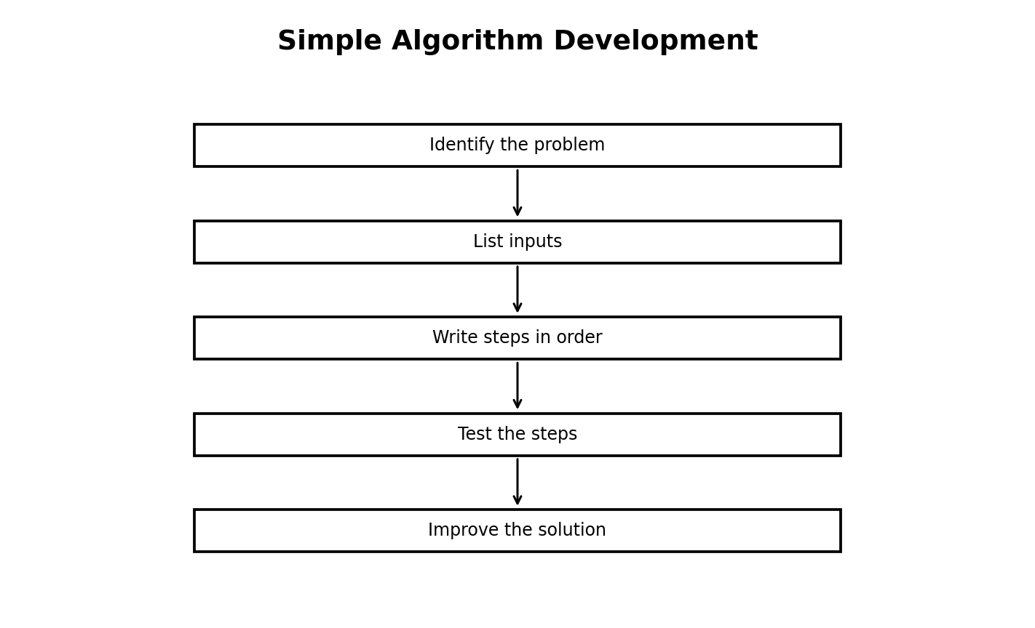
Figure 13.3: simple algorithm-development process
Illustration description: A flow from identifying a problem through inputs, ordered steps, testing and improvement.

13.4 Worked Example: Calculate an Average
Suppose a student wants to calculate the average of three scores. The inputs are the three scores. First add the scores. Then divide the total by 3. Finally display the average.
Algorithm: 1. Start. 2. Enter score 1. 3. Enter score 2. 4. Enter score 3. 5. Add the three scores. 6. Divide by 3. 7. Display the answer. 8. Stop.
TRY THIS
Write a similar algorithm for finding the total cost of three school items.

13.5 Testing and Debugging an Algorithm
A solution that looks correct on paper may fail when tested. Testing means trying the procedure with known examples. Debugging means finding and correcting problems.
If an average algorithm divides by the wrong number, the result will be wrong even though all the data may have been entered correctly.
Table 13.1: Simple test cases
Input | Expected result | Pass / fail
10, 20, 30 | 20 | Pass
5, 5, 5 | 5 | Pass
0, 10, 20 | 10 | Pass

13.6 Practical Algorithm Tasks
Write algorithms for three real-life tasks: washing a uniform item according to its care instructions, calculating the total cost of two items, and deciding whether a student has completed a required class task.
Exchange one algorithm with a partner. The partner follows the written steps literally and reports any unclear instruction. Rewrite the algorithm based on the feedback.
- Choose the task.
- Identify the starting information.
- Write the steps in order.
- Test with a partner.
- Correct ambiguous or missing steps.
- Submit the final algorithm.

Practical Activity
Objective: Apply the main skill from this chapter in a controlled classroom task.
Materials/software: Use the school laboratory, permitted software, exercise files and teacher-approved resources.
Procedure: Review the relevant worked example, perform the task step by step, save your work, then check the expected result.
Expected result: A complete and correctly saved practical product that demonstrates the skill taught in this chapter.
Reflection: What step was easiest? What step was most difficult? What would you improve after receiving feedback?

Guided Practice
- Repeat the main skill with a new example.
- Compare your result with a partner or model answer.
- Correct one error you found.

Student Practice
- Complete a similar task independently.
- Explain the result in your own words.
- Save the work using a clear filename.

Challenge Activity
Adapt the practical task to a new situation in your school or community. Explain why your solution is appropriate and identify one limitation.

Project
Project title: Chapter 13 Applied Digital Project
Problem statement: Use the chapter skill to create a useful digital product or solution for a school-related need.
Requirements: clear objective, appropriate tools, correct procedure, saved output and a short explanation.
Assessment criteria: accuracy, completeness, presentation, responsible use of technology and ability to explain the work.
Extension: Add one improvement that makes the solution more useful or accessible.

Chapter Summary
This chapter introduced the main concepts, showed how they work in practical situations and provided opportunities to apply them. Review the key terms and repeat the practical activity until you can perform it with minimal assistance.

Worked Example and Extended Practice
Worked Example: Imagine a Nigerian school where a practical problem related to algorithms and problem-solving for beginners has been identified. The teacher first states the goal in simple language, lists the available resources and decides what a successful result should look like. Students then carry out the task in small stages, checking their work after each stage. This approach reduces errors and makes it easier to improve the final product.
Step 1 — Understand the task: underline the important words in the question and identify what must be produced. Step 2 — Plan: choose the appropriate tool, information and sequence. Step 3 — Perform: work carefully and save at sensible points. Step 4 — Check: compare the result with the requirements. Step 5 — Improve: correct mistakes and make one useful improvement.
COMMON MISTAKES
Typical beginner errors include skipping instructions, choosing a tool before understanding the task, failing to save work, using unclear filenames, ignoring a safety rule, and submitting a result without checking it. A strong learner learns to notice these mistakes early and correct them.

Practice Scenario: Your teacher gives you a new task related to this chapter but does not tell you every button to press. Explain what you would do before asking for help. A good response should include identifying the goal, recalling a similar procedure, checking available menus or help resources, trying a safe first step, and asking a clear question if the problem remains.
Table 13.X: Skills checklist
Skill | Beginning | Developing | Independent
I can explain the main idea | Need help | Can explain with prompts | Can explain clearly
I can perform the basic task | Need step-by-step help | Can complete most steps | Can work independently
I can check my result | Rarely checks | Checks when reminded | Always checks and corrects
I can work responsibly | Needs reminders | Usually follows rules | Consistently follows rules

Discussion and Critical Thinking
- Why is planning useful before starting a digital task?
- What could happen if a person uses the right tool but follows the wrong procedure?
- Which part of this chapter would be most useful in your school, and why?
- How could you teach one skill from this chapter to a younger learner?
- What change would make the practical activity easier to understand without making it too easy?

Independent Mini-Task
Design a small personal practice task based on this chapter. Write the objective, materials or software, five to eight steps, the expected result and one way to test the result. Complete the task, save the evidence of your work and write three sentences describing what you improved after testing.

Teacher Demonstration Prompt
Demonstrate one complete task without performing unrelated steps. Pause at the points where students must make a decision, ask a prediction question, then continue. End by showing how the final result is checked.

Extended Practice Workshop
Case Study: A student is asked to complete a new task involving algorithms and problem-solving for beginners. The student has the basic tools but no step-by-step answer. Before touching the computer, the student identifies the goal, chooses the most suitable resource, predicts the result and lists the checks that will prove the work is correct. This is the habit of an independent digital learner.
Worked practice: 1) Read the task twice. 2) Circle the important requirements. 3) Separate the task into smaller actions. 4) Complete one action at a time. 5) Save after important changes. 6) Test the result using at least one example. 7) Correct any error. 8) Explain what you learned.
Application task: Rewrite the chapter activity for a different school situation. For example, a document skill can be applied to a club notice, a data skill to a class survey, a network skill to a laboratory diagram, an algorithm skill to a school routine, or a programming skill to an educational quiz. Your version should keep the same learning objective while changing the context.
Table 13.Y: Practice quality checklist
Question | Yes / Not yet | Evidence
Did I understand the task? |  | Written plan
Did I use an appropriate tool? |  | Tool selected
Did I follow a safe procedure? |  | Safety check
Did I test the result? |  | Test example
Did I improve the work? |  | Change made
REFLECT
The most important improvement you can make as a digital learner is to become comfortable with testing. A first attempt does not need to be perfect. What matters is that you can identify what happened, explain why it happened and make a sensible improvement.

ASSESSMENT
Complete the objective, theory and practical tasks below. Your teacher may select some items for continuous assessment.

A. Objective Questions
1. Which statement best describes the main purpose of the topic in this chapter? (A) Option A (B) Option B (C) Option C (D) Option D
2. Which option is an example rather than a definition of the concept studied? (A) Option A (B) Option B (C) Option C (D) Option D
3. Which action is the safest or most effective procedure in the practical activity? (A) Option A (B) Option B (C) Option C (D) Option D
4. Which pair is correctly matched? (A) Option A (B) Option B (C) Option C (D) Option D
5. Which sequence shows the correct order of the process? (A) Option A (B) Option B (C) Option C (D) Option D
6. What would most likely happen if an important step were skipped? (A) Option A (B) Option B (C) Option C (D) Option D
7. Which statement shows responsible use of digital technology? (A) Option A (B) Option B (C) Option C (D) Option D
8. Which result would you expect after completing the practical task? (A) Option A (B) Option B (C) Option C (D) Option D
B. Theory Questions
- Define two important terms from this chapter in your own words.
- Explain one real-life use of the main skill learned in this chapter.
- Describe the steps you would follow to complete the practical activity safely.
- State two common mistakes and explain how to avoid them.
C. Practical Questions
- Perform the main practical task from the chapter using the software available in your laboratory.
- Save your work with a meaningful filename and show the finished result to your teacher.
- Explain one improvement you would make to your work after testing it.
CHAPTER REVIEW
- Write five facts you remember from the chapter.
- Write three things you can now do that you could not do before the lesson.
- Choose one idea from the chapter and explain how it could help a Nigerian school or community.
- What question do you still have about the topic?

CHAPTER 14: Visual Programming: Variables, Conditions and Loops
Learning Objectives
- explain what programming is and why programs use instructions;
- describe the role of events, actions and blocks in visual programming;
- create and use simple variables;
- use conditions to make decisions;
- use loops to repeat actions;
- test and debug simple visual programs;
Key Terms: Visual Programming, Variables, Conditions and Loops
Introduction: This chapter connects the topic to everyday school and community experiences. Read the explanations carefully, then complete the practical tasks with teacher supervision.

14.1 What Is Programming?
Programming is the process of creating instructions that a computer can execute to perform a task. Visual programming uses blocks or graphical elements instead of requiring every instruction to be typed as text. Scratch is a common beginner environment.
The important ideas are still the same: sequence, input, output, decisions, repetition and data. Visual blocks make these ideas easier to see.
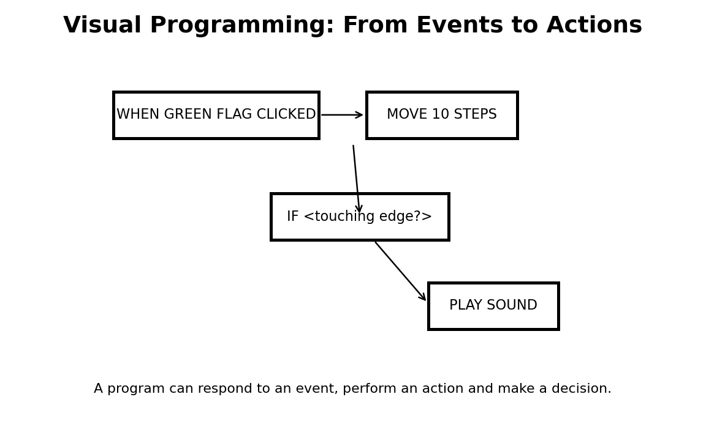
Figure 14.1: visual programming flow
Illustration description: A conceptual view of an event triggering actions, a decision and a sound response.

14.2 Events and Sequences
An event is something that starts or triggers part of a program. In Scratch, a student may use a green-flag event to start a project. A sequence is the order in which instructions are performed.
For example, when the project starts, a character can move, speak and play a sound in a particular order. Changing the order changes the behaviour.

14.3 Variables
A variable is a named place used by a program to store a value that may change. In a quiz game, a variable called “score” can hold the student’s current score.
Variable names should be meaningful. A name such as “score” communicates purpose more clearly than “x”. In visual programming, students can create a variable and change its value as the project runs.
KEY IDEA
A variable stores a value. The value can change while the program is running.

14.4 Conditions and Decisions
A condition is a statement that can be evaluated as true or false. Programs use conditions to choose what to do. For example, if the player’s score is greater than or equal to 5, the game may display “You win”. Otherwise it may display “Try again”.
Decision-making makes a program responsive. Without conditions, a program may always perform the same actions regardless of what happens.
- Create a variable named score.
- Set score to 0 at the start.
- When the player answers correctly, change score by 1.
- Check whether score is greater than or equal to 5.
- Display a message based on the result.

14.5 Loops and Repetition
A loop repeats one or more actions. A program can repeat an action a fixed number of times or continue while a condition remains true. Loops reduce the need to write the same block sequence many times.
TECH TIP
When a program repeats unexpectedly, check the condition that controls the loop and the value that should eventually change.

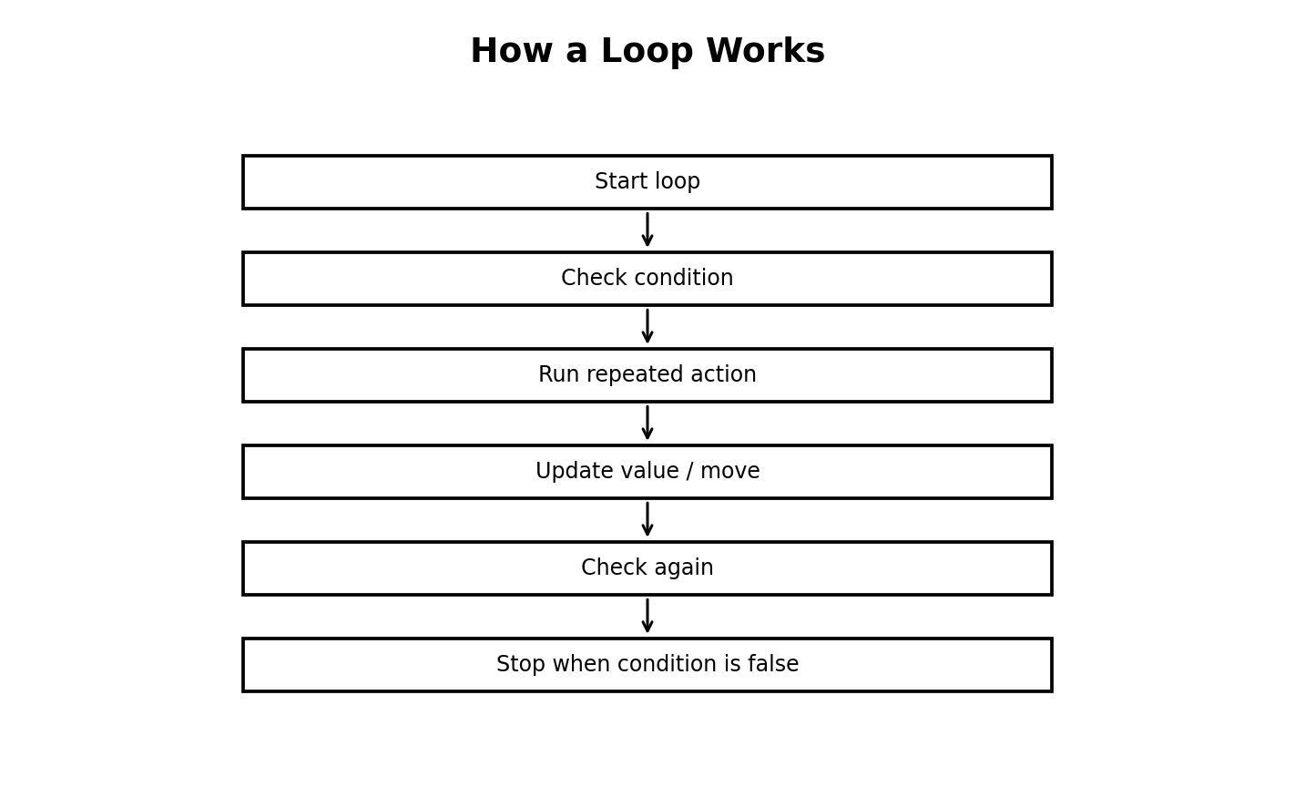
Figure 14.5: how a loop works
Illustration description: A flowchart showing a condition being checked and an action repeated until the condition is false.

14.6 Debugging and Testing Visual Programs
Debugging is finding and correcting errors. A program may have a syntax-like mistake, a logic mistake or an unintended design choice. In block coding, errors may appear as a sprite moving too far, a score failing to change or a loop never stopping.
Test one part at a time. Change one thing, run the program and observe the result. Keep notes on what you changed. This is much faster than making many changes at once.
- Run the program.
- Describe the unexpected behaviour.
- Locate the block sequence involved.
- Change the smallest necessary part.
- Run the program again.
- Record whether the problem was fixed.

Practical Activity
Objective: Apply the main skill from this chapter in a controlled classroom task.
Materials/software: Use the school laboratory, permitted software, exercise files and teacher-approved resources.
Procedure: Review the relevant worked example, perform the task step by step, save your work, then check the expected result.
Expected result: A complete and correctly saved practical product that demonstrates the skill taught in this chapter.
Reflection: What step was easiest? What step was most difficult? What would you improve after receiving feedback?

Guided Practice
- Repeat the main skill with a new example.
- Compare your result with a partner or model answer.
- Correct one error you found.

Student Practice
- Complete a similar task independently.
- Explain the result in your own words.
- Save the work using a clear filename.

Challenge Activity
Adapt the practical task to a new situation in your school or community. Explain why your solution is appropriate and identify one limitation.

Project
Project title: Chapter 14 Applied Digital Project
Problem statement: Use the chapter skill to create a useful digital product or solution for a school-related need.
Requirements: clear objective, appropriate tools, correct procedure, saved output and a short explanation.
Assessment criteria: accuracy, completeness, presentation, responsible use of technology and ability to explain the work.
Extension: Add one improvement that makes the solution more useful or accessible.

Chapter Summary
This chapter introduced the main concepts, showed how they work in practical situations and provided opportunities to apply them. Review the key terms and repeat the practical activity until you can perform it with minimal assistance.

Worked Example and Extended Practice
Worked Example: Imagine a Nigerian school where a practical problem related to visual programming: variables, conditions and loops has been identified. The teacher first states the goal in simple language, lists the available resources and decides what a successful result should look like. Students then carry out the task in small stages, checking their work after each stage. This approach reduces errors and makes it easier to improve the final product.
Step 1 — Understand the task: underline the important words in the question and identify what must be produced. Step 2 — Plan: choose the appropriate tool, information and sequence. Step 3 — Perform: work carefully and save at sensible points. Step 4 — Check: compare the result with the requirements. Step 5 — Improve: correct mistakes and make one useful improvement.
COMMON MISTAKES
Typical beginner errors include skipping instructions, choosing a tool before understanding the task, failing to save work, using unclear filenames, ignoring a safety rule, and submitting a result without checking it. A strong learner learns to notice these mistakes early and correct them.

Practice Scenario: Your teacher gives you a new task related to this chapter but does not tell you every button to press. Explain what you would do before asking for help. A good response should include identifying the goal, recalling a similar procedure, checking available menus or help resources, trying a safe first step, and asking a clear question if the problem remains.
Table 14.X: Skills checklist
Skill | Beginning | Developing | Independent
I can explain the main idea | Need help | Can explain with prompts | Can explain clearly
I can perform the basic task | Need step-by-step help | Can complete most steps | Can work independently
I can check my result | Rarely checks | Checks when reminded | Always checks and corrects
I can work responsibly | Needs reminders | Usually follows rules | Consistently follows rules

Discussion and Critical Thinking
- Why is planning useful before starting a digital task?
- What could happen if a person uses the right tool but follows the wrong procedure?
- Which part of this chapter would be most useful in your school, and why?
- How could you teach one skill from this chapter to a younger learner?
- What change would make the practical activity easier to understand without making it too easy?

Independent Mini-Task
Design a small personal practice task based on this chapter. Write the objective, materials or software, five to eight steps, the expected result and one way to test the result. Complete the task, save the evidence of your work and write three sentences describing what you improved after testing.

Teacher Demonstration Prompt
Demonstrate one complete task without performing unrelated steps. Pause at the points where students must make a decision, ask a prediction question, then continue. End by showing how the final result is checked.

Extended Practice Workshop
Case Study: A student is asked to complete a new task involving visual programming: variables, conditions and loops. The student has the basic tools but no step-by-step answer. Before touching the computer, the student identifies the goal, chooses the most suitable resource, predicts the result and lists the checks that will prove the work is correct. This is the habit of an independent digital learner.
Worked practice: 1) Read the task twice. 2) Circle the important requirements. 3) Separate the task into smaller actions. 4) Complete one action at a time. 5) Save after important changes. 6) Test the result using at least one example. 7) Correct any error. 8) Explain what you learned.
Application task: Rewrite the chapter activity for a different school situation. For example, a document skill can be applied to a club notice, a data skill to a class survey, a network skill to a laboratory diagram, an algorithm skill to a school routine, or a programming skill to an educational quiz. Your version should keep the same learning objective while changing the context.
Table 14.Y: Practice quality checklist
Question | Yes / Not yet | Evidence
Did I understand the task? |  | Written plan
Did I use an appropriate tool? |  | Tool selected
Did I follow a safe procedure? |  | Safety check
Did I test the result? |  | Test example
Did I improve the work? |  | Change made
REFLECT
The most important improvement you can make as a digital learner is to become comfortable with testing. A first attempt does not need to be perfect. What matters is that you can identify what happened, explain why it happened and make a sensible improvement.

ASSESSMENT
Complete the objective, theory and practical tasks below. Your teacher may select some items for continuous assessment.

A. Objective Questions
1. Which statement best describes the main purpose of the topic in this chapter? (A) Option A (B) Option B (C) Option C (D) Option D
2. Which option is an example rather than a definition of the concept studied? (A) Option A (B) Option B (C) Option C (D) Option D
3. Which action is the safest or most effective procedure in the practical activity? (A) Option A (B) Option B (C) Option C (D) Option D
4. Which pair is correctly matched? (A) Option A (B) Option B (C) Option C (D) Option D
5. Which sequence shows the correct order of the process? (A) Option A (B) Option B (C) Option C (D) Option D
6. What would most likely happen if an important step were skipped? (A) Option A (B) Option B (C) Option C (D) Option D
7. Which statement shows responsible use of digital technology? (A) Option A (B) Option B (C) Option C (D) Option D
8. Which result would you expect after completing the practical task? (A) Option A (B) Option B (C) Option C (D) Option D
B. Theory Questions
- Define two important terms from this chapter in your own words.
- Explain one real-life use of the main skill learned in this chapter.
- Describe the steps you would follow to complete the practical activity safely.
- State two common mistakes and explain how to avoid them.
C. Practical Questions
- Perform the main practical task from the chapter using the software available in your laboratory.
- Save your work with a meaningful filename and show the finished result to your teacher.
- Explain one improvement you would make to your work after testing it.
CHAPTER REVIEW
- Write five facts you remember from the chapter.
- Write three things you can now do that you could not do before the lesson.
- Choose one idea from the chapter and explain how it could help a Nigerian school or community.
- What question do you still have about the topic?

CHAPTER 15: Game Development, Debugging and Integrated Programming Project
Learning Objectives
- plan a simple educational game;
- combine events, variables, conditions and loops;
- use basic scoring and feedback;
- test a game systematically and correct errors;
- present and explain a completed digital project;
Key Terms: Game Development, Debugging and Integrated Programming Project
Introduction: This chapter connects the topic to everyday school and community experiences. Read the explanations carefully, then complete the practical tasks with teacher supervision.

15.1 Designing a Simple Game
A good beginner game starts with a clear idea. Decide the goal, the player action, how the game gives feedback and what counts as success. A small game is better than a large unfinished one.
A useful planning table includes characters, background, controls, score, rules and ending condition.

15.2 Game Structure
A simple quiz game can begin by setting the score to zero, displaying a question and accepting an answer. A correct answer can increase the score. The game can repeat for several questions and then display the final score.
The structure combines sequence, variables, conditions and repetition. This is the main learning value of the project.
Table 15.1: Quiz game plan
Part | Example
Start | Set score to 0
Input | Ask question
Decision | Check answer
Action | Increase score if correct
Loop | Repeat for next question
End | Display final score

15.3 Building the Project
Create the project in small stages. First build the start sequence. Then test the question. Then add the score. Next add the decision and repetition. Finally improve the appearance and sounds.
Testing after each stage makes problems easier to locate because there are fewer possible causes.
WATCH OUT!
Do not add many decorative effects before the core game works. Function first, decoration second.

15.4 Testing Checklist
A testing checklist helps you decide whether the project works. Test the normal case, incorrect answers, repeated play and the end of the game. Check that the score starts correctly and does not carry over accidentally between games.
- Does the project start correctly?
- Does the score reset?
- Does a correct answer receive the correct response?
- Does an incorrect answer receive useful feedback?
- Does the loop stop at the right time?
- Does the final score display correctly?

15.5 Improving User Experience
After the game works, improve readability and interaction. Use clear instructions, appropriate text size and simple visual feedback. Keep the project suitable for the age group and avoid content that could be offensive or embarrassing.
Ask a classmate to test the game without explaining the controls. Any point where the classmate gets confused is a clue that the instructions or design can be improved.

15.6 Final Project Presentation
Present your completed game to the class. Explain the problem or learning goal, show the main programming structures, demonstrate the program and describe one error you found and fixed.
The final presentation should show both the finished product and your understanding of how it works.
- Introduce the game and its purpose.
- Demonstrate the main interaction.
- Show the variable or score system.
- Explain one condition and one loop.
- Describe a debugging problem and solution.
- Collect audience feedback for one improvement.

Practical Activity
Objective: Apply the main skill from this chapter in a controlled classroom task.
Materials/software: Use the school laboratory, permitted software, exercise files and teacher-approved resources.
Procedure: Review the relevant worked example, perform the task step by step, save your work, then check the expected result.
Expected result: A complete and correctly saved practical product that demonstrates the skill taught in this chapter.
Reflection: What step was easiest? What step was most difficult? What would you improve after receiving feedback?

Guided Practice
- Repeat the main skill with a new example.
- Compare your result with a partner or model answer.
- Correct one error you found.

Student Practice
- Complete a similar task independently.
- Explain the result in your own words.
- Save the work using a clear filename.

Challenge Activity
Adapt the practical task to a new situation in your school or community. Explain why your solution is appropriate and identify one limitation.

Project
Project title: Chapter 15 Applied Digital Project
Problem statement: Use the chapter skill to create a useful digital product or solution for a school-related need.
Requirements: clear objective, appropriate tools, correct procedure, saved output and a short explanation.
Assessment criteria: accuracy, completeness, presentation, responsible use of technology and ability to explain the work.
Extension: Add one improvement that makes the solution more useful or accessible.

Chapter Summary
This chapter introduced the main concepts, showed how they work in practical situations and provided opportunities to apply them. Review the key terms and repeat the practical activity until you can perform it with minimal assistance.

Worked Example and Extended Practice
Worked Example: Imagine a Nigerian school where a practical problem related to game development, debugging and integrated programming project has been identified. The teacher first states the goal in simple language, lists the available resources and decides what a successful result should look like. Students then carry out the task in small stages, checking their work after each stage. This approach reduces errors and makes it easier to improve the final product.
Step 1 — Understand the task: underline the important words in the question and identify what must be produced. Step 2 — Plan: choose the appropriate tool, information and sequence. Step 3 — Perform: work carefully and save at sensible points. Step 4 — Check: compare the result with the requirements. Step 5 — Improve: correct mistakes and make one useful improvement.
COMMON MISTAKES
Typical beginner errors include skipping instructions, choosing a tool before understanding the task, failing to save work, using unclear filenames, ignoring a safety rule, and submitting a result without checking it. A strong learner learns to notice these mistakes early and correct them.

Practice Scenario: Your teacher gives you a new task related to this chapter but does not tell you every button to press. Explain what you would do before asking for help. A good response should include identifying the goal, recalling a similar procedure, checking available menus or help resources, trying a safe first step, and asking a clear question if the problem remains.
Table 15.X: Skills checklist
Skill | Beginning | Developing | Independent
I can explain the main idea | Need help | Can explain with prompts | Can explain clearly
I can perform the basic task | Need step-by-step help | Can complete most steps | Can work independently
I can check my result | Rarely checks | Checks when reminded | Always checks and corrects
I can work responsibly | Needs reminders | Usually follows rules | Consistently follows rules

Discussion and Critical Thinking
- Why is planning useful before starting a digital task?
- What could happen if a person uses the right tool but follows the wrong procedure?
- Which part of this chapter would be most useful in your school, and why?
- How could you teach one skill from this chapter to a younger learner?
- What change would make the practical activity easier to understand without making it too easy?

Independent Mini-Task
Design a small personal practice task based on this chapter. Write the objective, materials or software, five to eight steps, the expected result and one way to test the result. Complete the task, save the evidence of your work and write three sentences describing what you improved after testing.

Teacher Demonstration Prompt
Demonstrate one complete task without performing unrelated steps. Pause at the points where students must make a decision, ask a prediction question, then continue. End by showing how the final result is checked.

Extended Practice Workshop
Case Study: A student is asked to complete a new task involving game development, debugging and integrated programming project. The student has the basic tools but no step-by-step answer. Before touching the computer, the student identifies the goal, chooses the most suitable resource, predicts the result and lists the checks that will prove the work is correct. This is the habit of an independent digital learner.
Worked practice: 1) Read the task twice. 2) Circle the important requirements. 3) Separate the task into smaller actions. 4) Complete one action at a time. 5) Save after important changes. 6) Test the result using at least one example. 7) Correct any error. 8) Explain what you learned.
Application task: Rewrite the chapter activity for a different school situation. For example, a document skill can be applied to a club notice, a data skill to a class survey, a network skill to a laboratory diagram, an algorithm skill to a school routine, or a programming skill to an educational quiz. Your version should keep the same learning objective while changing the context.
Table 15.Y: Practice quality checklist
Question | Yes / Not yet | Evidence
Did I understand the task? |  | Written plan
Did I use an appropriate tool? |  | Tool selected
Did I follow a safe procedure? |  | Safety check
Did I test the result? |  | Test example
Did I improve the work? |  | Change made
REFLECT
The most important improvement you can make as a digital learner is to become comfortable with testing. A first attempt does not need to be perfect. What matters is that you can identify what happened, explain why it happened and make a sensible improvement.

ASSESSMENT
Complete the objective, theory and practical tasks below. Your teacher may select some items for continuous assessment.

A. Objective Questions
1. Which statement best describes the main purpose of the topic in this chapter? (A) Option A (B) Option B (C) Option C (D) Option D
2. Which option is an example rather than a definition of the concept studied? (A) Option A (B) Option B (C) Option C (D) Option D
3. Which action is the safest or most effective procedure in the practical activity? (A) Option A (B) Option B (C) Option C (D) Option D
4. Which pair is correctly matched? (A) Option A (B) Option B (C) Option C (D) Option D
5. Which sequence shows the correct order of the process? (A) Option A (B) Option B (C) Option C (D) Option D
6. What would most likely happen if an important step were skipped? (A) Option A (B) Option B (C) Option C (D) Option D
7. Which statement shows responsible use of digital technology? (A) Option A (B) Option B (C) Option C (D) Option D
8. Which result would you expect after completing the practical task? (A) Option A (B) Option B (C) Option C (D) Option D
B. Theory Questions
- Define two important terms from this chapter in your own words.
- Explain one real-life use of the main skill learned in this chapter.
- Describe the steps you would follow to complete the practical activity safely.
- State two common mistakes and explain how to avoid them.
C. Practical Questions
- Perform the main practical task from the chapter using the software available in your laboratory.
- Save your work with a meaningful filename and show the finished result to your teacher.
- Explain one improvement you would make to your work after testing it.
CHAPTER REVIEW
- Write five facts you remember from the chapter.
- Write three things you can now do that you could not do before the lesson.
- Choose one idea from the chapter and explain how it could help a Nigerian school or community.
- What question do you still have about the topic?

CHAPTER 16: Emerging Technologies: AI, Robotics, IoT and Smart Services
Learning Objectives
- describe artificial intelligence, robotics, the Internet of Things and automation at an introductory level;
- identify simple everyday applications of emerging technologies;
- distinguish between a robot, a program and an AI-based service;
- discuss benefits, risks and responsible use;
- connect emerging technologies with Nigerian opportunities and community needs;
Key Terms: Emerging Technologies, AI, Robotics, IoT and Smart Services
Introduction: This chapter connects the topic to everyday school and community experiences. Read the explanations carefully, then complete the practical tasks with teacher supervision.

16.1 What Are Emerging Technologies?
Emerging technologies are tools and methods that are developing rapidly or becoming more widely used. Examples include artificial intelligence, robotics, Internet of Things systems, automation and cloud-based services. JSS1 study focuses on understanding the ideas rather than learning advanced engineering.
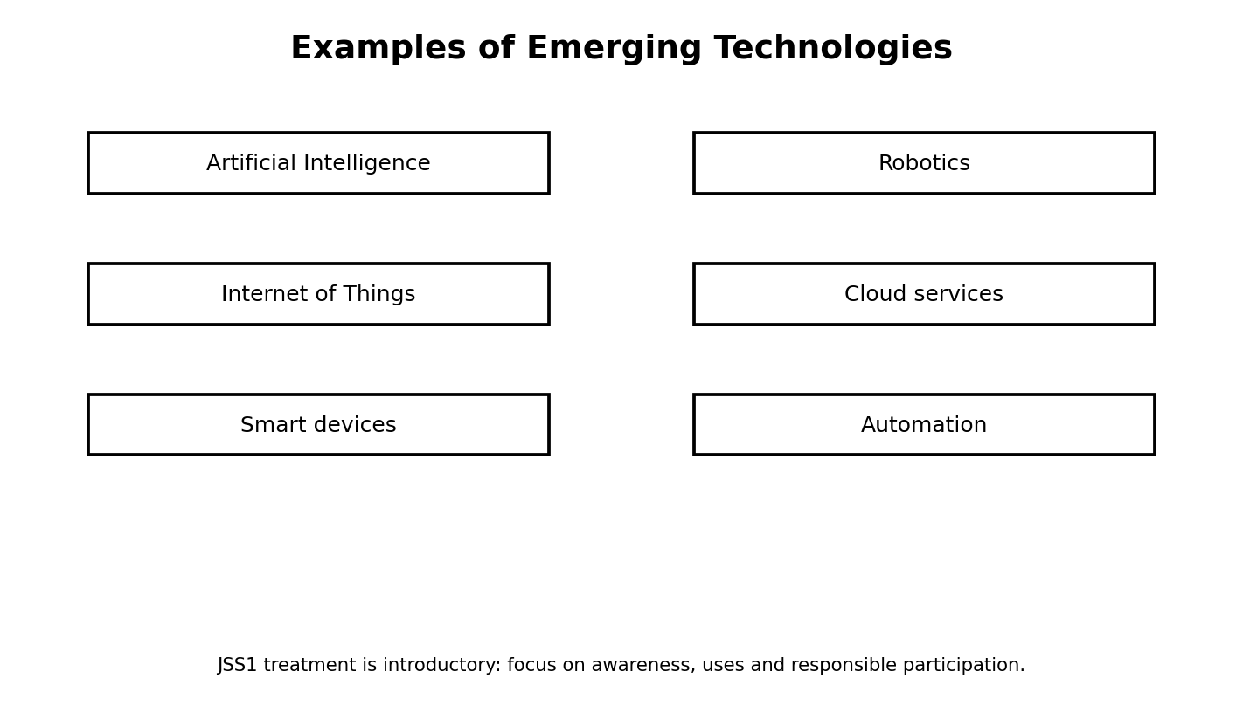
Figure 16.1: examples of emerging technologies
Illustration description: Six introductory areas: AI, robotics, IoT, cloud services, smart devices and automation.

16.2 Artificial Intelligence
Artificial intelligence, or AI, refers to computer systems designed to perform tasks that can involve pattern recognition, prediction, language processing, planning or other forms of intelligent behaviour. Students may encounter AI in recommendation systems, voice assistants, image recognition and educational tools.
AI does not mean that a machine has human feelings or a human mind. It is a collection of techniques and systems designed to perform particular tasks.

16.3 Robotics and Automation
A robot is a machine designed to sense or receive information and carry out actions, often using programmed control. Automation refers to systems carrying out tasks with limited human intervention. Some robots use AI, but not every robot uses AI.
Examples include industrial machines, educational robot kits, agricultural equipment and automated systems used for sorting, cleaning or movement.

16.4 Internet of Things and Smart Devices
The Internet of Things, often shortened to IoT, describes physical devices that collect, send or receive data through connected networks. Smart watches, environmental sensors and connected household devices are examples.
A sensor may collect information such as temperature. A connected system may then send the reading to another device for monitoring.

16.5 Opportunities and Challenges
Emerging technologies can support education, health, agriculture, transport, communication and business. They may improve speed, convenience or access to information. At the same time, they can create concerns about privacy, bias, job changes, security, reliability and unequal access.
Students should learn to ask balanced questions: What benefit does the technology provide? What risks exist? Who controls the data? What happens if the system makes a mistake?
THINK ABOUT IT
A smart device may be convenient, but should it collect every possible piece of information about its user? Explain your view.

16.6 Community Challenge: Technology for a Local Problem
Choose one practical problem in your school or community, such as excessive electricity use, difficulty monitoring waste, or long waiting times for information. Propose a simple technology-based idea using one emerging technology.
The task is a design proposal, not a demand to build a real robot or AI system. State what the system would do, what information it would need and how people would use it responsibly.
- Describe the problem.
- Propose the technology.
- Explain how it would work.
- List one benefit.
- List two risks or limitations.
- Explain one responsible-use rule.

Practical Activity
Objective: Apply the main skill from this chapter in a controlled classroom task.
Materials/software: Use the school laboratory, permitted software, exercise files and teacher-approved resources.
Procedure: Review the relevant worked example, perform the task step by step, save your work, then check the expected result.
Expected result: A complete and correctly saved practical product that demonstrates the skill taught in this chapter.
Reflection: What step was easiest? What step was most difficult? What would you improve after receiving feedback?

Guided Practice
- Repeat the main skill with a new example.
- Compare your result with a partner or model answer.
- Correct one error you found.

Student Practice
- Complete a similar task independently.
- Explain the result in your own words.
- Save the work using a clear filename.

Challenge Activity
Adapt the practical task to a new situation in your school or community. Explain why your solution is appropriate and identify one limitation.

Project
Project title: Chapter 16 Applied Digital Project
Problem statement: Use the chapter skill to create a useful digital product or solution for a school-related need.
Requirements: clear objective, appropriate tools, correct procedure, saved output and a short explanation.
Assessment criteria: accuracy, completeness, presentation, responsible use of technology and ability to explain the work.
Extension: Add one improvement that makes the solution more useful or accessible.

Chapter Summary
This chapter introduced the main concepts, showed how they work in practical situations and provided opportunities to apply them. Review the key terms and repeat the practical activity until you can perform it with minimal assistance.

Worked Example and Extended Practice
Worked Example: Imagine a Nigerian school where a practical problem related to emerging technologies: ai, robotics, iot and smart services has been identified. The teacher first states the goal in simple language, lists the available resources and decides what a successful result should look like. Students then carry out the task in small stages, checking their work after each stage. This approach reduces errors and makes it easier to improve the final product.
Step 1 — Understand the task: underline the important words in the question and identify what must be produced. Step 2 — Plan: choose the appropriate tool, information and sequence. Step 3 — Perform: work carefully and save at sensible points. Step 4 — Check: compare the result with the requirements. Step 5 — Improve: correct mistakes and make one useful improvement.
COMMON MISTAKES
Typical beginner errors include skipping instructions, choosing a tool before understanding the task, failing to save work, using unclear filenames, ignoring a safety rule, and submitting a result without checking it. A strong learner learns to notice these mistakes early and correct them.

Practice Scenario: Your teacher gives you a new task related to this chapter but does not tell you every button to press. Explain what you would do before asking for help. A good response should include identifying the goal, recalling a similar procedure, checking available menus or help resources, trying a safe first step, and asking a clear question if the problem remains.
Table 16.X: Skills checklist
Skill | Beginning | Developing | Independent
I can explain the main idea | Need help | Can explain with prompts | Can explain clearly
I can perform the basic task | Need step-by-step help | Can complete most steps | Can work independently
I can check my result | Rarely checks | Checks when reminded | Always checks and corrects
I can work responsibly | Needs reminders | Usually follows rules | Consistently follows rules

Discussion and Critical Thinking
- Why is planning useful before starting a digital task?
- What could happen if a person uses the right tool but follows the wrong procedure?
- Which part of this chapter would be most useful in your school, and why?
- How could you teach one skill from this chapter to a younger learner?
- What change would make the practical activity easier to understand without making it too easy?

Independent Mini-Task
Design a small personal practice task based on this chapter. Write the objective, materials or software, five to eight steps, the expected result and one way to test the result. Complete the task, save the evidence of your work and write three sentences describing what you improved after testing.

Teacher Demonstration Prompt
Demonstrate one complete task without performing unrelated steps. Pause at the points where students must make a decision, ask a prediction question, then continue. End by showing how the final result is checked.

Extended Practice Workshop
Case Study: A student is asked to complete a new task involving emerging technologies: ai, robotics, iot and smart services. The student has the basic tools but no step-by-step answer. Before touching the computer, the student identifies the goal, chooses the most suitable resource, predicts the result and lists the checks that will prove the work is correct. This is the habit of an independent digital learner.
Worked practice: 1) Read the task twice. 2) Circle the important requirements. 3) Separate the task into smaller actions. 4) Complete one action at a time. 5) Save after important changes. 6) Test the result using at least one example. 7) Correct any error. 8) Explain what you learned.
Application task: Rewrite the chapter activity for a different school situation. For example, a document skill can be applied to a club notice, a data skill to a class survey, a network skill to a laboratory diagram, an algorithm skill to a school routine, or a programming skill to an educational quiz. Your version should keep the same learning objective while changing the context.
Table 16.Y: Practice quality checklist
Question | Yes / Not yet | Evidence
Did I understand the task? |  | Written plan
Did I use an appropriate tool? |  | Tool selected
Did I follow a safe procedure? |  | Safety check
Did I test the result? |  | Test example
Did I improve the work? |  | Change made
REFLECT
The most important improvement you can make as a digital learner is to become comfortable with testing. A first attempt does not need to be perfect. What matters is that you can identify what happened, explain why it happened and make a sensible improvement.

ASSESSMENT
Complete the objective, theory and practical tasks below. Your teacher may select some items for continuous assessment.

A. Objective Questions
1. Which statement best describes the main purpose of the topic in this chapter? (A) Option A (B) Option B (C) Option C (D) Option D
2. Which option is an example rather than a definition of the concept studied? (A) Option A (B) Option B (C) Option C (D) Option D
3. Which action is the safest or most effective procedure in the practical activity? (A) Option A (B) Option B (C) Option C (D) Option D
4. Which pair is correctly matched? (A) Option A (B) Option B (C) Option C (D) Option D
5. Which sequence shows the correct order of the process? (A) Option A (B) Option B (C) Option C (D) Option D
6. What would most likely happen if an important step were skipped? (A) Option A (B) Option B (C) Option C (D) Option D
7. Which statement shows responsible use of digital technology? (A) Option A (B) Option B (C) Option C (D) Option D
8. Which result would you expect after completing the practical task? (A) Option A (B) Option B (C) Option C (D) Option D
B. Theory Questions
- Define two important terms from this chapter in your own words.
- Explain one real-life use of the main skill learned in this chapter.
- Describe the steps you would follow to complete the practical activity safely.
- State two common mistakes and explain how to avoid them.
C. Practical Questions
- Perform the main practical task from the chapter using the software available in your laboratory.
- Save your work with a meaningful filename and show the finished result to your teacher.
- Explain one improvement you would make to your work after testing it.
CHAPTER REVIEW
- Write five facts you remember from the chapter.
- Write three things you can now do that you could not do before the lesson.
- Choose one idea from the chapter and explain how it could help a Nigerian school or community.
- What question do you still have about the topic?

Comprehensive Revision
Use the revision section to prepare for practical and written assessment. Review both concepts and procedures. Practise the computer-based tasks rather than relying only on memorisation.
• Identify ten digital devices and state one use for each.
• Compare RAM and storage.
• Create a one-page Word document with a table and image.
• Prepare a five-slide PowerPoint presentation.
• Enter a small class dataset and produce a chart.
• Draw a simple LAN diagram.
• Write an algorithm for a school task.
• Create a visual program that uses a variable and a loop.
• Explain five online safety rules.
• Describe one possible AI or IoT application for a Nigerian school.

Practical Examination
1. Create and format a one-page school notice in Word.
2. Create a five-slide presentation with a title, image, diagram and conclusion.
3. Enter ten fictional student scores into a spreadsheet and calculate total and average.
4. Draw a flowchart or write an algorithm for a simple school problem.
5. Create a short Scratch-style quiz with a score variable and one decision.
6. Create a one-minute digital-media product or storyboard explaining a safety rule.
Practical marking focus
Plan before using the computer; follow instructions; save correctly; demonstrate accuracy; explain your work; observe safety and responsible-use rules.

Theory Examination
Answer all sections according to your teacher’s instructions.
Section A — Definitions and Concepts: Define hardware, software, digital technology, network, browser, data, algorithm, variable, multimedia and phishing.
Section B — Explanations: Explain the difference between input and output devices; describe the data-processing cycle; explain the purpose of a computer network; discuss two online safety practices; distinguish an algorithm from a program.
Section C — Application: Describe how you would plan a short digital project for your school. Include the problem, tools, steps, expected result and one safety or ethical consideration.

Objective Examination
1. Which part of a computer carries out instructions and performs calculations? (A) A. Keyboard (B) B. CPU (C) C. Monitor (D) D. Speaker
2. Which of the following is an example of digital technology? (A) A. Abacus (B) B. Chalkboard (C) C. Smartphone (D) D. Paper file
3. Which storage device is designed to keep files even when power is turned off? (A) A. RAM (B) B. SSD (C) C. Cache only (D) D. Register
4. Which software is mainly used for creating and formatting letters and reports? (A) A. Microsoft Word (B) B. Calculator (C) C. File Explorer (D) D. Paint only
5. Which feature is useful for organising a long Word document with consistent headings? (A) A. Styles (B) B. Volume control (C) C. Recycle Bin (D) D. Screen brightness
6. What is a slide layout in PowerPoint? (A) A. A computer cable (B) B. An arrangement of placeholders on a slide (C) C. A storage unit (D) D. A network protocol
7. Which PowerPoint feature controls how one slide changes to the next? (A) A. Transition (B) B. Formula (C) C. Folder (D) D. Variable
8. Which tool in Paint 3D helps create or modify a three-dimensional model? (A) A. 3D Shapes (B) B. Mail Merge (C) C. Spreadsheet (D) D. Browser tab
9. What is data processing? (A) A. Deleting all files (B) B. Converting collected data into useful information (C) C. Turning off a computer (D) D. Drawing only
10. Which is the best example of processed information? (A) A. Raw attendance marks (B) B. A sorted report showing monthly attendance (C) C. Unlabelled numbers (D) D. A blank form
11. Which device is commonly used to connect a computer to a wired network? (A) A. Network interface or Ethernet connection (B) B. Projector (C) C. Webcam (D) D. Microphone
12. What is a computer network? (A) A. A single computer (B) B. Connected devices that can communicate or share resources (C) C. A type of printer (D) D. A word-processing document
13. Which network usually covers a small area such as a school laboratory? (A) A. LAN (B) B. WAN only (C) C. Global Internet only (D) D. Satellite
14. What is the Internet? (A) A. One website (B) B. A worldwide interconnection of networks (C) C. A single computer program (D) D. A printer driver
15. Which application is used to access web pages? (A) A. Web browser (B) B. Word processor (C) C. Paint 3D (D) D. File compressor only
16. Which search practice is most useful for finding a precise answer? (A) A. Use clear keywords (B) B. Type random letters (C) C. Open every result (D) D. Ignore the question
17. Which password is strongest? (A) A. 123456 (B) B. password (C) C. Ade2026 (D) D. A long unique passphrase with mixed characters
18. What should you do when a message asks for your password through a suspicious link? (A) A. Click immediately (B) B. Share it with friends (C) C. Ignore or report it and verify the source (D) D. Reply with more personal information
19. What is phishing? (A) A. A method of printing (B) B. A deceptive attempt to steal information or make a user take an unsafe action (C) C. A type of keyboard (D) D. A presentation theme
20. Which is an example of responsible digital behaviour? (A) A. Sharing another person’s private photo without permission (B) B. Using respectful language online (C) C. Guessing someone’s password (D) D. Copying a project without credit
21. Which media type can contain moving pictures? (A) A. Video (B) B. Text only (C) C. Table only (D) D. Folder
22. Which action changes an image to remove unwanted edges? (A) A. Cropping (B) B. Booting (C) C. Filtering a network (D) D. Formatting a disk
23. Which combination is multimedia? (A) A. Text only (B) B. Image only (C) C. Text, image and audio in one digital product (D) D. A folder name
24. What is an algorithm? (A) A. A step-by-step method for solving a problem (B) B. A type of monitor (C) C. A storage cable (D) D. A social-media account
25. Which flowchart symbol is normally used for a decision? (A) A. Rectangle (B) B. Diamond (C) C. Oval only (D) D. Arrow only
26. Which order represents a simple problem-solving process? (A) A. Test, guess, save, plan (B) B. Understand, plan, perform, test and improve (C) C. Delete, restart, print, guess (D) D. Open, close, ignore, submit
27. What is decomposition in computational thinking? (A) A. Combining unrelated tasks (B) B. Breaking a larger problem into smaller parts (C) C. Removing every file (D) D. Turning text into audio
28. What is a variable in a program? (A) A. A named place for storing a value that can change (B) B. A keyboard key (C) C. A network cable (D) D. A slide transition
29. Which programming structure makes a program choose between alternatives? (A) A. Selection or condition (B) B. Storage (C) C. Formatting (D) D. Printing
30. What does a loop do? (A) A. Deletes a program (B) B. Repeats a set of instructions (C) C. Changes the monitor (D) D. Shuts down the computer
31. In Scratch, what is a sprite? (A) A. A character or object that can be programmed (B) B. A storage device (C) C. A document style (D) D. A network
32. Why is testing important in programming? (A) A. It makes the computer heavier (B) B. It helps find errors and check whether the program behaves as expected (C) C. It removes the need for planning (D) D. It replaces variables
33. What is debugging? (A) A. Designing a poster (B) B. Finding and correcting errors in a program (C) C. Printing a document (D) D. Connecting speakers
34. Which project is most suitable for combining a variable, a condition and a loop? (A) A. A Scratch quiz game (B) B. A printed letter (C) C. A paper notebook (D) D. A keyboard cleaning task
35. Which technology enables machines to sense their environment and exchange data over networks? (A) A. IoT (B) B. Word processing (C) C. Paint 3D (D) D. File naming
36. Which is a common example of artificial intelligence? (A) A. A ruler (B) B. A system that recognises speech or patterns (C) C. A paper poster (D) D. A cable tie
37. Which career focuses on protecting systems, networks and data from attacks? (A) A. Cybersecurity specialist (B) B. Typist only (C) C. Graphic printer (D) D. Accountant only
38. Which quality is especially important for someone learning digital technology? (A) A. Carelessness (B) B. Curiosity and willingness to test ideas (C) C. Refusing feedback (D) D. Sharing passwords
39. A good digital project should begin with which question? (A) A. Which colour should I use first? (B) B. What problem am I trying to solve? (C) C. How quickly can I finish? (D) D. Who can do it for me?
40. Why should students save files with clear filenames? (A) A. To make files harder to find (B) B. To organise work and locate the correct version easily (C) C. To increase electricity use (D) D. To prevent editing forever

Integrated Projects

Project 1: School Digital Notice Board
Combine Word processing and digital media to create a notice containing text, a table and a relevant image.
Assessment criteria: problem understanding, planning, technical accuracy, creativity, responsible use, presentation and reflection.

Project 2: Our Class Data Story
Collect a small classroom dataset, process it, create a chart and explain two findings.
Assessment criteria: problem understanding, planning, technical accuracy, creativity, responsible use, presentation and reflection.

Project 3: Safe Internet Campaign
Create three presentation slides and a short poster explaining safe online behaviour.
Assessment criteria: problem understanding, planning, technical accuracy, creativity, responsible use, presentation and reflection.

Project 4: Scratch Quiz Challenge
Create a quiz that uses a score variable, a condition and a loop.
Assessment criteria: problem understanding, planning, technical accuracy, creativity, responsible use, presentation and reflection.

Project 5: Community Technology Idea
Propose a responsible use of AI, IoT, robotics or automation to address a local problem.
Assessment criteria: problem understanding, planning, technical accuracy, creativity, responsible use, presentation and reflection.

Glossary
Algorithm: A clear sequence of steps for solving a problem or completing a task.
Analogue: Information represented as continuously varying values.
Application software: Software designed to help a user perform a particular task.
Artificial intelligence (AI): Computer-based techniques that perform tasks involving functions such as pattern recognition, prediction or language processing.
Browser: Software used to access and interact with web pages.
Byte: A common unit of digital information equal to eight bits.
CPU: Central Processing Unit; the main processor that carries out instructions.
Cyberbullying: Harmful or threatening behaviour carried out through digital communication.
Data: Recorded facts, observations or values.
Digital footprint: The trail of information created by a person’s digital activities.
Digital media: Information communicated in digital forms such as text, images, audio and video.
Hardware: The physical components of a computer system.
Internet: A large interconnected system of networks.
LAN: Local Area Network; a network covering a limited area.
Loop: A programming structure that repeats an action or group of actions.
Malware: Malicious software designed to cause harm or gain unauthorised access.
Multimedia: A communication product combining two or more media types.
Network: A group of connected devices that can communicate or share resources.
Operating system: System software that manages computer resources and provides services for applications and users.
Phishing: A deceptive attempt to trick a user into revealing information or taking an unsafe action.
Plagiarism: Presenting another person’s words or ideas as your own without appropriate acknowledgement.
RAM: Temporary working memory used by a computer while programs are running.
Router: A networking device that directs data between networks.
Software: Instructions and programs used by digital devices.
Spreadsheet: Software or a digital worksheet used to organise data, calculate values and create charts.
URL: A web address used to locate a resource.
Variable: A named storage location whose value can change during program execution.

Index
AI
CPU
Internet
LAN
PowerPoint
RAM
Scratch
Word processing
algorithm
browser
computer network
data
digital citizenship
digital media
digital technology
file
hardware
loop
malware
multimedia
network
operating system
programming
software
storage
variable

References
• Nigerian Educational Research and Development Council (NERDC). Digital Technologies Curriculum, Junior Secondary School 1 (JSS1), revised curriculum material.
• Nigerian Educational Research and Development Council (NERDC). New national curriculum implementation information and curriculum portal materials.
• Microsoft. Microsoft Word documentation and Microsoft PowerPoint documentation (consulted for general feature descriptions; software interfaces vary by version).
• Scratch Foundation. Scratch educational resources and beginner programming concepts.
• General classroom practice references for digital citizenship, safe Internet use, data literacy and introductory computing.
Source note
The curriculum structure used for this manuscript is based primarily on the current NERDC JSS1 Digital Technologies material and supporting public curriculum summaries. Specific software buttons and interface layouts may change across versions and should be demonstrated using the software available in the school laboratory.

Back Cover Copy
ABOUT THE BOOK
JSS1 Digital Technology is a practical introduction to the digital skills young Nigerians need for school, community life and future learning. The book moves from digital foundations and computer hardware to documents, presentations, 3D modelling, data processing, networks, Internet research, digital safety, media creation, algorithms and visual programming. It closes with game development, emerging technologies and integrated projects.
WHAT STUDENTS WILL LEARN
• Understand digital devices and computer components.
• Create professional school documents and presentations.
• Process simple data and communicate findings.
• Understand computer networks and Internet basics.
• Create digital media responsibly.
• Write algorithms and build beginner visual programs.
• Use technology safely and ethically.
• Explore digital careers and emerging technologies.
KEY FEATURES
• Practical activities and guided exercises
• Worked examples and step-by-step procedures
• Figures, diagrams, tables and visual explanations
• Nigerian school and community contexts
• Projects and differentiated challenge activities
• End-of-chapter objective, theory and practical assessment
• Comprehensive revision, examinations, glossary and index
Author: ______________________________
Publisher: ____________________________
Website/Contact: ______________________
ISBN / Barcode Area: __________________

