Software development 2

Coursework assessment

Owusu-Amankrah, Natasha 2- 3224849

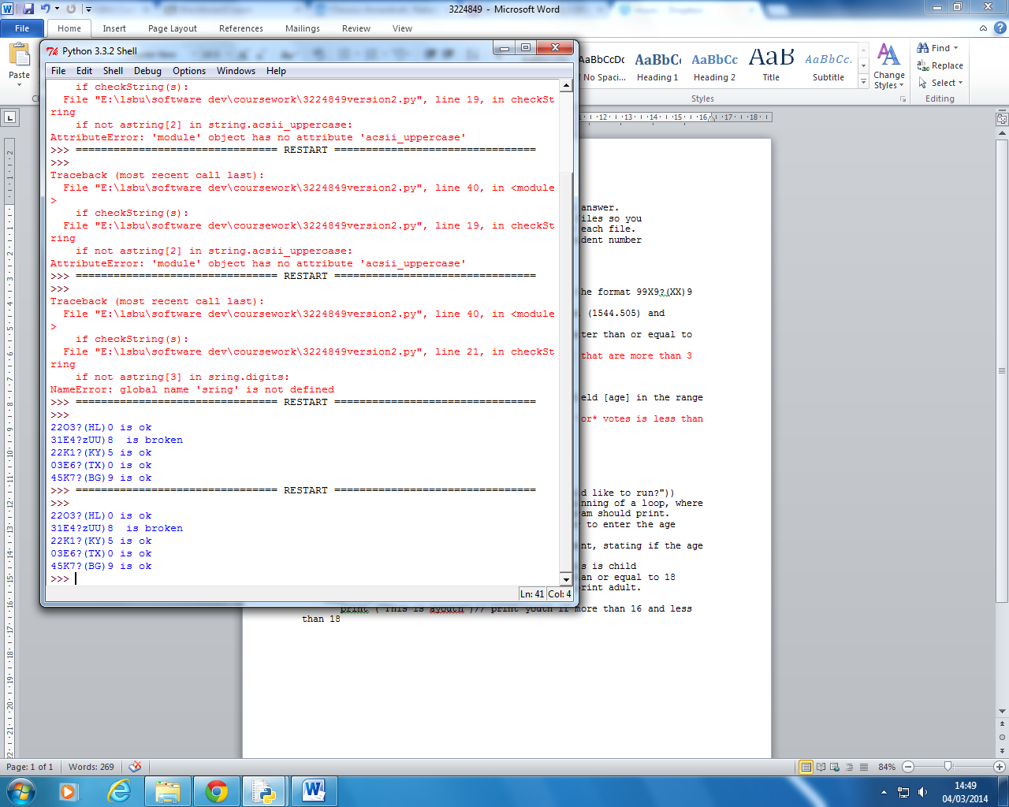

I was able to achieve this..

After several attempts and incorrect spelling of string and comments out of loops

The code above runs the first five lines in the file and tests which lines are okay and are broken, from the result it shows that two lines are broken from the file. The screen grab shows a clearer result. These tests are for the first part of the program which is structured programming.

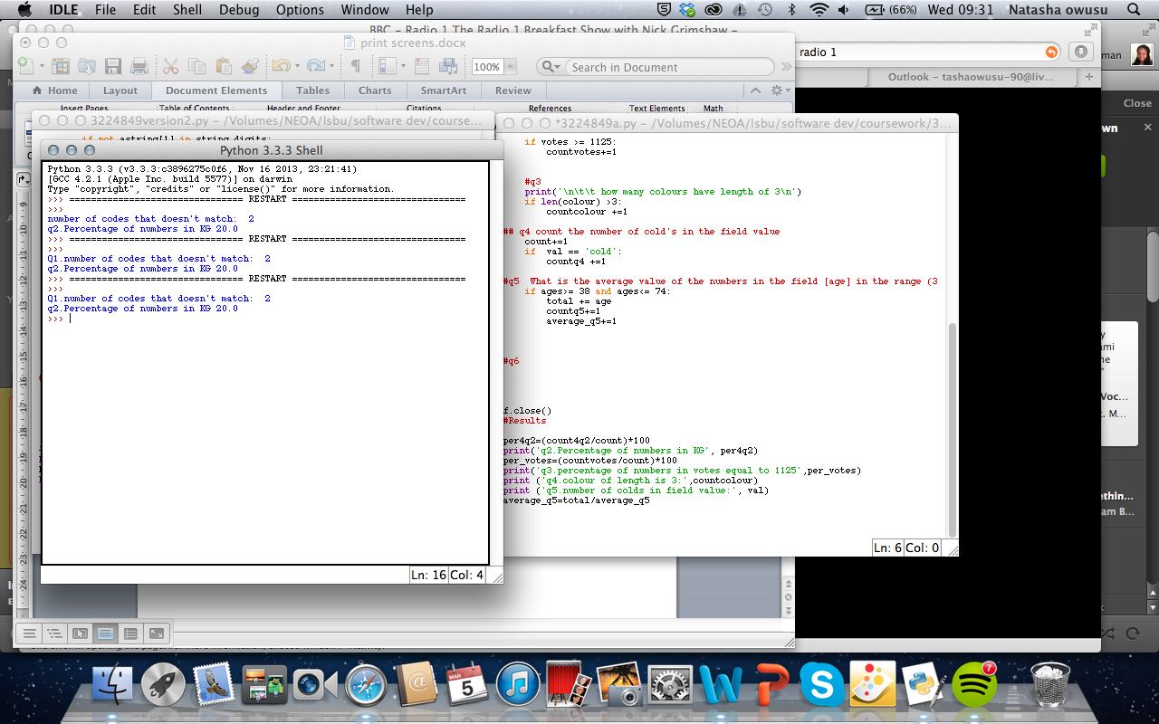

This answer is to show how many lines in the fields are invalid. This happens to be 2 lines in the field.

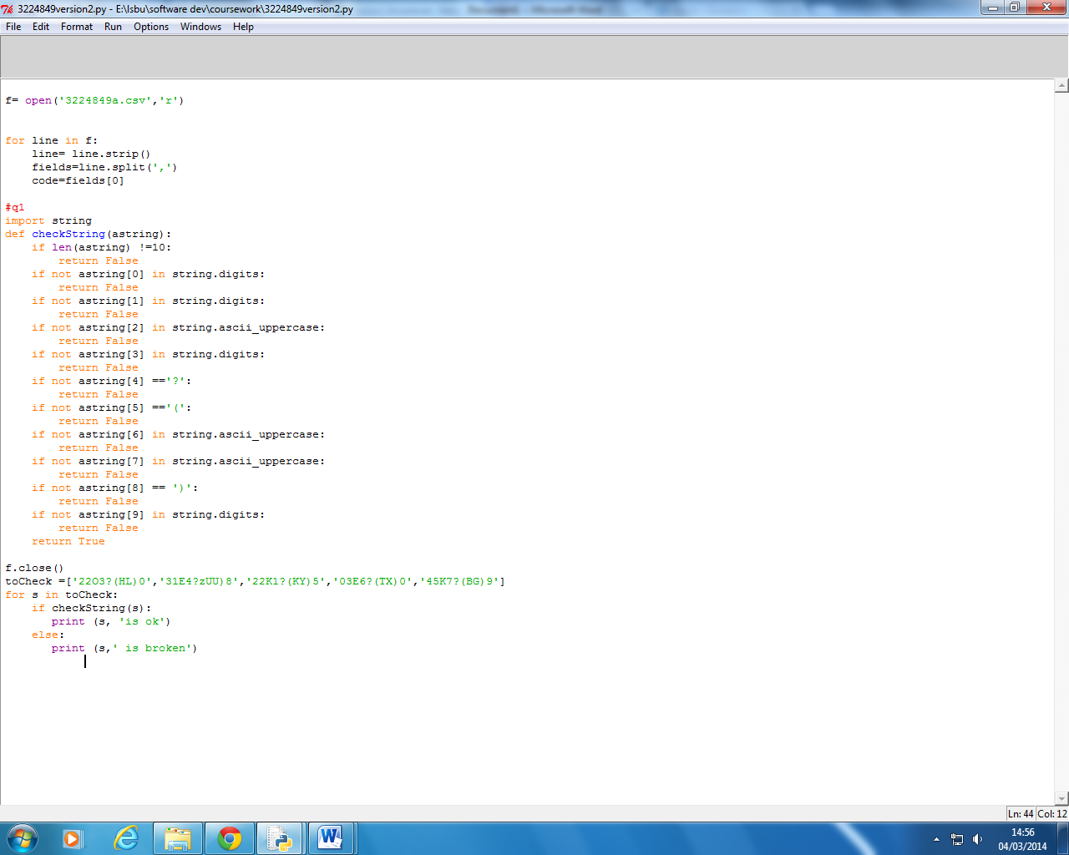

Format strings verify whether the

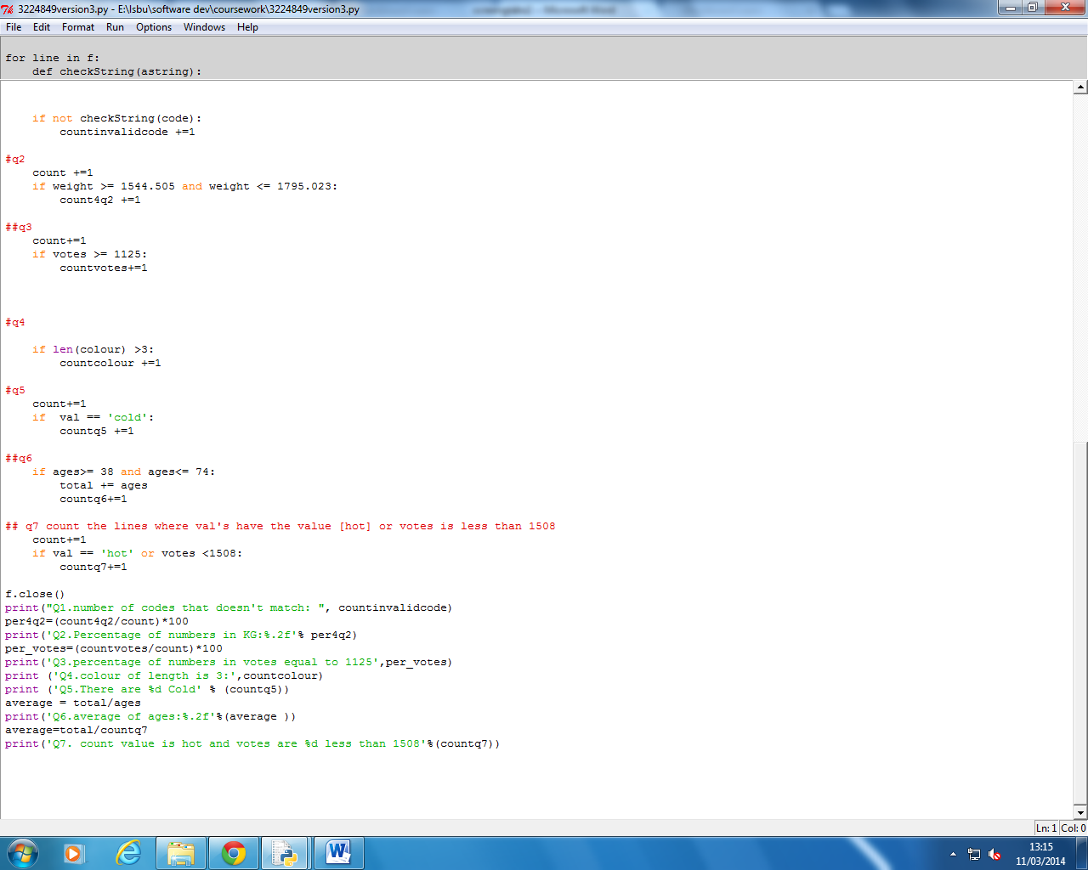

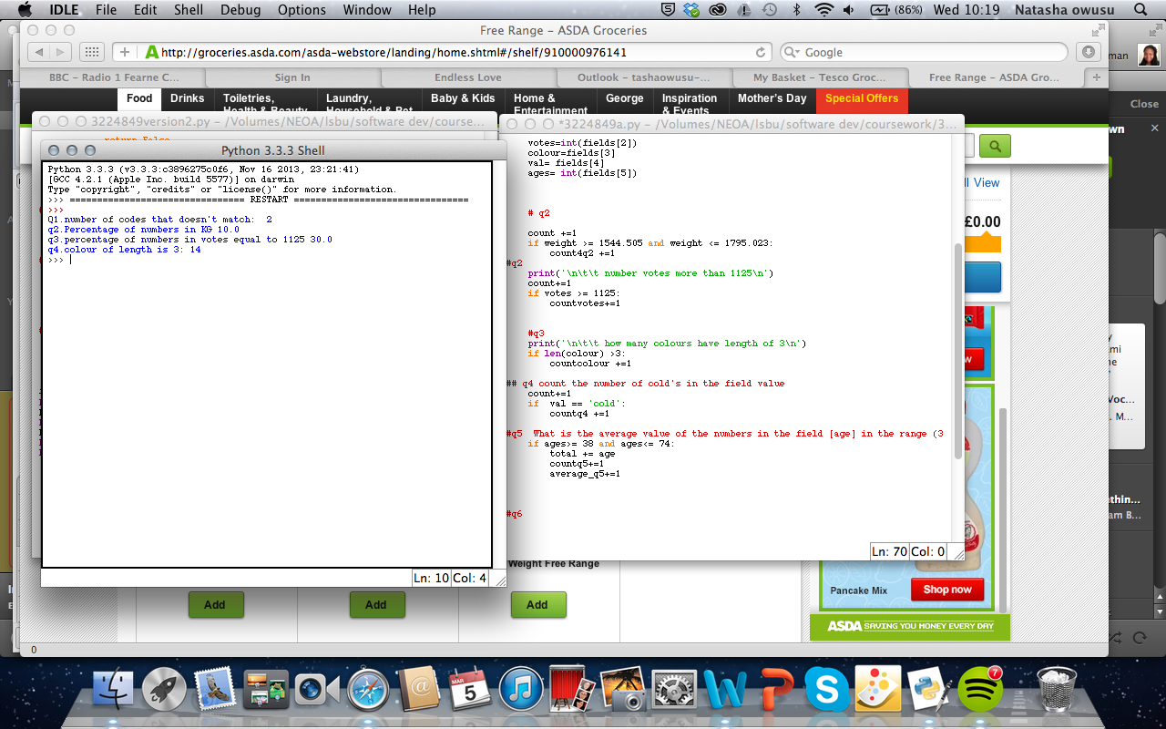

The user has the option of choosing which file they would like to display.

Functions:

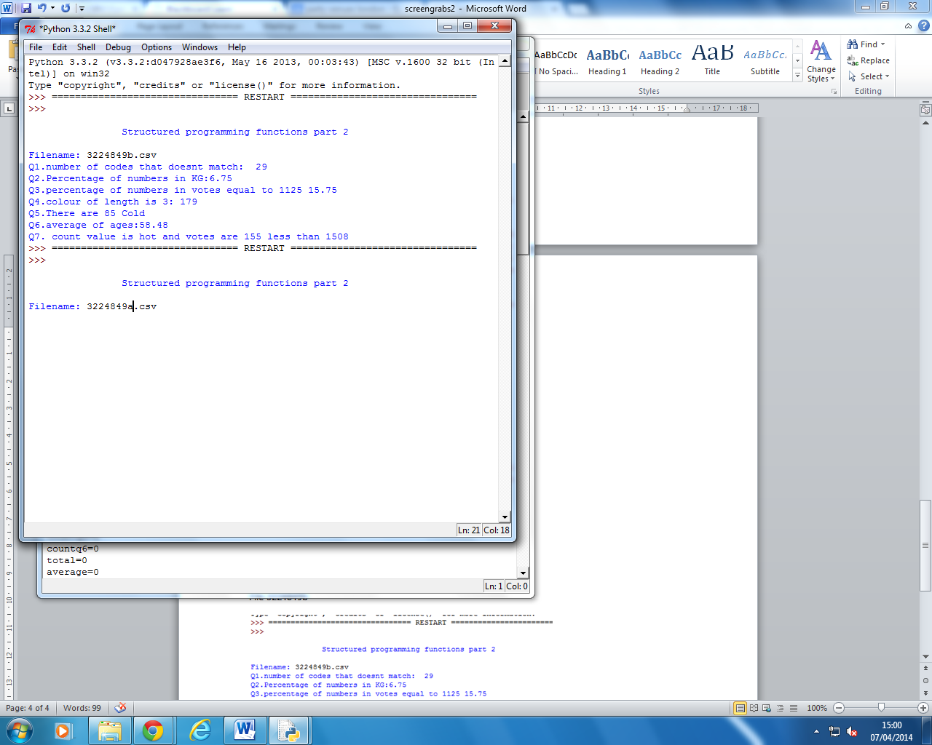

Once the file has been opened the program responds with the following results to the following seven questions.

File 3224849b

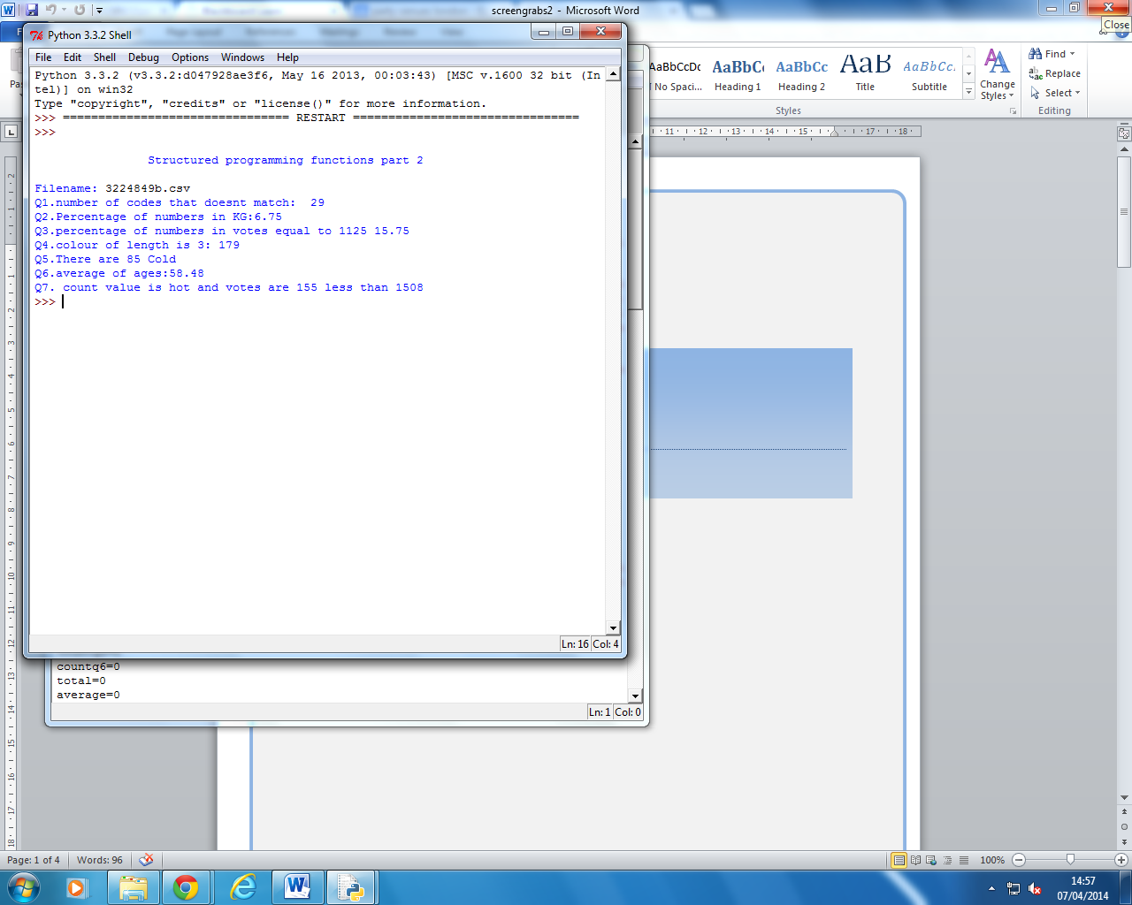

The next part of assignment is based on object oriented programming where the structured programming is structured with class objects. The first is the class counter, demonstrator, filereader and a class function that opens each file at once.