 | Practical – 1
Aim | A national bank is modernizing its information system to enhance employee management and customer service. The bank requires a well-structured database that can store different job roles (e.g., Clerk, Manager, Loan Officer), along with employees working in each role. At the same time, the bank needs to separate account customers (savings, current, fixed deposit holders) from loan customers (home loan, vehicle loan, personal loan borrowers) to provide better tracking and faster processing. Task is to design the database schema that supports these requirements and implement it using SQL.
Q-1 | Create Table Job_137 (job_id, job_title, min_sal, max_sal)
A | 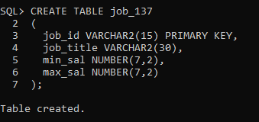  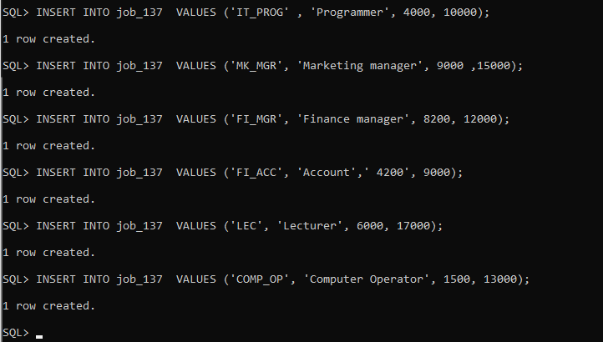  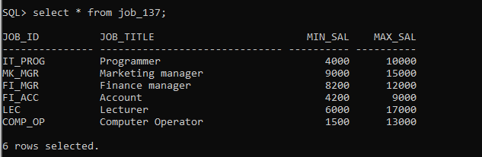
Q-2 | Create table Employee_137 (emp_no, emp_name, emp_sal, emp_comm, dept_no)
A | 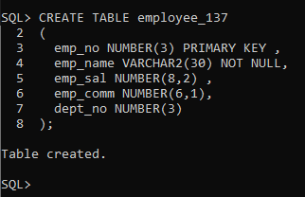  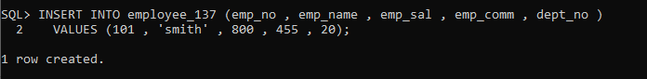  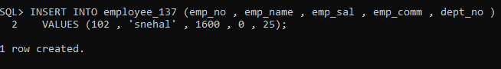  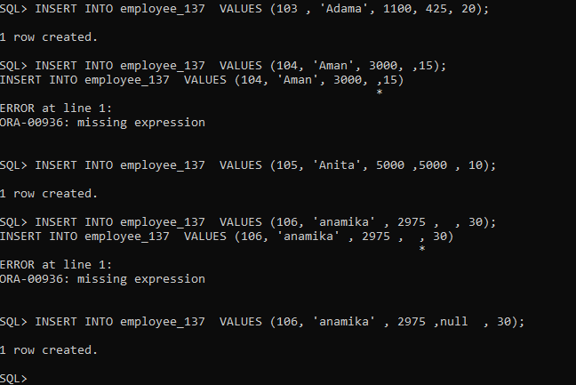  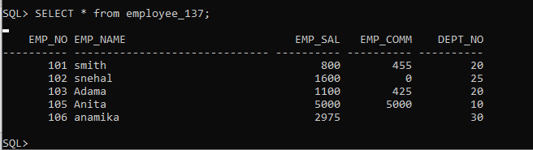
Q-3 | CREATE TABLE deposit_137 (  a_no VARCHAR2(5) PRIMARY KEY,  cname VARCHAR2(15) NOT NULL,  bname VARCHAR2(10) NOT NULL,  amount NUMBER(7,2) CHECK (amount >= 1000), a_date DATE NOT NULL );
A | 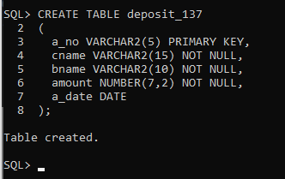  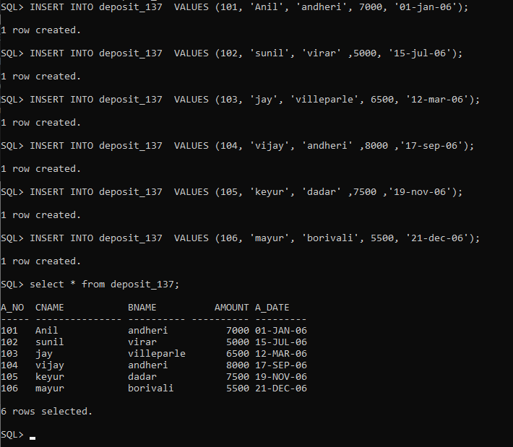

Q-4 | CREATE TABLE borrow_137 (  loanno VARCHAR2(5) PRIMARY KEY,  cname VARCHAR2(15) NOT NULL,  bname VARCHAR2(10) NOT NULL,  amount NUMBER(7,2) CHECK (amount > 0)  );
A | 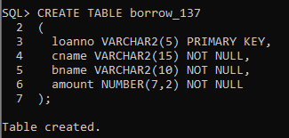  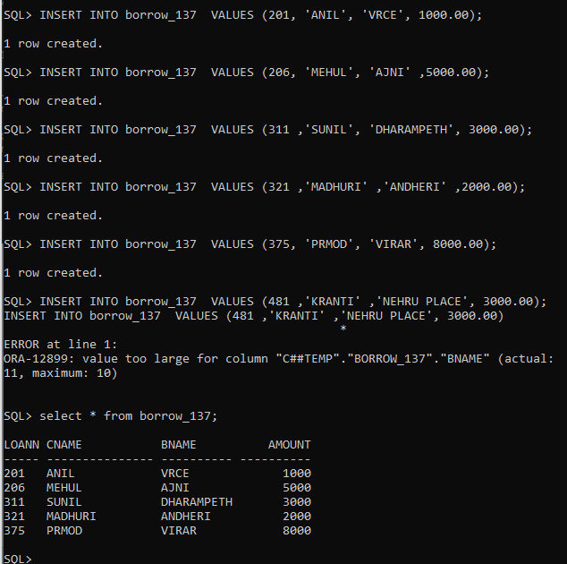
Q-4 | Desc job_137;  Desc deposit_137;  Desc employee_137;  Desc borrow_137;
A | 