 | Practical – 1
Aim | Aim: To manage and update a company’s employee-related database by performing essential Data  Definition Language (DDL) operations. In this scenario, the organization is restructuring its data  system and needs to create new tables, duplicate existing structures, rename tables, modify column  definitions, enforce constraints, and remove unwanted fields. The objective is to ensure that the  database schema remains accurate, consistent, and adaptable to organizational changes.
Q-1 | CREATE TABLE SUPPLIER_137  AS SELECT * FROM EMPLOYEE_137;  DESC SUPPLIER_137;
A | 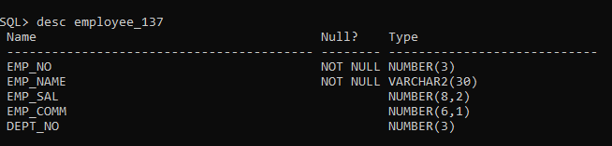  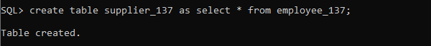  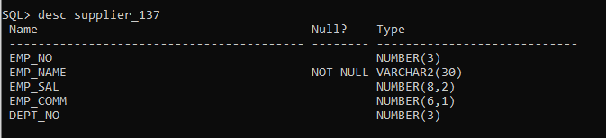
Q-2 | CREATE TABLE SUP1_137  AS SELECT emp_no, emp_name FROM EMPLOYEE_137;  DESC SUP1_137;
A | 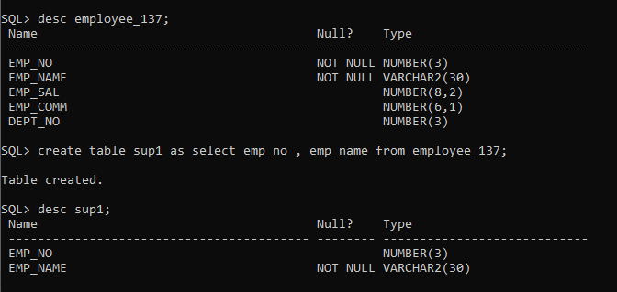
Q-3 | CREATE TABLE SUP2_137  AS SELECT * FROM EMPLOYEE_137 WHERE 1=2;  SELECT * FROM SUP2_137;
A | 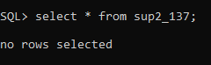

Q-4 | INSERT INTO SUP2_137  SELECT * FROM EMPLOYEE_137  WHERE emp_name = 'Anita';  SELECT * FROM SUP2_137;
A | 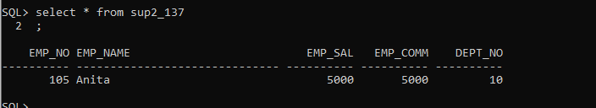
Q-5 | RENAME SUPlier2_137 TO SUP2_NEW_137;  Desc SUPlier2_137;
A | 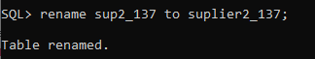  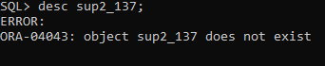

Q-6 | DROP TABLE SUP1_137;  Desc SUP1_137;
A | 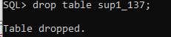
Q-7 | ALTER TABLE EMPLOYEE_137  ADD phone VARCHAR2(10);  DESC EMPLOYEE_137;
A | 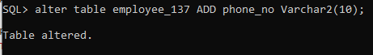  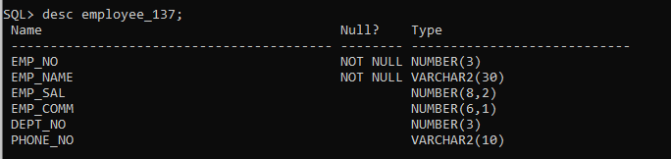
Q-8 | ALTER TABLE EMPLOYEE_137  MODIFY phone CHAR(10);  DESC EMPLOYEE_137;
A | 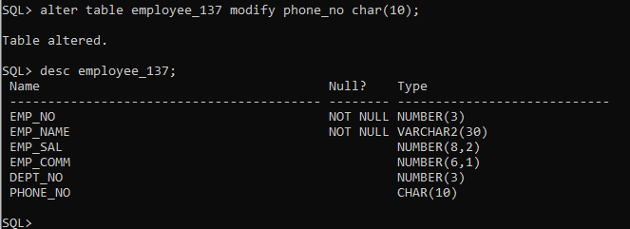
Q-9 | ALTER TABLE SUP2_NEW_137  DROP COLUMN emp_name;  DESC SUP2_NEW_137;
A | 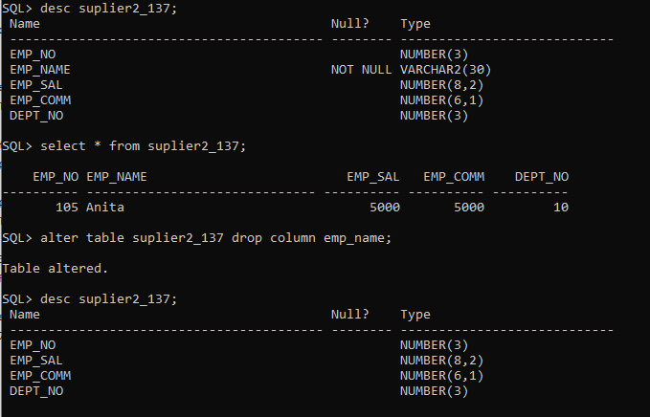
Q-10 | ALTER TABLE SUP2_NEW_137  2 RENAME COLUMN emp_sal TO new_sal;  DESC SUP2_NEW_137;
A | 