 | Practical – 3
Aim | To assist a banking organization in efficiently managing and analyzing their employee, job, and  customer-related data by performing essential SQL queries on the existing database schema. The bank  requires accurate retrieval of information for decision-making, auditing, and operational activities. In  this scenario, the database administrator is tasked with extracting detailed reports such as employee  department-wise details, customer deposit information based on date criteria, job salary structures,  and identification of specific attributes like non-null commission values
Q-1 | SELECT * FROM EMPLOYEE_137;  SELECT * FROM JOB_137;  SELECT * FROM DEPOSIT_137;
A | 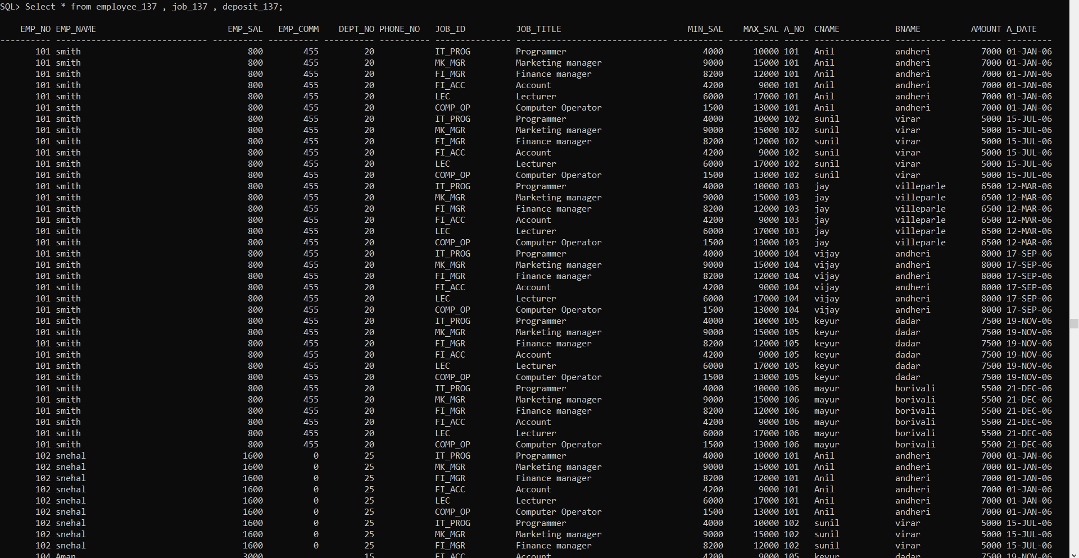
Q-2 | SELECT job_title, max_sal  FROM JOB_137;
A | 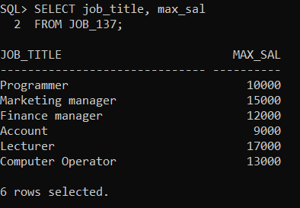
Q-3 | SELECT DISTINCT bname  FROM DEPOSIT_137;
A | 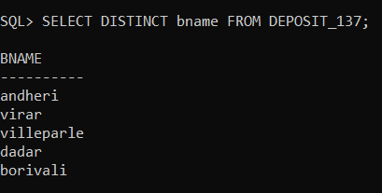

Q-4 | SELECT a_no  FROM DEPOSIT_137  WHERE a_date BETWEEN TO_DATE('01-01-06','DD-MM-YY')  AND TO_DATE('25-07-06','DD-MM-YY');
A | 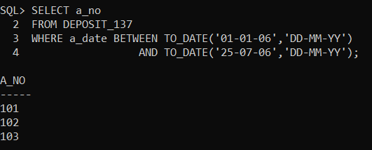
Q-5 | SELECT cname  FROM DEPOSIT_137  WHERE a_date > TO_DATE('09-10-06','DD-MM-YY');
A | 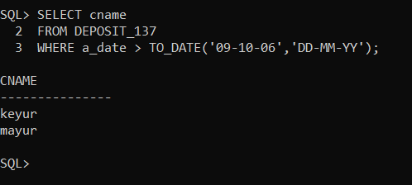

Q-6 | SELECT emp_name AS employee_name, emp_sal  FROM EMPLOYEE_137  WHERE dept_no = 20;
A | 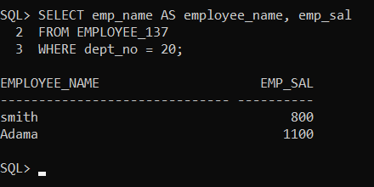
Q-7 | SELECT emp_no, emp_name, dept_no  FROM EMPLOYEE_137  WHERE dept_no IN (10, 20);
A | 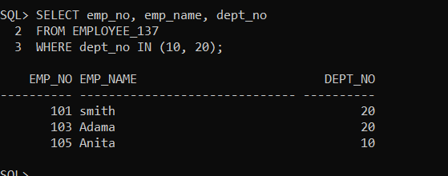
Q-8 | SELECT emp_no, emp_name, dept_no  FROM EMPLOYEE_137  WHERE dept_no NOT IN (15, 30)  AND dept_no <> 25;
A | 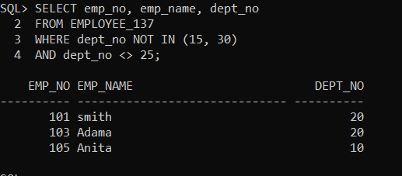
Q-9 | SELECT emp_no, emp_name, dept_no  FROM EMPLOYEE_137  WHERE dept_no BETWEEN 15 AND 25;
A | 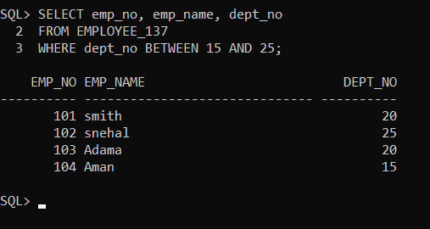
Q-10 | SELECT emp_name  FROM EMPLOYEE_137  WHERE emp_comm IS NOT NULL;
A | 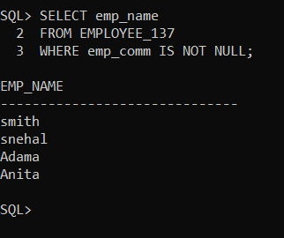
Q-11 | SELECT job_title,  min_sal || ' - ' || max_sal AS salary_range  FROM JOB_137;
A | 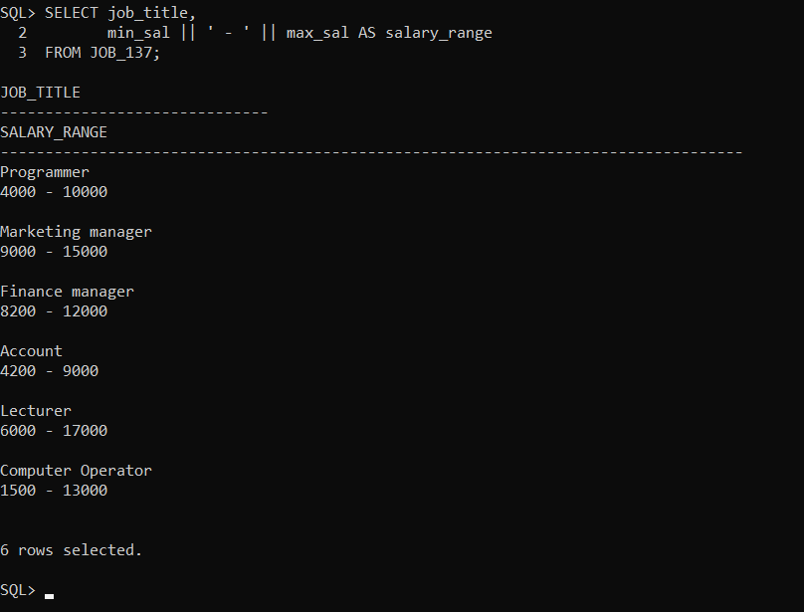

Q-12 | INSERT INTO SUP2_NEW_137 (emp_no, new_sal, emp_comm, dept_no)  SELECT emp_no, emp_sal, emp_comm, dept_no  FROM EMPLOYEE_137;
A | 