 | Practical – 3
Aim | To support a banking organization in maintaining accurate, consistent, and meaningful data  within their employee and job-related database by performing essential Data Manipulation Language  (DML) operations and analytical SQL queries. In this scenario, the bank's database administrator is  responsible for updating employee records, deleting outdated or incorrect information, modifying  commission values, and generating aggregated insights such as maximum/minimum salary, average  salary, and departmental statistics.  6  The organization also requires well-structured data retrieval, sorted in various orders and filtered by  business rules, to enable effective monitoring of employee performance, salary distribution, and  department-wise data analysis.
Q-1 | DELETE FROM SUPPLIER_137;
A | 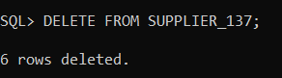
Q-2 | DELETE FROM SUPPLIER_137  WHERE emp_no = 103;
A | 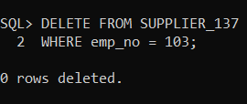
Q-3 | UPDATE EMPLOYEE_137  SET emp_name = 'Aman'  WHERE emp_name = 'Anita';
A | 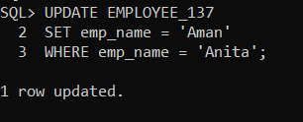

Q-4 | UPDATE EMPLOYEE_137  SET emp_name = 'Updated_Name'  WHERE emp_no = 103;
A | 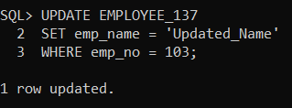
Q-5 | SELECT MAX(max_sal) AS max_salary,  MIN(min_sal) AS min_salary  FROM JOB_137;
A | 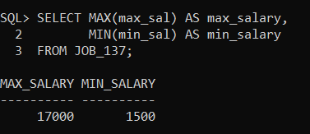

Q-6 | SELECT AVG(emp_sal) AS avg_salary  FROM EMPLOYEE_137;
A | 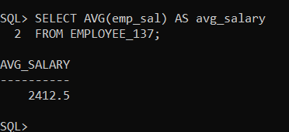
Q-7 | SELECT COUNT(dept_no) AS total_departments,  COUNT(DISTINCT dept_no) AS distinct_departments  FROM EMPLOYEE_137  WHERE emp_sal > 1000;
A | 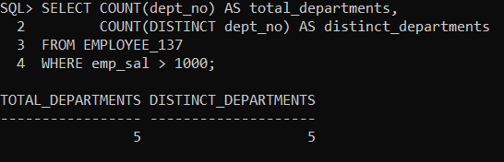
Q-8 | SELECT *  FROM EMPLOYEE_137  ORDER BY emp_name ASC, emp_no DESC;
A | 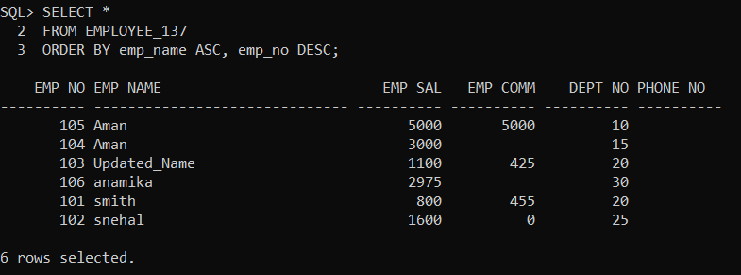
Q-9 | SELECT emp_no, emp_name, dept_no, emp_comm  FROM EMPLOYEE_137  ORDER BY dept_no ASC, emp_comm DESC;
A | 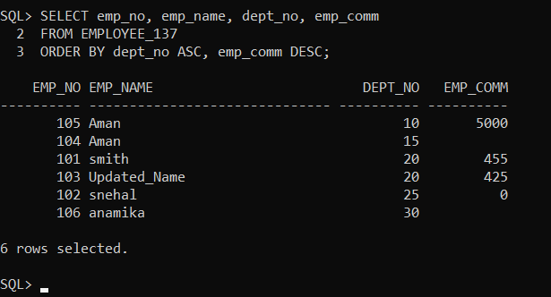
Q-10 | UPDATE EMPLOYEE_137  SET emp_comm = 500  WHERE dept_no = 20;
A | 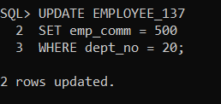
Q-11 | SELECT emp_sal, emp_comm  FROM EMPLOYEE_137  ORDER BY emp_comm ASC NULLS FIRST,  emp_sal DESC;
A | 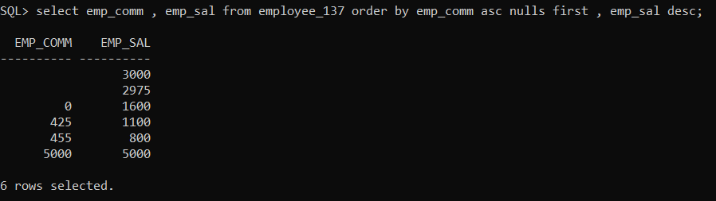

Q-12 | SELECT emp_no, emp_comm  FROM EMPLOYEE_137  ORDER BY emp_comm ASC NULLS LAST,  emp_no DESC;
A | 