 | Practical – 7
Aim | To solve various queries related to grouping and aggregate functions by  manipulating data in the product and emp_company tables.  Constraints –  • Not Null Constraints: Ensure critical fields are not null.  • Unique Constraints: Ensure data integrity by limiting column values.  • Check Constraints: Ensure columns have unique values where required.
Q-1 | Insert the following values into the product table.  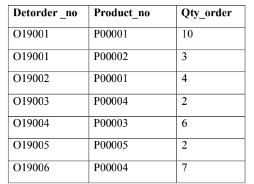  Test Case: Verify that the values are inserted correctly into the product table.
A | 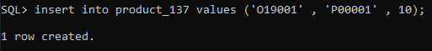  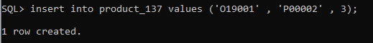  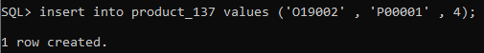  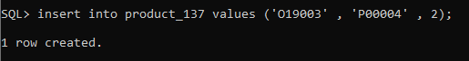  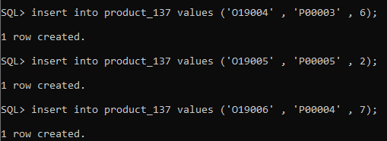  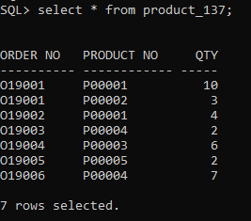
Q-2 | Retrieve the product numbers and total quantity ordered for each product from the product table.
A | 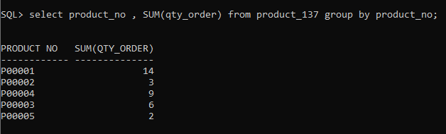
Q-3 | Retrieve the product no and the total quantity ordered for product’s ‘P00001’ and ‘P00004’ from product table.
 | 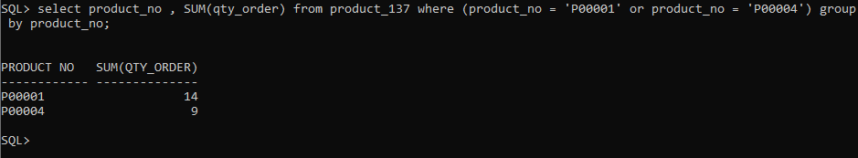
4) | 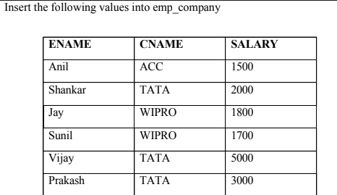  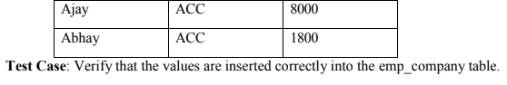
 | 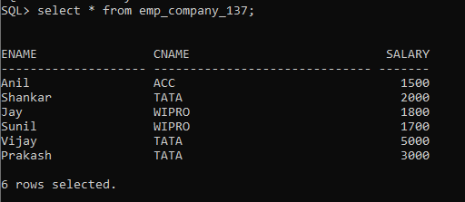
5) | List the name of the company and the maximum salary in that company.
 | 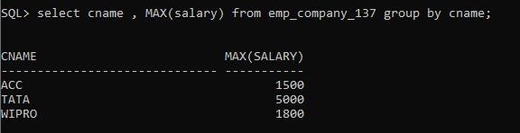
6) | Find out the average salary of each company.
 | 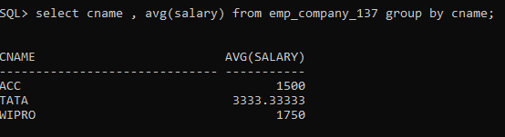
7) | Find out the names of companies having an average salary of more than 1500.
 | 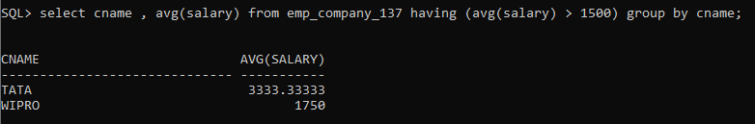
8) | Find out the average salary of each company except ‘ACC’.
 | 