 | Practical – 9
Aim | To apply the concept of integrity/data constraints while creating or  altering tables in a database for managing sales-related data.
Q-1 | Create Table Salespeople where Snum number(4) P.K, Sname varchar2(20)  NOT NULL, City varchar2(15), Comm number(5,2).  Constraints  1. Primary Key Constraint: Ensure Snum uniquely identifies each record.  2. Not Null Constraint: Ensure Sname is not null.  Tasks:  Test Case 1: Insert a valid record.  Objective: Verify that a valid record can be inserted into the Salespeople table.  Expected Result: The record should be inserted successfully.  Test Case 2: Insert a record with a duplicate Snum  Objective: Verify that inserting a record with a duplicate Snum results in an error.  Expected Result: The insertion should fail with a primary key constraint violation error.  Test Case 3: Insert a record with a null Sname  Objective: Verify that inserting a record with a null Sname results in an error.  Expected Result: The insertion should fail with a not-null constraint violation error.  Test Case 4: Insert a record with missing City and Comm  Objective: Verify that a record can be inserted with City and Comm as null.  Expected Result: The record should be inserted successfully with City and Comm as null.  Test Case 5: Retrieve all records from the Salespeople table.  Objective: Verify that all records can be retrieved from the table.
A | 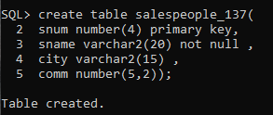  Test case 1:  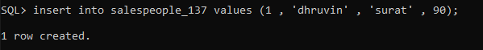  Test case 2:  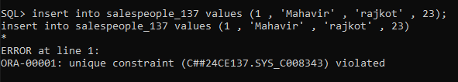  Test case 3:  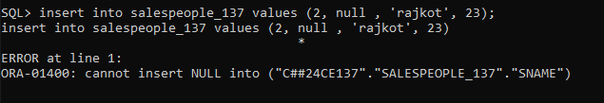  Test case 4:  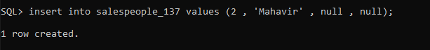  Test case 5 :  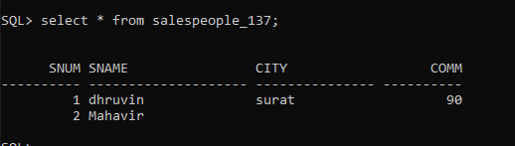
Q-2 | Create Table customer where Cnum number (4) P.K, Cname  varchar2(20)NOT NULL, City varchar2(20), Rating number(3) DEFAULT  10, Snum number(4) F.K.(where snum refer salespeople table).  Constraints  1. Primary Key Constraint: Ensure Cnum uniquely identifies each record.  2. Not Null Constraint: Ensure Cname is not null.  3. Foreign Key Constraint: Ensure Snum references the Snum field in the Salespeople table.  4. Default Constraint: Ensure Rating defaults to 10 if no value is provided.  Tasks:  Test Case 1: Insert a valid record  Objective: Verify that a valid record can be inserted into the Customer table.  Expected Result: The record should be inserted successfully.  Test Case 2: Insert a record with a missing Rating  Objective: Verify that a record can be inserted with a Rating defaulting to 10.  Expected Result: The record should be inserted successfully with a Rating of 10.  Test Case 3: Insert a record with a null Cname  Objective: Verify that inserting a record with a null Cname results in an error.  Expected Result: The insertion should fail with a not null constraint violation error.  Test Case 4: Insert a record with a non-existent Snum  Objective: Verify that inserting a record with a non-existent Snum results in an error.  Expected Result: The insertion should fail with a foreign key constraint violation error.  Test Case 5: Insert a record with missing City and Rating  Objective: Verify that a record can be inserted with City and Rating as null/default.  Expected Result: The record should be inserted successfully with City as null and Rating as 10.  Test Case 6: Retrieve all records from the Customer table  Objective: Verify that all records can be retrieved from the table.  Expected Result: The query should return all the inserted records.
A | 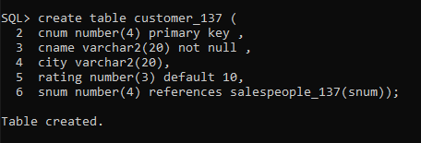  Test Case 1:  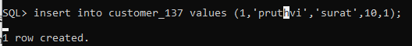  Test Case 2:  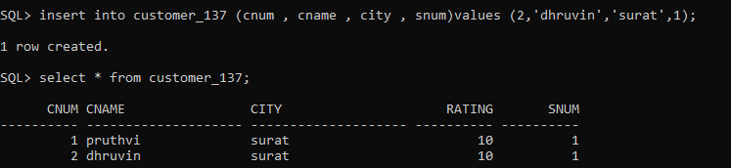  Test Case 3:  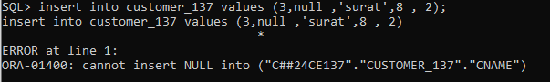  Test Case 4:  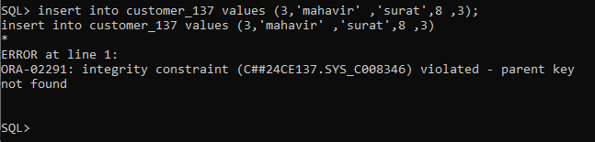  Test case 5:  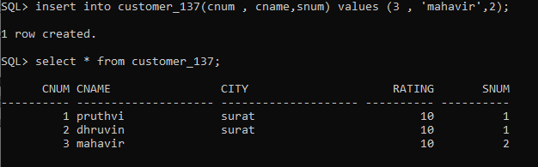  Test Case 6:  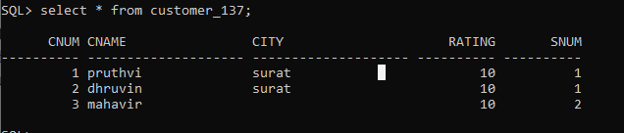
Q-3 | Create table Order where Order_no number(4) P.K, Amount number(5), Odate  varchar2(10), Cnum number(4) F.K, (where cnum refer customer table). Snum  number(4) F.K (where snum refers salespeople table).  Constraints  1. Primary Key Constraint: Ensure Order_no uniquely identifies each record.  2. Foreign Key Constraint: Ensure Cnum references the Cnum field in the Customer table.  3. Foreign Key Constraint: Ensure Snum references the Snum field in the Salespeople table.  Tasks:  Test Case 1: Insert a valid record  Objective: Verify that a valid record can be inserted into the Orders table.  Expected Result: The record should be inserted successfully.  Test Case 2: Insert a record with a non-existent Cnum  Objective: Verify that inserting a record with a non-existent Cnum results in an error.  Expected Result: The insertion should fail with a foreign key constraint violation error for Cnum.  Test Case 3: Insert a record with a non-existent Snum  Objective: Verify that inserting a record with a non-existent Snum results in an error.  Expected Result: The insertion should fail with a foreign key constraint violation error for Snum.  Test Case 4: Insert a record with a null Amount  Objective: Verify that a record can be inserted with Amount as null.  Expected Result: The record should be inserted successfully with Amount as null.  Test Case 5: Insert a record with null Odate  Objective: Verify that a record can be inserted with Odate as null.  Expected Result: The record should be inserted successfully with Odate as null.  Test Case 6: Retrieve all records from the Orders table  Objective: Verify that all records can be retrieved from the table.  Expected Result: The query should return all the inserted records.
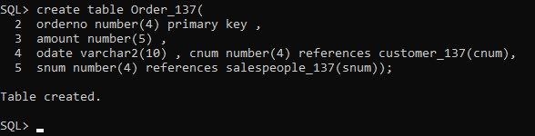
Test Case 1:
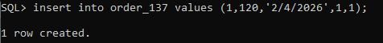
Test Case 2:
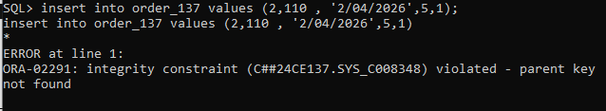
Test case 3:
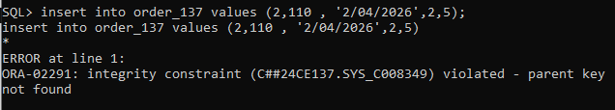
Test Case 4:
Test Case 5:

Test Case 6:
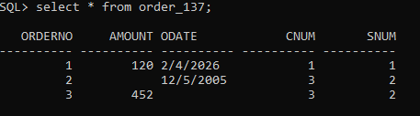
4) | Table: Sales_order  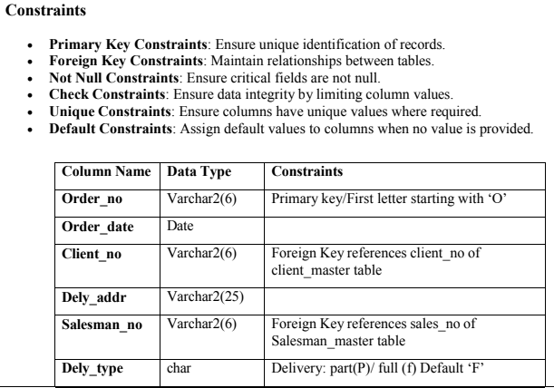

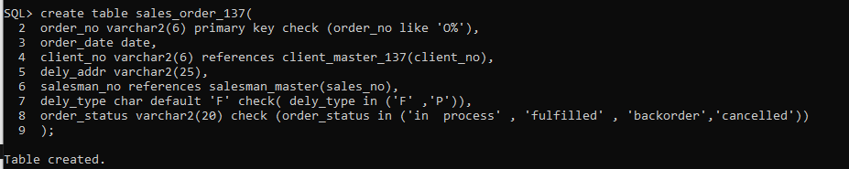
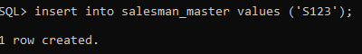
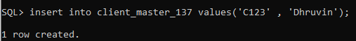
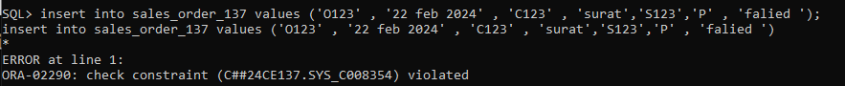
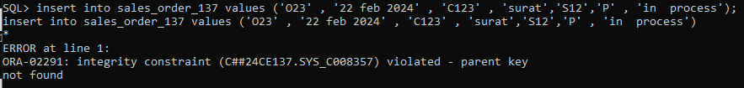
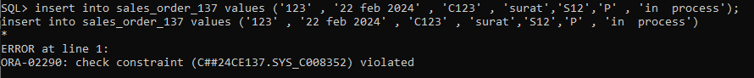
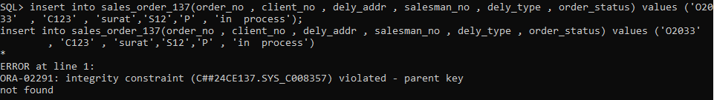
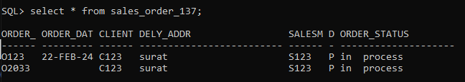
5) | 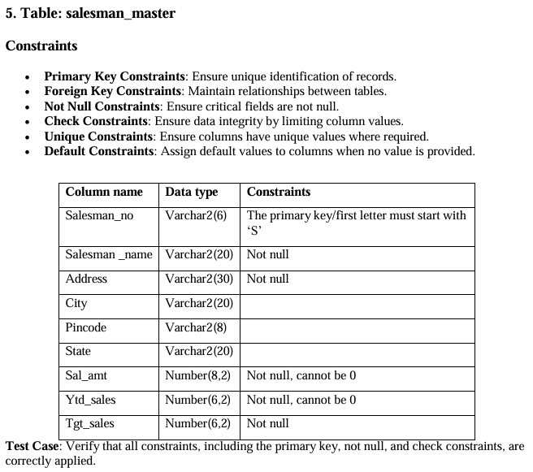
 | 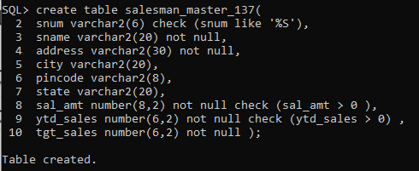
6) | 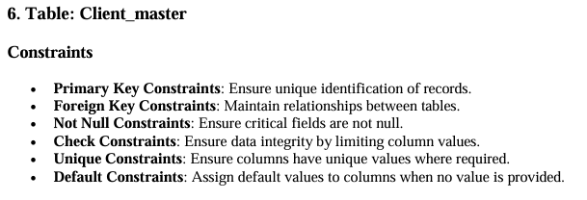  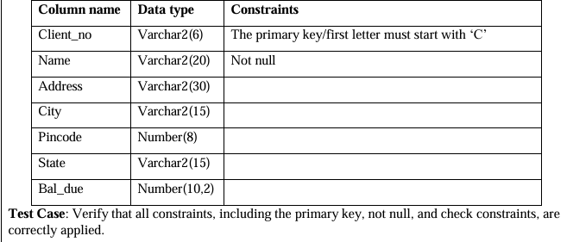
 | 