Oxford Digital Signage System
Power user and system maintainer documentation

University of Oxford IT Services
Guido Klingbeil
Marko Jung

24 April 2013

Table of Contents
General notes 2
Login to the Oxford Digital Signage System 2
How to add a digital sign (post) to a display and schedule it 4
How to delete a post 5

General notes

The Oxford Digital signage system is build on top of the well known WordPress (www.wordpress.org) to create websites or blogs. This means we have to define some nomenclature up front:
WordPress is build around the concept of posts written and edited by the user and finally displayed or published. Each post is at least associated with one category. Another WordPress concept is that of pages. While posts are one time snippets of information such as a blog entry, a page contains static information such as the contact details of the website.
The Oxford Digital Signage System redefines some of these terms. A post is a single digital sign you want to display such as to advertise a special event.
A page is a display such as a monitor next to a lecture room door displaying digital signs. A page shows multiple digital signs of a given category in a round robin fashion. The number of digital signs displayed and the time they are shown may be configured by the user.

Login to the Oxford Digital Signage System

Navigate to the system's home page and follow the “login” link by clicking on it.

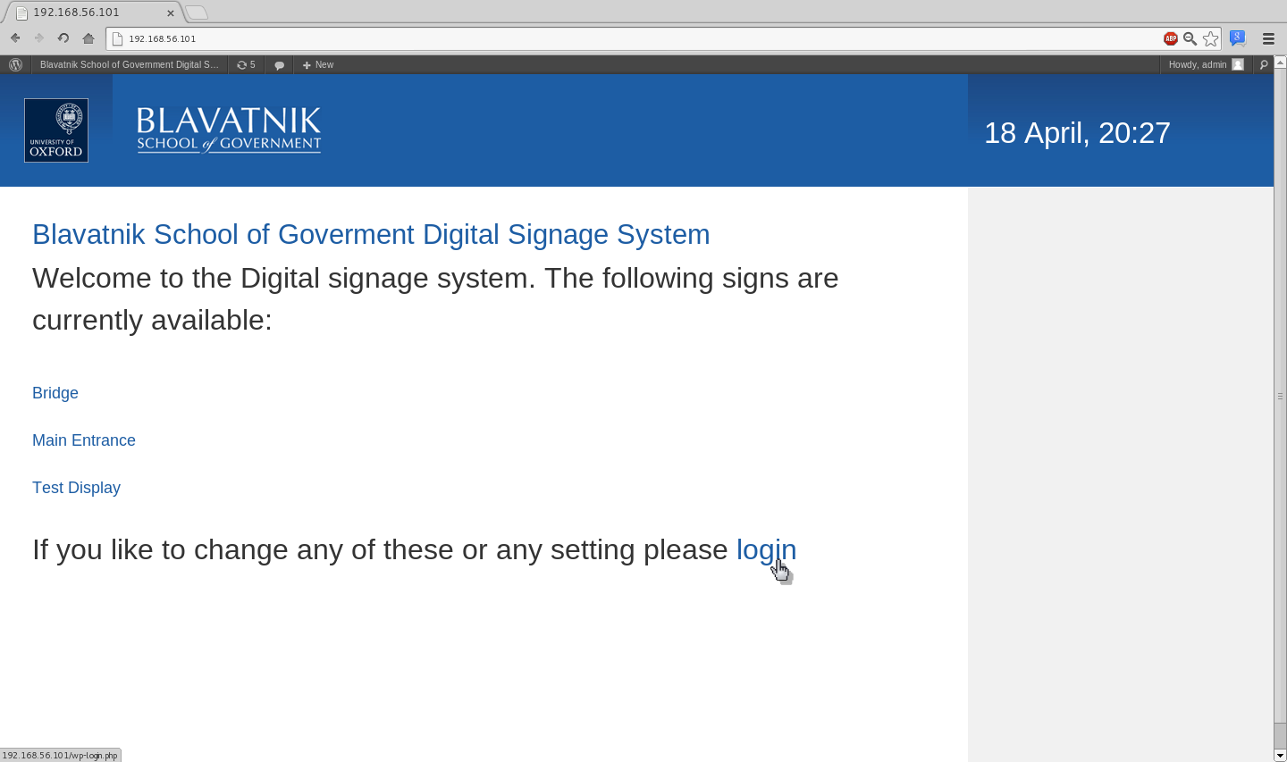

This takes you to the login screen:

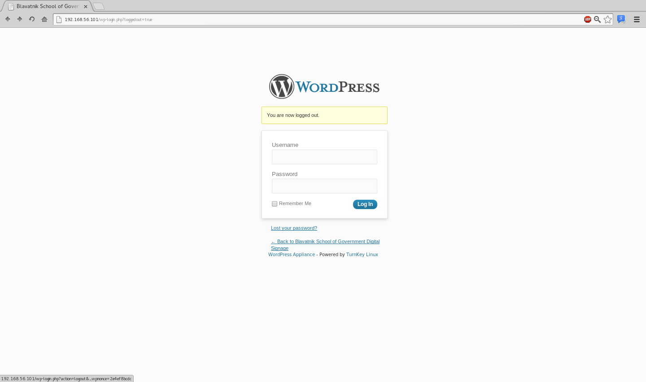
Entering your user name and password takes you to the administration dashboard. This is the central administration page of the WordPress system. Whenever you are logged into the WordPress system you will see the dark grey bar “toolbar” at the top of your browser window. For more details please follow the introductory WordPress guide on codex.wordpress.org/First_Steps_With_WordPress.

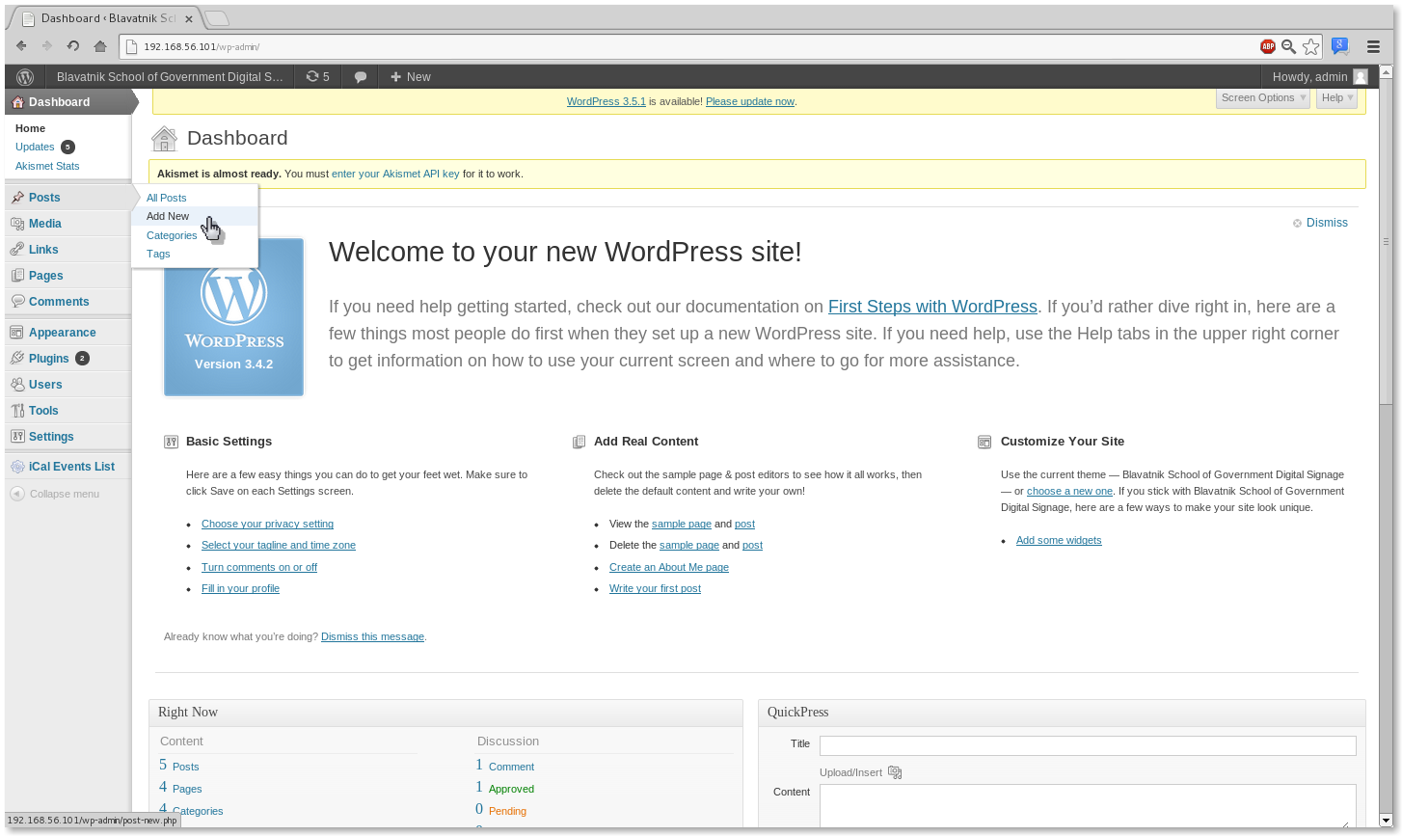

How to add a digital sign (post) to a display and schedule it

To add a post position the mouse pointer on the “Posts” menu item on the left hand side of the screen. A submenu will appear. Click on the “Add New” menu item.

This leads you to a screen which allows you to edit the title and content of the post as well as scheduling it.
An introductory guide how to write posts, in our context digital signs, is available at: codex.wordpress.org/Writing_Posts. It is possible to add media such as images to digital signs. A guide how to include media can be found at: http://codex.wordpress.org/Working_with_WordPress#WordPress_Media.
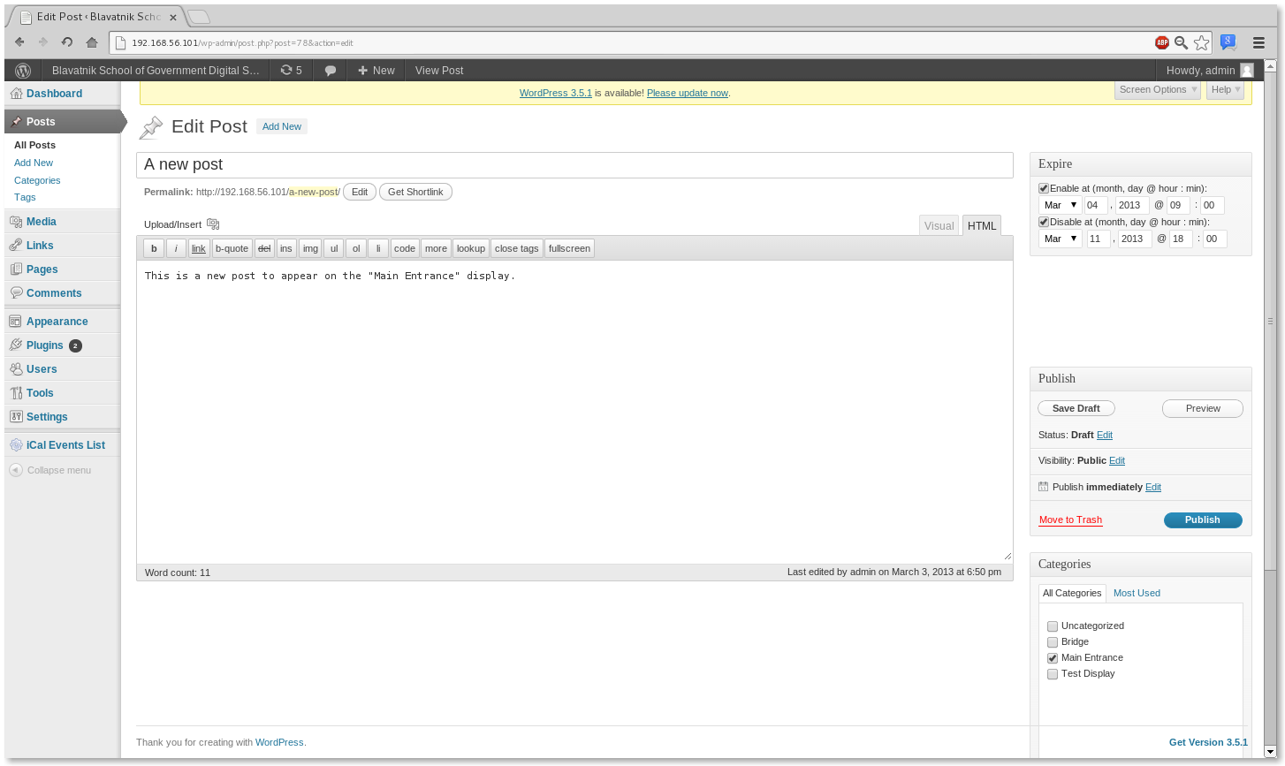
Title of Sign (Post)
Content
Scheduler
Display
selection
Digital signs may be scheduled and every sign has an enable and a disable date and time associated with it. This is given in the options box in the upper right hand corner. If the check box “Enable at” or “Disable at” are checked, the post will be publish as soon as the given enable date and time has passed and disabled again as soon as the given disable date and time has passed. Please note, that these dates are independent and either of them may be given without the other.
Select at least one category for the post. The category defines the display the post will be shown on.
Finally, publish the post by clicking on the “Publish” button. Please be aware, if a time to enable the post has been given and not yet passed, the status of the post will automatically be changed from “Published” to “Draft”.

How to delete a post

At the administrator dashboard click on “Posts” on the left hand side to get a list of all posts. Posts may either be deleted one at a time or multiple posts as a bulk action.
To delete a single post, place the mouse pointer on the post title. A horizontal menu appears below the post title. Click on the menu item “Trash” to delete the post.

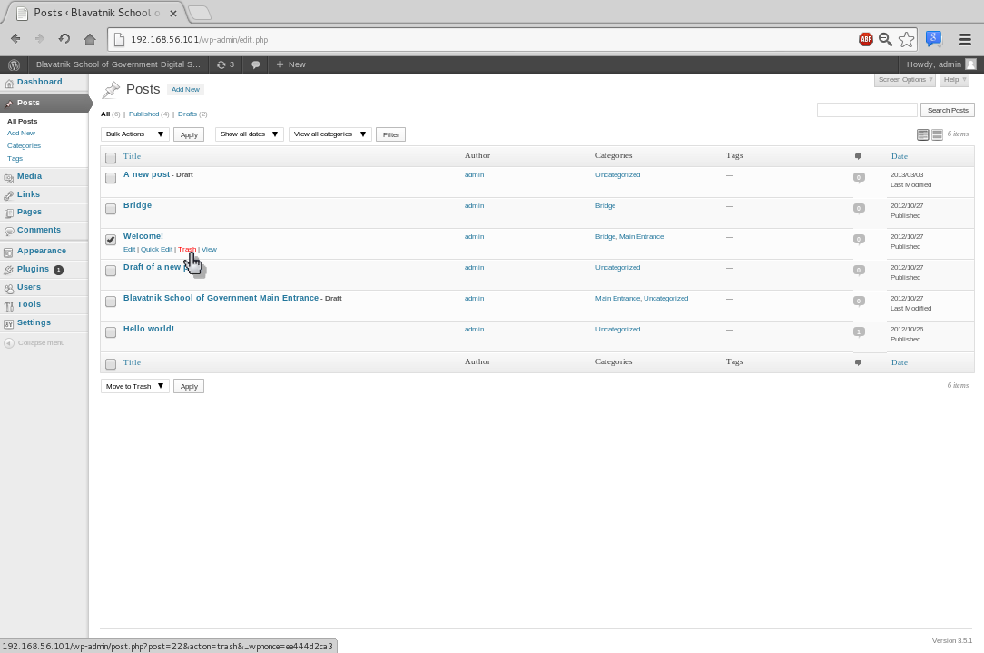
To delete multiple posts select the posts to be deleted by marking them as shown in the screen shot below. Then select the action “Move to trash” from the drop down menu above or below the list of post. Click the “Apply” button to delete the posts.
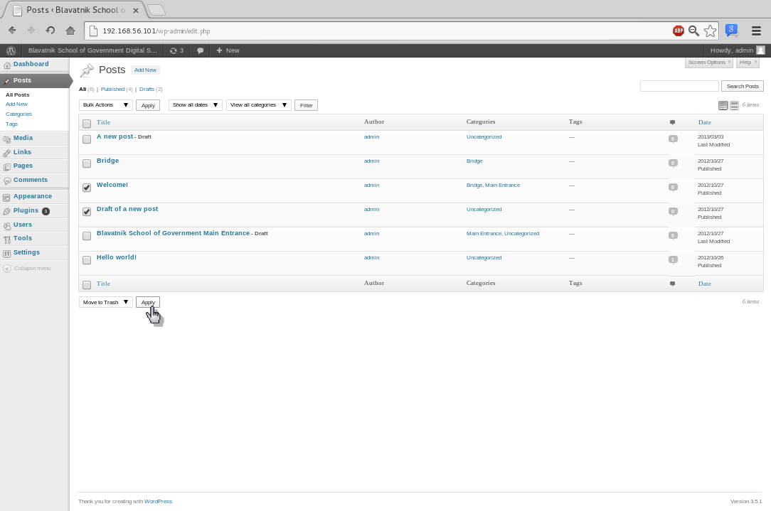

How to use the Test display
There is a display named “Test Display” with a Category representing it. This display is not actually presented on a screen on the premises. By enabling a post only on this display you can check its layout using your workstation. It can easily be viewed by pointing a browser to the location https://bsg-elsinore.bsg.ox.ac.uk/test/.

