Oxford Digital Signage System
Power user and system maintainer documentation

University of Oxford IT Services
Guido Klingbeil
Marko Jung

24 April 2013

Table of Contents
System overview 1
Installation 2
Wordpress system 2
Add users 2
Configuration of the displays 4
Configure the widgets 5

System overview
The Oxford Digital Signage System provides digital signs to displays. A digital sign is a piece of content such as a lecture announcement or event advertisement and a display is a device such as a monitor. The system is build on top of the well known WordPress (www.wordpress.org) to create websites or blogs. This means we have to define some nomenclature up front:
WordPress is build around the concept of posts written and edited by the user and finally displayed or published. Each post is at least associated with one category. Another wordpress concept is that of pages. While posts are one time snippets of information such as a blog entry, a page contains static information such as the contact details of the website.
The Oxford Digital signage system redefines some of these terms. A post is a single digital sign you want to display such as to advertise a special event.
A page is a display such as a monitor next to a lecture room door displaying digital signs. A page shows multiple digital signs of a given category in a round robin fashion. The number of digital signs displayed and the time they are shown may be configured by the user.
The Oxford Digital Signage system extends the WordPress system by a theme and three plugins / widgets supplemented by a fourth third party plugin / widget. A brief description of the responsibilities of the plugins is given below:
- Oxford Digital signage plugin: displays a single post (digital sign) on a page (display). It defines how many signs are displayed in a round robin fashion and how long each sign is displayed. Furthermore, this plugin defines the category of the digital signs to be shown as well as the option to define the location of the display
- Oxford post scheduler plugin: allows the scheduling of posts (digital signs). For each post an enable date / time and a disable date / time may be defined. At the enabled date / time the post is automatically published and displayed. As soon as the disable date / time the post is no longer shown. The post is not deleted from the system.
- Oxford calendar widget: Display a calendar within a Wordpress sidebar. This widget cooperates with the Blavatnik School of Government (BSG) theme. Whenever an event takes currently place in a specific location such as a lecture room a message is displayed that the room is in use on all displays linked with the location.
- My Twitter Widget: third party widget not part of the Oxford digital signage system. Displays a twitter feed within a Wordpress sidebar.
The BSG theme ensures the digital signage system reflects the corporate identity of the Blavatnik School of Government.

Installation
Before starting the installation process it should be noted that this documentation is for the digital signage system deployed at the Blavatnik School of Government. However, it should be easy to adopt these instructions to install your own system.

Wordpress system
A basic WordPress (www.wordpress.org) installation is prerequisite of the digital signage system. Please follow the installation guide (codex.wordpress.org/Installing_WordPress) to install Wordpress on your system.
Apply the following settings specific to the Blavatnik School of Government digital signage system:
- General settings (at the Dashboard select the Settings menu on the left hand side and then the General tab):
- Site Title: “Blavatnik of Governmnet Digital Signage”
- Wordpress Address (URL): http://bsg-elsinore.bsg.ox.ac.uk
- Site Address (URL): http://bsg-elsinore.bsg.ox.ac.uk
- Set the contact email address.
- Timezone: London
- Permalink settings:
- Select the post name (http://bsg-elsinore.bsg.ox.ac.uk/sample-post/) radio button.
- Edit the file .htaccess in the root folder of the WordPress installation to contain the following two lines to limit access to Oxford hosts:
Order Allow,Deny
Allow from .ox.ac.uk
We recommend using a WordPress extension like WP Htaccess Editor (http://wordpress.org/extend/plugins/wp-htaccess-editor/).
The Blavatnik School of Governmnet theme: install the theme BSG_theme by following the guide codex.wordpress.org/Themes. No further configuration of the theme is required. The repository of the theme is https://github.com/ox-it/ox-theme-bsg-signage.
Installation of the required plugins. install the required plugins ox-digital-signage, ox-post-scheduler, ox-calendar, and My Twitter Widget and activate them. The plugins themselves do not require any further configuration. Further reading: codex.wordpress.org/Managing_Plugins
The plugin repositories are:
- ox-digital signage plugin: https://github.com/ox-it/ox-digital-signage,
- ox-post-scheduler: https://github.com/ox-it/ox-post-scheduler,
- ox-calendar-widget: https://github.com/ox-it/ox-calendar-widget,
- My Twitter Widget: http://wordpress.org/extend/plugins/my-twitter-widget/.
Please note: to avoid long delays loading the calendar file, it is advisable to start with a new and empty calendar file each academic year.

Add users
For a detailed description how to add and manage users please refer to the Wordpress online guide codex.wordpress.org/Working_with_WordPress. Two roles seem to be appropriate in the context of the digital signage system, the administrator and the editor.
Responsibilities of an editor:
- Add, edit, and delete posts and posts,
- Publish and unpublish pages and posts.
Additional responsibilities of an administrator beyond the previous ones:
- Install and update plugins, widgets and themes,
- Edit plugins, widgets and themes,
- Add, edit, and delete users.

Configuration of the displays
As a brief reminder, pages are displays displaying a number of digital signs in a round robin fashion. A post is a digital sign. Digital signs are are assigned to pages by their category. The configuration of the displays consists of several steps:
- create categories to link signs to displays
- for each display create a page
- configure the pages themselves.
In the example shown below there are three displays called “Bridge”, “Main Entrance”, and “Test Display”. The posts (digital signs) are linked to one or more displays by their categories. A digital sign may be displayed on multiple displays by assigning multiple categories to a post. For each display add a category and a brief description:

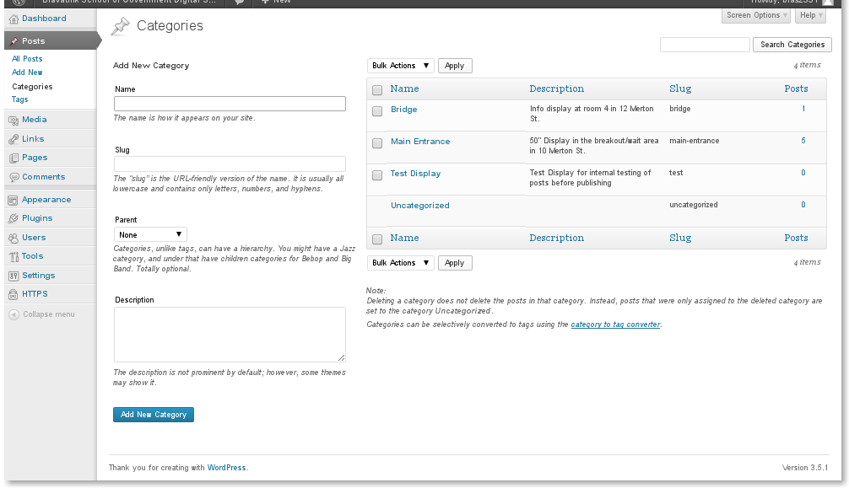
For each display, add a page. It should be noted that it is not technically required for the pages to have the same names as the categories. However, consistent naming should make it easier to asign digital signs to displays in the daily operations.
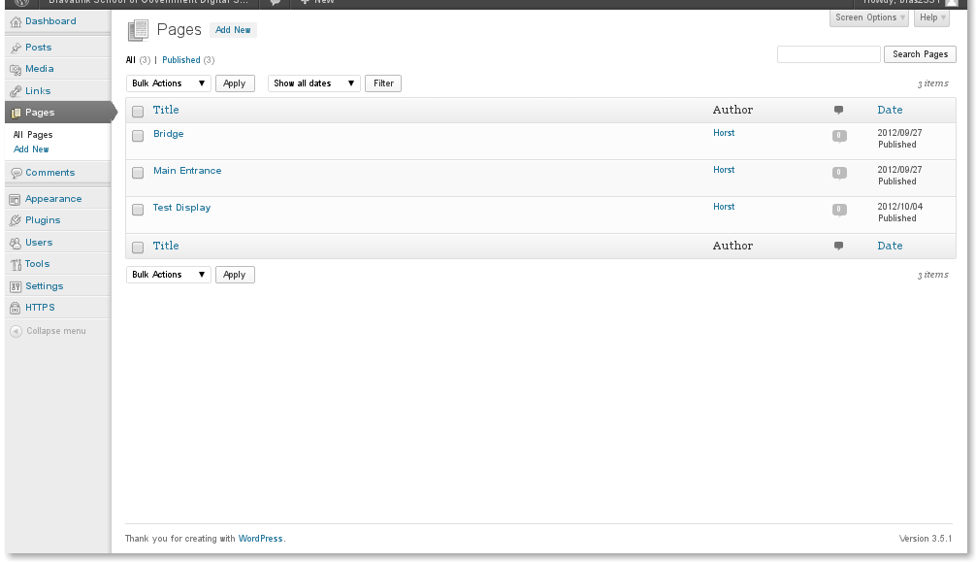
Configuration of the pages. Add the Wordpress short code [oxds_add_sign] as the sole content to the page. To configure the options of the ox-digital-signage plugin for the page enter a time to refresh or load the next digital sign in seconds and the number of signs to cycle. If there are more published signs available within the chosen category only the first ones will be cycled. Select the category from the drop down list. Only signs of the given category will be displyed. Set the location, the spelling needs to match the location spelling used in the calendar exactly and case sensitive. Finally, publish the page.

Configure the widgets
The next task is to configure the widgets to be displayed in the right sidebar and the bottom sidebar. The screenshot below gives an impression of the fully configured system. The left sidebar is the light gray area at the right of the screen shot. It shows the next upcoming events taken from a calendar. The bottom sidebar is the darker gray area at the bottom of the screen. It displays a twitter feed. These sidebars are defined by the BSG theme and they are the only ones considered in this manual.
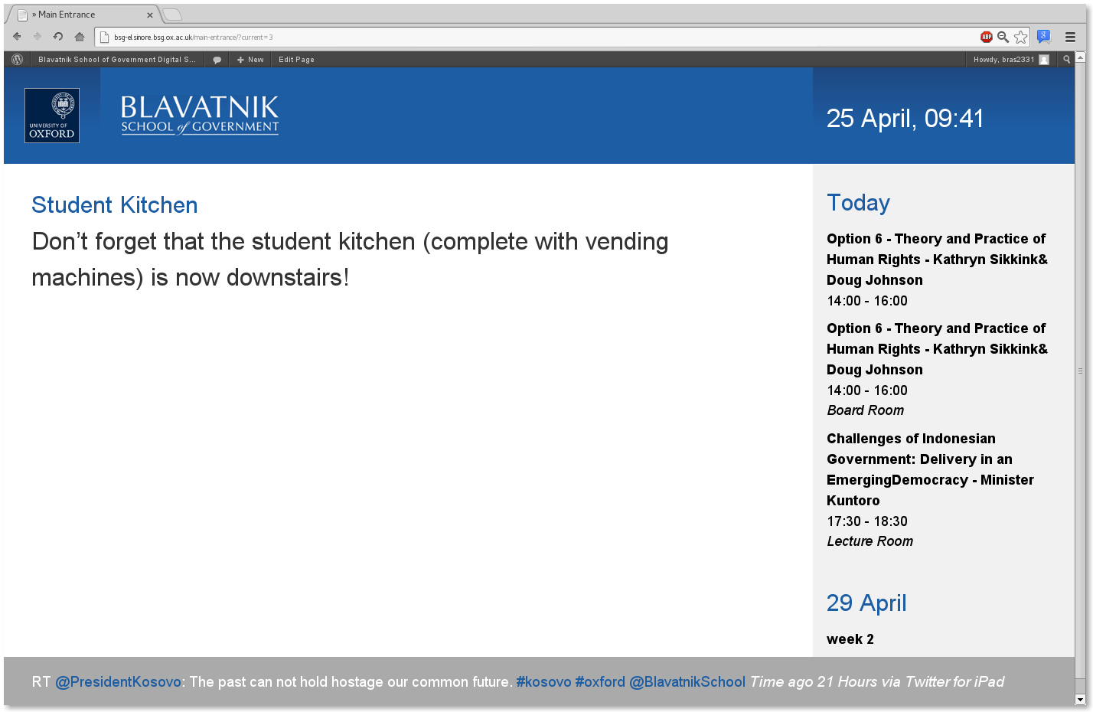
First, please add the OX Calendar Widget in the theme options to the left sidebar.
- Give the title of the event list to be displayed. This is optional. If no title is given, the title of the calendar will be used. Whether the title is actually shown is configured by the check box “Show title”,
- Give the url of the calendar file containing the event list to be shown (either webcal or http),
- Give the number of upcoming events to be displayed. The optimal value depends on the physical display size,
- Optional: Give a date range for the events. This option is not covered by this document,
- The CSS stylesheet provided by the BSG theme overrides the stylesheet provided by the widget. To revert delete the section named CALENDAR WIDGET from the file [wordpress base path]/wp-content/themes/ox-theme-bsg-signage/style.css.
The miscellaneous options controlled by the check boxes are self explanatory. The screenshot below shows the actual configuration of the deployed system at the Blavatnik School of Government.
A note regarding events that last an entire day or Multiple days: Select whether events lasting an entire day and multi day events are to be shown. An example of a multi day event is the week of term. The example above shows week 2 starting on 29 April. The start and end time of events lasting an entire day or more than one day is not shown.

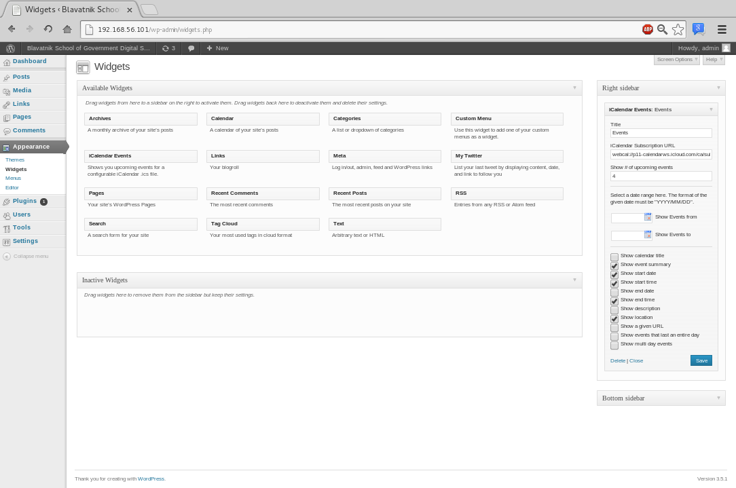
Second, configure the bottom sidebar with the My Twitter Widget. It should be noted that the My Twitter Widget is a third party widget not maintained by the Oxford University IT services. It is available at http://wordpress.org/extend/plugins/my-twitter-widget/.
- The twitter user name defines the Twitter feed to be displayed. The number of tweets to be show is self explanatory,
- The My Twitter Widget provides a caching mechanism. The tweets are cached for the given time in seconds. A time of 0 seconds disables the caching mechanism,
- The CSS stylesheet provided by the Blavatnik School of Government theme overrides the stylesheet provided by the widget. To revert delete the section name TWITTER WIDGET from the file [wordpress base path]/wp-content/themes/ox-theme-bsg-signage/style.css.
The screenshot below shows the actual configuration of the My Twitter Widget as used by the deployed system:
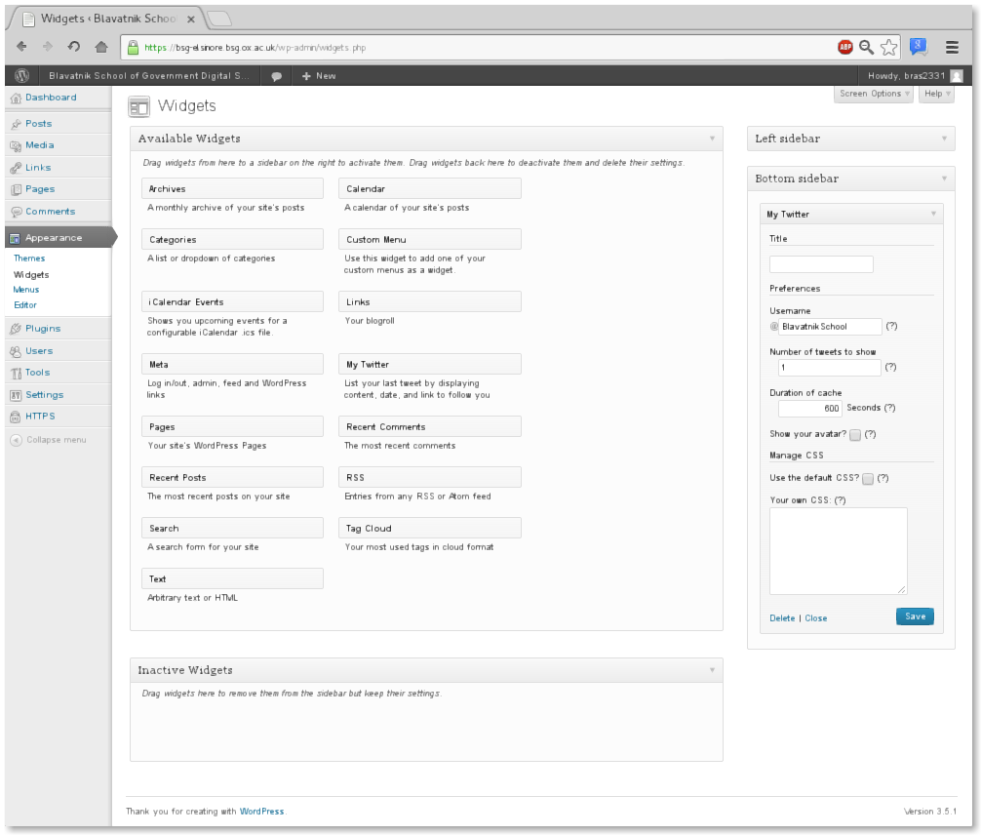
Note: the customisation of the bottom sidebar as well as the My Twitter Widget is part of the CSS style sheet provided by the BSG_theme. No customisation is required here.

