Library Availability Web Services

1. Primo web service request

Request: protocol//host/library-availability/library?id=id [&format=format] [&callback=callback]

id is a valid DAIAuri, for example

http://solo.bodleian.ox.ac.uk/primo_library/libweb/action/display.do?doc=UkOxUUkOxUb15585873&vid=OXVU1&fn=display&displayMode=full

format possible values are json, jsonp and xml (not supported yet), default value is json.
callback parameter only applies to format jsonp, default value is callback.

Response: Requested information in requested DAIA format.

Sequence diagram for the service

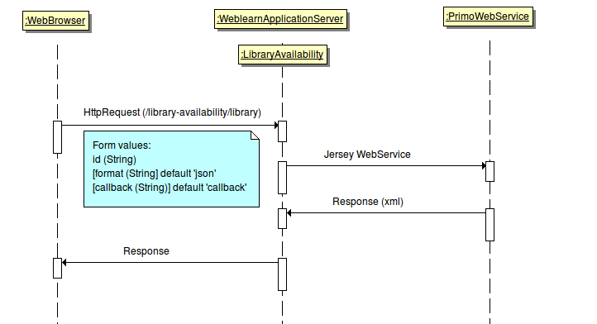

2. SFX (electronic) web service request

Request: protocol//host/library-availability/library?id=id [&format=format] [&callback=callback]

id is a valid openuri, for example

http://oxfordsfx-direct.hosted.exlibrisgroup.com/oxford?ctx_ver=Z39.88-2004&ctx_enc=info:ofi/enc:UTF-8&ctx_tim=2010-12-17T17%3A09%3A33IST&url_ver=Z39.88-2004&url_ctx_fmt=infofi/fmt:kev:mtx:ctx&rfr_id=info:sid/primo.exlibrisgroup.com:primo3-Article-elsevier&rft_val_fmt=info:ofi/fmt:kev:mtx:&rft.genre=article&rft.atitle=Chemical%20changes%20that%20predispose%20smoked%20Cheddar%20cheese%20to%20calcium%20lactate%20crystallization&rft.jtitle=Journal%20of%20Dairy%20Science&rft.btitle=&rft.aulast=Rajbhandari&rft.auinit=&rft.auinit1=&rft.auinitm=&rft.ausuffix=&rft.au=Rajbhandari,%20P.&rft.aucorp=&rft.date=200908&rft.volume=92&rft.issue=8&rft.part=&rft.quarter=&rft.ssn=&rft.spage=3616&rft.epage=3622&rft.pages=3616-3622&rft.artnum=&rft.issn=00220302&rft.eissn=&rft.isbn=&rft.sici=&rft.coden=&rft_id=info:doi/10.3168/jds.2009-2157&rft.object_id=&rft_dat=%3Celsevier%3EOM09120A_00220302_00920008_09706824%3C/elsevier%3E&rft.eisbn=&rft_id=http%3A%2F%2Fsolo.bodleian.ox.ac.uk%2Fprimo_library%2Flibweb%2Faction%2Fdisplay.do%3Fdoc%3DTN_elsevierOM09120A_00220302_00920008_09706824%26vid%3DOXVU1%26fn%3Ddisplay%26displayMode%3Dfull

format possible values are json, jsonp and xml (not supported yet), default value is json.
callback parameter only applies to format jsonp, default value is callback.

Response: Requested information in requested DAIA format.

Sequence diagram for the service

