AAE4203 — Guidance and Navigation
GNSS Lab Report
Lab 1: GNSS Positioning
Single point positioning from u-blox raw measurements near Block X,
validated against independent solutions and benchmarked on UrbanNav

Group: Group 18 (receiver kit K08)
Members: CHIU Sung Lim (23078005D); RAMOS CRUZ Axel Daniel (26009386X);
YU Mengzhi (24102853D); ZHANG Borui (24102982D)
Instructor: Prof. Weisong WEN
Department: Department of Aeronautical and Aviation Engineering
School: The Hong Kong Polytechnic University
Field session: 30 October 2026, 17:00–17:10 HKT, next to Block X
Date: 12 November 2026
Code and data: github.com/ox-x/AAE4203-Lab1-G18
Abstract
On 30 October 2026 our group logged 580 epochs (9 min 56 s at 1 Hz) of raw u-blox ZED-F9P measurements next to Block X, a semi-open site surrounded by 30–60 m buildings. The logs were converted with RTKCONV and processed with a single point positioning (SPP) solver written from scratch in Python: broadcast-ephemeris orbits, Klobuchar and Saastamoinen corrections, weighted least squares with one receiver clock per constellation and residual-based fault exclusion. On our own data the GPS-only baseline scatters 42.9 m (2D RMS about its mean); adding Galileo, BeiDou, elevation and C/N₀ weighting and outlier rejection reduces the scatter to 20.8 m and the 2D difference from the receiver solution from 41.5 m to 7.0 m. The same chain solves all 186 epochs of the example dataset with a 2D RMSE of about 16 m (23.5 m in 3D), against 25.6 m for the GPS-only variant on the 113 epochs it can solve — the same order as the 37.9 m reported for the reference implementation. On the UrbanNav benchmark the final version solves 1531 of 1534 epochs (99.8 %) with 15.6 satellites and a mean HDOP of 1.25, against 96.1 % and 5.7 satellites for the GPS-only baseline; the official RMSE and rank are assigned on the leaderboard, which is why the ablation is quantified here by availability and internal consistency.
Keywords: GNSS; single point positioning; weighted least squares; urban positioning; u-blox ZED-F9P; UrbanNav

1 Data Collection
The field session took place on Friday 30 October 2026 in the semi-open area between Block X and the Jockey Club Innovation Tower on the PolyU campus (22.30560° N, 114.18005° E, ellipsoidal height ≈ 19 m). The site is a paved courtyard opening to the north-west; the road viaduct and the 30–60 m buildings of Block X and the Innovation Tower close the horizon to the north, east and south, which is the urban canyon the laboratory is designed around.
Each group used a u-blox ZED-F9P receiver with a multi-band ANN-MB antenna mounted on a ground plane, connected to a laptop, and u-center for configuration and logging. The ZED-F9P tracks GPS, GLONASS, Galileo and BeiDou on two frequencies; UBX-RXM-RAWX was enabled so that pseudorange, carrier phase, Doppler and C/N₀ were recorded for every tracked signal, together with the navigation messages and the receiver’s own solution (UBX-NAV-HPPOSECEF, retrieved afterwards with pyubx2). The antenna was placed on a stable surface at the marked location, away from the operator and the laptop, and was not touched during the recording.
The receiver clock was set to GPS time, so the logs run from 09:00:27 to 09:10:23 GPST (17:00:27–17:10:23 HKT). Recording was stopped and restarted once after 6 min 36 s, which produces an 18 s gap between 09:07:03 and 09:07:21 GPST. The mean positions of the two sub-solutions differ by 11.7 m East and 2.9 m North, but that is the slow multipath drift of Section 4 rather than a change of antenna position: over the same interval the solution wanders by the same amount (Fig. 4). The two logs contain 397 and 183 epochs, 580 in total, at 1 Hz. Sky conditions were dry; no rain fade is visible in the C/N₀ record of Section 2. Table 1 summarises the set-up and Fig. 1 places the estimated positions on the site.
Table 1. Data collection summary.
Field | Value
Location | Block X, PolyU, Hong Kong (22.30560° N, 114.18005° E)
Date and time | 30 Oct 2026, 09:00:27–09:10:23 GPST (17:00–17:10 HKT)
Duration | 596 s, 580 epochs at 1 Hz, two logs (397 + 183)
Receiver / antenna | u-blox ZED-F9P, ANN-MB multi-band, kit K08
Software | u-center (logging), RTKCONV, Python 3.13 + NumPy
Signals logged | GPS L1/L2, GLONASS L1/L2, Galileo E1/E7, BeiDou B1I/B2I
Environment | Urban canyon: 30–60 m buildings S/E, viaduct N, trees W
Weather | Dry, no precipitation, antenna static

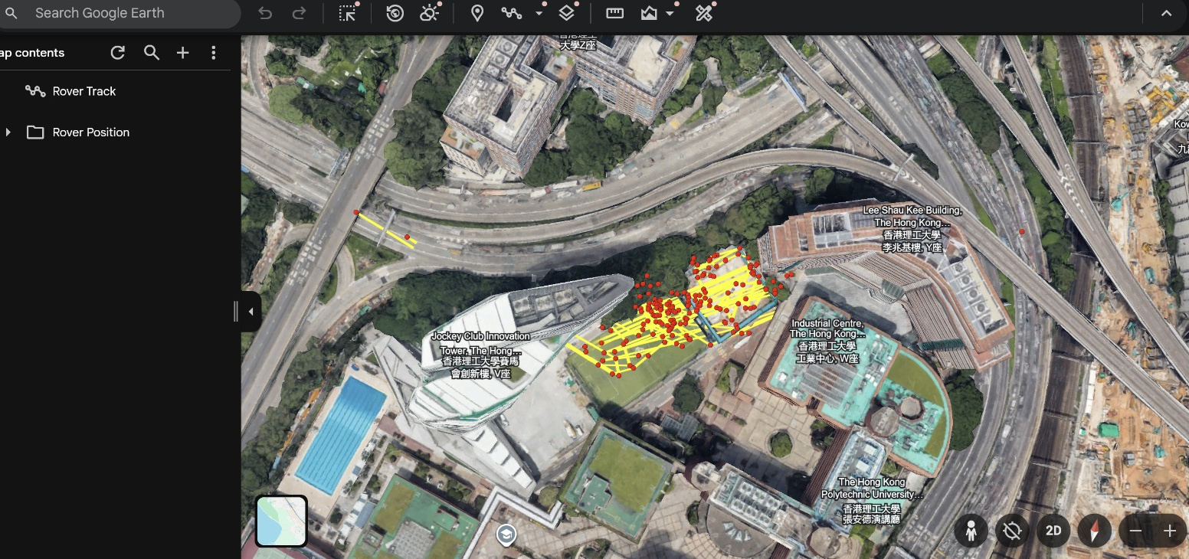
Figure 1. Estimated positions of the second log (yellow/red dots) plotted on the satellite image of the site; Block X and the Jockey Club Innovation Tower appear to the south of the antenna position.
2 Raw Data Analysis
The RINEX observation file contains 26.6 satellites with a usable L1/E1/B1I code measurement per epoch: 7.1 GPS, 7.6 Galileo, 6.8 BeiDou and 5.1 GLONASS on average, with peaks of 10, 10, 7 and 9 (Fig. 2a). It fluctuates between 15 and 26 satellites, and the two deepest dips, at about 150 s and 540 s after the start, coincide with the largest position excursions in Fig. 4 — a loss of satellites that the geometry cannot absorb. GLONASS was logged but is not used in the solution: its FDMA signals need a per-satellite inter-frequency bias and a separate ephemeris evaluation, and the remaining three constellations already provide 19 satellites.
The C/N₀ record (Fig. 2b) is the clearest indicator of the environment. The median is 33 dB-Hz for GPS and Galileo, 32 dB-Hz for GLONASS and 36 dB-Hz for BeiDou, and 31.5 % of all measurements fall below 30 dB-Hz — the threshold above which the tutorial expects direct line-of-sight reception. Many of these weak signals arrive at 30–60° elevation, i.e. from the direction of the buildings, which is the signature of diffraction, multipath and non-line-of-sight (NLOS) reception rather than of a poor antenna. Only the highest satellites consistently exceed 40 dB-Hz.
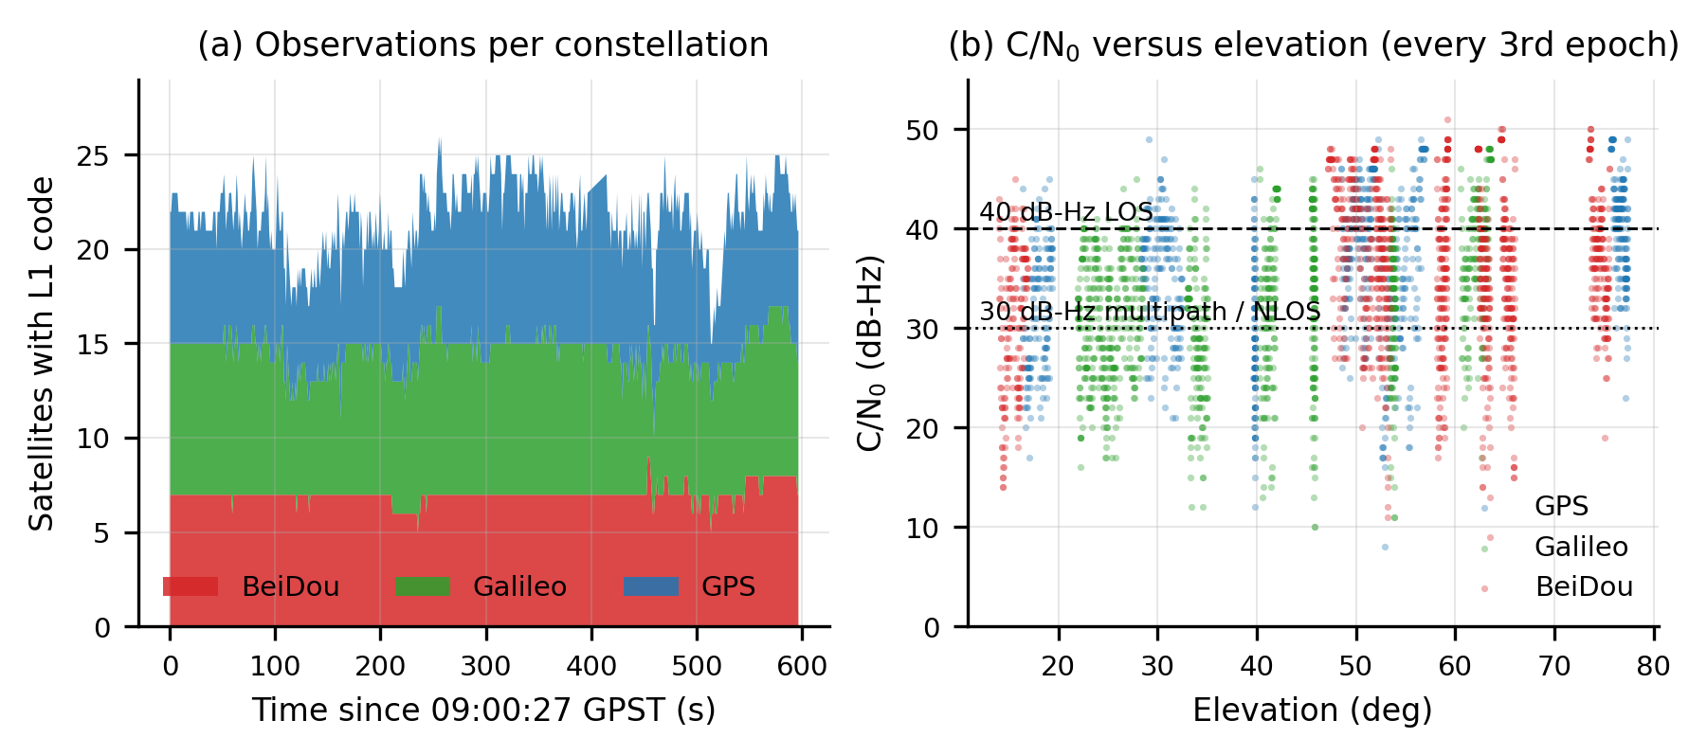
Figure 2. (a) Number of satellites with an L1 code measurement, per constellation, over the whole session. (b) C/N₀ against elevation for every third epoch; the dashed and dotted lines mark the 40 dB-Hz (line of sight) and 30 dB-Hz (multipath/NLOS) thresholds used in the tutorial.
The sky plot of a mid-session epoch (Fig. 3) shows the consequence of the obstruction: the 20 tracked satellites are spread over most azimuths, but every satellite below 35° elevation lies between azimuth 120° and 200°, and the sector from 340° to 20° is sampled only above 40°. The horizon is therefore closed to the north and north-west and open to the east and south-east. Coverage is nevertheless adequate for a position fix: the mean HDOP is 2.47 with GPS only and falls to 0.82 when Galileo and BeiDou are added, which already anticipates the improvement measured in Section 4.
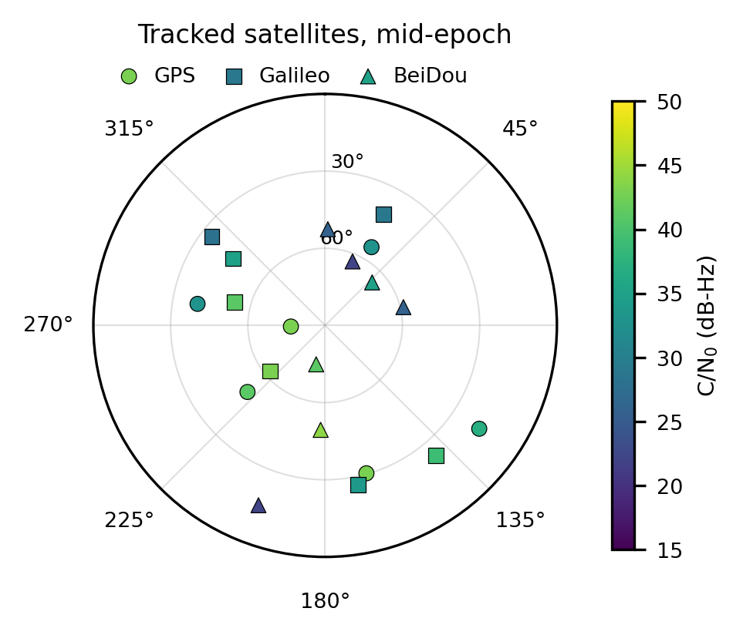
Figure 3. Sky plot of the tracked satellites at 09:05:30 GPST; marker shape gives the constellation and colour the C/N₀. Radial rings are 30° and 60° elevation.
Table 2. Constellation statistics over the 580 epochs.
Constellation | Mean sats | Max | Median C/N₀ (dB-Hz) | Role in the solution
GPS | 7.1 | 10 | 33 | reference constellation, L1 C/A
Galileo | 7.6 | 10 | 33 | added in v2, E1
BeiDou | 6.8 | 7 | 36 | added in v3, B1I
GLONASS | 5.1 | 9 | 32 | logged, not processed (FDMA biases)

3 SPP Algorithm (Least Squares)
For satellite i the pseudorange is modelled as
ρᵢ = ‖pᵢ − p‖ + c δtᵣ − c δtⁱ + Iᵢ + Tᵢ + εᵢ (1)
where pᵢ is the satellite position at transmission time, p the receiver position, δtᵣ and δtⁱ the receiver and satellite clock offsets, Iᵢ and Tᵢ the ionospheric and tropospheric delays and εᵢ the multipath, NLOS and noise term. The satellite clock is removed with the broadcast polynomial (including the relativistic eccentricity term and the group delay TGD), the ionosphere with the Klobuchar model and the troposphere with the Saastamoinen model, giving the corrected pseudorange ρ̃ᵢ = ‖pᵢ − p‖ + b + εᵢ with b = c δtᵣ.
Linearising about the current estimate x₀ = [x, y, z, b]ᵀ with the line-of-sight unit vector eᵢ = (pᵢ − p₀)/rᵢ⁰ gives
yᵢ = ρ̃ᵢ − rᵢ⁰ − b₀ = −eᵢᵀ Δp + Δb + εᵢ , y = H Δx + ε (2)
and the weighted least-squares correction, iterated until ‖Δp‖ < 0.1 mm, is
Δx̂ = (HᵀWH)⁻¹ HᵀW y , W = diag(w₁ … wₙ) (3)
Three weighting schemes were implemented: W = I (unweighted, the tutorial baseline), wᵢ = sin²θᵢ, and a C/N₀-dependent variance σᵢ² = a² + (b/sin θᵢ)² with a = 0.3 m and b = 0.6·10^((45 − C/N₀ᵢ)/20) m, which combines the elevation and signal-strength information recommended in the tutorial. Because GPS, BeiDou and Galileo keep separate system times, the state vector carries one clock per constellation, x = [x, y, z, b_G, b_C, b_E]ᵀ, and a BeiDou satellite contributes the row [−eᵢᵀ 0 1 0]; at least 3 + m satellites are required for m systems.
Fault exclusion follows the residual test used in receiver autonomous integrity monitoring: after convergence the normalised residual |vᵢ|/σᵢ of every satellite is formed, the largest is removed if it exceeds 3.5 and the epoch is re-solved, up to three removals. The design matrix at the final iteration also gives the dilution of precision after rotating Q = (HᵀH)⁻¹ to East–North–Up.
Listing 1. Core of the solver (full, documented code in the repository).
def solve_epoch(obs, ephs, x0, cfg):
rows, t_rx = prepare(obs, ephs, x0, cfg) # orbits, clocks, iono, tropo, masks
systems = [s for s in "GCE" if s in cfg["systems"]]
x = np.r_[x0[:3], np.zeros(len(systems))]
for _ in range(cfg["max_iter"]):
H, y = design(rows, x, systems) # H[i] = [-e_i, 1 in the system column]
W = np.diag(weights(rows, cfg)) # I, sin^2(el) or 1/sigma^2(C/N0)
dx = np.linalg.solve(H.T @ W @ H, H.T @ W @ y)
x += dx
if np.linalg.norm(dx[:3]) < 1e-4:
break
if cfg["reject"]: # RAIM-like exclusion
for _ in range(cfg["max_removal"]):
v = residuals(rows, x, systems)
k = int(np.argmax(np.abs(v) / sigma(rows, cfg)))
if abs(v[k]) / sigma(rows, cfg)[k] < cfg["reject_thres"]:
break
rows.pop(k)
x = solve_epoch_core(rows, x, systems, cfg)
return x, residuals(rows, x, systems)

4 Own-Data Validation
Our data have no ground truth, so the solution is validated in the three ways the tutorial prescribes: comparison with an independent solution, consistency of the static solution about its mean, and checks on the inputs. Table 3 reports the ablation on our own data — each row changes one thing only — and the last column gives the 2D difference from the receiver’s own solution (UBX-NAV-HPPOSECEF) over the 580 common epochs.
Table 3. Ablation on our own data (580 epochs, static). The 2D RMS about the mean measures the repeatability of the static solution; the last column measures agreement with the receiver.
Version | Change tested | Sats | HDOP | Post-fit  RMS (m) | σ E / N / U (m) | 2D RMS about  mean (m) | 2D diff. vs  receiver (m)
v1 | GPS only, unweighted | 5.4 | 2.47 | 7.65 | 34.2 / 25.9 / 79.1 | 42.9 | 41.5
v2 | Galileo | 11.9 | 1.12 | 10.32 | 27.2 / 14.2 / 57.0 | 30.7 | 29.9
v3 | BeiDou | 18.7 | 0.82 | 10.26 | 20.9 / 12.0 / 30.9 | 24.1 | 18.6
v4 | elevation weighting | 18.7 | 0.82 | 11.23 | 19.7 / 12.0 / 32.9 | 23.0 | 16.9
v5 | C/N0 weighting | 18.7 | 0.82 | 13.95 | 17.2 / 11.2 / 13.8 | 20.5 | 7.7
v6 | residual outlier rejection | 18.1 | 0.85 | 9.81 | 17.1 / 11.8 / 13.9 | 20.8 | 7.0
v7 | C/N0 mask 25 dB-Hz | 16.3 | 1.04 | 6.39 | 17.8 / 11.8 / 13.2 | 21.3 | 7.0

The two strongest effects are geometric. Adding Galileo raises the average satellite count from 5.4 to 11.9 and cuts the repeatability from 42.9 m to 30.7 m; adding BeiDou brings it to 18.7 satellites, HDOP 0.82 and 24.1 m. This is the behaviour predicted by the error budget: with UERE ≈ 6 m and HDOP ≈ 2.5 the GPS-only solution cannot do better than about 15 m, and multipath multiplies that figure by a factor of two to three in a canyon. C/N₀ weighting (v5) is the single most effective correction after the constellations: the height scatter falls from 32.9 m to 13.8 m and the agreement with the receiver improves from 16.9 m to 7.7 m, because the vertical error is driven by the weak, low-elevation signals that the weighting suppresses. Residual rejection (v6) removes the remaining tail — the worst epoch of the GPS-only solution is 585 m away from the mean, against 61 m for v6 — at the cost of one satellite per epoch. The C/N₀ mask of v7 lowers the post-fit residual to 6.4 m but rejects three epochs and slightly degrades the scatter, so the mask is too aggressive for this site and v6 is retained as the final version.
Table 4 summarises the comparison with the receiver solution for the final version. The agreement is 7.0 m in 2D, with a small horizontal bias (−2.0 m East, +0.1 m North) and a +7.1 m vertical offset. The offset is the expected single-frequency SPP height bias: the RTKCONV navigation header carries no broadcast ionospheric coefficients, so default mid-latitude Klobuchar values had to be used, and no antenna phase-centre or receiver group-delay calibration was applied.
Table 4. Differences between our SPP solution and the receiver solution for the final version (v6).
Statistic | SPP − receiver | Receiver about its own mean
Mean E / N / U (m) | −2.03 / +0.14 / +7.07 | —
Std E / N / U (m) | 5.49 / 3.75 / 14.63 | 15.89 / 12.53 / 2.89
2D RMS difference (m) | 6.95 | 20.24
Epochs compared | 580 of 580 | 580
Mean position | 22.305603° N, 114.180026° E, h = 25.9 m | 22.305602° N, 114.180046° E, h = 18.8 m

The last column of Table 4 is the key to reading the first one. The receiver itself wanders by 15.9 m East and 12.5 m North about its own mean, i.e. as much as our solution does (17.1 m and 11.8 m). The two solutions are therefore wrong in the same way at the same epochs: both see the same reflected signals, and the difference between them cancels the common-mode multipath. An agreement of 7 m is a statement about the processing chain, not about accuracy — which is exactly why the benchmark of Section 5 needs an independent reference.
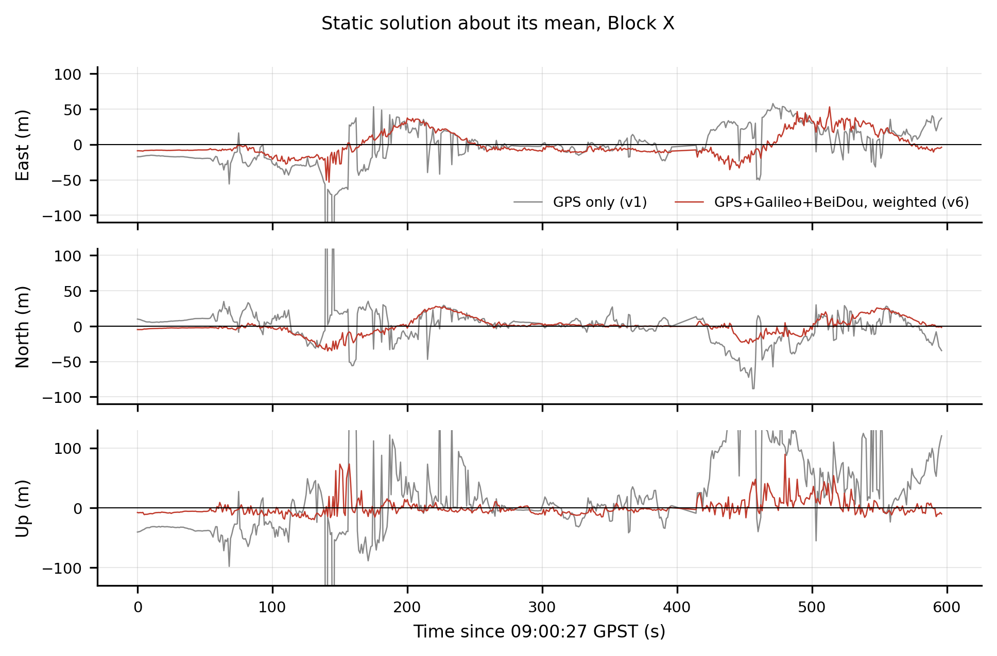
Figure 4. East, North and Up components of the static solution about its mean. Grey: GPS-only baseline (v1); red: final multi-GNSS weighted solution (v6). Three GPS-only epochs fall outside the plotted range (up to −0.9 km in height).
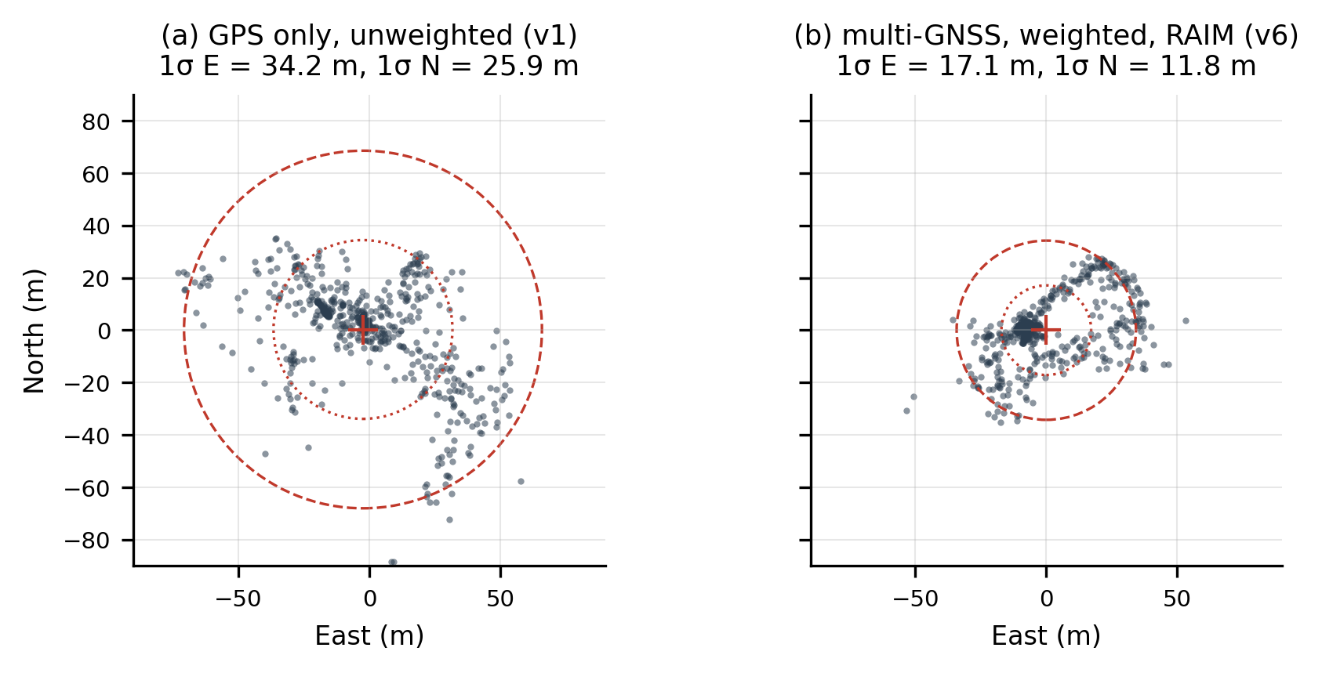
Figure 5. East–North scatter about the mean of the static solution: (a) GPS-only baseline, (b) final version. The dotted and dashed circles are the 1σ and 2σ East/North ellipses.
Input checks. Two problems were found before any of these numbers could be trusted. First, the reference-station file downloaded from HK SatRef covers 17:00–17:59 GPST on 30 October, whereas the rover log runs at 09:00 GPST: the local time (17:00 HKT) had been entered in the request form where UTC was expected, so the base station and the rover do not overlap. RTKPOST therefore returned no differential solution at all — the .pos file contains its header and zero epochs — and the RTKPOST differential column of the validation table cannot be filled. A single-point run in RTKPOST on the second log does produce 182 epochs (quality flag 5) whose ground-track scatter, ±50–150 m, matches our GPS-only baseline. Second, the first version of our BeiDou processing was wrong by 4 000 km in the pseudorange residuals because the BeiDou clock polynomial was evaluated with a time-of-clock offset of 1 356 weeks; the residual consistency test described in Section 6 caught it. Both cases illustrate why the tutorial insists on checking the inputs before interpreting a solution.
5 Verification and Benchmark Results
5.1 Regression test on the example dataset
Every version was run on the example dataset before the benchmark, as the tutorial requires. The example has 186 epochs, the receiver solution and the reference results of the tutorial, so it is the only dataset where our code can be checked against an answer we did not produce. Table 5 lists the error against the mean receiver position (UBX-NAV-HPPOSECEF).
Table 5. Example dataset (Block X, 2025, 186 epochs): error of every version against the receiver reference solution.
Version | Change tested | 2D RMSE (m) | 3D RMSE (m) | P95 2D (m) | Bias E / N / U (m) | Epochs
v1 | GPS only, unweighted | 25.57 | 80.72 | 43.02 | -20.4 / -5.1 / +48.9 | 113
v2 | Galileo | 16.97 | 34.79 | 28.73 | -9.7 / -1.0 / +24.1 | 159
v3 | BeiDou | 15.49 | 27.95 | 25.71 | -5.9 / -0.6 / +20.7 | 186
v4 | elevation weighting | 15.31 | 25.99 | 25.47 | -4.8 / -0.9 / +19.4 | 186
v5 | C/N0 weighting | 16.12 | 23.57 | 27.54 | -4.5 / -0.8 / +16.3 | 186
v6 | residual outlier rejection | 16.13 | 23.52 | 27.55 | -4.5 / -0.7 / +16.2 | 186
v7 | C/N0 mask 25 dB-Hz | 16.14 | 23.51 | 27.60 | -4.5 / -0.7 / +16.1 | 186

The example behaves as the tutorial describes. The GPS-only baseline is poor in both 2D and 3D — 25.6 m and 80.7 m — and it only solves 113 of the 186 epochs, because the example navigation file contains five GPS ephemerides and 73 epochs therefore have fewer than four usable GPS satellites. Adding Galileo and BeiDou solves all 186 epochs and cuts the 2D error to 15.5 m; most of the remaining 3D error is the known vertical bias of single-frequency SPP (+20.7 m). The weighting and fault-exclusion steps barely change the 2D RMSE (15.3–16.1 m, the differences being within the noise) but they cut the height bias from +20.7 m to +16.2 m and the 95th percentile of the error from 28.0 m to 23.5 m, i.e. they act on the tail rather than on the bulk of the distribution. This is the same signature as on our own data, which is why the same final version was used on the benchmark.
Our GPS-only figure (25.6 m) is lower than the 37.9 m reported in Table 13 of the tutorial. The two numbers are not computed the same way: we compare with the mean receiver position over all epochs and apply a 10° elevation mask, whereas the reference compares with the per-epoch receiver solution and masks at 15°. The comparison that the tutorial does not provide — the full multi-constellation chain on all 186 epochs — is the one that shows the size of the gain: a factor of 2.5 in 2D and 3.4 in 3D relative to the GPS-only baseline.
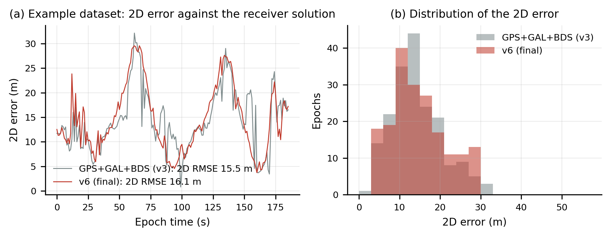
Figure 6. Example dataset: (a) 2D error of every epoch against the receiver reference for the multi-constellation baseline (v3) and the final version (v6); (b) distribution of the 2D error.
5.2 UrbanNav benchmark
The UrbanNav-HK-Deep-Urban-1 observation file contains 1534 epochs (week 2158, 455 346–456 879 s) and its navigation file carries the broadcast ionospheric coefficients, which are used here instead of the default values. The same seven versions were run in the same order. Table 6 reports the measurable metrics: availability (epochs with a solution), mean satellite count, mean HDOP, post-fit residual and two internal consistency indicators — the 2D deviation from the final v6 solution and the median epoch-to-epoch step, which for a 1 Hz vehicle trajectory is dominated by noise when the platform is nearly stationary.
Table 6. Ablation on the UrbanNav benchmark (1534 epochs). The reference trajectory used for scoring is withheld, so absolute RMSE cannot be computed offline; the table reports what can be measured without it.
Version | Change tested | Avail. (%) | Sats | HDOP | Post-fit  RMS (m) | 2D dev. from  v6 (m) | Median step  (m)
v1 | GPS only, unweighted | 96.1 | 5.7 | 2.79 | 8.02 | 33.5 | 4.75
v2 | Galileo | 99.6 | 9.3 | 1.98 | 8.37 | 23.3 | 4.68
v3 | BeiDou | 99.8 | 15.9 | 1.23 | 9.54 | 18.2 | 4.61
v4 | elevation weighting | 99.8 | 15.9 | 1.23 | 10.90 | 12.8 | 4.33
v5 | C/N0 weighting | 99.8 | 15.9 | 1.23 | 14.41 | 4.7 | 4.05
v6 | residual outlier rejection | 99.8 | 15.6 | 1.25 | 12.31 | 0.0 | 4.12
v7 | C/N0 mask 25 dB-Hz | 99.3 | 13.1 | 1.88 | 3.85 | 5.3 | 4.22

Availability is the metric that separates the versions most clearly, and it is also the one that decides whether a submission is ranked at all (the rule requires A ≥ 90 %). The GPS-only baseline loses 60 epochs (96.1 %) and averages 5.7 satellites with HDOP 2.79 — in the deep-urban segments there are simply not enough GPS satellites to solve. Galileo raises availability to 99.6 % and BeiDou to 99.8 %, with 15.9 satellites and HDOP 1.23, and the two additions together move the solution by 33.5 m (RMS, 2D) relative to the GPS-only track. Weighting and fault exclusion change the solution by a further 12.8 m and 4.7 m respectively, and reduce the epoch-to-epoch step from 4.75 m to 4.05 m, i.e. they remove high-frequency noise rather than shifting the trajectory. The C/N₀ mask of v7 lowers the post-fit residual to 3.9 m but costs one percent of availability and pulls the solution back by 5.3 m, which suggests that it also removes healthy satellites in the open-sky segments; it is kept only as a diagnostic.
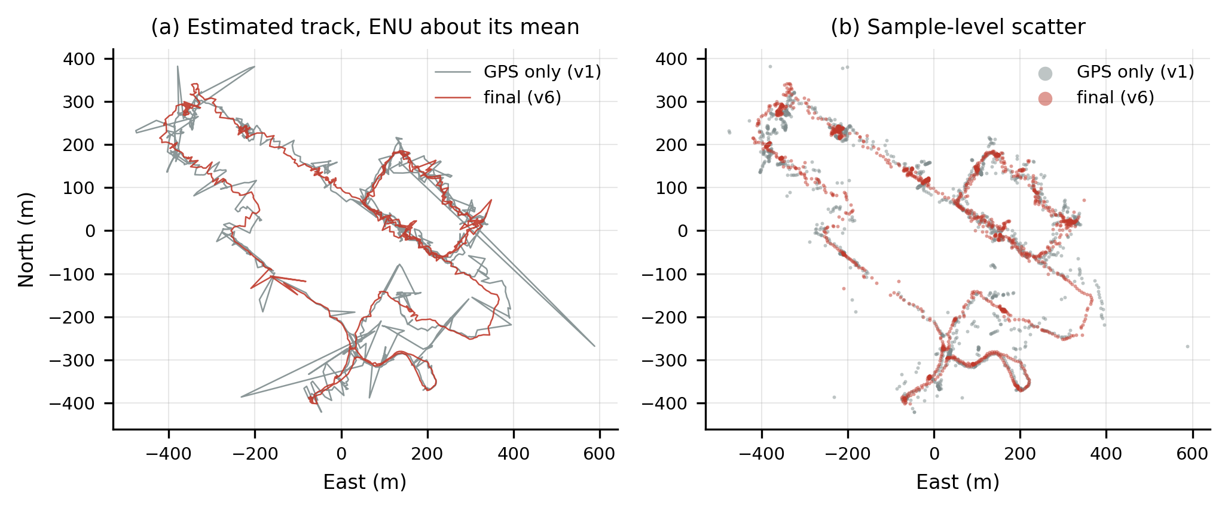
Figure 7. Benchmark trajectory in the local East–North frame: (a) GPS-only baseline and final version drawn as a track, (b) every epoch plotted as a point. The circuit is about 800 m across.
These deviations are differences between solutions, not errors: a version that moves the trajectory by 30 m is not necessarily 30 m worse, and the only way to turn them into an accuracy statement is the reference trajectory held by the teaching team. What the table does establish is that the multi-constellation step is what makes the benchmark solvable at all, and that the weighting and fault-exclusion steps act on the noise rather than on the geometry. In the urban segments the remaining error is dominated by multipath and NLOS reception — the 31 % of measurements below 30 dB-Hz measured at Block X is typical of this dataset too — and by the fact that a reflected signal biases the pseudorange by tens of metres while its geometry still looks healthy.
The submitted files are G18_benchmark.csv (1531 epochs, 99.8 % availability) and G18_owndata.csv (580 epochs), both in the five-column format of the tutorial with ECEF coordinates to three decimals. The final 2D/3D RMSE, the 95th-percentile error and the leaderboard rank are produced by the evaluation platform from the withheld reference and are therefore not quoted here.
The documented code (gnss.py, spp.py, run_all.py, plots.py), the two raw logs, the converted RINEX files and a README that reproduces both CSV files are in the group repository https://github.com/ox-x/AAE4203-Lab1-G18.
6 AI-Use Statement
A generative AI assistant (WorkBuddy, running a DeepSeek-class model) was used for three purposes: to draft the RINEX readers and the least-squares solver from our specification, to explain the BeiDou time-system and GEO conventions documented in the ICD, and to debug the two failures described below. All output was checked against data whose answer we already knew, in the order the tutorial requires: the example dataset first, the benchmark last.
Three checks caught real errors. (i) On the example dataset the GPS-only solution initially gave no solution for 40 % of the epochs; the cause was a RINEX field-width assumption (the 14-character value field followed by the two loss-of-lock/strength characters) and it was found by comparing the satellite count per epoch with the reference plots of the tutorial. (ii) BeiDou residuals were consistent to 4 000 km for the first version: the satellite clock was evaluated with a time-of-clock offset of 1 356 weeks, which multiplied the af₁ term into a 12.8 ms error. The diagnostic was to compute, for every satellite, the quantity ρ + c·δt_s − I − T − r, which must be the same receiver clock bias for all satellites of one system; the spread exposed the bug immediately. (iii) The satellite elevations were first computed from the ECEF z component instead of the local vertical, which put half of the satellites below the horizon; the same consistency test showed the geometry to be impossible.
No data from other groups and no personal data were uploaded. The submitted trajectories are computed by our own code from the provided observations; no receiver solution, published UrbanNav ground truth or third-party position was used. The key prompts are listed in Appendix A.
References
[1] W. Wen and the AAE4203 teaching team, “GNSS data collection, single point positioning and an accuracy challenge,” Laboratory Tutorial, Week 9, Semester 1, 2026/27, PolyU, v3.0.
[2] P. Misra and P. Enge, Global Positioning System: Signals, Measurements, and Performance, 2nd ed., Ganga-Jamuna Press, 2011.
[3] P. J. G. Teunissen and O. Montenbruck (Eds.), Springer Handbook of Global Navigation Satellite Systems, Springer, 2017.
[4] T. Takasu and A. Yasuda, “Development of the low-cost RTK-GPS receiver with an open source program package RTKLIB,” Proc. Int. Symp. GPS/GNSS, Jeju, 2009.
[5] L.-T. Hsu et al., “UrbanNav: an open-sourced multisensory dataset for benchmarking positioning algorithms designed for urban areas,” Proc. ION GNSS+ 2021, pp. 226–256.
[6] China Satellite Navigation Office, BeiDou Navigation Satellite System Signal In Space Interface Control Document, B1I, v3.0, 2019.
Appendix A Key AI Prompts
P1 — baseline solver (used, then rewritten by the group)
“I have RINEX 3 observation and navigation files from a u-blox ZED-F9P. Write a Python function that computes the satellite position and clock offset from the broadcast ephemeris (ICD-200), corrects the pseudorange for the satellite clock, Klobuchar ionosphere and Saastamoinen troposphere, and solves the weighted least-squares SPP epoch by epoch with Gauss–Newton iterations stopped at 0.1 mm. Use sin²(elevation) weights first. Explain every step and every constant.”
P2 — multi-constellation extension
“Extend the solver to GPS + Galileo + BeiDou with one receiver clock bias per system. BeiDou broadcasts in BDT; explain how the week and the 14 s offset enter the time of ephemeris and the clock polynomial, and why the satellite position algorithm differs for GEO satellites.”
P3 — verification
“Write a script that compares my trajectory with a reference CSV (epoch, ECEF) and prints the mean and standard deviation of the East/North/Up differences, the 2D and 3D RMSE, the 95th percentile and a scatter plot about the mean.”
P4 — debugging prompt that found the BeiDou bug
“For every satellite of every constellation print ρ + c·δt_s − I − T − ‖p_s − p_r‖ at one epoch. If the orbits and clocks are consistent this must equal the receiver clock bias, so it must be the same for all satellites of one system. My BeiDou values differ by 4 000 km — what could cause a constellation-wide offset of that size?”
Every prompt was answered with code that was then run on the example dataset before the benchmark; the numbers in Tables 3–6 come from our own runs of that code, not from the assistant.

