**Dec Making Spring ’24**

**HW 2**

**Dept. of Mechanical Engineering**

**2019-17973 Seung Seok Oh**

**1. Dynamics of two-joint manipulator is given as following:**

(a)

Assume desired trajectory is given.

Given dynamics can be changed as (1)

whereSince error can be described as

Define sliding surface as following

Then

If we design control input like following,

The stability of the system can be guaranteed by Lyapunov candidate and its derivative

**(b)**

First, assume there is no disturbance torque .Using sign function generates chatter in the control inputs as shown in Figure 1. Input with saturation function took more time for the system converge to the desired states, but reduced the chatter in input.

|  |  |
| --- | --- |
|  |  |

Figure 1 Sliding mode control for system without disturbance torque

In case of disturbance, I added sine function for disturbance torque given as and implemented it like Figure 2. Control input using saturation function reduced chatter as well, but due to the disturbance, sliding mode function does not “slide” through the surface and oscillates with a small amplitude. But the trajectory of simulator is successfully converging to desired trajectory, which shows the robustness of Sliding Mode Control despite external disturbances.

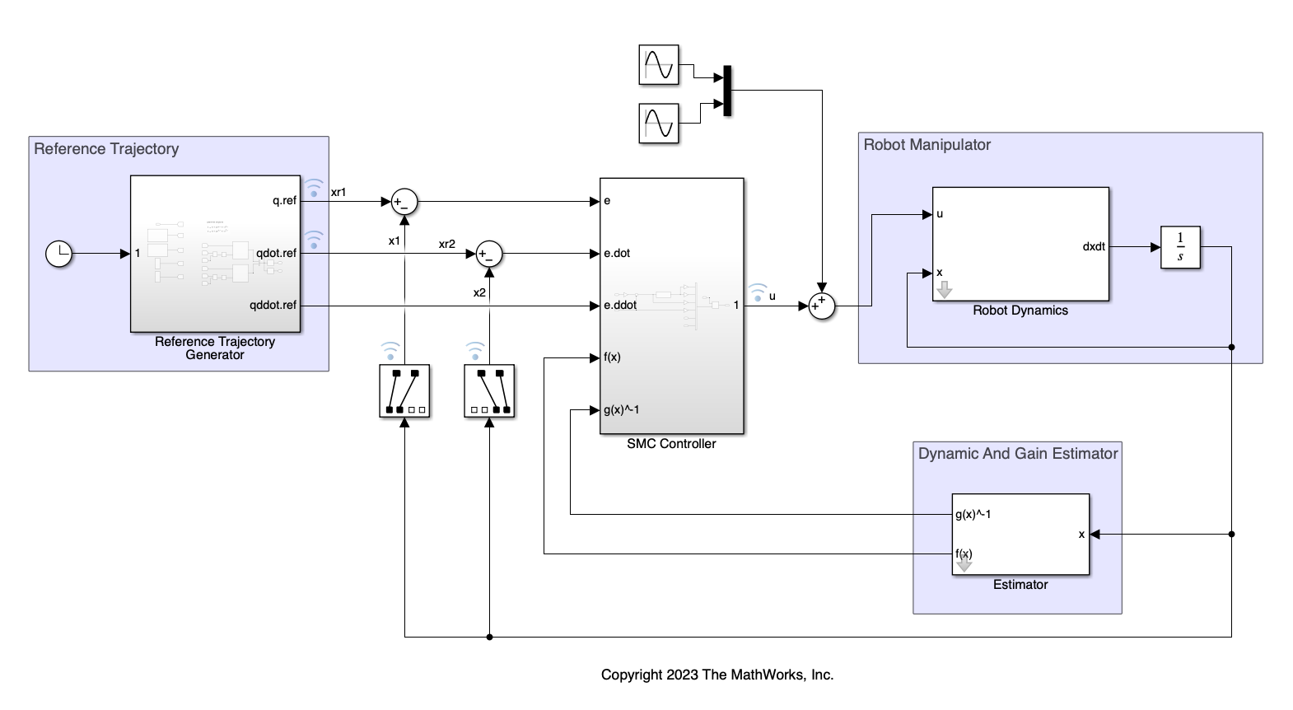

Figure 2 Simulink diagram for disturbance affected manipulator system

|  |  |
| --- | --- |
|  |  |

Figure 3 Sliding mode control for system with disturbance torque

2. Design MPC controller for the same system.

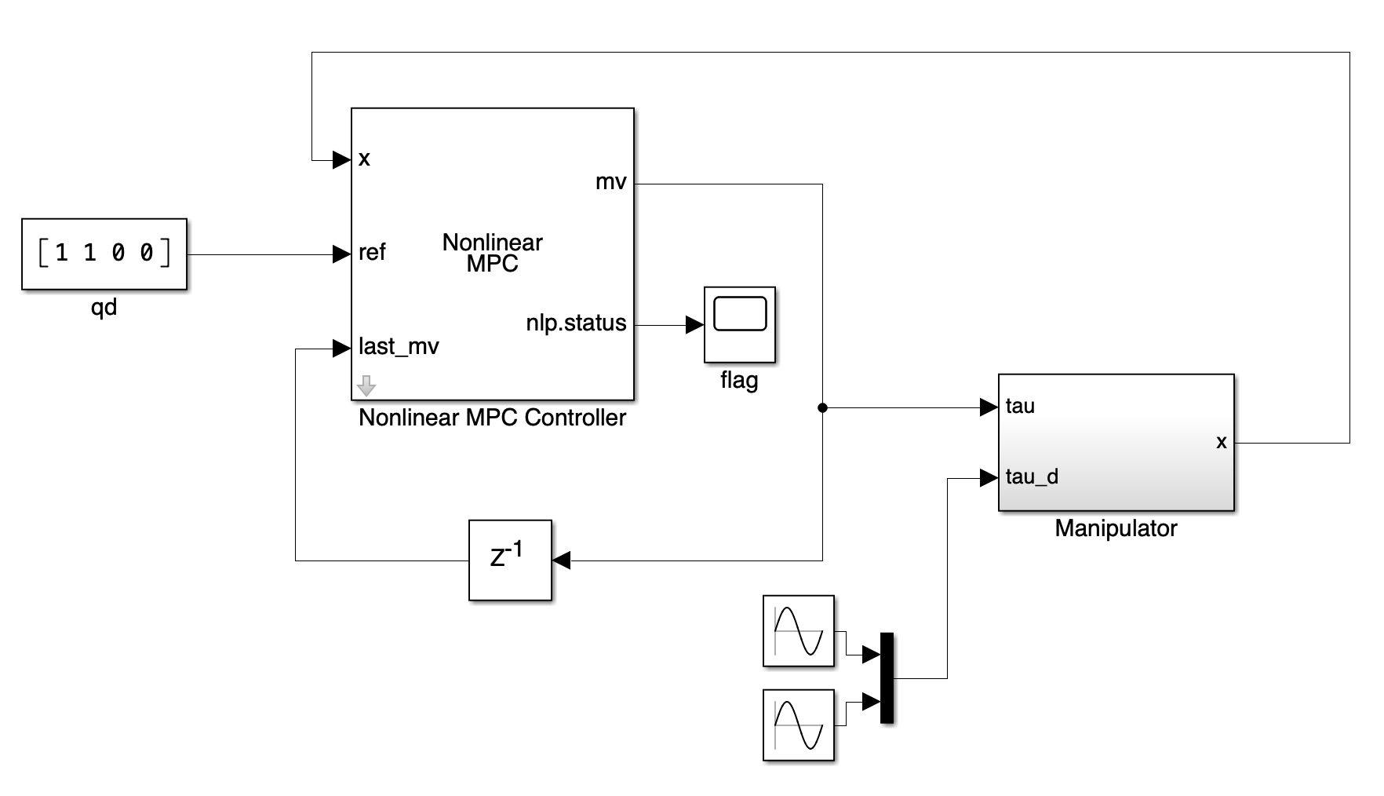

Figure 4 Simulink diagram of MPC controller for manipulator with sinusoid disturbance

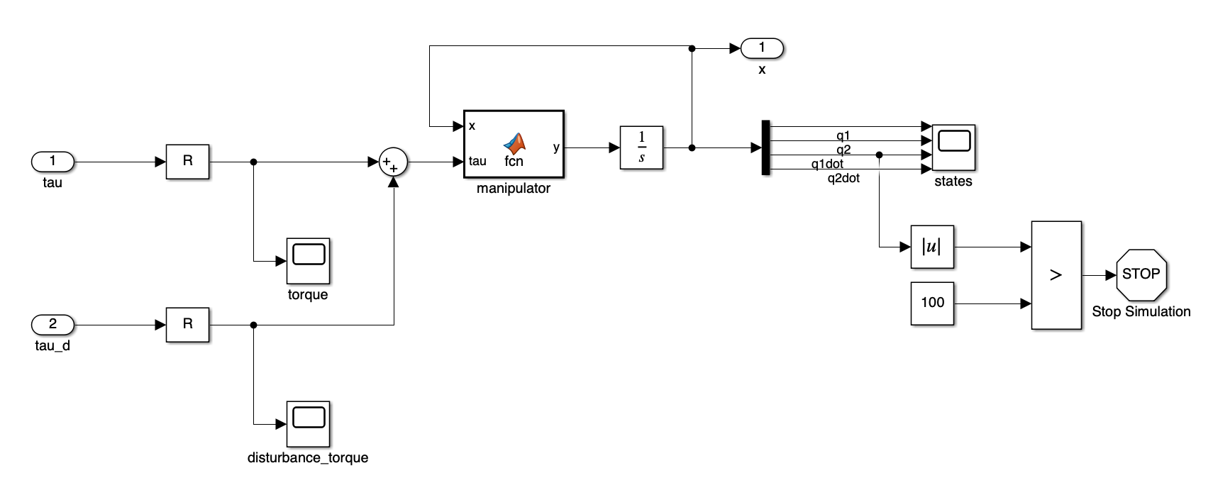

Figure 5 Simulink diagram of manipulator dynamics

|  |  |
| --- | --- |
|  |  |

Figure 6 Output of MPC Controller (left) no disturbance torque (right) sinusoid disturbance torque

As shown in Figure 6, system with disturbance torque does converge to desired state but still has oscillation around the final state. Obviously, since the disturbance torque is not considered in the manipulator model which is used in MPC calculation, control with continuous input is inevitable.

**3. System given as**

(a)

Since we want to follow , define error Consider Lyapunov candidate

To make as negative definite, design virtual input as following

where that will make .

Let and make z converge to 0.

Consider new Lyapunov candidate Design input u as following

Then we can make which is negative definite.

(b) If a is unknown constant

Similar to (a), define error

Choose the virtual input as

where is an estimate of the unknown parameter and .

The error dynamics becomes like following

Let and consider Lyapunov candidate with the adaptive gain

Choose the adaption law as , then

which is negative definite. Therefore, is globally asymptotically stable and converge to 0.

Let

Consider a new Lyapunov candidate as following

If we design , the derivative of becomes

which is negative definite, and guarantee e and z is asymptotically globally stable around (0,0).

(c)

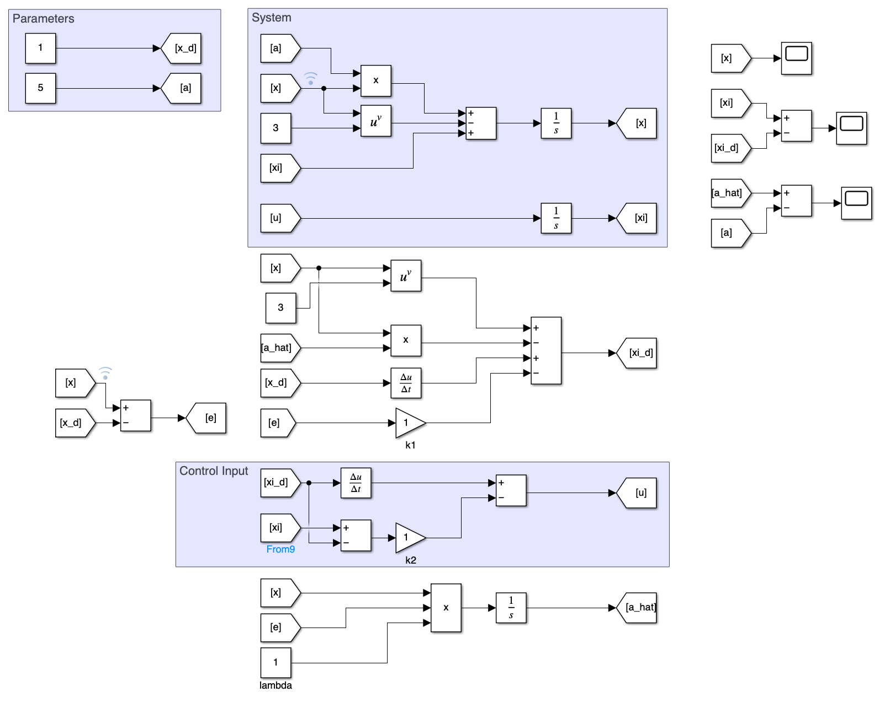

Figure 7 Simulink diagram for system and control calculated by backstepping method

Case 1: Assume desired is constant, and unknown value of system is 5. Diagram used to simulate the system is shown as Figure 7, and the result is shown as Figure 8. Successfully, converged to the desired value, and predicted parameter also converged to real value.

|  |  |
| --- | --- |
|  |  |
|  | |
|  | |

Figure 8 Result of case 1. (left) (right) (middle)

Case 2:

Next, the case of linearly increasing is assumed. In Simulink diagram, the part that defining was modified as Figure 9. As shown in Figure 10, successfully tracks , and the predicted parameter also converged to real value.

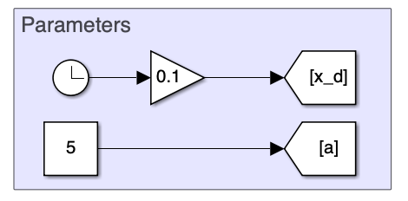

Figure 9 Simulink diagram of case 2

|  |  |
| --- | --- |
|  |  |
|  | |

Figure 10 Result of case 2. (1) (2) (3)

Case 3:

Simulation for sinusoidal desired state was also conducted as Figure 11.

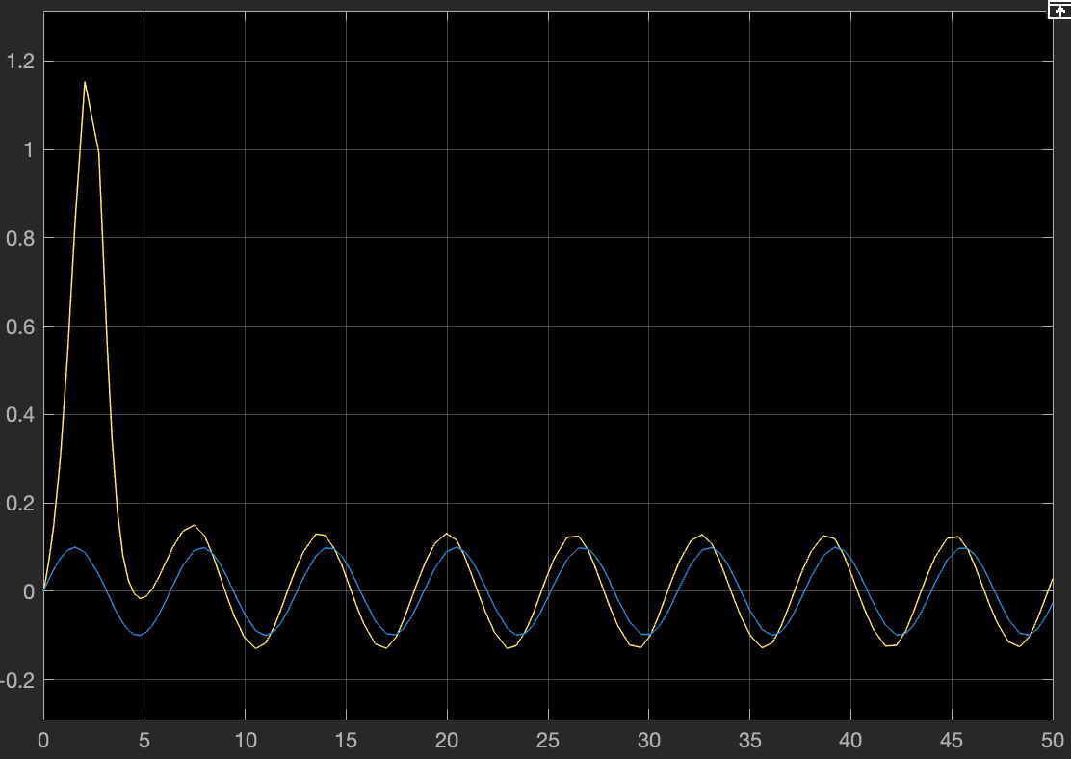

Figure 11 Result of case 3.

**4. Given nonlinear system:**

(a)

Control input u appeared in second derivative of y. Therefore, the system has relative degree of two.

(b)

We can rewrite the system in vector:

To make a normal form, we define like following

And find internal variable that satisfies

Since , we can assume which makes

Then the system can be written as normal form like

(c)

The zero dynamics is case that derives to 0

To show that the origin of the zero dynamics is globally asymptotically stable, consider Lyapunov candidate Since and , the origin is globally asymptotically stable.

(d)

To achieve global asymptotic stability, we use feedback linearization.

If we design our input as

Then

This feedback law ensures that the closed-loop system is globally asymptotically stable.