Jake Anderson and Evan Cogswell

Test Cases for Example (Counsel Interface)

Start program and main menu appears.

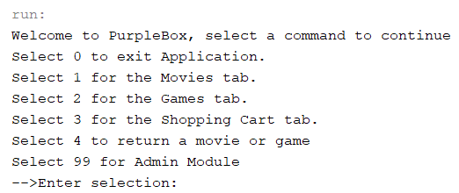

Test options

Select 0 – Program exits

Select 1 – for Movies

Select 2 – for Games Tab

Select 3 for Shopping Cart Tab

Select 4 to return a movie or a game

Select 99 for Admin Module

Select 1 for movies.

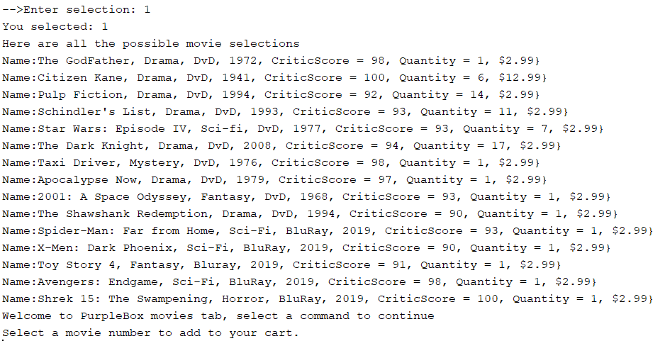

*Failed Need to test loading of selected movie but replaced version does not have later code.*

Test option 2 for games tab

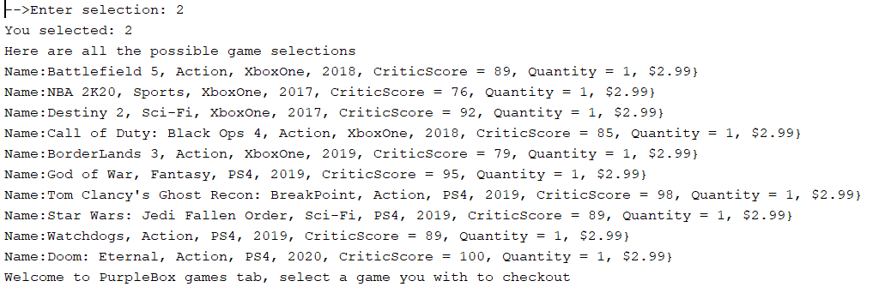

Test option 3 to print shopping cart and also show selections. (FAILED) code is missing to do the additional steps.

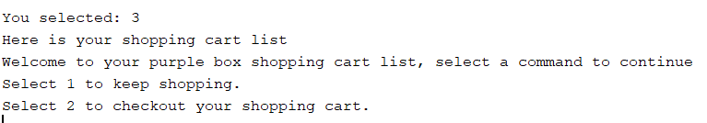

Option 4 to return a movie. Movies list prints

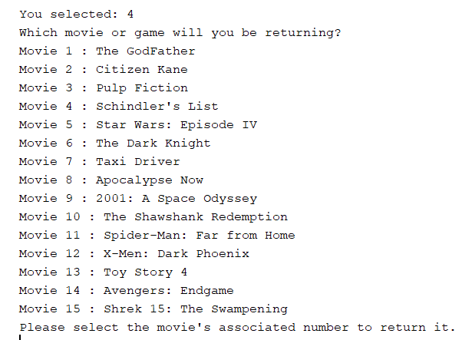

Select 99 for admin Module (Pass code 12345 required) , select 0 to leave admin and return to main menu.

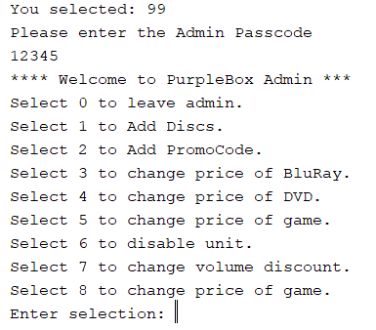

Test 0 - succeeded to exit back to main menu

Test 1 to add disc

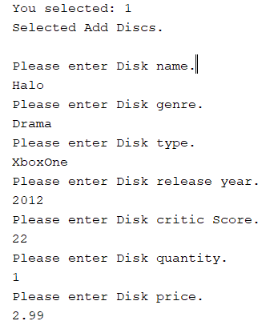

Confirm was added to listing of games -- Failed. Movies Works Games is missing code (Duplication of movies but change to games.

Test remaining admin module selection calls Admin functions from Admin interface but coding is not completed and older version is missing a lot of it

Failed. All later Admin options are back to original.