

Agricultural Restructuring in Mainland Portugal
Regional and Temporal Patterns from 1989 to 2019



Authors:
Nº 26298 | Fernanda Chácara Nº 27916 | Dandara França Nº 27916 | Andrea Dombe

UC | Analysis and Visualization of Complex Agro-Environmental Data
Lisbon, June 09th, 2026

Introduction

Agriculture remains an important dimension for understanding territorial and economic change in Portugal. Although its relative weight in the national economy has declined over time, it continues to shape rural landscapes, employment structures and land-use patterns. Therefore, studying agricultural change is not only about production, but also about understanding how rural territories have been transformed.

In recent decades, Portuguese agriculture has undergone significant structural changes. The 2019 Agricultural Census shows a decrease in the number of agricultural holdings compared with 2009, while the utilized agricultural area increased, suggesting a process of concentration and restructuring rather than a simple decline of the sector (INE, 2020). This transformation is relevant because it affects how agricultural activity is organized, who works in agriculture and how land is used across different regions.

Agricultural labour is one of the clearest indicators of this process. Its decline may reflect broader changes such as mechanization, ageing rural populations and the weakening of small-scale family farming. At the same time, changes in temporary crops, permanent crops, grasslands and productivity help reveal how agricultural systems have evolved differently across mainland Portugal. These dimensions are also commonly used in European agricultural statistics to analyze farm structure and agricultural transformation (Eurostat, 2024).

This project analyses the structural transformation of agriculture in mainland Portugal between 1989 and 2019, using data from the INE database. The main objective is to understand how agricultural labour, land use, crop systems and productivity evolved over time, and whether these changes suggest decline, concentration, regional specialization or a combination of these processes.
The main research question guiding this project is:

How did the structure of agriculture in mainland Portugal change between 1989 and 2019?

To answer this question, the analysis is guided by the following hypotheses:

H1: Agricultural labour decreased between 1989 and 2019, reflecting a long-term reduction in the labour force involved in agricultural activities.

H2: Agricultural land use changed over time, with different trajectories for temporary crops, permanent crops, grasslands and pastures.

H3: Temporary crops and permanent crops did not follow the same pattern of change, suggesting different forms of agricultural restructuring.

H4: Permanent grasslands and pastures became an important indicator of land-use transformation, especially in regions more associated with extensive agricultural systems.

H5: Productivity patterns varied across agricultural activities and regions, indicating that agricultural change was not homogeneous throughout mainland Portugal.

Overall, this project does not approach Portuguese agriculture only as a declining sector. Instead, it understands agricultural change as a process of restructuring, in which labour, land use, crop systems and productivity evolve unevenly across time and space.

Database Description

The data used in this project were collected from the Statistics Portugal database and focus on agricultural indicators for mainland Portugal between 1989 and 2019. The datasets cover different dimensions of agricultural structure, including agricultural labour, utilized agricultural area, temporary crops, permanent crops, permanent grasslands and pastures, and productivity of main agricultural crops. These variables were selected because they allow the analysis of agricultural transformation from different perspectives: labour, land use, crop systems and productivity.

2.1 Description of the datasets
The project uses several datasets related to different dimensions of agricultural activity in mainland Portugal. Each dataset focuses on a specific aspect of agricultural structure, allowing the analysis to combine information on labour, land use, crops and productivity.
The agricultural labour dataset is used to examine changes in the number of people working in agriculture. The study area dataset provides information on agricultural land, making it possible to analyze changes in the spatial dimension of agricultural activity. The datasets on temporary crops and permanent crops allow a comparison between different types of crop systems, while the dataset on permanent grasslands and pastures is used to identify changes in extensive land use. Finally, the productivity dataset provides information on the productive performance of main agricultural crops over time.
Together, these datasets make it possible to analyze Portuguese agriculture as a multidimensional process of transformation, rather than focusing only on one indicator.
Description of the datasets used in the analysis
Dataset | Main indicator | What it measures | Use in the project
Agricultural labour | Agricultural labour force | Number of people working in agriculture | To analyse whether agricultural labour decreased between 1989 and 2019
Study area | Agricultural area | Area used for agricultural activity | To observe changes in land use across mainland Portugal
Temporary crops | Temporary crop holdings / area | Crops cultivated for a limited production cycle | To analyse changes in temporary crop systems
Permanent crops | Permanent crop holdings / area | Crops that remain in the soil for several years | To compare long-term crop systems with temporary crops
Permanent grasslands and pastures | Grasslands and pastures area | Area occupied by permanent grasslands and pastures | To identify changes in extensive land use and land management
Productivity of main agricultural crops | Crop productivity | Productive performance of selected agricultural crops | To analyse whether structural changes were accompanied by changes in productivity
Table 1. Description of the datasets used in the analysis.
This table presents the main datasets used in the project, including their key indicators, measurement focus and analytical purpose. Together, these datasets support the analysis of agricultural labour, land use, crop systems and productivity in mainland Portugal between 1989 and 2019.

2.2 Variables used in the analysis
The main variables used in the analysis are year, geographical area, agricultural labour, agricultural area, crop type, grasslands and pastures, and productivity values. The year variable is essential for identifying changes over time, while the geographical variable allows the analysis of regional differences within mainland Portugal.
Agricultural labour is used to assess whether the number of people working in agriculture decreased between 1989 and 2019. Land-use variables are used to examine how agricultural areas, temporary crops, permanent crops, and grasslands evolved during the period under analysis. Productivity indicators are included to determine whether changes in agricultural structure were accompanied by changes in productive performance.
These variables were selected because they are directly connected to the research question and to the hypotheses defined in the introduction.
Variables used in the analysis
Variable | Meaning | Purpose in the analysis
Year | Reference year of each observation | To analyse agricultural evolution over time, especially between 1989 and 2019
Region / geographical area | Territorial unit of each observation | To compare regional patterns within mainland Portugal
Agricultural labour | Labour force involved in agricultural activity | To test whether agricultural labour declined over the period analysed
Agricultural area | Area used for agricultural activity | To observe changes in land use and agricultural concentration
Temporary crops | Crops cultivated for a limited production cycle | To examine the evolution of temporary crop systems
Permanent crops | Crops that remain in the soil for several years | To compare long-term crop systems with temporary crops
Permanent grasslands and pastures | Area occupied by grasslands and pastures | To analyse changes in extensive land use and land management
Productivity | Productive performance of selected agricultural crops | To assess whether structural change was accompanied by changes in productivity
Table 2. Variables used in the analysis.
This table presents the main variables used in the project, explaining their meaning and their analytical purpose in the study of structural change in mainland Portuguese agriculture between 1989 and 2019.

2.3 Data preparation and cleaning
Before starting the analysis, the datasets were imported into Python using the pandas library. Each dataset was inspected to understand its structure, identify the available variables, check the data types and detect possible missing values.
The first step consisted of opening each CSV file and examining the first rows of the data. Then, the column names were checked and standardized to make the datasets easier to work with. The existence of missing values was also verified, as well as the temporal coverage and the geographical units available in each dataset.
After this initial inspection, the relevant variables were selected according to the objectives of the project. When necessary, the data were grouped by year and region to create summary tables for the exploratory analysis. These prepared datasets were then used to produce descriptive statistics, visualizations and inferential tests.

3. Exploratory Data Analysis
This section presents the first analytical reading of the data through descriptive statistics and visualizations. The aim is to identify the main temporal and regional patterns before applying inferential tests.
The analysis focuses on the indicators directly connected to the research hypotheses: agricultural labour, agricultural area, temporary crops, permanent crops, permanent grasslands and pastures, and productivity. These dimensions make it possible to observe whether agricultural change in mainland Portugal followed patterns of decline, restructuring or regional differentiation.
The results presented in this section provide the basis for the statistical tests and for the final interpretation of the hypotheses.

Evolution of Agricultural Labour in Mainland Portugal

3.1.1 National trend (1989 - 2019)

According to the database from the Instituto Nacional de Estatistica (INE), agricultural labour in the mainland has decreased substantially between 1989 and 2019. The table below presents the evolution of the total agricultural workforce over the years 1989, 1999, 2009 and 2019.

Table 3.1 - Agricultural labour in mainland Portugal (1989 – 2019)

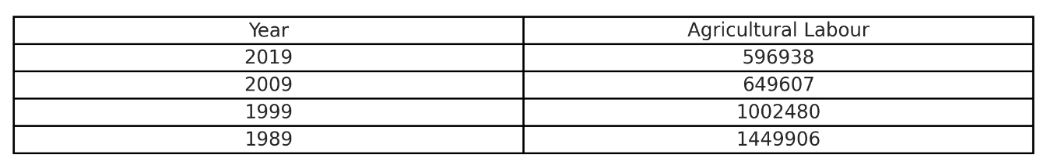

Source: INE - Agricultural labour by geographic location (NUTS 2013), type of labour and work duration regime. Values for “Continente”.

From this table it is apparent that approximately 1.45 million people were employed in agricultural activities in the mainland in 1989. Over the last 30-year period this number fell to just under 597,000 – a reduction of approximately 59%. For better reference, Figure 3.1 illustrates the difference between the years.

Figure 3.1 – Evolution of agricultural labour in mainland Portugal (1989 – 2019)

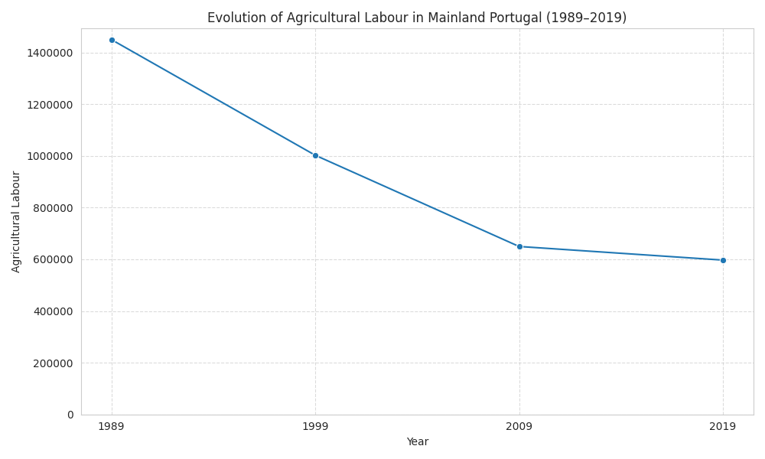

Source: INE - Agricultural labour by geographic location (NUTS 2013), type of labour and work duration regime. Values for “Continente”.

Three key observations stand out:
- Steep initial decline (1989 - 1999): The loss of nearly 450,000 workers in the first decade reflects a period of intense rural exodus, mechanization, and the abandonment of small, non-viable farms following Portugal's integration into the European Economic Community (now EU) in 1986.
- Continued but slower decline (1999 - 2009): The reduction of another 350,000 workers suggests that restructuring continued, though possibly at a more moderate pace as the agricultural sector adapted to EU policies, including the Common Agricultural Policy (CAP).
- Moderation of decline (2009 - 2019): The sharp reduction in the rate of decline (only 52,669 workers lost) suggests that the agricultural labour force may be approaching a lower baseline. This remaining workforce likely consists of more specialized, full-time, and professional farmers.
Overall, these patterns are consistent with a process of agricultural restructuring, where fewer workers are needed to manage larger, more mechanized, and more capital-intensive farms. The slowing rate of decline after 2009 may also reflect stabilization of the sector after decades of transformation.

Changes in agricultural area / land use

Beyond the decline in agricultural labour, understanding how agricultural land use evolved is essential for characterizing the restructuring process. This section examines changes in total agricultural area, temporary crop holdings, permanent crop holdings, and the relationship between these different land use categories between 1989 and 2019.

3.2.1 Evolution of Total Agricultural Area

Contrary to the sharp decline observed in agricultural labour, total agricultural area in mainland Portugal remained relatively stable over the 30-year period. Table 3.2 presents the evolution of the total agricultural holdings area between 1989 and 2019.

Table 3.2 - Total Agricultural Holdings Area in Mainland Portugal (1989 - 2019)

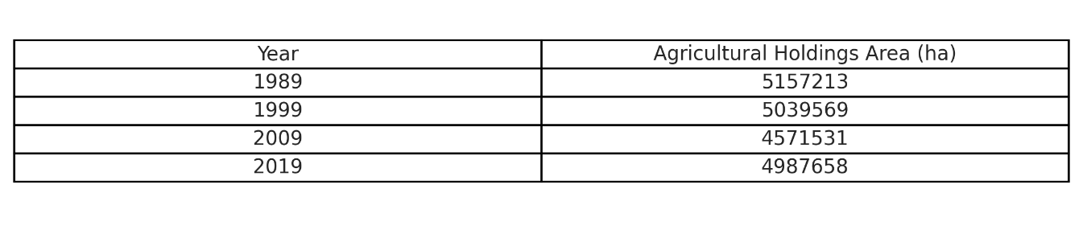

Source: INE – Agricultural holdings area by geographic location (NUTS 2013). Values for "Continente".

The total agricultural area decreased by only 3.3% between 1989 and 2019, from approximately 5.16 million hectares to 4.99 million hectares. This stands in stark contrast to the 59% reduction in agricultural labour over the same period, suggesting that land abandonment was not the primary driver of labour decline.

Figure 3.2 - Evolution of Total Agricultural Area (1989–2019)

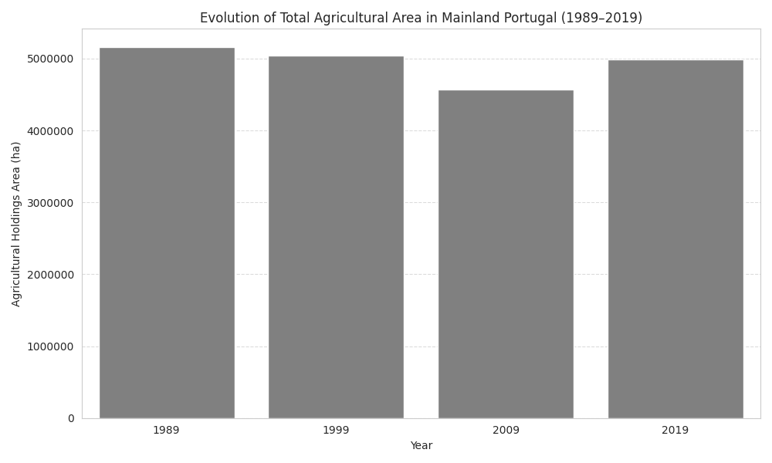

Source: INE – Agricultural Area in Mainland Portugal (NUTS 2013). Values for "Continente".

Three key observations emerge from this analysis:

Relative stability (1989 - 1999): The agricultural area remained nearly constant between 1989 and 1999, decreasing by only 117,644 ha (2.3%). This suggests that during the first decade of analysis, labour decline was driven primarily by mechanization and efficiency gains rather than land abandonment.

Notable decline (1999 - 2009):The period between 1999 and 2009 saw the largest reduction in agricultural area, with a loss of 468,038 ha (9.3%). This coincides with the continued adjustment to CAP reforms and may reflect the abandonment of marginal agricultural land, particularly in less productive regions.

Recovery and stabilization (2009 - 2019): Between 2009 and 2019, agricultural area increased by 416,127 ha (9.1%), nearly recovering to 1999 levels. This recovery may be associated with the expansion of permanent crops, particularly olive groves and vineyards, which have been supported by EU investment programs (INE, 2020).

3.2.2 Land Use Concentration and Restructuring

The data reveal a process of agricultural concentration and restructuring. While total agricultural area decreased only slightly (3.3%), the number of holdings fell dramatically (63%), suggesting that farms became larger on average. This is consistent with the restructuring hypothesis: agricultural land is being managed by fewer, larger, and more specialized operations.

Table 3.3 - Average Holding Size by Crop Type (1989 - 2019)

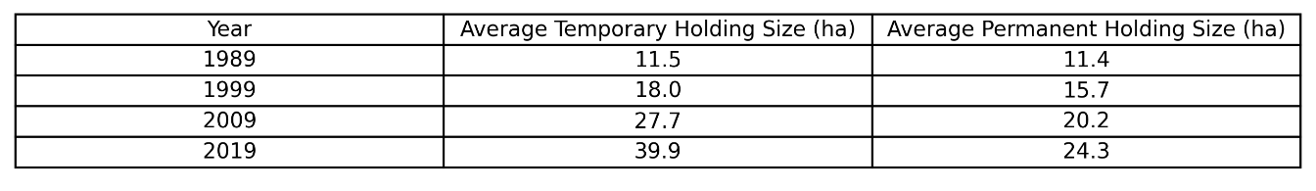

The average temporary crop holding size increased by 247% (from 11.5 to 39.9 ha), while average permanent crop holding size increased by 113% (from 11.4 to 24.3 ha). This suggests that the consolidation process was more pronounced in temporary cropping systems, where mechanization and scale economies are more readily achievable.

Figure – 3.3 Average Holding Size by Crop Type (1989 - 2019)

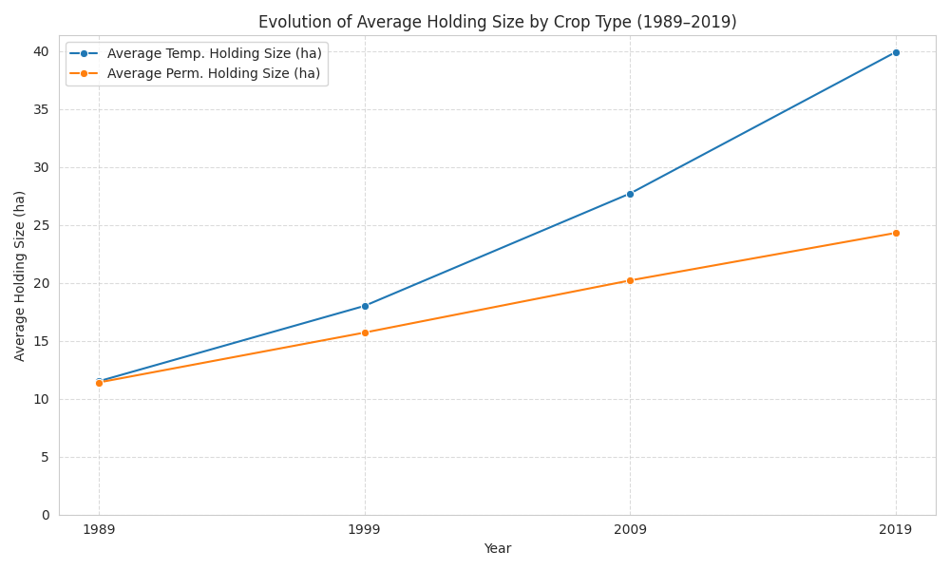

The sharp increase in average holding size, combined with the reduction in labour intensity, points to a clear pattern of agricultural intensification: fewer, larger farms employing less labour per hectare, particularly in temporary cropping systems.

Temporary and permanent crops

The distinction between temporary and permanent crops is fundamental for understanding agricultural restructuring in mainland Portugal. Temporary crops are cultivated on a seasonal basis and require annual replanting (cereals, pulses, potatoes, horticultural crops), while permanent crops remain in the ground for multiple years (vineyards, olive groves, fruit trees). These two categories respond differently to economic incentives, policy frameworks, and environmental conditions, making their comparative analysis particularly revealing.

3.3.1 Evolution of Temporary Crop Holdings

Temporary crops experienced the most dramatic decline among all agricultural indicators analyzed. Table 3.4 presents the evolution of temporary crop holdings by category between 2989 and 2019.

Table 3.4 - Temporary Crop Holdings by Category in Mainland Portugal (1989–2019)

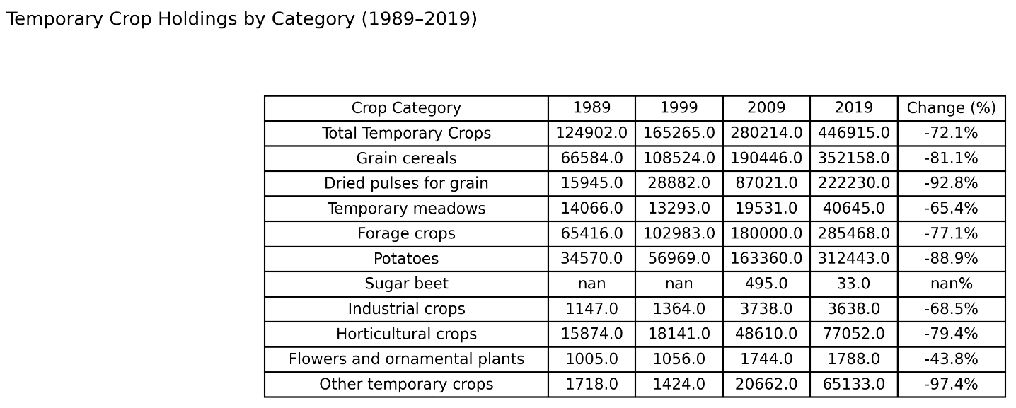

Source: INE – Temporary crops holdings by geographic location (NUTS 2013). Values for "Continente"

Figure 3.4 - Evolution of Major Temporary Crop Holdings (1989–2019)

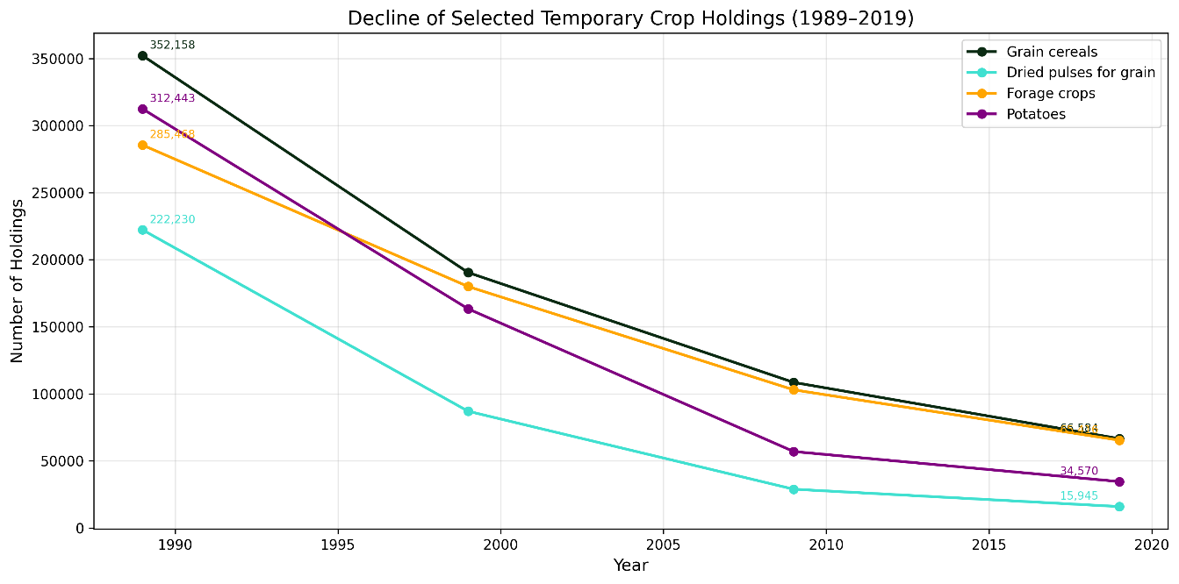
The data reveals an extraordinary contraction in temporary crop holdings, with the total declining by 72.1% between 1989 and 2019. However, the decline was not uniform across categories. Several patterns stand out:

1. Collapse of traditional arable crops:
- Dried pulses for grain experienced the most severe decline (-92.8%), from 222,230 to 15,945 holdings. This reflects the abandonment of traditional legume cultivation in favour of more profitable crops or grassland conversion.
- Potatoes declined by 88.9% (from 312,443 to 34,570 holdings), reflecting the concentration of potato production in specialized, large-scale operations, primarily in the Centre and North regions.
- Grain cereals declined by 81.1% (from 352,158 to 66,584 holdings), consistent with the consolidation of cereal production in the Alentejo and Ribatejo regions.

2. Decline of forage and temporary meadows:
- Forage crops declined by 77.1% (from 285,468 to 65,416 holdings), while temporary meadows declined by 65.4% (from 40,645 to 14,066 holdings). This is particularly significant because forage crops are directly linked to livestock production. Their decline suggests a shift from crop-based animal feed (grown on arable land) to extensive grazing on permanent grasslands.

3. Horticultural crops:
- Horticultural crops declined by 79.4% (from 77,052 to 15,874 holdings). This decline may reflect the concentration of horticultural production in specialized regions (e.g., Algarve for vegetables, Oeste for fruit) and the consolidation of small holdings into larger operations.

4. Near disappearance of other categories:
- Other temporary crops declined by 97.4% (from 65,133 to 1,718 holdings), suggesting that many small-scale, diversified farms disappeared entirely.

3.3.2 Evolution of Permanent Crop Holdings

While temporary crop holdings declined sharply, permanent crop holdings followed a different trajectory, as shown in Table 3.5.

Table 3.5 – Permanent Crop Holdings (1989 – 2019)

Source: INE – Permanent crops holdings by geographic location (NUTS 2013). Values for "Continente".

Figure 3.5 - Evolution of Permanent Crop Holdings (1989–2019)

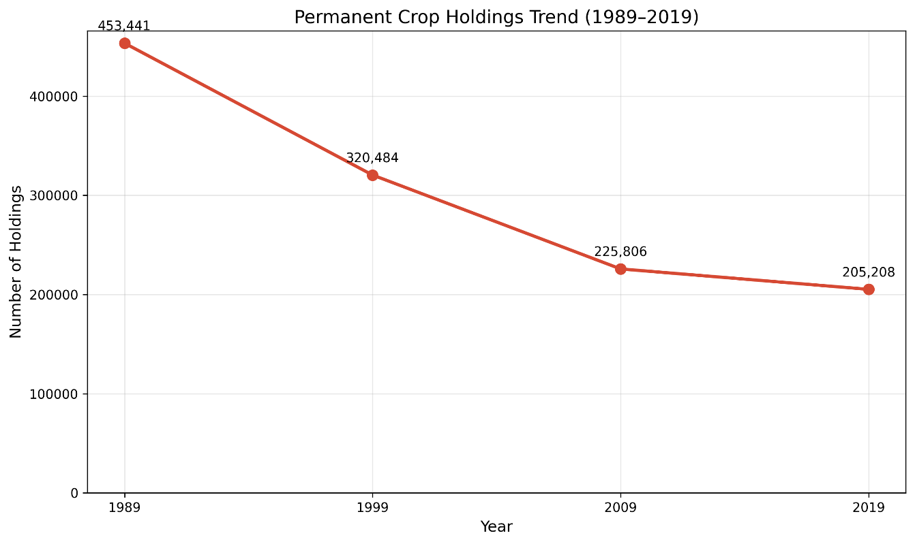
The permanent crop holdings declined by 54.8% between 1989 and 2019, a smaller
decrease than the 72.1% decline in temporary crop holdings. More importantly, the rate of decline slowed considerably after 2009 (only 9.1% between 2009 and 2019), suggesting
that permanent crop holdings may be stabilizing. This is likely reflected:

- The expansion of olive groves (super-intensive systems) and vineyards, which increased demand for permanent crop holdings;
- The conversion of marginal arable land to permanent crops;
- The professionalization of permanent crop farming, with larger, more viable operations.

3.3.3 Comparative Analysis: Temporary vs. Permanent Crop Holdings (1989 - 2019)

The divergent trajectories of temporary and permanent crops reveal fundamental
differences in the restructuring process. Figure 3.6 summarizes the contrasting patterns.

Figure 3.6 - Comparative Analysis: Temporary vs. Permanent Crop Holdings (1989–2019)
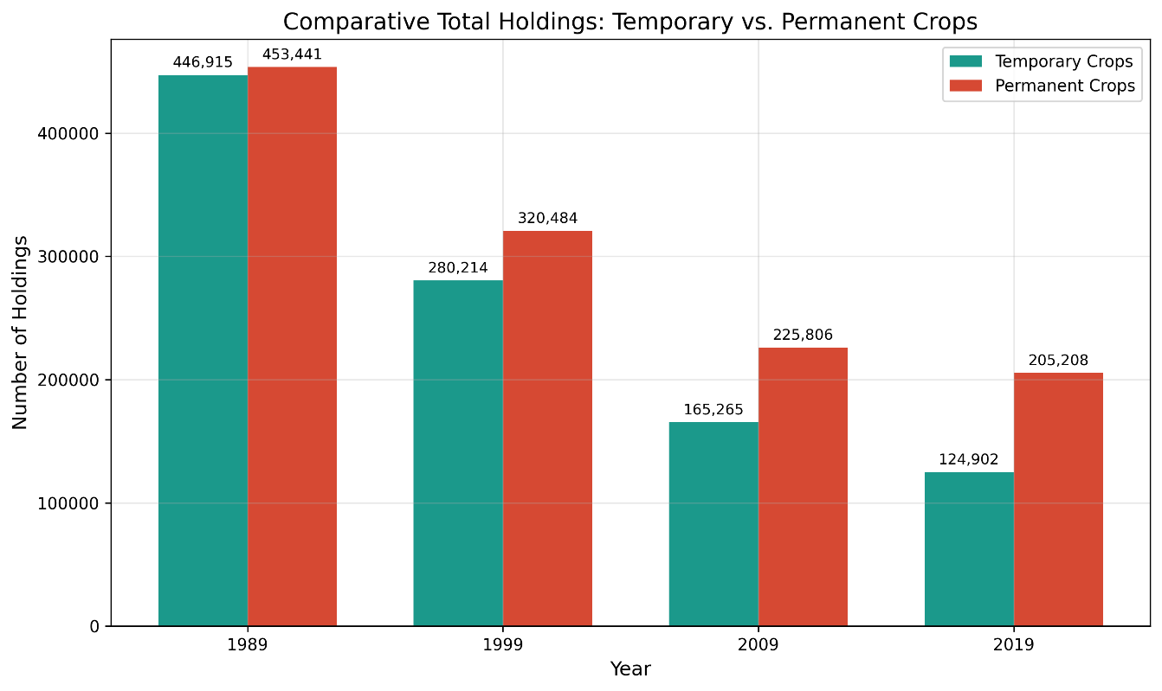
Key Observations:

- Diverging trajectories: While both types of crop holdings declined, permanent crops declined less and showed stronger signs of stabilization after 2009. This suggests that permanent crop systems have proven more resilient to the pressures of agricultural restructuring.

- Structural shift: In 1989, temporary crops represented 49.6% of total crop holdings, while permanent crops represented 50.4%. By 2019, permanent crops represented 62.2% and temporary crops only 37.8%. Portuguese agriculture has transitioned from a balanced mix to a permanent-crop-dominated sector.

- Policy implications: This shift towards permanent crops reflects the influence of EU policies (CAP payments, rural development programs) that favoured permanent crop expansion, particularly olives and vines. These crops are often more profitable per hectare and benefit from EU subsidies.

- Environmental implications: The shift to permanent crops has significant environmental implications, including changes in water use (irrigation for olives and vines), soil conservation (permanent cover vs. annual tillage), and biodiversity (monoculture expansion).

3.3.4 Concentration and Consolidation

The decline in the number of holdings does not necessarily mean that crop production decreased. Rather, it reflects consolidation: fewer, larger farms managing the same or greater area.

Figure 3.7 - Average Holding Size: Temporary vs. Permanent Crops (1989–2019)
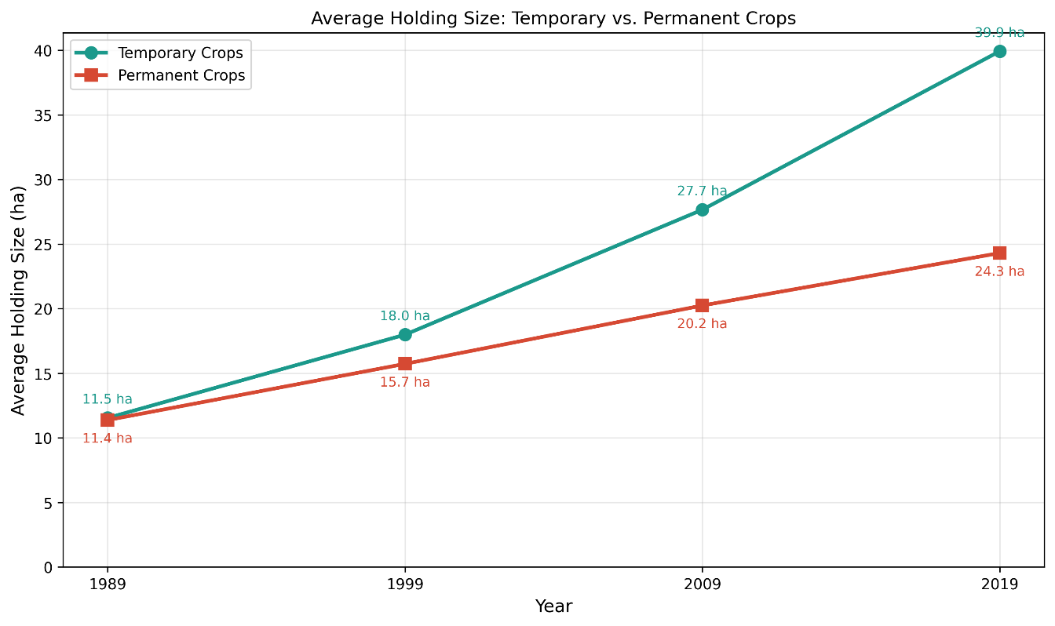

The average temporary crop holding increased from 11.5 to 39.9 ha, while permanent crop holdings increased by from 11.4 to 24.3 ha. This suggests that consolidation was more pronounced in temporary cropping systems, where mechanization and economies of scale are more achievable.

These patterns reinforce the overall narrative of agricultural restructuring: Portuguese agriculture is becoming more specialized, more concentrated, and more oriented towards permanent crops, while labour and small-scale farming continue to decline.

Permanent grasslands and pastures

Permanent grasslands represent a distinct land use category in Portuguese agriculture, associated primarily with extensive livestock systems and forage production. Unlike temporary crops or permanent crops, grasslands are not typically cultivated annually and are managed for grazing or hay production. This section examines the evolution of permanent grassland area in mainland Portugal between 1989 and 2019.

Table 3.7 – Evolution of Permanent Grassland and Pasture Area (1989 - 2019)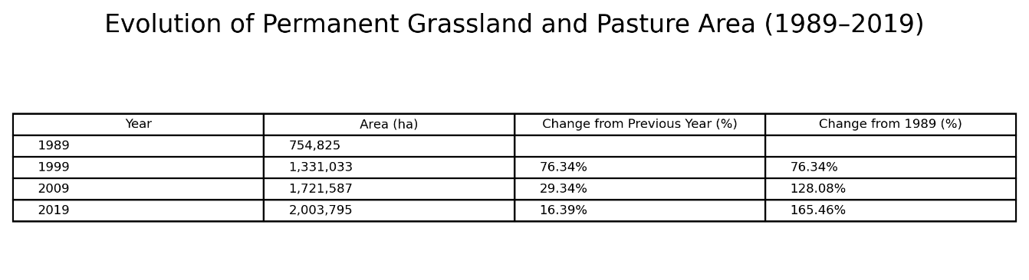

Source: INE – Permanent grasslands area by geographic location (NUTS 2013). Values for "Continente"

Figure 3.8 - Evolution of Permanent Grassland and Pasture Area

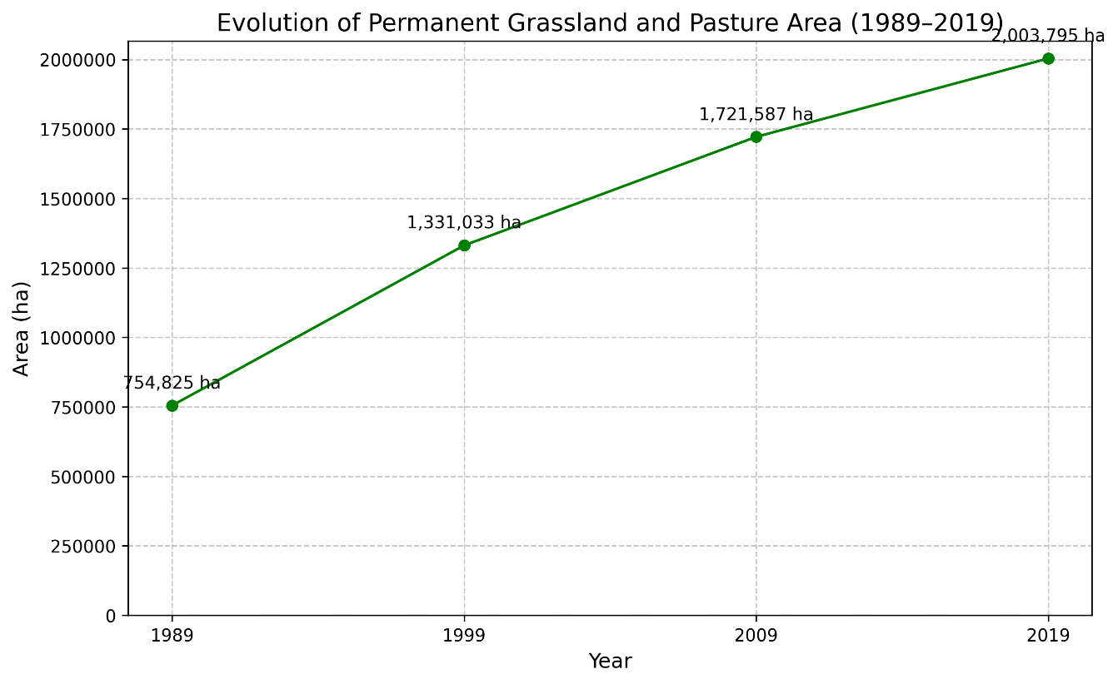

The data reveal a striking and consistent increase in permanent grassland area, which more than doubled between 1989 and 2019, growing by 165.5% (from 754,825 ha to 2,003,795 ha). This is the most dramatic change among all land use indicators analyzed.

Three key observations stand out:

1. Accelerated expansion (1989–1999): Grasslands increased by 576,208 ha (76.3%) in the first decade, the most rapid period of expansion. This likely reflects the abandonment of marginal arable land and its conversion to extensive grazing systems, as well as the impact of CAP policies that supported livestock production.

2. Continued growth (1999–2009): The expansion continued at a substantial rate, adding another 390,554 ha (29.3%). By 2009, grasslands had become a dominant land use category in many regions, particularly in the interior of the country where arable farming was less viable.

3. Moderating but sustained growth (2009–2019): While the rate of expansion slowed to 16.4%, grasslands continued to increase, reaching over 2 million hectares by 2019. This suggests that the conversion to grassland may be approaching a ceiling, but the trend remains positive.

What the Grassland Data Reveals about Agricultural Restructuring

The expansion of permanent grasslands tells a different story from the trends observed in temporary and permanent crops. While crop holdings declined sharply, grasslands expanded significantly. This divergence reflects three important processes:

- Land use polarization: Marginal arable land was converted to extensive grazing, while
productive land remained in crop production or shifted to permanent crops (olives, vines). This created a polarized agricultural landscape: intensive cropping in productive areas,
extensive livestock in marginal areas.

- Specialization of livestock systems: The growth of large grassland holdings suggests a
move towards specialized, large-scale livestock operations, consistent with broader trends
in European agriculture.

- Abandonment disguised as extensification: In many cases, the conversion of arable land to grassland may represent a form of land abandonment, where land remains in agricultural use but with much lower labour and capital inputs. This is consistent with the labour
decline.

The grassland data thus adds a crucial dimension to the restructuring narrative:
Portuguese agriculture did not simply decline or intensify uniformly. Instead, it underwent a
dual process of intensification in crop production (particularly permanent crops) and
extensification in grassland systems. This dual trajectory is a key characteristic of agricultural change in Mediterranean Europe.

3.5 Productivity of main agricultural crops

Understanding how productivity evolved alongside labour and land use changes is essential for characterizing the restructuring process. If labour declined but productivity increased, this would suggest intensification and efficiency gains. If productivity stagnated or declined alongside labour, it would suggest sectoral decline. This section analyzes productivity trends for major crop groups in mainland Portugal between 1989 and 2019.

Table 3.8 – Crop Productivity by Category (1989 – 2019)
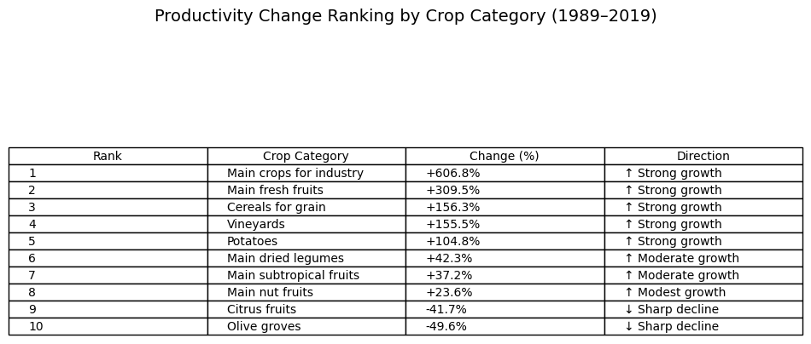

Table 3.8 presents productivity values for the main crop categories between 1989 and 2019. While the exact units vary by crop, the trends reveal important patterns of agricultural change.

3.5.1 Strong Productivity Growth

Main crops for industry showed the most remarkable increase (+606.8%), from 9,303 to 65,754 units. This reflects the expansion of intensive, irrigated agriculture in the Alentejo, driven by technological adoption, improved varieties, and investment in irrigation infrastructure.

Main fresh fruits increased by +309.5% (from 3,773 to 15,451 units), reflecting the expansion of intensive fruit orchards in the Oeste and Algarve regions. The adoption of modern cultivation techniques, including trellising and drip irrigation, has contributed significantly to this growth.

Cereals for grain increased by +156.3% (from 2,013 to 5,160 units), consistent with mechanization, improved varieties, and farm consolidation. This aligns with the increase in average temporary holding size.

Vineyards increased by +155.5% (from 971 to 2,481 units), reflecting varietal improvements, investment in trellising and irrigation, and the modernization of Portuguese viticulture in regions like Douro, Dão, and Alentejo.

Potatoes increased by +104.8% (from 11,209 to 22,953 units), reflecting concentration in specialized, large-scale operations and the adoption of improved varieties and irrigation.

3.5.2 Moderate Growth

Main dried legumes increased by +42.3% (from 560 to 797 units). Despite a dramatic 92.8% decline in the number of holdings, productivity increased, suggesting that the remaining operations became more specialized and efficient.

Main subtropical fruits increased by +37.2% (from 7,791 to 10,690 units), reflecting the expansion of these crops in warmer regions, particularly the Algarve, where favourable climatic conditions and market demand have driven investment.

Main nut fruits increased by +23.6% (from 4,003 to 4,948 units), representing modest but steady growth. Nut production has traditionally been associated with extensive, low-input systems in marginal areas, with gradual improvements in orchard management.

3.5.3 Sharp Decline

Olive groves decreased by -49.6% (from 3,932 to 1,981 units). This decline is paradoxical given the significant expansion of olive groves. The explanation lies in the coexistence of traditional and intensive systems:

- Traditional olive groves (low density, rainfed, low productivity) are being maintained or expanded in marginal areas
- Intensive/super-intensive olive groves (high density, irrigated, high productivity) are expanding in productive regions
- Average productivity decreased because traditional systems (with low yields) dominate the total area

Citrus fruits decreased by -41.7% (from 1,325 to 772 units). This decline may reflect orchard ageing, increased pest and disease pressure, and the expansion of citrus production into marginal areas with lower yields.

Inferential Statistics
After identifying the main patterns through exploratory data analysis, this section applies inferential statistics to assess whether the observed trends are statistically meaningful. While the previous section focused on visual interpretation and descriptive comparisons, this stage aims to evaluate the strength and direction of the relationship between time and the selected agricultural indicators.
For this purpose, simple correlation and linear regression tests were applied. The variable year was used as the independent variable, while the agricultural indicators were used as dependent variables. This approach makes it possible to examine whether each indicator presents a positive, negative or weak trend over the period analyzed.
The inferential analysis is organized according to the main hypotheses of the project. Each statistical test is therefore connected to a specific dimension of agricultural transformation, allowing the results to be interpreted in relation to the research question.

Statistical test of agricultural labour

Statistical test of land-use indicators

Statistical test of crop systems

Statistical test of grasslands and pastures

4.5. Statistical test of productivity indicators

Discussion and Conclusion

Referências Bibliográficas

Eurostat. (2024). Agriculture statistics. European Commission. https://ec.europa.eu/eurostat/web/agriculture
Instituto Nacional de Estatística. (2020). Recenseamento Agrícola 2019: Análise dos principais resultados. INE.
Instituto Nacional de Estatística. (2021). Recenseamento Agrícola 2019. INE.

