Slaap it!

The classic retro game Pong recreated using Pygame and python

Index

Screenshots:

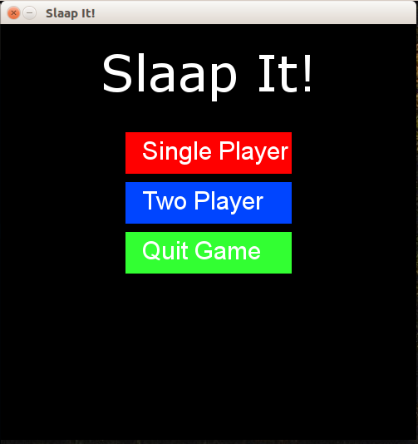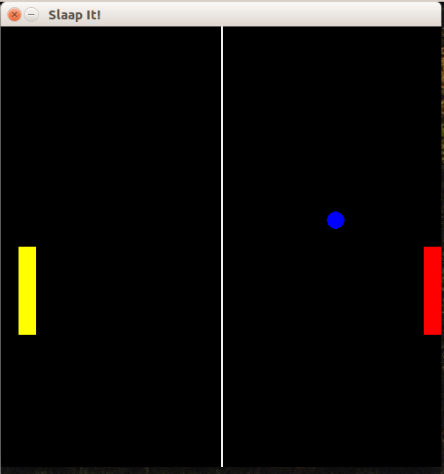

Game features:

1 player vs Computer player mode

2 player mode

Controls:

|  |  |
| --- | --- |
| Button | Action |
| Down key | Player 2 moves down |
| Up key | Player 2 moves up |
| W key | Player 1 moves up |
| S key | Player 1 moves down |

Installation:

Contributors:

License: