Source Data Mapping Approach to CDMV5.1.0

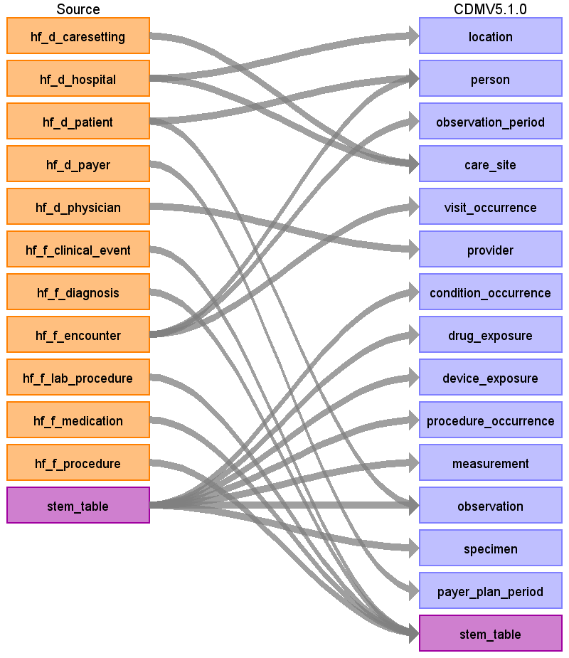

# Table name: location

Reading from hf_d_hospital

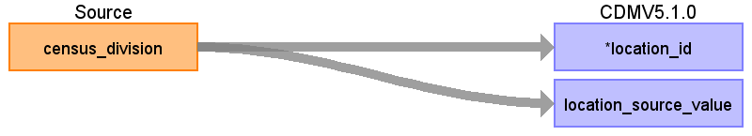

|  |  |  |  |
| --- | --- | --- | --- |
| Destination Field | Source Field | Logic | Comment |
| location_id | census_division |  | Autogenerate |
| address_1 |  |  |  |
| address_2 |  |  |  |
| city |  |  |  |
| state |  |  |  |
| zip |  |  |  |
| county |  |  |  |
| location_source_value | census_division | Map the census_division values as follows:  1= (CT, ME, MA, NH, RI, VT),  2= (NJ, NY, PA),  3= (IA, KS, MN, MO, ND, SD),  4= (IL, IN, MI, OH, WI),  5= (AL, KY, MS, TN),  6= (DE, DC, FL, GA, MD, NC, SC, VA, WV),  7= (AR, LA, OK, TX),  8= (AZ, CO, ID, MT, NV, NM, UT, WY),  9= (AK, CA, HI, OR, WA) |  |

# Table name: person

## Reading from hf_d_patient

We will use the hf_f_encounter table to identify the most recent patient record. Otherwise we will have multiple patient_ids per unique person.

* Delete individuals whose DOBYR < 1900 or > the current year.
* Delete individuals who do not have a valid gender

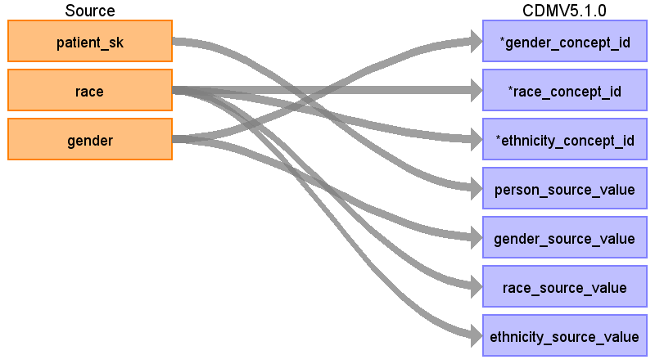

|  |  |  |  |
| --- | --- | --- | --- |
| Destination Field | Source Field | Logic | Comment |
| person_id |  |  | Auto generate this number. |
| gender_concept_id | gender | Male=8507; Female=8532 |  |
| year_of_birth |  |  | Admitted date |
| month_of_birth |  |  |  |
| day_of_birth |  |  |  |
| birth_datetime |  |  |  |
| race_concept_id | race | Caucasian=8527  African American=8516  Hispanic=0  Asian=8515  Native American=8657  Biracial=0  Pacific Islander=38003613  Asian/Pacific Islander=38003613  Mid Eastern Indian=38003615  Take the most recent racial record, if the most recent is something other than what is listed above map to 0. |  |
| ethnicity_concept_id | race | Caucasian=38003564  African American=38003564  Hispanic=38003563  Asian=38003564  Native American=38003564  Biracial=38003564  Pacific Islander=38003564  Asian/Pacific Islander=38003564  Mid Eastern Indian=38003564  Take the most recent racial record, if the most recent is something other than what is listed above map to 0. |  |
| location_id |  |  |  |
| provider_id |  |  |  |
| care_site_id |  |  |  |
| person_source_value | patient_sk |  |  |
| gender_source_value | gender | If the most recent record has an unknown gender other than female or male - then exclude. If a person's gender changes (male to female or female to male) at any point in their record then exclude. Otherwise use the most recent gender recorded. |  |
| gender_source_concept_id |  |  |  |
| race_source_value | race |  |  |
| race_source_concept_id |  |  |  |
| ethnicity_source_value | race |  |  |
| ethnicity_source_concept_id |  |  |  |

## Reading from hf_f_encounter

Use the max(discharged_dt_tm) to identify the most recent date to identify the most recent patient_id. Use this patient_id in the hf_d_patient table to find the most recent demographics. This patient_id can also be used to find the patient_sk, which is the unique patient identifier.

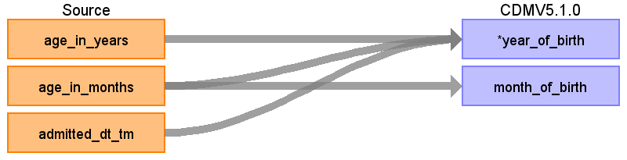

|  |  |  |  |
| --- | --- | --- | --- |
| Destination Field | Source Field | Logic | Comment |
| person_id |  |  | Auto generate this number. |
| gender_concept_id |  |  |  |
| year_of_birth | age_in_years  age_in_months  admitted_dt_tm | If age_in_years <2 then check to see if age_in_months is populated. If so, use admission_dt_tm - age_in_months to find the year_of_birth and month_of_birth  Using admitted_dt_tm, subtract age_in_years from year of most recent encounter | Admitted date |
| month_of_birth | age_in_months |  |  |
| day_of_birth |  |  |  |
| birth_datetime |  |  |  |
| race_concept_id |  |  |  |
| ethnicity_concept_id |  |  |  |
| location_id |  |  |  |
| provider_id |  |  |  |
| care_site_id |  |  |  |
| person_source_value |  |  |  |
| gender_source_value |  |  |  |
| gender_source_concept_id |  |  |  |
| race_source_value |  |  |  |
| race_source_concept_id |  |  |  |
| ethnicity_source_value |  |  |  |
| ethnicity_source_concept_id |  |  |  |

# Table name: observation_period

String together any encounters that have 0 days between them into 1 observation period.

If a person has an OBSERVATION_PERIOD where OBSERVATION_PERIOD_END_DATE < OBSERVATION_PERIOD_START_DATE then set OBSERVATION_PERIOD_END_DATE = OBSERVATION_PERIOD_START_DATE.

## Reading from hf_f_encounter

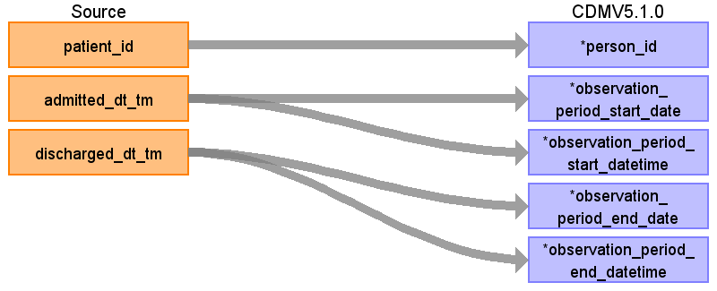

|  |  |  |  |
| --- | --- | --- | --- |
| Destination Field | Source Field | Logic | Comment |
| observation_period_id |  |  |  |
| person_id | patient_id | Map patient_id to hf_d_patient to find patient_sk and map patient_sk to person_source_value to find person_id. |  |
| observation_period_start_date | admitted_dt_tm | Take the date from admitted_dt_tm. |  |
| observation_period_start_datetime | admitted_dt_tm |  |  |
| observation_period_end_date | discharged_dt_tm | Take the date from discharged_dt_tm. |  |
| observation_period_end_datetime | discharged_dt_tm |  |  |
| period_type_concept_id |  |  |  |

# Table name: care_site

## Reading from hf_d_hospital

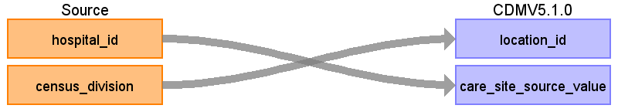

|  |  |  |  |
| --- | --- | --- | --- |
| Destination Field | Source Field | Logic | Comment |
| care_site_id |  |  | For every hospital_id/caresetting_id pair create a new care_site_id. These pairs will be found in hf_f_encounter using the following query:  select distinct hospital_id, discharge_caresetting_id, caresetting_desc  from hf_f_encounter e  left join hf_d_caresetting c  on e.discharge_caresetting_id = c.caresetting_id |
| care_site_name |  |  |  |
| place_of_service_concept_id |  |  |  |
| location_id | census_division |  | Map census division to the correction location_id |
| care_site_source_value | hospital_id |  |  |
| place_of_service_source_value |  |  |  |

## Reading from hf_d_caresetting

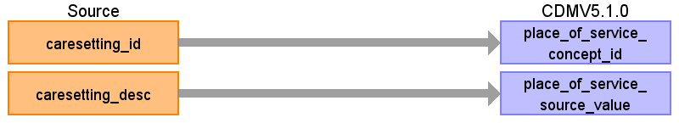

|  |  |  |  |
| --- | --- | --- | --- |
| Destination Field | Source Field | Logic | Comment |
| care_site_id |  |  | For every hospital_id/ caresetting_id pair create a new care_site_id. These pairs will be found in hf_f_encounter using the following query:  select distinct hospital_id, discharge_caresetting_id, caresetting_desc  from hf_f_encounter e  left join hf_d_caresetting c  on e.discharge_caresetting_id = c.caresetting_id |
| care_site_name |  |  |  |
| place_of_service_concept_id | caresetting_id |  | Map caresetting_id to a concept_id using the SOURCE -> STANDARD query with the filter:  WHERE source_vocabulary_id = ‘JNJ_CERNER_CRSTNG’ |
| location_id |  |  | Map census division to the correction location_id |
| care_site_source_value |  |  |  |
| place_of_service_source_value | caresetting_desc |  |  |

# Table name: visit_occurrence

## Reading from hf_f_encounter

After assigning a visit_concept_id to each record in hf_f_encounter, apply the following logic:

For visit_concept_id = 9201 (IP):

Sort data in ascending order by person_id, admitted_dt_tm, discharge_dt_tm and admitting_physician_id. Then by person_id, collapse records as long as the time between the discharge_dt_tm of one line and the admitted_dt_tm of the next <= 0 days.

Then set

min(admitted_dt_tm) as visit_start_date

max(discharge_dt_tm) as visit_end_date

As you are collapsing records take the admitting_physician_id from the first record and assign it to provider_id for the whole visit. Also take the patient_type_id from the first record to find visit_source_value.

See if any OP (9202) or ER (9203) records occur during an IP visit. These should be consolidated into that IP visit, unless it is an ER visit that starts and ends on the first day of the IP visit.

For visit_concept_id = 9203 (ER):

Sort data in ascending order by person_id, admitted_dt_tm, discharge_dt_tm and admitting_physician_id. Then by person_id, collapse all ER records that start on the same day as one ER visit, then take admitted_dt_tm as visit_start_date and max(discharge_dt_tm) as visit_end_date. As you are collapsing records take the admitting_physician_id from the first record and assign it to provider_id for the whole visit.

For visit_concept_id = 9202 (OP):

Sort data in ascending order by person_id, admitted_dt_tm, discharge_dt_tm and admitting_physician_id. Then by person_id, collapse all OP records that start on the same day as one OP visit and that have the same admitting_physician_id. Then take admitted_dt_tm as visit_start_date and max(discharge_dt_tm) as visit_end_date. As you are collapsing records take the admitting_physician_id from the first record and assign it to provider_id for the whole visit.

If a person has a visit where VISIT_END_DATE < VISIT_START_DATE then set VISIT_END_DATE = VISIT_START_DATE.

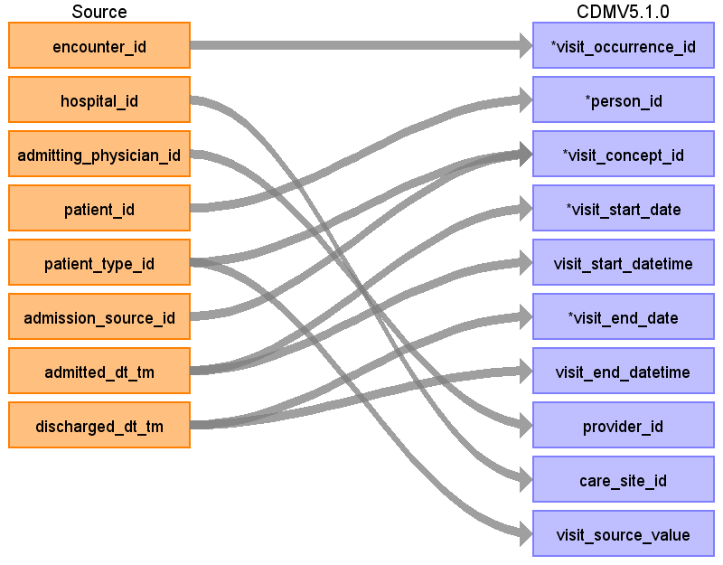

|  |  |  |  |
| --- | --- | --- | --- |
| Destination Field | Source Field | Logic | Comment |
| visit_occurrence_id | encounter_id |  |  |
| person_id | patient_id | Map patient_id to find patient_sk in the hf_d_patient table then use patient_sk to find person_id by mapping patient_sk to person_source_value |  |
| visit_concept_id | patient_type_id  admission_source_id | Map the visit_concept_id as follows:  patient_type_id visit_concept_id  98 9202 OP  84 9203 ER  87 9201 IP  145,108,86,90 42898160 LTC  All others should be mapped to 9202 |  |
| visit_start_date | admitted_dt_tm |  |  |
| visit_start_datetime | admitted_dt_tm |  |  |
| visit_end_date | discharged_dt_tm |  |  |
| visit_end_datetime | discharged_dt_tm |  |  |
| visit_type_concept_id |  |  | All records should have the value 44818518, 'Visit derived from EHR record' |
| provider_id | admitting_physician_id | map admitting_physician_id to provider_id in the provider table using admitting_physician_id = provider_source_value |  |
| care_site_id | hospital_id + discharge_caresetting_id | map hospital_id + discharge_caresetting_id to care_site_id. Use hospital_id = care_site_source_value and use the hf_d_caresetting to look up caresetting_desc. Then use caresetting_desc = place_of_service_source_value |  |
| visit_source_value | patient_type_id | Map patient_type_id to patient_type_desc in the hf_d_patient_type table and store patient_type_desc in the visit_source_value field |  |
| visit_source_concept_id |  |  |  |

# Table name: provider

## Reading from hf_d_physician

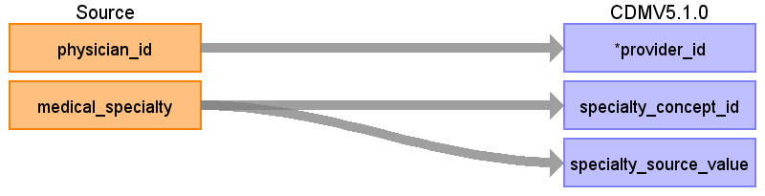

|  |  |  |  |
| --- | --- | --- | --- |
| Destination Field | Source Field | Logic | Comment |
| provider_id | physician_id | For duplicate physician_id take the specialty that is not NULL  NULLs include:  Count Medical_Specialty  ---------------------------------------------  9769557 NULL  1784498  344160 Not Mapped  297872 Not a Medical Speciality  63755 Undefined / Unknown  974 No Value / Undefined  4 Not a Medical Specialty, Not Active  1 Not a Medical Specialty, Obsolete | There should only be 18 physician_ids with duplicates. |
| provider_name |  |  |  |
| npi |  |  |  |
| dea |  |  |  |
| specialty_concept_id | medical_specialty | Use the source_to_concept_map to map medical_specialty using the filter:  Where source_vocabulary_id = ‘JNJ_CERNER_PROV_SPEC’ |  |
| care_site_id |  |  |  |
| year_of_birth |  |  |  |
| gender_concept_id |  |  |  |
| provider_source_value |  |  |  |
| specialty_source_value | medical_specialty |  |  |
| specialty_source_concept_id |  |  |  |
| gender_source_value |  |  |  |
| gender_source_concept_id |  |  |  |

# Table name: condition_occurrence

## Reading from stem_table

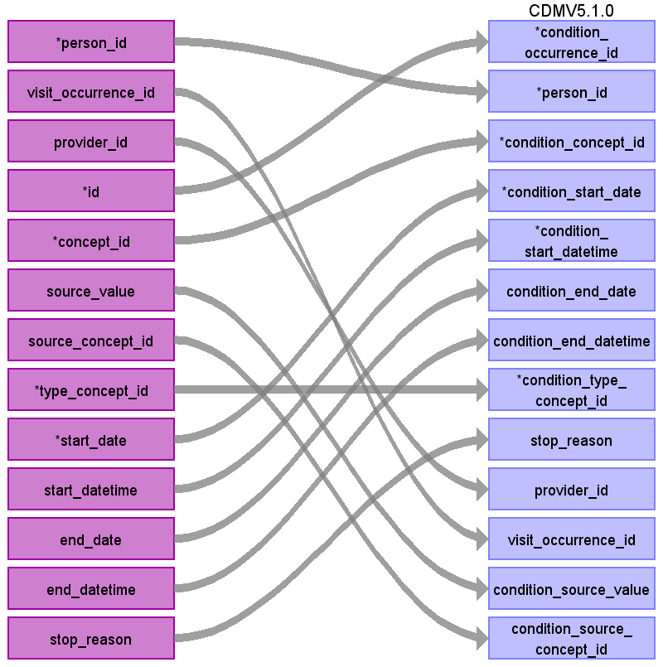

|  |  |  |  |
| --- | --- | --- | --- |
| Destination Field | Source Field | Logic | Comment |
| condition_occurrence_id | id |  |  |
| person_id | person_id |  |  |
| condition_concept_id | concept_id |  |  |
| condition_start_date | start_date |  |  |
| condition_start_datetime | start_datetime |  |  |
| condition_end_date | end_date |  |  |
| condition_end_datetime | end_datetime |  |  |
| condition_type_concept_id | type_concept_id |  |  |
| stop_reason | stop_reason |  |  |
| provider_id | provider_id |  |  |
| visit_occurrence_id | visit_occurrence_id |  |  |
| condition_source_value | source_value |  |  |
| condition_source_concept_id | source_concept_id |  |  |

# Table name: drug_exposure

## Reading from stem_table

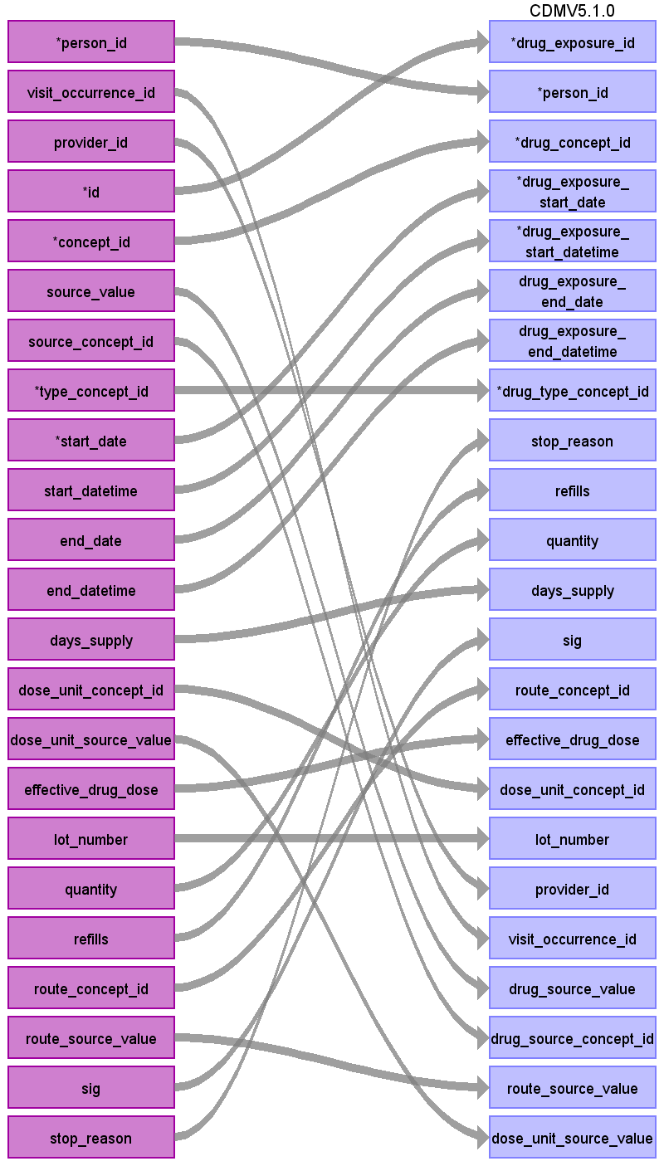

|  |  |  |  |
| --- | --- | --- | --- |
| Destination Field | Source Field | Logic | Comment |
| drug_exposure_id | id |  |  |
| person_id | person_id |  |  |
| drug_concept_id | concept_id |  |  |
| drug_exposure_start_date | start_date |  |  |
| drug_exposure_start_datetime | start_datetime |  |  |
| drug_exposure_end_date | end_date |  |  |
| drug_exposure_end_datetime | end_datetime |  |  |
| drug_type_concept_id | type_concept_id |  |  |
| stop_reason | stop_reason |  |  |
| refills | refills |  |  |
| quantity | quantity |  |  |
| days_supply | days_supply |  |  |
| sig | sig |  |  |
| route_concept_id | route_concept_id |  |  |
| effective_drug_dose | effective_drug_dose |  |  |
| dose_unit_concept_id | dose_unit_concept_id |  |  |
| lot_number | lot_number |  |  |
| provider_id | provider_id |  |  |
| visit_occurrence_id | visit_occurrence_id |  |  |
| drug_source_value | source_value |  |  |
| drug_source_concept_id | source_concept_id |  |  |
| route_source_value | route_source_value |  |  |
| dose_unit_source_value | dose_unit_source_value |  |  |

# Table name: device_exposure

## Reading from stem_table

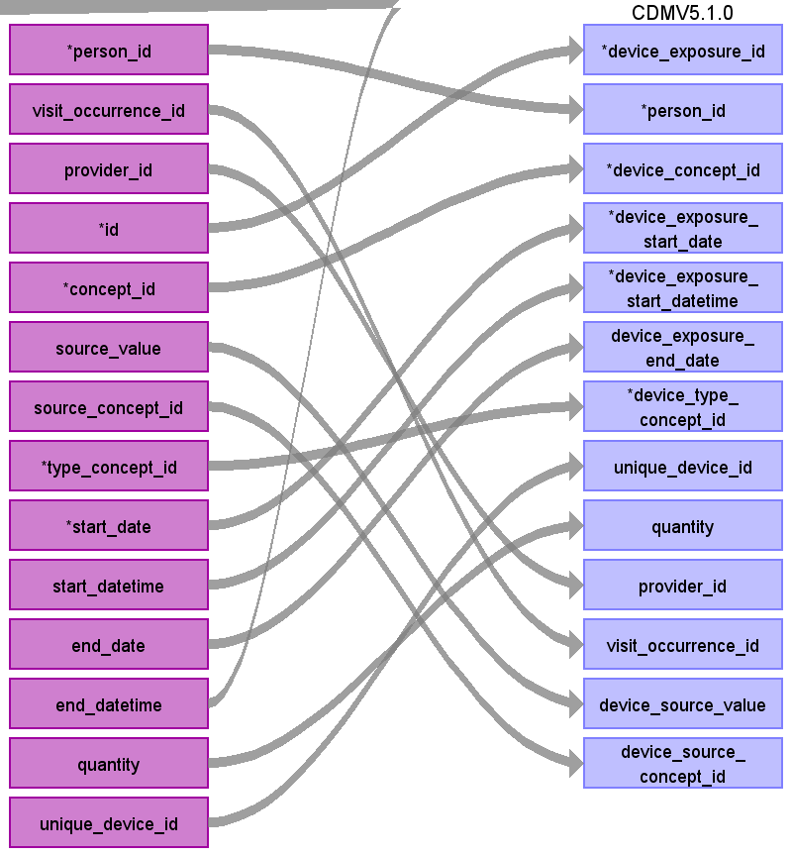

|  |  |  |  |
| --- | --- | --- | --- |
| Destination Field | Source Field | Logic | Comment |
| device_exposure_id | id |  |  |
| person_id | person_id |  |  |
| device_concept_id | concept_id |  |  |
| device_exposure_start_date | start_date |  |  |
| device_exposure_start_datetime | start_datetime |  |  |
| device_exposure_end_date | end_date |  |  |
| device_exposure_end_date |  |  |  |
| device_type_concept_id | type_concept_id |  |  |
| unique_device_id | unique_device_id |  |  |
| quantity | quantity |  |  |
| provider_id | provider_id |  |  |
| visit_occurrence_id | visit_occurrence_id |  |  |
| device_source_value | source_value |  |  |
| device_source_concept_id | source_concept_id |  |  |

# Table name: procedure_occurrence

## Reading from stem_table

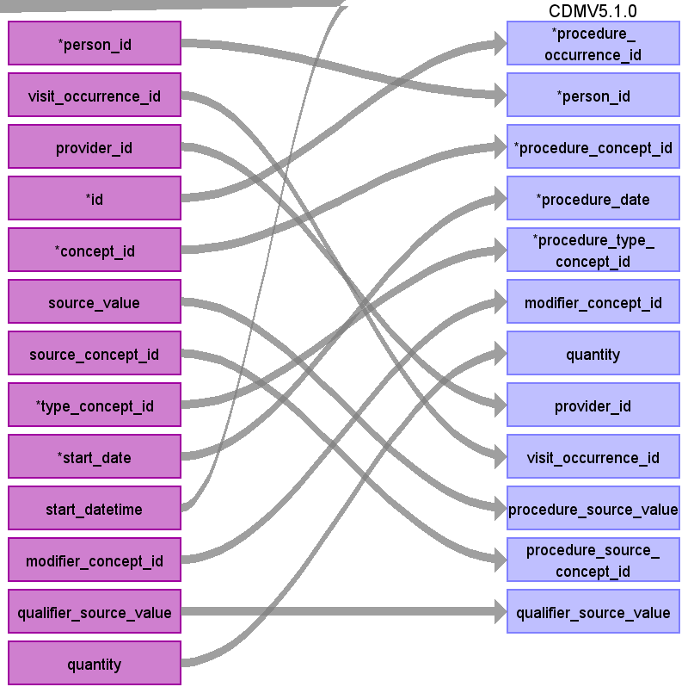

|  |  |  |  |
| --- | --- | --- | --- |
| Destination Field | Source Field | Logic | Comment |
| procedure_occurrence_id | id |  |  |
| person_id | person_id |  |  |
| procedure_concept_id | concept_id |  |  |
| procedure_date | start_date |  |  |
| procedure_type_concept_id | type_concept_id |  |  |
| modifier_concept_id | modifier_concept_id |  |  |
| quantity | quantity |  |  |
| provider_id | provider_id |  |  |
| visit_occurrence_id | visit_occurrence_id |  |  |
| procedure_source_value | source_value |  |  |
| procedure_source_concept_id | source_concept_id |  |  |
| qualifier_source_value | qualifier_source_value |  |  |

# Table name: measurement

## Reading from stem_table

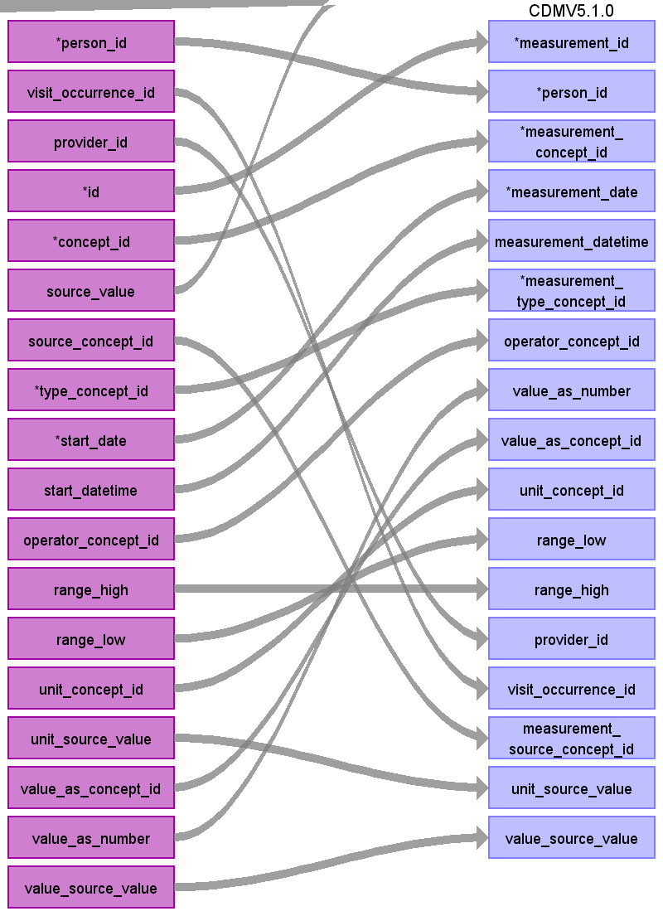

|  |  |  |  |
| --- | --- | --- | --- |
| Destination Field | Source Field | Logic | Comment |
| measurement_id | id |  |  |
| person_id | person_id |  |  |
| measurement_concept_id | concept_id |  |  |
| measurement_date | start_date |  |  |
| measurement_datetime | start_datetime |  |  |
| measurement_type_concept_id | type_concept_id |  |  |
| operator_concept_id | operator_concept_id |  |  |
| value_as_number | value_as_number |  |  |
| value_as_concept_id | value_as_concept_id |  |  |
| unit_concept_id | unit_concept_id |  |  |
| range_low | range_low |  |  |
| range_high | range_high |  |  |
| provider_id | provider_id |  |  |
| visit_occurrence_id | visit_occurrence_id |  |  |
| measurement_source_value |  |  |  |
| measurement_source_concept_id | source_concept_id |  |  |
| unit_source_value | unit_source_value |  |  |
| value_source_value | value_source_value |  |  |

# Table name: observation

Think about capturing all marital statuses, not just most recent

## Reading from hf_d_patient

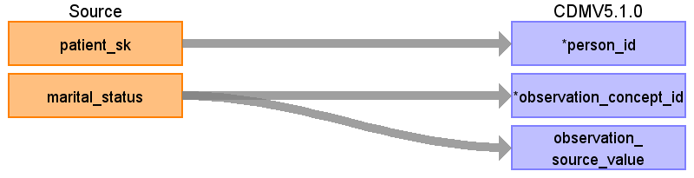

|  |  |  |  |
| --- | --- | --- | --- |
| Destination Field | Source Field | Logic | Comment |
| observation_id |  |  |  |
| person_id | patient_sk | Look up in person table using patient_sk. |  |
| observation_concept_id | marital_status |  |  |
| observation_date |  |  |  |
| observation_datetime |  |  |  |
| observation_type_concept_id |  | 38000280 ‘Observation recorded from EHR’ |  |
| value_as_number |  |  |  |
| value_as_string |  |  |  |
| value_as_concept_id |  |  |  |
| qualifier_concept_id |  |  |  |
| unit_concept_id |  |  |  |
| provider_id |  |  |  |
| visit_occurrence_id |  |  |  |
| observation_source_value | marital_status | Married=4338692  Single=4053842  Divorced=4069297  Widowed=4143188  Legally Separated=4027529  Life Partner=4212893  Using the hf_f_encounter table, find the most recent encounter. Use the patient_id of the most recent encounter to map marital status. Use most recent, all else should be mapped to 0. |  |
| observation_source_concept_id |  |  |  |
| unit_source_value |  |  |  |
| qualifier_source_value |  |  |  |

## Reading from stem_table

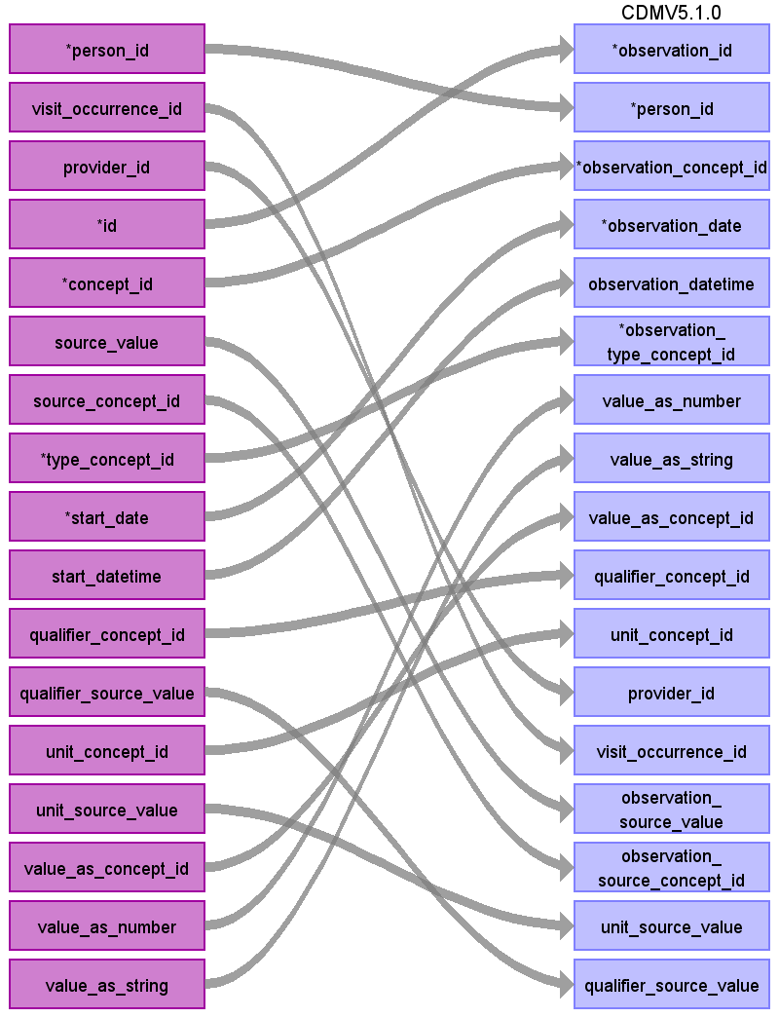

|  |  |  |  |
| --- | --- | --- | --- |
| Destination Field | Source Field | Logic | Comment |
| observation_id | id |  |  |
| person_id | person_id |  |  |
| observation_concept_id | concept_id |  |  |
| observation_date | start_date |  |  |
| observation_datetime | start_datetime |  |  |
| observation_type_concept_id | type_concept_id |  |  |
| value_as_number | value_as_number |  |  |
| value_as_string | value_as_string |  |  |
| value_as_concept_id | value_as_concept_id |  |  |
| qualifier_concept_id | qualifier_concept_id |  |  |
| unit_concept_id | unit_concept_id |  |  |
| provider_id | provider_id |  |  |
| visit_occurrence_id | visit_occurrence_id |  |  |
| observation_source_value | source_value |  |  |
| observation_source_concept_id | source_concept_id |  |  |
| unit_source_value | unit_source_value |  |  |
| qualifier_source_value | qualifier_source_value |  |  |

# Table name: specimen

## Reading from stem_table

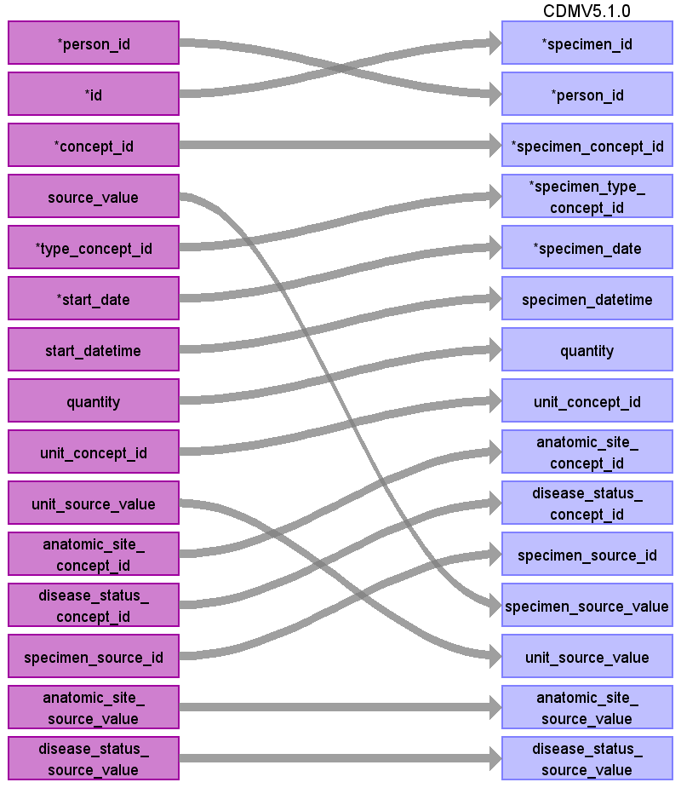

|  |  |  |  |
| --- | --- | --- | --- |
| Destination Field | Source Field | Logic | Comment |
| specimen_id | id |  |  |
| person_id | person_id |  |  |
| specimen_concept_id | concept_id |  |  |
| specimen_type_concept_id | type_concept_id |  |  |
| specimen_date | start_date |  |  |
| specimen_datetime | start_datetime |  |  |
| quantity | quantity |  |  |
| unit_concept_id | unit_concept_id |  |  |
| anatomic_site_concept_id | anatomic_site_concept_id |  |  |
| disease_status_concept_id | disease_status_concept_id |  |  |
| specimen_source_id | specimen_source_id |  |  |
| specimen_source_value | source_value |  |  |
| unit_source_value | unit_source_value |  |  |
| anatomic_site_source_value | anatomic_site_source_value |  |  |
| disease_status_source_value | disease_status_source_value |  |  |

# Table name: payer_plan_period

## Reading from hf_d_payer

Lookup patient_id and payer_id in encounter table, and then string encounters together with the same patient_id and payer_id and for consecutive encounters with the same payer_id take min(admit_date) for payer_plan_period_start_date and max(discharge_date) for payer_plan_period_end_date.

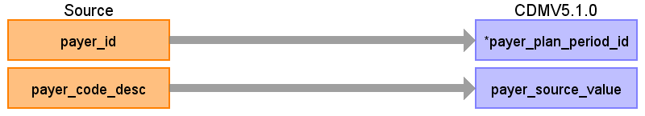

|  |  |  |  |
| --- | --- | --- | --- |
| Destination Field | Source Field | Logic | Comment |
| payer_plan_period_id | payer_id | If payer_id in (20,22,23) then disregard as these are unknown/NULL values |  |
| person_id |  |  |  |
| payer_plan_period_start_date |  |  |  |
| payer_plan_period_end_date |  |  |  |
| payer_source_value | payer_code_desc |  |  |
| plan_source_value |  |  |  |
| family_source_value |  |  |  |

Table name: drug_era

Table name: dose_era

Table name: condition_era

Table name: cdm_source

Table name: cohort

Table name: cohort_definition

Table name: cohort_attribute

Table name: attribute_definition

Table name: cost

# Table name: stem_table

## Reading from hf_f_clinical_event

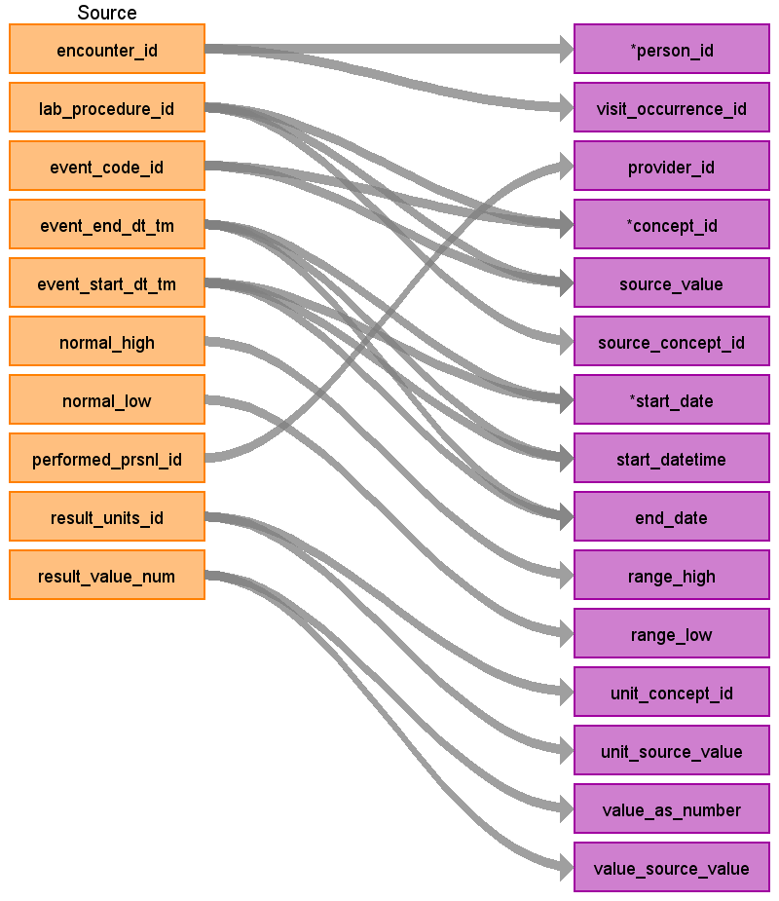

|  |  |  |  |
| --- | --- | --- | --- |
| Destination Field | Source Field | Logic | Comment |
| domain_id |  |  |  |
| person_id | encounter_id | Use encounter_id to find the patient_id in the hf_f_encounter table, then use the patient_id to find the patient_sk in the hf_d_patient table and use the patient_sk as the person_source_value to find the person_id |  |
| visit_occurrence_id | encounter_id | Use encounter_id to find the visit_occurrence_id |  |
| provider_id | performed_prsnl_id | map performed_prsnl_id to provider_source_value to find provider_id. If there is no map then set to NULL. |  |
| id |  |  | autogenerated |
| concept_id | lab_procedure_id  event_code_id | First, map lab_procedure_id to loinc_code using the hf_d_lab_procedure table. If there is a loinc_code available, map that code to a standard concept using the source->standard vocabulary query and store that standard concept in the concept_id value. If there is no loinc code, use the event_code_id to map a standard concept using the source->standard vocabulary query with the filter:  Where source_vocabulary_id = ‘JNJ_CERNER_EVENT_COD’ |  |
| source_value | lab_procedure_id  event_code_id | If the lab_procedure_id was used to find a loinc code to map concept_id, map lab_procedure_id to the lab_procedure_name in the hf_d_lab_procedure table and store that in the source_value field.  If the event_code_id was used to map concept_id, map event_code_id to event_code_desc in the table hf_d_event_code and store event_code_desc in the source_value field |  |
| source_concept_id | lab_procedure_id | If a loinc code was used to map to a standard concept as the concept_id, store the source_concept_id of the loinc code here. Otherwise, if the event_code_id was used to map the concept_id store a 0 in this field. |  |
| type_concept_id |  | Give all records the concept_id 45754805 (EHR Episode Entry) |  |
| start_date | event_end_dt_tm  event_start_dt_tm | If event_start_dt_tm is not available, store event_end_dt_tm as start_date. Otherwise store event_start_dt_tm as start_date |  |
| start_datetime | event_end_dt_tm  event_start_dt_tm | If event_end_dt_tm is not available, store event_start_dt_tm as end_date. Otherwise store event_end_dt_tm as end_date. |  |
| end_date | event_end_dt_tm  event_start_dt_tm | If event_start_dt_tm is not available, store event_end_dt_tm as start_date. Otherwise store event_start_dt_tm as start_date |  |
| end_datetime |  |  |  |
| days_supply |  |  |  |
| dose_unit_concept_id |  |  |  |
| dose_unit_source_value |  |  |  |
| effective_drug_dose |  |  |  |
| lot_number |  |  |  |
| modifier_concept_id |  |  |  |
| operator_concept_id |  |  |  |
| qualifier_concept_id |  |  |  |
| qualifier_source_value |  |  |  |
| quantity |  |  |  |
| range_high | normal_high |  |  |
| range_low | normal_low |  |  |
| refills |  |  |  |
| route_concept_id |  |  |  |
| route_source_value |  |  |  |
| sig |  |  |  |
| stop_reason |  |  |  |
| unique_device_id |  |  |  |
| unit_concept_id | result_units_id | map result_units_id to a concept_id using the source -> standard query and the filter:  where source_vocabulary_id = ‘JNJ_CERNER_UNITS’ |  |
| unit_source_value | result_units_id | map result_units_id to unit_id in hf_d_unit and store unit_desc as unit_source_value |  |
| value_as_concept_id |  |  |  |
| value_as_number | result_value_num |  |  |
| value_as_string |  |  |  |
| value_source_value | result_value_num |  |  |
| anatomic_site_concept_id |  |  |  |
| disease_status_concept_id |  |  |  |
| specimen_source_id |  |  |  |
| anatomic_site_source_value |  |  |  |
| disease_status_source_value |  |  |  |

## Reading from hf_f_procedure

Use the following table to assign type_concept_id:

|  |  |  |  |
| --- | --- | --- | --- |
| **Type of Associated Visit** | **Procedure_priority** | **Type_concept_id** | **CONCEPT_NAME** |
| IP | 1 | 38000251 | Inpatient header - 1st position |
| 2 | 38000252 | Inpatient header - 2nd position |
| 3 | 38000253 | Inpatient header - 3rd position |
| 4 | 38000254 | Inpatient header - 4th position |
| 5 | 38000255 | Inpatient header - 5th position |
| 6 | 38000256 | Inpatient header - 6th position |
| 7 | 38000257 | Inpatient header - 7th position |
| 8 | 38000258 | Inpatient header - 8th position |
| 9 | 38000259 | Inpatient header - 9th position |
| 10 | 38000260 | Inpatient header - 10th position |
| 11 | 38000261 | Inpatient header - 11th position |
| 12 | 38000262 | Inpatient header - 12th position |
| 13 | 38000263 | Inpatient header - 13th position |
| 14 | 38000264 | Inpatient header - 14th position |
| 15 | 38000265 | Inpatient header - 15th position |
| >15 | 38000265 | Inpatient header - 15th position |
| ER or OP | 1 | 38000269 | Outpatient header - 1st position |
| 2 | 38000270 | Outpatient header - 2nd position |
| 3 | 38000271 | Outpatient header - 3rd position |
| 4 | 38000272 | Outpatient header - 4th position |
| 5 | 38000273 | Outpatient header - 5th position |
| 6 | 38000274 | Outpatient header - 6th position |
|  | >6 | 38000274 | Outpatient header - 6th position |

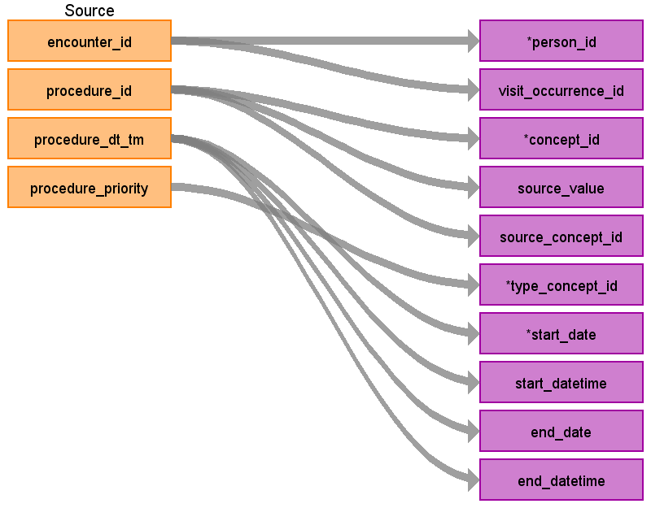

|  |  |  |  |
| --- | --- | --- | --- |
| Destination Field | Source Field | Logic | Comment |
| domain_id |  |  |  |
| person_id | encounter_id | Use encounter_id to find the patient_id in the hf_f_procedure table, then use the patient_id to find the patient_sk in the hf_d_patient table and use the patient_sk as the person_source_value to find the person_id |  |
| visit_occurrence_id | encounter_id | Use encounter_id to find the visit_occurrence_id |  |
| provider_id |  |  |  |
| id |  |  | autogenerated |
| concept_id | procedure_id | Use the procedure_id to map to procedure code in the hf_d_procedure table. Use the procedure_code and procedure_type from this table to map to a standard concept using this filter on the source->standard query :  WHERE SOURCE_VOCABULARY_ID IN ('ICD9Proc','HCPCS','CPT4',’ICD10PCS’)  AND TARGET_STANDARD_CONCEPT IS NOT NULL  AND TARGET_INVALID_REASON IS NULL  AND TARGET_CONCEPT_CLASS_ID NOT IN ('HCPCS Modifier','CPT4 Modifier',’CPT4 Hierarchy’, ‘ICD10PCS Hierarchy’) |  |
| source_value | procedure_id | Map to procedure_code in hf_d_procedure |  |
| source_concept_id | procedure_id | Use the procedure_id to map to procedure code in the hf_d_procedure table. Use the procedure_code and procedure_type from this table to find the source_concept_id using this filter on the source->source query :  WHERE SOURCE_VOCABULARY_ID IN ('ICD9Proc','HCPCS','CPT4',’ICD10PCS’)  AND TARGET_VOCABULARY_ID IN ('ICD9Proc','HCPCS','CPT4',’ICD10PCS’)  AND TARGET_CONCEPT_CLASS_ID NOT IN ('HCPCS Modifier','CPT4 Modifier',’CPT4 Hierarchy’,’ICD10PCS Hierarchy’) |  |
| type_concept_id | procedure_priority | Refer to table above to assign this column |  |
| start_date | procedure_dt_tm | If the procedure_dt_tm is blank, use the encounter_id to find the visit_occurrence_id and store visit_start_date here instead |  |
| start_datetime | procedure_dt_tm | If the procedure_dt_tm is blank, use the encounter_id to find the visit_occurrence_id and store visit_start_date here instead |  |
| end_date |  |  |  |
| end_datetime |  |  |  |
| days_supply |  |  |  |
| dose_unit_concept_id |  |  |  |
| dose_unit_source_value |  |  |  |
| effective_drug_dose |  |  |  |
| lot_number |  |  |  |
| modifier_concept_id |  |  |  |
| operator_concept_id |  |  |  |
| qualifier_concept_id |  |  |  |
| qualifier_source_value |  |  |  |
| quantity |  |  |  |
| range_high |  |  |  |
| range_low |  |  |  |
| refills |  |  |  |
| route_concept_id |  |  |  |
| route_source_value |  |  |  |
| sig |  |  |  |
| stop_reason |  |  |  |
| unique_device_id |  |  |  |
| unit_concept_id |  |  |  |
| unit_source_value |  |  |  |
| value_as_concept_id |  |  |  |
| value_as_number |  |  |  |
| value_as_string |  |  |  |
| value_source_value |  |  |  |
| anatomic_site_concept_id |  |  |  |
| disease_status_concept_id |  |  |  |
| specimen_source_id |  |  |  |
| anatomic_site_source_value |  |  |  |
| disease_status_source_value |  |  |  |

## Reading from hf_f_diagnosis

Use the following table to assign type_concept_id:

|  |  |  |  |
| --- | --- | --- | --- |
| **Type of Associated Visit** | **Diagnosis_priority** | **Type_concept_id** | **CONCEPT_NAME** |
| IP | 1 | 38000200 | Inpatient header - 1st position |
| 2 | 38000201 | Inpatient header - 2nd position |
| 3 | 38000202 | Inpatient header - 3rd position |
| 4 | 38000203 | Inpatient header - 4th position |
| 5 | 38000204 | Inpatient header - 5th position |
| 6 | 38000205 | Inpatient header - 6th position |
| 7 | 38000206 | Inpatient header - 7th position |
| 8 | 38000207 | Inpatient header - 8th position |
| 9 | 38000208 | Inpatient header - 9th position |
| 10 | 38000209 | Inpatient header - 10th position |
| 11 | 38000210 | Inpatient header - 11th position |
| 12 | 38000211 | Inpatient header - 12th position |
| 13 | 38000212 | Inpatient header - 13th position |
| 14 | 38000213 | Inpatient header - 14th position |
| 15 | 38000214 | Inpatient header - 15th position |
| >15 | 38000214 | Inpatient header - 15th position |
| ER or OP | 1 | 38000230 | Outpatient header - 1st position |
| 2 | 38000231 | Outpatient header - 2nd position |
| 3 | 38000232 | Outpatient header - 3rd position |
| 4 | 38000233 | Outpatient header - 4th position |
| 5 | 38000234 | Outpatient header - 5th position |
| 6 | 38000235 | Outpatient header - 6th position |
| 7 | 38000236 | Outpatient header - 7th position |
| 8 | 38000237 | Outpatient header - 8th position |
| 9 | 38000238 | Outpatient header - 9th position |
| 10 | 38000239 | Outpatient header - 10th position |
| 11 | 38000240 | Outpatient header - 11th position |
| 12 | 38000241 | Outpatient header - 12th position |
| 13 | 38000242 | Outpatient header - 13th position |
| 14 | 38000243 | Outpatient header - 14th position |
| 15 | 38000244 | Outpatient header - 15th position |
|  | >15 | 38000244 | Outpatient header - 15th position |

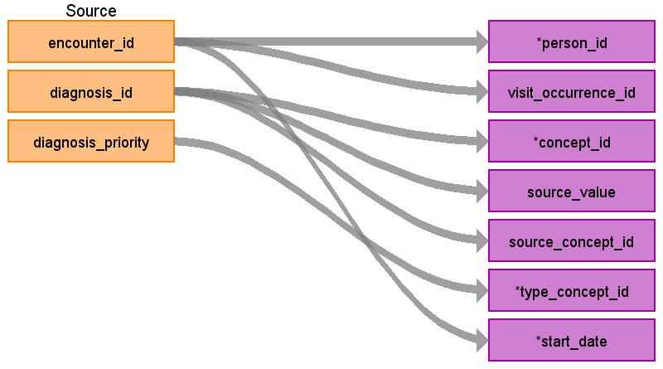

|  |  |  |  |
| --- | --- | --- | --- |
| Destination Field | Source Field | Logic | Comment |
| domain_id |  |  |  |
| person_id | encounter_id | Use encounter_id to find the patient_id in the hf_f_diagnosis table.  Use patient_id to find the patient_sk in the hf_d_patient table and use the patient_sk as the person_source_value assign the person_id. |  |
| visit_occurrence_id | encounter_id | Use encounter_id to find the visit_occurrence_id. |  |
| provider_id |  |  |  |
| id |  |  | autogenerated |
| concept_id | diagnosis_id | Use the diagnosis_id to map to procedure code in the hf_d_diagnosis table. Use the diagnosis_code and diagnosis_type from this table to map to a standard concept using this filter on the source->standard query we use in Truven:  If diagnosis_type = ‘ICD9’ use the filter  WHERE SOURCE_VOCABULARY_ID IN ('ICD9CM')  AND TARGET_STANDARD_CONCEPT IS NOT NULL  AND TARGET_INVALID_REASON IS NULL  If diagnosis_type = ‘ICD10-CM’ use the filter  WHERE SOURCE_VOCABULARY_ID IN ('ICD10CM')  AND TARGET_STANDARD_CONCEPT IS NOT NULL  AND TARGET_INVALID_REASON IS NULL  AND TARGET_CONCEPT_CLASS_ID NOT IN (‘ICD10CM Hierarchy’) |  |
| source_value | diagnosis_id | Map diagnosis_id to diagnosis_code in hf_d_diagnosis and store diagnosis_code here. |  |
| source_concept_id | diagnosis_id | Use the diagnosis_id to map to diagnosis code in the hf_d_diagnosis table. Use the diagnosis_code and diagnosis_type from this table to find the source_concept_id  If diagnosis_type = ‘ICD9’  Use the source-> source query with the filters:  Where source_vocabulary_id in ('ICD9CM')  and target_vocabulary_id in ('ICD9CM')  If diagnosis_type = ‘ICD10-CM’  Use the source-> source query with the filters:  Where source_vocabulary_id in ('ICD10CM')  and target_vocabulary_id in ('ICD10CM') |  |
| type_concept_id | diagnosis_priority | Refer to the above table to assign this variable |  |
| start_date | encounter_id | Use encounter_id in hf_f_encounter to find visit_start_date |  |
| start_datetime |  |  |  |
| end_date |  |  |  |
| end_datetime |  |  |  |
| days_supply |  |  |  |
| dose_unit_concept_id |  |  |  |
| dose_unit_source_value |  |  |  |
| effective_drug_dose |  |  |  |
| lot_number |  |  |  |
| modifier_concept_id |  |  |  |
| operator_concept_id |  |  |  |
| qualifier_concept_id |  |  |  |
| qualifier_source_value |  |  |  |
| quantity |  |  |  |
| range_high |  |  |  |
| range_low |  |  |  |
| refills |  |  |  |
| route_concept_id |  |  |  |
| route_source_value |  |  |  |
| sig |  |  |  |
| stop_reason |  |  |  |
| unique_device_id |  |  |  |
| unit_concept_id |  |  |  |
| unit_source_value |  |  |  |
| value_as_concept_id |  |  |  |
| value_as_number |  |  |  |
| value_as_string |  |  |  |
| value_source_value |  |  |  |
| anatomic_site_concept_id |  |  |  |
| disease_status_concept_id |  |  |  |
| specimen_source_id |  |  |  |
| anatomic_site_source_value |  |  |  |
| disease_status_source_value |  |  |  |

## Reading from hf_f_lab_procedure

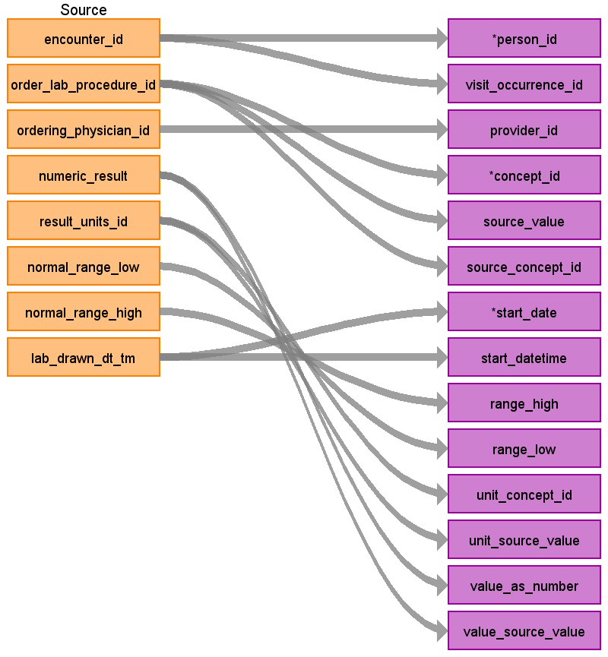

|  |  |  |  |
| --- | --- | --- | --- |
| Destination Field | Source Field | Logic | Comment |
| domain_id |  |  |  |
| person_id | encounter_id | Use encounter_id to find the patient_id in the hf_f_encounter table, then use the patient_id to find the patient_sk in the hf_d_patient table and use the patient_sk as the person_source_value to find the person_id |  |
| visit_occurrence_id | encounter_id | Use encounter_id to find the visit_occurrence_id |  |
| provider_id | ordering_physician_id | Map ordering_physician_id to physician_source_value to find provider_id. If there is no map then set to NULL. |  |
| id |  |  | autogenerated |
| concept_id | order_lab_procedure_id | Use the order_lab_procedure_id to map to hf_d_lab_procedure.lab_procedure_id to find the loinc code associated with the procedure. Then use the source-> standard vocabulary mapping query with the filter:  WHERE SOURCE_VOCABULARY_ID = 'LOINC'  AND TARGET_INVALID_REASON IS NULL  AND TARGET_STANDARD_CONCEPT IS NOT NULL |  |
| source_value | order_lab_procedure_id | Use the order_lab_procedure_id to map to hf_d_lab_procedure.lab_procedure_id to find the loinc code associated with the procedure. |  |
| source_concept_id | order_lab_procedure_id | Use the order_lab_procedure_id to map to hf_d_lab_procedure.lab_procedure_id to find the loinc code associated with the procedure. Then use the source-> source vocabulary mapping query with the filter:  WHERE SOURCE_VOCABULARY_ID = 'LOINC'  AND TARGET_VOCABULARY_ID = 'LOINC' |  |
| type_concept_id |  | 44818702 ‘Lab result’ |  |
| start_date | lab_drawn_dt_tm |  |  |
| start_datetime | lab_drawn_dt_tm |  |  |
| end_date |  |  |  |
| end_datetime |  |  |  |
| days_supply |  |  |  |
| dose_unit_concept_id |  |  |  |
| dose_unit_source_value |  |  |  |
| effective_drug_dose |  |  |  |
| lot_number |  |  |  |
| modifier_concept_id |  |  |  |
| operator_concept_id |  |  |  |
| qualifier_concept_id |  |  |  |
| qualifier_source_value |  |  |  |
| quantity |  |  |  |
| range_high | normal_range_high |  |  |
| range_low | normal_range_low |  |  |
| refills |  |  |  |
| route_concept_id |  |  |  |
| route_source_value |  |  |  |
| sig |  |  |  |
| stop_reason |  |  |  |
| unique_device_id |  |  |  |
| unit_concept_id | hf_d_unit.unit_display | map the result_units_id to unit_id in hf_d_units and then map hf_d_unit.unit_display to a UCUM concept_id using the source->standard query with the filters:  WHERE source_vocabulary_id = 'UCUM'  If there is no map to a UCUM, use the source->standard query with the filter  WHERE source_vocabulary_id = 'JNJ_UNITS' |  |
| unit_source_value | hf_d_unit.unit_display | map the result_units_id to unit_id in hf_d_units and store hf_d_unit.unit_display in this column |  |
| value_as_concept_id |  |  |  |
| value_as_number | numeric_result |  |  |
| value_as_string |  |  |  |
| value_source_value | numeric_result |  |  |
| anatomic_site_concept_id |  |  |  |
| disease_status_concept_id |  |  |  |
| specimen_source_id |  |  |  |
| anatomic_site_source_value |  |  |  |
| disease_status_source_value |  |  |  |

## Reading from hf_f_medication

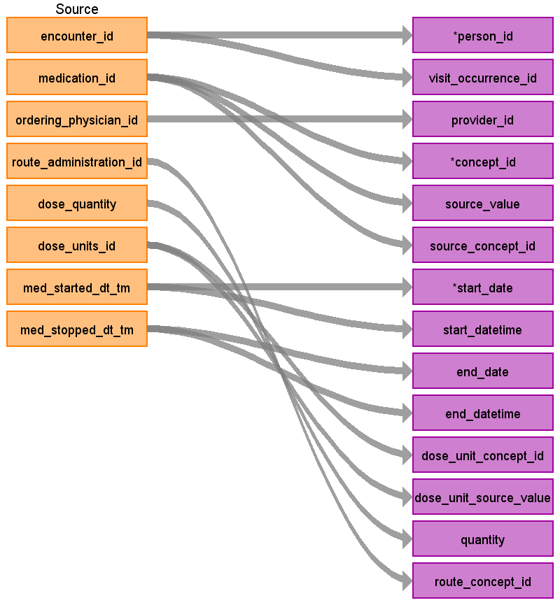

|  |  |  |  |
| --- | --- | --- | --- |
| Destination Field | Source Field | Logic | Comment |
| domain_id |  |  |  |
| person_id | encounter_id |  |  |
| visit_occurrence_id | encounter_id |  |  |
| provider_id | ordering_physician_id | Map ordering_physician_id to physician_source_value to find provider_id. If there is no map then set to NULL. |  |
| id |  |  | autogenerated |
| concept_id | medication_id | Use medication_id to link to hf_d_medication to find ndc_code. Use ndc_code with source->standard query with the filters:  where source_vocabulary_id = 'NDC'  and target_invalid_reason is null  and target_vocabulary_id = 'RxNorm'  and drug_exposure_start_date between valid_start_date - 1 yr and valid_end_date + 1 yr  When mapping DRUG_SOURCE_VALUE to a concept_id, map the 11-digit NDC code to SOURCE_CODE in OMOP vocab first. If no mapping found, map the first 9 digits of NDC code to SOURCE_CODE. If there is still no mapping found, remove leading and trailing zeros from the SOURCE_CODE in OMOP vocab and then try mapping the NDC code |  |
| source_value | medication_id | link to hf_d_medication to find ndc_code. |  |
| source_concept_id | medication_id | link to hf_d_medication to find ndc_code.  Use the source-> source query with the filters:  where source_vocabulary_id = 'NDC'  and target_vocabulary_id = 'NDC'  and drug_exposure_start_date between valid_start_date + 1yr and valid_end_date + 1yr  When mapping DRUG_SOURCE_VALUE to a concept_id, map the 11-digit NDC code to SOURCE_CODE in OMOP vocab first. If no mapping found, map the first 9 digits of NDC code to SOURCE_CODE. If there is still no mapping found, remove leading and trailing zeros from the SOURCE_CODE in OMOP vocab and then try mapping the NDC code |  |
| type_concept_id |  |  | give all drugs the type concept 581373. |
| start_date | med_started_dt_tm |  |  |
| start_datetime | med_started_dt_tm |  |  |
| end_date | med_stopped_dt_tm |  |  |
| end_datetime | med_stopped_dt_tm |  |  |
| days_supply |  |  |  |
| dose_unit_concept_id | dose_units_id | map dose_unit_id to hf_d_unit and then map to a concept_id using the source-> standard query with the filters:  where source_vocabulary_id = 'JNJ_CERNER_UNITS' |  |
| dose_unit_source_value | dose_units_id |  |  |
| effective_drug_dose |  |  |  |
| lot_number |  |  |  |
| modifier_concept_id |  |  |  |
| operator_concept_id |  |  |  |
| qualifier_concept_id |  |  |  |
| qualifier_source_value |  |  |  |
| quantity | dose_quantity |  |  |
| range_high |  |  |  |
| range_low |  |  |  |
| refills |  |  |  |
| route_concept_id | route_administration_id | Use the source -> standard query to map the field route_administration_id using the filter:  Where source_vocabulary_id = ‘JNJ_CERNER_ROUTE_ADM’ |  |
| route_source_value |  |  |  |
| sig |  |  |  |
| stop_reason |  |  |  |
| unique_device_id |  |  |  |
| unit_concept_id |  |  |  |
| unit_source_value |  |  |  |
| value_as_concept_id |  |  |  |
| value_as_number |  |  |  |
| value_as_string |  |  |  |
| value_source_value |  |  |  |
| anatomic_site_concept_id |  |  |  |
| disease_status_concept_id |  |  |  |
| specimen_source_id |  |  |  |
| anatomic_site_source_value |  |  |  |
| disease_status_source_value |  |  |  |

Appendix: source tables

Table: _version

|  |  |  |  |
| --- | --- | --- | --- |
| Field | Type | Most freq. value | Comment |
| version_id | integer | List truncated... |  |
| version_date | date | List truncated... |  |

Table: hf_d_admission_source

|  |  |  |  |
| --- | --- | --- | --- |
| Field | Type | Most freq. value | Comment |
| admission_source_id | smallint | List truncated... |  |
| admission_source_code | character varying | List truncated... |  |
| admission_source_code_desc | character varying | List truncated... |  |

Table: hf_d_admission_type

|  |  |  |  |
| --- | --- | --- | --- |
| Field | Type | Most freq. value | Comment |
| admission_type_id | smallint | List truncated... |  |
| admission_type_code | character varying | List truncated... |  |
| admission_type_code_desc | character varying | List truncated... |  |

Table: hf_d_anesthesia_type

|  |  |  |  |
| --- | --- | --- | --- |
| Field | Type | Most freq. value | Comment |
| anesthesia_type_id | smallint | List truncated... |  |
| anesthesia_type_desc | character varying | List truncated... |  |

Table: hf_d_antimicrobial

|  |  |  |  |
| --- | --- | --- | --- |
| Field | Type | Most freq. value | Comment |
| antimicrobial_id | smallint | List truncated... |  |
| antimicrobial_dcode | character varying |  |  |
| antimicrobial_desc | character varying | List truncated... |  |
| drug_classification | character varying | quinolones |  |
| antibiogram_class | character varying |  |  |
| antimicrobial_mnemonic | character varying |  |  |
| loinc_long | character varying |  |  |
| loinc_short | character varying |  |  |

Table: hf_d_asa_class

|  |  |  |  |
| --- | --- | --- | --- |
| Field | Type | Most freq. value | Comment |
| asa_class_id | smallint | List truncated... |  |
| asa_class_code | character varying | List truncated... |  |
| asa_class_desc | character varying | List truncated... |  |

Table: hf_d_cancel_reason

|  |  |  |  |
| --- | --- | --- | --- |
| Field | Type | Most freq. value | Comment |
| cancel_reason_id | smallint | List truncated... |  |
| cancel_reason_desc | character varying | List truncated... |  |

Table: hf_d_caresetting

|  |  |  |  |
| --- | --- | --- | --- |
| Field | Type | Most freq. value | Comment |
| caresetting_id | smallint | List truncated... |  |
| caresetting_desc | character varying | List truncated... |  |

Table: hf_d_collection_src_site

|  |  |  |  |
| --- | --- | --- | --- |
| Field | Type | Most freq. value | Comment |
| collection_source_site_id | smallint | List truncated... |  |
| snomed_code | character varying |  |  |
| collection_source_site_desc | character varying | List truncated... |  |
| source_type | character varying |  |  |

Table: hf_d_collection_status

|  |  |  |  |
| --- | --- | --- | --- |
| Field | Type | Most freq. value | Comment |
| collection_status_id | smallint | List truncated... |  |
| collection_status_code | integer | List truncated... |  |
| collection_status_desc | character varying | List truncated... |  |

Table: hf_d_compliance_status

|  |  |  |  |
| --- | --- | --- | --- |
| Field | Type | Most freq. value | Comment |
| compliance_status_id | smallint | List truncated... |  |
| compliance_desc | character varying | List truncated... |  |

Table: hf_d_date

|  |  |  |  |
| --- | --- | --- | --- |
| Field | Type | Most freq. value | Comment |
| date_id | double precision | List truncated... |  |
| year | smallint | 2008 |  |
| quarter | smallint | 3 |  |
| month | smallint | 12 |  |
| month_name | character varying | OCT |  |
| day_number_in_month | smallint | 19 |  |
| week_number_in_year | smallint | 35 |  |
| day_of_week | character varying | MONDAY |  |
| day_number_of_week | smallint | 3 |  |
| holiday_ind | smallint | 0 |  |
| weekday_ind | smallint | 1 |  |

Table: hf_d_diagnosis

|  |  |  |  |
| --- | --- | --- | --- |
| Field | Type | Most freq. value | Comment |
| diagnosis_id | integer | List truncated... |  |
| diagnosis_type | character varying | ICD10-CM |  |
| diagnosis_code | character varying | List truncated... |  |
| diagnosis_description | character varying | List truncated... |  |

Table: hf_d_diagnosis_type

|  |  |  |  |
| --- | --- | --- | --- |
| Field | Type | Most freq. value | Comment |
| diagnosis_type_id | smallint | List truncated... |  |
| diagnosis_type_display | character varying | List truncated... |  |

Table: hf_d_diagnostic_grouping

|  |  |  |  |
| --- | --- | --- | --- |
| Field | Type | Most freq. value | Comment |
| diagnostic_grouping_id | smallint | List truncated... |  |
| mdc_code | character varying | 99 |  |
| mdc_code_desc | character varying | Unknown/Invalid |  |
| drg_code | character varying | 999 |  |
| drg_code_desc | character varying | MS Ungroupable |  |
| drg_id | smallint | -1 |  |
| mdc_id | smallint | 99 |  |
| drg_type | character varying | DRG |  |

Table: hf_d_dischg_disp

|  |  |  |  |
| --- | --- | --- | --- |
| Field | Type | Most freq. value | Comment |
| dischg_disp_id | smallint | List truncated... |  |
| dischg_disp_code | integer | List truncated... |  |
| dischg_disp_code_desc | character varying | List truncated... |  |
| beg_effective_dt_tm | timestamp without time zone | 1800-01-01.000000 |  |
| end_effective_dt_tm | timestamp without time zone | 2100-12-31.000000 |  |

Table: hf_d_discontinue_reason

|  |  |  |  |
| --- | --- | --- | --- |
| Field | Type | Most freq. value | Comment |
| discontinue_reason_id | smallint | List truncated... |  |
| discontinue_reason_code | character varying | List truncated... |  |
| discontinue_reason_desc | character varying | List truncated... |  |

Table: hf_d_event_class

|  |  |  |  |
| --- | --- | --- | --- |
| Field | Type | Most freq. value | Comment |
| event_class_id | smallint | List truncated... |  |
| event_class_desc | character varying | List truncated... |  |

Table: hf_d_event_code

|  |  |  |  |
| --- | --- | --- | --- |
| Field | Type | Most freq. value | Comment |
| event_code_id | smallint | List truncated... |  |
| event_code_desc | character varying | List truncated... |  |
| event_code_display | character varying | Braden Scale |  |
| event_code_group | character varying | Blood Gas Test |  |
| event_code_category | character varying | Vital Sign |  |

Table: hf_d_event_reltn

|  |  |  |  |
| --- | --- | --- | --- |
| Field | Type | Most freq. value | Comment |
| event_reltn_id | smallint | List truncated... |  |
| event_reltn_desc | character varying | List truncated... |  |

Table: hf_d_event_source

|  |  |  |  |
| --- | --- | --- | --- |
| Field | Type | Most freq. value | Comment |
| event_source_id | smallint | List truncated... |  |
| event_source_desc | character varying | List truncated... |  |

Table: hf_d_formulary_type

|  |  |  |  |
| --- | --- | --- | --- |
| Field | Type | Most freq. value | Comment |
| formulary_type_id | smallint | List truncated... |  |
| formulary_type_code | character varying | List truncated... |  |
| formulary_type_desc | character varying | List truncated... |  |

Table: hf_d_frequency

|  |  |  |  |
| --- | --- | --- | --- |
| Field | Type | Most freq. value | Comment |
| frequency_id | smallint | List truncated... |  |
| frequency_disp | character varying | List truncated... |  |
| frequency_desc | character varying | List truncated... |  |

Table: hf_d_hospital

|  |  |  |  |
| --- | --- | --- | --- |
| Field | Type | Most freq. value | Comment |
| hospital_id | smallint | List truncated... |  |
| census_region | character varying | South |  |
| census_division | character varying | 6 |  |
| bed_size_range | character varying | <5 |  |
| teaching_facility_ind | smallint | 0 |  |
| cath_lab_full_ind | smallint | 0 |  |
| cath_lab_diagnostic_ind | smallint | 0 |  |
| urban_rural_status | character varying | Urban |  |
| acute_status | character varying | Acute |  |
| alt_hospital_id | smallint |  |  |
| alt_health_system_id | smallint | 79 |  |

Table: hf_d_interp_result

|  |  |  |  |
| --- | --- | --- | --- |
| Field | Type | Most freq. value | Comment |
| interp_result_id | smallint | List truncated... |  |
| interp_result_desc | character varying | List truncated... |  |

Table: hf_d_isolate

|  |  |  |  |
| --- | --- | --- | --- |
| Field | Type | Most freq. value | Comment |
| isolate_id | smallint | List truncated... |  |
| isolate_name | character varying | List truncated... |  |
| isolate_type | character varying | Bacteria |  |
| isolate_category | character varying | Salmonella |  |
| isolate_group | character varying |  |  |
| isolate_rept_category | character varying | Salmonella |  |
| phin_loinc_code | character varying |  |  |
| alt_loinc_code | character varying |  |  |
| snomed_code | character varying |  |  |
| snomedct_code | character varying |  |  |

Table: hf_d_lab_procedure

|  |  |  |  |
| --- | --- | --- | --- |
| Field | Type | Most freq. value | Comment |
| lab_procedure_id | smallint | List truncated... |  |
| lab_procedure_mnemonic | character varying | List truncated... |  |
| lab_procedure_name | character varying | List truncated... |  |
| lab_procedure_group | character varying | Allergy Test |  |
| lab_super_group | character varying | General Test |  |
| loinc_code | character varying |  |  |
| loinc_ind | character varying |  |  |
| loinc_long | character varying |  |  |
| loinc_short | character varying |  |  |

Table: hf_d_lab_result_type

|  |  |  |  |
| --- | --- | --- | --- |
| Field | Type | Most freq. value | Comment |
| lab_result_type_id | smallint | List truncated... |  |
| lab_result_type_desc | character varying | List truncated... |  |

Table: hf_d_manufacturer

|  |  |  |  |
| --- | --- | --- | --- |
| Field | Type | Most freq. value | Comment |
| manufacturer_id | smallint | List truncated... |  |
| manufacturer_name | character varying | List truncated... |  |
| manufacturer_alt_name | character varying |  |  |

Table: hf_d_med_order_status

|  |  |  |  |
| --- | --- | --- | --- |
| Field | Type | Most freq. value | Comment |
| med_order_status_id | double precision | List truncated... |  |
| med_order_status_desc | character varying | List truncated... |  |

Table: hf_d_med_product

|  |  |  |  |
| --- | --- | --- | --- |
| Field | Type | Most freq. value | Comment |
| med_product_id | smallint | List truncated... |  |
| drug_code | character varying | d03770 |  |
| drug_mnemonic_code | character varying | List truncated... |  |
| drug_desc | character varying | emollients, topical |  |
| drug_mnemonic_desc | character varying | List truncated... |  |

Table: hf_d_med_reason

|  |  |  |  |
| --- | --- | --- | --- |
| Field | Type | Most freq. value | Comment |
| med_reason_id | smallint | List truncated... |  |
| med_reason_desc | character varying | List truncated... |  |

Table: hf_d_medication

|  |  |  |  |
| --- | --- | --- | --- |
| Field | Type | Most freq. value | Comment |
| medication_id | integer | List truncated... |  |
| ndc_code | double precision | List truncated... |  |
| brand_name | character varying | Ibuprofen |  |
| generic_name | character varying | ibuprofen |  |
| product_strength_description | character varying |  |  |
| route_description | character varying | oral |  |
| dose_form_description | character varying | tablet |  |
| obsolete_dt_tm | timestamp without time zone |  |  |

Table: hf_d_mic_order_status

|  |  |  |  |
| --- | --- | --- | --- |
| Field | Type | Most freq. value | Comment |
| micro_order_status_id | smallint | List truncated... |  |
| micro_order_status_code | integer | List truncated... |  |
| micro_order_status_desc | character varying | List truncated... |  |

Table: hf_d_micro_result_type

|  |  |  |  |
| --- | --- | --- | --- |
| Field | Type | Most freq. value | Comment |
| micro_result_type_id | smallint | List truncated... |  |
| test_type | character varying | Microbiology |  |
| micro_result_type_code | integer | List truncated... |  |
| micro_result_type_desc | character varying | List truncated... |  |

Table: hf_d_normalcy

|  |  |  |  |
| --- | --- | --- | --- |
| Field | Type | Most freq. value | Comment |
| normalcy_id | smallint | List truncated... |  |
| normalcy_desc | character varying | List truncated... |  |

Table: hf_d_normalcy_method

|  |  |  |  |
| --- | --- | --- | --- |
| Field | Type | Most freq. value | Comment |
| normalcy_method_id | smallint | List truncated... |  |
| normalcy_method_desc | character varying | List truncated... |  |

Table: hf_d_order_stop_type

|  |  |  |  |
| --- | --- | --- | --- |
| Field | Type | Most freq. value | Comment |
| order_stop_type_id | smallint | List truncated... |  |
| order_stop_type_desc | character varying | List truncated... |  |

Table: hf_d_order_type

|  |  |  |  |
| --- | --- | --- | --- |
| Field | Type | Most freq. value | Comment |
| order_type_id | smallint | List truncated... |  |
| order_type_desc | character varying | List truncated... |  |

Table: hf_d_patient

|  |  |  |  |
| --- | --- | --- | --- |
| Field | Type | Most freq. value | Comment |
| patient_id | integer | List truncated... |  |
| patient_sk | character varying | List truncated... |  |
| race | character varying | Caucasian |  |
| gender | character varying | Female |  |
| marital_status | character varying | Single |  |

Table: hf_d_patient_type

|  |  |  |  |
| --- | --- | --- | --- |
| Field | Type | Most freq. value | Comment |
| patient_type_id | smallint | List truncated... |  |
| patient_type_desc | character varying | List truncated... |  |

Table: hf_d_payer

|  |  |  |  |
| --- | --- | --- | --- |
| Field | Type | Most freq. value | Comment |
| payer_id | smallint | List truncated... |  |
| payer_code | character varying | List truncated... |  |
| payer_code_desc | character varying | List truncated... |  |

Table: hf_d_physician

|  |  |  |  |
| --- | --- | --- | --- |
| Field | Type | Most freq. value | Comment |
| physician_id | integer | List truncated... |  |
| medical_specialty | character varying | NULL |  |

Table: hf_d_present_on_admit

|  |  |  |  |
| --- | --- | --- | --- |
| Field | Type | Most freq. value | Comment |
| present_on_admit_id | smallint | List truncated... |  |
| present_on_admit_code | character varying | List truncated... |  |
| present_on_admit_desc | character varying | List truncated... |  |

Table: hf_d_procedure

|  |  |  |  |
| --- | --- | --- | --- |
| Field | Type | Most freq. value | Comment |
| procedure_id | integer | List truncated... |  |
| procedure_type | character varying | ICD10-PCS |  |
| procedure_code | character varying | 043EECA7-F13 |  |
| procedure_description | character varying | CPT |  |

Table: hf_d_procedure_modifier

|  |  |  |  |
| --- | --- | --- | --- |
| Field | Type | Most freq. value | Comment |
| procedure_modifier_id | smallint | List truncated... |  |
| procedure_modifier_desc | character varying | List truncated... |  |

Table: hf_d_reporting_priority

|  |  |  |  |
| --- | --- | --- | --- |
| Field | Type | Most freq. value | Comment |
| reporting_priority_id | smallint | List truncated... |  |
| reporting_priority_code | character varying | List truncated... |  |
| reporting_priority_desc | character varying | List truncated... |  |

Table: hf_d_result_indicator

|  |  |  |  |
| --- | --- | --- | --- |
| Field | Type | Most freq. value | Comment |
| result_indicator_id | smallint | List truncated... |  |
| result_indicator_desc | character varying | List truncated... |  |

Table: hf_d_result_type_proc

|  |  |  |  |
| --- | --- | --- | --- |
| Field | Type | Most freq. value | Comment |
| result_type_proc_id | smallint | List truncated... |  |
| result_type_proc_desc | character varying | List truncated... |  |

Table: hf_d_route_admin

|  |  |  |  |
| --- | --- | --- | --- |
| Field | Type | Most freq. value | Comment |
| route_admin_id | smallint | List truncated... |  |
| route_admin_display | character varying | List truncated... |  |
| route_admin_description | character varying | List truncated... |  |

Table: hf_d_surgical_case_level

|  |  |  |  |
| --- | --- | --- | --- |
| Field | Type | Most freq. value | Comment |
| surgical_case_level_id | smallint | List truncated... |  |
| surgical_case_level_desc | character varying | List truncated... |  |

Table: hf_d_surgical_procedure

|  |  |  |  |
| --- | --- | --- | --- |
| Field | Type | Most freq. value | Comment |
| surgical_procedure_id | smallint | List truncated... |  |
| surgical_procedure_desc | character varying | List truncated... |  |
| order_type | character varying | Surgery |  |
| order_specialty | character varying |  |  |
| anatomic_site | character varying |  |  |
| surgical_procedure_device | character varying |  |  |
| icd9_code | character varying |  |  |
| icd9_desc | character varying |  |  |
| revision_ind | smallint |  |  |

Table: hf_d_surgical_specialty

|  |  |  |  |
| --- | --- | --- | --- |
| Field | Type | Most freq. value | Comment |
| surgical_specialty_id | smallint | List truncated... |  |
| surgical_specialty_desc | character varying | List truncated... |  |

Table: hf_d_test_type

|  |  |  |  |
| --- | --- | --- | --- |
| Field | Type | Most freq. value | Comment |
| test_type_id | smallint | List truncated... |  |
| test_type_mnemonic | character varying | List truncated... |  |
| test_type_desc | character varying | List truncated... |  |

Table: hf_d_unit

|  |  |  |  |
| --- | --- | --- | --- |
| Field | Type | Most freq. value | Comment |
| unit_id | smallint | List truncated... |  |
| unit_display | character varying | List truncated... |  |
| unit_desc | character varying | List truncated... |  |

Table: hf_d_wound_class

|  |  |  |  |
| --- | --- | --- | --- |
| Field | Type | Most freq. value | Comment |
| wound_class_id | smallint | List truncated... |  |
| wound_class_desc | character varying | List truncated... |  |

Table: hf_f_clinical_event

|  |  |  |  |
| --- | --- | --- | --- |
| Field | Type | Most freq. value | Comment |
| encounter_id | bigint | 634785782 |  |
| accession_nbr | character varying |  |  |
| lab_procedure_id | smallint | 23 |  |
| critical_high | character varying |  |  |
| critical_low | character varying |  |  |
| event_code_id | smallint | 226 |  |
| event_class_id | smallint | 15 |  |
| event_end_dt_tm | timestamp without time zone | 2010-02-19 14:44:00.000000 |  |
| event_end_dt_id | integer | 5530 |  |
| event_reltn_id | smallint | 4 |  |
| event_start_dt_tm | timestamp without time zone |  |  |
| event_start_dt_id | integer | 4019 |  |
| event_expiration_dt_tm | timestamp without time zone |  |  |
| event_expiration_dt_id | smallint | 4019 |  |
| event_normalcy_id | smallint | -1 |  |
| event_normalcy_method_id | smallint | -1 |  |
| normal_high | character varying |  |  |
| normal_low | character varying |  |  |
| performed_dt_tm | timestamp without time zone |  |  |
| performed_dt_id | smallint | 4019 |  |
| performed_prsnl_id | integer | -9 |  |
| result_normalcy_flg | smallint | 0 |  |
| result_time_unit_id | smallint | 250 |  |
| result_units_id | smallint | 250 |  |
| result_value_dt_tm | timestamp without time zone |  |  |
| result_value_dt_id | smallint | 4019 |  |
| result_value_num | numeric |  |  |
| result_feasible_ind | smallint | 0 |  |
| result_inaccurate_ind | smallint | 0 |  |
| event_source_id | smallint | -1 |  |
| verified_dt_tm | timestamp without time zone |  |  |
| verified_dt_id | smallint | 4019 |  |
| verified_prsnl_id | integer | -9 |  |
| _extractyear | smallint | 2014 |  |

Table: hf_f_diagnosis

|  |  |  |  |
| --- | --- | --- | --- |
| Field | Type | Most freq. value | Comment |
| encounter_id | bigint | 394231374 |  |
| diagnosis_id | integer | 7278 |  |
| diagnosis_priority | integer | 1 |  |
| diagnosis_type_id | smallint | 83 |  |
| present_on_admit_id | smallint | 6 |  |
| third_party_ind | smallint | 0 |  |
| _extractyear | smallint | 2014 |  |

Table: hf_f_enc_history

|  |  |  |  |
| --- | --- | --- | --- |
| Field | Type | Most freq. value | Comment |
| encounter_id | bigint | 634785782 |  |
| patient_type_id | smallint | 98 |  |
| caresetting_id | smallint | 16 |  |
| begin_dt_tm | timestamp without time zone | 2014-01-08 12:00:00.000000 |  |
| end_dt_tm | timestamp without time zone | 2014-01-08 12:00:00.000000 |  |
| begin_dt_id | smallint | 7739 |  |
| end_dt_id | smallint | 7733 |  |
| estimate_ind | smallint |  |  |
| _extractyear | smallint | 2014 |  |

Table: hf_f_encounter

|  |  |  |  |
| --- | --- | --- | --- |
| Field | Type | Most freq. value | Comment |
| encounter_id | bigint | List truncated... |  |
| hospital_id | smallint | 84 |  |
| admitting_physician_id | integer | -1 |  |
| discharge_caresetting_id | smallint | 16 |  |
| patient_id | integer | List truncated... |  |
| patient_type_id | smallint | 98 |  |
| admitted_dt_id | smallint | 4019 |  |
| discharged_dt_id | smallint | 4019 |  |
| discharge_disposition_id | smallint | 1 |  |
| diagnostic_grouping_id | smallint | 1 |  |
| admission_source_id | smallint | 1 |  |
| admission_type_id | smallint | 3 |  |
| payer_id | smallint | 22 |  |
| age_in_years | smallint |  |  |
| age_in_months | smallint |  |  |
| age_in_weeks | smallint |  |  |
| age_in_days | integer |  |  |
| age_in_hours | integer |  |  |
| total_charges | numeric | 0.000000 |  |
| billing_ind | smallint | 1 |  |
| weight | double precision |  |  |
| weight_unit_id | character varying | 250 |  |
| admitted_dt_tm | timestamp without time zone |  |  |
| discharged_dt_tm | timestamp without time zone | 2014-01-08.000000 |  |
| admitted_tm_valid_ind | smallint | 1 |  |
| discharged_tm_valid_ind | smallint | 1 |  |
| _extractyear | smallint | 2014 |  |

Table: hf_f_implant_log

|  |  |  |  |
| --- | --- | --- | --- |
| Field | Type | Most freq. value | Comment |
| manufacturer_id | smallint | -9 |  |
| expiration_dt_tm | timestamp without time zone |  |  |
| expiration_dt_id | smallint | 4019 |  |
| surgical_case_id | integer | 6021842 |  |
| encounter_id | bigint | 360742999 |  |
| _extractyear | smallint | 2016 |  |

Table: hf_f_lab_procedure

|  |  |  |  |
| --- | --- | --- | --- |
| Field | Type | Most freq. value | Comment |
| encounter_id | bigint | 634818267 |  |
| detail_lab_procedure_id | smallint | 13 |  |
| order_lab_procedure_id | smallint | 526 |  |
| ordering_physician_id | integer |  |  |
| lab_order_caresetting_id | smallint | 16 |  |
| reporting_priority_id | smallint | 1 |  |
| lab_result_type_id | smallint | 7 |  |
| result_indicator_id | smallint | 8 |  |
| lab_ordered_dt_id | smallint | 4019 |  |
| lab_drawn_dt_id | smallint | 4019 |  |
| lab_received_dt_id | smallint | 4019 |  |
| lab_completed_dt_id | smallint | 4019 |  |
| lab_cancelled_dt_id | smallint | 4019 |  |
| lab_performed_dt_id | smallint |  |  |
| lab_verified_dt_id | smallint | 4019 |  |
| accession | character varying |  |  |
| date_result_id | numeric | 4019.000000 |  |
| numeric_result | numeric |  |  |
| result_units_id | double precision | 250.0 |  |
| normal_range_low | character varying |  |  |
| normal_range_high | character varying |  |  |
| lab_ordered_dt_tm | timestamp without time zone |  |  |
| lab_drawn_dt_tm | timestamp without time zone |  |  |
| lab_received_dt_tm | timestamp without time zone |  |  |
| lab_completed_dt_tm | timestamp without time zone |  |  |
| lab_cancelled_dt_tm | timestamp without time zone |  |  |
| lab_performed_dt_tm | timestamp without time zone |  |  |
| lab_verified_dt_tm | timestamp without time zone |  |  |
| lab_ordered_tm_vld_flg | smallint | 1 |  |
| lab_drawn_tm_vld_flg | smallint | 1 |  |
| lab_received_tm_vld_flg | smallint | 1 |  |
| lab_completed_tm_vld_flg | smallint | 1 |  |
| lab_cancelled_tm_vld_flg | smallint | 0 |  |
| lab_verified_tm_vld_flg | smallint | 1 |  |
| lab_performed_tm_vld_flg | smallint | 1 |  |
| lab_performed_caresetting_id | smallint | 174 |  |
| collection_source_id | smallint | 522 |  |
| collection_method_id | smallint |  |  |
| _extractyear | smallint |  |  |

Table: hf_f_med_history

|  |  |  |  |
| --- | --- | --- | --- |
| Field | Type | Most freq. value | Comment |
| encounter_id | bigint | 634785782 |  |
| ordering_physician_id | integer | -1 |  |
| med_history_flg | smallint | 1 |  |
| req_start_dt_tm | timestamp without time zone |  |  |
| req_start_dt_id | smallint | 4019 |  |
| req_start_tm_vld_flg | smallint |  |  |
| prn_ind | smallint |  |  |
| route_administration_id | smallint | 57 |  |
| order_stop_type_id | smallint | 4 |  |
| med_stopped_dt_tm | timestamp without time zone |  |  |
| med_stopped_dt_id | smallint | 4019 |  |
| med_stopped_tm_vld_flg | smallint |  |  |
| frequency_id | smallint | 111 |  |
| collected_ind | smallint |  |  |
| order_strength | double precision |  |  |
| order_strength_units_id | smallint | 250 |  |
| order_volume | double precision |  |  |
| order_volume_units_id | smallint | 250 |  |
| total_dispensed_doses | double precision |  |  |
| duration | integer |  |  |
| duration_unit_id | smallint | 250 |  |
| next_dose_dt_tm | timestamp without time zone |  |  |
| next_dose_dt_id | smallint | 4019 |  |
| next_dose_tm_vld_flg | smallint |  |  |
| infusion_rate | double precision |  |  |
| infusion_rate_units_id | smallint | 250 |  |
| med_reason_id | smallint | -1 |  |
| cancel_reason_id | smallint | -1 |  |
| dispensed_quantity | bigint |  |  |
| dispensed_quantity_units_id | smallint | 250 |  |
| compliance_status_id | smallint | -1 |  |
| med_entered_dt_tm | timestamp without time zone | 2015-05-15 08:37:00.000000 |  |
| med_entered_dt_id | smallint | 7137 |  |
| med_entered_tm_vld_flg | smallint | 1 |  |
| med_product_id | smallint | 791 |  |
| _extractyear | smallint | 2014 |  |

Table: hf_f_medication

|  |  |  |  |
| --- | --- | --- | --- |
| Field | Type | Most freq. value | Comment |
| encounter_id | bigint | 120885265 |  |
| medication_id | integer | 14883 |  |
| ordering_physician_id | integer |  |  |
| med_dispensed_caresetting_id | smallint | 174 |  |
| med_request_caresetting_id | smallint | 174 |  |
| discontinue_reason_id | smallint | 1 |  |
| route_administration_id | smallint | 56 |  |
| formulary_type_id | smallint | 1 |  |
| frequency_id | smallint | 110 |  |
| order_stop_type_id | smallint | 2 |  |
| order_type_id | smallint | 4 |  |
| med_order_status_id | smallint | 4 |  |
| med_started_dt_id | smallint | 7118 |  |
| med_entered_dt_id | smallint | 7118 |  |
| med_stopped_dt_id | smallint | 4019 |  |
| med_discontinued_dt_id | smallint | 4019 |  |
| order_no | character varying | List truncated... |  |
| total_dispensed_doses | double precision | 0.0 |  |
| dose_quantity | double precision | 1.0 |  |
| initial_dose_quantity | double precision | 0.0 |  |
| dose_units_id | smallint | 39 |  |
| charge_quantity | double precision | 0.0 |  |
| credit_quantity | double precision | 0.0 |  |
| infusion_rate | double precision | 0.0 |  |
| infusion_time | double precision |  |  |
| infusion_time_units_id | smallint | 250 |  |
| order_strength | double precision |  |  |
| order_strength_units_id | smallint | 174 |  |
| order_volume | double precision | 1.0 |  |
| order_volume_units_id | smallint | 162 |  |
| total_volume | double precision |  |  |
| unit_cost | double precision |  |  |
| unit_price | double precision |  |  |
| med_started_dt_tm | timestamp without time zone | 2011-05-22 08:42:00.000000 |  |
| med_entered_dt_tm | timestamp without time zone | List truncated... |  |
| med_stopped_dt_tm | timestamp without time zone |  |  |
| med_discontinued_dt_tm | timestamp without time zone |  |  |
| med_started_tm_valid_flg | smallint | 1 |  |
| med_entered_tm_valid_flg | smallint | 1 |  |
| med_stopped_tm_valid_flg | smallint | 1 |  |
| med_discontinued_tm_valid_flg | smallint | 1 |  |
| _extractyear | smallint | 2014 |  |

Table: hf_f_micro_susceptibility

|  |  |  |  |
| --- | --- | --- | --- |
| Field | Type | Most freq. value | Comment |
| encounter_id | bigint | 252004367 |  |
| order_lab_procedure_id | smallint | 337 |  |
| test_type_id | smallint | 1 |  |
| isolate_id | smallint | 2211 |  |
| antimicrobial_id | smallint | 87 |  |
| interp_result_id | smallint | 8 |  |
| interp_perf_dt_id | smallint | 4019 |  |
| interp_perf_dt_tm | timestamp without time zone |  |  |
| interp_perf_tm_vld_flg | smallint | 0 |  |
| interp_verf_dt_id | smallint | 4019 |  |
| interp_verf_dt_tm | timestamp without time zone |  |  |
| interp_verf_tm_vld_flg | smallint | 1 |  |
| accession | character varying | List truncated... |  |
| numeric_result | character varying | 0 |  |
| numeric_result_perf_dt_id | smallint | 4019 |  |
| numeric_result_perf_dt_tm | timestamp without time zone |  |  |
| numeric_result_perf_tm_vld_flg | smallint | 0 |  |
| numeric_result_verf_dt_id | smallint | 4019 |  |
| numeric_result_verf_dt_tm | timestamp without time zone |  |  |
| numeric_result_verf_tm_vld_flg | smallint | 1 |  |
| result_units_id | smallint | 250 |  |
| collection_source_id | smallint | 411 |  |
| collection_site_id | smallint | 522 |  |
| collection_method_id | smallint |  |  |
| _extractyear | smallint | 2014 |  |

Table: hf_f_microbiology

|  |  |  |  |
| --- | --- | --- | --- |
| Field | Type | Most freq. value | Comment |
| encounter_id | bigint | 559056352 |  |
| order_lab_procedure_id | smallint | 76 |  |
| isolate_id | smallint | 2521 |  |
| ordering_physician_id | integer |  |  |
| micro_order_caresetting_id | smallint | 25 |  |
| micro_result_type_id | smallint | 2 |  |
| result_type_procedure_id | smallint | 24 |  |
| collection_source_id | smallint | 29 |  |
| collection_site_id | smallint | 522 |  |
| reporting_priority_id | smallint | 1 |  |
| micro_order_status_id | smallint | 3 |  |
| collection_status_id | smallint | 14 |  |
| micro_lab_ordered_dt_id | smallint | 6871 |  |
| micro_lab_drawn_dt_id | smallint | 4019 |  |
| micro_lab_received_dt_id | smallint | 4019 |  |
| micro_lab_completed_dt_id | smallint | 4019 |  |
| micro_lab_cancelled_dt_id | smallint | 4019 |  |
| first_report_entered_dt_id | smallint | 4019 |  |
| last_report_updated_dt_id | smallint | 4019 |  |
| accession | character varying |  |  |
| false_positive_ind | smallint |  |  |
| total_report_updates | smallint | 1 |  |
| micro_lab_ordered_dt_tm | timestamp without time zone |  |  |
| micro_lab_drawn_dt_tm | timestamp without time zone |  |  |
| micro_lab_received_dt_tm | timestamp without time zone |  |  |
| micro_lab_completed_dt_tm | timestamp without time zone |  |  |
| micro_lab_cancelled_dt_tm | timestamp without time zone |  |  |
| first_report_entered_dt_tm | timestamp without time zone |  |  |
| last_report_updated_dt_tm | timestamp without time zone |  |  |
| micro_lab_ordered_tm_vld_flg | smallint |  |  |
| micro_lab_drawn_tm_vld_flg | smallint | 1 |  |
| micro_lab_received_tm_vld_flg | smallint | 1 |  |
| micro_lab_complted_tm_vld_flg | smallint | 1 |  |
| micro_lab_cancelled_tm_vld_flg | smallint | 1 |  |
| first_rpt_entered_tm_vld_flg | smallint | 0 |  |
| last_rpt_updated_tm_vld_flg | smallint |  |  |
| collection_method_id | smallint |  |  |
| _extractyear | smallint | 2013 |  |

Table: hf_f_procedure

|  |  |  |  |
| --- | --- | --- | --- |
| Field | Type | Most freq. value | Comment |
| encounter_id | bigint | 552264616 |  |
| procedure_id | integer | 2616 |  |
| procedure_dt_id | smallint | 4019 |  |
| procedure_dt_tm | timestamp without time zone |  |  |
| procedure_priority | integer | 1 |  |
| third_party_ind | smallint | 0 |  |
| _extractyear | smallint | 2014 |  |

Table: hf_f_surgical_case

|  |  |  |  |
| --- | --- | --- | --- |
| Field | Type | Most freq. value | Comment |
| surgical_case_id | integer | List truncated... |  |
| encounter_id | bigint | 411950461 |  |
| case_level_id | smallint | -9 |  |
| case_start_dt_tm | timestamp without time zone |  |  |
| case_stop_dt_tm | timestamp without time zone |  |  |
| case_start_dt_id | smallint | 4019 |  |
| case_stop_dt_id | smallint | 4019 |  |
| case_duration | bigint | 10 |  |
| scheduled_case_start_dt_tm | timestamp without time zone |  |  |
| scheduled_case_stop_dt_tm | timestamp without time zone |  |  |
| scheduled_case_start_dt_id | smallint | 4019 |  |
| scheduled_case_stop_dt_id | smallint | 4019 |  |
| scheduled_case_duration | smallint | 60 |  |
| case_specialty_id | smallint | -9 |  |
| case_completed_ind | smallint | 1 |  |
| case_cancelled_dt_tm | timestamp without time zone |  |  |
| case_cancelled_dt_id | smallint | 4019 |  |
| case_cancelled_reason_id | smallint | -1 |  |
| case_closing_start_dt_tm | timestamp without time zone |  |  |
| case_closing_start_dt_id | smallint | 4019 |  |
| transport_requested_dt_tm | timestamp without time zone |  |  |
| transport_requested_dt_id | smallint | 4019 |  |
| operating_room_setup_dt_tm | timestamp without time zone |  |  |
| operating_room_ready_dt_tm | timestamp without time zone |  |  |
| operating_room_setup_dt_id | smallint | 4019 |  |
| operating_room_ready_dt_id | smallint | 4019 |  |
| patient_in_preop_hold_dt_tm | timestamp without time zone |  |  |
| patient_out_preop_hold_dt_tm | timestamp without time zone |  |  |
| patient_in_preop_hold_dt_id | smallint | 4019 |  |
| patient_out_preop_hold_dt_id | smallint | 4019 |  |
| preop_antibiotic_admin_dt_tm | timestamp without time zone |  |  |
| preop_antibiotic_admin_dt_id | smallint | 4019 |  |
| patient_in_oper_room_dt_tm | timestamp without time zone |  |  |
| patient_out_oper_room_dt_tm | timestamp without time zone |  |  |
| patient_out_oper_room_dt_id | smallint | 4019 |  |
| anesthesia_start_dt_tm | timestamp without time zone |  |  |
| anesthesia_induct_dt_tm | timestamp without time zone |  |  |
| anesthesia_stop_dt_tm | timestamp without time zone |  |  |
| anesthesia_start_dt_id | smallint | 4019 |  |
| anesthesia_induct_dt_id | smallint | 4019 |  |
| anesthesia_stop_dt_id | smallint | 4019 |  |
| anesthesia_induct_stop_duratn | integer |  |  |
| surgeon_in_oper_room_dt_tm | timestamp without time zone |  |  |
| surgeon_in_oper_room_dt_id | smallint | 4019 |  |
| patient_in_pacu_dt_tm | timestamp without time zone |  |  |
| patient_out_pacu_dt_tm | timestamp without time zone |  |  |
| patient_in_pacu_ii_dt_tm | timestamp without time zone |  |  |
| patient_out_pacu_ii_dt_tm | timestamp without time zone |  |  |
| patient_in_pacu_dt_id | smallint | 4019 |  |
| patient_out_pacu_dt_id | smallint | 4019 |  |
| patient_in_pacu_ii_dt_id | smallint | 4019 |  |
| patient_out_pacu_ii_dt_id | smallint | 4019 |  |
| patient_in_oper_room_dt_id | smallint | 4019 |  |
| _extractyear | smallint | 2013 |  |

Table: hf_f_surgical_procedure

|  |  |  |  |
| --- | --- | --- | --- |
| Field | Type | Most freq. value | Comment |
| encounter_id | bigint | 287078471 |  |
| surgical_case_id | integer | List truncated... |  |
| surgical_procedure_id | smallint | -9 |  |
| wound_class_id | smallint | 2 |  |
| asa_class_id | smallint | 3 |  |
| procedure_specialty_id | smallint | 17 |  |
| procedure_revision_ind | smallint | 0 |  |
| procedure_modifier_01_id | smallint | -1 |  |
| procedure_modifier_02_id | smallint | -1 |  |
| procedure_modifier_03_id | smallint | -1 |  |
| procedure_duration | integer | 10 |  |
| procedure_start_dt_tm | timestamp without time zone | 2012-08-17 13:03:00.000000 |  |
| procedure_stop_dt_tm | timestamp without time zone |  |  |
| procedure_start_dt_id | smallint | 7257 |  |
| procedure_stop_dt_id | smallint | 7257 |  |
| primary_procedure_ind | smallint | 1 |  |
| scheduled_procedure_duration | smallint | 0 |  |
| procedure_completion_ind | smallint | 1 |  |
| concurrent_procedure_ind | smallint | 0 |  |
| anesthesia_type_id | smallint | 7 |  |
| expected_case_level_id | smallint | -1 |  |
| case_level_id | smallint | 9 |  |
| _extractyear | smallint | 2014 |  |

Table: stem_table

|  |  |  |  |
| --- | --- | --- | --- |
| Field | Type | Most freq. value | Comment |
| domain_id | CHARACTER VARYING |  |  |
| person_id | INTEGER |  |  |
| visit_occurrence_id | INTEGER |  |  |
| provider_id | INTEGER |  |  |
| id | INTEGER |  | autogenerated |
| concept_id | INTEGER |  |  |
| source_value | CHARACTER VARYING |  |  |
| source_concept_id | INTEGER |  |  |
| type_concept_id | INTEGER |  | give all drugs the type concept 581373. |
| start_date | DATE |  |  |
| start_datetime | DATETIME |  |  |
| end_date | DATE |  |  |
| end_datetime | DATETIME |  |  |
| days_supply | INTEGER |  |  |
| dose_unit_concept_id | INTEGER |  |  |
| dose_unit_source_value | CHARACTER VARYING |  |  |
| effective_drug_dose | FLOAT |  |  |
| lot_number | CHARACTER VARYING |  |  |
| modifier_concept_id | INTEGER |  |  |
| operator_concept_id | INTEGER |  |  |
| qualifier_concept_id | INTEGER |  |  |
| qualifier_source_value | CHARACTER VARYING |  |  |
| quantity | INTEGER |  |  |
| range_high | FLOAT |  |  |
| range_low | FLOAT |  |  |
| refills | INTEGER |  |  |
| route_concept_id | INTEGER |  |  |
| route_source_value | CHARACTER VARYING |  |  |
| sig | CHARACTER VARYING |  |  |
| stop_reason | CHARACTER VARYING |  |  |
| unique_device_id | CHARACTER VARYING |  |  |
| unit_concept_id | INTEGER |  |  |
| unit_source_value | CHARACTER VARYING |  |  |
| value_as_concept_id | INTEGER |  |  |
| value_as_number | DECIMAL |  |  |
| value_as_string | CHARACTER VARYING |  |  |
| value_source_value | CHARACTER VARYING |  |  |
| anatomic_site_concept_id | INTEGER |  |  |
| disease_status_concept_id | INTEGER |  |  |
| specimen_source_id | INTEGER |  |  |
| anatomic_site_source_value | CHARACTER VARYING |  |  |
| disease_status_source_value | CHARACTER VARYING |  |  |