Source Data Mapping Approach to CDMV5.0.1

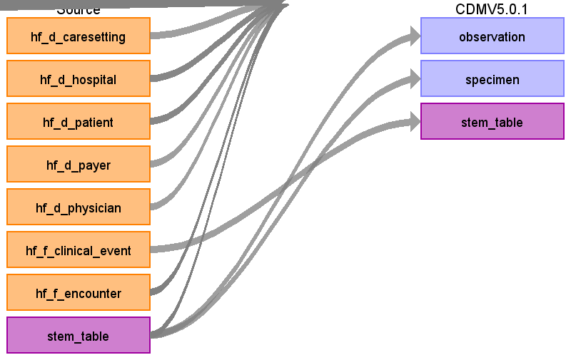

Table name: location

Table name: person

Table name: observation_period

Table name: care_site

Table name: visit_occurrence

Table name: provider

Table name: condition_occurrence

Table name: death

Table name: drug_exposure

Table name: device_exposure

Table name: procedure_occurrence

Table name: measurement

Table name: observation

Reading from stem_table

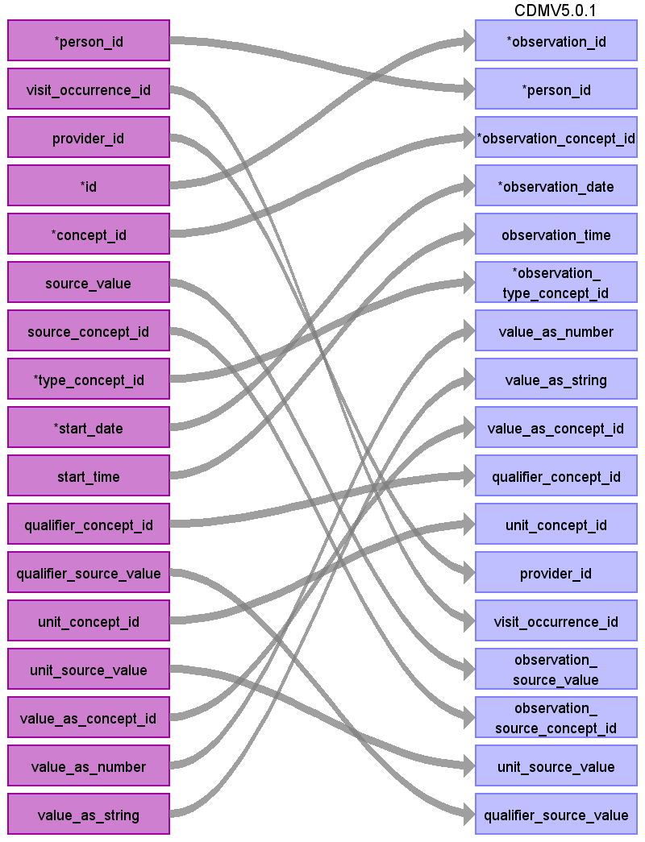

|  |  |  |  |
| --- | --- | --- | --- |
| Destination Field | Source Field | Logic | Comment |
| observation_id | id |  |  |
| person_id | person_id |  |  |
| observation_concept_id | concept_id |  |  |
| observation_date | start_date |  |  |
| observation_time | start_time |  |  |
| observation_type_concept_id | type_concept_id |  |  |
| value_as_number | value_as_number |  |  |
| value_as_string | value_as_string |  |  |
| value_as_concept_id | value_as_concept_id |  |  |
| qualifier_concept_id | qualifier_concept_id |  |  |
| unit_concept_id | unit_concept_id |  |  |
| provider_id | provider_id |  |  |
| visit_occurrence_id | visit_occurrence_id |  |  |
| observation_source_value | source_value |  |  |
| observation_source_concept_id | source_concept_id |  |  |
| unit_source_value | unit_source_value |  |  |
| qualifier_source_value | qualifier_source_value |  |  |

Table name: note

Table name: specimen

Reading from stem_table

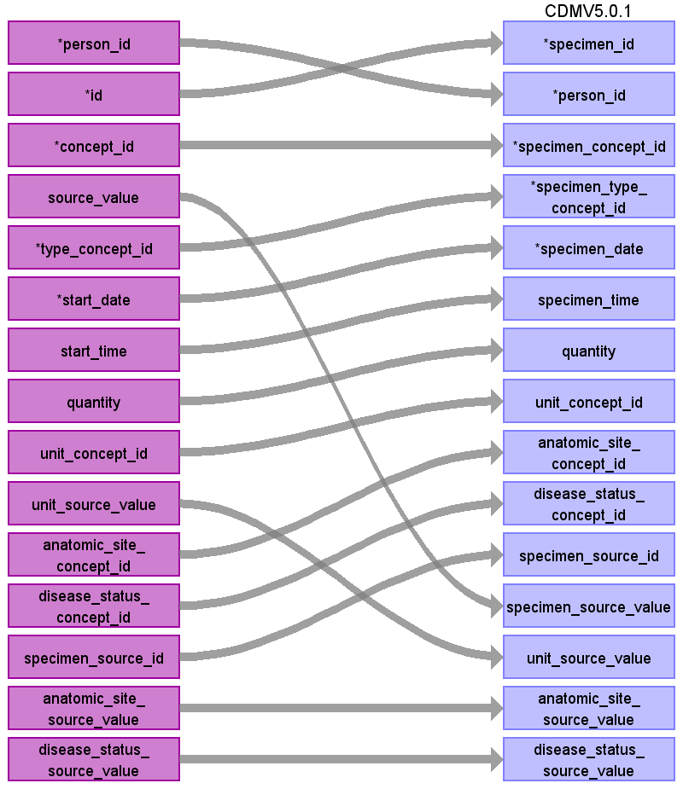

|  |  |  |  |
| --- | --- | --- | --- |
| Destination Field | Source Field | Logic | Comment |
| specimen_id | id |  |  |
| person_id | person_id |  |  |
| specimen_concept_id | concept_id |  |  |
| specimen_type_concept_id | type_concept_id |  |  |
| specimen_date | start_date |  |  |
| specimen_time | start_time |  |  |
| quantity | quantity |  |  |
| unit_concept_id | unit_concept_id |  |  |
| anatomic_site_concept_id | anatomic_site_concept_id |  |  |
| disease_status_concept_id | disease_status_concept_id |  |  |
| specimen_source_id | specimen_source_id |  |  |
| specimen_source_value | source_value |  |  |
| unit_source_value | unit_source_value |  |  |
| anatomic_site_source_value | anatomic_site_source_value |  |  |
| disease_status_source_value | disease_status_source_value |  |  |

Table name: fact_relationship

Table name: payer_plan_period

Table name: drug_era

Table name: dose_era

Table name: condition_era

Table name: cdm_source

Table name: cohort

Table name: cohort_definition

Table name: cohort_attribute

Table name: attribute_definition

Table name: cost

Table name: stem_table

Reading from hf_f_clinical_event

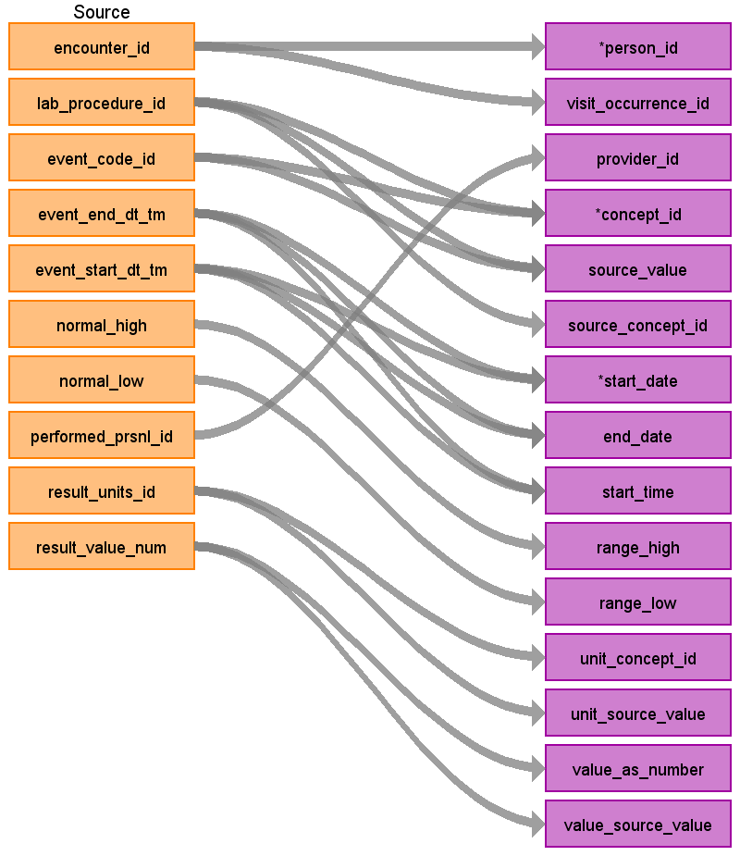

|  |  |  |  |
| --- | --- | --- | --- |
| Destination Field | Source Field | Logic | Comment |
| domain_id |  |  |  |
| person_id | encounter_id | Use encounter_id to find the patient_id in the hf_f_encounter table, then use the patient_id to find the patient_sk in the hf_d_patient table and use the patient_sk as the person_source_value to find the person_id |  |
| visit_occurrence_id | encounter_id | Use encounter_id to find the visit_occurrence_id |  |
| provider_id | performed_prsnl_id | map performed_prsnl_id to provider_source_value to find provider_id |  |
| id |  |  | autogenerate |
| concept_id | event_code_id  lab_procedure_id | First, map lab_procedure_id to loinc_code using the hf_d_lab_procedure table. If there is a loinc_code available, map that code to a standard concept using the source->standard vocabulary query and store that standard concept in the concept_id value. If there is no loinc code, use the event_code_id to map a standard concept using the source->standard vocabulary query.  First, map lab_procedure_id to loinc_code using the hf_d_lab_procedure table. If there is a loinc_code available, map that code to a standard concept using the source->standard vocabulary query and store that standard concept in the concept_id value. If there is no loinc code, use the event_code_id to map a standard concept using the source->standard vocabulary query. |  |
| source_value | lab_procedure_id  event_code_id | If the lab_procedure_id was used to find a loinc code to map concept_id, map lab_procedure_id to the lab_procedure_name in the hf_d_lab_procedure table and store that in the source_value field.  If the event_code_id was used to map concept_id, map event_code_id to event_code_desc in the hf_d_event_code and store event_code_desc in the source_value field |  |
| source_concept_id | lab_procedure_id | If a loinc code was used to map to a standard concept as the concept_id, store the source_concept_id of the loinc code here. Otherwise, if the event_code_id was used to map the concept_id store a 0 in this field. |  |
| type_concept_id |  |  |  |
| start_date | event_start_dt_tm  event_end_dt_tm | If event_start_dt_tm is not available, store event_end_dt_tm as start_date. Otherwise store event_start_dt_tm as start_date |  |
| end_date | event_end_dt_tm  event_start_dt_tm | If event_end_dt_tm is not available, store event_start_dt_tm as end_date. Otherwise store event_end_dt_tm as end_date. |  |
| start_time | event_start_dt_tm  event_end_dt_tm | If event_start_dt_tm is not available, store event_end_dt_tm as start_date. Otherwise store event_start_dt_tm as start_date |  |
| days_supply |  |  |  |
| dose_unit_concept_id |  |  |  |
| dose_unit_source_value |  |  |  |
| effective_drug_dose |  |  |  |
| lot_number |  |  |  |
| modifier_concept_id |  |  |  |
| operator_concept_id |  |  |  |
| qualifier_concept_id |  |  |  |
| qualifier_source_value |  |  |  |
| quantity |  |  |  |
| range_high | normal_high |  |  |
| range_low | normal_low |  |  |
| refills |  |  |  |
| route_concept_id |  |  |  |
| route_source_value |  |  |  |
| sig |  |  |  |
| stop_reason |  |  |  |
| unique_device_id |  |  |  |
| unit_concept_id | result_units_id | map result_units_id to a concept_id using the source -> standard query |  |
| unit_source_value | result_units_id | map result_units_id to unit_id in hf_d_unit and store unit_desc as unit_source_value |  |
| value_as_concept_id |  |  |  |
| value_as_number | result_value_num |  |  |
| value_as_string |  |  |  |
| value_source_value | result_value_num |  |  |
| anatomic_site_concept_id |  |  |  |
| disease_status_concept_id |  |  |  |
| specimen_source_id |  |  |  |
| anatomic_site_source_value |  |  |  |
| disease_status_source_value |  |  |  |

Appendix: source tables

Table: _version

|  |  |  |  |
| --- | --- | --- | --- |
| Field | Type | Most freq. value | Comment |
| version_id | integer | List truncated... |  |
| version_date | date | List truncated... |  |

Table: hf_d_admission_source

|  |  |  |  |
| --- | --- | --- | --- |
| Field | Type | Most freq. value | Comment |
| admission_source_id | smallint | List truncated... |  |
| admission_source_code | character varying | List truncated... |  |
| admission_source_code_desc | character varying | List truncated... |  |

Table: hf_d_admission_type

|  |  |  |  |
| --- | --- | --- | --- |
| Field | Type | Most freq. value | Comment |
| admission_type_id | smallint | List truncated... |  |
| admission_type_code | character varying | List truncated... |  |
| admission_type_code_desc | character varying | List truncated... |  |

Table: hf_d_anesthesia_type

|  |  |  |  |
| --- | --- | --- | --- |
| Field | Type | Most freq. value | Comment |
| anesthesia_type_id | smallint | List truncated... |  |
| anesthesia_type_desc | character varying | List truncated... |  |

Table: hf_d_antimicrobial

|  |  |  |  |
| --- | --- | --- | --- |
| Field | Type | Most freq. value | Comment |
| antimicrobial_id | smallint | List truncated... |  |
| antimicrobial_dcode | character varying |  |  |
| antimicrobial_desc | character varying | List truncated... |  |
| drug_classification | character varying | quinolones |  |
| antibiogram_class | character varying |  |  |
| antimicrobial_mnemonic | character varying |  |  |
| loinc_long | character varying |  |  |
| loinc_short | character varying |  |  |

Table: hf_d_asa_class

|  |  |  |  |
| --- | --- | --- | --- |
| Field | Type | Most freq. value | Comment |
| asa_class_id | smallint | List truncated... |  |
| asa_class_code | character varying | List truncated... |  |
| asa_class_desc | character varying | List truncated... |  |

Table: hf_d_cancel_reason

|  |  |  |  |
| --- | --- | --- | --- |
| Field | Type | Most freq. value | Comment |
| cancel_reason_id | smallint | List truncated... |  |
| cancel_reason_desc | character varying | List truncated... |  |

Table: hf_d_caresetting

|  |  |  |  |
| --- | --- | --- | --- |
| Field | Type | Most freq. value | Comment |
| caresetting_id | smallint | List truncated... |  |
| caresetting_desc | character varying | List truncated... |  |

Table: hf_d_collection_src_site

|  |  |  |  |
| --- | --- | --- | --- |
| Field | Type | Most freq. value | Comment |
| collection_source_site_id | smallint | List truncated... |  |
| snomed_code | character varying |  |  |
| collection_source_site_desc | character varying | List truncated... |  |
| source_type | character varying |  |  |

Table: hf_d_collection_status

|  |  |  |  |
| --- | --- | --- | --- |
| Field | Type | Most freq. value | Comment |
| collection_status_id | smallint | List truncated... |  |
| collection_status_code | integer | List truncated... |  |
| collection_status_desc | character varying | List truncated... |  |

Table: hf_d_compliance_status

|  |  |  |  |
| --- | --- | --- | --- |
| Field | Type | Most freq. value | Comment |
| compliance_status_id | smallint | List truncated... |  |
| compliance_desc | character varying | List truncated... |  |

Table: hf_d_date

|  |  |  |  |
| --- | --- | --- | --- |
| Field | Type | Most freq. value | Comment |
| date_id | double precision | List truncated... |  |
| year | smallint | 2008 |  |
| quarter | smallint | 3 |  |
| month | smallint | 12 |  |
| month_name | character varying | OCT |  |
| day_number_in_month | smallint | 19 |  |
| week_number_in_year | smallint | 35 |  |
| day_of_week | character varying | MONDAY |  |
| day_number_of_week | smallint | 3 |  |
| holiday_ind | smallint | 0 |  |
| weekday_ind | smallint | 1 |  |

Table: hf_d_diagnosis

|  |  |  |  |
| --- | --- | --- | --- |
| Field | Type | Most freq. value | Comment |
| diagnosis_id | integer | List truncated... |  |
| diagnosis_type | character varying | ICD10-CM |  |
| diagnosis_code | character varying | List truncated... |  |
| diagnosis_description | character varying | List truncated... |  |

Table: hf_d_diagnosis_type

|  |  |  |  |
| --- | --- | --- | --- |
| Field | Type | Most freq. value | Comment |
| diagnosis_type_id | smallint | List truncated... |  |
| diagnosis_type_display | character varying | List truncated... |  |

Table: hf_d_diagnostic_grouping

|  |  |  |  |
| --- | --- | --- | --- |
| Field | Type | Most freq. value | Comment |
| diagnostic_grouping_id | smallint | List truncated... |  |
| mdc_code | character varying | 99 |  |
| mdc_code_desc | character varying | Unknown/Invalid |  |
| drg_code | character varying | 999 |  |
| drg_code_desc | character varying | MS Ungroupable |  |
| drg_id | smallint | -1 |  |
| mdc_id | smallint | 99 |  |
| drg_type | character varying | DRG |  |

Table: hf_d_dischg_disp

|  |  |  |  |
| --- | --- | --- | --- |
| Field | Type | Most freq. value | Comment |
| dischg_disp_id | smallint | List truncated... |  |
| dischg_disp_code | integer | List truncated... |  |
| dischg_disp_code_desc | character varying | List truncated... |  |
| beg_effective_dt_tm | timestamp without time zone | 1800-01-01.000000 |  |
| end_effective_dt_tm | timestamp without time zone | 2100-12-31.000000 |  |

Table: hf_d_discontinue_reason

|  |  |  |  |
| --- | --- | --- | --- |
| Field | Type | Most freq. value | Comment |
| discontinue_reason_id | smallint | List truncated... |  |
| discontinue_reason_code | character varying | List truncated... |  |
| discontinue_reason_desc | character varying | List truncated... |  |

Table: hf_d_event_class

|  |  |  |  |
| --- | --- | --- | --- |
| Field | Type | Most freq. value | Comment |
| event_class_id | smallint | List truncated... |  |
| event_class_desc | character varying | List truncated... |  |

Table: hf_d_event_code

|  |  |  |  |
| --- | --- | --- | --- |
| Field | Type | Most freq. value | Comment |
| event_code_id | smallint | List truncated... |  |
| event_code_desc | character varying | List truncated... |  |
| event_code_display | character varying | Braden Scale |  |
| event_code_group | character varying | Blood Gas Test |  |
| event_code_category | character varying | Vital Sign |  |

Table: hf_d_event_reltn

|  |  |  |  |
| --- | --- | --- | --- |
| Field | Type | Most freq. value | Comment |
| event_reltn_id | smallint | List truncated... |  |
| event_reltn_desc | character varying | List truncated... |  |

Table: hf_d_event_source

|  |  |  |  |
| --- | --- | --- | --- |
| Field | Type | Most freq. value | Comment |
| event_source_id | smallint | List truncated... |  |
| event_source_desc | character varying | List truncated... |  |

Table: hf_d_formulary_type

|  |  |  |  |
| --- | --- | --- | --- |
| Field | Type | Most freq. value | Comment |
| formulary_type_id | smallint | List truncated... |  |
| formulary_type_code | character varying | List truncated... |  |
| formulary_type_desc | character varying | List truncated... |  |

Table: hf_d_frequency

|  |  |  |  |
| --- | --- | --- | --- |
| Field | Type | Most freq. value | Comment |
| frequency_id | smallint | List truncated... |  |
| frequency_disp | character varying | List truncated... |  |
| frequency_desc | character varying | List truncated... |  |

Table: hf_d_hospital

|  |  |  |  |
| --- | --- | --- | --- |
| Field | Type | Most freq. value | Comment |
| hospital_id | smallint | List truncated... |  |
| census_region | character varying | South |  |
| census_division | character varying | 6 |  |
| bed_size_range | character varying | <5 |  |
| teaching_facility_ind | smallint | 0 |  |
| cath_lab_full_ind | smallint | 0 |  |
| cath_lab_diagnostic_ind | smallint | 0 |  |
| urban_rural_status | character varying | Urban |  |
| acute_status | character varying | Acute |  |
| alt_hospital_id | smallint |  |  |
| alt_health_system_id | smallint | 79 |  |

Table: hf_d_interp_result

|  |  |  |  |
| --- | --- | --- | --- |
| Field | Type | Most freq. value | Comment |
| interp_result_id | smallint | List truncated... |  |
| interp_result_desc | character varying | List truncated... |  |

Table: hf_d_isolate

|  |  |  |  |
| --- | --- | --- | --- |
| Field | Type | Most freq. value | Comment |
| isolate_id | smallint | List truncated... |  |
| isolate_name | character varying | List truncated... |  |
| isolate_type | character varying | Bacteria |  |
| isolate_category | character varying | Salmonella |  |
| isolate_group | character varying |  |  |
| isolate_rept_category | character varying | Salmonella |  |
| phin_loinc_code | character varying |  |  |
| alt_loinc_code | character varying |  |  |
| snomed_code | character varying |  |  |
| snomedct_code | character varying |  |  |

Table: hf_d_lab_procedure

|  |  |  |  |
| --- | --- | --- | --- |
| Field | Type | Most freq. value | Comment |
| lab_procedure_id | smallint | List truncated... |  |
| lab_procedure_mnemonic | character varying | List truncated... |  |
| lab_procedure_name | character varying | List truncated... |  |
| lab_procedure_group | character varying | Allergy Test |  |
| lab_super_group | character varying | General Test |  |
| loinc_code | character varying |  |  |
| loinc_ind | character varying |  |  |
| loinc_long | character varying |  |  |
| loinc_short | character varying |  |  |

Table: hf_d_lab_result_type

|  |  |  |  |
| --- | --- | --- | --- |
| Field | Type | Most freq. value | Comment |
| lab_result_type_id | smallint | List truncated... |  |
| lab_result_type_desc | character varying | List truncated... |  |

Table: hf_d_manufacturer

|  |  |  |  |
| --- | --- | --- | --- |
| Field | Type | Most freq. value | Comment |
| manufacturer_id | smallint | List truncated... |  |
| manufacturer_name | character varying | List truncated... |  |
| manufacturer_alt_name | character varying |  |  |

Table: hf_d_med_order_status

|  |  |  |  |
| --- | --- | --- | --- |
| Field | Type | Most freq. value | Comment |
| med_order_status_id | double precision | List truncated... |  |
| med_order_status_desc | character varying | List truncated... |  |

Table: hf_d_med_product

|  |  |  |  |
| --- | --- | --- | --- |
| Field | Type | Most freq. value | Comment |
| med_product_id | smallint | List truncated... |  |
| drug_code | character varying | d03770 |  |
| drug_mnemonic_code | character varying | List truncated... |  |
| drug_desc | character varying | emollients, topical |  |
| drug_mnemonic_desc | character varying | List truncated... |  |

Table: hf_d_med_reason

|  |  |  |  |
| --- | --- | --- | --- |
| Field | Type | Most freq. value | Comment |
| med_reason_id | smallint | List truncated... |  |
| med_reason_desc | character varying | List truncated... |  |

Table: hf_d_medication

|  |  |  |  |
| --- | --- | --- | --- |
| Field | Type | Most freq. value | Comment |
| medication_id | integer | List truncated... |  |
| ndc_code | double precision | List truncated... |  |
| brand_name | character varying | Ibuprofen |  |
| generic_name | character varying | ibuprofen |  |
| product_strength_description | character varying |  |  |
| route_description | character varying | oral |  |
| dose_form_description | character varying | tablet |  |
| obsolete_dt_tm | timestamp without time zone |  |  |

Table: hf_d_mic_order_status

|  |  |  |  |
| --- | --- | --- | --- |
| Field | Type | Most freq. value | Comment |
| micro_order_status_id | smallint | List truncated... |  |
| micro_order_status_code | integer | List truncated... |  |
| micro_order_status_desc | character varying | List truncated... |  |

Table: hf_d_micro_result_type

|  |  |  |  |
| --- | --- | --- | --- |
| Field | Type | Most freq. value | Comment |
| micro_result_type_id | smallint | List truncated... |  |
| test_type | character varying | Microbiology |  |
| micro_result_type_code | integer | List truncated... |  |
| micro_result_type_desc | character varying | List truncated... |  |

Table: hf_d_normalcy

|  |  |  |  |
| --- | --- | --- | --- |
| Field | Type | Most freq. value | Comment |
| normalcy_id | smallint | List truncated... |  |
| normalcy_desc | character varying | List truncated... |  |

Table: hf_d_normalcy_method

|  |  |  |  |
| --- | --- | --- | --- |
| Field | Type | Most freq. value | Comment |
| normalcy_method_id | smallint | List truncated... |  |
| normalcy_method_desc | character varying | List truncated... |  |

Table: hf_d_order_stop_type

|  |  |  |  |
| --- | --- | --- | --- |
| Field | Type | Most freq. value | Comment |
| order_stop_type_id | smallint | List truncated... |  |
| order_stop_type_desc | character varying | List truncated... |  |

Table: hf_d_order_type

|  |  |  |  |
| --- | --- | --- | --- |
| Field | Type | Most freq. value | Comment |
| order_type_id | smallint | List truncated... |  |
| order_type_desc | character varying | List truncated... |  |

Table: hf_d_patient

|  |  |  |  |
| --- | --- | --- | --- |
| Field | Type | Most freq. value | Comment |
| patient_id | integer | List truncated... |  |
| patient_sk | character varying | List truncated... |  |
| race | character varying | Caucasian |  |
| gender | character varying | Female |  |
| marital_status | character varying | Single |  |

Table: hf_d_patient_type

|  |  |  |  |
| --- | --- | --- | --- |
| Field | Type | Most freq. value | Comment |
| patient_type_id | smallint | List truncated... |  |
| patient_type_desc | character varying | List truncated... |  |

Table: hf_d_payer

|  |  |  |  |
| --- | --- | --- | --- |
| Field | Type | Most freq. value | Comment |
| payer_id | smallint | List truncated... |  |
| payer_code | character varying | List truncated... |  |
| payer_code_desc | character varying | List truncated... |  |

Table: hf_d_physician

|  |  |  |  |
| --- | --- | --- | --- |
| Field | Type | Most freq. value | Comment |
| physician_id | integer | List truncated... |  |
| medical_specialty | character varying | NULL |  |

Table: hf_d_present_on_admit

|  |  |  |  |
| --- | --- | --- | --- |
| Field | Type | Most freq. value | Comment |
| present_on_admit_id | smallint | List truncated... |  |
| present_on_admit_code | character varying | List truncated... |  |
| present_on_admit_desc | character varying | List truncated... |  |

Table: hf_d_procedure

|  |  |  |  |
| --- | --- | --- | --- |
| Field | Type | Most freq. value | Comment |
| procedure_id | integer | List truncated... |  |
| procedure_type | character varying | ICD10-PCS |  |
| procedure_code | character varying | 043EECA7-F13 |  |
| procedure_description | character varying | CPT |  |

Table: hf_d_procedure_modifier

|  |  |  |  |
| --- | --- | --- | --- |
| Field | Type | Most freq. value | Comment |
| procedure_modifier_id | smallint | List truncated... |  |
| procedure_modifier_desc | character varying | List truncated... |  |

Table: hf_d_reporting_priority

|  |  |  |  |
| --- | --- | --- | --- |
| Field | Type | Most freq. value | Comment |
| reporting_priority_id | smallint | List truncated... |  |
| reporting_priority_code | character varying | List truncated... |  |
| reporting_priority_desc | character varying | List truncated... |  |

Table: hf_d_result_indicator

|  |  |  |  |
| --- | --- | --- | --- |
| Field | Type | Most freq. value | Comment |
| result_indicator_id | smallint | List truncated... |  |
| result_indicator_desc | character varying | List truncated... |  |

Table: hf_d_result_type_proc

|  |  |  |  |
| --- | --- | --- | --- |
| Field | Type | Most freq. value | Comment |
| result_type_proc_id | smallint | List truncated... |  |
| result_type_proc_desc | character varying | List truncated... |  |

Table: hf_d_route_admin

|  |  |  |  |
| --- | --- | --- | --- |
| Field | Type | Most freq. value | Comment |
| route_admin_id | smallint | List truncated... |  |
| route_admin_display | character varying | List truncated... |  |
| route_admin_description | character varying | List truncated... |  |

Table: hf_d_surgical_case_level

|  |  |  |  |
| --- | --- | --- | --- |
| Field | Type | Most freq. value | Comment |
| surgical_case_level_id | smallint | List truncated... |  |
| surgical_case_level_desc | character varying | List truncated... |  |

Table: hf_d_surgical_procedure

|  |  |  |  |
| --- | --- | --- | --- |
| Field | Type | Most freq. value | Comment |
| surgical_procedure_id | smallint | List truncated... |  |
| surgical_procedure_desc | character varying | List truncated... |  |
| order_type | character varying | Surgery |  |
| order_specialty | character varying |  |  |
| anatomic_site | character varying |  |  |
| surgical_procedure_device | character varying |  |  |
| icd9_code | character varying |  |  |
| icd9_desc | character varying |  |  |
| revision_ind | smallint |  |  |

Table: hf_d_surgical_specialty

|  |  |  |  |
| --- | --- | --- | --- |
| Field | Type | Most freq. value | Comment |
| surgical_specialty_id | smallint | List truncated... |  |
| surgical_specialty_desc | character varying | List truncated... |  |

Table: hf_d_test_type

|  |  |  |  |
| --- | --- | --- | --- |
| Field | Type | Most freq. value | Comment |
| test_type_id | smallint | List truncated... |  |
| test_type_mnemonic | character varying | List truncated... |  |
| test_type_desc | character varying | List truncated... |  |

Table: hf_d_unit

|  |  |  |  |
| --- | --- | --- | --- |
| Field | Type | Most freq. value | Comment |
| unit_id | smallint | List truncated... |  |
| unit_display | character varying | List truncated... |  |
| unit_desc | character varying | List truncated... |  |

Table: hf_d_wound_class

|  |  |  |  |
| --- | --- | --- | --- |
| Field | Type | Most freq. value | Comment |
| wound_class_id | smallint | List truncated... |  |
| wound_class_desc | character varying | List truncated... |  |

Table: hf_f_clinical_event

|  |  |  |  |
| --- | --- | --- | --- |
| Field | Type | Most freq. value | Comment |
| encounter_id | bigint | 634785782 |  |
| accession_nbr | character varying |  |  |
| lab_procedure_id | smallint | 23 |  |
| critical_high | character varying |  |  |
| critical_low | character varying |  |  |
| event_code_id | smallint | 226 |  |
| event_class_id | smallint | 15 |  |
| event_end_dt_tm | timestamp without time zone | 2010-02-19 14:44:00.000000 |  |
| event_end_dt_id | integer | 5530 |  |
| event_reltn_id | smallint | 4 |  |
| event_start_dt_tm | timestamp without time zone |  |  |
| event_start_dt_id | integer | 4019 |  |
| event_expiration_dt_tm | timestamp without time zone |  |  |
| event_expiration_dt_id | smallint | 4019 |  |
| event_normalcy_id | smallint | -1 |  |
| event_normalcy_method_id | smallint | -1 |  |
| normal_high | character varying |  |  |
| normal_low | character varying |  |  |
| performed_dt_tm | timestamp without time zone |  |  |
| performed_dt_id | smallint | 4019 |  |
| performed_prsnl_id | integer | -9 |  |
| result_normalcy_flg | smallint | 0 |  |
| result_time_unit_id | smallint | 250 |  |
| result_units_id | smallint | 250 |  |
| result_value_dt_tm | timestamp without time zone |  |  |
| result_value_dt_id | smallint | 4019 |  |
| result_value_num | numeric |  |  |
| result_feasible_ind | smallint | 0 |  |
| result_inaccurate_ind | smallint | 0 |  |
| event_source_id | smallint | -1 |  |
| verified_dt_tm | timestamp without time zone |  |  |
| verified_dt_id | smallint | 4019 |  |
| verified_prsnl_id | integer | -9 |  |
| _extractyear | smallint | 2014 |  |

Table: hf_f_diagnosis

|  |  |  |  |
| --- | --- | --- | --- |
| Field | Type | Most freq. value | Comment |
| encounter_id | bigint | 394231374 |  |
| diagnosis_id | integer | 7278 |  |
| diagnosis_priority | integer | 1 |  |
| diagnosis_type_id | smallint | 83 |  |
| present_on_admit_id | smallint | 6 |  |
| third_party_ind | smallint | 0 |  |
| _extractyear | smallint | 2014 |  |

Table: hf_f_enc_history

|  |  |  |  |
| --- | --- | --- | --- |
| Field | Type | Most freq. value | Comment |
| encounter_id | bigint | 634785782 |  |
| patient_type_id | smallint | 98 |  |
| caresetting_id | smallint | 16 |  |
| begin_dt_tm | timestamp without time zone | 2014-01-08 12:00:00.000000 |  |
| end_dt_tm | timestamp without time zone | 2014-01-08 12:00:00.000000 |  |
| begin_dt_id | smallint | 7739 |  |
| end_dt_id | smallint | 7733 |  |
| estimate_ind | smallint |  |  |
| _extractyear | smallint | 2014 |  |

Table: hf_f_encounter

|  |  |  |  |
| --- | --- | --- | --- |
| Field | Type | Most freq. value | Comment |
| encounter_id | bigint | List truncated... |  |
| hospital_id | smallint | 84 |  |
| admitting_physician_id | integer | -1 |  |
| discharge_caresetting_id | smallint | 16 |  |
| patient_id | integer | List truncated... |  |
| patient_type_id | smallint | 98 |  |
| admitted_dt_id | smallint | 4019 |  |
| discharged_dt_id | smallint | 4019 |  |
| discharge_disposition_id | smallint | 1 |  |
| diagnostic_grouping_id | smallint | 1 |  |
| admission_source_id | smallint | 1 |  |
| admission_type_id | smallint | 3 |  |
| payer_id | smallint | 22 |  |
| age_in_years | smallint |  |  |
| age_in_months | smallint |  |  |
| age_in_weeks | smallint |  |  |
| age_in_days | integer |  |  |
| age_in_hours | integer |  |  |
| total_charges | numeric | 0.000000 |  |
| billing_ind | smallint | 1 |  |
| weight | double precision |  |  |
| weight_unit_id | character varying | 250 |  |
| admitted_dt_tm | timestamp without time zone |  |  |
| discharged_dt_tm | timestamp without time zone | 2014-01-08.000000 |  |
| admitted_tm_valid_ind | smallint | 1 |  |
| discharged_tm_valid_ind | smallint | 1 |  |
| _extractyear | smallint | 2014 |  |

Table: hf_f_implant_log

|  |  |  |  |
| --- | --- | --- | --- |
| Field | Type | Most freq. value | Comment |
| manufacturer_id | smallint | -9 |  |
| expiration_dt_tm | timestamp without time zone |  |  |
| expiration_dt_id | smallint | 4019 |  |
| surgical_case_id | integer | 6021842 |  |
| encounter_id | bigint | 360742999 |  |
| _extractyear | smallint | 2016 |  |

Table: hf_f_lab_procedure

|  |  |  |  |
| --- | --- | --- | --- |
| Field | Type | Most freq. value | Comment |
| encounter_id | bigint | 634818267 |  |
| detail_lab_procedure_id | smallint | 13 |  |
| order_lab_procedure_id | smallint | 526 |  |
| ordering_physician_id | integer |  |  |
| lab_order_caresetting_id | smallint | 16 |  |
| reporting_priority_id | smallint | 1 |  |
| lab_result_type_id | smallint | 7 |  |
| result_indicator_id | smallint | 8 |  |
| lab_ordered_dt_id | smallint | 4019 |  |
| lab_drawn_dt_id | smallint | 4019 |  |
| lab_received_dt_id | smallint | 4019 |  |
| lab_completed_dt_id | smallint | 4019 |  |
| lab_cancelled_dt_id | smallint | 4019 |  |
| lab_performed_dt_id | smallint |  |  |
| lab_verified_dt_id | smallint | 4019 |  |
| accession | character varying |  |  |
| date_result_id | numeric | 4019.000000 |  |
| numeric_result | numeric |  |  |
| result_units_id | double precision | 250.0 |  |
| normal_range_low | character varying |  |  |
| normal_range_high | character varying |  |  |
| lab_ordered_dt_tm | timestamp without time zone |  |  |
| lab_drawn_dt_tm | timestamp without time zone |  |  |
| lab_received_dt_tm | timestamp without time zone |  |  |
| lab_completed_dt_tm | timestamp without time zone |  |  |
| lab_cancelled_dt_tm | timestamp without time zone |  |  |
| lab_performed_dt_tm | timestamp without time zone |  |  |
| lab_verified_dt_tm | timestamp without time zone |  |  |
| lab_ordered_tm_vld_flg | smallint | 1 |  |
| lab_drawn_tm_vld_flg | smallint | 1 |  |
| lab_received_tm_vld_flg | smallint | 1 |  |
| lab_completed_tm_vld_flg | smallint | 1 |  |
| lab_cancelled_tm_vld_flg | smallint | 0 |  |
| lab_verified_tm_vld_flg | smallint | 1 |  |
| lab_performed_tm_vld_flg | smallint | 1 |  |
| lab_performed_caresetting_id | smallint | 174 |  |
| collection_source_id | smallint | 522 |  |
| collection_method_id | smallint |  |  |
| _extractyear | smallint |  |  |

Table: hf_f_med_history

|  |  |  |  |
| --- | --- | --- | --- |
| Field | Type | Most freq. value | Comment |
| encounter_id | bigint | 634785782 |  |
| ordering_physician_id | integer | -1 |  |
| med_history_flg | smallint | 1 |  |
| req_start_dt_tm | timestamp without time zone |  |  |
| req_start_dt_id | smallint | 4019 |  |
| req_start_tm_vld_flg | smallint |  |  |
| prn_ind | smallint |  |  |
| route_administration_id | smallint | 57 |  |
| order_stop_type_id | smallint | 4 |  |
| med_stopped_dt_tm | timestamp without time zone |  |  |
| med_stopped_dt_id | smallint | 4019 |  |
| med_stopped_tm_vld_flg | smallint |  |  |
| frequency_id | smallint | 111 |  |
| collected_ind | smallint |  |  |
| order_strength | double precision |  |  |
| order_strength_units_id | smallint | 250 |  |
| order_volume | double precision |  |  |
| order_volume_units_id | smallint | 250 |  |
| total_dispensed_doses | double precision |  |  |
| duration | integer |  |  |
| duration_unit_id | smallint | 250 |  |
| next_dose_dt_tm | timestamp without time zone |  |  |
| next_dose_dt_id | smallint | 4019 |  |
| next_dose_tm_vld_flg | smallint |  |  |
| infusion_rate | double precision |  |  |
| infusion_rate_units_id | smallint | 250 |  |
| med_reason_id | smallint | -1 |  |
| cancel_reason_id | smallint | -1 |  |
| dispensed_quantity | bigint |  |  |
| dispensed_quantity_units_id | smallint | 250 |  |
| compliance_status_id | smallint | -1 |  |
| med_entered_dt_tm | timestamp without time zone | 2015-05-15 08:37:00.000000 |  |
| med_entered_dt_id | smallint | 7137 |  |
| med_entered_tm_vld_flg | smallint | 1 |  |
| med_product_id | smallint | 791 |  |
| _extractyear | smallint | 2014 |  |

Table: hf_f_medication

|  |  |  |  |
| --- | --- | --- | --- |
| Field | Type | Most freq. value | Comment |
| encounter_id | bigint | 120885265 |  |
| medication_id | integer | 14883 |  |
| ordering_physician_id | integer |  |  |
| med_dispensed_caresetting_id | smallint | 174 |  |
| med_request_caresetting_id | smallint | 174 |  |
| discontinue_reason_id | smallint | 1 |  |
| route_administration_id | smallint | 56 |  |
| formulary_type_id | smallint | 1 |  |
| frequency_id | smallint | 110 |  |
| order_stop_type_id | smallint | 2 |  |
| order_type_id | smallint | 4 |  |
| med_order_status_id | smallint | 4 |  |
| med_started_dt_id | smallint | 7118 |  |
| med_entered_dt_id | smallint | 7118 |  |
| med_stopped_dt_id | smallint | 4019 |  |
| med_discontinued_dt_id | smallint | 4019 |  |
| order_no | character varying | List truncated... |  |
| total_dispensed_doses | double precision | 0.0 |  |
| dose_quantity | double precision | 1.0 |  |
| initial_dose_quantity | double precision | 0.0 |  |
| dose_units_id | smallint | 39 |  |
| charge_quantity | double precision | 0.0 |  |
| credit_quantity | double precision | 0.0 |  |
| infusion_rate | double precision | 0.0 |  |
| infusion_time | double precision |  |  |
| infusion_time_units_id | smallint | 250 |  |
| order_strength | double precision |  |  |
| order_strength_units_id | smallint | 174 |  |
| order_volume | double precision | 1.0 |  |
| order_volume_units_id | smallint | 162 |  |
| total_volume | double precision |  |  |
| unit_cost | double precision |  |  |
| unit_price | double precision |  |  |
| med_started_dt_tm | timestamp without time zone | 2011-05-22 08:42:00.000000 |  |
| med_entered_dt_tm | timestamp without time zone | List truncated... |  |
| med_stopped_dt_tm | timestamp without time zone |  |  |
| med_discontinued_dt_tm | timestamp without time zone |  |  |
| med_started_tm_valid_flg | smallint | 1 |  |
| med_entered_tm_valid_flg | smallint | 1 |  |
| med_stopped_tm_valid_flg | smallint | 1 |  |
| med_discontinued_tm_valid_flg | smallint | 1 |  |
| _extractyear | smallint | 2014 |  |

Table: hf_f_micro_susceptibility

|  |  |  |  |
| --- | --- | --- | --- |
| Field | Type | Most freq. value | Comment |
| encounter_id | bigint | 252004367 |  |
| order_lab_procedure_id | smallint | 337 |  |
| test_type_id | smallint | 1 |  |
| isolate_id | smallint | 2211 |  |
| antimicrobial_id | smallint | 87 |  |
| interp_result_id | smallint | 8 |  |
| interp_perf_dt_id | smallint | 4019 |  |
| interp_perf_dt_tm | timestamp without time zone |  |  |
| interp_perf_tm_vld_flg | smallint | 0 |  |
| interp_verf_dt_id | smallint | 4019 |  |
| interp_verf_dt_tm | timestamp without time zone |  |  |
| interp_verf_tm_vld_flg | smallint | 1 |  |
| accession | character varying | List truncated... |  |
| numeric_result | character varying | 0 |  |
| numeric_result_perf_dt_id | smallint | 4019 |  |
| numeric_result_perf_dt_tm | timestamp without time zone |  |  |
| numeric_result_perf_tm_vld_flg | smallint | 0 |  |
| numeric_result_verf_dt_id | smallint | 4019 |  |
| numeric_result_verf_dt_tm | timestamp without time zone |  |  |
| numeric_result_verf_tm_vld_flg | smallint | 1 |  |
| result_units_id | smallint | 250 |  |
| collection_source_id | smallint | 411 |  |
| collection_site_id | smallint | 522 |  |
| collection_method_id | smallint |  |  |
| _extractyear | smallint | 2014 |  |

Table: hf_f_microbiology

|  |  |  |  |
| --- | --- | --- | --- |
| Field | Type | Most freq. value | Comment |
| encounter_id | bigint | 559056352 |  |
| order_lab_procedure_id | smallint | 76 |  |
| isolate_id | smallint | 2521 |  |
| ordering_physician_id | integer |  |  |
| micro_order_caresetting_id | smallint | 25 |  |
| micro_result_type_id | smallint | 2 |  |
| result_type_procedure_id | smallint | 24 |  |
| collection_source_id | smallint | 29 |  |
| collection_site_id | smallint | 522 |  |
| reporting_priority_id | smallint | 1 |  |
| micro_order_status_id | smallint | 3 |  |
| collection_status_id | smallint | 14 |  |
| micro_lab_ordered_dt_id | smallint | 6871 |  |
| micro_lab_drawn_dt_id | smallint | 4019 |  |
| micro_lab_received_dt_id | smallint | 4019 |  |
| micro_lab_completed_dt_id | smallint | 4019 |  |
| micro_lab_cancelled_dt_id | smallint | 4019 |  |
| first_report_entered_dt_id | smallint | 4019 |  |
| last_report_updated_dt_id | smallint | 4019 |  |
| accession | character varying |  |  |
| false_positive_ind | smallint |  |  |
| total_report_updates | smallint | 1 |  |
| micro_lab_ordered_dt_tm | timestamp without time zone |  |  |
| micro_lab_drawn_dt_tm | timestamp without time zone |  |  |
| micro_lab_received_dt_tm | timestamp without time zone |  |  |
| micro_lab_completed_dt_tm | timestamp without time zone |  |  |
| micro_lab_cancelled_dt_tm | timestamp without time zone |  |  |
| first_report_entered_dt_tm | timestamp without time zone |  |  |
| last_report_updated_dt_tm | timestamp without time zone |  |  |
| micro_lab_ordered_tm_vld_flg | smallint |  |  |
| micro_lab_drawn_tm_vld_flg | smallint | 1 |  |
| micro_lab_received_tm_vld_flg | smallint | 1 |  |
| micro_lab_complted_tm_vld_flg | smallint | 1 |  |
| micro_lab_cancelled_tm_vld_flg | smallint | 1 |  |
| first_rpt_entered_tm_vld_flg | smallint | 0 |  |
| last_rpt_updated_tm_vld_flg | smallint |  |  |
| collection_method_id | smallint |  |  |
| _extractyear | smallint | 2013 |  |

Table: hf_f_procedure

|  |  |  |  |
| --- | --- | --- | --- |
| Field | Type | Most freq. value | Comment |
| encounter_id | bigint | 552264616 |  |
| procedure_id | integer | 2616 |  |
| procedure_dt_id | smallint | 4019 |  |
| procedure_dt_tm | timestamp without time zone |  |  |
| procedure_priority | integer | 1 |  |
| third_party_ind | smallint | 0 |  |
| _extractyear | smallint | 2014 |  |

Table: hf_f_surgical_case

|  |  |  |  |
| --- | --- | --- | --- |
| Field | Type | Most freq. value | Comment |
| surgical_case_id | integer | List truncated... |  |
| encounter_id | bigint | 411950461 |  |
| case_level_id | smallint | -9 |  |
| case_start_dt_tm | timestamp without time zone |  |  |
| case_stop_dt_tm | timestamp without time zone |  |  |
| case_start_dt_id | smallint | 4019 |  |
| case_stop_dt_id | smallint | 4019 |  |
| case_duration | bigint | 10 |  |
| scheduled_case_start_dt_tm | timestamp without time zone |  |  |
| scheduled_case_stop_dt_tm | timestamp without time zone |  |  |
| scheduled_case_start_dt_id | smallint | 4019 |  |
| scheduled_case_stop_dt_id | smallint | 4019 |  |
| scheduled_case_duration | smallint | 60 |  |
| case_specialty_id | smallint | -9 |  |
| case_completed_ind | smallint | 1 |  |
| case_cancelled_dt_tm | timestamp without time zone |  |  |
| case_cancelled_dt_id | smallint | 4019 |  |
| case_cancelled_reason_id | smallint | -1 |  |
| case_closing_start_dt_tm | timestamp without time zone |  |  |
| case_closing_start_dt_id | smallint | 4019 |  |
| transport_requested_dt_tm | timestamp without time zone |  |  |
| transport_requested_dt_id | smallint | 4019 |  |
| operating_room_setup_dt_tm | timestamp without time zone |  |  |
| operating_room_ready_dt_tm | timestamp without time zone |  |  |
| operating_room_setup_dt_id | smallint | 4019 |  |
| operating_room_ready_dt_id | smallint | 4019 |  |
| patient_in_preop_hold_dt_tm | timestamp without time zone |  |  |
| patient_out_preop_hold_dt_tm | timestamp without time zone |  |  |
| patient_in_preop_hold_dt_id | smallint | 4019 |  |
| patient_out_preop_hold_dt_id | smallint | 4019 |  |
| preop_antibiotic_admin_dt_tm | timestamp without time zone |  |  |
| preop_antibiotic_admin_dt_id | smallint | 4019 |  |
| patient_in_oper_room_dt_tm | timestamp without time zone |  |  |
| patient_out_oper_room_dt_tm | timestamp without time zone |  |  |
| patient_out_oper_room_dt_id | smallint | 4019 |  |
| anesthesia_start_dt_tm | timestamp without time zone |  |  |
| anesthesia_induct_dt_tm | timestamp without time zone |  |  |
| anesthesia_stop_dt_tm | timestamp without time zone |  |  |
| anesthesia_start_dt_id | smallint | 4019 |  |
| anesthesia_induct_dt_id | smallint | 4019 |  |
| anesthesia_stop_dt_id | smallint | 4019 |  |
| anesthesia_induct_stop_duratn | integer |  |  |
| surgeon_in_oper_room_dt_tm | timestamp without time zone |  |  |
| surgeon_in_oper_room_dt_id | smallint | 4019 |  |
| patient_in_pacu_dt_tm | timestamp without time zone |  |  |
| patient_out_pacu_dt_tm | timestamp without time zone |  |  |
| patient_in_pacu_ii_dt_tm | timestamp without time zone |  |  |
| patient_out_pacu_ii_dt_tm | timestamp without time zone |  |  |
| patient_in_pacu_dt_id | smallint | 4019 |  |
| patient_out_pacu_dt_id | smallint | 4019 |  |
| patient_in_pacu_ii_dt_id | smallint | 4019 |  |
| patient_out_pacu_ii_dt_id | smallint | 4019 |  |
| patient_in_oper_room_dt_id | smallint | 4019 |  |
| _extractyear | smallint | 2013 |  |

Table: hf_f_surgical_procedure

|  |  |  |  |
| --- | --- | --- | --- |
| Field | Type | Most freq. value | Comment |
| encounter_id | bigint | 287078471 |  |
| surgical_case_id | integer | List truncated... |  |
| surgical_procedure_id | smallint | -9 |  |
| wound_class_id | smallint | 2 |  |
| asa_class_id | smallint | 3 |  |
| procedure_specialty_id | smallint | 17 |  |
| procedure_revision_ind | smallint | 0 |  |
| procedure_modifier_01_id | smallint | -1 |  |
| procedure_modifier_02_id | smallint | -1 |  |
| procedure_modifier_03_id | smallint | -1 |  |
| procedure_duration | integer | 10 |  |
| procedure_start_dt_tm | timestamp without time zone | 2012-08-17 13:03:00.000000 |  |
| procedure_stop_dt_tm | timestamp without time zone |  |  |
| procedure_start_dt_id | smallint | 7257 |  |
| procedure_stop_dt_id | smallint | 7257 |  |
| primary_procedure_ind | smallint | 1 |  |
| scheduled_procedure_duration | smallint | 0 |  |
| procedure_completion_ind | smallint | 1 |  |
| concurrent_procedure_ind | smallint | 0 |  |
| anesthesia_type_id | smallint | 7 |  |
| expected_case_level_id | smallint | -1 |  |
| case_level_id | smallint | 9 |  |
| _extractyear | smallint | 2014 |  |

Table: stem_table

|  |  |  |  |
| --- | --- | --- | --- |
| Field | Type | Most freq. value | Comment |
| domain_id | CHARACTER VARYING |  |  |
| person_id | INTEGER |  |  |
| visit_occurrence_id | INTEGER |  |  |
| provider_id | INTEGER |  |  |
| id | INTEGER |  | autogenerate |
| concept_id | INTEGER |  |  |
| source_value | CHARACTER VARYING |  |  |
| source_concept_id | INTEGER |  |  |
| type_concept_id | INTEGER |  |  |
| start_date | DATE |  |  |
| end_date | DATE |  |  |
| start_time | TIME |  |  |
| days_supply | INTEGER |  |  |
| dose_unit_concept_id | INTEGER |  |  |
| dose_unit_source_value | CHARACTER VARYING |  |  |
| effective_drug_dose | FLOAT |  |  |
| lot_number | CHARACTER VARYING |  |  |
| modifier_concept_id | INTEGER |  |  |
| operator_concept_id | INTEGER |  |  |
| qualifier_concept_id | INTEGER |  |  |
| qualifier_source_value | CHARACTER VARYING |  |  |
| quantity | INTEGER |  |  |
| range_high | FLOAT |  |  |
| range_low | FLOAT |  |  |
| refills | INTEGER |  |  |
| route_concept_id | INTEGER |  |  |
| route_source_value | CHARACTER VARYING |  |  |
| sig | CHARACTER VARYING |  |  |
| stop_reason | CHARACTER VARYING |  |  |
| unique_device_id | CHARACTER VARYING |  |  |
| unit_concept_id | INTEGER |  |  |
| unit_source_value | CHARACTER VARYING |  |  |
| value_as_concept_id | INTEGER |  |  |
| value_as_number | DECIMAL |  |  |
| value_as_string | CHARACTER VARYING |  |  |
| value_source_value | CHARACTER VARYING |  |  |
| anatomic_site_concept_id | INTEGER |  |  |
| disease_status_concept_id | INTEGER |  |  |
| specimen_source_id | INTEGER |  |  |
| anatomic_site_source_value | CHARACTER VARYING |  |  |
| disease_status_source_value | CHARACTER VARYING |  |  |