CDM v5.2 ETL for Optum Pan-Therapeutic (Panther) Electronic Health Records (EHR)

Anthony Sena, Chris Knoll, Ajit Londhe, Erica Voss

# Changelog

|  |  |
| --- | --- |
| Date | Comments |
| 6/10/2016 | Phase 1 ETL with the following tables: LOCATION, CARE_SITE, PROVIDER, PERSON, OBSERVATION_PERIOD, DEATH, VISIT_OCCURRENCE, CONDITION_OCCURRENCE, DRUG_EXPOSURE |
| 7/13/2016 | Person table changes - no patients with unknown gender or unknown birth year  New death table rule to prevent death status for patients with data 32+ days after date_of_death |
| 7/20/2016 | Changed drug_exposure_start_date mapping in medication_administration → drug_exposure to use admin_date/admin_time. Added mappings for drug_exposure, device_exposure, procedure_occurence, measurement and observation |
| 8/11/2016 | Adjusted all STCM file names. Added CDM_Domain_Meta and CDM_Source. |
| 8/24/2016 | Adjusted logic of prescriptions_written → drug_exposure (quantities, unit source value). |
| 9/15/2016 | Cleanup of logic and comments fields. More details on concept_id mappings, referring to appendices as appropriate |
| 1/11/2018 | Translating from Optum Oncology specification to Optum Panther. Also translating from CDM v5.0 to v5.2 |
| 4/5/2018 | Splitting source to concept map JNJ_OPTUM_EHR_LABNAM into 2 different lists: JNJ_OPTUM_EHR_LABNAM is sourced from the native lab table and was mapped using Usagi to the Measurement domain and Lab Test concept class. JNJ_OPTUM_EHR_NLPM is sourced from the native nlp_measurement table and mapped using Usagi to the Measurement domain.  Also, we removed the filter on the source lab data. Originally, we only imported those rows where the lab record had been unevaluated or evaluated and with a value within an acceptable range. This turned out to be too restrictive. Here is the filter that was removed:  SELECT *  FROM native.labs  WHERE EVALUATED_FOR_RANGE IS NULL or  (EVALUATED_FOR_RANGE IN ('Y') and VALUE_WITHIN_RANGE IN ('Y')) |
| 5/29/2018 | Updated rule for drug_exposure mapping to consider 11-digit NDCs as the primary mapping rule and to use 9-digit NDCs as a secondary mapping if the 11-digit does not map to the vocabulary.  The prescriptions_written.days_supply column contains decimals. Round these up to the nearest integer. |

# Source Data Mapping Approach to CDMV5

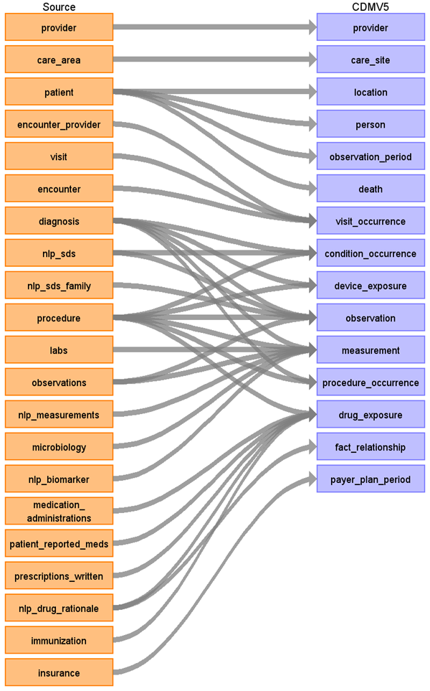

## Default Domains

The following table lists the default domain for a given source table/source column where a CDM row should be inserted with an unmapped concept ID (0) if no other domains were found for this source row.

|  |  |
| --- | --- |
| **Table.Column** | **Default Domain** |
| diagnosis.diagnosis_cd | Condition |
| medication_administratons.ndc | Drug |
| prescriptions_written.ndc | Drug |
| immunization.ndc | Drug |
| procedure.proc_code | Procedure |
| patient_reported_meds.ndc | Drug |
| labs.test_name | Measurement |
| observations.obs_type | Observation |
| nlp_measurement | Measurement |

## Table name: provider

### Reading from provider

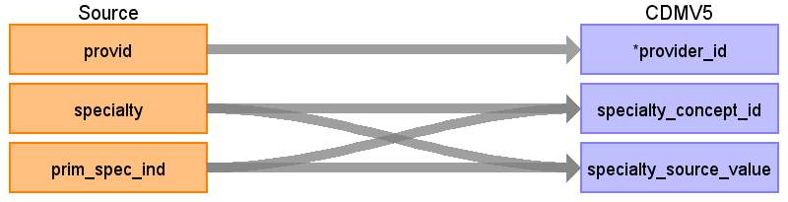

|  |  |  |  |
| --- | --- | --- | --- |
| Destination Field | Source Field | Logic | Comment |
| provider_id | provid |  |  |
| provider_name |  |  |  |
| npi |  |  |  |
| dea |  |  |  |
| specialty_concept_id | specialty |  | Use mapping JNJ_OPTUM_EHR_SPCLTY.csv. |
| care_site_id |  |  |  |
| year_of_birth |  |  |  |
| gender_concept_id |  |  |  |
| provider_source_value |  |  |  |
| specialty_source_value | specialty |  |  |
| specialty_source_concept_id | specialty |  | Use mapping JNJ_OPTUM_EHR_SPCLTY.csv. |
| gender_source_value |  |  |  |
| gender_source_concept_id |  |  |  |

Use the following query to select the provid, specialty to use for creating the provider table:

SELECT provid, specialty

FROM (

 select provid, specialty, prim_spec_ind, row_number() over (      partition by provid, specialty order by prim_spec_ind desc) ordinal

from native.provider

) P

WHERE P.ordinal = 1

## Table name: care_site

The Optum Oncology EHR does not contain site specific information. The care_area information relates to divisions of organizations and not physical locations, so we are not producing a care_site mapping for this ETL.

## Table name: location

### Reading from patient

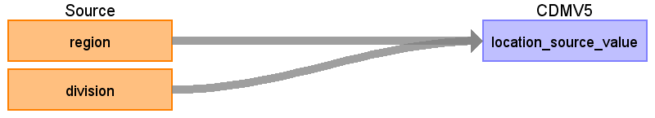

|  |  |  |  |
| --- | --- | --- | --- |
| Destination Field | Source Field | Logic | Comment |
| location_id |  |  | Autogen |
| address_1 |  |  |  |
| address_2 |  |  |  |
| city |  |  |  |
| state |  |  |  |
| zip |  |  |  |
| county |  |  |  |
| location_source_value | division  region | {region}_{division} | Concatenate region_division region to create unique location_id |

## Table name: person

### Reading from patient

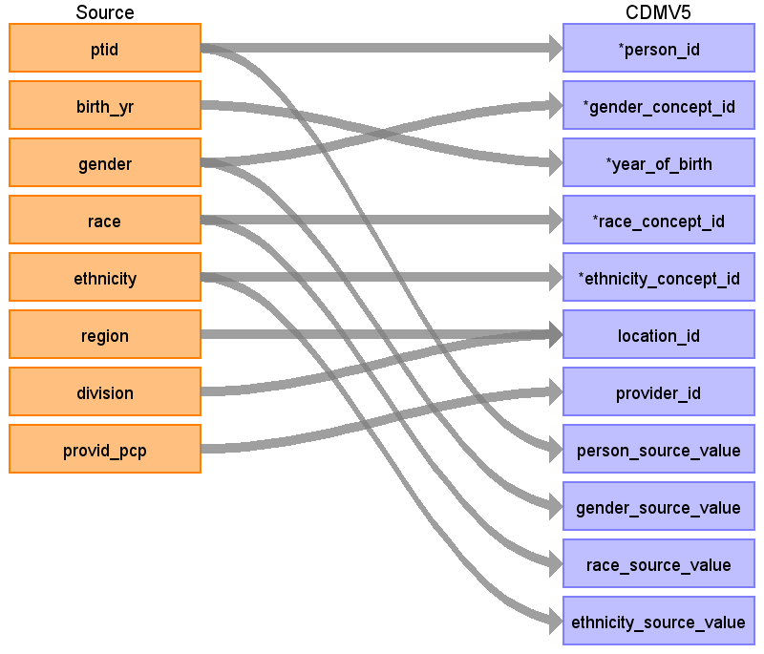

|  |  |  |  |
| --- | --- | --- | --- |
| Destination Field | Source Field | Logic | Comment |
| person_id | ptid |  | Remove ‘PT’ prefix: cast(replace(ptid, 'PT','') as bigint) |
| gender_concept_id | gender | If gender = ‘Unknown’ then remove  Else if gender = 'Male' then 8507  else if gender = 'Female' then 8532 |  |
| year_of_birth | birth_yr | if birth_yr == 'Unknown' then remove  Else if birth_yr <> 'Unknown' then  if birth_yr = '1927 and earlier' then 1927  else birth_yr |  |
| month_of_birth |  |  |  |
| day_of_birth |  |  |  |
| time_of_birth |  |  |  |
| race_concept_id | race | if 'Caucasian' then 8527  else if 'African American' then 8516  else if 'Asian' then 8515  else 0 |  |
| ethnicity_concept_id | ethnicity | if 'Hispanic' then 38003563  else 0 |  |
| location_id | region  division | Look up from Location table |  |
| provider_id | provid_pcp | Look up from Provider table. In the case when the value is “” in the source, set the provider_id to NULL. |  |
| care_site_id |  |  |  |
| person_source_value | ptid |  |  |
| gender_source_value | gender |  |  |
| gender_source_concept_id |  |  |  |
| race_source_value | race |  |  |
| race_source_concept_id |  |  |  |
| ethnicity_source_value | ethnicity |  |  |
| ethnicity_source_concept_id |  |  |  |

## Table name: observation_period

### Reading from patient

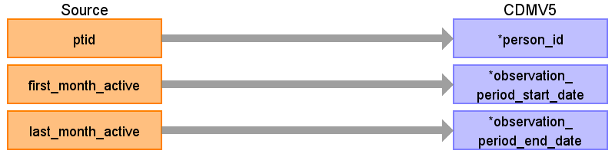

|  |  |  |  |
| --- | --- | --- | --- |
| Destination Field | Source Field | Logic | Comment |
| observation_period_id |  |  |  |
| person_id | ptid |  |  |
| observation_period_start_date | first_month_active | First day of first_month_active |  |
| observation_period_end_date | last_month_active | Last day of last_month_active  Add 1 month to last month active |  |
| period_type_concept_id | 38000280 |  | Observation recorded from EHR |

## Table name: death

Reading from patient

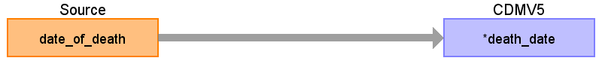

**A person’s death should be removed if any data available > 30 days after date_of_death**

|  |  |  |  |
| --- | --- | --- | --- |
| Destination Field | Source Field | Logic | Comment |
| person_id |  |  |  |
| death_date | date_of_death | if patient.date_of_death is not null, then use the last day of the month of death: Same logic as observation_period_end_date:  Add 1 to month of death and subtract 1 day. Example: month of death of 200402 becomes Feb + 1 month = March 1st - 1 day = Feb 29th, 2004. |  |
| death_type_concept_id |  |  |  |
| cause_concept_id |  |  |  |
| cause_source_value |  |  |  |
| cause_source_concept_id |  |  |  |

## Table name: visit_occurrence

When creating visits, create a temporary mapping table named **TEMP_VISIT** to associate encids from the native to VISIT_OCCURRENCE in cdm. This lookup will be needed when ETLing the CONDITION_OCCURRENCE, DRUG_EXPOSRE, PROCEDURE_OCCURRENCE, and any native table which references an encounter_id that maps into a CDM table with a visit_id.

**TEMP_VISIT table query**

select Q.visitid source_visit_id, Q.encid cdm_visit_id, e.encid as source_encounterid

from

(

select v.visitid, e.encid, row_number() over (partition by v.visitid order by e.interaction_date) as ordinal

from native.visit v

join native.encounter e on v.visitid = e.visitid

) Q

JOIN native.encounter e on e.visitid = Q.visitid

where Q.ordinal = 1

NOTE: As of CDM V5.2, the VISIT_OCCURRENCE table supports providing an admitting/discharge reason and a preceding visit ID which should be considered with the logic used above. The OPTUM Pan-ther encounter source table contains fields: admission_source and discharge_disposition that we should map.

### Reading from encounter

**Note: when pulling in encounters, only pull in encounters not associated with a visit:**

LEFT JOIN visit v on e.visitid = v.visitid where v.visitid is null

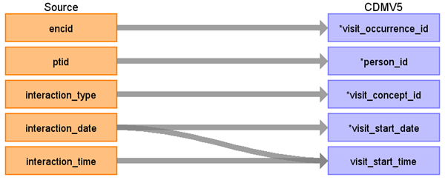

|  |  |  |  |
| --- | --- | --- | --- |
| Destination Field | Source Field | Logic | Comment |
| visit_occurrence_id | encid |  |  |
| person_id | ptid |  |  |
| visit_concept_id | interaction_type | STCM Lookup JNJ_OPTUM_EHR_VISIT.csv |  |
| visit_start_date | interaction_date |  |  |
| visit_start_time | interaction_time |  |  |
| visit_end_date | interaction_date |  |  |
| visit_end_time |  |  |  |
| visit_type_concept_id |  | 44818518 | Visit derived from EHR record |
| provider_id | encid | Look up in Provider table using encounter_provider.provid | When joining to the provider table, employ the following logic to ensure only 1 provider is associated with the visit:   * If there is > 1 provider, prioritize the provider where provider_role == ‘ATTENDING’.   + If there is > 1 record after applying this filter, sort by the specialty and pick the first. * If there is > 1 provider and 0 meet the criteria of provider_role == ‘ATTENDING’, sort by the role & specialty and pick the first. |
| care_site_id |  |  |  |
| visit_source_value | encid |  |  |
| visit_source_concept_id | interaction_type | STCM Lookup JNJ_OPTUM_EHR_VISIT.csv |  |
| ADMITTING_SOURCE_CONCEPT_ID | Admission_source |  |  |
| ADMITTING_SOURCE_VALUE | Admission_source | STCM Lookup:  JNJ_OPTUM_VISIT_ADM.csv |  |
| DISCHARGE_TO_CONCEPT_ID | discharge_disposition |  |  |
| DISCHARGE_TO_SOURCE_VALUE | discharge_disposition | STCM Lookup:  JNJ_OPTUM_VISIT_DIS.csv |  |
| PRECEDING_VISIT_OCCURRENCE_ID | NULL |  |  |

### Reading from visit

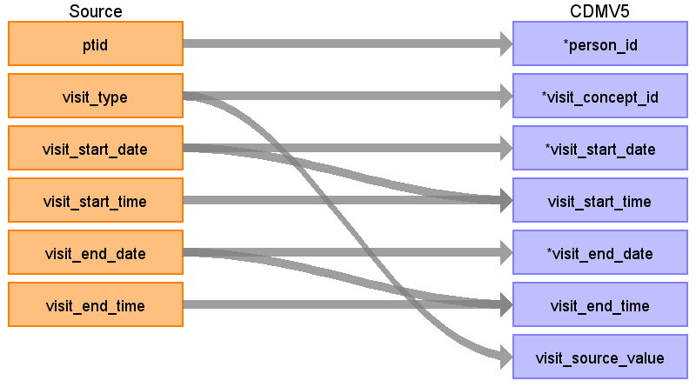

|  |  |  |  |
| --- | --- | --- | --- |
| Destination Field | Source Field | Logic | Comment |
| visit_occurrence_id | visitid | Lookup visitid in TEMP_VISIT and use cdm_visit_id |  |
| person_id | ptid |  |  |
| visit_concept_id | visit_type | Case ‘Inpatient’ : 9201 Case ‘Emergency Patient’: 9203 Case ‘Observation Patient’: 9201  ELSE: 0 |  |
| visit_start_date | visit_start_date |  |  |
| visit_start_time | visit_start_time | Use the date portion from visit_start_date |  |
| visit_end_date | visit_end_date |  |  |
| visit_end_time | visit_end_time | Use the date portion from visit_end_date |  |
| visit_type_concept_id |  | 44818518 | Visit derived from EHR record |
| provider_id | visitid | Use visitid to first encounter.encid associated, then to encounter_provider.provid | To avoid duplication, apply the same logic described when transforming the encounter table to visit_occurrence above. |
| care_site_id |  |  |  |
| visit_source_value | visit_type |  |  |
| visit_source_concept_id |  | Use first encid associated to visit. |  |
| ADMITTING_SOURCE_VALUE | Admission_source |  |  |
| DISCHARGE_TO_CONCEPT_ID | Admission_source | STCM Lookup:  JNJ_OPTUM_VISIT_ADM.csv |  |
| DISCHARGE_TO_SOURCE_VALUE | discharge_disposition |  |  |
| PRECEDING_VISIT_OCCURRENCE_ID | discharge_disposition | STCM Lookup:  JNJ_OPTUM_VISIT_DIS.csv |  |
| PRECEDING_VISIT_OCCURRENCE_ID | NULL |  |  |

## Table name: condition_occurrence

Any row mapped to a target concept must be in the Condition domain when inserting into CONDITION_OCCURRENCE.

**This is the only table where duplicate records should be collapsed.**

### Reading from diagnosis

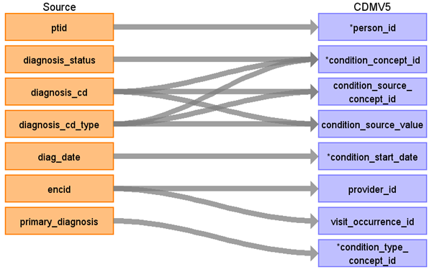

**Only use diagnosis records with DIAGNOSIS_STATUS = 'Diagnosis of'**

|  |  |  |  |
| --- | --- | --- | --- |
| Destination Field | Source Field | Logic | Comment |
| condition_occurrence_id |  | autogen |  |
| person_id | ptid |  |  |
| condition_concept_id | diagnosis_cd_type  Diagnosis_cd  diagnosis_status | Use Appendix 1.1.2.  If diagnosis_status = ‘Diagnosis of’  Then  { Case diagnosis_cd_type = ‘ICD9’:  Use lookup for ICD9CM Case diagnosis_cd_type = ‘ICD10’:  Use lookup for ICD10CM Case diagnosis_cd_type = ‘SNOMED’:  Use lookup for SNOMED CASE ‘’:   Lookup code in ICD9CM, ICD10CM, SNOMED CASE ELSE: 0 }  Else exclude record | For diagnosis_cd_type = ICD9, strip dot from lookup  For diagnosis_cd_type = ICD10, leave dots in lookup. |
| condition_start_date | diag_date |  |  |
| condition_end_date |  |  |  |
| condition_type_concept_id | primary_diagnosis | If primary_diagnosis = ‘1’ then 44786627 Else 44786629 |  |
| stop_reason |  |  |  |
| provider_id | encid | join to encounter_provider to attempt to lookup the provid | To avoid duplication, apply the same logic described when transforming the encounter table to visit_occurrence above. |
| visit_occurrence_id | encid | If encid is found in TEMP_VISIT, use cdm_visit_id, else use encid |  |
| condition_source_value | diagnosis_cd  diagnosis_cd_type | Use diagnosis_cd if available. Otherwise use diagnosis_cd_type |  |
| condition_source_concept_id | diagnosis_cd  diagnosis_cd_type | Use Appendix 1.1.1, and obtain the source_vocabulary_id and target_vocabulary_id for the where clause using this:  If diagnosis_status = ‘Diagnosis of’  Then  {  Case diagnosis_cd_type = ‘ICD9’:  Use lookup for ICD9CM  Case diagnosis_cd_type = ‘ICD10’:  Use lookup for ICD10CM  Case diagnosis_cd_type = ‘SNOMED’:  Use lookup for SNOMED  CASE ‘’:  Lookup code in ICD9CM, ICD10CM, SNOMED  CASE ELSE: 0  }  else exclude record | For diagnosis_cd_type = ICD9, strip dot from lookup  For diagnosis_cd_type = ICD10, leave dots in lookup. |
| Condition_status_concept_id | Poa  Admitting_diagnosis  Discharge_diagnosis  Primary_diagnosis | Use the following logic to determine the concept_id  CASE  WHEN admitting_diagnosis = ‘1’ THEN 4203942  WHEN discharge_diagnosis = ‘1’ THEN 4230359  WHEN primary_diagnosis = ‘1’ THEN 3001410  WHEN poa = ‘1’ THEN 46236988 END  END | Concept_id reference:  4203942 - Admitting diagnosis  4230359 - Final diagnosis: – should also be used for ‘Discharge diagnosis’  4033240 - Preliminary diagnosis:  3001410 - Primary diagnosis (LOINC)  46236988 - Diagnosis present on admission |
| Condition_status_source_value | Poa  Admitting_diagnosis  Discharge_diagnosis  Primary_diagnosis | Concatenate those field names that equal ‘1’. For example, if POA = ‘1’ and ‘primary_diagnosis = ‘1’ this field should read:  ‘POA;PRIMARY_DIAGNOSIS’ |  |

### Reading from procedure

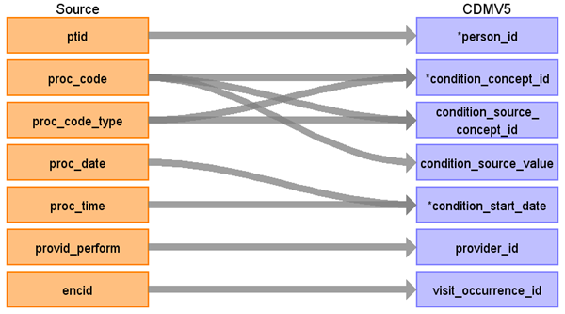

|  |  |  |  |
| --- | --- | --- | --- |
| Destination Field | Source Field | Logic | Comment |
| condition_occurrence_id |  | Autogen |  |
| person_id | ptid |  |  |
| condition_concept_id | proc_code  proc_code_type | Use Appendix 1.1.2  Case proc_code_type: “CPT4” : use CPT4 Vocab “HCPCS”: use HCPCS Vocab “ICD10”: user ICD10PCS “ICD9”: use ICD9Proc Vocab Else: 0 |  |
| condition_start_date | proc_date |  |  |
| condition_source_value | proc_code |  |  |
| condition_source_concept_id | proc_code  proc_code_type | Use Appendix 1.1.1.  Case proc_code_type: “CPT4” : use CPT4 Vocab “HCPCS”: use HCPCS Vocab “ICD9”: use ICD9Proc Vocab Else: 0 |  |
| provider_id | provid_perform | Use Provider Lookup | To avoid duplication, apply the same logic described when transforming the encounter table to visit_occurrence above. |
| visit_occurrence_id | encid |  |  |
| condition_end_date |  |  |  |
| condition_type_concept_id |  | 0 |  |
| stop_reason |  |  |  |
| Condition_status_concept_id | 0 |  |  |
| Condition_status_source_value | NULL |  |  |

## Table name: drug_exposure

### Reading from medication_administrations

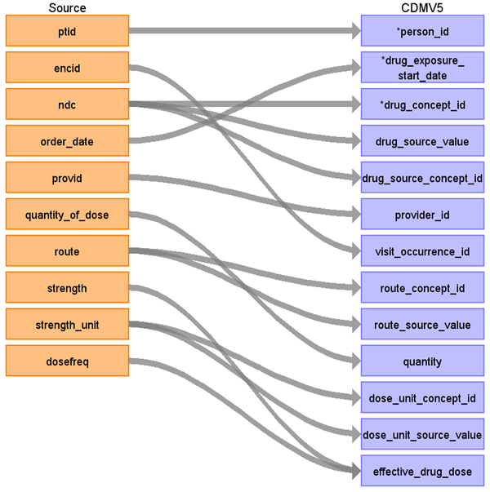

|  |  |  |  |
| --- | --- | --- | --- |
| Destination Field | Source Field | Logic | Comment |
| drug_exposure_id |  | autogen |  |
| person_id | ptid |  |  |
| drug_concept_id | ndc | Use Appendix 1.1.2  WHERE Vocabulary_ID = ‘NDC’ | When mapping a prescription drug, map the 11-digit NDC code to SOURCE_CODE in OMOP vocab first. If no mapping found, map the first 9 digits of NDC code to SOURCE_CODE. |
| drug_exposure_start_date | order_date |  |  |
| drug_exposure_end_date | Order_date |  | This is now required in v5.2 so set to the order_date |
| Verbatim_end_date | NULL |  |  |
| drug_type_concept_id |  | 38000180 | Inpatient Administration |
| stop_reason |  |  |  |
| refills |  |  |  |
| quantity | quantity_of_dose |  |  |
| days_supply |  |  |  |
| sig |  |  |  |
| route_concept_id | route | STCM Lookup JNJ_OPTUM_EHR_ROUTE.csv |  |
|  |  |  |  |
|  |  |  |  |
| lot_number |  |  |  |
| provider_id | Provid  encid | If the provid is not specified, look at the encounter associated with this record. If there is a provider specified, used that value here. | To avoid duplication, apply the same logic described when transforming the encounter table to visit_occurrence above. |
| visit_occurrence_id | encid |  |  |
| drug_source_value | ndc |  |  |
| drug_source_concept_id | ndc |  |  |
| route_source_value | route |  |  |
| dose_unit_source_value | strength_unit |  |  |

### Reading from prescriptions_written

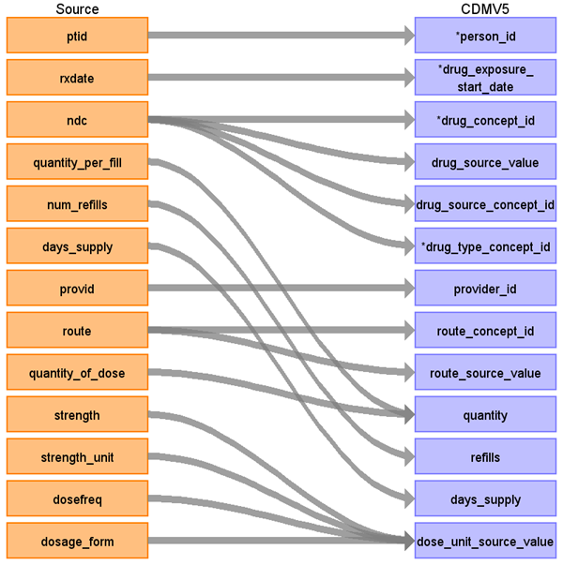

|  |  |  |  |
| --- | --- | --- | --- |
| Destination Field | Source Field | Logic | Comment |
| drug_exposure_id |  |  |  |
| person_id | ptid |  |  |
| drug_exposure_start_date | rxdate |  |  |
| Drug_exposure_end_date | Days_supply  rxdate | If (days_supply > 0) Then use  DATEADD(dd, days_supply, rxdate)  Else set to  rxdate |  |
| Verbatim_end_date | NULL |  |  |
| drug_concept_id | ndc |  | When mapping a prescription drug, map the 11-digit NDC code to SOURCE_CODE in OMOP vocab first. If no mapping found, map the first 9 digits of NDC code to SOURCE_CODE. |
| drug_source_value | ndc |  |  |
| drug_source_concept_id | ndc |  |  |
| drug_type_concept_id | ndc | 38000177 |  |
| provider_id | provid |  | To avoid duplication, apply the same logic described when transforming the encounter table to visit_occurrence above. |
| visit_occurrence_id |  |  |  |
| route_concept_id | route | Lookup route value in the STCM Lookup JNJ_OPTUM_EHR_ROUTE |  |
| route_source_value | route |  |  |
| quantity | quantity_per_fill  quantity_of_dose | IF quantity_per_fill != null THEN  cdm.quantity = split(quantity_per_fill).first()  ELSE IF quantity_of_dose != null THEN  cdm.quantity = quantity_per_dose  ELSE 0; |  |
| refills | num_refills |  |  |
| days_supply | days_supply |  | Check for decimal values in the source data. When present, round these up to the nearest integer. |
|  |  |  |  |
| dose_unit_source_value | strength  strength_unit  dosage_form  dosefreq | Concatenate: strength + strength_unit + dosage_form + dosefreq with a semi-colon for delimiter |  |
|  |  |  |  |
| stop_reason |  |  |  |
| sig |  |  |  |
| lot_number |  |  |  |
| drug_exposure_end_date |  |  |  |

### Reading from patient_reported_meds

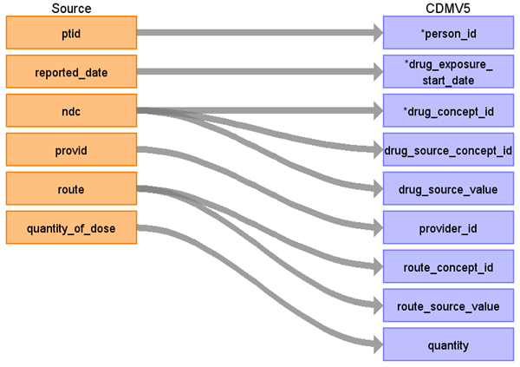

|  |  |  |  |
| --- | --- | --- | --- |
| Destination Field | Source Field | Logic | Comment |
| drug_exposure_id |  |  |  |
| person_id | ptid |  |  |
| drug_exposure_start_date | reported_date |  |  |
| Drug_exposure_end_date | reported_date |  |  |
| Verbatim_end_date | NULL |  |  |
| drug_concept_id | ndc |  | When mapping a prescription drug, map the 11-digit NDC code to SOURCE_CODE in OMOP vocab first. If no mapping found, map the first 9 digits of NDC code to SOURCE_CODE. |
| drug_source_concept_id | ndc |  |  |
| drug_source_value | ndc |  |  |
| drug_type_concept_id |  | 44787730 | Patient Self-Reported Medication |
| provider_id | provid |  | To avoid duplication, apply the same logic described when transforming the encounter table to visit_occurrence above. |
| route_concept_id | route | Lookup route value in the STCM Lookup JNJ_OPTUM_EHR_ROUTE |  |
| route_source_value | route |  |  |
| quantity | quantity_of_dose |  |  |
| refills |  |  |  |
| days_supply |  |  |  |
|  |  |  |  |
| dose_unit_source_value |  |  |  |
|  |  |  |  |
| visit_occurrence_id |  |  |  |
| stop_reason |  |  |  |
| sig |  |  |  |
| lot_number |  |  |  |
| drug_exposure_end_date |  |  |  |

### Reading from immunization

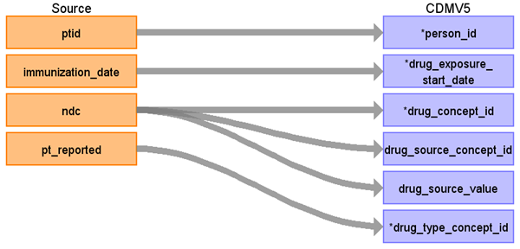

|  |  |  |  |
| --- | --- | --- | --- |
| Destination Field | Source Field | Logic | Comment |
| drug_exposure_id |  |  |  |
| person_id | ptid |  |  |
| drug_concept_id | ndc  pt_reported | where pt_reported = 'N' | When mapping a prescription drug, map the 11-digit NDC code to SOURCE_CODE in OMOP vocab first. If no mapping found, map the first 9 digits of NDC code to SOURCE_CODE. |
| drug_exposure_start_date | immunization_date |  |  |
| drug_exposure_end_date | immunization_date |  |  |
| Verbatim_end_date | NULL |  |  |
| drug_type_concept_id |  | 43542358 | Physician administered drug (identified from EHR observation) |
| stop_reason |  |  |  |
| refills |  |  |  |
| quantity |  |  |  |
| days_supply |  |  |  |
| sig |  |  |  |
| route_concept_id |  |  |  |
|  |  |  |  |
|  |  |  |  |
| lot_number |  |  |  |
| provider_id |  |  | To avoid duplication, apply the same logic described when transforming the encounter table to visit_occurrence above. |
| visit_occurrence_id |  |  |  |
| drug_source_value | ndc |  |  |
| drug_source_concept_id | ndc |  |  |
| route_source_value |  |  |  |
| dose_unit_source_value |  |  |  |

### Reading from procedure

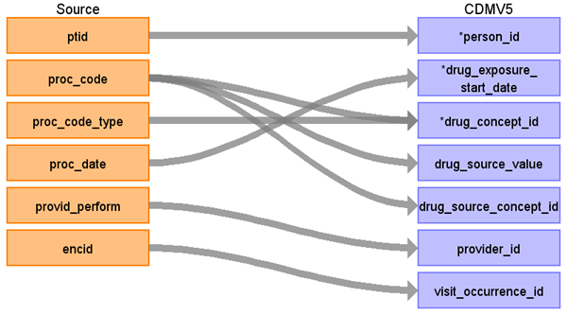

|  |  |  |  |
| --- | --- | --- | --- |
| Destination Field | Source Field | Logic | Comment |
| drug_exposure_id |  |  |  |
| person_id | ptid |  |  |
| drug_exposure_start_date | proc_date |  |  |
| drug_exposure_end_date | Proc_date |  |  |
| Verbatim_end_date | NULL |  |  |
| drug_concept_id | proc_code  proc_code_type |  | Only map rows where the proc_code and proc_code_type map to a concept in the vocabulary that has domain_id = ‘drug’ |
| drug_source_value | proc_code |  |  |
| drug_source_concept_id | proc_code |  |  |
| drug_type_concept_id |  | 38000275 | EHR order list entry |
| provider_id | provid_perform |  | To avoid duplication, apply the same logic described when transforming the encounter table to visit_occurrence above. |
| visit_occurrence_id | encid |  |  |
| route_concept_id |  |  |  |
| route_source_value |  |  |  |
| quantity |  |  |  |
| refills |  |  |  |
| days_supply |  |  |  |
|  |  |  |  |
| dose_unit_source_value |  |  |  |
|  |  |  |  |
| stop_reason |  |  |  |
| sig |  |  |  |
| lot_number |  |  |  |
| drug_exposure_end_date |  |  |  |

### Reading from nlp_drug_rationale

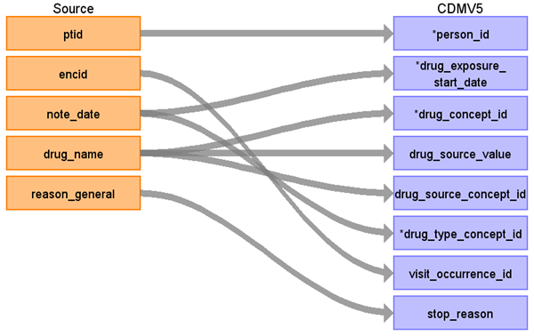

Only map the rows that match the following query:

select *

from nlp_drug_rationale

where (drug_action in ( ‘TAKE’, ‘START’, ‘ADMINISTER’, ‘MEDICATE’))

AND (sentiment is null)

|  |  |  |  |
| --- | --- | --- | --- |
| Destination Field | Source Field | Logic | Comment |
| drug_exposure_id |  |  |  |
| person_id | ptid |  |  |
| drug_exposure_start_date | note_date |  |  |
| drug_exposure_end_date | note_date |  |  |
| Verbatim_end_date | NULL |  |  |
| drug_concept_id | drug_name | STCM Lookup JNJ_OPTUM_NLP_DRUG.csv |  |
| drug_source_value | drug_name |  |  |
| drug_source_concept_id | drug_name |  |  |
| drug_type_concept_id | note_date | 38000281 = Observation recorded from EHR with text result |  |
| provider_id |  |  |  |
| visit_occurrence_id | encid |  |  |
| route_concept_id |  |  |  |
| route_source_value |  |  |  |
| quantity |  |  |  |
| refills |  |  |  |
| days_supply |  |  |  |
|  |  |  |  |
| dose_unit_source_value |  |  |  |
|  |  |  |  |
| stop_reason | reason_general |  |  |
| sig |  |  |  |
| lot_number |  |  |  |
| drug_exposure_end_date |  |  |  |

## Table name: nlp_note

### Reading from nlp_biomarkers

|  |  |  |  |
| --- | --- | --- | --- |
| Destination Field | Source Field | Logic | Comment |
| Note_id |  | Auto-increment |  |
| person_id | ptid |  |  |
| note_date | note_date |  |  |
| Note_datetime |  |  |  |
| Note_type_concept_id | 44814642 | Pathology report |  |
| Note_class_concept_id | 44817649 | Plan of care and summary note |  |
| Note_title | ‘NLP_BIOMARKERS’ | Store the name of the table of origin |  |
| Note_text | biomarker_status  variation_detail  biomarker | Format as a single string by concatenating as a set of name value pairs. The resulting text should look like:  Concatenate biomarker:<biomarker>; variation_detail :<variation_detail>; biomarker_status:<biomarker_status>  This may require truncation of the string on MPP platforms since the resulting string could be quite long. |  |
| Encoding_concept_id | 0 |  |  |
| Language_concept_id | 40639387 | US English |  |
| Provider_id | encid | Links the encounter back to the encounter_provider table. Then use the cooresponding provider ID. | To avoid duplication, apply the same logic described when transforming the encounter table to visit_occurrence above. |
| Note_source_value | NULL |  |  |
| Visit_occurrence_id | encid |  |  |

### Reading from nlp_custom

|  |  |  |  |
| --- | --- | --- | --- |
| Destination Field | Source Field | Logic | Comment |
| Note_id |  | Auto-increment |  |
| person_id | ptid |  |  |
| note_date | note_date |  |  |
| Note_datetime |  |  |  |
| Note_type_concept_id | 44814642 | Note – note type concept |  |
| Note_class_concept_id | 44817649 | Plan of care and summary note |  |
| Note_title | ‘NLP_CUSTOM’ | Store the name of the table of origin |  |
| Note_text | Nlp_term  Nlp_term_attribute_1  Nlp_term_attribute_2  Nlp_term_qualifier | Format as a single string by concatenating as a set of name value pairs. The resulting text should look like:  Concatenate term:<nlp_term>; term_attribute_1:<nlp_term_attribute_1>;term_attribute_2:<nlp_term_attribute_2>;nlp_term_qualifier:<nlp_term_qualifier>  This may require truncation of the string on MPP platforms since the resulting string could be quite long. |  |
| Encoding_concept_id | 0 |  |  |
| Language_concept_id | 40639387 | US English |  |
| Provider_id | encid | Links the encounter back to the encounter_provider table. Then use the cooresponding provider ID. | To avoid duplication, apply the same logic described when transforming the encounter table to visit_occurrence above. |
| Note_source_value | Note_section |  |  |
| Visit_occurrence_id | encid |  |  |

### Reading from nlp_drug_rationale

|  |  |  |  |
| --- | --- | --- | --- |
| Destination Field | Source Field | Logic | Comment |
| Note_id |  |  |  |
| person_id | ptid |  |  |
| note_date | note_date |  |  |
| Note_datetime |  |  |  |
| Note_type_concept_id | 44814645 | Note – note type concept |  |
| Note_class_concept_id | 44817649 | Plan of care and summary note |  |
| Note_title | ‘NLP_DRUG_RATIONALE’ | Store the name of the table of origin |  |
| Note_text | Drug_name  drug_action  drug_action_preposition  reason_general  sentiment  sentiment_who | Format as a single string by concatenating as a set of name value pairs. The resulting text should look like:  drug_name:<drug_name>;drug_Action: <drug_action>; drug_action_preposition:<drug_action_preposition>; reason_general:< reason_general>;sentiment:<sentiment>; sentiment_who:<sentiment_who>  This may require truncation of the string on MPP platforms since the resulting string could be quite long. |  |
| Encoding_concept_id | 0 |  |  |
| Language_concept_id | 40639387 | US English |  |
| Provider_id | encid | Links the encounter back to the encounter_provider table. Then use the cooresponding provider ID. | To avoid duplication, apply the same logic described when transforming the encounter table to visit_occurrence above. |
| Note_source_value | Note_section |  |  |
| Visit_occurrence_id | encid |  |  |

### Reading from nlp_measurement

|  |  |  |  |
| --- | --- | --- | --- |
| Destination Field | Source Field | Logic | Comment |
| Note_id |  |  |  |
| person_id | ptid |  |  |
| note_date | note_date |  |  |
| Note_datetime |  |  |  |
| Note_type_concept_id | 44814645 | Note – note type concept |  |
| Note_class_concept_id | 44817649 | Plan of care and summary note |  |
| Note_title | ‘NLP_MEASUREMENT’ | Store the name of the table of origin |  |
| Note_text | measurement_type,  measurement_value,  measurement_detail,  measurement_year,  measurement_monthyear,  measurement_date | Format as a single string by concatenating as a set of name value pairs. The resulting text should look like:  type:<measurement_type>;value: <measurement_value>; detail:<measurement_detail>; year:<measurement_year>;monthyear:<monthyear>; date:<measurement_date>  This may require truncation of the string on MPP platforms since the resulting string could be quite long. |  |
| Encoding_concept_id | 0 |  |  |
| Language_concept_id | 40639387 | US English |  |
| Provider_id | encid | Links the encounter back to the encounter_provider table. Then use the cooresponding provider ID. | To avoid duplication, apply the same logic described when transforming the encounter table to visit_occurrence above. |
| Note_source_value | Note_section |  |  |
| Visit_occurrence_id | encid |  |  |

### Reading from nlp_sds

|  |  |  |  |
| --- | --- | --- | --- |
| Destination Field | Source Field | Logic | Comment |
| Note_id |  |  |  |
| person_id | ptid |  |  |
| note_date | note_date |  |  |
| Note_datetime |  |  |  |
| Note_type_concept_id | 44814645 | Note – note type concept |  |
| Note_class_concept_id | 44817649 | Plan of care and summary note |  |
| Note_title | ‘NLP_SDS’ | Store the name of the table of origin |  |
| Note_text | sds_term sds_location  sds_attribute  sds_sentiment | Format as a single string by concatenating as a set of name value pairs. The resulting text should look like:  term:<sds_term>;location: <sds_location>; attribute:<sds_attribute>; sentiment:<sds_sentiment>  This may require truncation of the string on MPP platforms since the resulting string could be quite long. |  |
| Encoding_concept_id | 0 |  |  |
| Language_concept_id | 40639387 | US English |  |
| Provider_id | encid | Links the encounter back to the encounter_provider table. Then use the cooresponding provider ID. | To avoid duplication, apply the same logic described when transforming the encounter table to visit_occurrence above. |
| Note_source_value | Note_section |  |  |
| Visit_occurrence_id | encid |  |  |

### Reading from nlp_sds_family

|  |  |  |  |
| --- | --- | --- | --- |
| Destination Field | Source Field | Logic | Comment |
| Note_id |  |  |  |
| person_id | ptid |  |  |
| note_date | note_date |  |  |
| Note_datetime |  |  |  |
| Note_type_concept_id | 44814645 | Note – note type concept |  |
| Note_class_concept_id | 44817649 | Plan of care and summary note |  |
| Note_title | ‘NLP_SDS_FAMILY’ | Store the name of the table of origin |  |
| Note_text | sds_term  sds_location sds_family_member  sds_sentiment | Format as a single string by concatenating as a set of name value pairs. The resulting text should look like:  term:<sds_term>;location: <sds_location>; family_member:<sds_family_member>; sentiment:<sds_sentiment>  This may require truncation of the string on MPP platforms since the resulting string could be quite long. |  |
| Encoding_concept_id | 0 |  |  |
| Language_concept_id | 40639387 | US English |  |
| Provider_id | encid | Links the encounter back to the encounter_provider table. Then use the cooresponding provider ID. | To avoid duplication, apply the same logic described when transforming the encounter table to visit_occurrence above. |
| Note_source_value | Note_section |  |  |
| Visit_occurrence_id | encid |  |  |

## Table name: device_exposure

### Reading from procedure

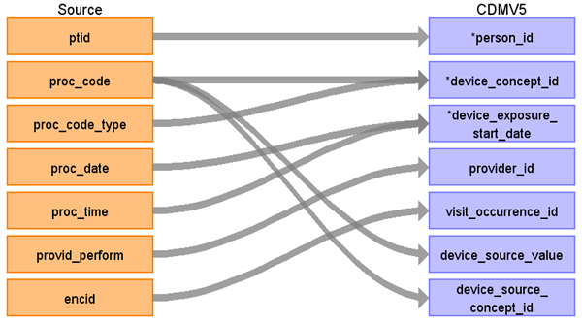



|  |  |  |  |
| --- | --- | --- | --- |
| Destination Field | Source Field | Logic | Comment |
| device_exposure_id |  |  | Auto-incremented |
| person_id | ptid |  |  |
| device_concept_id | proc_code |  | Domain_id = Device for those procedures that have device concepts in the proc_code (mainly HCPCS) |
| device_exposure_start_date | Proc_date |  |  |
| device_exposure_end_date |  |  |  |
| device_type_concept_id |  |  |  |
| unique_device_id |  |  |  |
| quantity |  |  |  |
| provider_id | provid |  | To avoid duplication, apply the same logic described when transforming the encounter table to visit_occurrence above. |
| visit_occurrence_id | encid |  | Lookup using visit_occurrence mapping logic |
| device_source_value | proc_code |  |  |
| device_source_concept_id | Proc_code mapped to concept_id |  | Source code mapped to vocabulary |

### Reading from diagnosis

|  |  |  |  |
| --- | --- | --- | --- |
| Destination Field | Source Field | Logic | Comment |
| device_exposure_id |  |  |  |
| person_id | ptid |  |  |
| device_concept_id | diagnosis_cd  diagnosis_status  diagnosis_cd_type |  | Domain_id = Device for those procedures that have device concepts in the proc_code (mainly HCPCS) |
| device_exposure_start_date | diag_date |  |  |
| device_exposure_end_date |  |  |  |
| device_type_concept_id | primary_diagnosis |  | If primary_diagnosis = ‘1’ then 44786627  Else 44786629 |
| unique_device_id |  |  |  |
| quantity |  |  |  |
| provider_id | Encid -> provider_id |  | Use this field to map up to the encounter_provider. To avoid duplication, apply the same logic described when transforming the encounter table to visit_occurrence above. |
| visit_occurrence_id | encid |  | Use the visit_occurrence mapping logic |
| device_source_value | diagnosis_cd |  |  |
| device_source_concept_id | diagnosis_cd |  |  |

## Table name: procedure_occurrence

### Reading from procedure

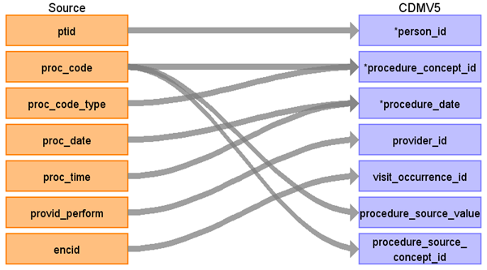

|  |  |  |  |
| --- | --- | --- | --- |
| Destination Field | Source Field | Logic | Comment |
| procedure_occurrence_id |  |  |  |
| person_id | ptid |  |  |
| procedure_concept_id | proc_code  proc_code_type |  | Lookup to the vocabulary using the proc_code_type to find the proper vocabulary_id |
| procedure_date | proc_date |  |  |
| procedure_type_concept_id | 38000275 |  | EHR order list entry |
| modifier_concept_id |  |  |  |
| quantity |  |  |  |
| provider_id | provid_perform |  | To avoid duplication, apply the same logic described when transforming the encounter table to visit_occurrence above. |
| visit_occurrence_id | encid |  |  |
| procedure_source_value | proc_code |  |  |
| procedure_source_concept_id | proc_code |  |  |
| qualifier_source_value |  |  |  |

### Reading from diagnosis

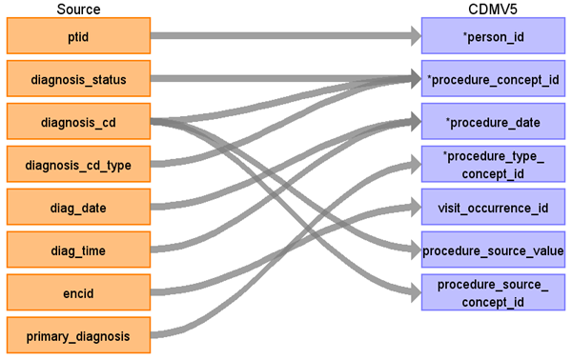

|  |  |  |  |
| --- | --- | --- | --- |
| Destination Field | Source Field | Logic | Comment |
| procedure_occurrence_id |  |  |  |
| person_id | ptid |  |  |
| procedure_concept_id | diagnosis_status  diagnosis_cd  diagnosis_cd_type |  | Diagnosis_status = ‘Diagnosis Of’ and diagnosis_cd must map to domain = procedure  Where the target vocabulary_id = diagnaosis_cd_type. |
| procedure_date | diag_date  diag_time |  |  |
| procedure_type_concept_id | 42865906 |  | ‘Condition Procedure’ |
| modifier_concept_id |  |  |  |
| quantity |  |  |  |
| provider_id |  |  | To avoid duplication, apply the same logic described when transforming the encounter table to visit_occurrence above. |
| visit_occurrence_id | encid |  |  |
| procedure_source_value | diagnosis_cd |  |  |
| procedure_source_concept_id | diagnosis_cd |  |  |
| qualifier_source_value |  |  |  |

## Table name: measurement

### Reading from diagnosis

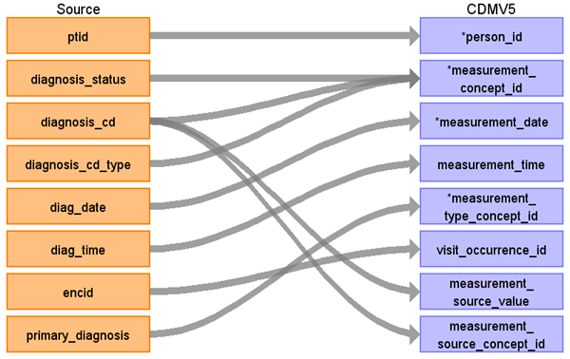

|  |  |  |  |
| --- | --- | --- | --- |
| Destination Field | Source Field | Logic | Comment |
| measurement_id |  |  |  |
| person_id | ptid |  |  |
| measurement_concept_id | diagnosis_status  diagnosis_cd  diagnosis_cd_type | Use Appendix 1.1.2 to obtain the source_vocabulary_id for the where clause  If diagnosis_status = ‘Diagnosis of’  Then  {  Case diagnosis_cd_type = ‘ICD9’:  Use lookup for ICD9CM  Case diagnosis_cd_type = ‘ICD10’:  Use lookup for ICD10CM  Case diagnosis_cd_type = ‘SNOMED’:  Use lookup for SNOMED  CASE ‘’:  Lookup code in ICD9CM, ICD10CM, SNOMED  CASE ELSE: 0  } | For diagnosis_cd_type = ICD9, strip dot from lookup  For diagnosis_cd_type = ICD10, leave dots in lookup. |
| measurement_date | diag_date |  |  |
| measurement_time | diag_time |  |  |
| measurement_type_concept_id | primary_diagnosis | if primary_diagnosis = ‘1’ then 44786627  else 44786629 |  |
| operator_concept_id | 0 |  |  |
| value_as_number |  |  |  |
| value_as_concept_id | 0 |  |  |
| unit_concept_id | 0 |  |  |
| range_low |  |  |  |
| range_high |  |  |  |
| provider_id |  |  | To avoid duplication, apply the same logic described when transforming the encounter table to visit_occurrence above. |
| visit_occurrence_id | encid |  |  |
| measurement_source_value | diagnosis_cd |  |  |
| measurement_source_concept_id | diagnosis_cd | Use Appendix 1.1.1 to obtain the source_vocabulary_id for the where clause  If diagnosis_status = ‘Diagnosis of’  Then  {  Case diagnosis_cd_type = ‘ICD9’:  Use lookup for ICD9CM  Case diagnosis_cd_type = ‘ICD10’:  Use lookup for ICD10CM  Case diagnosis_cd_type = ‘SNOMED’:  Use lookup for SNOMED  CASE ‘’:  Lookup code in ICD9CM, ICD10CM, SNOMED  CASE ELSE: 0  } | For diagnosis_cd_type = ICD9, strip dot from lookup  For diagnosis_cd_type = ICD10, leave dots in lookup. |
| unit_source_value |  |  |  |
| value_source_value |  |  |  |

### Reading from labs

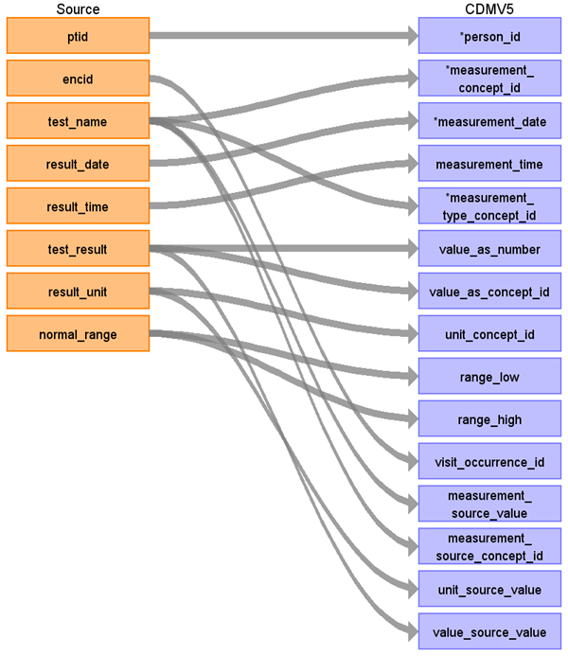

|  |  |  |  |
| --- | --- | --- | --- |
| Destination Field | Source Field | Logic | Comment |
| measurement_id |  |  |  |
| person_id | ptid |  |  |
| measurement_concept_id | test_name |  | STCM Lookup JNJ_OPTUM_EHR_LABNAM.csv |
| measurement_date | result_date |  |  |
| measurement_time | result_time |  |  |
| measurement_type_concept_id | 44818702 |  | Lab result |
| operator_concept_id | relative_indicator |  | When relative_indicator is NULL/empty, leave the value as NULL. These will map to domain_id = 'Meas Value Operator' in the vocabulary.  CASE WHEN relative_incicator == ‘<=’ THEN 4171754  CASE WHEN relative_incicator == ‘>=’ THEN 4171755  CASE WHEN relative_incicator == ‘<’ THEN 4171756  CASE WHEN relative_incicator == ‘=’ THEN 4172703  CASE WHEN relative_incicator == ‘>’ THEN 4172704  ELSE 0 |
| value_as_number | test_result |  | Only do this if test_result is numeric |
| value_as_concept_id | test_result |  | If test_result is NOT NUMERIC THEN  STCM Lookup JNJ_OPTUM_EHR_LABRES.csv |
| unit_concept_id | result_unit |  | Map to UCUM vocabulary using a CASE-SENSITIVE matching; if no match if found, match to the JNJ_UNITS STCM. If no match is found in either vocabulary, set this field to 0. |
| range_low | normal_range |  | Parse lower bound (split on hyphen), first piece |
| range_high | normal_range |  | Parse upper bound (split on hyphen), second piece |
| provider_id | encid |  | Look up provider from the encounter. To avoid duplication, apply the same logic described when transforming the encounter table to visit_occurrence above. |
| visit_occurrence_id | encid |  |  |
| measurement_source_value | test_name |  |  |
| measurement_source_concept_id | test_name | 0 |  |
| unit_source_value | result_unit |  |  |
| value_source_value | test_result |  |  |

### Reading from nlp_measurement

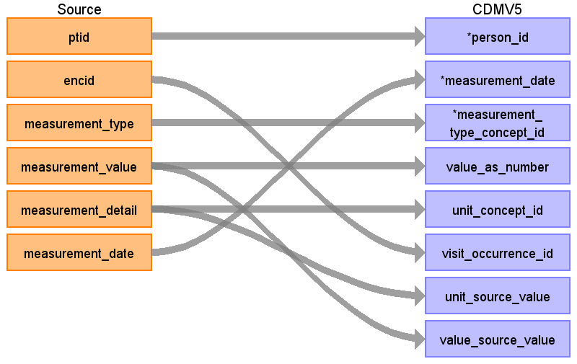

|  |  |  |  |
| --- | --- | --- | --- |
| Destination Field | Source Field | Logic | Comment |
| measurement_id |  |  |  |
| person_id | ptid |  |  |
| measurement_concept_id | measurement_type |  | STCM Lookup JNJ_OPTUM_EHR_NLPM.csv |
| measurement_date | measurement_date |  |  |
| measurement_time |  |  |  |
| measurement_type_concept_id | 45754907 |  | Derived value |
| operator_concept_id |  |  |  |
| value_as_number | measurement_value |  | Only do this if measurement_value is numeric |
| value_as_concept_id | measurement_value |  |  |
| unit_concept_id | measurement_detail |  | If the inbound record maps to measurement_concept_id = (Body mass index), then set the unit_concept_id to 9531 (kilogram per square meter). Otherwise, follow these rules: Map to UCUM vocabulary using a CASE-SENSITIVE matching; if no match if found, match to the JNJ_UNITS STCM. If no match is found in either vocabulary, set this field to 0. |
| range_low |  |  |  |
| range_high |  |  |  |
| provider_id |  |  | To avoid duplication, apply the same logic described when transforming the encounter table to visit_occurrence above. |
| visit_occurrence_id | encid |  |  |
| measurement_source_value |  |  |  |
| measurement_source_concept_id |  |  |  |
| unit_source_value | measurement_detail |  |  |
| value_source_value | measurement_value |  |  |

### Reading from observations

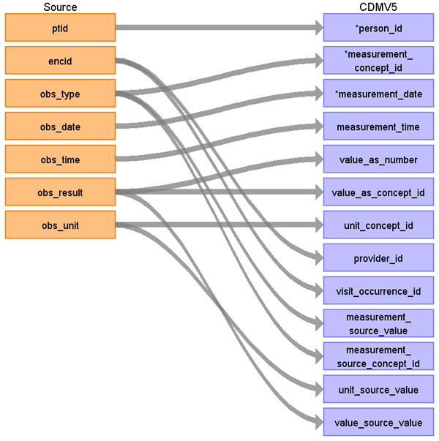

|  |  |  |  |
| --- | --- | --- | --- |
| Destination Field | Source Field | Logic | Comment |
| measurement_id |  |  |  |
| person_id | ptid |  |  |
| measurement_concept_id | obs_type |  | STCM Lookup JNJ_OPTUM_EHR_OBTYPE.csv  Create a source to concept map (STCM) for the native observations that should map to the CDM measurement table. Then when mapping rows to the the CDM Measurement table, only push over the rows that are in the STCM via an inner join. When the target is the CDM observation table, do a left join and bring over the values that are NOT in the STCM. |
| measurement_date | obs_date |  |  |
| measurement_time | obs_time |  |  |
| measurement_type_concept_id | 45754907 |  | Derived value |
| operator_concept_id | 0 |  |  |
| value_as_number | obs_result |  |  |
| value_as_concept_id | obs_result |  |  |
| unit_concept_id | obs_unit |  | Map to UCUM vocabulary using a CASE-SENSITIVE matching; if no match if found, match to the JNJ_UNITS STCM. If no match is found in either vocabulary, set this field to 0. |
| range_low |  |  |  |
| range_high |  |  |  |
| provider_id | encid |  | Map encid to encounter_provider. To avoid duplication, apply the same logic described when transforming the encounter table to visit_occurrence above. |
| visit_occurrence_id | encid |  |  |
| measurement_source_value | obs_type |  |  |
| measurement_source_concept_id | obs_type |  |  |
| unit_source_value | obs_unit |  |  |
| value_source_value | obs_result |  |  |

### Reading from procedure

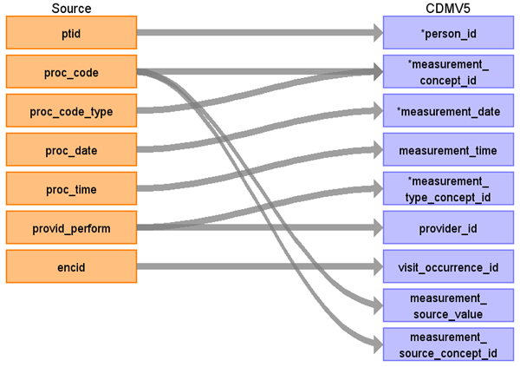

|  |  |  |  |
| --- | --- | --- | --- |
| Destination Field | Source Field | Logic | Comment |
| measurement_id |  |  |  |
| person_id | ptid |  |  |
| measurement_concept_id | proc_code  proc_code_type |  | Lookup to the vocabulary using the proc_code_type to find the proper vocabulary_id |
| measurement_date | proc_date |  |  |
| measurement_time | proc_time |  |  |
| measurement_type_concept_id | provid_perform |  | 44818701  45754907    Derived value |
| operator_concept_id | 0 |  |  |
| value_as_number |  |  |  |
| value_as_concept_id | 0 |  |  |
| unit_concept_id | 0 |  |  |
| range_low |  |  |  |
| range_high |  |  |  |
| provider_id | provid_perform |  | To avoid duplication, apply the same logic described when transforming the encounter table to visit_occurrence above. |
| visit_occurrence_id | encid |  |  |
| measurement_source_value | proc_code |  |  |
| measurement_source_concept_id | proc_code |  |  |
| unit_source_value |  |  |  |
| value_source_value |  |  |  |

## Table name: observation

### Reading from observations

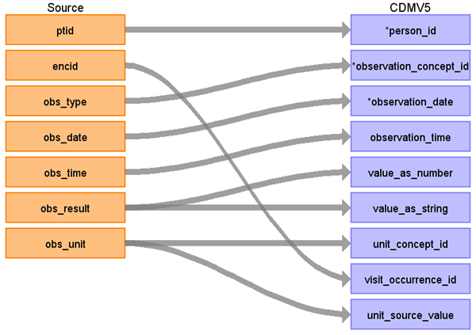

|  |  |  |  |
| --- | --- | --- | --- |
| Destination Field | Source Field | Logic | Comment |
| observation_id |  |  |  |
| person_id | ptid |  |  |
| observation_concept_id | obs_type | CASE WHEN ‘SMOKE’ THEN <concept_id>  CASE WHEN ‘ALCOHOL’ THEN <concept_id>  CASE WHEN ‘EXERCISE’ THEN <concept_id>  ELSE 0 | STCM Lookup JNJ_OPTUM_EHR_OBTYPE.csv  Create a source to concept map (STCM) for the native observations that should map to the CDM measurement table. Then when mapping rows to the the CDM Measurement table, only push over the rows that are in the STCM via an inner join. When the target is the CDM observation table, do a left join and bring over the values that are NOT in the STCM and use 0 for the concept id. |
| observation_date | obs_date |  |  |
| observation_time | obs_time |  |  |
| observation_type_concept_id |  |  | 38000280 |
| value_as_number | obs_result |  | When obs_result can be treated as a decimal, place the value in this field |
| value_as_string | obs_result |  | When the obs_result cannot be treated as a decimal, please the value in this field. |
| value_as_concept_id |  |  |  |
| qualifier_concept_id |  |  |  |
| unit_concept_id | obs_unit |  | Map to UCUM vocabulary using a CASE-SENSITIVE matching |
| provider_id | encid |  | To avoid duplication, apply the same logic described when transforming the encounter table to visit_occurrence above. |
| visit_occurrence_id | encid |  |  |
| observation_source_value |  |  |  |
| observation_source_concept_id |  |  |  |
| unit_source_value | obs_unit |  |  |
| qualifier_source_value |  |  |  |

### Reading from diagnosis

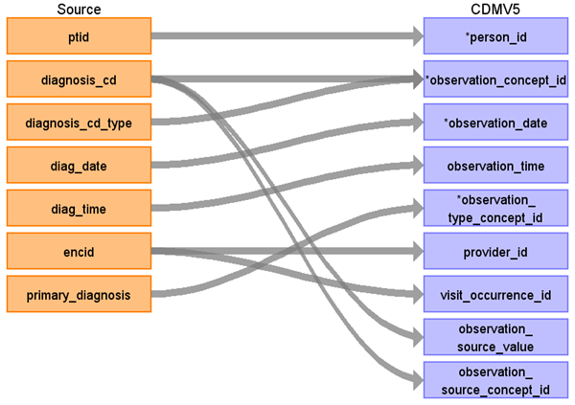

|  |  |  |  |
| --- | --- | --- | --- |
| Destination Field | Source Field | Logic | Comment |
| observation_id |  |  |  |
| person_id | ptid |  |  |
| observation_concept_id | diagnosis_cd  diagnosis_cd_type |  |  |
| observation_date | diag_date |  |  |
| observation_time | diag_time |  |  |
| observation_type_concept_id | primary_diagnosis |  | If primary_diagnosis = ‘1’ then 44786627  Else 44786629 |
| value_as_number |  |  |  |
| value_as_string |  |  |  |
| value_as_concept_id |  |  |  |
| qualifier_concept_id |  |  |  |
| unit_concept_id |  |  |  |
| provider_id | encid |  | To avoid duplication, apply the same logic described when transforming the encounter table to visit_occurrence above. |
| visit_occurrence_id | encid |  |  |
| observation_source_value | diagnosis_cd |  |  |
| observation_source_concept_id | diagnosis_cd |  |  |
| unit_source_value |  |  |  |
| qualifier_source_value |  |  |  |

### Reading from procedure

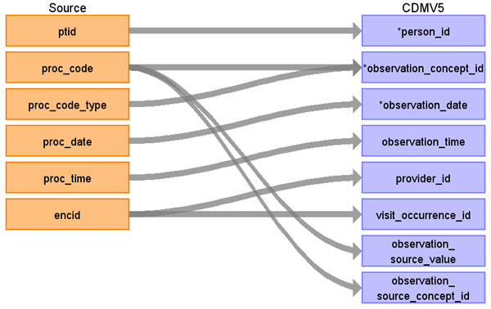

|  |  |  |  |
| --- | --- | --- | --- |
| Destination Field | Source Field | Logic | Comment |
| observation_id |  |  |  |
| person_id | ptid |  |  |
| observation_concept_id | proc_code  proc_code_type | Look for procedures that map to the vocabulary with domain_id = observation |  |
| observation_date | proc_date |  |  |
| observation_time | proc_time |  |  |
| observation_type_concept_id |  |  |  |
| value_as_number |  |  |  |
| value_as_string |  |  |  |
| value_as_concept_id |  |  |  |
| qualifier_concept_id |  |  |  |
| unit_concept_id |  |  |  |
| provider_id | encid |  | To avoid duplication, apply the same logic described when transforming the encounter table to visit_occurrence above. |
| visit_occurrence_id | encid |  |  |
| observation_source_value | proc_code |  |  |
| observation_source_concept_id | proc_code |  |  |
| unit_source_value |  |  |  |
| qualifier_source_value |  |  |  |

### Reading from microbiology

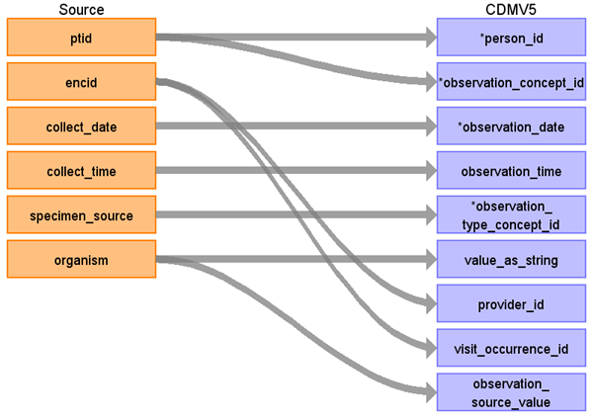

|  |  |  |  |
| --- | --- | --- | --- |
| Destination Field | Source Field | Logic | Comment |
| observation_id |  |  |  |
| person_id | ptid |  |  |
| observation_concept_id | ptid | 4155370 Microbiology |  |
| observation_date | collect_date |  |  |
| observation_time | collect_time |  |  |
| observation_type_concept_id | specimen_source | 44818702 Lab result  44818703 Pathology finding |  |
| value_as_number |  |  |  |
| value_as_string | organism |  |  |
| value_as_concept_id |  |  |  |
| qualifier_concept_id |  |  |  |
| unit_concept_id |  |  |  |
| provider_id | encid |  |  |
| visit_occurrence_id | encid |  |  |
| observation_source_value | organism |  |  |
| observation_source_concept_id |  |  |  |
| unit_source_value |  |  |  |
| qualifier_source_value |  |  |  |

### Reading from Insurance

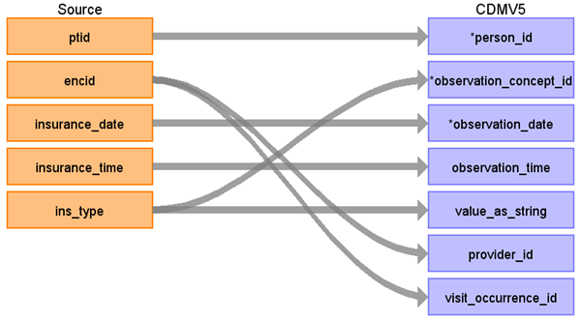

|  |  |  |  |
| --- | --- | --- | --- |
| Destination Field | Source Field | Logic | Comment |
| observation_id |  |  |  |
| person_id | ptid |  |  |
| observation_concept_id | ins_type | 45877222 | Insurance status/requirement |
| observation_date | insurance_date |  |  |
| observation_time | insurance_time |  |  |
| observation_type_concept_id |  |  |  |
| value_as_number |  |  |  |
| value_as_string | ins_type |  |  |
| value_as_concept_id |  |  |  |
| qualifier_concept_id |  |  |  |
| unit_concept_id |  |  |  |
| provider_id | encid |  | To avoid duplication, apply the same logic described when transforming the encounter table to visit_occurrence above. |
| visit_occurrence_id | encid |  |  |
| observation_source_value |  |  |  |
| observation_source_concept_id |  |  |  |
| unit_source_value |  |  |  |
| qualifier_source_value |  |  |  |

## Table Name: CDM_DOMAIN_META

|  |  |  |  |
| --- | --- | --- | --- |
| **CDM_DOMAIN_META** | | | |
| **Destination Field** | **Source Field** | **Applied Rule** | **Comment** |
| DOMAIN_ID | DOMAIN_ID from the table below |  |  |
| DESCRIPTION | DESCRIPTION from the lookup table below |  |  |

## Tables Not Mapped:

|  |  |  |
| --- | --- | --- |
| **Meta Data Lookup Table for OPTUM ONCOLOGY HER** | | |
| **TABLE NAME** | **DOMAIN_ID** | **DESCRIPTION** |
| PERSON | Person |  |
| OBSERVATION_PERIOD | Observation Period |  |
| CARE_SITE | Care Site |  |
| VISIT_OCCURRENCE | Visit |  |
| PROVIDER | Provider |  |
| DEATH | Death |  |
| CONDITION_OCCURRENCE | Condition |  |
| DRUG_EXPOSURE | Drug |  |
| PROCEDURE_OCCURRENCE | Procedure |  |
| MEASUREMENT | Measurement |  |
| OBSERVATION | Observation |  |

### Table name: cdm_source

|  |  |  |  |
| --- | --- | --- | --- |
| SOURCE_DOCUMENTATION_REFERENCE |  | <https://jnj.sharepoint.com/sites/PHM-GCSP-RND/RWE/Pages/DataSourceDetails.aspx?DataSourceItem=36> |  |
| CDM_ETL_REFERENCE |  | http://www.ohdsi.org/web/wiki/  doku.php?id=documentation:example_etls |  |
| SOURCE_RELEASE_DATE |  | SELECT VERSION_DATE  FROM [_Version] | Get from the source tables. |
| CDM_RELEASE_DATE |  | SELECT CONVERT(VARCHAR(10), GETDATE(),102) | Get the date the run completes on. |
| CDM_VERSION | - | V5.0 |  |
| VOCABULARY_VERSION | - | SELECT VOCABULARY_VERSION  FROM vocabulary  WHERE VOCABULARY_ID = 'None' | Taken from the Vocabulary loaded into the CDM. |

### Table name: payer_plan_period

### Table name: procedure_cost

### Table name: visit_cost

### Table name: drug_cost

### Table name: device_cost

### Table name: drug_era

### Table name: dose_era

### Table name: condition_era

### Table name: cohort

### Table name: cohort_definition

### Table name: cohort_attribute

### Table name: attribute_definition

# Appendix

# 1 Code Snippets

## 1.1 Vocabulary Mapping

Use this code to map source codes to concept ids; change the source_vocabulary_id and target_vocabulary_id as needed.

### 1.1.1 Source to Source

WITH CTE_VOCAB_MAP AS (

SELECT c.concept_code AS SOURCE_CODE, c.concept_id AS SOURCE_CONCEPT_ID, c.CONCEPT_NAME AS SOURCE_CODE_DESCRIPTION,

c.vocabulary_id AS SOURCE_VOCABULARY_ID, c.domain_id AS SOURCE_DOMAIN_ID, c.concept_class_id AS SOURCE_CONCEPT_CLASS_ID,

c.VALID_START_DATE AS SOURCE_VALID_START_DATE, c.VALID_END_DATE AS SOURCE_VALID_END_DATE, c.invalid_reason AS SOURCE_INVALID_REASON,

c.concept_ID as TARGET_CONCEPT_ID, c.concept_name AS TARGET_CONCEPT_NAME, c.vocabulary_id AS TARGET_VOCABULARY_ID, c.domain_id AS TARGET_DOMAIN_ID,

c.concept_class_id AS TARGET_CONCEPT_CLASS_ID, c.INVALID_REASON AS TARGET_INVALID_REASON,

c.STANDARD_CONCEPT AS TARGET_STANDARD_CONCEPT

FROM CONCEPT c

UNION

SELECT source_code, SOURCE_CONCEPT_ID, SOURCE_CODE_DESCRIPTION, source_vocabulary_id, c1.domain_id AS SOURCE_DOMAIN_ID, c2.CONCEPT_CLASS_ID AS SOURCE_CONCEPT_CLASS_ID,

c1.VALID_START_DATE AS SOURCE_VALID_START_DATE, c1.VALID_END_DATE AS SOURCE_VALID_END_DATE,stcm.INVALID_REASON AS SOURCE_INVALID_REASON,

target_concept_id, c2.CONCEPT_NAME AS TARGET_CONCEPT_NAME, target_vocabulary_id, c2.domain_id AS TARGET_DOMAIN_ID, c2.concept_class_id AS TARGET_CONCEPT_CLASS_ID,

c2.INVALID_REASON AS TARGET_INVALID_REASON, c2.standard_concept AS TARGET_STANDARD_CONCEPT

FROM source_to_concept_map stcm

LEFT OUTER JOIN CONCEPT c1

ON c1.concept_id = stcm.source_concept_id

LEFT OUTER JOIN CONCEPT c2

ON c2.CONCEPT_ID = stcm.target_concept_id

WHERE stcm.INVALID_REASON IS NULL

)

SELECT *

FROM CTE_VOCAB_MAP

/*EXAMPLE FILTERS*/

WHERE SOURCE_VOCABULARY_ID IN ('ICD9CM')

AND TARGET_VOCABULARY_ID IN ('ICD9CM')

### 1.1.2 Source to Standard Terminology

WITH CTE_VOCAB_MAP AS (

SELECT c.concept_code AS SOURCE_CODE, c.concept_id AS SOURCE_CONCEPT_ID, c.concept_name AS SOURCE_CODE_DESCRIPTION, c.vocabulary_id AS SOURCE_VOCABULARY_ID,

c.domain_id AS SOURCE_DOMAIN_ID, c.CONCEPT_CLASS_ID AS SOURCE_CONCEPT_CLASS_ID,

c.VALID_START_DATE AS SOURCE_VALID_START_DATE, c.VALID_END_DATE AS SOURCE_VALID_END_DATE, c.INVALID_REASON AS SOURCE_INVALID_REASON,

c1.concept_id AS TARGET_CONCEPT_ID, c1.concept_name AS TARGET_CONCEPT_NAME, c1.VOCABULARY_ID AS TARGET_VOCABUALRY_ID, c1.domain_id AS TARGET_DOMAIN_ID, c1.concept_class_id AS TARGET_CONCEPT_CLASS_ID,

c1.INVALID_REASON AS TARGET_INVALID_REASON, c1.standard_concept AS TARGET_STANDARD_CONCEPT

FROM CONCEPT C

JOIN CONCEPT_RELATIONSHIP CR

ON C.CONCEPT_ID = CR.CONCEPT_ID_1

AND CR.invalid_reason IS NULL

AND cr.relationship_id = 'Maps To'

JOIN CONCEPT C1

ON CR.CONCEPT_ID_2 = C1.CONCEPT_ID

AND C1.INVALID_REASON IS NULL

UNION

SELECT source_code, SOURCE_CONCEPT_ID, SOURCE_CODE_DESCRIPTION, source_vocabulary_id, c1.domain_id AS SOURCE_DOMAIN_ID, c2.CONCEPT_CLASS_ID AS SOURCE_CONCEPT_CLASS_ID,

c1.VALID_START_DATE AS SOURCE_VALID_START_DATE, c1.VALID_END_DATE AS SOURCE_VALID_END_DATE,

stcm.INVALID_REASON AS SOURCE_INVALID_REASON,target_concept_id, c2.CONCEPT_NAME AS TARGET_CONCEPT_NAME, target_vocabulary_id, c2.domain_id AS TARGET_DOMAIN_ID, c2.concept_class_id AS TARGET_CONCEPT_CLASS_ID,

c2.INVALID_REASON AS TARGET_INVALID_REASON, c2.standard_concept AS TARGET_STANDARD_CONCEPT

FROM source_to_concept_map stcm

LEFT OUTER JOIN CONCEPT c1

ON c1.concept_id = stcm.source_concept_id

LEFT OUTER JOIN CONCEPT c2

ON c2.CONCEPT_ID = stcm.target_concept_id

WHERE stcm.INVALID_REASON IS NULL

)

SELECT *

FROM CTE_VOCAB_MAP

/*EXAMPLE FILTERS*/

WHERE SOURCE_VOCABULARY_ID IN ('NDC')

AND TARGET_VOCABULARY_ID IN ('RxNORM')

### 1.1.3 Source to Maps to Value

WITH CTE_VOCAB_MAP AS (

SELECT c.concept_code AS SOURCE_CODE, c.concept_id AS SOURCE_CONCEPT_ID, c.concept_name AS SOURCE_CODE_DESCRIPTION, c.vocabulary_id AS SOURCE_VOCABULARY_ID,

c.domain_id AS SOURCE_DOMAIN_ID, c.CONCEPT_CLASS_ID AS SOURCE_CONCEPT_CLASS_ID,

c.VALID_START_DATE AS SOURCE_VALID_START_DATE, c.VALID_END_DATE AS SOURCE_VALID_END_DATE, c.INVALID_REASON AS SOURCE_INVALID_REASON,

c1.concept_id AS TARGET_CONCEPT_ID, c1.concept_name AS TARGET_CONCEPT_NAME, c1.VOCABULARY_ID AS TARGET_VOCABUALRY_ID, c1.domain_id AS TARGET_DOMAIN_ID, c1.concept_class_id AS TARGET_CONCEPT_CLASS_ID,

c1.INVALID_REASON AS TARGET_INVALID_REASON, c1.standard_concept AS TARGET_STANDARD_CONCEPT

FROM CONCEPT C

JOIN CONCEPT_RELATIONSHIP CR

ON C.CONCEPT_ID = CR.CONCEPT_ID_1

AND CR.invalid_reason IS NULL

AND cr.relationship_id = 'Maps To Value'

JOIN CONCEPT C1

ON CR.CONCEPT_ID_2 = C1.CONCEPT_ID

AND C1.INVALID_REASON IS NULL

)

SELECT *

FROM CTE_VOCAB_MAP

/*EXAMPLE FILTERS*/

WHERE SOURCE_CODE = 'V87.43'

## Source tables

### Table: patient

|  |  |  |  |
| --- | --- | --- | --- |
| Field | Type | Most freq. value | Comment |
| ptid | character | List truncated... | Create new integer value unique to PTID |
| birth_yr | character varying | 1930 and Earlier |  |
| gender | character varying | Male |  |
| race | character varying | Caucasian |  |
| ethnicity | character varying | Not Hispanic |  |
| region | character varying | South | ACTION: confirm it's clean mapping from region to division. If it is, then just bring division as it's more granular. |
| division | character varying | South Atl/West South Crl |  |
| avg_hh_income | double precision | 39005.0 |  |
| pct_college_educ | double precision | 26.0 |  |
| deceased_indicator | character varying | 0 |  |
| date_of_death | character |  |  |
| provid_pcp | character varying |  |  |
| idn_indicator | character | 1 |  |
| first_month_active | character varying | 200601 |  |
| last_month_active | character varying | 201506 |  |
| notes_eligible | character | 1 |  |
| has_notes | character | 1 |  |
| sourceid | character varying | S0034 |  |
| source_data_through | character varying | 201506 |  |

### Table: diagnosis

|  |  |  |  |
| --- | --- | --- | --- |
| Field | Type | Most freq. value | Comment |
| ptid | character | List truncated... |  |
| encid | character varying |  |  |
| diag_date | date | 2014-05-02 |  |
| diag_time | timestamp without time zone | 1900-01-01.000000 |  |
| diagnosis_cd | character varying |  |  |
| diagnosis_cd_type | character varying | ICD9 | To save time, create reference table with source concept and standard concept |
| diagnosis_status | character varying | Diagnosis of | Only use 'Diagnosis of' in CONDITION_OCCURRENCE |
| poa | character | 0 |  |
| admitting_diagnosis | character | 0 |  |
| discharge_diagnosis | character | 0 |  |
| primary_diagnosis | character | 0 |  |
| problem_list | character | N |  |

### Table: care_area

|  |  |  |  |
| --- | --- | --- | --- |
| Field | Type | Most freq. value | Comment |
| ptid | character | PT095853463 |  |
| encid | character varying | List truncated... |  |
| carearea | character varying | UNKNOWN CARE AREA |  |
| carearea_date | date |  |  |
| carearea_time | timestamp without time zone | 1900-01-01.000000 |  |

### Table: encounter_provider

|  |  |  |  |
| --- | --- | --- | --- |
| Field | Type | Most freq. value | Comment |
| encid | character varying | List truncated... |  |
| provid | character varying | 70371 |  |
| provider_role | character varying | ATTENDING |  |

### Table: provider

|  |  |  |  |
| --- | --- | --- | --- |
| Field | Type | Most freq. value | Comment |
| provid | character varying | List truncated... |  |
| specialty | character varying | Unspecified |  |
| prim_spec_ind | character | 1 |  |

### Table: visit

|  |  |  |  |
| --- | --- | --- | --- |
| Field | Type | Most freq. value | Comment |
| ptid | character | PT091048451 |  |
| visitid | bigint | List truncated... |  |
| visit_type | character varying | Inpatient |  |
| visit_start_date | date | 2012-08-13 |  |
| visit_start_time | timestamp without time zone | 1900-01-01.000000 | delete the null time 1900-01-01.000000 21,485 23.0 |
| visit_end_date | date | 2014-07-25 |  |
| visit_end_time | timestamp without time zone | 1900-01-01.000000 |  |
| discharge_disposition | character varying | 01 DISCHARGED TO HOME OR SELF CARE |  |
| admission_source | character varying | Referred by physician or self referral; non-healthcare facility point of origin |  |
| drg | character varying |  |  |

### Table: encounter

|  |  |  |  |
| --- | --- | --- | --- |
| Field | Type | Most freq. value | Comment |
| ptid | character | List truncated... |  |
| visitid | bigint |  |  |
| encid | character varying | List truncated... |  |
| interaction_type | character varying | Office or clinic patient | Outpatient, Inpatient, ER, LTC. "Prescriptions and refills" don't sound like a valid encounter. Shouldn't be just going to the pharmacy. "other" --> unknown |
| interaction_date | date | 2014-06-16 |  |
| interaction_time | timestamp without time zone | 1900-01-01.000000 |  |

### Table: nlp_sds

|  |  |  |  |
| --- | --- | --- | --- |
| Field | Type | Most freq. value | Comment |
| ptid | character | List truncated... |  |
| encid | character varying |  |  |
| note_date | date | 2013-04-23 |  |
| sds_term | character varying | pain | usagi. restrict to condition, only use high quality mapping. everything else, drop it. |
| sds_location | character varying |  |  |
| sds_attribute | character varying |  |  |
| sds_sentiment | character varying |  | need to express only 'positive' findings in CONDITION_OCCURRENCE |
| note_section | character varying |  |  |

### Table: medication_administrations

|  |  |  |  |
| --- | --- | --- | --- |
| Field | Type | Most freq. value | Comment |
| ptid | character | PT093154612 |  |
| encid | character varying |  |  |
| drug_name | character varying | SODIUM CHLORIDE 0.9 % |  |
| ndc | character varying | 00338004904 |  |
| ndc_source | character varying | Derived |  |
| order_date | date | 2014-10-07 |  |
| order_time | timestamp without time zone | 1900-01-01.000000 |  |
| admin_date | date |  |  |
| admin_time | timestamp without time zone |  |  |
| provid | character varying |  |  |
| quantity_of_dose | character varying |  |  |
| route | character varying | Intravenous |  |
| strength | character varying |  |  |
| strength_unit | character varying |  |  |
| dosage_form | character varying |  |  |
| dosefreq | character varying |  |  |
| generic_desc | character varying | SODIUM CHLORIDE |  |
| drug_class | character varying | Intravenous nutritional therapy; electrolyte; trace element; metal; vitamin; alone or combinations |  |

### Table: patient_reported_meds

|  |  |  |  |
| --- | --- | --- | --- |
| Field | Type | Most freq. value | Comment |
| ptid | character | PT155237089 |  |
| reported_date | date | 2009-03-27 |  |
| drug_name | character varying |  |  |
| ndc | character varying | 49999035930 |  |
| ndc_source | character varying | Direct |  |
| provid | character varying |  |  |
| route | character varying | Oral |  |
| quantity_of_dose | character varying |  |  |
| strength | character varying |  |  |
| strength_unit | character varying | mg |  |
| dosage_form | character varying | Tabs |  |
| dosefreq | character varying |  |  |
| generic_desc | character varying |  |  |
| drug_class | character varying | Salicylates |  |

### Table: prescriptions_written

|  |  |  |  |
| --- | --- | --- | --- |
| Field | Type | Most freq. value | Comment |
| ptid | character | PT118881881 |  |
| rxdate | date | 2014-02-24 |  |
| rxtime | timestamp without time zone | 1900-01-01.000000 |  |
| drug_name | character varying |  |  |
| ndc | character varying | 00406035705 |  |
| ndc_source | character varying | Direct |  |
| provid | character varying |  |  |
| route | character varying | Oral |  |
| quantity_of_dose | character varying |  |  |
| strength | character varying |  |  |
| strength_unit | character varying | mg |  |
| dosage_form | character varying | Tabs |  |
| dosefreq | character varying |  |  |
| quantity_per_fill | character varying | 30 |  |
| num_refills | double precision | 0.0 |  |
| days_supply | double precision |  |  |
| generic_desc | character varying |  |  |
| drug_class | character varying | HMG & CoA reductase inhibitors (statins) |  |

### Table: nlp_drug_rationale

|  |  |  |  |
| --- | --- | --- | --- |
| Field | Type | Most freq. value | Comment |
| ptid | character | PT191017751 |  |
| encid | character varying |  |  |
| note_date | date | 2013-04-23 |  |
| note_section | character varying | MEDICATIONS |  |
| drug_name | character varying | ASPIRIN |  |
| drug_action | character varying | N/A |  |
| drug_action_preposition | character varying | OF |  |
| reason_general | character varying |  |  |
| sentiment | character varying |  |  |
| sentiment_who | character varying |  |  |

### Table: immunization

|  |  |  |  |
| --- | --- | --- | --- |
| Field | Type | Most freq. value | Comment |
| ptid | character | PT194773862 |  |
| immunization_date | date |  |  |
| immunization_desc | character varying | INFLUENZA VIRUS VACCINE; INACTIVATED |  |
| mapped_name | character varying | Influenza Inactivated Vaccine |  |
| ndc | character varying | 49281001350 |  |
| ndc_source | character varying | Derived |  |
| pt_reported | character |  |  |

### Table: procedure

|  |  |  |  |
| --- | --- | --- | --- |
| Field | Type | Most freq. value | Comment |
| ptid | character | List truncated... |  |
| encid | character varying |  |  |
| proc_date | date | 2012-10-22 |  |
| proc_time | timestamp without time zone | 1900-01-01.000000 |  |
| proc_code | character varying |  |  |
| proc_desc | character varying |  |  |
| proc_code_type | character varying | CPT4 |  |
| provid_perform | character varying |  |  |
| provid_order | character varying |  |  |
| betos_code | character varying |  |  |
| betos_desc | character varying |  |  |

### Table: nlp_measurements

|  |  |  |  |
| --- | --- | --- | --- |
| Field | Type | Most freq. value | Comment |
| ptid | character | PT130234983 |  |
| encid | character varying |  |  |
| note_date | date | 2013-04-23 |  |
| measurement_type | character varying | DBP |  |
| measurement_value | character varying | 2 |  |
| measurement_detail | character varying |  |  |
| note_section | character varying |  |  |
| measurement_date | date |  |  |

### Table: insurance

|  |  |  |  |
| --- | --- | --- | --- |
| Field | Type | Most freq. value | Comment |
| ptid | character | PT130555350 |  |
| encid | character varying | List truncated... |  |
| insurance_date | date | 2008-09-15 |  |
| insurance_time | timestamp without time zone | 1900-01-01.000000 |  |
| ins_type | character varying | Medicare |  |

### Table: labs

|  |  |  |  |
| --- | --- | --- | --- |
| Field | Type | Most freq. value | Comment |
| ptid | character | PT143890838 |  |
| encid | character varying |  |  |
| test_name | character varying | O2 saturation.oximetry |  |
| order_date | date |  |  |
| order_time | timestamp without time zone |  |  |
| collected_date | date |  |  |
| collected_time | timestamp without time zone |  |  |
| result_date | date |  |  |
| result_time | timestamp without time zone | 1900-01-01.000000 |  |
| test_result | character varying | Negative |  |
| relative_indicator | character varying |  |  |
| result_unit | character varying | % |  |
| normal_range | character varying |  |  |
| evaluated_for_range | character | N |  |
| value_within_range | character | U |  |

### Table: observations

|  |  |  |  |
| --- | --- | --- | --- |
| Field | Type | Most freq. value | Comment |
| ptid | character | PT143890838 |  |
| encid | character varying |  |  |
| obs_type | character varying | SBP |  |
| obs_date | date | 2014-06-10 |  |
| obs_time | timestamp without time zone | 1900-01-01.000000 |  |
| obs_result | character varying | 18 |  |
| obs_unit | character varying | mm Hg |  |
| evaluated_for_range | character | N |  |
| value_within_range | character | U |  |

### Table: microbiology

|  |  |  |  |
| --- | --- | --- | --- |
| Field | Type | Most freq. value | Comment |
| ptid | character | PT117858758 |  |
| encid | character varying |  |  |
| order_date | date |  |  |
| order_time | timestamp without time zone | 1900-01-01.000000 |  |
| collect_date | date |  |  |
| collect_time | timestamp without time zone | 1900-01-01.000000 |  |
| receive_date | date |  |  |
| receive_time | timestamp without time zone |  |  |
| result_date | date | 2015-05-22 |  |
| result_time | timestamp without time zone | 1900-01-01.000000 |  |
| result_status | character varying |  |  |
| specimen_source | character varying | Urine |  |
| organism | character varying |  |  |
| mapped_organism_found | character varying |  |  |
| mapped_organism_excluded | character varying |  |  |
| culture_growth | character varying |  |  |
| culture_value | character varying |  |  |
| culture_unit | character varying |  |  |
| antibiotic | character varying |  |  |
| mapped_antibiotic | character varying |  |  |
| sensitivity | character varying |  |  |

### Table: nlp_biomarker

|  |  |  |  |
| --- | --- | --- | --- |
| Field | Type | Most freq. value | Comment |
| ptid | character | PT084542965 |  |
| note_date | date | 2013-04-23 |  |
| biomarker | character varying | CD20 |  |
| variation_detail | character varying |  |  |
| biomarker_status | character varying | positive |  |

### Table: nlp_sds_family

|  |  |  |  |
| --- | --- | --- | --- |
| Field | Type | Most freq. value | Comment |
| ptid | character | PT084524827 |  |
| encid | character varying |  |  |
| note_date | date | 2014-07-23 |  |
| sds_term | character varying | cancer |  |
| sds_location | character varying |  |  |
| sds_family_member | character varying | who=family |  |
| sds_sentiment | character varying |  |  |
| note_section | character varying | family medical history |  |

|  |  |  |  |  |  |  |  |  |  |
| --- | --- | --- | --- | --- | --- | --- | --- | --- | --- |
| 38000175 | Prescription dispensed in pharmacy | Type Concept | Drug Type | Drug Type | S | OMOP generated | 1970-01-01 | 2099-12-31 |  |
| 38000176 | Prescription dispensed through mail order | Type Concept | Drug Type | Drug Type | S | OMOP generated | 1970-01-01 | 2099-12-31 |  |
| 38000177 | Prescription written | Type Concept | Drug Type | Drug Type | S | OMOP generated | 1970-01-01 | 2099-12-31 |  |
| 38000178 | Medication list entry | Type Concept | Drug Type | Drug Type | S | OMOP generated | 1970-01-01 | 2099-12-31 |  |
| 38000179 | Physician administered drug (identified as procedure) | Type Concept | Drug Type | Drug Type | S | OMOP generated | 1970-01-01 | 2099-12-31 |  |
| 38000180 | Inpatient administration | Type Concept | Drug Type | Drug Type | S | OMOP generated | 1970-01-01 | 2099-12-31 |  |
| 38000181 | Drug era - 0 days persistence window | Type Concept | Drug Type | Drug Type | S | OMOP generated | 1970-01-01 | 2099-12-31 |  |
| 38000182 | Drug era - 30 days persistence window | Type Concept | Drug Type | Drug Type | S | OMOP generated | 1970-01-01 | 2099-12-31 |  |
| 44787730 | Patient Self-Reported Medication | Type Concept | Drug Type | Drug Type | S | OMOP generated | 1970-01-01 | 2099-12-31 |  |
| 43542356 | Physician administered drug (identified from EHR problem list) | Type Concept | Drug Type | Drug Type | S | OMOP generated | 1970-01-01 | 2099-12-31 |  |
| 43542357 | Physician administered drug (identified from referral record) | Type Concept | Drug Type | Drug Type | S | OMOP generated | 1970-01-01 | 2099-12-31 |  |
| 43542358 | Physician administered drug (identified from EHR observation) | Type Concept | Drug Type | Drug Type | S | OMOP generated | 1970-01-01 | 2099-12-31 |  |
| 44777970 | Randomized Drug | Type Concept | Drug Type | Drug Type | S | OMOP generated | 1970-01-01 | 2099-12-31 |  |