My first automatic report

## Amoxicillin

### Attrition

There were identified a total of 42788 in the database with a total of 161717 records. Of those only 19457 (45.5%) satisfied the inclusion criteria. See the attrition below:

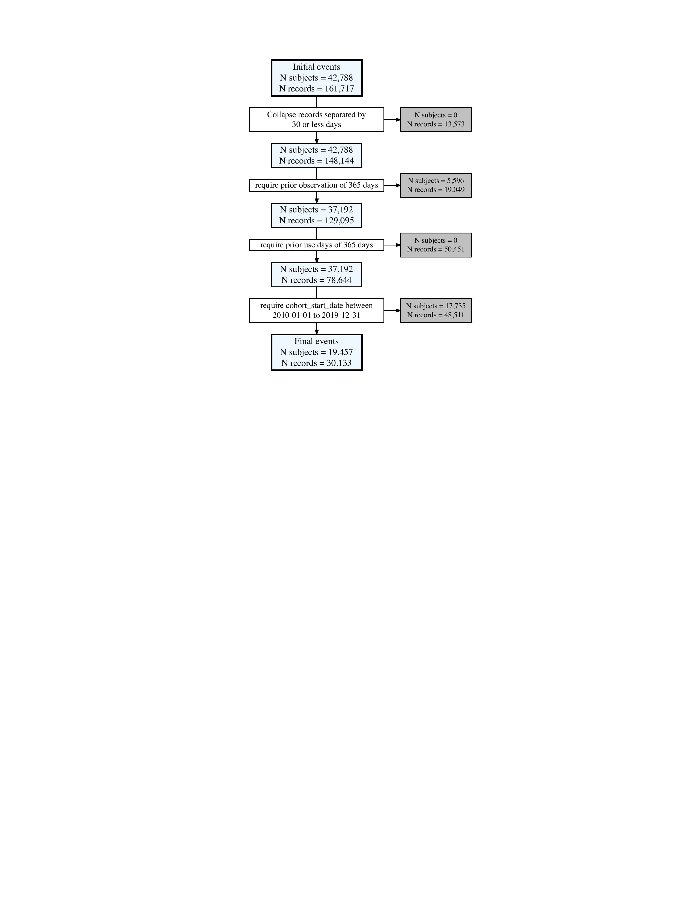

### Characteristics

The characteristics of the new users of amoxicillin was the following:

| Variable name | Variable level | Estimate name | Estimate value |
| --- | --- | --- | --- |
| Number records | - | N | 30,133 |
| Number subjects | - | N | 19,457 |
| Cohort start date | - | Median [Q25 - Q75] | 2013-10-17 [2011-11-21 - 2016-03-09] |
|  |  | Range | 2010-01-01 to 2019-12-31 |
| Cohort end date | - | Median [Q25 - Q75] | 2013-10-23 [2011-11-27 - 2016-03-16] |
|  |  | Range | 2010-01-07 to 2020-01-23 |
| Age | - | Median [Q25 - Q75] | 45 [21 - 65] |
|  |  | Mean (SD) | 43.16 (26.08) |
|  |  | Range | 1 to 112 |
| Age group | 0 to 19 | N (%) | 7,155 (23.74%) |
|  | 20 to 39 | N (%) | 5,915 (19.63%) |
|  | 40 to 59 | N (%) | 7,624 (25.30%) |
|  | 60 to 79 | N (%) | 6,997 (23.22%) |
|  | 80 to 150 | N (%) | 2,442 (8.10%) |
| Sex | Female | N (%) | 17,311 (57.45%) |
|  | Male | N (%) | 12,822 (42.55%) |
| Prior observation | - | Median [Q25 - Q75] | 3,413 [1,674 - 4,950] |
|  |  | Mean (SD) | 3,503.70 (2,137.64) |
|  |  | Range | 365 to 11,197 |
| Future observation | - | Median [Q25 - Q75] | 1,888 [841 - 3,170] |
|  |  | Mean (SD) | 2,089.88 (1,436.62) |
|  |  | Range | 0 to 5,271 |
| Days in cohort | - | Median [Q25 - Q75] | 7 [7 - 7] |
|  |  | Mean (SD) | 7.71 (8.19) |
|  |  | Range | 1 to 645 |
| Number of visits in the year prior | - | Median [Q25 - Q75] | 13.00 [5.00 - 26.00] |
|  |  | Mean (SD) | 18.42 (17.78) |
|  |  | Range | 0.00 to 310.00 |
| Medications in the year prior | D dermatologicals | N (%) | 9,761 (32.39%) |
|  | N nervous system | N (%) | 13,906 (46.15%) |
|  | R respiratory system | N (%) | 10,904 (36.19%) |
|  | S sensory organs | N (%) | 3,909 (12.97%) |
|  | A alimentary tract and metabolism | N (%) | 12,565 (41.70%) |
|  | B blood and blood forming organs | N (%) | 5,276 (17.51%) |
|  | P antiparasitic products insecticides and repellents | N (%) | 1,425 (4.73%) |
|  | J antiinfectives for systemic use | N (%) | 11,146 (36.99%) |
|  | G genito urinary system and sex hormones | N (%) | 6,901 (22.90%) |
|  | M musculo skeletal system | N (%) | 7,433 (24.67%) |
|  | V various | N (%) | 1,692 (5.62%) |
|  | H systemic hormonal preparations excl sex hormones and insulins | N (%) | 3,562 (11.82%) |
|  | L antineoplastic and immunomodulating agents | N (%) | 1,030 (3.42%) |
|  | C cardiovascular system | N (%) | 11,495 (38.15%) |
| Conditions any time prior | Diseases of the nervous system | N (%) | 5,957 (19.77%) |
|  | Certain conditions originating in the perinatal period | N (%) | 849 (2.82%) |
|  | Certain infectious and parasitic diseases | N (%) | 13,262 (44.01%) |
|  | Mental and behavioural disorders | N (%) | 1,198 (3.98%) |
|  | Pregnancy childbirth and the puerperium | N (%) | 1,034 (3.43%) |
|  | Endocrine nutritional and metabolic diseases | N (%) | 1,564 (5.19%) |
|  | Neoplasms | N (%) | 1,278 (4.24%) |
|  | Diseases of the digestive system | N (%) | 4,091 (13.58%) |
|  | Diseases of the circulatory system | N (%) | 8,233 (27.32%) |
|  | Symptoms signs and abnormal clinical and laboratory findings not elsewhere classified | N (%) | 25,540 (84.76%) |
|  | Diseases of the skin and subcutaneous tissue | N (%) | 7,414 (24.60%) |
|  | Injury poisoning and certain other consequences of external causes | N (%) | 11,340 (37.63%) |
|  | Diseases of the ear and mastoid process | N (%) | 1,727 (5.73%) |
|  | Diseases of the genitourinary system | N (%) | 3,298 (10.94%) |
|  | Diseases of the respiratory system | N (%) | 5,365 (17.80%) |
|  | Congenital malformations deformations and chromosomal abnormalities | N (%) | 185 (0.61%) |
|  | Codes for special purposes | N (%) | 4,564 (15.15%) |
|  | Diseases of the musculoskeletal system and connective tissue | N (%) | 9,840 (32.66%) |
|  | Diseases of the eye and adnexa | N (%) | 2,660 (8.83%) |
|  | Factors influencing health status and contact with health services | N (%) | 25,780 (85.55%) |
|  | Diseases of the blood and blood forming organs and certain disorders involving the immune mechanism | N (%) | 2,307 (7.66%) |
|  | External causes of morbidity and mortality | N (%) | 793 (2.63%) |

#### By sex

|  |  |  | **Sex** | | |
| --- | --- | --- | --- | --- | --- |
| Variable name | Variable level | Estimate name | overall | Female | Male |
| Number records | - | N | 30,133 | 17,311 | 12,822 |
| Number subjects | - | N | 19,457 | 10,876 | 8,581 |
| Cohort start date | - | Median [Q25 - Q75] | 2013-10-17 [2011-11-21 - 2016-03-09] | 2013-10-25 [2011-11-18 - 2016-03-16] | 2013-10-08 [2011-11-22 - 2016-02-26] |
|  |  | Range | 2010-01-01 to 2019-12-31 | 2010-01-01 to 2019-12-31 | 2010-01-04 to 2019-12-31 |
| Cohort end date | - | Median [Q25 - Q75] | 2013-10-23 [2011-11-27 - 2016-03-16] | 2013-11-03 [2011-11-24 - 2016-03-22] | 2013-10-14 [2011-11-28 - 2016-03-03] |
|  |  | Range | 2010-01-07 to 2020-01-23 | 2010-01-07 to 2020-01-23 | 2010-01-08 to 2020-01-22 |
| Age | - | Median [Q25 - Q75] | 45 [21 - 65] | 45 [24 - 65] | 45 [15 - 64] |
|  |  | Mean (SD) | 43.16 (26.08) | 44.28 (25.46) | 41.65 (26.82) |
|  |  | Range | 1 to 112 | 1 to 112 | 1 to 106 |
| Age group | 0 to 19 | N (%) | 7,155 (23.74%) | 3,509 (20.27%) | 3,646 (28.44%) |
|  | 20 to 39 | N (%) | 5,915 (19.63%) | 3,859 (22.29%) | 2,056 (16.03%) |
|  | 40 to 59 | N (%) | 7,624 (25.30%) | 4,514 (26.08%) | 3,110 (24.26%) |
|  | 60 to 79 | N (%) | 6,997 (23.22%) | 3,883 (22.43%) | 3,114 (24.29%) |
|  | 80 to 150 | N (%) | 2,442 (8.10%) | 1,546 (8.93%) | 896 (6.99%) |
| Sex | Female | N (%) | 17,311 (57.45%) | 17,311 (100.00%) | - |
|  | Male | N (%) | 12,822 (42.55%) | - | 12,822 (100.00%) |
| Prior observation | - | Median [Q25 - Q75] | 3,413 [1,674 - 4,950] | 3,499 [1,764 - 5,002] | 3,302 [1,586 - 4,867] |
|  |  | Mean (SD) | 3,503.70 (2,137.64) | 3,563.78 (2,133.80) | 3,422.59 (2,140.23) |
|  |  | Range | 365 to 11,197 | 365 to 10,993 | 365 to 11,197 |
| Future observation | - | Median [Q25 - Q75] | 1,888 [841 - 3,170] | 1,881 [848 - 3,167] | 1,899 [833 - 3,180] |
|  |  | Mean (SD) | 2,089.88 (1,436.62) | 2,088.59 (1,434.32) | 2,091.62 (1,439.78) |
|  |  | Range | 0 to 5,271 | 1 to 5,269 | 0 to 5,271 |
| Days in cohort | - | Median [Q25 - Q75] | 7 [7 - 7] | 7 [7 - 7] | 7 [7 - 7] |
|  |  | Mean (SD) | 7.71 (8.19) | 7.78 (9.70) | 7.60 (5.52) |
|  |  | Range | 1 to 645 | 1 to 645 | 1 to 128 |
| Number of visits in the year prior | - | Median [Q25 - Q75] | 13.00 [5.00 - 26.00] | 15.00 [7.00 - 27.00] | 11.00 [4.00 - 24.00] |
|  |  | Mean (SD) | 18.42 (17.78) | 19.52 (17.70) | 16.94 (17.79) |
|  |  | Range | 0.00 to 310.00 | 0.00 to 207.00 | 0.00 to 310.00 |
| Medications in the year prior | D dermatologicals | N (%) | 9,761 (32.39%) | 5,835 (33.71%) | 3,926 (30.62%) |
|  | N nervous system | N (%) | 13,906 (46.15%) | 8,742 (50.50%) | 5,164 (40.27%) |
|  | R respiratory system | N (%) | 10,904 (36.19%) | 6,532 (37.73%) | 4,372 (34.10%) |
|  | S sensory organs | N (%) | 3,909 (12.97%) | 2,344 (13.54%) | 1,565 (12.21%) |
|  | A alimentary tract and metabolism | N (%) | 12,565 (41.70%) | 7,633 (44.09%) | 4,932 (38.47%) |
|  | B blood and blood forming organs | N (%) | 5,276 (17.51%) | 3,417 (19.74%) | 1,859 (14.50%) |
|  | P antiparasitic products insecticides and repellents | N (%) | 1,425 (4.73%) | 984 (5.68%) | 441 (3.44%) |
|  | J antiinfectives for systemic use | N (%) | 11,146 (36.99%) | 7,259 (41.93%) | 3,887 (30.32%) |
|  | G genito urinary system and sex hormones | N (%) | 6,901 (22.90%) | 4,967 (28.69%) | 1,934 (15.08%) |
|  | M musculo skeletal system | N (%) | 7,433 (24.67%) | 4,710 (27.21%) | 2,723 (21.24%) |
|  | V various | N (%) | 1,692 (5.62%) | 1,186 (6.85%) | 506 (3.95%) |
|  | H systemic hormonal preparations excl sex hormones and insulins | N (%) | 3,562 (11.82%) | 2,496 (14.42%) | 1,066 (8.31%) |
|  | L antineoplastic and immunomodulating agents | N (%) | 1,030 (3.42%) | 748 (4.32%) | 282 (2.20%) |
|  | C cardiovascular system | N (%) | 11,495 (38.15%) | 6,563 (37.91%) | 4,932 (38.47%) |
| Conditions any time prior | Diseases of the nervous system | N (%) | 5,957 (19.77%) | 3,723 (21.51%) | 2,234 (17.42%) |
|  | Certain conditions originating in the perinatal period | N (%) | 849 (2.82%) | 416 (2.40%) | 433 (3.38%) |
|  | Certain infectious and parasitic diseases | N (%) | 13,262 (44.01%) | 7,927 (45.79%) | 5,335 (41.61%) |
|  | Mental and behavioural disorders | N (%) | 1,198 (3.98%) | 801 (4.63%) | 397 (3.10%) |
|  | Pregnancy childbirth and the puerperium | N (%) | 1,034 (3.43%) | 995 (5.75%) | 39 (0.30%) |
|  | Endocrine nutritional and metabolic diseases | N (%) | 1,564 (5.19%) | 925 (5.34%) | 639 (4.98%) |
|  | Neoplasms | N (%) | 1,278 (4.24%) | 769 (4.44%) | 509 (3.97%) |
|  | Diseases of the digestive system | N (%) | 4,091 (13.58%) | 2,480 (14.33%) | 1,611 (12.56%) |
|  | Diseases of the circulatory system | N (%) | 8,233 (27.32%) | 4,813 (27.80%) | 3,420 (26.67%) |
|  | Symptoms signs and abnormal clinical and laboratory findings not elsewhere classified | N (%) | 25,540 (84.76%) | 15,193 (87.77%) | 10,347 (80.70%) |
|  | Diseases of the skin and subcutaneous tissue | N (%) | 7,414 (24.60%) | 4,331 (25.02%) | 3,083 (24.04%) |
|  | Injury poisoning and certain other consequences of external causes | N (%) | 11,340 (37.63%) | 6,875 (39.71%) | 4,465 (34.82%) |
|  | Diseases of the ear and mastoid process | N (%) | 1,727 (5.73%) | 1,013 (5.85%) | 714 (5.57%) |
|  | Diseases of the genitourinary system | N (%) | 3,298 (10.94%) | 2,456 (14.19%) | 842 (6.57%) |
|  | Diseases of the respiratory system | N (%) | 5,365 (17.80%) | 3,012 (17.40%) | 2,353 (18.35%) |
|  | Congenital malformations deformations and chromosomal abnormalities | N (%) | 185 (0.61%) | 76 (0.44%) | 109 (0.85%) |
|  | Codes for special purposes | N (%) | 4,564 (15.15%) | 2,413 (13.94%) | 2,151 (16.78%) |
|  | Diseases of the musculoskeletal system and connective tissue | N (%) | 9,840 (32.66%) | 5,831 (33.68%) | 4,009 (31.27%) |
|  | Diseases of the eye and adnexa | N (%) | 2,660 (8.83%) | 1,531 (8.84%) | 1,129 (8.81%) |
|  | Factors influencing health status and contact with health services | N (%) | 25,780 (85.55%) | 15,329 (88.55%) | 10,451 (81.51%) |
|  | Diseases of the blood and blood forming organs and certain disorders involving the immune mechanism | N (%) | 2,307 (7.66%) | 1,439 (8.31%) | 868 (6.77%) |
|  | External causes of morbidity and mortality | N (%) | 793 (2.63%) | 532 (3.07%) | 261 (2.04%) |