# Triangulating evidence of the cause-effect relationship between sclerostin inhibition and cardiovascular outcomes

## Figures

Authors: Marta Alcalde-Herraiz, Junqing Xie,

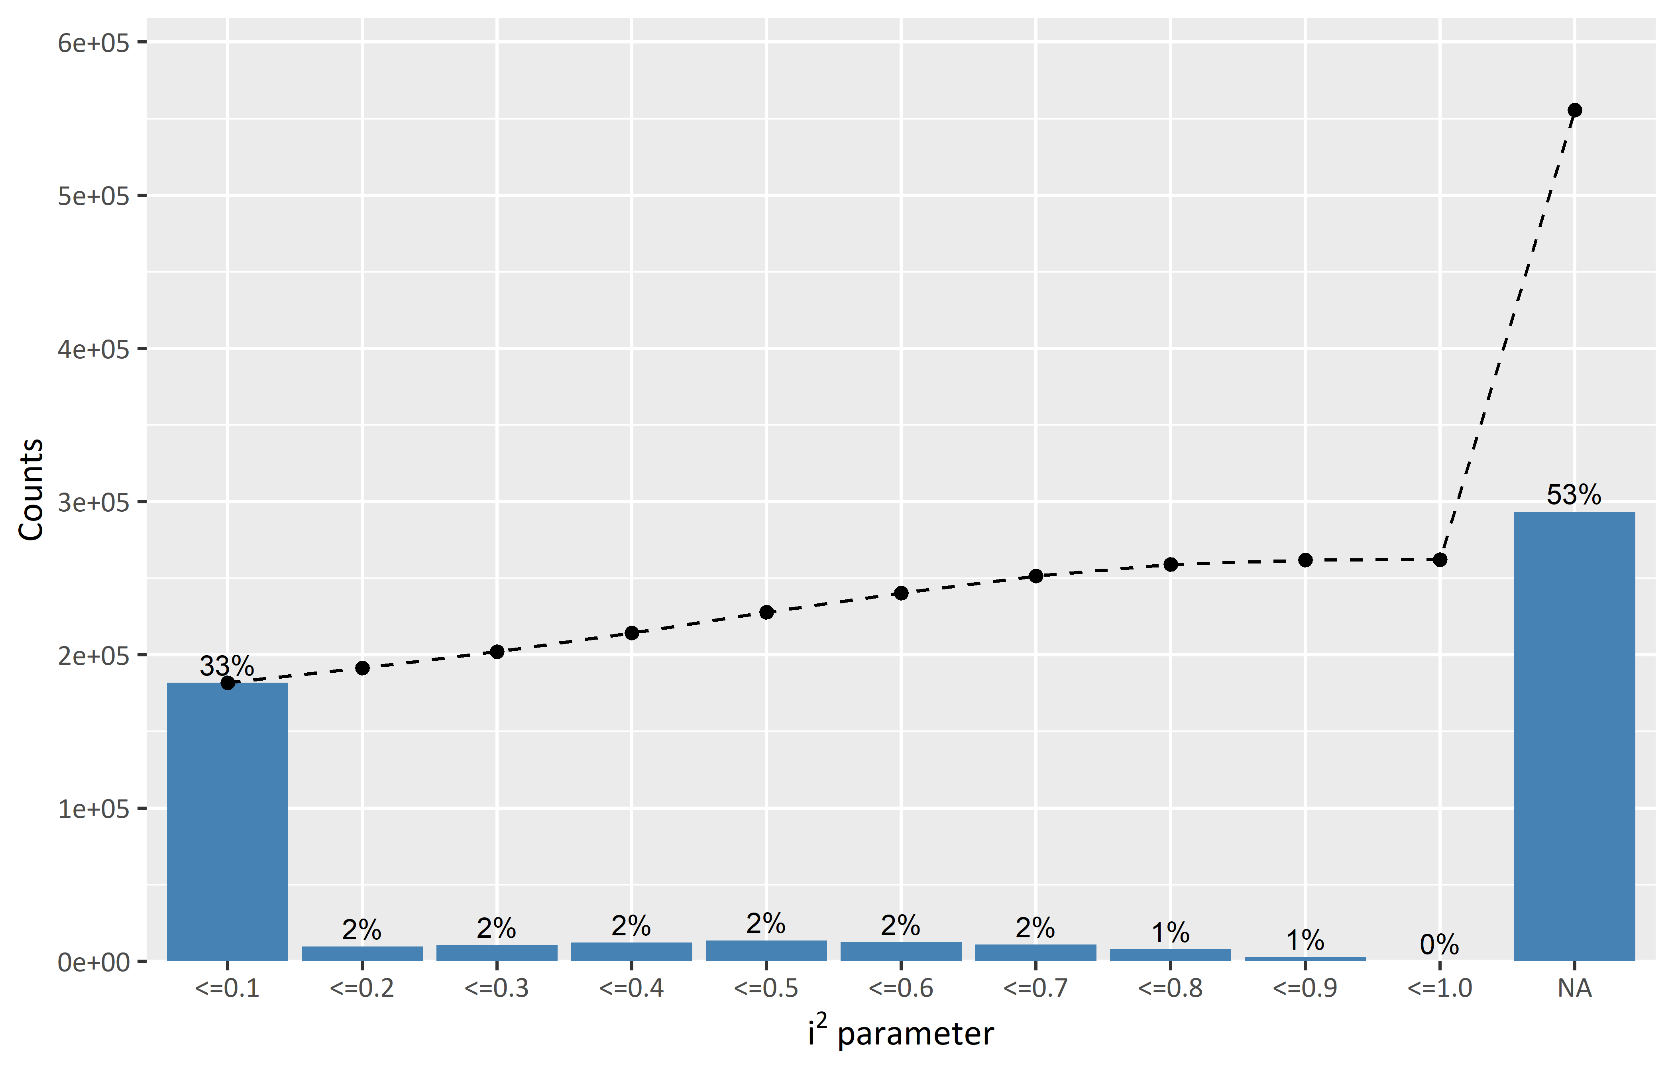

**Figure 1.** Heterogeneity between databases.

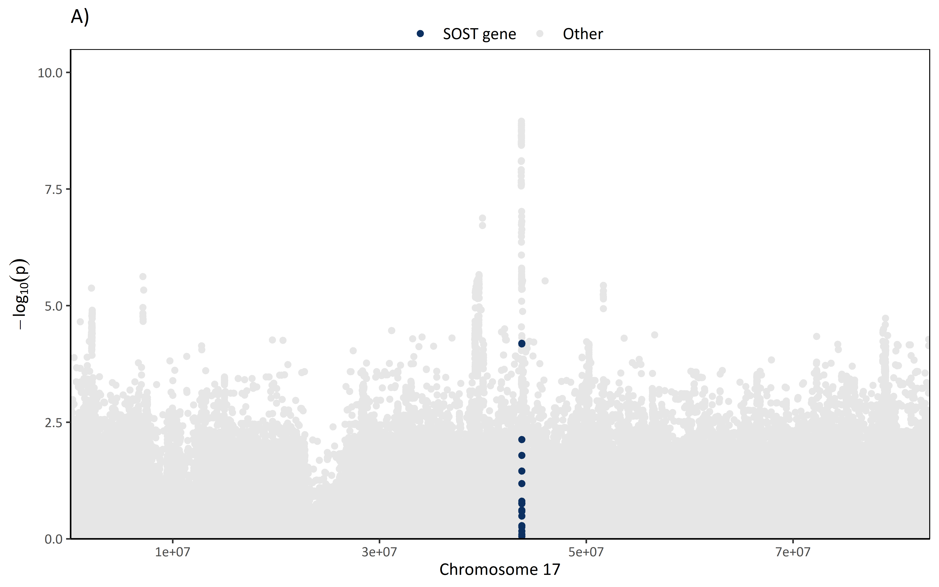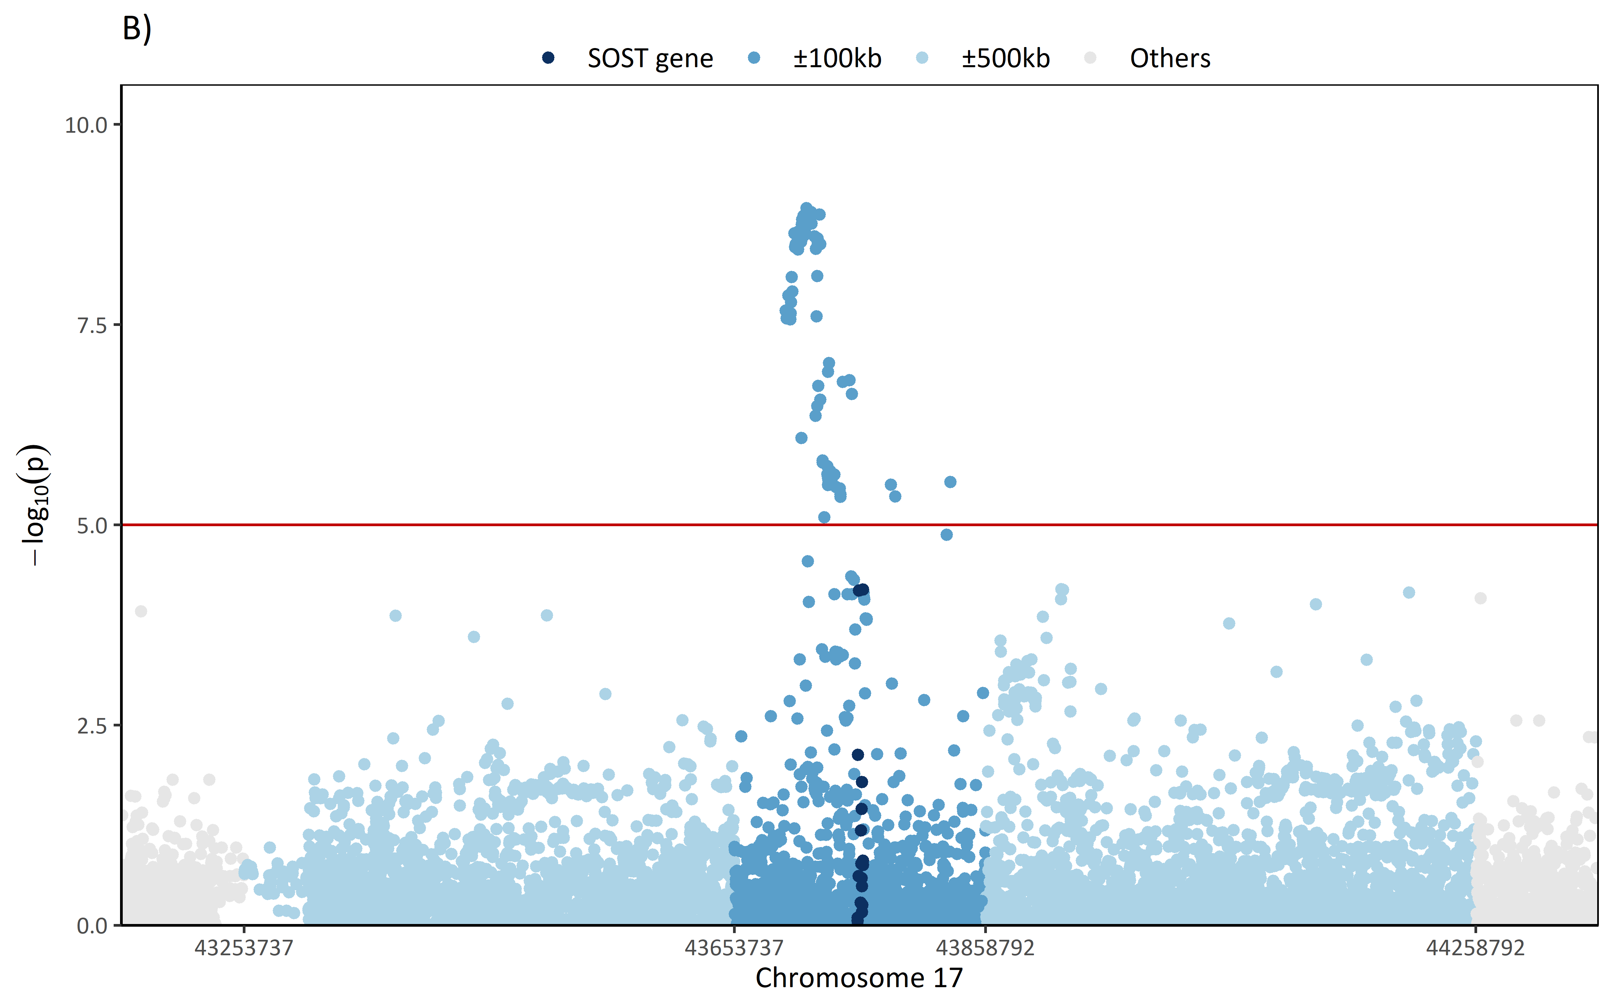**Figure 2.** Manhattan plot of the meta-analysed SNPs (fixed-effects method). **(A)** Manhattan plot of the whole chromosome 17. Dark blue dots correspond to SNPs within the SOST gene. **(B)** Manhattan plot from ±600kb of the start/end of the SOST gene. Dark blued dots correspond to SNPs within the SOST gene. Dark-light blue dots correspond to SNPs within ±100kb from the start/end of the SOST gene. Light blue dots correspond to SNPs withi ±500kb from the start/end of the SOST gene.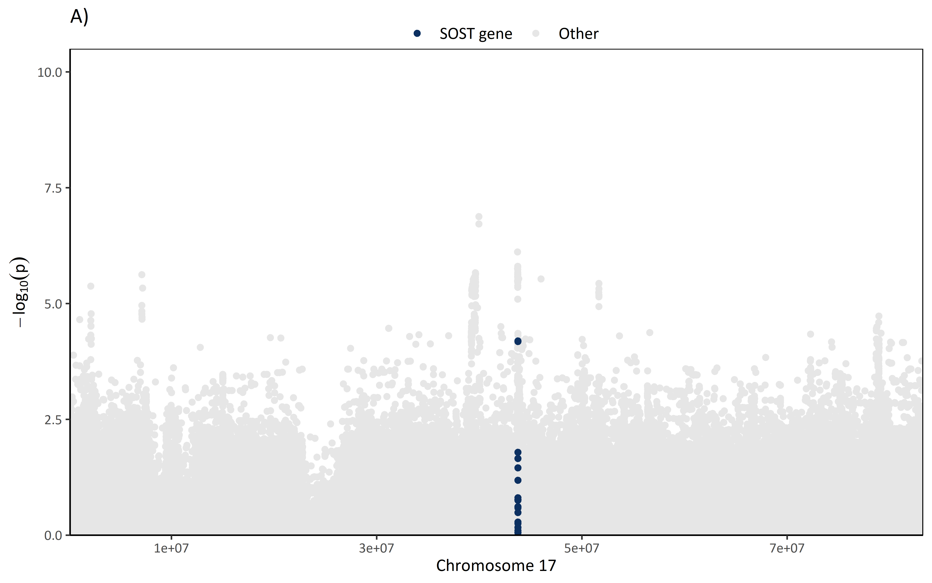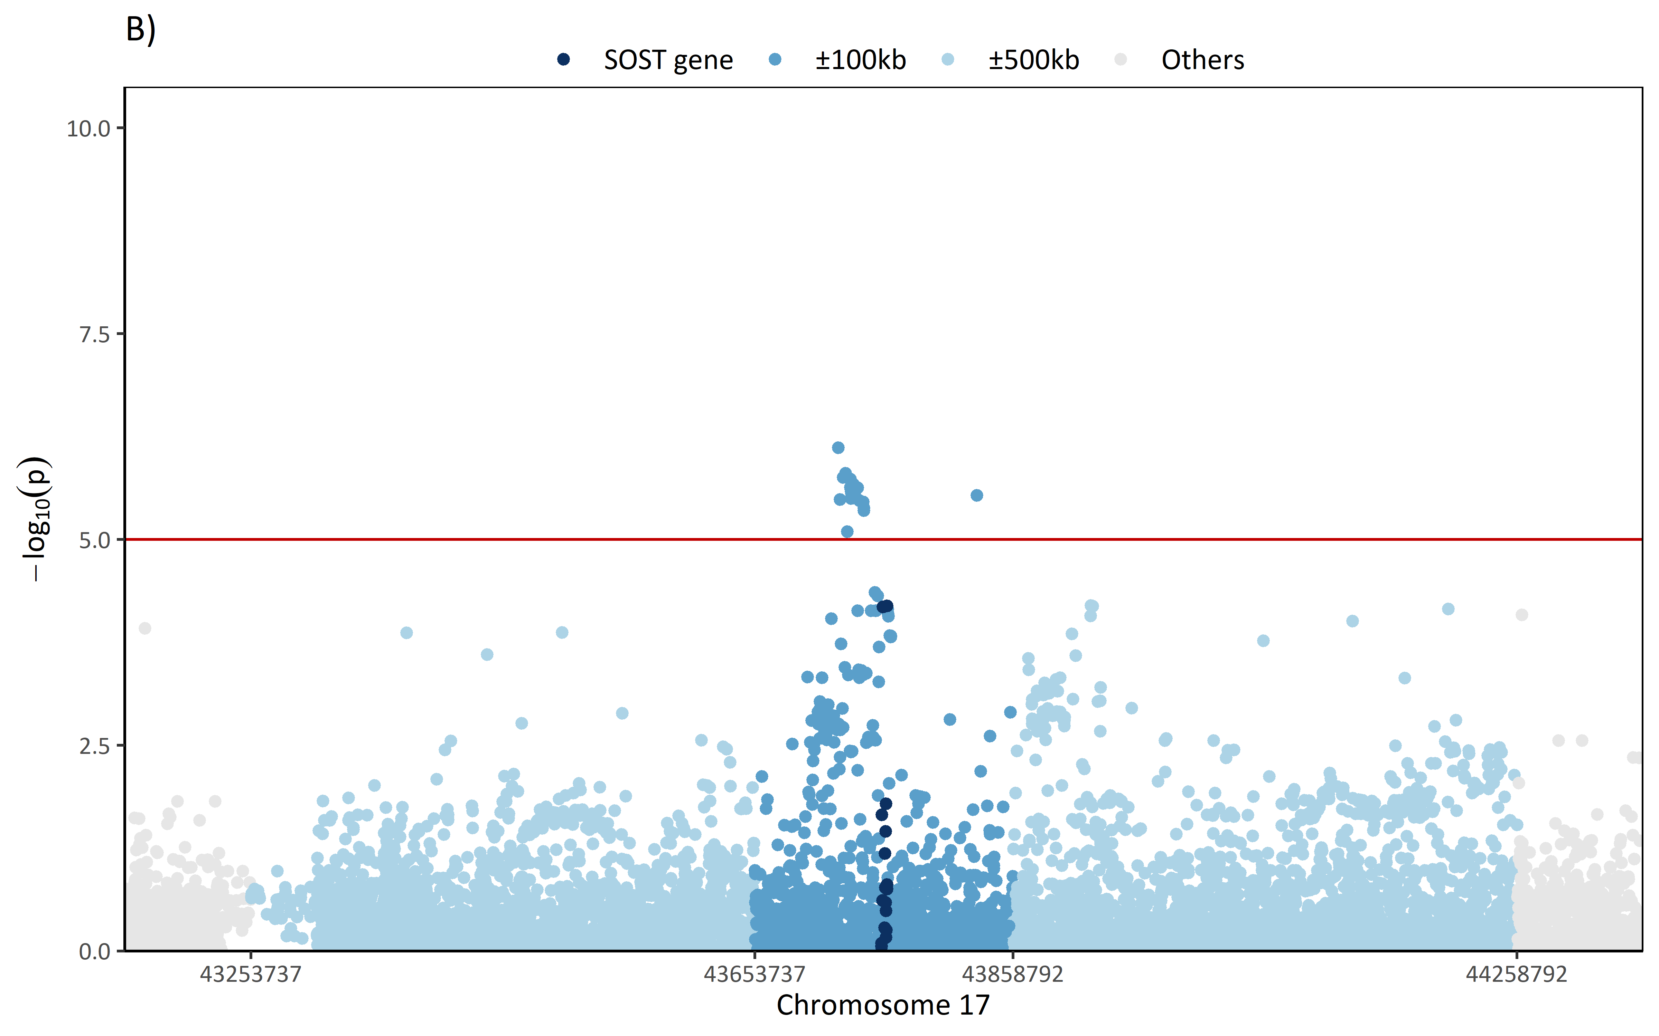**Figure 3.** Manhattan plot of the meta-analysed SNPs (random-effects method). **(A)** Manhattan plot of the whole chromosome 17. Dark blue dots correspond to SNPs within the SOST gene. **(B)** Manhattan plot from ±600kb of the start/end of the SOST gene. Dark blued dots correspond to SNPs within the SOST gene. Dark-light blue dots correspond to SNPs within ±100kb from the start/end of the SOST gene. Light blue dots correspond to SNPs withi ±500kb from the start/end of the SOST gene.

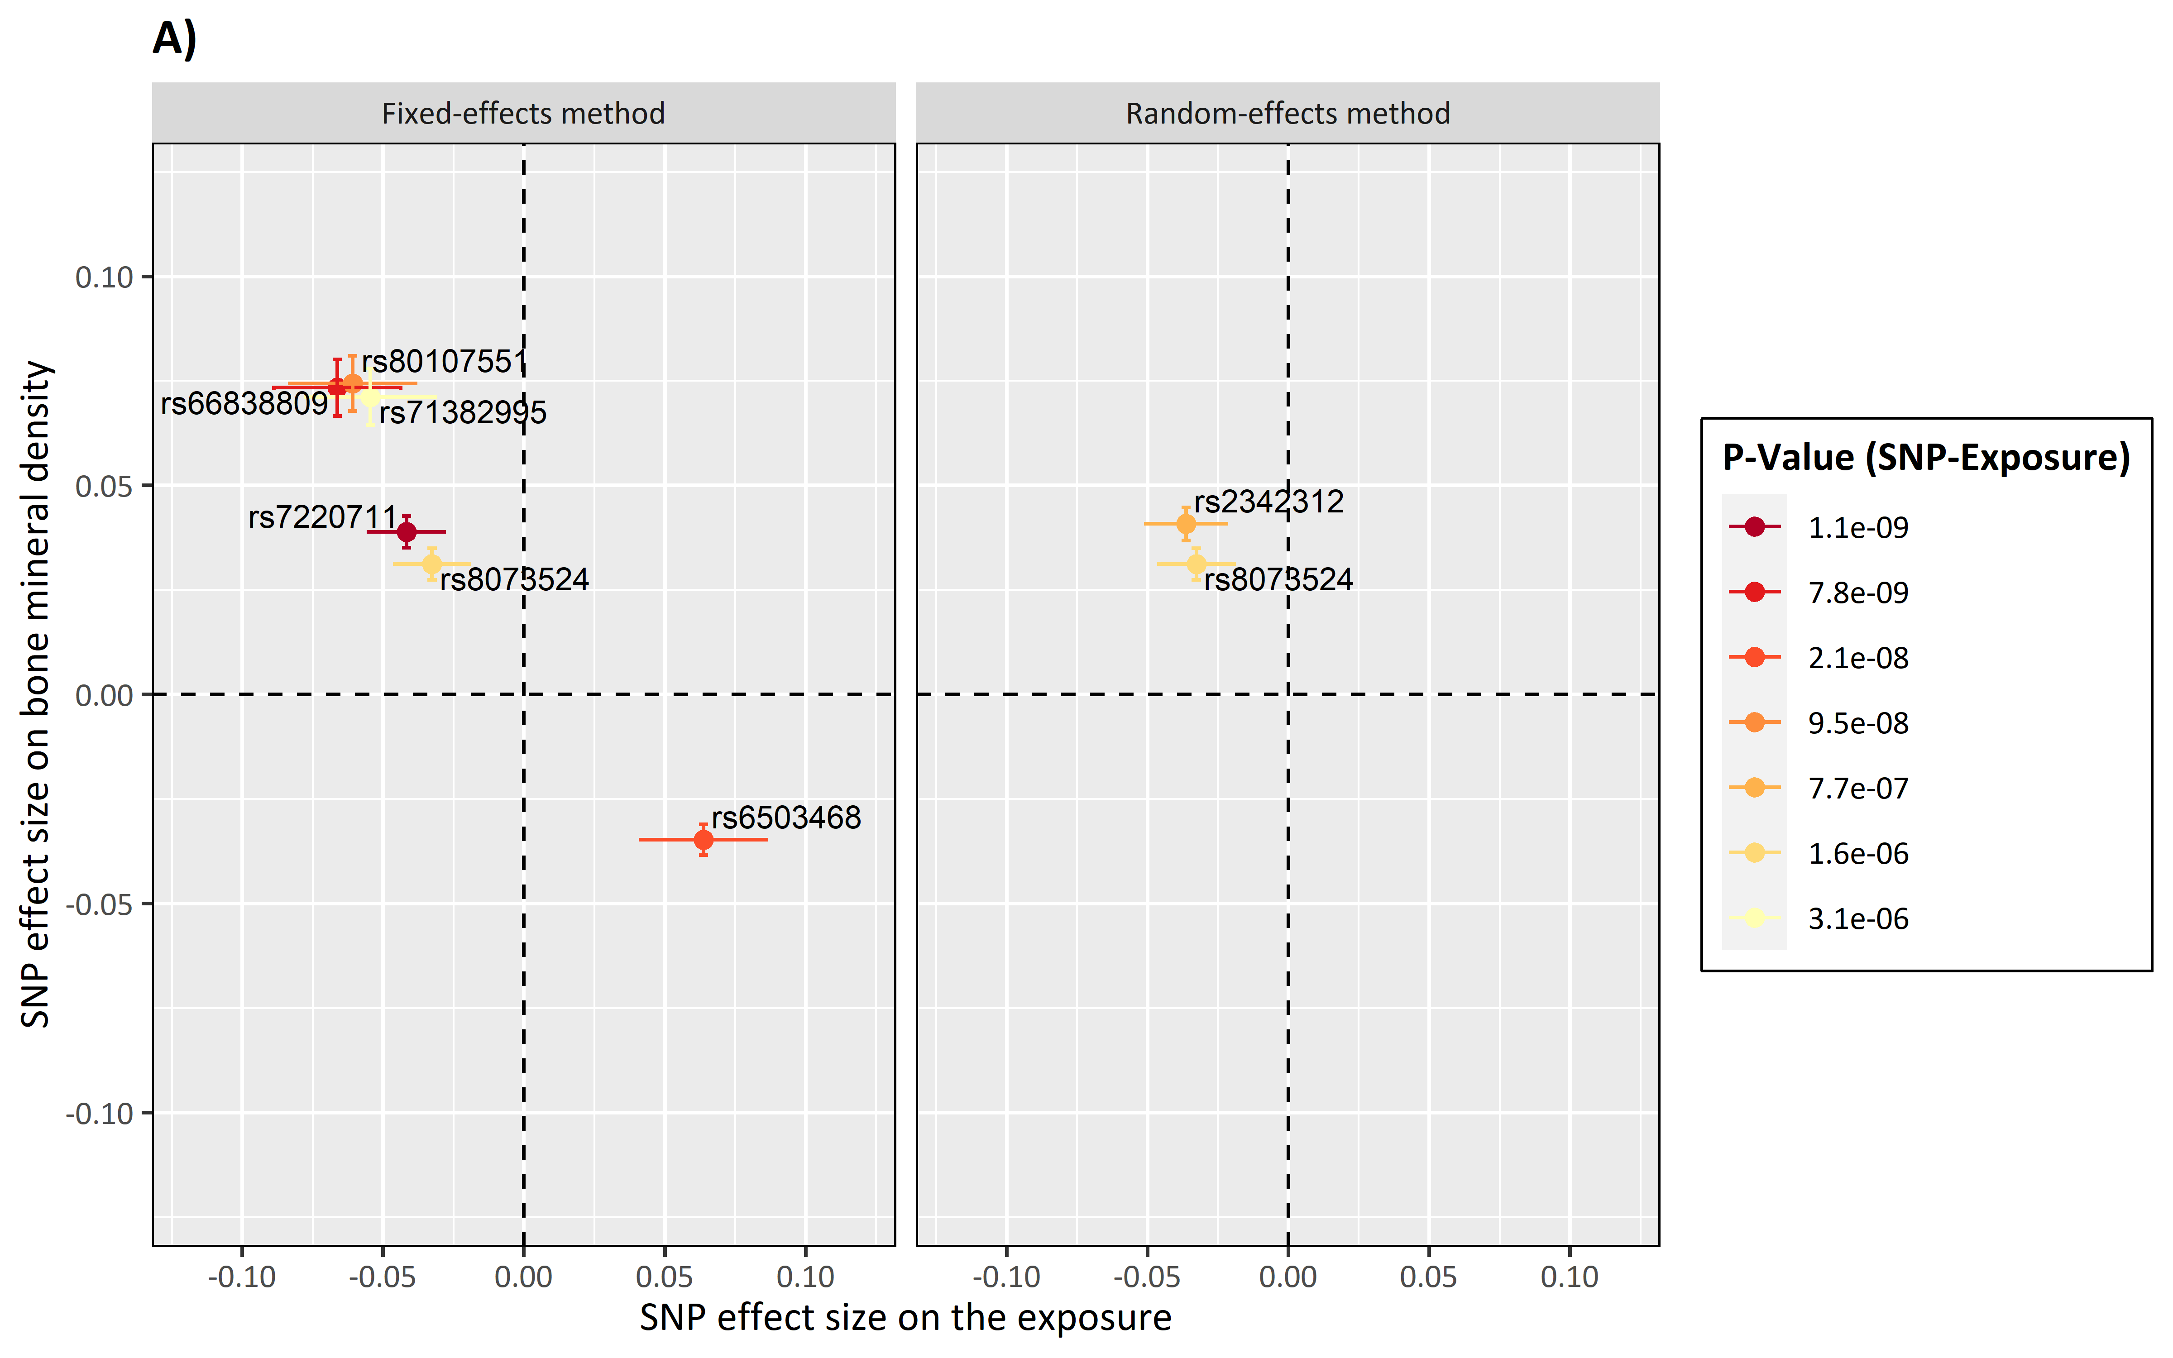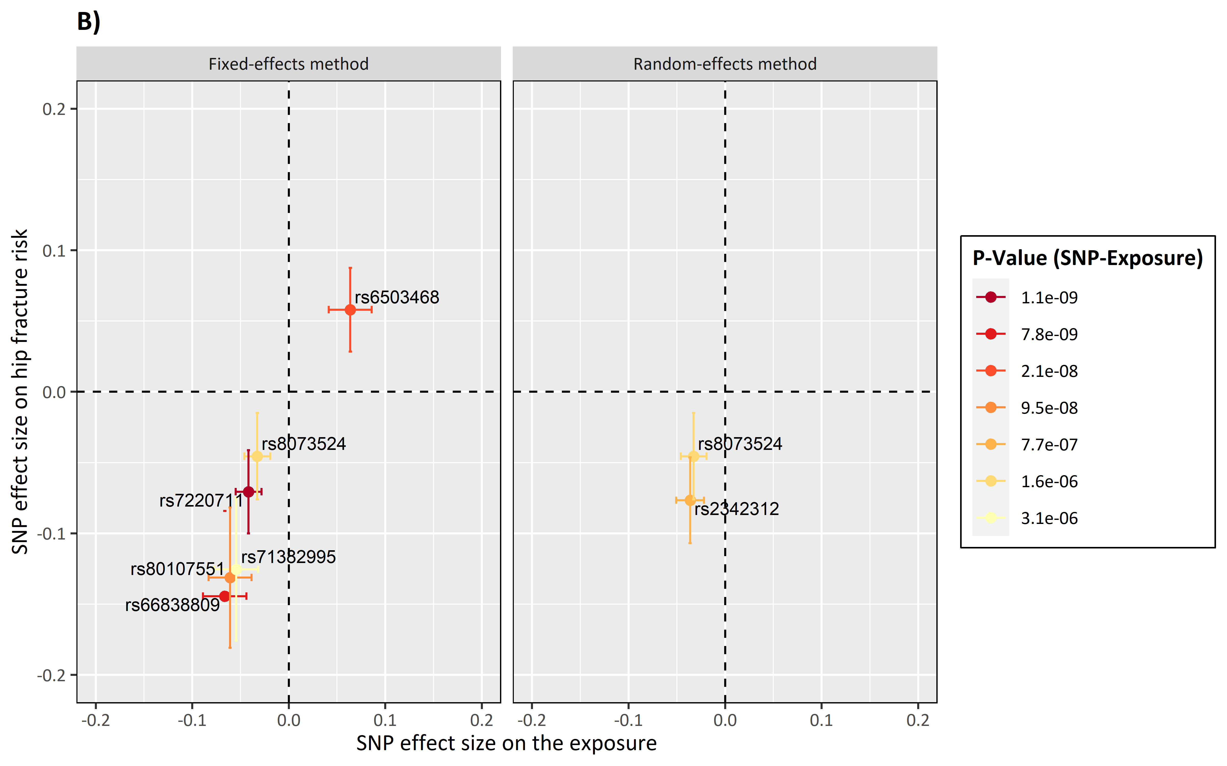**Figure 4 .** SNPs effect size on the positive control outcomes. **(A)** Positive control outcome is bone mineral density. **(B)** Positive control outcome is hip fracture risk.

