Triangulating evidence of the cause-effect relationship between sclerostin inhibition and cardiovascular outcomes

Figures
Authors: Marta Alcalde-Herraiz, Junqing Xie,
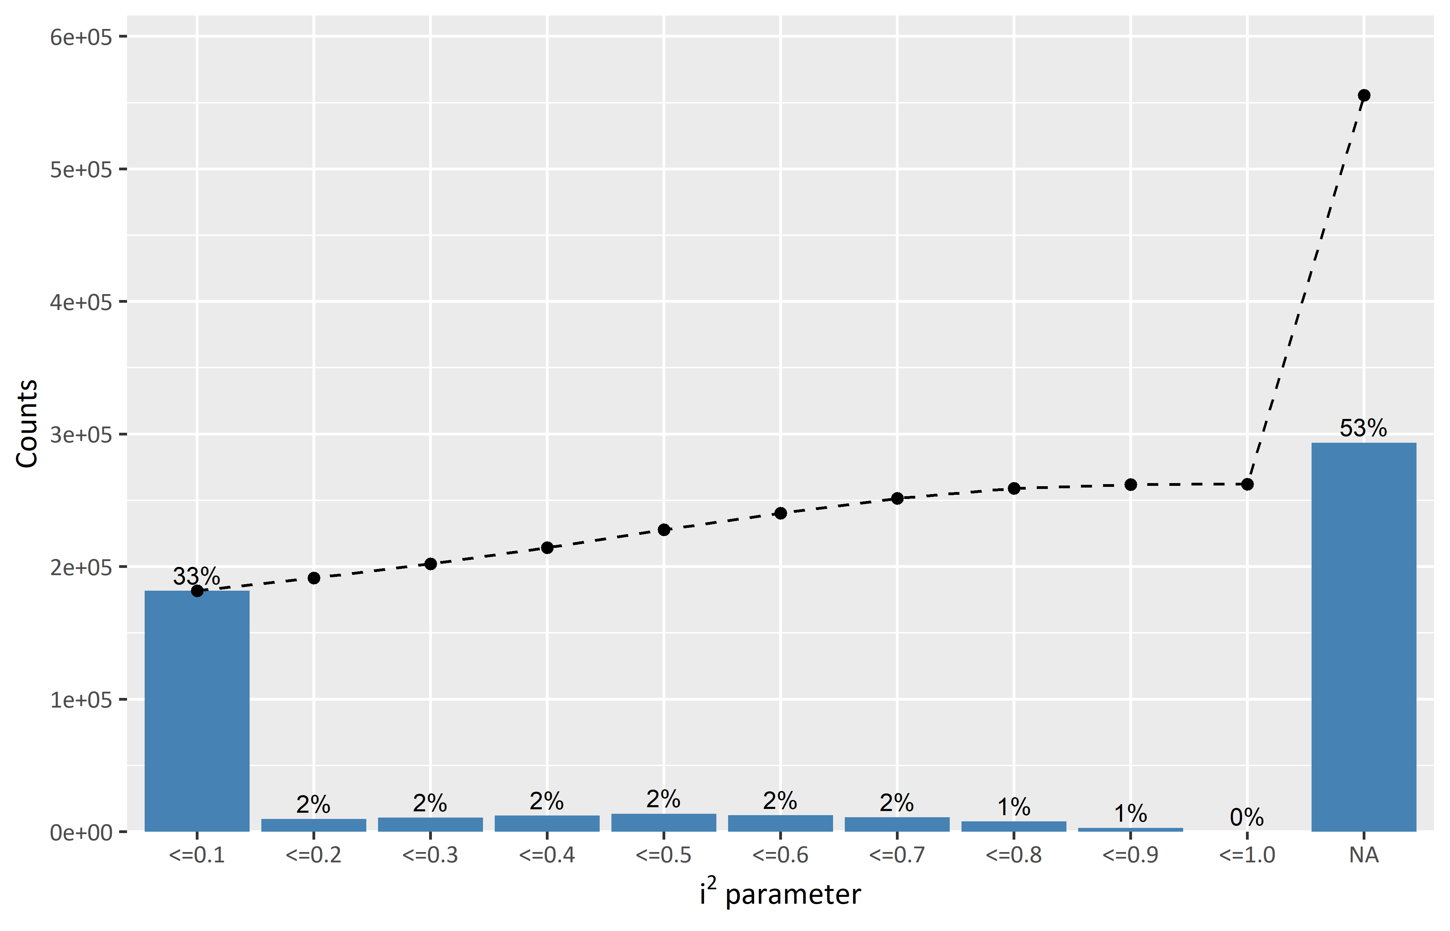
Figure 1. Heterogeneity between databases.

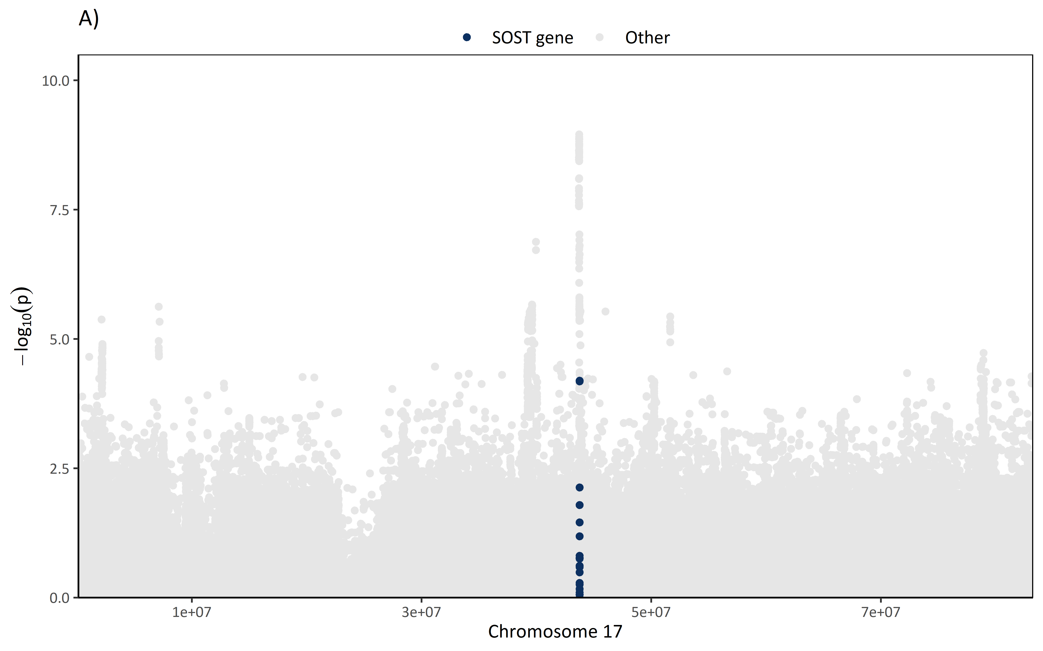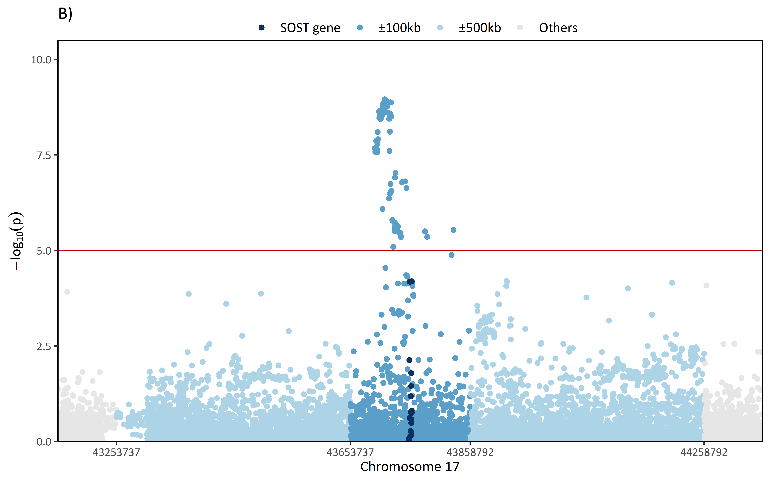Figure 2. Manhattan plot of the meta-analysed SNPs (fixed-effects method). (A) Manhattan plot of the whole chromosome 17. Dark blue dots correspond to SNPs within the SOST gene. (B) Manhattan plot from ±600kb of the start/end of the SOST gene. Dark blued dots correspond to SNPs within the SOST gene. Dark-light blue dots correspond to SNPs within ±100kb from the start/end of the SOST gene. Light blue dots correspond to SNPs withi ±500kb from the start/end of the SOST gene.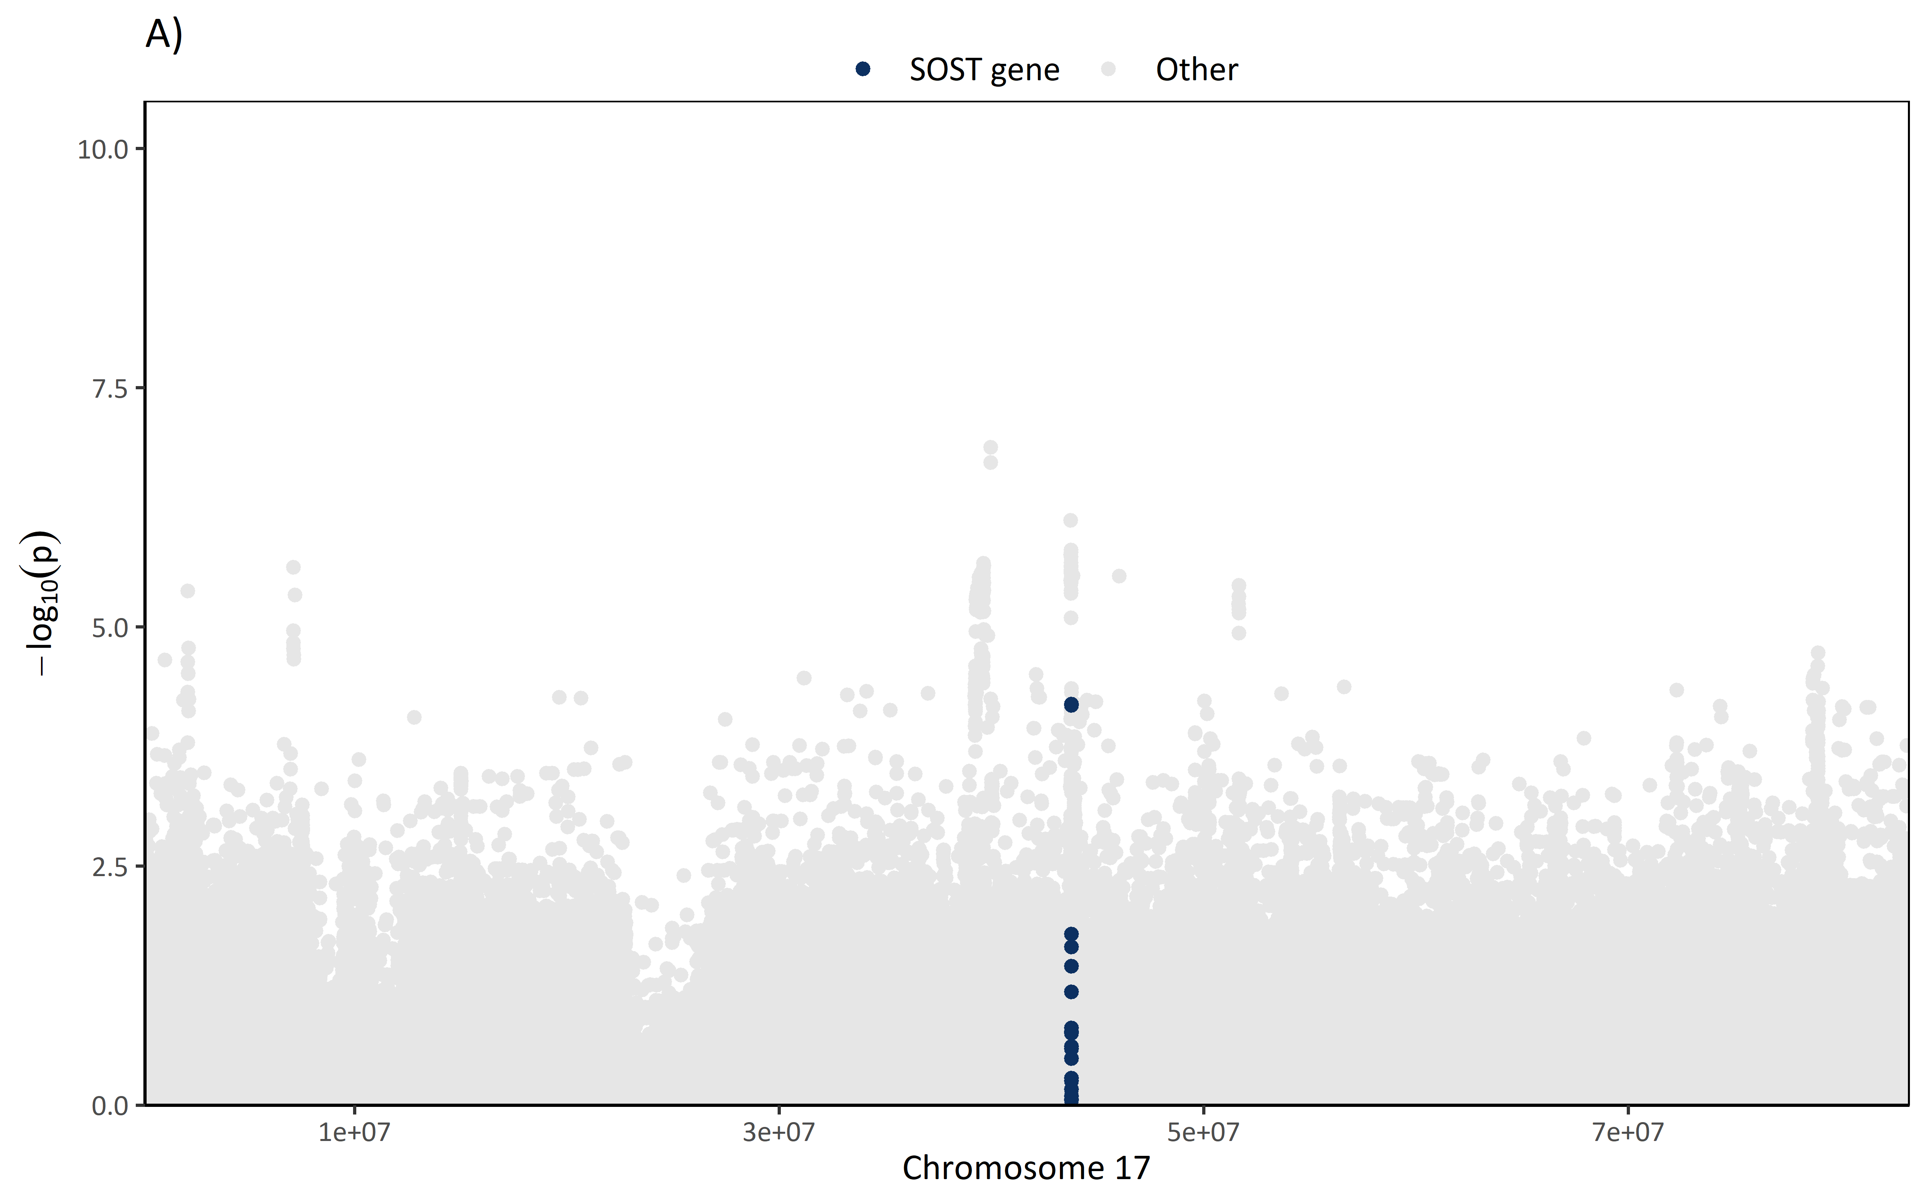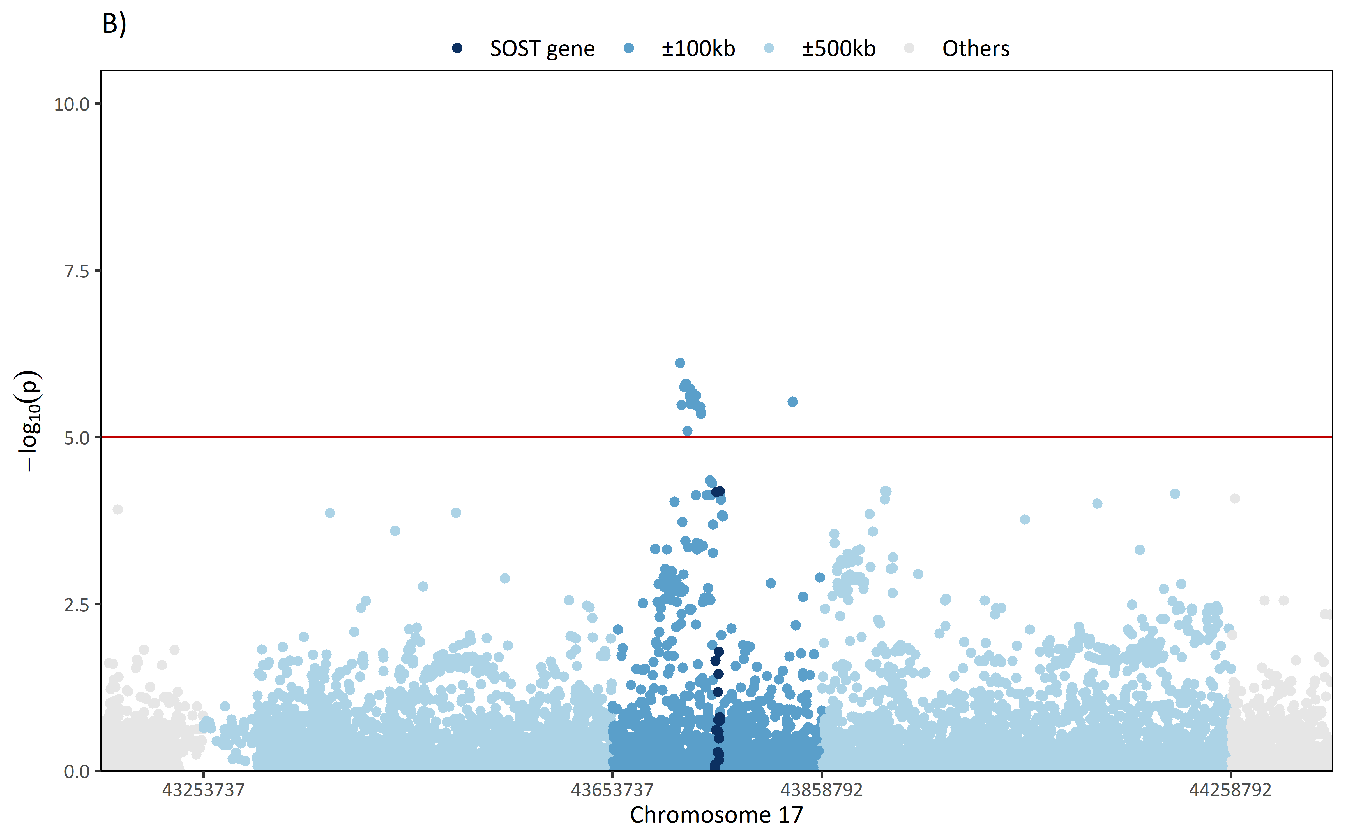Figure 3. Manhattan plot of the meta-analysed SNPs (random-effects method). (A) Manhattan plot of the whole chromosome 17. Dark blue dots correspond to SNPs within the SOST gene. (B) Manhattan plot from ±600kb of the start/end of the SOST gene. Dark blued dots correspond to SNPs within the SOST gene. Dark-light blue dots correspond to SNPs within ±100kb from the start/end of the SOST gene. Light blue dots correspond to SNPs withi ±500kb from the start/end of the SOST gene.
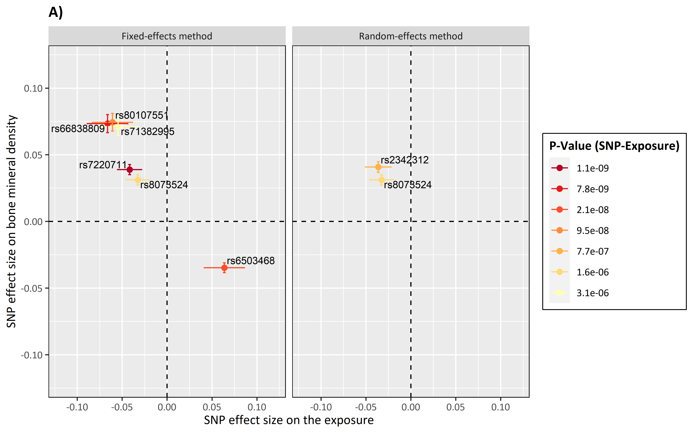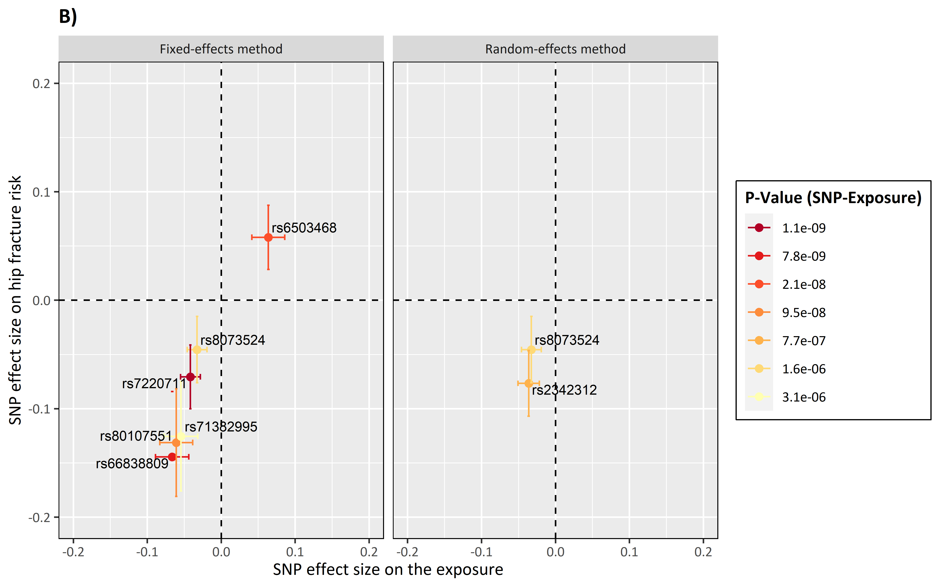Figure 4 . SNPs effect size on the positive control outcomes. (A) Positive control outcome is bone mineral density. (B) Positive control outcome is hip fracture risk.
