**Table 1.** Single nucleotide polymporphisms selected as instruments for phosphodiesterase 5 (PDE5) inhibition in the Mendelian randomization analysis. *Note:* CHR = Chromosome, EA = Effect allele, OA = Other allele, EAF = Effect allele frequency, SE = Standard error, N = Number of individuals.

| **SNP** | **CHR** | **Position (GRCh19/hg37)** | **EA** | **OA** | **EAF** | **Beta (mmHg)** | **SE** | **N** | **PValue** |
| --- | --- | --- | --- | --- | --- | --- | --- | --- | --- |
| rs66887589 | 4 | 120,509,279 | T | C | 0.52 | -0.16 | 0.02 | 754,581 | 1.8e-20 |
| rs10050092 | 4 | 120,532,085 | C | T | 0.66 | -0.13 | 0.02 | 754,583 | 8.6e-13 |
| rs12646525 | 4 | 120,502,461 | T | C | 0.22 | -0.10 | 0.02 | 746,319 | 6.7e-06 |
| rs80223330 | 4 | 120,423,094 | G | A | 0.14 | -0.10 | 0.03 | 749,960 | 1.2e-04 |
| rs17355550 | 4 | 120,416,096 | C | T | 0.97 | -0.14 | 0.05 | 746,320 | 4.1e-03 |

**Table 2.** Colocalization results.

| **Outcome** | **nsnps** | **P1 (%)** | **P2 (%)** | **P12 (%)** | **H0 (%)** | **H1 (%)** | **H2 (%)** | **H3 (%)** | **H4 (%)** |
| --- | --- | --- | --- | --- | --- | --- | --- | --- | --- |
| Lambert | 316 | 0.0001 | 0.0001 | 0.00001 | <1 | 98.54 | <1 | 0.58 | 0.87 |

**Supplementary table 1.**  Linkage disequilibrium matrix of the instruments used for the Mendelian randomization analysis. Notice that values correspond to r (not r2).

| **SNP** | **rs10050092 (C/T)** | **rs12646525 (T/C)** | **rs17355550 (C/T)** | **rs66887589 (C/T)** | **rs80223330 (A/G)** |
| --- | --- | --- | --- | --- | --- |
| **rs10050092 (C/T)** | 1.00 | -0.24 | -0.17 | -0.64 | -0.32 |
| **rs12646525 (T/C)** | -0.24 | 1.00 | 0.36 | -0.47 | -0.18 |
| **rs17355550 (C/T)** | -0.17 | 0.36 | 1.00 | -0.13 | -0.07 |
| **rs66887589 (C/T)** | -0.64 | -0.47 | -0.13 | 1.00 | 0.38 |
| **rs80223330 (A/G)** | -0.32 | -0.18 | -0.07 | 0.38 | 1.00 |

**Supplementary Table 2.** Harmonized variants respect the alleles of the linkage disequilibrium matrix. *Note:* EA = Effect allele, OA = Other allele, SE = Standard error, EAF = Effect allele frequency.

| **SNP** | **EA** | **OA** | **Beta** | | **SE** | | **EAF** | | **PValue** | |
| --- | --- | --- | --- | --- | --- | --- | --- | --- | --- | --- |
| **Exposure** | **Outcome** | **Exposure** | **Outcome** | **Exposure** | **Outcome** | **Exposure** | **Outcome** |
| rs17355550 | C | T | -0.14 | 0.10 | 0.05 | 0.05 | 0.03 |  | 4.1e-03 | 5.3e-02 |
| rs80223330 | A | G | 0.10 | 0.04 | 0.03 | 0.03 | 0.14 |  | 1.2e-04 | 2.0e-01 |
| rs12646525 | T | C | -0.10 | 0.00 | 0.02 | 0.02 | 0.22 |  | 6.7e-06 | 9.9e-01 |
| rs66887589 | C | T | 0.16 | 0.00 | 0.02 | 0.02 | 0.48 |  | 1.8e-20 | 8.8e-01 |
| rs10050092 | C | T | -0.13 | -0.01 | 0.02 | 0.02 | 0.34 |  | 8.6e-13 | 6.1e-01 |

**Supplementary Table 3.** Results of the two-step *cis*-Mendelian randomisation analysis.

| **Outcome** | **Confounder** | **GWAS ID** | **Associated SNPs** | **OR** | **SE** | **P-Value** |
| --- | --- | --- | --- | --- | --- | --- |
| Lambert | BMI | ukb-b-19953 |  | 0.99 | 0.11 | 0.96 |
| Lambert | Coronary artery disease | ebi-a-GCST005195 | rs66887589, rs80223330 | 0.99 | 0.11 | 0.96 |
| Lambert | Granulocyte count | ebi-a-GCST004614 | rs66887589 | 0.99 | 0.12 | 0.94 |
| Lambert | Impedance of arm (left) | ukb-b-19379 | rs10050092 | 1.00 | 0.12 | 0.97 |
| Lambert | Impedance of arm (right) | ukb-b-7859 | rs10050092 | 1.00 | 0.12 | 0.97 |
| Lambert | Impedance of leg (left) | ukb-b-14068 | rs10050092, rs12646525 | 0.99 | 0.11 | 0.95 |
| Lambert | Impedance of leg (right) | ukb-b-7376 | rs10050092, rs12646525 | 0.99 | 0.12 | 0.96 |
| Lambert | Impedance of whole body | ukb-b-19921 | rs10050092 | 0.99 | 0.11 | 0.95 |
| Lambert | Myeloid white cell count | ebi-a-GCST004626 | rs10050092, rs66887589 | 0.99 | 0.12 | 0.95 |
| Lambert | Platelet count | ukb-d-30080_irnt | rs10050092 | 1.00 | 0.11 | 0.97 |
| Lambert | Plateletcrit | ebi-a-GCST004607 | rs66887589 | 0.99 | 0.11 | 0.96 |
| Lambert | Standing height | ukb-b-10787 | rs10050092 | 1.00 | 0.12 | 0.98 |
| Lambert | Sum basophil neutrophil counts | ebi-a-GCST004620 | rs66887589 | 0.99 | 0.12 | 0.94 |
| Lambert | White blood cell count | ieu-b-30 | rs66887589 | 1.00 | 0.11 | 1.00 |

**Supplementary Table 4.** Results of the leave-one-out analysis

| **SNP** | **N Instruments** | **OR** | **se** | **P-value** |
| --- | --- | --- | --- | --- |
| All | 5 | 1.001 | 0.02 | 0.96 |
| rs17355550 | 4 | 0.995 | 0.02 | 0.77 |
| rs80223330 | 4 | 0.999 | 0.02 | 0.98 |
| rs12646525 | 4 | 1.004 | 0.02 | 0.88 |
| rs66887589 | 4 | 1.000 | 0.02 | 1.00 |
| rs10050092 | 4 | 1.003 | 0.03 | 0.90 |

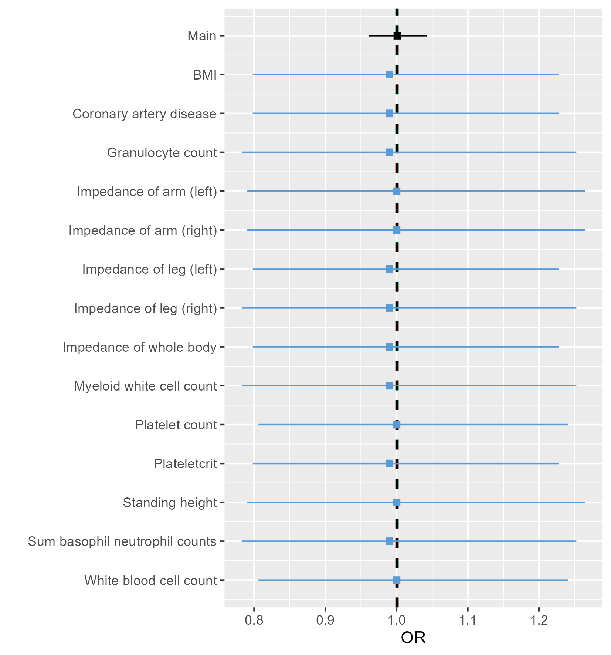

**Supplementary Figure 1.** Results of Two-Step *cis*-Mendelian Randomisation.

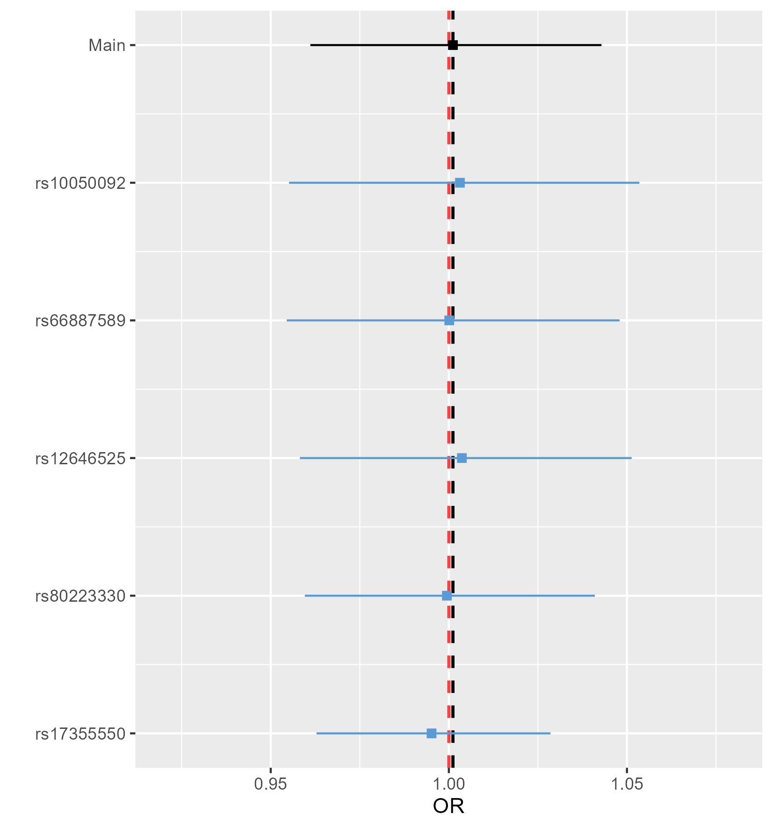

**Supplementary Figure 2.**  Results of leave-one-out analysis.

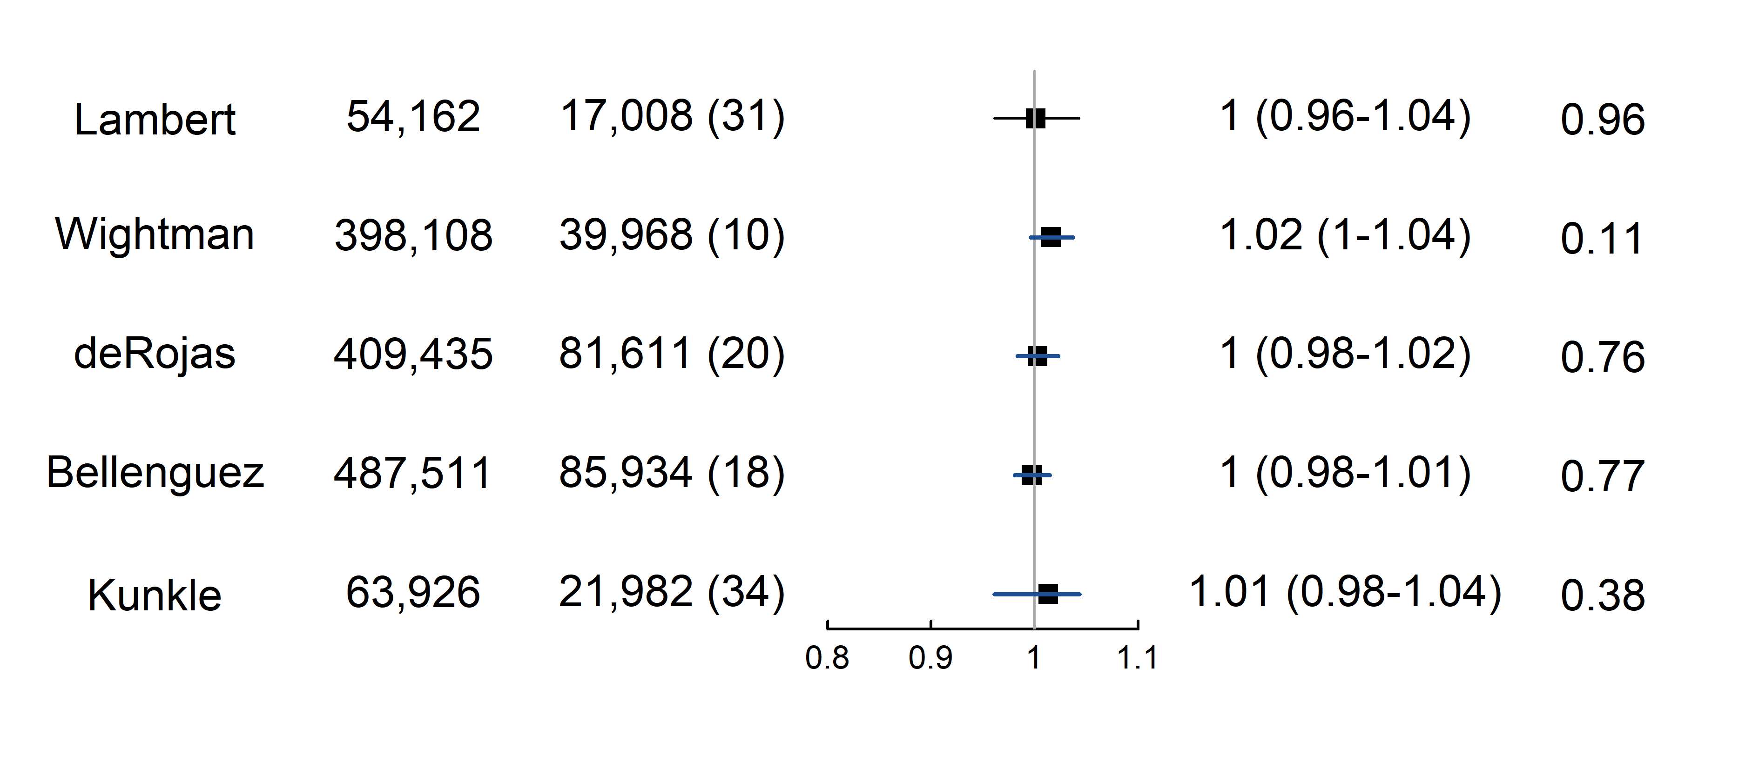

**Supplementary Figure 3.** Mendelian randomization results with other Alzheimer’s disease GWAS.

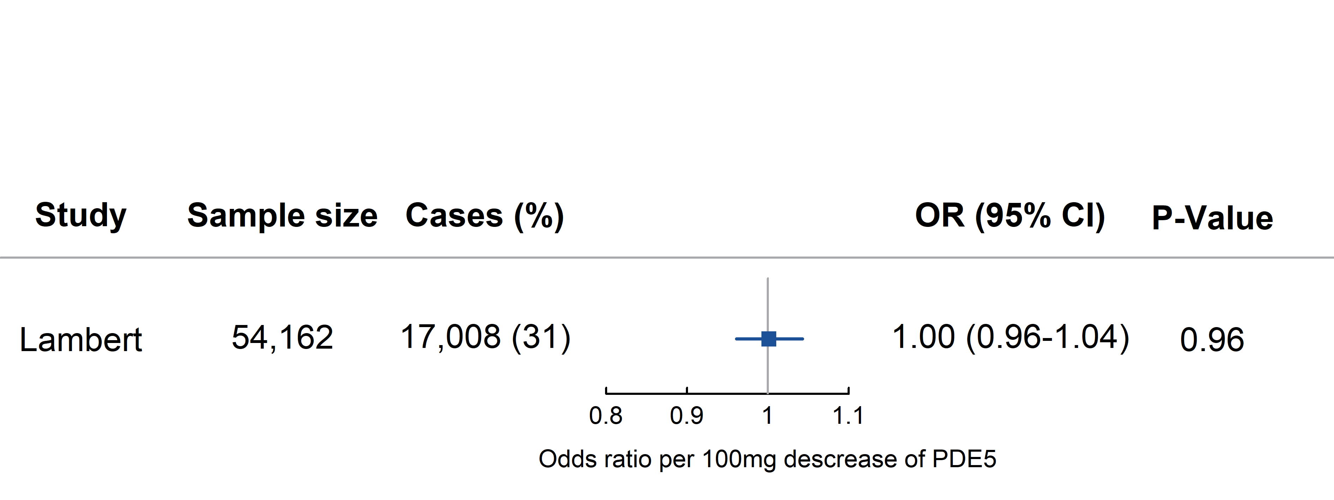

**Figure 2.** Mendelian randomisation results of the main analysis.