Genetic determinants of COVID-19 vaccine response: genome-wide association studies of immunogenicity and breakthrough infection in UK biobank

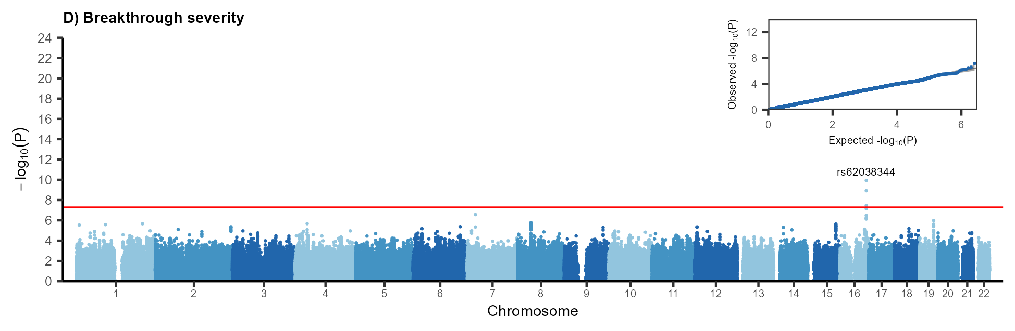

**Figure 2.** Flow chart of antibody positivity