  - FINAL PROJECT DELIVERABLE / TASK 17

Banking Loan Portfolio
& Credit Risk Analysis
SQL management report | PostgreSQL banking_capstone | Snapshot: 25 October 2026
Data source: fictional, randomly generated Zambian bank portfolio; aggregate outputs verified against the completed SQL tasks and seven final database assertions.

Executive summary
The synthetic portfolio contains 20,000 customers and 40,000 loan records across eight branches. Recorded original loan principal totals K5,672,889,156.80 (K5.67 billion). A total of 5,313 loans are marked Defaulted (13.28% of loan records), corresponding to K917,841,641.54 (16.18% of recorded principal). These are descriptive snapshot shares, not regulatory non-performing loan ratios or loss estimates.
The most pronounced observed differences in default shares were associated with customer monthly-income categories (8.51% to 18.49%) and loan-size categories (7.91% to 17.94%). In contrast, interest-rate categories ranged from 12.95% to 13.58% and loan-product categories from 12.50% to 14.00%.
At branch level, Ndola had the highest defaulted loan count (713) and count share (14.17%), while Chingola had the highest recorded principal associated with defaulted loans (K124.40 million). All planned data-validation assertions passed.

Verified portfolio headlines
Measure | Verified result
Customers / branches | 20,000 / 8
Loan records | 40,000
Active / Defaulted / Paid | 31,027 / 5,313 / 3,660
Recorded original principal | K5,672,889,156.80
Defaulted original principal | K917,841,641.54
Defaulted count share / principal share | 13.28% / 16.18%
Average original loan amount | K141,822.23
Customers with ≥1 defaulted loan | 4,572

1. Default patterns: income and loan size
Income bands are analytical classifications created for this project, not official income classes. All segment rates below divide defaulted loan records by loan records in the same segment.
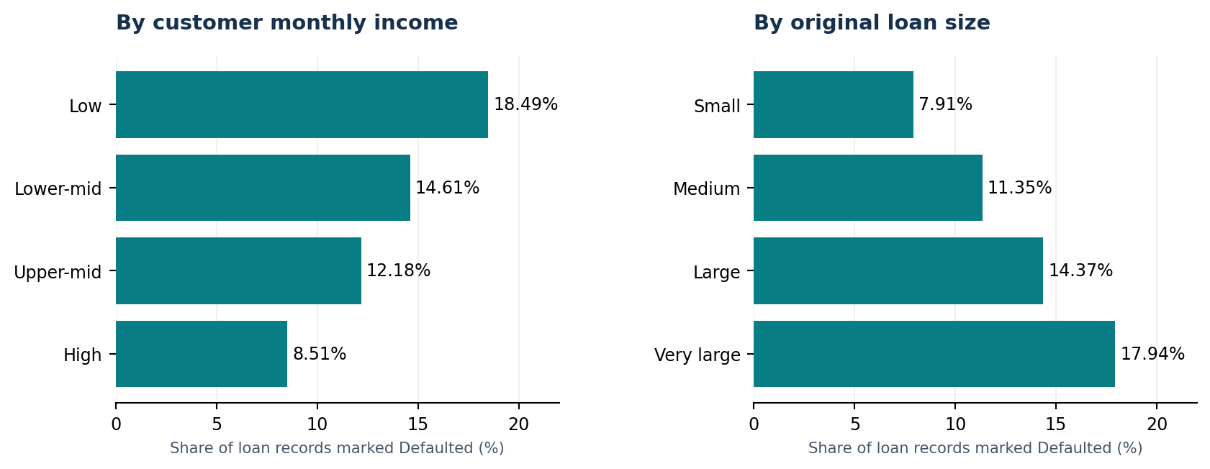

Customer income segments
Monthly income group | Loans | Defaulted | Default % | Defaulted principal
Low (<K10k) | 11,462 | 2,119 | 18.49% | K346.71m
Lower-middle (K10k–<20k) | 6,727 | 983 | 14.61% | K173.60m
Upper-middle (K20k–<40k) | 9,666 | 1,177 | 12.18% | K219.37m
High (≥K40k) | 12,145 | 1,034 | 8.51% | K178.15m
Key finding: Loans linked to customers in the lowest income band show an 18.49% defaulted-record share versus 8.51% for the highest band. Low-income customers account for K346.71m in recorded defaulted original principal. This pattern is descriptive; it cannot establish causality.

Original loan-size segments
Loan size category | Loans | Defaulted | Default % | Defaulted principal
Very large (≥K200k) | 12,535 | 2,249 | 17.94% | K619.50m
Large (K100k–<200k) | 10,390 | 1,493 | 14.37% | K223.79m
Medium (K50k–<100k) | 6,416 | 728 | 11.35% | K54.59m
Small (<K50k) | 10,659 | 843 | 7.91% | K19.97m
Key finding: The very-large-loan group (≥K200,000) accounts for 2,249 defaulted records and K619.50m in recorded defaulted principal—approximately 67.50% of total defaulted principal. Its 17.94% defaulted-record share is over twice the small-loan group’s 7.91%.

2. Interest-rate and loan-product comparison

Interest-rate groups
Interest rate band | Loans | Defaulted | Default %
29%+ | 8,878 | 1,206 | 13.58%
Below 15% | 10,348 | 1,390 | 13.43%
22%–<29% | 10,325 | 1,364 | 13.21%
15%–<22% | 10,449 | 1,353 | 12.95%
Defaulted-record shares vary only 0.63 percentage points across rate bands, from 12.95% to 13.58%, without a monotonic pattern. No claim about pricing causing default can be drawn from this cross-sectional comparison.

Loan products
Loan product | Loans | Defaulted | Default % | Total principal
Business | 10,045 | 1,406 | 14.00% | K1,434.40m
Vehicle | 5,571 | 745 | 13.37% | K788.06m
Education | 4,669 | 618 | 13.24% | K660.80m
Personal | 12,842 | 1,685 | 13.12% | K1,806.55m
Agriculture | 6,873 | 859 | 12.50% | K983.08m
Business loans have the highest loan-product defaulted-record share at 14.00%, while Agriculture has the lowest at 12.50%. Personal loans produce the largest absolute number of defaulted records (1,685), largely reflecting their portfolio volume.

3. Customer borrowing behaviour
Loans per customer | Customers | Loan records | Defaulted loans | Loan default % | Customers with default | Customer default %
0 loans | 2,757 | 0 | 0 | N/A | 0 | 0.00%
1 loan | 5,480 | 5,480 | 693 | 12.65 | 693 | 12.65%
2 loans | 5,382 | 10,764 | 1,427 | 13.26 | 1,319 | 24.51%
3+ loans | 6,381 | 23,756 | 3,193 | 13.44 | 2,560 | 40.12%
Borrowing is concentrated: 6,381 customers with three or more loans hold 23,756 loans (59.39% of all loan records). A total of 2,757 customers have no loan records. Among customers with three or more loans, 40.12% have at least one recorded defaulted loan; this cross-sectional proportion is not a prediction of future default.
The loan-level defaulted-record shares among customers with one, two, or three-plus loans are much closer (12.65%, 13.26%, and 13.44%). The much larger change in customer-level prevalence (12.65% to 40.12%) partly reflects more opportunities for multiple-loan customers to hold at least one defaulted loan.

Branch-level results
Branch | Loans | Defaults | Default % | Defaulted principal | Value share
Chingola | 5,097 | 699 | 13.71% | K124.40m | 17.20%
Livingstone | 5,163 | 683 | 13.23% | K117.96m | 16.10%
Ndola | 5,030 | 713 | 14.17% | K117.38m | 16.42%
Lusaka Central | 5,019 | 663 | 13.21% | K114.15m | 16.05%
Cairo Road | 4,903 | 650 | 13.26% | K113.42m | 16.35%
Kitwe | 4,858 | 645 | 13.28% | K112.49m | 16.11%
Kafue | 4,990 | 633 | 12.69% | K111.23m | 15.98%
Kabwe | 4,940 | 627 | 12.69% | K106.80m | 15.20%
Branch priorities: Chingola has the largest recorded defaulted principal (K124.40m, or 17.20% of its recorded original principal), whereas Ndola has the highest default count and defaulted-record percentage (713; 14.17%). These different rankings call for both count-based and value-based monitoring.

4. Data quality assurance — Task 16
The user executed Tasks 16A–16E on the local PostgreSQL database and supplied the resulting outputs. This report records the checks performed and their observed results.
Validation area | Observed result | Assessment
16A · Duplicate loan IDs | Zero rows returned | PASS
16B · Orphan loan references | Zero rows returned | PASS
16C · Nulls, invalid amounts/statuses/rates/IDs | 40,000 assessed; six invalid-condition counts = 0 | PASS
16D · Count and principal reconciliation | 40,000, K5,672,889,156.80, 5,313 and K917,841,641.54 all match; totals_reconcile = true | PASS
16E · Seven database assertions | All seven return PASS | PASS
The seven assertions covered complete customer-and-branch joins, expected row counts (8 branches, 20,000 customers, 40,000 loans), defaulted record count (5,313), and reconciliation of both total and defaulted original principal.
Quality conclusion: The checked structural, missing-value and aggregate controls pass. This is not evidence that every underlying value is economically realistic, that customer identity is verified, or that the synthetic loan portfolio is representative of actual Zambian bank lending.

5. Management implications and conclusion
1. Prioritise further review of large loans and low-income segments, where snapshot default shares are most pronounced. Evaluate loan age, disbursement cohorts, affordability, loan purpose and borrower characteristics before recommending changes to underwriting.
2. Monitor branch risk using both default counts and original-principal exposure shares. Chingola and Ndola emerge as distinct investigation priorities for value-based and frequency-based monitoring, respectively.
3. Avoid equating original principal of defaulted loans with losses. Any usable regulatory non-performing-loan, expected credit loss, or outstanding-risk estimate requires balances, repayment histories, days past due, recoveries, collateral, and an appropriate reporting cutoff.
4. Treat interest-rate and product comparisons cautiously. The small unadjusted differences are not compelling causal evidence. In a real bank, cohort and multivariable analysis would be needed to assess independent associations.

Final conclusion
The completed capstone demonstrates a coherent SQL workflow: relational joins, CTEs, conditional aggregation, segmentation, count-based and value-based performance metrics, borrowing-frequency analysis, and structured validation. All supplied verification outputs are internally consistent. As a portfolio project, it is suitable for demonstrating SQL and financial analysis skills when clearly labelled as synthetic; it should not be presented as a real bank credit-risk assessment.

Methodology and reproduction notes
All figures in this report come from the user’s recorded outputs for Tasks 9–16 and earlier portfolio overview queries. Table names: banking_capstone.bank_loans, bank_customers, and bank_branches. The companion project package contains the executable SQL for Tasks 12–17. The original database generator uses random sampling; rebuilding it from scratch can change numeric outputs. Preserve a reproducible snapshot before final GitHub publication.

