School of Computer Science and Software Engineering

2016 Research Conference Registration

The 22nd School of Computer Science and Software Engineering Research Conference is held from 7 to 9 Nov 2016 at Sebel, Mandurah. Participants are required to submit this form to the CSSE reception by 4th Oct 2016.

1. PARTICIPANT DETAILS

SURNAME: | ___White ___________ | STAFF/STUDENT ID: | ____20361362______________
GIVEN NAMES: | ___Lyndon__________________ | TITLE: Mr, Ms, Mrs, Dr etc. | __________Mr_______________
DEGREE: For students. | _____PhD___________________ | Gender: | _________Male______________
EMAIL: | Lyndon.white@research.uwa.edu.au | CONTACT NO.: | ___________________________

2. DIETARY REQUIREMENTS

 HALAL |  VEGETARIAN
 Other Requirements: | __________________________________________________________________________
MEALS REQUIRED: | ☑ Lunch (07 Nov) | ☑ Dinner (07 Nov) | ☑ Breakfast (08 Nov)
☑ Lunch (08 Nov) | ☑ Dinner (08 Nov)** | ☑ Breakfast (09 Nov)**
Please state your requirements for lunch and dinner to facilitate our bookings.
** Depending on the number of interested participants.

3. TRANSPORTATION

☑ will manage myself
 Have Own Transport |  | Able to pick-up others: Y / N
Additional Pax: | ___________________________ | Leaving from: Address. | ___________________________

4. PAPER DETAILS

Research students have to submit either a full or short paper depending on their current stage of studies. For more details, please refer to http://web.csse.uwa.edu.au/research/school-research-conferences/2016-research-conference
☑☑ ☑ Full Paper (Year 2+ Postgrads) |  |  Short Paper (Beginning Postgrads)
TITLE OF PAPER: | Aligning Word Sense Embeddings, Using a Single Example, with Applications in Word Sense Disambiguation
SUPERVISOR(S): For students. | Roberto Tognerio, Wei Liu, Mohammed Bennamoun

5. REGISTRATION FEES

Please select your registration type and pay the registration fees (in cash) to the CSSE reception, along with this form.
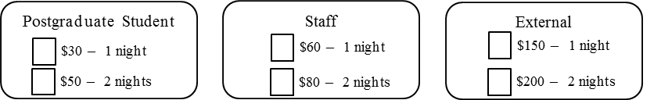
____________
Date

_______________________
Signature of Participant

