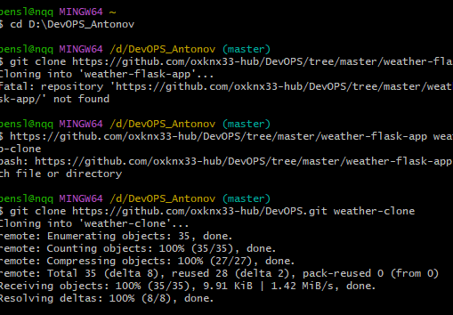
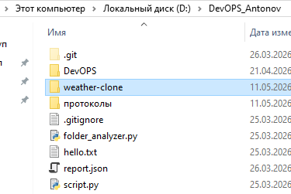
Изменение app.py:
@app.route('/api/get-coords', methods=['GET'])
def get_coords():
city = request.args.get('city', '').strip()
if not city:
return {'error': 'City name required'}, 400
geo_url = f"https://geocoding-api.open-meteo.com/v1/search?name={city}&count=1&language=ru&format=json"
try:
resp = requests.get(geo_url)
resp.raise_for_status()
data = resp.json()
if data.get('results'):
res = data['results'][0]
return {
'lat': res['latitude'],
'lon': res['longitude'],
'name': res['name']
}, 200
return {'error': 'City not found'}, 404
except Exception as e:
return {'error': str(e)}, 500
Изменение index.html:
<form action="/weather" method="get">
<div class="form-group">
<label for="city">Or enter city:</label>
<input type="text" id="city" placeholder="Example: Kazan">
<button type="button" onclick="fetchCoords()" style="margin-top:5px;">Get Coords</button>
</div>
<div class="form-group">
<label for="lat">Latitude:</label>
<input type="text" id="lat" name="lat" placeholder="55.7558" required>
</div>
<div class="form-group">
<label for="lon">Longitude:</label>
<input type="text" id="lon" name="lon" placeholder="37.6173" required>
</div>
<button type="submit">Get Weather</button>
</form>
<script>
function fetchCoords() {
const city = document.getElementById('city').value;
if (!city) return alert('Enter city name');
fetch(`/api/get-coords?city=${encodeURIComponent(city)}`)
.then(r => r.json())
.then(data => {
if (data.lat && data.lon) {
document.getElementById('lat').value = data.lat;
document.getElementById('lon').value = data.lon;
if (data.name) document.getElementById('city').value = data.name;
} else {
alert('Error: ' + (data.error || 'Coords not found'));
}
})
.catch(() => alert('Request failed'));
}
</script>
