 | 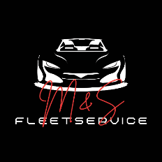 |  |  |  |  | M&S Fleetservice Inh. Salman Ali  Friesdorfer Straße 120  53173 Bonn  Tel: +49 151 28349391
 | M&S Fleetservice, Inh. Salman Ali, Friesdorfer Str. 120, 53173 Bonn
 | {{ customer.firma }}
 | {{ customer.adresse }}
 | {{ customer.plz }} {{ customer.ort }}
 |  |  |  |  |  | Datum: {{ letter.date }}
{{ letter.subject }}
{{ letter.content }}

