|  |  |  |
| --- | --- | --- |
| **EXCELLENT CONDITIONS** | **EXCELLENT CONDITIONS** | **EXCELLENT CONDITIONS** |
| **SKI CONDITIONS**  **BLUE ICE**  HEADWALL and SUICIDE closed. At their turn, skiers on these trails return to SUMMIT HOUSE and start skiing another trail. | **EXCELLENT CONDITIONS** | **EXCELLENT CONDITIONS** |
| **SKI CONDITIONS**  **TEMPERATURE DROP**  If skiers do not have either —THERMAL UNDERWEAR or FLASK they must proceed directly to BASE, at their turn, without collecting trail GROSCHEN. | **SPRING SKIING CONDITIONS**  Skiers must have WAX or move at 1/2 speed on trails (roll one dice). If WAX is used, skiers return WAX to SKI SHOPPE upon reaching BASE | **POOR SKIING CONDITIONS**  Skiers landing on red spaces lose 10 GROSCHEN. (select SITZMARK CARD as usual). |
| **SKI CONDITIONS**  **AVALANCHE ON SUGARLOAF**  At their turn, skiers on this trail return to BASE. Do not collect trail GROSCHEN. | **SKI CONDITIONS**  **PAUL'S FOLLY CLOSED**  BEAR sighted on this trail. At their turn, skiers on PAUL'S FOLLY return to SUMMIT HOUSE and start skiing another trail. | **SKI CONDITIONS**  **BITING COLD**  Hot mulled wine at LODGE. All skiers awarded 15 extra GROSCHEN when arriving at BASE while this card is in effect. |
| **SKI CONDITIONS**  **ICY TRAILS**  Skiers move at 1/4 speed on trails. Skiers on lift take 2 sips and proceed. | **SKI CONDITIONS**  **WET STICKY SNOW**  SUGARLOAF AND EDEIWEISS closed. At their turn, skiers on these trails return to SUMMIT HOUSE and start skiing another trail. | **SKI CONDITIONS**  **RAIN**   1. All skiers proceed immediately to BASE. 2. Do not collect trail GROSCHEN. 3. Turn up next SKI CONDITION CARD. |
| **SKI CONDITIONS**  **TWO INCHES NEW POWDER**  All skiers awarded 10 extra GROSCHEN upon reaching BASE while his card is in effect. | **SKI CONDITIONS**  **SNOW FLURRIES**  Skiers must have GOGGLES or move at 1/2 speed on trails.(roll one dice only). | **SKI CONDITIONS**  **DRIVING SNOW STORM**  Skiers must have GOGGLES or stop moving on trails. Skiers return GOGGLES to SKI SHOPPE if this card is in effect when reaching BASE. |
|  | **SKI CONDITIONS**  **FREEZING RAIN**  SKI LIFT jams. Skiers on LIFT may not move and skiers may not enter LIFT. Sip at will. | **SKI CONDITIONS**  **DEEP POWDER ON SUGARLOAF AND EDELWEISS**  Skiers on these trails awarded 15 extra GROSCHEN upon reaching BASE. |

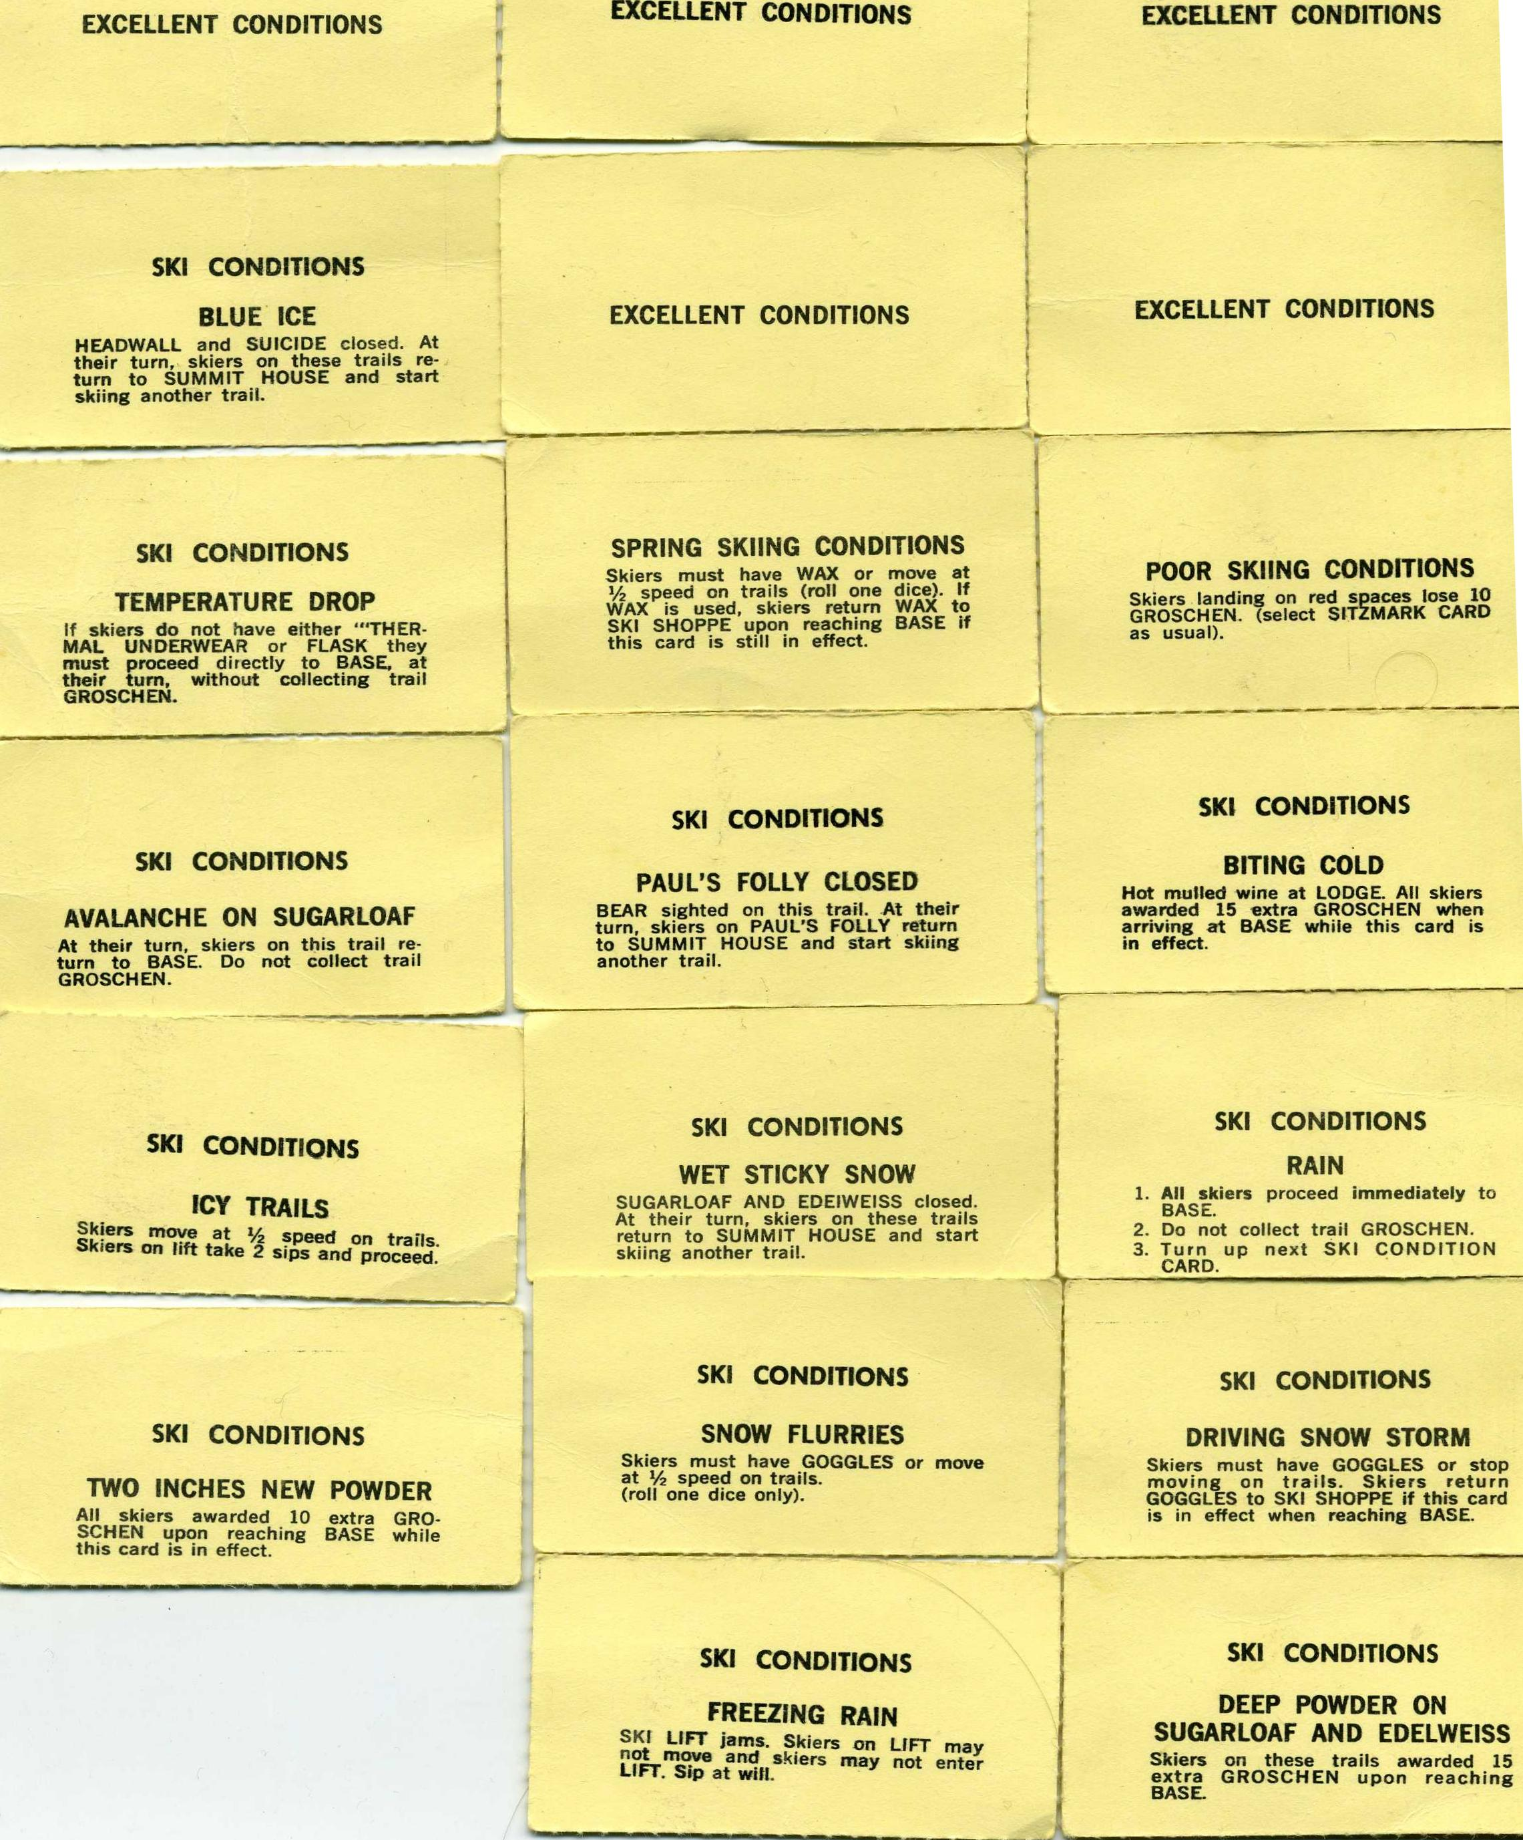

**EXCELLENT CONDITIONS EXCELLENT CONDITIONS**

**EXCELLENT CONDITIONS**

**SKI CONDITIONS**

**SKI CONDITIONS**

**SNOW FLURRIES**

Skiers must have GOGGLES or move at V, speed on trails.

(roll one dice only).

**SKI CONDITIONS**

**FREEZING RAIN**

SKI LIFT jams. Skiers on LIFT may not move and skiers may not enter **LIFT.** Sip at will.

**TWO INCHES NEW POWDER**All skiers awarded 10 extra GRO-   
SCHEN upon reaching BASE while   
this card is in effect.

**SKI CONDITIONS**

,•■■■d■•••■■■•■■■•■•••■•■•■■••■•■••■■•■•■•■■••••

**DRIVING SNOW STORM**

Skiers must have GOGGLES or stop moving on trails. Skiers return GOGGLES to SKI SHOPPE if this card is in effect when reaching BASE.

**SKI CONDITIONS**

**BLUE ICE**

HEADWALL and SUICIDE closed. At their turn, skiers on these trails re­turn to SUMMIT HOUSE and start skiing another trail.

**SKI CONDITIONS**

**TEMPERATURE DROP**

If skiers do not have either —THER­MAL UNDERWEAR or FLASK they must proceed directly to BASE, at their turn, without collecting trail GROSCHEN.

**SKI CONDITIONS**

**AVALANCHE ON SUGARLOAF**At their turn, skiers on this trail re-   
turn to BASE. Do not collect trail   
GROSCHEN.

**SPRING SKIING CONDITIONS**Skiers must have WAX or move at   
1/2 speed on trails (roll one dice). If   
WAX is used, skiers return WAX to   
SKI SHOPPE upon reaching BASE if   
this card is still in effect.

**SKI CONDITIONS**

**PAUL'S FOLLY CLOSED**

BEAR sighted on this trail. At their turn, skiers on PAUL'S FOLLY return to SUMMIT HOUSE and start skiing another trail.

**EXCELLENT CONDITIONS**

**SKI CONDITIONS**

**ICY TRAILS**

Skiers move at 1/4 speed on trails.   
Skiers on lift take 2 sips and proceed.

**SKI CONDITIONS**

**WET STICKY SNOW**

SUGARLOAF AND EDEIWEISS closed. At their turn, skiers on these trails return to SUMMIT HOUSE and start skiing another trail.

**POOR SKIING CONDITIONS**Skiers landing on red spaces lose 10   
GROSCHEN. (select SITZMARK CARD   
as usual).

**SKI CONDITIONS**

**BITING COLD**

Hot mulled wine at LODGE. All skiers awarded 15 extra GROSCHEN when arriving at BASE while this card is in effect.

**SKI CONDITIONS**

**DEEP POWDER ON   
SUGARLOAF AND EDELWEISS**

Skiers on these trails awarded 15 extra GROSCHEN upon reaching BASE.

**EXCELLENT CONDITIONS**

**SKI CONDITIONS**

**RAIN**

1. All skiers proceed immediately to BASE.
2. Do not collect trail GROSCHEN.
3. Turn up next SKI CONDITION CARD.