Home page – hero image
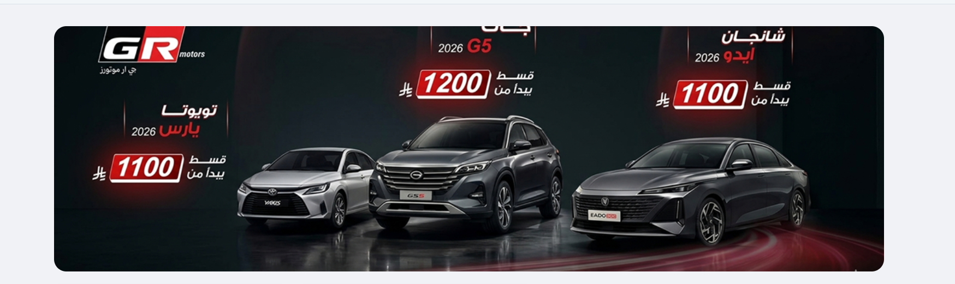
Home page - filtration


Home page – brands filtration and search


All cars – hero image
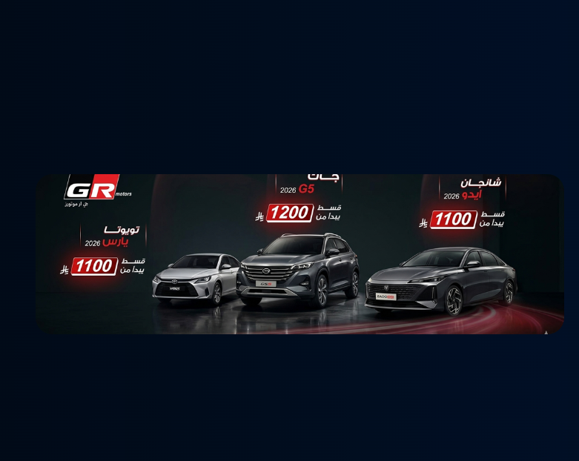
All cars – other filtrations
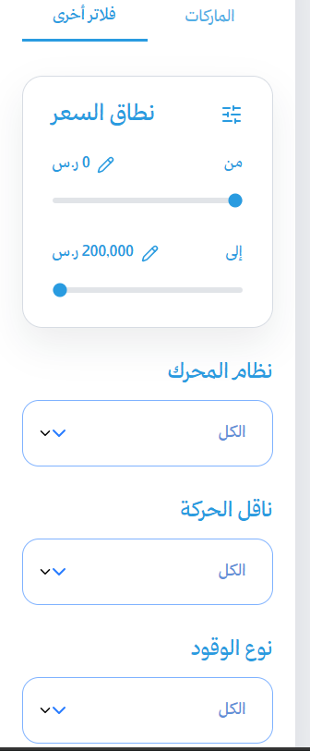

Offers page – filtration


Car details page - hero image is not returned any more
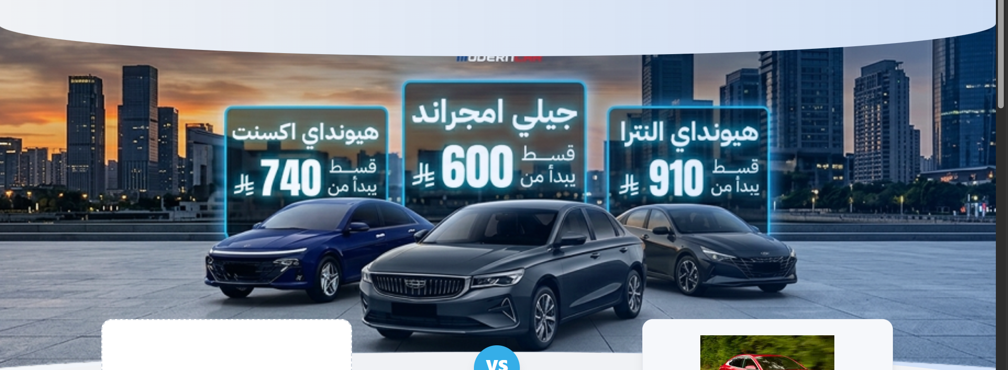

Car details – saving amount

