1.

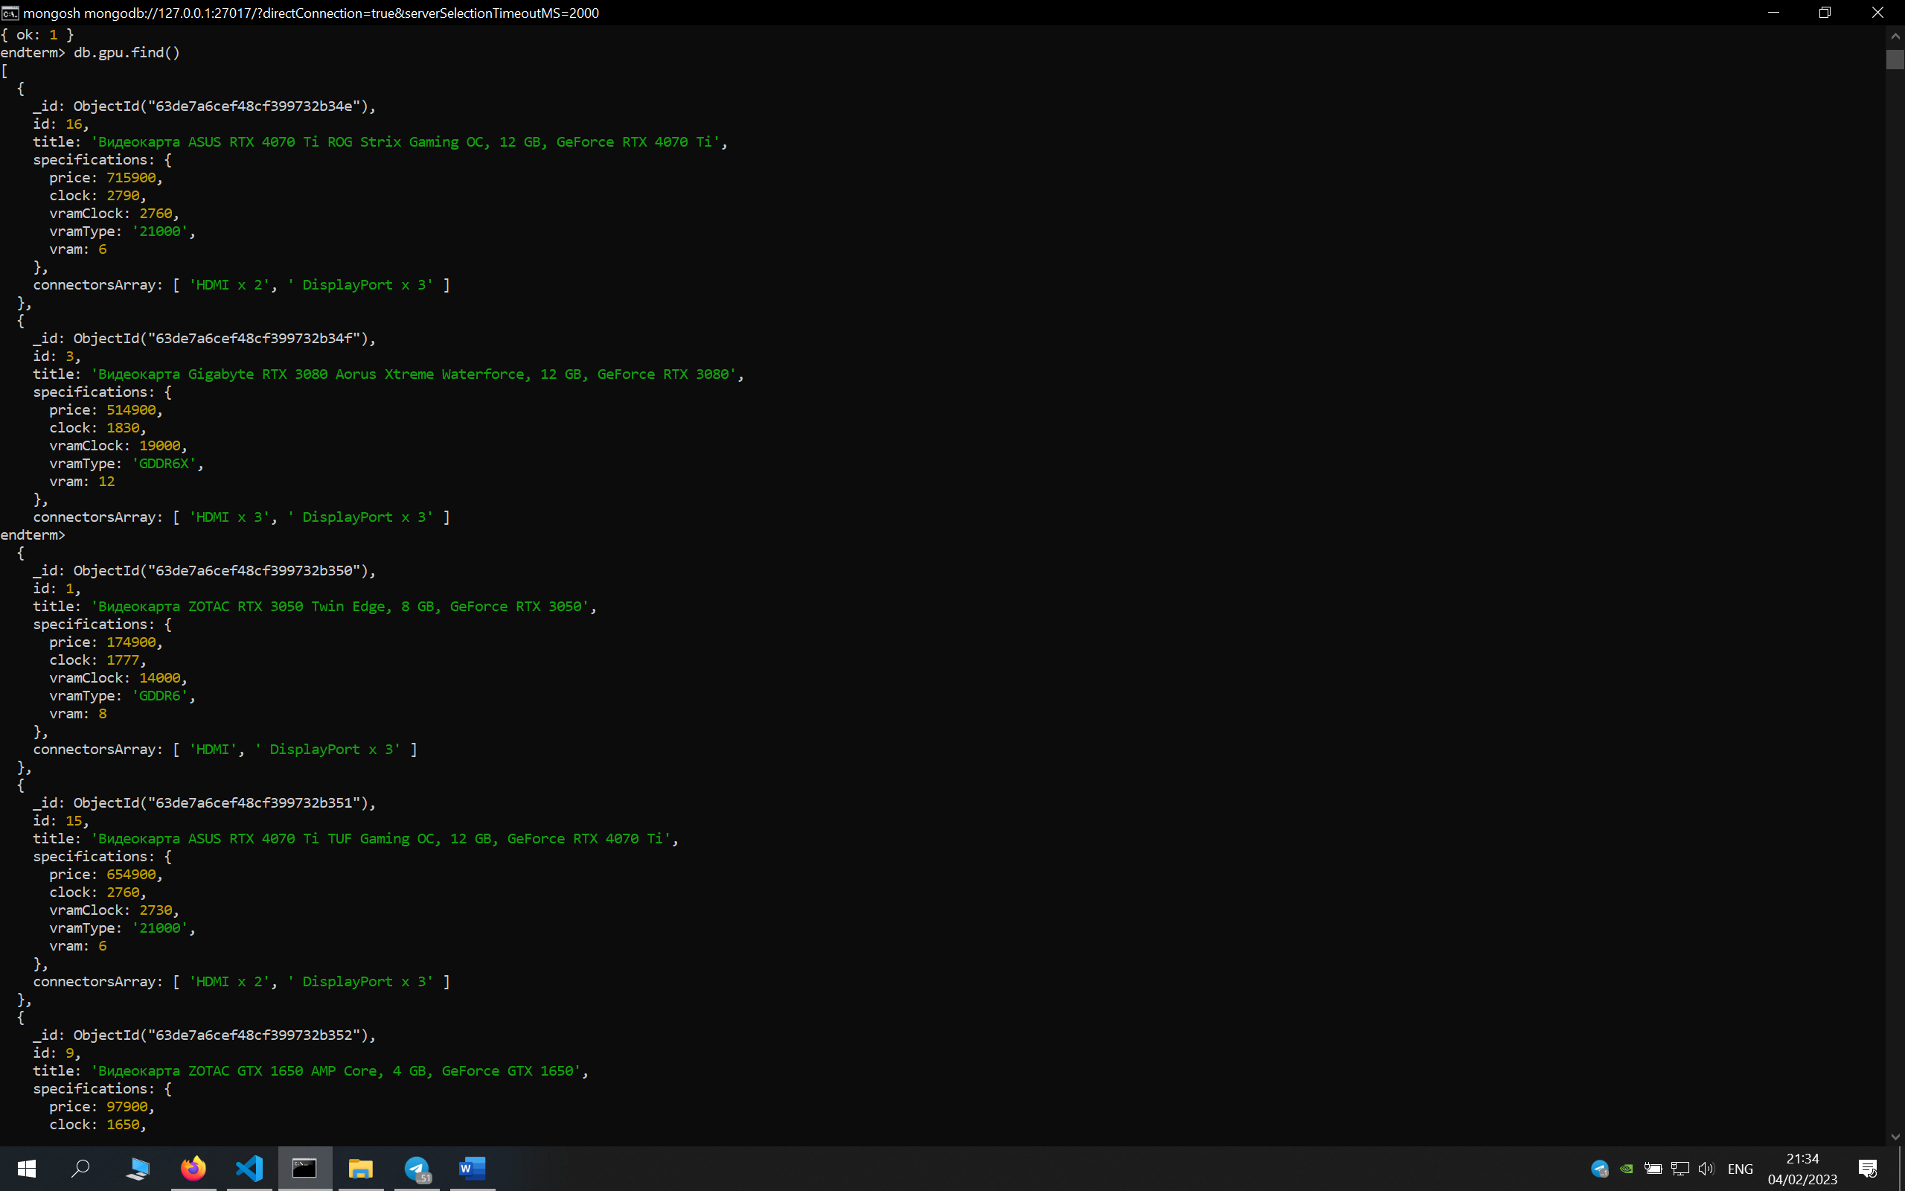

2.

db.gpu.insertOne({id: 275, title: "Rx 580 Sapphire", specifications: {price: 100000, clock: 2750, vramClock: 5000, vramType: "GDDR5", vram: 8}, connectorsArray: ["HDMI", "VGA"]})

3.

4.

5.

db.gpu.deleteMany({'specifications.vramType': {$not: /^GDDR/}})

6.

db.gpu.find({connectorsArray: 'HDMI'})

7.

db.gpu.find({connectorsArray: 'VGA'})

8.

var gpu = db.gpu.find({ $and:[ {'specifications.clock': {$gt: 1700}}, {'specifications.vram': {$gte: 8}}] }).sort({id: 1})

gpu.forEach(function(a) {var b = a.specifications.price/a.specifications.clock; ratio.push(b) })

db.gpu.aggregate([{$addFields: {'ratio': 0}}])

db.gpu.updateMany({}, {$set: {'ratio': 0}})

db.gpu.find({ $and:[ {'specifications.clock': {$gt: 1700}}, {'specifications.vram': {$gte: 8}}] }).sort({id: 1}).forEach(function(item) { var b = item.specifications.price/item.specifications.clock; var idx = item.id; db.gpu.updateOne({id: idx}, {$set: {ratio: b}}) })

mongoexport --db=endterm --collection=gpu --fields=id,title,specifications,ratio,connectorsArray --query="{\"$and\":[ {\"specifications.clock\": {\"$gte\": 1400}}, {\"specifications.clock\": {\"$lte\": 2000}}, {\"specifications.vram\": {\"$gte\": 8}}]}" --sort="{\"id\": 1}" --out C:\nosql\endterm\gpu_data_filtered.json

--db=endterm --collection=gpu --fields=id,title,specifications --query="{\"id\": 274}" --out C:\nosql\endterm\gpu_data_filtered.json

mongoexport --db=endterm --collection=gpu --fields=id,title,specifications,ratio,connectorsArray --query="{\"$and\":[ {\"specifications.clock\": {\"$gt\": 1700}}, {\"specifications.vram\": {\"$gte\": 8}}]}" --sort="{\"id\": 1}" --out C:\nosql\endterm\gpu_data_filtered.json

https://stackoverflow.com/questions/57977309/mongoexport-issue-with-json-query-extended-json-invalid-json-input