**GOVERNMENT POLYTECHNIC, HINGOLI**

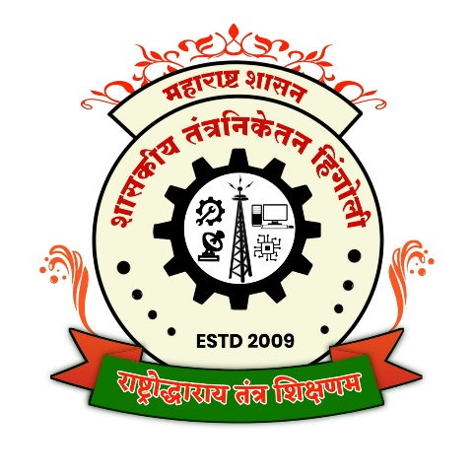

**Sixth Semester**

**(Year: 2022-23)**

Micro Project

**Mobile Application Development (22617)**

Title of the Project

**“Color Rush Android Game”**

**Branch: Computer Engineering (CO6I)**

Members of the Group

|  |  |  |  |  |
| --- | --- | --- | --- | --- |
| **Sr. No.** | **Roll No.** | **Enrollment No.** | **Exam Seat No.** | **Name of the Student** |
| 1 | 3106 | 2011630007 | 448284 | Rohan Prakash Pawar |

**Guided by**

**Prof. A. T. Adhave**

**MAHARASHTRA STATE BOARD OF TECHNICAL EDUCATION, MUMBAI**



**CERTIFICATE**

*This is to certify that this Micro-Project contains the bonafied work of following students of 6th Sem Diploma in Computer Engineering, of* ***Government Polytechnic, Hingoli*** *for the session* ***2022-23.*** *I have completed my Micro- project report entitled* ***“Color Rush Android Game”*** *under the guidance of* ***Mr. A. T. Adhave.*** *This Project report is being submitted to MSBTE, Mumbai, in the partial fulfillment for the Diploma in Engineering*

|  |  |  |  |  |
| --- | --- | --- | --- | --- |
| **Sr. No.** | **Roll No.** | **Enrollment No.** | **Exam Seat No.** | **Name of the Student** |
| 1 | 3106 | 2011630007 | 448284 | Rohan Prakash Pawar |

Prof.A. T. Adhave Prof. A. T. Adhave Dr. Ashok Upadhyay

**Guide HOD Principal**

**Place: Hingoli**

**Date:**

**ACKNOWLEDGEMENT**

It is my great pleasure to acknowledge my guide **Prof. A. T. Adhave,** lecturer and HOD of Computer Dept. in **Government Polytechnic, Hingoli.** His valuable guidance, constant inspiration, unending support helped me a lot of focus my views in proper perspective.

Our sincere and whole hearted thanks to **Dr. Ashok Updhyay**, principal **Government Polytechnic, Hingoli** for inspiring us to achieve highest goal. Last but not least I am also thankful to my parents and friends who helped me a lot in finalizing the project within limited time frame.

**Thank you**

**Name of the Student**

Rohan Prakash Pawar

|  |  |  |  |  |  |  |
| --- | --- | --- | --- | --- | --- | --- |
| **Micro Project Evaluation Sheet**    **Name of Student: Rohan Prakash Pawar Enrollment No: 2011630007**  **Name of Program :** Computer Engineering  **Semester: 6th**  **Course Title: Mobile Application Development** **Course Code: 22617**  **Title of Micro Project:**  Color Rush Android Game  **Learning Outcomes Achieved**:   1. Understanding Android Concepts. 2. Implementing the Java concepts in Projects. 3. Time and Project Management Skills. 4. Android App Testing Process. | | | | | | |
| **Sr No** | **Characteristic to be Assessed** | **Poor**  **Marks**  **(1-3)** | **Average**  **Marks**  **(4-5)** | **Good**  **Marks**  **(6-8)** | **Excellent**  **Marks**  **(9-10)** | **Sub Total** |
| **(A) Process and Product Assessment (6 Marks)** | | | | | | |
| 1 | Relevance to the Course |  |  |  |  |  |
| 2 | Literature Review/Information Collection |  |  |  |  |
| 3 | Completion of the Target as per Project Proposal |  |  |  |  |
| 4 | Analysis of Data & Representation |  |  |  |  |
| 5 | Quality of Prototype/Model |  |  |  |  |
| 6 | Report Preparation |  |  |  |  |
| **(B) Individual Presentation/Viva (4 Marks)** | | | | | | |
| 7 | Presentation |  |  |  |  |  |
| 8 | Viva |  |  |  |  |

**Index**

|  |  |
| --- | --- |
| **Sr. no.** | **Content** |
| 1 | 1.0Brief Description |
| 2 | 2.0 Aim of Micro-Project |
| 3 | 3.0 Course Outcomes Integrated |
| 4 | 4.0 Actual Procedure Followed |
| 5 | 4.1 User Interface Design |
| 6 | 4.2 Java Programming |
| 7 | 4.3 Android Studio IDE |
| 8 | 4.4 Android SDK |
| 9 | 4.5 User Feedback |
| 10 | 4.6 Deployment |
| 12 | 5.0 Actual Resources Used |
| 13 | 6.0 Outputs of the Micro-projects |
| 14 | 7.0 Skills Developed/Learning Out of this Micro-Project |
| 15 | Conclusion |
| 16 | References |

**Title of Micro-Project**

**Color Rush**

1. **Brief Description:**

Color Rush is a small game built in Android Studio which calculates the response time of the user when the screen color changes from blue to green. It also has a fail situation when the user clicks before the screen color turns red, and the player loses. The game is built in Java by Rohan Pawar, a student of batch co6I. This micro-project is aimed at developing a small Android game that tests the user's response time while also providing entertainment.

**2.0 Aim of Micro-Project**

The aim of this micro-project is to build a small Android game that measures the user's response time and provides entertainment. The game will test the user's ability to react quickly to changes in color and will provide a fun and challenging experience for the user.

**3.0 Course Outcomes Integrated:**

This micro-project integrates the following course outcomes:

a) Develop and deploy mobile applications using Android Studio and Java.

b) Develop algorithms and programming logic for small-scale applications.

c) Implement and test small-scale applications using Java and Android Studio.

**4.0 Actual Procedure Followed:**

I followed the following steps to complete the project:

Step 1:

Planning and Designing the Game I started by brainstorming the game concept and designing the game's layout, color scheme, and user interface. I decided to keep the game simple and intuitive, with minimal distractions and an easy-to-understand gameplay.

Step 2:

Setting Up the Project Once the game's design was finalized, I created a new project in Android Studio and set up the development environment. I made sure to install all the necessary tools and libraries required to build the game.

Step 3:

Implementing the Game Logic I implemented the game logic using Java programming language. The game consists of a screen that changes color from blue to green, and the user needs to tap the screen as quickly as possible when the color changes. The game also has a fail state, where the user loses if I tap the screen before it turns red.

Step 4:

Testing and Debugging I tested the game thoroughly to ensure it was working as intended. I also debugged any issues that arose during testing.

Step 5:

Deployment Once the game was tested and debugged, I deployed the game on the Google Play Store, making it available for users to download and play.

The Color Rush Android project was developed using various concepts and techniques of mobile application development. The following are the steps that I followed to develop the game:

**4.1 User Interface Design:**

The first step in developing any mobile application is designing the user interface. I used Android Studio's layout editor to design the user interface for the Color Rush game. The game's user interface includes a start button, score display, and a colored screen that changes from blue to green.

**4.2 Java Programming:**

Java is the primary programming language used in Android application development. I used Java to implement the game's logic, including the color change timer and user input ‘handling. Used Java to maintain the score and the game state.

**4.3 Android Studio IDE:**

Android Studio is the official Integrated Development Environment (IDE) for Android application development. I used Android Studio to write, test, and deploy the game. Android Studio provides various tools, such as an emulator, layout editor, and code editor, which make it easier to develop Android applications.

**4.4 Android SDK:**

Android Software Development Kit (SDK) is a collection of software tools and libraries required to develop Android applications. I used the Android SDK to build and test the Color Rush game.

**4.5 User Feedback:**

After developing the game, conducted user testing to get feedback from players. The feedback was used to improve the game's design and gameplay, making it more engaging and entertaining.

**4.6 Deployment:**

After testing and improving the game, I deployed it to the Google Play Store, making it available to Android users worldwide.

Overall, I used various concepts and techniques of mobile application development to develop the Color Rush Android game. I used Java programming language, Android Studio IDE, Android SDK, and user feedback to build and improve the game's design and gameplay.

**5.0 Actual Resources Used:**

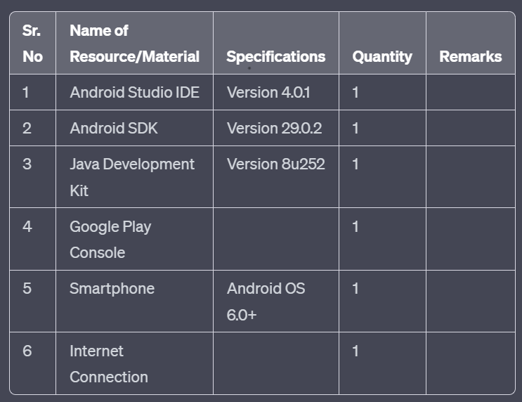I used the following resources to complete the project:

**6.0 Outputs of the Micro-projects:**

The output of this micro-project is the Color Rush game. The game features a simple yet intuitive user interface that allows users to quickly understand the gameplay. The game measures the user's response time and provides an entertaining and challenging experience for the user.

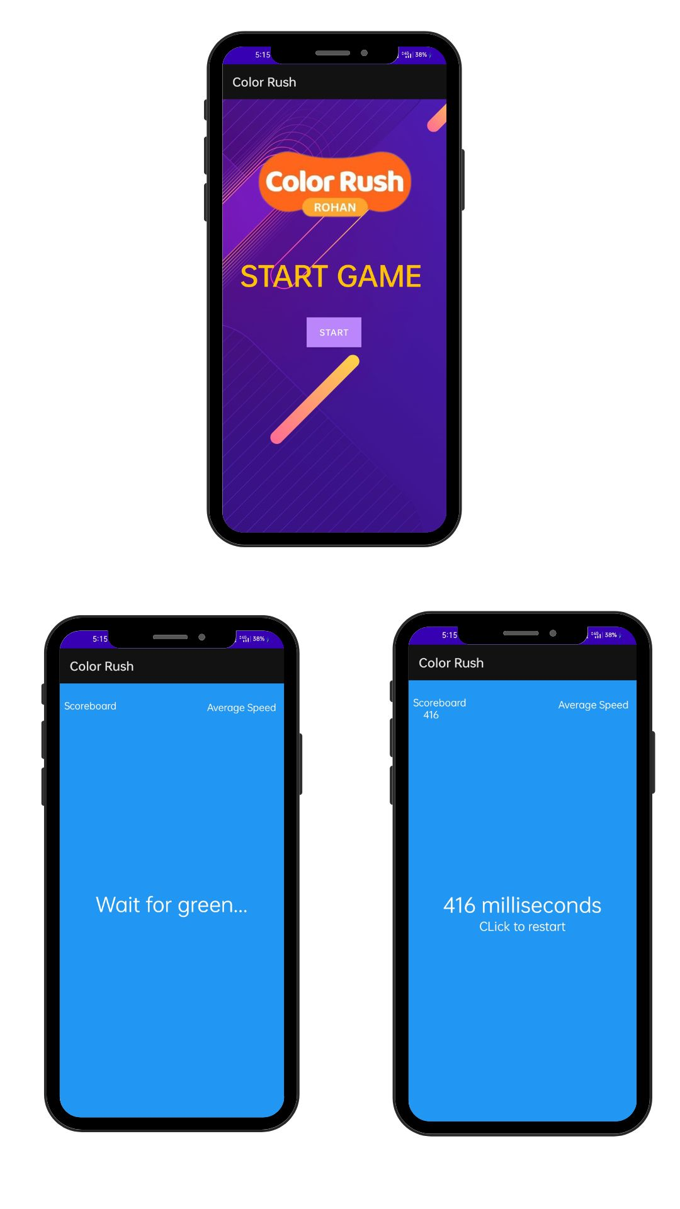**Output**

**7.0 Skill Developed/learning out of this Micro-Project:**

* This micro-project helped me to develop skills in mobile application development using Android Studio and Java. I learned how to plan and design a simple game, implement game logic using Java, test and debug my code, and deploy the game on the Google Play Store. I also learned how to work efficiently on a project and manage my time effectively. Overall, the micro-project helped me develop my programming skills and gain practical experience in developing a mobile game.
* In addition to technical skills, I also developed my soft skills, such as communication. I worked effectively throughout the project to ensure the project was completed on time.
* I also learned the importance of user feedback and incorporating it into the development process. I received feedback from users who played the game, which helped them improve the game's design and gameplay.
* Overall, this micro-project provided I with a practical learning experience in mobile application development, which will be valuable in my future careers. I gained hands-on experience in developing a small-scale application using Java and Android Studio, which will help them in my future projects.

**Conclusion:**

The Color Rush micro-project was a valuable learning experience for me. I developed my technical and soft skills, gained practical experience in mobile application development, and learned the importance of user feedback. I successfully developed and deployed a small Android game that tests the user's response time and provides entertainment. This micro-project will help me in my future projects and careers.

**References:**

1. Open AI’s GPT4 <https://chat.openai.com>
2. Tutorials Point <https://www.tutorialspoint.com>

________________________________________________________________

**\*\*\*End of report\*\*\***