1.

% Jonathan Shipley

% Driven Pendulum and Chaos

% Program calculates angle as a function of time for driven Pendulum

% Assume that l = 9.81m so that the natural period of osciallation is w = 1 rad/s

% Driving frequency wD = 2/3.

% Variables for input from user are driving force, Fd, initial release angle th1, and

% damping parameter

% time step is dt = 0.04 s

% ask user for input for Fd, th1, and q, the damping parameter

% set all other known variables: wD, l, w, dt

% Output is array of theta. Can plot t vs theta

t = 0:0.04:200;

amount = 200/0.04 +1;

dt = 0.04;

th = zeros(amount);

w = zeros(amount);

g = -9.81;

L = 9.81;

wD = 2/3;

Fd = input('Input Fd: ');

th(1) = input('Input th(1): ');

q = input('Input q: ');

for k = 1:amount

w(k+1) = w(k) + ((g/L)\*sin(th(k))- q\*w(k)+Fd\*sin(wD\*t(k)))\*dt;

th(k+1) = th(k) +w(k+1)\*dt;

end

plot(t, th, 'g')

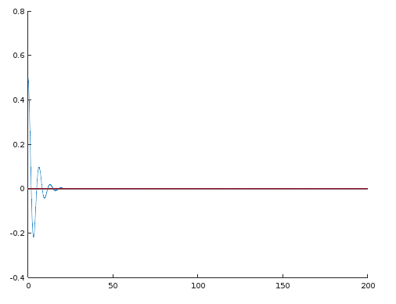

Force = 0, Initial Theta = 0.5, q = 0.5

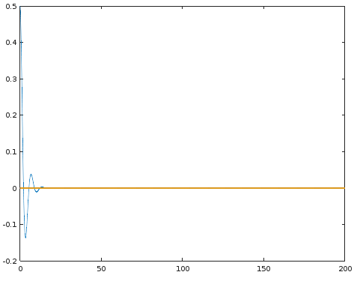

Force = 0; Initial Theta = 0.5; q = 0.75

2.

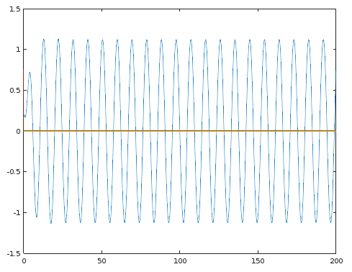

Force = 0.6; Initial theta = 0.2; q = 0.5

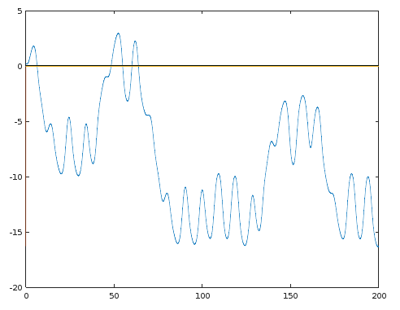

Force = 1.2; Initial theta = 0.2; q = 0.5

The linear frequency of the Force = 0.6 plot ends up being 2/3. The linear frequency if there was no driving force would be 1.