**Live programming – 27.01.2023**

*Solve problems presented below and upload your solutions .py and additional .txt files to the moodle.*

**Problem 1.** Write a function with a list of integer numbers as an argument that will return the list, where each element is increased by the average value of all elements in the given list. Use list comprehension.

**Example:** For a list [2,3,4,5,6] your function should return [6,7,8,9,10].

**Problem 2.** Let list1 = [4,5,6,7,8,9,10,11,12,13,14]. What should be put instead of … in *list2 = list[ … ]* that you have as a result *list2*:

* 1. [4,8,12]
  2. [13]
  3. [13,9,5]

**Problem 3.** Write a Python script that will ask the user about two numbers. Than calculate results of addition, subtraction, multiplication and division of this numbers. Your problem should handle possible errors (the user can be mean to us and put on purpose some strange values as 0 or “134l2”) through exceptions. The exceptions should be handled with additional communicate to the user and the input should be requested again if any problem happens. If input are successful this also should be communicate to the user.

**Problem 4.** Modify previous problem and write input from user and calculated results to the file named problem4.txt. The structure of the file should be as presented

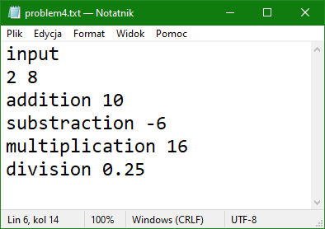

**Problem 5.** Read the results written to file problem4.txt and print the multiplication of them.

**Problem 6.** Calculate expression using math module:

$$sin\left(32.2°\right)+\sqrt{5^{5}-π*\left|-7\right|}+log_{3}10$$