Cherry blossom

Contents

Cherry blossom 1

Cherry blossom 1

Culinary use 1

# Cherry blossom

*Text content from Wikipedia, the free encyclopedia*

A **cherry blossom** is a [flower](https://en.wikipedia.org/wiki/Flower) of many trees of genus [*Prunus*](https://en.wikipedia.org/wiki/Prunus). The most well-known species is the **Japanese cherry**, [*Prunus serrulata*](https://en.wikipedia.org/wiki/Prunus_serrulata), which is commonly called **sakura** ([桜](https://en.wiktionary.org/wiki/%E6%A1%9C#Japanese) or [櫻](https://en.wiktionary.org/wiki/%E6%AB%BB#Japanese); [さくら](https://en.wiktionary.org/wiki/%E3%81%95%E3%81%8F%E3%82%89)).

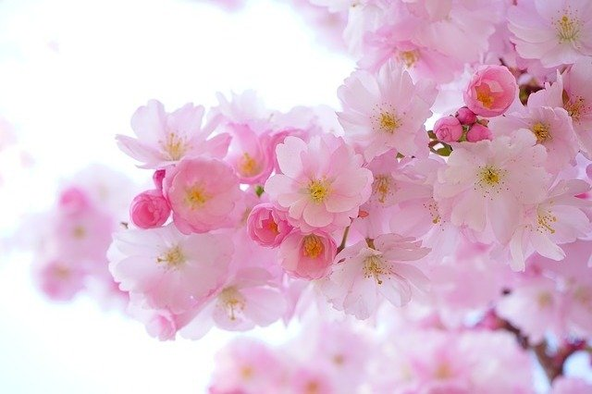

They are widely distributed, especially in the [temperate zone](https://en.wikipedia.org/wiki/Temperate_climate) of the [Northern Hemisphere](https://en.wikipedia.org/wiki/Northern_Hemisphere) including Japan, Taiwan, Korea, Mainland China, Nepal, India, Pakistan, Afghanistan, Iran, Myanmar, Thailand and West Siberia. Along with the [chrysanthemum](https://en.wikipedia.org/wiki/Chrysanthemum#Japan), the cherry blossom is considered the [national flower](https://en.wikipedia.org/wiki/National_flower) of Japan.

All varieties of cherry blossom trees produce small, unpalatable fruit or edible [cherries](https://en.wikipedia.org/wiki/Cherry). Edible cherries generally come from cultivars of the related species [*Prunus avium*](https://en.wikipedia.org/wiki/Prunus_avium) and [*Prunus cerasus*](https://en.wikipedia.org/wiki/Prunus_cerasus).

# Culinary use

Cherry blossoms and leaves are edible and both are used as food ingredients in Japan:

* The blossoms are pickled in salt and [umezu (ume vinegar)](https://en.wikipedia.org/wiki/Umeboshi), and used for coaxing out flavor in [wagashi](https://en.wikipedia.org/wiki/Wagashi), (a [traditional](https://en.wikipedia.org/wiki/Traditional) Japanese confectionery,) or [anpan](https://en.wikipedia.org/wiki/Anpan), (a Japanese sweet [bun](https://en.wikipedia.org/wiki/Bun), most-commonly filled with [red bean paste](https://en.wikipedia.org/wiki/Red_bean_paste)).
* Salt-pickled blossoms in hot water are called [sakurayu](https://en.wikipedia.org/wiki/Sakurayu), and drunk at festive events like weddings in place of [green tea](https://en.wikipedia.org/wiki/Green_tea).
* The [leaves](https://en.wikipedia.org/wiki/Leaf), mostly from the [Ōshima cherry](https://en.wikipedia.org/wiki/Prunus_speciosa) because of the softness, are also pickled in salted water and used for [sakuramochi](https://en.wikipedia.org/wiki/Sakuramochi).
* The fruit, the *sakuranbo*, is small and does not have much flesh beyond the seed within. Due to their bitter taste, the *sakuranbo* should not be eaten raw, or whole; the seed inside should be removed and the fruit-itself processed as preserves.

Since the leaves contain [coumarin](https://en.wikipedia.org/wiki/Coumarin), which is toxic in large doses, it is not recommended to eat them in great quantities. Likewise, the seeds should not be eaten.