Some Sample heading

Document to read with python and others

Plant Health Risk Assessment Unit and

Plant and Biotechnology Risk Assessment Unit

Plant Health Science Division

Ottawa, Ontario

2017-07-25

Table of Contents

Table of Contents 2

SUMMARY 3

BACKGROUND 3

Background sub-heading 3

Background sub-heading 2 3

Example of a tabbed list 4

Other heading 4

APPENDIX 1: Blah 5

Group1 5

Group2 5

# SUMMARY

Summary Summary Summary Summary Summary

Summary Summary Summary Summary Summary

# BACKGROUND

### Background sub-heading

Bla-bla-bla.

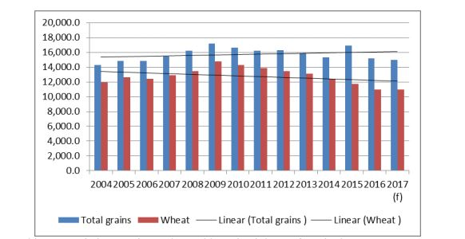

Figure 1 Bla-bla-bla

### Background sub-heading 2

lalalala.

**Table 2: Estimated areas, yield and production of triticale and wheat in Canada over the past five years**

|  |  |  |  |  |  |  |  |
| --- | --- | --- | --- | --- | --- | --- | --- |
|  |  | **Year** | | | | | **Average** |
| **metric** | **name** | **2012** | **2013** | **2014** | **2015** | **2016** |
| **Numbers1** | Name1 | 18,200 | 20,200 | 26,300 | 30,400 | 36,400 | 26,300 |
| Name1 | 9,630,300 | 10,625,600 | 9,791,000 | 9,800,600 | 9,420,100 | 9,853,520 |
| **Numbers2** | Name1 | 13,000 | 11,400 | 13,000 | 10,100 | 17,400 | 12,980 |
| Name1 | 9,497,200 | 10,441,500 | 9,480,100 | 9,577,400 | 8,877,900 | 9,574,820 |
| **Numbers3** | Name1 | 2,700 | 2,600 | 2,600 | 2,500 | 3,100 | 2,700 |
| Name1 | 2,900 | 3,600 | 3,100 | 2,900 | 3,600 | 3,220 |
| **Numbers4** | Name1 | 35,600 | 29,600 | 33,800 | 24,900 | 53,900 | 35,560 |
| Name1 | 27,205,200 | 37,529,600 | 29,419,600 | 27,594,100 | 31,728,600 | 30,695,420 |

### 

### Example of a tabbed list

1 *Text1*

2 *Text2*

3 *Text3*

# Other heading

Bla-bla-bla Bla-bla-bla Bla-bla-bla Bla-bla-bla

Bla-bla-bla

**Table 3: Summary of Stuff**

| **Name** | **Size** | **Appetite** | **Weight** | | **Risk** |
| --- | --- | --- | --- | --- | --- |
| **Group 1** | | | | | |
| *Name 1* | Medium | Low | Low | | Low |
| *Name 2* | Medium | Low | Low | | Low |
| **Group2** | | | | | |
| *Name 3* | High | Low / Medium | | Low / Medium | Medium |

|  |  |  |  |  |
| --- | --- | --- | --- | --- |
| **Group 3** | | | | |
| *Name 5* | High | Medium | High | Low |
| *Name 4* | Low* | Medium | Medium | High |
| **Group 4** | | | | |
| *Name 1*  *Name 2*  *Name 3* | Action pending | | | |
| *Name 1*  *Name 2*  *Name 3*  *Name 4* | Decision pending | | | |

# APPENDIX 1: Blah

Different tables for your consideration

| Group1 | | | | |
| --- | --- | --- | --- | --- |
| **Name** | **Present** | **Interesting** | **Fluffy** | **Information** |
| *Name 1* | Y | N | N | * **Some info about name 1** |
| *Name 2* | Y | N | N | * **bla:** notinteresting |

| Group2 | | | | |
| --- | --- | --- | --- | --- |
| **Pest Name** | **Present** | **Interesting** | **Fluffy** | **Information** |
| *Name 3* | Y | N | N | * **bla:** lalalalala lal alalala alala alamala |
| *Name 4* | Y | N | N | * **bla:** Some description text |
| *Name 5* | N | N | N | * **bla:** Some text that is not interesting and not intended to be read by a sensible being) * **la:** Some text that is not interesting and not intended to be read by a sensible being |
| *Name 6* | Y | N | N | * **bla:** Some text that is not interesting and not intended to be read by a sensible being |