NHSJS Manuscript Template Instructions — Online Citation Format
Thank you for preparing a manuscript for the National High School Journal of Science (NHSJS). Using this template helps us identify each part of your paper and format it correctly. Fill in the template that begins on the next page, replacing the italic instructional text in each section with your own content.
Delete this instructions page before you submit. Your manuscript itself begins on page 3 (the Title).
NHSJS requires at least two versions of your paper: a Standard version with numbered superscript citations, used for peer review, and an Online version with full citations in double parentheses (this file), used for publication. Prepare the standard version with the companion “Standard Citation Format” template.
Formatting requirements
• No more than 20 pages total, including all figures, tables, and any appendix.
• 12-point font; single line spacing; letter-size pages.
• Place figures and tables within the main text, near where they are first mentioned — not collected at the end.
• Name your file the same as your manuscript title, with no additional information.
Sections, in order
Present these sections in order:
- Title
- Authors and affiliations
- Abstract
- Introduction
- Methods
- Results
- Discussion
- Acknowledgments
- References
Cite every figure and table in order, and caption them as shown in the Results section below.
Citations in this file (online)
Instead of superscript numbers, place the complete citation inside double parentheses (( … )) at every point you cite it, with a space before the opening ((. Use exactly the same citation text every time you cite a source. For several sources at once, put each in its own (( … )) and separate them with a superscript comma (not a normal comma or apostrophe).
Example: …surface plasmon resonance ((U. Kreibig, M. Vollmer. Optical properties of metal clusters. Vol. 25 Springer Science & Business Media, 2013.)).
After inserting the citations, convert the separators to superscript commas: open Advanced Find & Replace; find )), (( and replace with ))§§ (( . Then find §§ and replace with , and set to superscript (Format → Font → Superscript).
Reference list format
List references in numerical order at the end. Begin each entry with its number and a period, and end each with a period. Include all author names as initials of given names followed by the surname (e.g., J. B. Robertson, P. L. Cole). Article titles are unitalicized and in sentence case; book titles are italicized and in sentence case. For websites, give the author(s) if known, the page title, the full URL, and the year.
Journal format: Journal. Vol. X, pg. Y–Z, Year, DOI.
Example: D. Tao, Z. He, Y. Lin, C. Liu, Q. Tao. Where does fear originate in the brain? a coordinate-based meta-analysis of explicit and implicit fear processing. NeuroImage. Vol. 227, pg. 117686, 2021, https://doi.org/10.1016/j.neuroimage.2020.117686.
Institutional Review Board (IRB) approval
If your study involves human participants or animal subjects — including surveys, interviews, behavioral experiments, or the collection of identifiable personal data — you likely need IRB approval before you collect data. High-school researchers without access to a university IRB can obtain review at https://jhss.scholasticahq.com/pages/944-irb. Report your approving body and protocol/approval number in the Methods (Ethical considerations) section.

Title: How to format an NHSJS paper (replace with your real title)
Authors: List all authors in one single paragraph (no line breaks), each written as a given name or initial followed by the family name and separated by commas. Link affiliations with superscript numbers, and use non-superscript symbols (*, †, ‡) for author notes (see below).
Examples: Author A. Name¹*, Author B. Name¹, Another Author¹, C. Author^{1,2}, D. E. Author²†, Example Author³†
Affiliations:
¹Precede each affiliation with the superscript number that matches the author list, and end each with a period. Use a semicolon to separate an institution from its address; only city and country are required (a full mailing address is not needed).
²Put each affiliation in its own paragraph.
³For a large group or consortium, use the group name and give the full list of authors and affiliations at the end of the manuscript.
*Corresponding author. Give the corresponding author’s email; mark them with an asterisk (*) in the author list and again before the email, after the affiliations.
†Use symbols in this order — †, ‡, §, ¶, #, ** — for author notes such as present addresses or “These authors contributed equally to this work.” Do not use footnotes for professional titles or data-contact requests; put those in the Acknowledgments.
Example:
Author Name¹*
¹Department of Interesting Field, Example High School; City, Country.
*Corresponding author. Email: student@example.org
Abstract: In one paragraph of 200–250 words, cover — in this order — the background and objective (the context, the gap in knowledge, and your research question), your methods, your results, and your conclusions.
Keywords: four to eight terms that index your paper, separated by commas.
Introduction
Introduce the broader field and context. State the problem and why it matters (gaps or limitations in existing work). Explain the significance and purpose of your study. State your specific objectives, and any hypotheses or research questions. Define the scope and limitations. If relevant, describe your theoretical framework, then briefly overview your methodology (save the details for Methods). Cite prior work using the format on the instructions page.
Methods
Use the set of subheadings that fits your study, and delete the other. Here are some examples:
For a research paper
Research design. Experimental, observational, cross-sectional, longitudinal, etc.
Participants or sample. Who or what was studied; demographics; selection criteria.
Data collection. How the data were gathered (surveys, experiments, observations…) and why.
Variables and measurements. Define the variables; how each was measured; any instruments.
Procedure. The step-by-step sequence from data collection to analysis.
Data analysis. The statistical or qualitative methods and the tools used.
Ethical considerations / IRB approval. State informed consent, confidentiality, and adherence to relevant guidelines. If your study involves human participants or animal subjects, give your IRB approving body and protocol/approval number. If you still need approval, apply at https://jhss.scholasticahq.com/pages/944-irb.
For a systematic review
Search strategy. Databases searched, keywords, and any filters or date limits.
Inclusion criteria. Publication dates, study designs, relevance, and other criteria.
Data extraction. What information was extracted from each included study.
Synthesis method. How the findings were combined (thematic analysis, narrative synthesis, etc.).
Quality assessment. How the validity and reliability of the included studies was judged.
Results
Present your findings objectively, using text, figures, and tables. Place each figure and table in the main text, near where you first mention it — not at the end of the manuscript. Number figures and tables in the order they are cited, and save interpretation for the Discussion. Put a figure’s caption below it and a table’s caption above it, using the format shown here:
[ Place your figure here, in the main text near where you first refer to it. ]

Figure 1 | Single-line description of the whole figure. A) Description of the first panel. B) Description of the second panel.
Table 1 | Single-line description of the table. Any other additional information about the table.
Variable | Group A (n = ) | Group B (n = )
[Measure 1] | [value ± SD] | [value ± SD]
[Measure 2] | [value ± SD] | [value ± SD]

(Replace these examples with your own. Begin the caption with the figure or table number and a vertical bar, and bold the number, the bar, and the one-line description; bold the panel letters — A), B), … — as well. A figure’s caption goes below it; a table’s caption goes above it.)
Discussion
Restate your key findings; discuss their implications and significance; connect back to your objectives; offer recommendations; and acknowledge the limitations of your study. End with a closing thought, and do not introduce new information.
Acknowledgments
Acknowledge funding (with grant numbers and agencies), contributions, and any competing interests. Disclose any AI-assisted tools used in preparing the manuscript.
References
List your references here, numbered in the order they first appear, using the format on the instructions page. Each entry begins with its number and a period and ends with a period. For example:
1. D. Tao, Z. He, Y. Lin, C. Liu, Q. Tao. Where does fear originate in the brain? a coordinate-based meta-analysis of explicit and implicit fear processing. NeuroImage. Vol. 227, pg. 117686, 2021, https://doi.org/10.1016/j.neuroimage.2020.117686.
2. [Author(s). Title. Journal. Vol. X, pg. Y–Z, Year, DOI.]
3. [Author(s). Title. Journal. Vol. X, pg. Y–Z, Year, DOI.]
PART 2 — Guided example
Below is a complete NHSJS-formatted paper shown as a model. The shaded boxes explain each section; they are annotations, not part of a real submission — delete them (and this box) in your own paper. This example uses the online double-parenthesis citation format.

Ceramics Research Done Smartly: Accelerating the Transition to Sustainable Ceramics
Abstract - one paragraph, 200-250 words, covering background/objective, methods, results, and conclusions, followed by a Keywords line.

Abstract
Ceramics have been a witness of human ingenuity throughout history. From their usage in pottery and artifacts in the past to industrial, electrical, and aerospace applications of ceramics in the present, ceramics are ubiquitous in our lives. Unfortunately, manufacturing ceramics is extremely energy-intensive and is responsible for more than 8% of global anthropogenic CO₂ emissions. There have been continuous efforts to make these valuable materials more sustainable. Recently, with the advance of data science, organizing and learning from data has become much less time-consuming. This literature review aims to coalesce the two fields, sustainability, and data science, with a focus on ceramics. Instead of narrowing our focus to specific ceramics, such as glass or cement, we proposed procedures that can be broadly applied. By analyzing different data science approaches and their applicability to creating ceramics databases, we evaluated various ways to promote ceramics sustainability using data science. More specifically, we analyzed vital insights or techniques that may be applied elsewhere and sought opportunities to create procedures that required the least human input and benefited the most from machine learning models. We categorized different approaches toward regression and data extraction, examined suitable approaches for various scenarios, and qualified these efforts by explaining the impact new databases can have on the sustainability of ceramics. We hope this literature review will prove relevant to readers with an interest in data science, sustainable ceramics, and their intersections.
Keywords: Ceramics, Sustainability, Data Science, Machine Learning (ML), Deep Learning, Large Language Model (LLM), Regression, Data Extraction
Introduction - sets the broader context, states the gap and why it matters, the significance and objectives of the study, and cites prior work. Notice the in-text citations: the complete reference sits inside double parentheses (( )) with a space before the ((.

Introduction
Ceramics are defined as materials that are neither metallic nor organic. These materials often present themselves with valuable properties, such as heat resistance, semiconducting behavior, or inertness. For example, refractories are used in extreme-temperature industrial processes because of their high resistance to heat, and technical ceramics are used in chemical processing plants because of their chemical inertness ((European Ceramic Industry Association and others. Ceramic roadmap to 2050. Brussels, Belgium: The European Ceramic Industry Association (2021).)). Ceramics are undoubtedly valuable, but unfortunately, producing ceramics is a highly energy-intensive process. Aside from the mechanical energy needed to mill and pulverize the mined raw materials (e.g., rocks of clays, silicas, limestones), these raw materials require incredibly high temperatures (e.g., above 1500 °C in specially equipped furnaces) to react in solid or molten form and yield the solid solutions that define the products. The associated greenhouse gas emissions are not attributable only to the energy input to the manufacturing process (e.g., process heat, electricity, mechanical power) but also to the process emissions emanating from the solid-state reactions responsible for chemically converting the raw materials to products, accentuating the climate impact of the ceramics industry via these process emissions. For instance, emissions from the European ceramic industry amount to 19 million tons of CO₂ annually ((European Ceramic Industry Association and others. Ceramic roadmap to 2050. Brussels, Belgium: The European Ceramic Industry Association (2021).)), and much research is necessary to make the ceramics industry more sustainable.
We provide a general schematic of the ceramics industry below to better explain the sustainability challenge in ceramics. After mining from Earth deposits, raw materials such as clay, silica, or limestone are transported to and stored in the manufacturing plant. This transportation process could lead to significant emissions if raw materials are mined far from the ceramic plant. The raw materials at the ceramic plant are then milled, mixed, and pulverized to increase the surface area available for the ensuing solid-state reactions. Often, they get formed into a paste and shaped into a mold before getting dried, to prepare them for the firing step. The raw materials then react under firing in furnaces, where heat management and distribution are of paramount importance to the quality of the product. Afterward, finishing often includes cooling, packaging, and regular testing for quality control of the products.
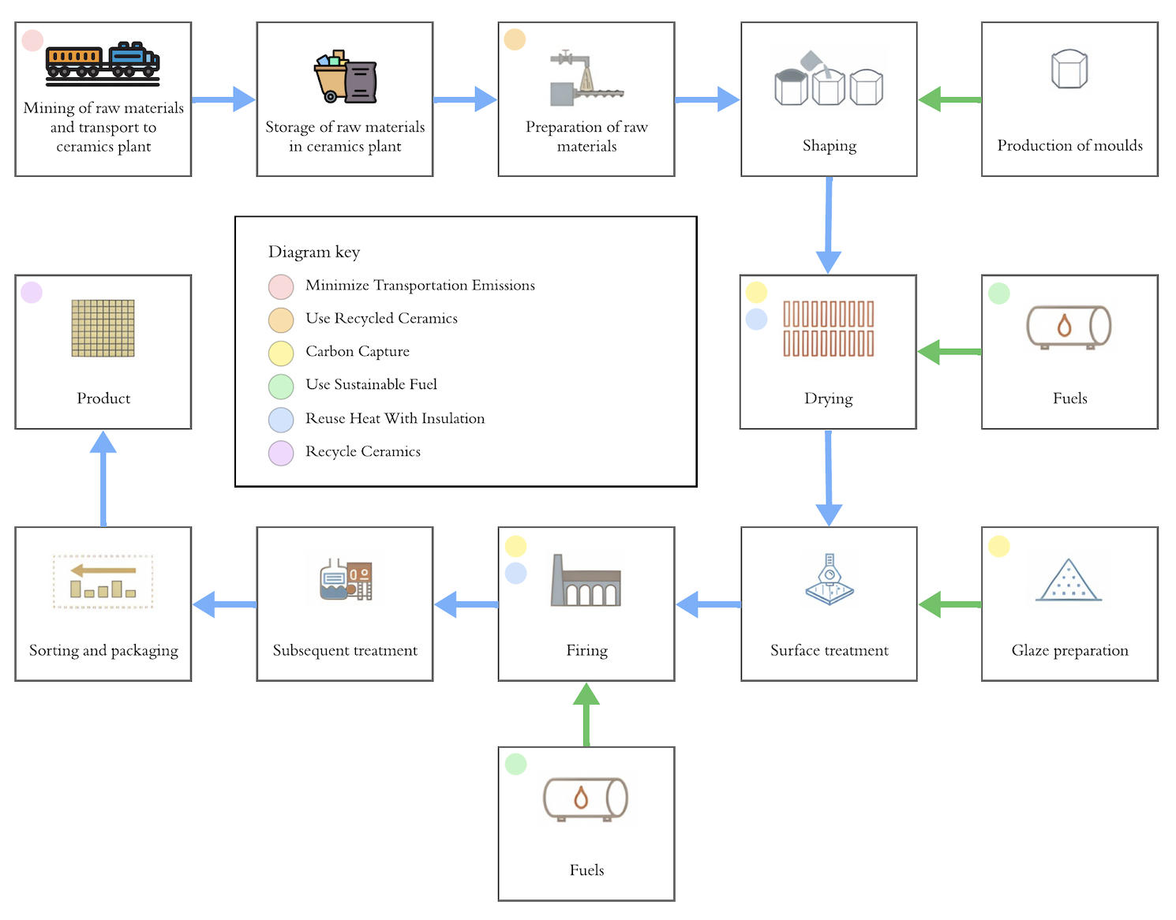
Figure 1 | A Simplified General Schematic of the Ceramics Manufacturing Process adapted from Ceramic Roadmap to 2050
Figure 1 overlays some examples of opportunities for sustainability in existing ceramic plants. Following the schematic above, one can start by placing the ceramics manufacturing site near the mining and raw materials extraction site to minimize transportation emissions. The drying step is crucial before firing, as this step controllably gets rid of water and volatile organic impurities contaminating the raw materials, ensuring the mechanical integrity of the fragile and, as of yet, wet shapes. Here, there exists an opportunity for heat integration, where the flue gases from the firing step heat the drying air or are applied directly to dry the incoming feed to the furnace. Using environmentally sustainable fuel sources such as green hydrogen during this firing stage could significantly improve the sustainability of the overall process. The furnace is also lined with ceramic refractories that trap the heat inside, offering effective insulation. Further, capturing the carbon released during the drying and firing stages can help decarbonize the production process. However, further research must be done to find more practical carbon removal technologies and offsetting measures because current methods, like carbon capture and storage, are too costly to be practical. The ceramics industry is heading towards a circular pathway as well, in which refuse from manufacturing and distribution sites is used as a filler to minimize new raw materials in the production mix, solving both a waste problem and an emissions problem. Some wall and floor tiles industry manufacturers transitioned from rotary printing to digital printing and created walls and floor tiles with 80% recycled ceramics using ceramic inks instead of decorative pastes. Clay pipes consisting of 40% new raw materials and refractories containing 20% to 80% new raw materials can be produced, and it is possible to reuse 90% of expanded clay products ((European Ceramic Industry Association and others. Ceramic roadmap to 2050. Brussels, Belgium: The European Ceramic Industry Association (2021).)). The goal should be to make all ceramic products 100% reusable so no waste is created. Although this might require significant research or technological breakthroughs, decreasing the percentage of raw materials used would result in substantial reductions in process emissions.
However, there is only so much that such improvements can do to turn the ceramics industry into a genuine engine for sustainability, for the ceramics industry remains intrinsically emissions-intensive and geared towards end products rather than advanced ceramics that go into further green technologies ((European Ceramic Industry Association and others. Ceramic roadmap to 2050. Brussels, Belgium: The European Ceramic Industry Association (2021).)). Here, we suggest that a smart approach towards sustainable ceramics research is data-centered, including building, maintaining, and seamlessly interacting with comprehensive databases that adhere to FAIR data principles (findable, accessible, interoperable, and reusable).
To make this point, we highlight two recent articles discussing the highly successful results of this endeavor. The first is by K. Gong and coworkers at Princeton University, where they established a strong research program geared towards the manufacture of cement with less emissions, by designing alkali-activated kaolin clays as raw materials that help turn industrial wastes and already-calcined clays (which emit no further CO₂ upon processing) into cementitious binders, minimizing process emissions ((K. Gong, K. Yang, C. E. White. Density functional modeling of the binding energies between aluminosilicate oligomers and different metal cations. Frontiers in Materials 10 (2023).)). Specifically, they applied computationally intensive density functional theory simulations to calculate the binding energies of seventeen such alkali cations to aluminosilicate dimers and trimers and then correlated these binding energies to two other properties that are readily obtainable (i.e., do not require DFT simulations): the ionic potential and field strength of these cations. The high-quality second-order polynomial correlations (R²=0.99-1.00) highlight their usability to rapidly estimate such binding energies of new cations or new substrates, extending this research's impact into materials not initially simulated by the authors ((K. Gong, K. Yang, C. E. White. Density functional modeling of the binding energies between aluminosilicate oligomers and different metal cations. Frontiers in Materials 10 (2023).)). The data on binding energies of different cations to different clay materials can help design alkali-activated kaolin clays as raw materials by providing insight into the performances (e.g., performance against sulfuric acid attacks) of the resulting sustainable cement. This endeavor highlights the importance of a data-centered approach toward innovative ceramics research.
The second article is by S. Kim and coworkers at Seoul National University. They successfully created an extensive band-gap database for semiconducting inorganic materials, as applied in photovoltaic devices. By using a hybrid functional and considering a stable magnetic ordering, they made a database for band gaps for 10,841 materials with a significantly smaller root-mean-square error of 0.36 eV than the 0.75-1.05 eV of existing databases (1 eV ~ 100 kJ/mol) ((S. Kim, M. Lee, C. Hong, Y. Yoon, H. An, D. Lee, W. Jeong, D. Yoo, Y. Kang, Y. Youn, S. Han. A band-gap database for semiconducting inorganic materials calculated with hybrid functional. Scientific Data 7, 387 (2020).)). Additionally, they identified a considerable number of small-gap materials that were misclassified as metals in other databases. By correctly classifying these materials as semiconducting inorganics, they provided a broader selection of materials that manufacturers or researchers may consider using. This can come with various benefits, such as reduced costs of materials, reduced transport emissions, and more. Overall, S. Kim and coworkers created a highly impactful (and highly cited) database utilizing a data-centered approach, further highlighting the potential of a data-centered approach for scientific research and innovation. Band gaps are but one of a myriad of properties that define the utility of ceramic materials in advanced and sustainable applications (see Table 1 for a non-comprehensive list of such properties and applications).
Table 1 | A Simplified Subset of Major Property Categories for Technical and Sustainable Ceramics
Property | Definition | Application | Type | Unit
Thermal Conductivity | Ability to conduct heat | Insulation, electronic cooling | Thermal | W/m/K (Watts per meter-Kelvin)
Band Gap | Energy difference between the highest valence bond and the lowest conduction band | Semiconductors, solar cells, LEDs | Electronic | eV (electron volt)
Piezoelectricity | Ability to generate an electric charge in response to mechanical stress, or vice versa | Sensors, actuators,  transducers | Electrical/Mechanical | Vm/N (voltage-meter per Newton)
Refractive Index | Measure of light bending in a material | Lenses, photonic devices, optical networks | Optical | dimensionless
Process Emissions | Emissions generated during manufacturing or industrial processes | Ceramic (cement) industry | Manufacturing | kg CO₂/kg product (kilogram CO₂ per kilogram product)
Corrosion Resistance | Ability to withstand degradation by chemical reactions | Chemical processing | Chemical | mm/yr (millimeter per year)
Melting Point | Temperature at which a material changes from solid to liquid | Material processing, casting, welding | Thermal | °C or K (degrees Celsius or Kelvin)
Fracture Toughness | Ability to resist fracture when a crack is present | Structural ceramics, dental implants | Mechanical | MPa  (megapascal times the square root of meters)
Oxygen Ionic Conductivity | Ability to conduct oxygen ions under an applied voltage gradient | Solid oxide fuel cells, oxygen sensors | Electrical | S/m (siemens per meter)

Lamentably, there is a severe lack of comprehensive, reliable, up-to-date, and accessible ceramics property databases ((S. Freiman, J. Rumble. Current availability of ceramic property data and future opportunities. American Ceramic Society Bulletin 92, 34–39 (2013).)), a problem that must be addressed to transition to sustainable ceramics efficiently. This paper suggests combinations of already-present machine learning methods to maximize the accuracy of ceramics property databases that can be extracted with minimal human input, current literature, and available data.
Methods - describes how the work was done. Studies involving human participants or animal subjects must state IRB approval and protocol number here.

Methods
We have mainly used the Google Scholars search engine to search prompts that relate various machine learning models (e.g., random forest decision tree), tasks (e.g., regression), or programs (e.g., Scikit-learn) to ceramics or materials research to find research papers, journals, and articles relevant to this paper. To verify the credibility of old sources, namely the journal written by S. Freiman et al., we’ve done further research, manually visiting databases such as the National Institute of Standards and Technology to validate whether the challenges mentioned in the journal persist. We also evaluated the publication date, which is of the greatest importance for the relevancy of machine learning methods for contemporary database creation, and how relevant the proposed methods are for the purpose of creating ceramic property databases. To assess the quality of the methods proposed, we’ve analyzed the design of the study, such as what type of data (e.g. experimental, DFT calculated) was used to train the machine learning models and the statistical measures provided. Also, we have visited websites created by reputable sources, such as IBM, to obtain general information regarding machine learning models. To organize the information obtained from surveying these sources, we’ve categorized these sources based on the machine learning task performed and the model used, which aligns with the overall structure of this paper as well.
Results - presents the findings objectively with figures and tables, placed in the main text. Every figure/table is cited in order and captioned in the “Figure N | …” format (figure captions below, table captions above).

Results
An Overview of Machine Learning Models
Following the recent rise of machine learning, there have been recent efforts to extract data from text using natural language processing models. For example, M. Polak and coworkers proposed a successful procedure using ChatGPT to extract mid-sized databases from text ((M. Polak, S. Modi, A. Latosinska, J. Zhang, C. Wang, S. Wang, A. Hazra, D. Morgan. Flexible, model-agnostic method for materials data extraction from text using general purpose language models. Digital Discovery 3, 1221 (2023).)). This process requires minimal prior knowledge of coding and the property being analyzed, but can generate databases with high precision and recall in a single day. This automatic quality of machine learning, being able to extract data from literature or learn from available data to create sufficiently accurate databases with minimal human input, is what makes machine learning so valuable and, thus, will be the focus of this literature review.
In the world of data science, machine learning methods have varying types of training data and tasks to solve. Supervised models or algorithms refer to models trained on data sets with labels — either categorical or continuous — corresponding to the data points, and can help predict material properties. Some supervised models, such as graph neural networks, can input graphs as data, which is useful when predicting properties based on molecular structures that are represented as graphs. In contrast, unsupervised models are trained on data sets that lack such labels and are often used for clustering or anomaly detections, but lack utility for the purpose of creating databases for ceramics data. This paper will focus on the following three most common types of supervised machine learning models that were present in the literature surveyed: Support Vector Machines, Decision Trees, and Neural Networks. A brief overview of these three types of models is described in Figure 2.
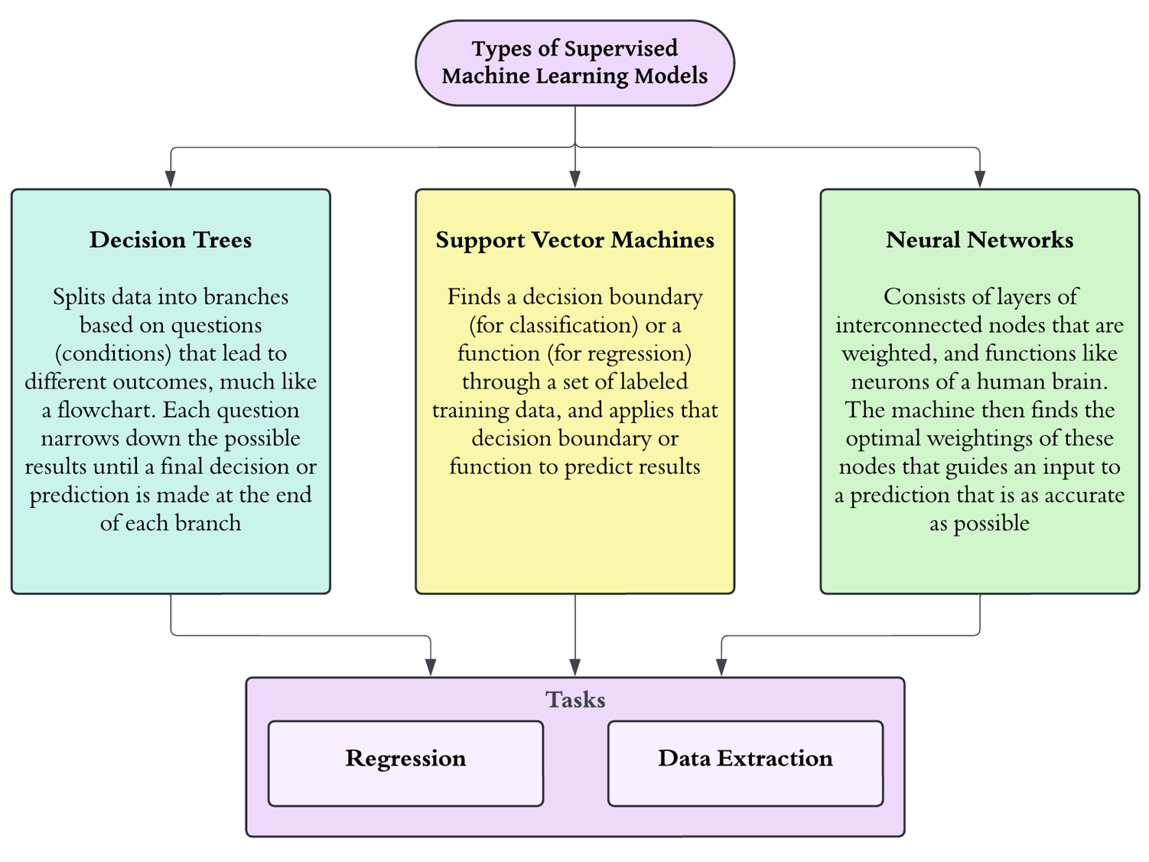
Figure 2 | A Simple Overview of Three Types of Machine Learning Models
Support Vector Machines
Support Vector Machines (SVMs) are supervised learning algorithms that can be applied for both classification and regression. For classification tasks, the machine finds the most optimal decision boundary, referred to as a hyperplane, that maximizes the margin, or distance, between the nearest data points of two different classes and the decision boundary. A larger margin implies a clearer separation between the two classes of data and, therefore, a better generalized classifying model. An SVM for regression, often referred to as Support Vector Regression (SVR), is an extension of SVM that predicts continuous variables. Instead of finding a decision boundary that maximizes the margin, an SVR finds a function that predicts the output value within a specified margin of tolerance ((IBM. What are support vector machines (SVMs)? (2023).)).
Decision Trees
Decision Trees are supervised learning algorithms that utilize tree-like structures to make predictions. These trees are composed of nodes and branches connecting the nodes. The starting node at the top of the tree is called a root node, where the input is given. The nodes at the bottom of the tree are called leaf nodes, and these nodes represent all possible outcomes within the dataset or scenario. Starting from the root node, at each node, the machine makes a decision based on its training of previous data points and sends the input to a new node that was connected to the previous node via a branch. This process is then repeated until the input arrives at a terminal node representing a possible output. There are various types of decision trees, including Random Forest, Gradient Boost, Extreme Gradient Boost, and Adaptive Boost decision trees, all of which are commonly used for regression. Figure 3 below is a brief overview of these four special types of decision trees for regression ((J. Deb, J. Gou, H. Song, C. Maiti. Machine learning approaches for predicting the ablation performance of ceramic matrix composites. Journal of Composites Science 8, 96 (2024).)), ((IBM. What is a decision tree? (2023).)), ((IBM. What is random forest? (2023).)).
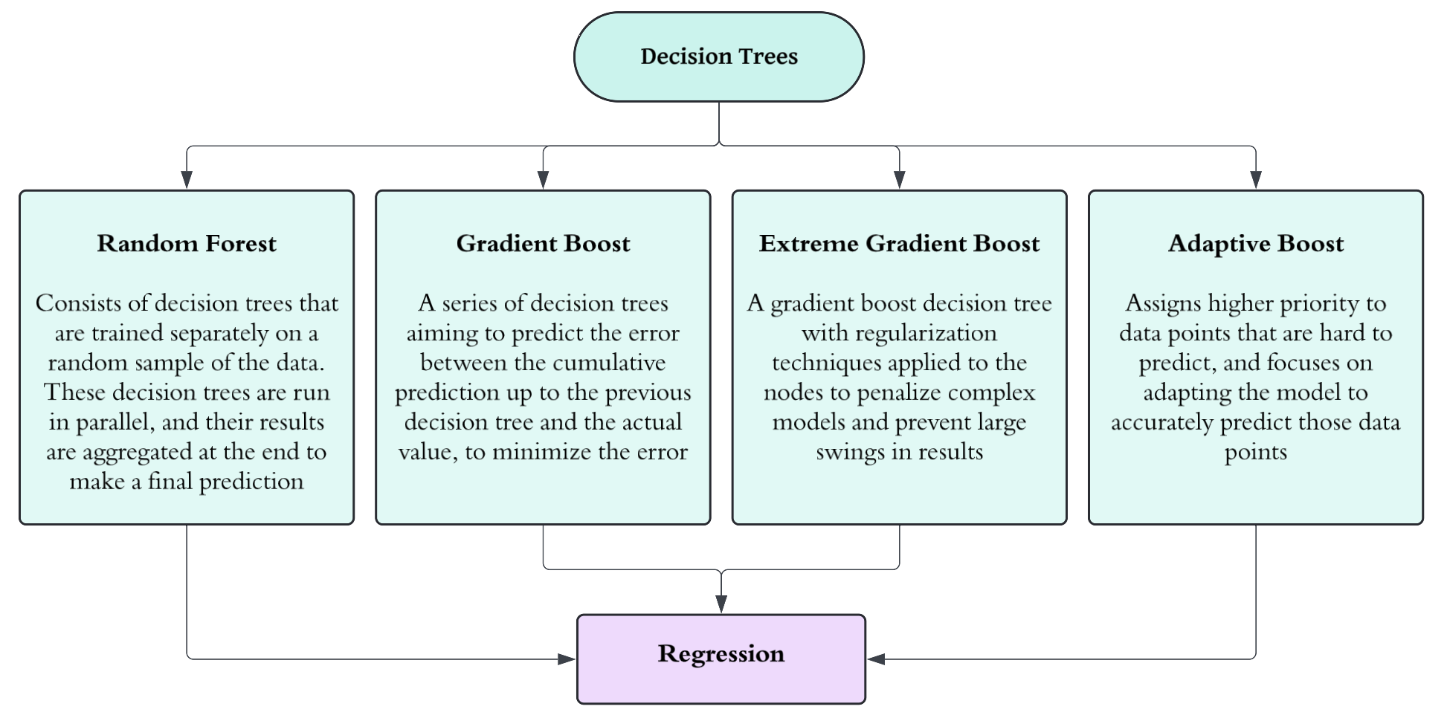
Figure 3 | A Non-Comprehensive Diagram Depicting Various Decision Trees for Regression
A random forest decision tree is an ensemble of decision trees trained separately on random samples of the training data. These independent decision trees are run in parallel when given an input, and the individual results generated by each of these decision trees are aggregated to make a final prediction. A gradient boost decision tree is a series of several decision trees that attempt to predict the errors from the previous decision trees in the series. An extreme gradient boost decision tree is a gradient boost decision tree with regularizations that prevent complex models that are overfitting the training data and/or aren’t generalizing well. These regularizations include but are not limited to, lasso regularizations, which encourage sparsity, and ridge regularizations, which reduce the variance of the model. An adaptive boost decision tree consists of a group of independent decision trees that learn adaptively, forcing decision trees that made significant errors to train more on those instances to reduce the large errors. The results from these independent decision trees are then weighted and compiled so that the decision trees that made those significant errors have less influence over the result ((J. Deb, J. Gou, H. Song, C. Maiti. Machine learning approaches for predicting the ablation performance of ceramic matrix composites. Journal of Composites Science 8, 96 (2024).)), ((IBM. What is a decision tree? (2023).)), ((IBM. What is random forest? (2023).)).
Neural Networks
A Neural Network is a program or model that intends to replicate how our brain makes decisions. The nodes in a neural network are connected to one another and serve as neurons of the machine. The individual nodes input data, calculate a weighted output using the input data, and compare the output to a specified threshold value to “make decisions” ((IBM. What is a neural network? (2023).)). When these models are trained on large data samples, they can classify, cluster, and estimate data rapidly and with high accuracy. Figure 4 is a diagram depicting common types of neural networks and a non-comprehensive type of tasks these models can complete.
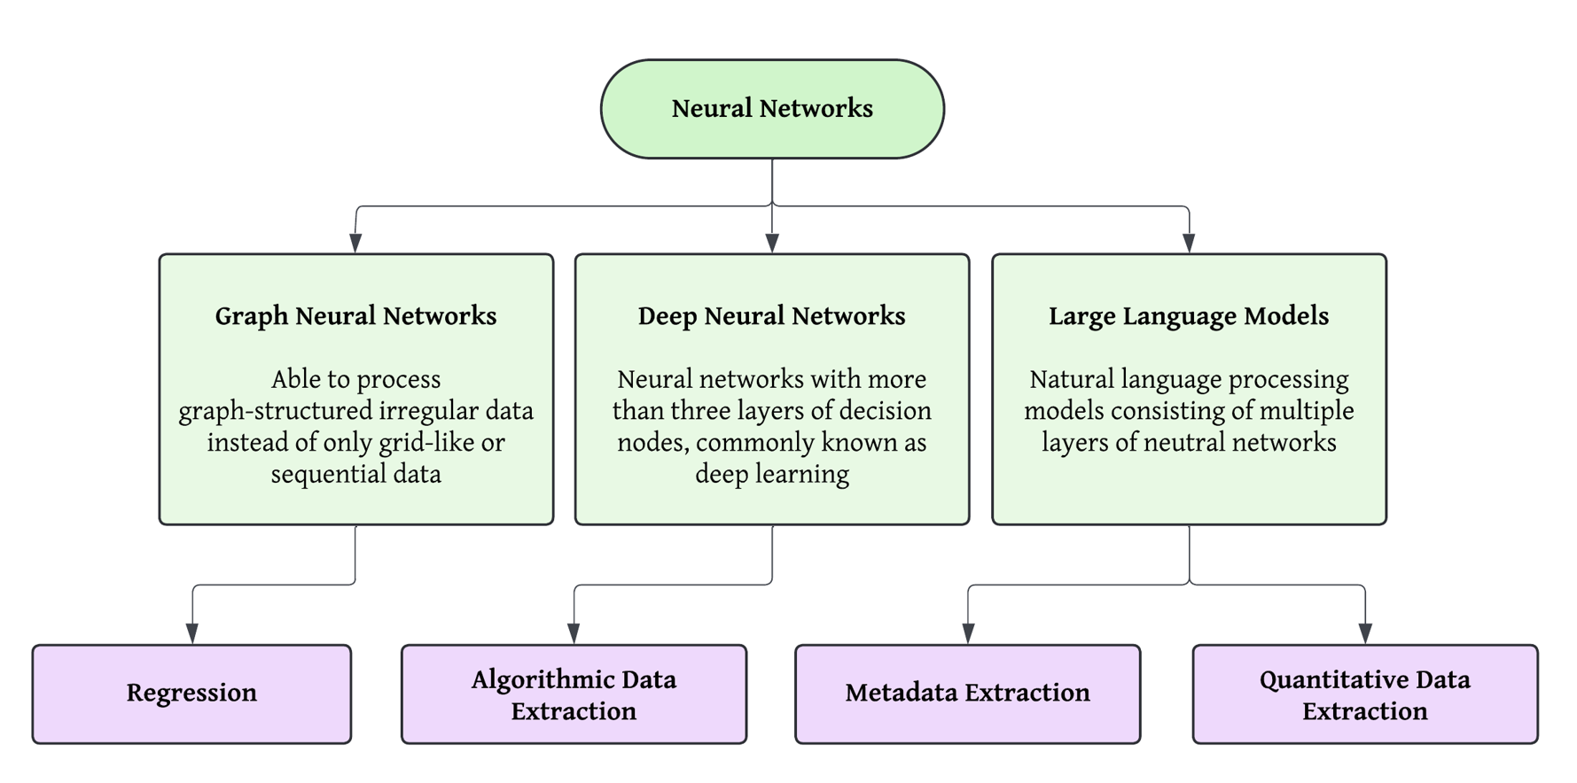
Figure 4 | A Non-Comprehensive Diagram Depicting Types of Neural Networks and Tasks
Graph Neural Networks are a type of neural network that can intake graph-structured irregular data. These neural networks are especially useful in understanding materials because they can input molecular structures as data and handle them efficiently. Deep Neural Networks, commonly referred to as Deep Learning, are neural networks with three or more layers, which is common for models that require complexity. These models can be trained to estimate material properties using other more available properties without knowing the specific relation between those properties beforehand. A Large Language Model (LLM) is an application of deep learning that utilizes multiple layers of deep neural networks for natural language processing and is trained on extremely large samples of textual data. These various types of neural networks can be useful in ceramics research because of their ability to interpret large amounts of data or text, to predict numerical data, or to extract different data from the vast sea of literature ((IBM. What are large language models (LLMs)? (2023).)).
Machine Learning Models Used for Regression
Machine learning models such as deep neural networks and the various decision trees can help solve regression tasks by using data that are more easily accessible to predict values of properties that are expensive or computationally intensive to compute. This is a common practice for scientific researchers, as seen by how K. Gong and coworkers successfully calculated binding energies using density functional theory (DFT) and then extrapolated them with second-order polynomials to avoid further DFT calculations on metal cations not previously calculated ((K. Gong, K. Yang, C. E. White. Density functional modeling of the binding energies between aluminosilicate oligomers and different metal cations. Frontiers in Materials 10 (2023).)). The main benefit of using machine learning models to make these predictions is that they can calculate predictions nearly instantaneously with no human input or background information on these properties.
Graph Neural Networks Used with Molecular Structure Data
The benefits of utilizing neural networks to estimate materials property data become apparent when considering interatomic potentials or inferring properties of materials that require DFT but are prohibitively expensive to obtain large samples of (e.g., high-entropy materials or catalysts). Graph neural networks specifically serve as relevant tools to predict these properties because of their ability to input the molecular structures of these high-entropy materials and predict properties rapidly. Such was the case when C. M. Clausen and coworkers successfully performed zero-shot inferences of adsorption energies of high-entropy materials utilizing a graph neural network. Here, zero-shot inference refers to the direct prediction of relaxed structure models and adsorption energies of materials using a machine learning model that was not explicitly trained to output those relaxed structures given an initial structure. Their model possessed inference speeds that were “practically instantaneous” thanks to the low number of parameters used in the neural network. Despite already achieving “state-of-the-art accuracy,” yielding mean absolute errors in adsorption energies of 0.04 eV (adsorption energies of these high-entropy materials are normally on the order of magnitude of 10⁰), with the fraction of the time DFT would take to emulate the high-entropy materials, C. M. Clausen and coworkers stated that a hyperparameter optimization could “further improve the performance” ((C. M. Clausen, J. Rossmeisi, Z. Ulissi. Adapting OC20-trained EquiformerV2 models for high-entropy materials. arXiv.org (2024).)). C. M. Clausen and coworkers’ work highlights the possibilities of using machine learning to accurately estimate data on materials that were out of the domain of previous experiments or data collections. Optimizing hyperparameters and increasing the depth of the neural networks appear to be valuable steps to take in the future because of the amount of time and resources these machine-learning models can save when compared to running DFT calculations with supercomputers. Further, substituting machine learning models in place of DFT calculations allows research normally involving computational quantum mechanical modeling methods to be much more accessible to researchers around the world, as supercomputers for scientific research may not be readily accessible for researchers, especially those in less developed countries.
Decision Trees Used with Continuous Data
Although the nature of decision trees makes them seem suitable for classification tasks related to categorial variables, some types of decision trees can be powerful tools that can predict quantitative variables rapidly. Similar to the application of graph neural networks, decision trees can be used to estimate properties of materials that are on par with the quality obtained from DFT calculations and experimental results. For example, K. Kaufmann and coworkers were able to use random forest decision trees to estimate the synthesizability of high-entropy materials ((K. Kaufmann, D. Maryanovsky, W. Mellor, C. Zhu, A. Rosengarten, T. Harrington, C. Oses, C. Toher, S. Curtarolo, K. Vecchio. Discovery of high-entropy ceramics via machine learning. NPJ Computational Materials 6, 42 (2020).)). K. Kaufmann and coworkers first chose a set of around 800 attributes of materials that may be relevant for synthesizability to feed as features for the machine learning model. Then, they utilized a feature named the SelectFromModel in Scikit-learn ((F. Pedregosa, G. Varoquaux, A. Gramfort, V. Michel, B. Thirion, O. Grisel, M. Blondel, P. Prettenhofer, R. Weiss, V. Dubourg, J. Vanderplas, A. Passos, D. Cournapeau, M. Brucher, M. Perrot, E. Duchesnay, G. Louppe. Scikit-learn: machine learning in python. Journal of Machine Learning Research 12, 2825–2830 (2011).)), a machine learning tool in Python, to narrow down the eight most relevant features to be used to train their model. Among these eight features related to chemistry, physics, or thermodynamics, K. Kaufmann and coworkers were able to predict which of these features contributed the most towards the final prediction of synthesizability ((K. Kaufmann, D. Maryanovsky, W. Mellor, C. Zhu, A. Rosengarten, T. Harrington, C. Oses, C. Toher, S. Curtarolo, K. Vecchio. Discovery of high-entropy ceramics via machine learning. NPJ Computational Materials 6, 42 (2020).)). This is a strong benefit of using decision trees for regression tasks: allowing us to peek inside the black box of machine learning models. Thanks to its flowchart-like structure, decision tree models are one of the most interpretable machine learning models available. In scenarios like these, where some sort of connection between quantitative variables is expected, being able to predict which quantitative attributes were responsible for the data can bring researchers one step closer to understanding the underlying cause and science that they were unaware of, which is why the interpretable quality of decision trees is valuable.
Unfortunately, some decision tree algorithms are much more complicated in nature and are harder to interpret than random forest decision trees or regular decision trees. Such is the case for extreme gradient boost and adaptive boost decision trees. Because normalizations and optimizations are applied to extreme gradient boost trees and because adaptive boost decision trees compare the training data, they are intrinsically too complex to interpret or understand. Still, these decision trees take comparatively much less time to make predictions. For example, when J. Deb and coworkers predicted the ablation performance of ceramic matrix composites using various decision trees to compare results, the extreme gradient boost and adaptive boost decision trees took significantly less simulation time ((J. Deb, J. Gou, H. Song, C. Maiti. Machine learning approaches for predicting the ablation performance of ceramic matrix composites. Journal of Composites Science 8, 96 (2024).)). Specifically, when using the performance parameters that resulted in the greatest R-squared scores and the least mean absolute errors among all decision trees, the extreme gradient boost and adaptive boost decision trees took 1 second and 2 seconds accordingly, the random forest decision tree took slightly longer than 2 minutes, the regular decision tree took longer than 18 minutes, and the gradient boost decision tree took close to 9 minutes ((J. Deb, J. Gou, H. Song, C. Maiti. Machine learning approaches for predicting the ablation performance of ceramic matrix composites. Journal of Composites Science 8, 96 (2024).)). This shows that the decision trees that are too complicated to be interpreted still serve a purpose, as they can drastically improve computing efficiency while still retaining high accuracy.
Flowchart of Machine Learning Methods to Utilize for Different Regression Tasks
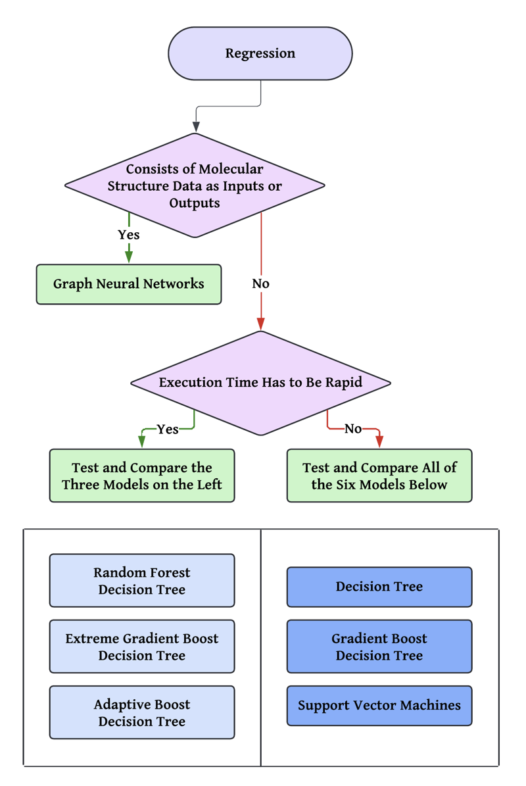
Figure 5 | A Brief Overview of What Machine Learning Models to Use Given Different Scenarios
The flowchart depicted in Figure 5 shows a summary of what machine learning models one should use depending on the type of regression task assigned. The properties of ceramics are dependent on the molecular structure of the material. As such, it is plausible that some form of molecular structure data is involved with the inputs or outputs of a given regression task. In such cases, it is encouraged to use a deep neural network to be able to take full advantage of the structured data. Further, predicting molecular structures of materials as an intermediate step before predicting a quantitative property could be useful, as knowing the molecular structures can help determine the distribution of electron density across the material, find distances between atoms, and find angles between bonds, all of which allow us to utilize DFT or quantum mechanical modeling to predict other properties of a material, if such level of accuracy is necessary for a project or experiment. For example, a graph neural network can be used to help narrow down which candidate has the significance to further test using expensive DFT calculations to make more accurate results.
When predicting continuous, quantitative data, you can utilize various decision trees or a support vector regression. In particular, the extreme gradient boost decision tree, adaptive boost decision tree, and random forest decision tree models execute the fastest among these six machine learning models shown in Figure 5. This was shown experimentally in J. Deb and coworkers’ experiments ((J. Deb, J. Gou, H. Song, C. Maiti. Machine learning approaches for predicting the ablation performance of ceramic matrix composites. Journal of Composites Science 8, 96 (2024).)), and aligns with the properties of the model: the extreme gradient boost tree is an optimization of a gradient boost tree that implements parallelization to speed up the tree-building process, while the adaptive boost decision tree and the random forest decision trees generate small trees to aggregate their results, which takes less time than generating a larger, more complex tree. Other than the apparent difference in the expected execution time of these models, it is hard to predict which model will perform the best in terms of accuracy or precision because of how unique these models are. Here, it is worth noting that the comparative performance of these models remains relatively constant even as the test data increases. Despite the small changes in the performances of the regression models as more of the test data was used for training, the relative order of performance among the regression models stayed constant in J. Deb and coworkers’ experiments ((J. Deb, J. Gou, H. Song, C. Maiti. Machine learning approaches for predicting the ablation performance of ceramic matrix composites. Journal of Composites Science 8, 96 (2024).)). This signifies that a researcher can simulate these six for a smaller percentage of the test data, say 10%, determine which model suits their need the best, and then continue the training for that model only, saving time and energy.
Machine Learning Models Used for Data, Metadata, and Algorithmic Data Extraction
Machine learning models such as large language models, support vector machines, and deep neural networks can help build databases by extracting quantitative data, metadata, and algorithmic data. The vast sea of literature and data floating online makes it overly time-consuming or expensive to manually extract information by hand. For large-scale projects with substantial budgets, extracting certain scientific data and metadata would be more plausible. However, in the ceramics community, there hasn’t been enough effort or budget to create a centralized and organized database hub for ceramics property data, as noted by S. Freiman and J. Rumble ((S. Freiman, J. Rumble. Current availability of ceramic property data and future opportunities. American Ceramic Society Bulletin 92, 34–39 (2013).)). As it stands, it is beneficial to be able to generate databases with high accuracy without requiring extensive manpower, and a combination of machine learning models can help researchers make those databases with minimal human input and without domain expertise.
Large Language Models for Quantitative Data Extraction
Despite the immensely practical and applicable nature of large language models (LLMs), it may seem troublesome to use them to extract data, because with such a black-box system, one cannot be entirely certain that the output is reliable. However, when combined with human supervision, LLMs can extract data from research papers with impressive accuracy, as shown in the works of M. Polak and coworkers ((M. Polak, S. Modi, A. Latosinska, J. Zhang, C. Wang, S. Wang, A. Hazra, D. Morgan. Flexible, model-agnostic method for materials data extraction from text using general purpose language models. Digital Discovery 3, 1221 (2023).)). The method of quantitative data extraction presented by M. Polak and coworkers was able to achieve 90% precision at 96% recall and can generate databases of up to around 1,000 entries within a single workday. Such a high precision and recall is noteworthy, because even “state-of-the-art” named entity recognition-based tools such as the ChemDataExtractor2 achieved a 52% precision at 37% recall in the same scenario ((M. Polak, S. Modi, A. Latosinska, J. Zhang, C. Wang, S. Wang, A. Hazra, D. Morgan. Flexible, model-agnostic method for materials data extraction from text using general purpose language models. Digital Discovery 3, 1221 (2023).)). In M. Polak and coworkers’ method, human input is necessary at the end of the process to manually extract the data values from a list of sentences that were predicted to be relevant to the data in question. However, “[fine-tuning] the LLM with example sentences” so that the LLM can more accurately distinguish relevant sentences, significantly reduced the number of irrelevant sentences among this mix, “about 99%” of them ((M. Polak, S. Modi, A. Latosinska, J. Zhang, C. Wang, S. Wang, A. Hazra, D. Morgan. Flexible, model-agnostic method for materials data extraction from text using general purpose language models. Digital Discovery 3, 1221 (2023).)). As the development of LLMs continues, using LLMs to extract data from research papers seems to be a promising way to extract data without needing a data scientist, as AI-powered LLMs such as ChatGPT can understand natural language as an input to function.
Support Vector Machines for Metadata Extraction
Support vector machines (SVMs) are well known for their ability to accurately classify data points of different classes. However, SVMs can be helpful in domains far beyond pure classification tasks. One example is using SVMs to extract metadata from literature.
By dividing relevant metadata into fifteen classes, such as title, author, abstract, and more, classifying each line as part of one or more of those classes, and iteratively correcting those classifications by observing neighboring lines, H. Han and coworkers were able to extract metadata fully automatically at accuracies above 98.5% for most of the fifteen classes of metadata, an accuracy “nominally better” than other available methods of metadata extraction ((H. Han, C. Giles, E. Manavoglu, H. Zha, Z. Zhang, E. Fox. Automatic document metadata extraction using support vector machines. 2003 Joint Conference on Digital Libraries, 2003. Proceedings. 37–48 (2003).)).
Deep Neural Networks for Algorithmic Data Extraction
To make the ceramics property databases adhere to the “interoperable” aspect of the FAIR principle, it is important to provide access to the code used to analyze the data present or provide a way to obtain such code without having to train domain experts in data science. Machine learning models, specifically deep neural networks (DNNs), can be used to extract algorithmic data so that the databases can contain pseudocode extracted alongside the data extracted using large language models. I. Safder and coworkers were able to create a procedure dedicated to extracting algorithmic data using clever techniques, showcased in Figure 6 ((I. Safder, S. Hassan, A. Visvizi, T. Noraset, R. Nawaz, S. Tuarob. Deep learning-based extraction of algorithmic metadata in full-text scholarly documents. Information Processing & Management 57, 102269 (2020).)).
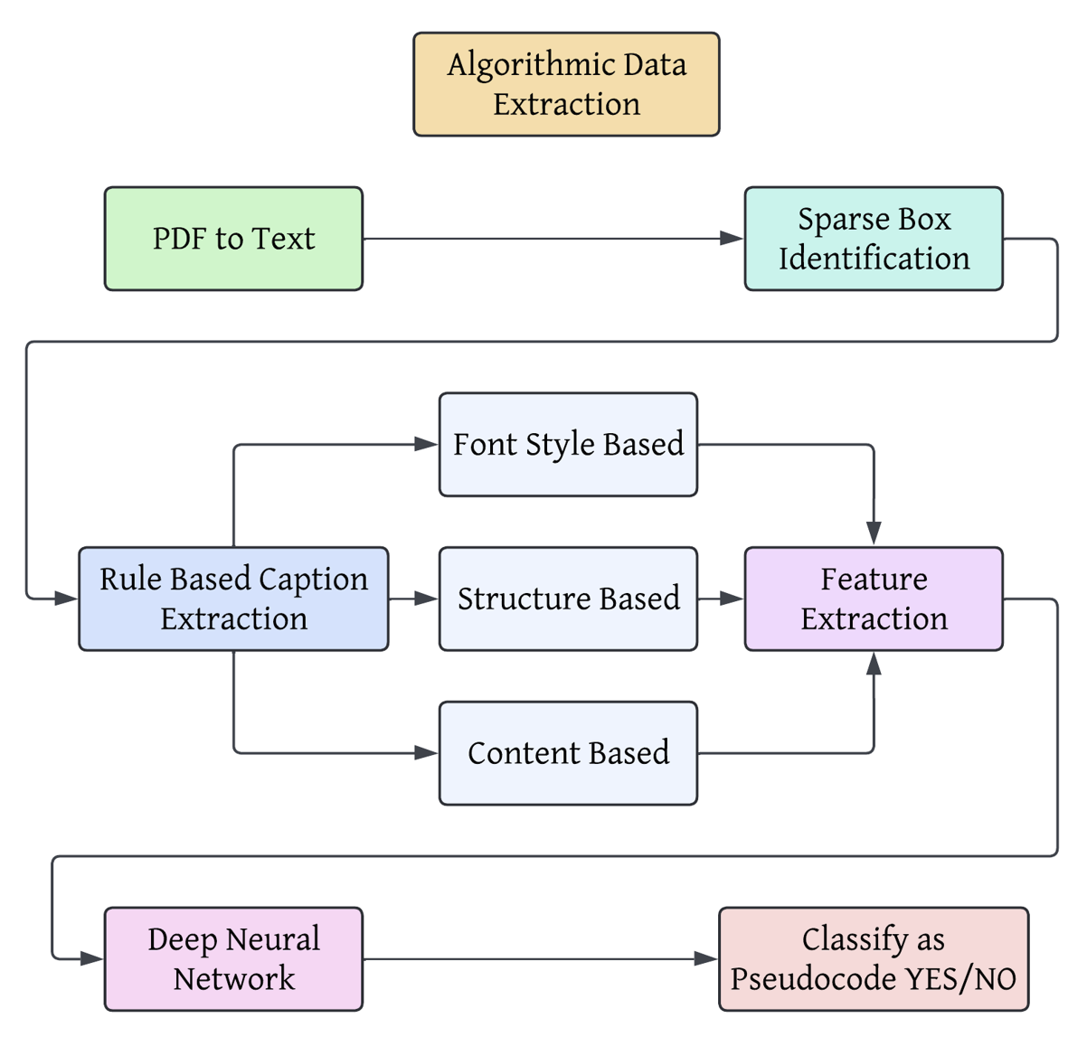
Figure 6 | Depiction of Procedure for Extracting Algorithmic Data from Literature, Adapted from Deep Learning-based Extraction of Algorithmic Metadata in Full-Text Scholarly Documents
As depicted in Figure 6, they first converted the PDF files into text files and looked for “sparse boxes” that were left sparse because of the formatting required for showcasing programming languages. Then, based on 60 features, including font, structure, and content of the text region, the DNN was trained to classify whether the text given contains algorithmic data or not. The classification resulting from this procedure had an F1-score of 93.32%, “outperforming the state-of-the-art techniques by 28%”, and a near 80% accuracy ((I. Safder, S. Hassan, A. Visvizi, T. Noraset, R. Nawaz, S. Tuarob. Deep learning-based extraction of algorithmic metadata in full-text scholarly documents. Information Processing & Management 57, 102269 (2020).)).
Flowchart of Machine Learning Methods to Utilize
Figure 7 depicts a flowchart to help guide which machine learning models to use and how to use them to create databases through extraction.
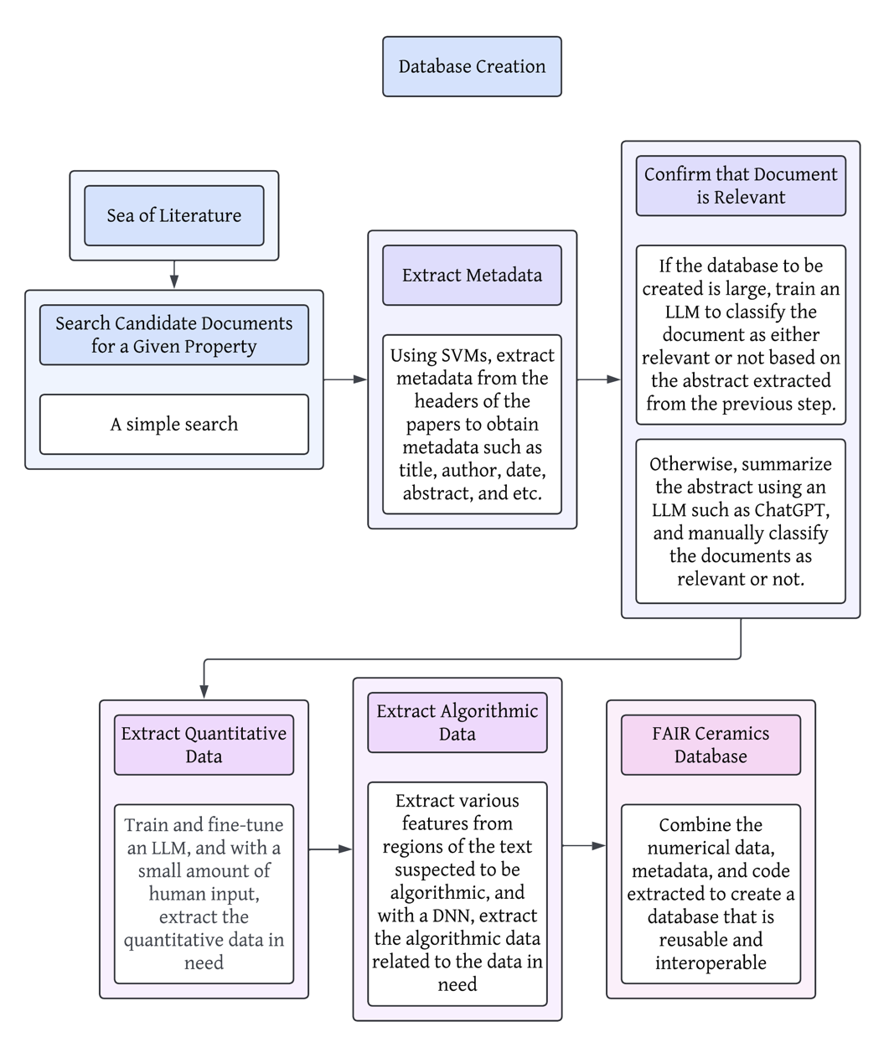
Figure 7 | Proposed Method of Database Creation Utilizing Machine Learning Models
First, from resources with an abundance of research papers, researchers can select candidates that may be relevant to the material property in question. Then, using the metadata extraction method with SVMs (2.3.2.), they can extract various metadata, including title, author, publication date, and, most importantly, the abstract. If the researchers are aiming to create a large database, it may be necessary to train an LLM to classify the documents as relevant to the property in question or not, based on their abstracts, as it may be overwhelming to sift through all the abstracts. However, for smaller databases, it may be more efficient to sift through summaries of the abstracts manually to look for key phrases, especially if those summaries can be generated quickly. According to D. Morgan, LLMs such as ChatGPT were “less successful at locating subtle, interpretive themes, and more successful at reproducing concrete, descriptive themes” ((D. Morgan. Exploring the use of artificial intelligence for qualitative data analysis: the case of ChatGPT. International Journal of Qualitative Methods 22 (2023).)). In other words, the LLM would be relatively reliable in summarizing and interpreting abstracts of scientific papers, usually written in a concrete and factual tone. After selecting the batch of relevant documents, the researchers can now use the quantitative data extraction method using LLMs (2.3.1.) to obtain the numerical data in question. Finally, they can extract any algorithmic data that can be used to analyze the data presented in various research papers, if any exists, to implement as resources for the database extracted. Overall, the resulting database would have the metadata required to decide whether the experiment or simulation used to obtain the data was reliable, and the algorithmic data to interoperate the data.
Discussion - interprets the findings, connects back to the objectives, and acknowledges limitations, without introducing new information.

Discussion
One of the biggest challenges the ceramic community must overcome for innovative research, as presented by E. Guire and coworkers, is the severe lack of infrastructure and a data-sharing platform. Currently, the ceramic community is given a minimal number of databases to research with, and more databases that adhere to the FAIR principles and promote data-sharing are necessary to accelerate data-driven research processes ((E. Guire, L. Bartolo, R. Brindle, R. Devanathan, E. Dickey, J. Fessler, R. French, U. Fotheringham, M. Harmer, E. Lara-Curzio, S. Lichtner, E. Maillet, J. Mauro, M. Mecklenborg, B. Meredi, K. Rajan, J. Rickman, S. Sinnott, C. Spahr, R. Weber. Data‐driven glass/ceramic science research: Insights from the glass and ceramic and data science/informatics communities. Journal of the American Ceramic Society 102 (2019).)). Using the proposal described in 2.3.4., we can create structured databases with metadata to validate the integrity of the data included.
Additionally, machine learning models have the potential to extrapolate data outside the bounds of the data they were trained on. By training regression models such as the various decision trees, a graph neural network, or support vector regression models, researchers can extrapolate outwards from a set of training data to achieve predictions with incredible accuracy, following the proposal described in 2.2.3.
Another challenge present in the ceramics society is the limited data accessibility and usability of ceramic materials ((E. Guire, L. Bartolo, R. Brindle, R. Devanathan, E. Dickey, J. Fessler, R. French, U. Fotheringham, M. Harmer, E. Lara-Curzio, S. Lichtner, E. Maillet, J. Mauro, M. Mecklenborg, B. Meredi, K. Rajan, J. Rickman, S. Sinnott, C. Spahr, R. Weber. Data‐driven glass/ceramic science research: Insights from the glass and ceramic and data science/informatics communities. Journal of the American Ceramic Society 102 (2019).)). We believe that the methods for creating databases discussed in this paper offer a reassuring prospect to help resolve this challenge. Through the methods proposed, large organizations such as the American Ceramic Society can create a hub for a comprehensive list of relevant ceramic materials data. This implies the possibility of a centralized database that one can access with a single access point and subscription or signup, reducing the redundancy of databases over the World Wide Web and improving the efficiency of researchers. Additionally, the algorithmic data extracted using the methodology proposed in 2.3.4. allows ceramics researchers to analyze and utilize the data in the databases to their fullest potential without having to contact a domain expert in data science. This will reduce the gap between the ceramics researchers and the data scientists, allowing the researchers to acquire the code necessary on the spot and accelerating the research process. Further, if no algorithmic data were to be present, the centralized database hub could implement a virtual assistant based on LLMs that can generate the code needed for the user on demand, just like how ChatGPT can generate functioning code snippets upon natural language instructions.
Another significant challenge the ceramic community must overcome is the lack of appropriate computational approaches to accurately calculate large-scale models of ceramics ((E. Guire, L. Bartolo, R. Brindle, R. Devanathan, E. Dickey, J. Fessler, R. French, U. Fotheringham, M. Harmer, E. Lara-Curzio, S. Lichtner, E. Maillet, J. Mauro, M. Mecklenborg, B. Meredi, K. Rajan, J. Rickman, S. Sinnott, C. Spahr, R. Weber. Data‐driven glass/ceramic science research: Insights from the glass and ceramic and data science/informatics communities. Journal of the American Ceramic Society 102 (2019).)). Machine learning is one of the keys to solving this challenge. By training machine learning models on high-fidelity simulation data to build accurate and universal interatomic potentials, they can then be used to simulate larger systems at a fraction of the computing time required by DFT. Some commercial platforms have already broken ground in this area in catalysis, organic chemistry, and polymers, but their application to ceramics remains limited. Considering how graph neural networks can input and predict excited and ground state molecular structures of materials accurately at a fraction of the time of a DFT simulation, further research into machine learning and their applications to ceramics has the potential for scientific breakthroughs in the future.
Finally, we would like to caution the readers that the recommendations presented here are based on a limited literature survey and are yet to be proven in practice. They should be taken as a first step towards addressing challenges facing sustainability research in materials science in the field of ceramics.
References - a single numbered list in order of first appearance, each entry formatted per the reference cheat sheet on the instructions page.

References
1. European Ceramic Industry Association and others. Ceramic roadmap to 2050. Brussels, Belgium: The European Ceramic Industry Association (2021).
2. K. Gong, K. Yang, C. E. White. Density functional modeling of the binding energies between aluminosilicate oligomers and different metal cations. Frontiers in Materials 10 (2023).
3. S. Kim, M. Lee, C. Hong, Y. Yoon, H. An, D. Lee, W. Jeong, D. Yoo, Y. Kang, Y. Youn, S. Han. A band-gap database for semiconducting inorganic materials calculated with hybrid functional. Scientific Data 7, 387 (2020).
4. S. Freiman, J. Rumble. Current availability of ceramic property data and future opportunities. American Ceramic Society Bulletin 92, 34–39 (2013).
5. M. Polak, S. Modi, A. Latosinska, J. Zhang, C. Wang, S. Wang, A. Hazra, D. Morgan. Flexible, model-agnostic method for materials data extraction from text using general purpose language models. Digital Discovery 3, 1221 (2023).
6. IBM. What are support vector machines (SVMs)? (2023).
7. J. Deb, J. Gou, H. Song, C. Maiti. Machine learning approaches for predicting the ablation performance of ceramic matrix composites. Journal of Composites Science 8, 96 (2024).
8. IBM. What is a decision tree? (2023).
9. IBM. What is random forest? (2023).
10. IBM. What is a neural network? (2023).
11. IBM. What are large language models (LLMs)? (2023).
12. C. M. Clausen, J. Rossmeisi, Z. Ulissi. Adapting OC20-trained EquiformerV2 models for high-entropy materials. arXiv.org (2024).
13. K. Kaufmann, D. Maryanovsky, W. Mellor, C. Zhu, A. Rosengarten, T. Harrington, C. Oses, C. Toher, S. Curtarolo, K. Vecchio. Discovery of high-entropy ceramics via machine learning. NPJ Computational Materials 6, 42 (2020).
14. F. Pedregosa, G. Varoquaux, A. Gramfort, V. Michel, B. Thirion, O. Grisel, M. Blondel, P. Prettenhofer, R. Weiss, V. Dubourg, J. Vanderplas, A. Passos, D. Cournapeau, M. Brucher, M. Perrot, E. Duchesnay, G. Louppe. Scikit-learn: machine learning in python. Journal of Machine Learning Research 12, 2825–2830 (2011).
15. H. Han, C. Giles, E. Manavoglu, H. Zha, Z. Zhang, E. Fox. Automatic document metadata extraction using support vector machines. 2003 Joint Conference on Digital Libraries, 2003. Proceedings. 37–48 (2003).
16. I. Safder, S. Hassan, A. Visvizi, T. Noraset, R. Nawaz, S. Tuarob. Deep learning-based extraction of algorithmic metadata in full-text scholarly documents. Information Processing & Management 57, 102269 (2020).
17. D. Morgan. Exploring the use of artificial intelligence for qualitative data analysis: the case of ChatGPT. International Journal of Qualitative Methods 22 (2023).
18. E. Guire, L. Bartolo, R. Brindle, R. Devanathan, E. Dickey, J. Fessler, R. French, U. Fotheringham, M. Harmer, E. Lara-Curzio, S. Lichtner, E. Maillet, J. Mauro, M. Mecklenborg, B. Meredi, K. Rajan, J. Rickman, S. Sinnott, C. Spahr, R. Weber. Data‐driven glass/ceramic science research: Insights from the glass and ceramic and data science/informatics communities. Journal of the American Ceramic Society 102 (2019).

