**Online LAB**

**LINUX PROGRAMMING**

Name:Yashwanth teja

Reg no: 17MIS1126

1. Sl command

Output:

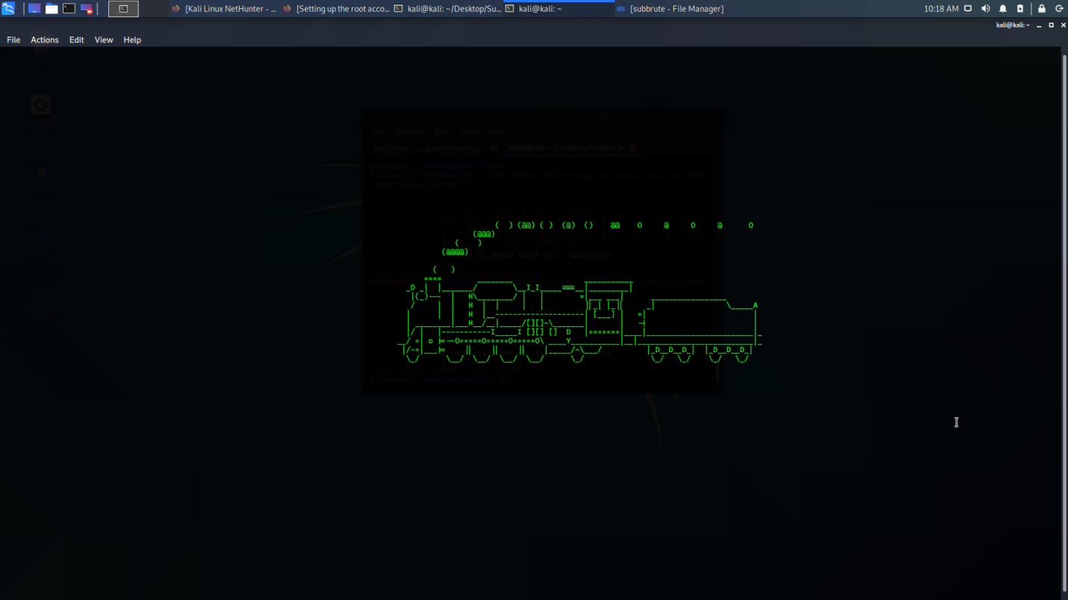

2) rev command

Output:



3) factor command

Output:



4) yes command

Output:

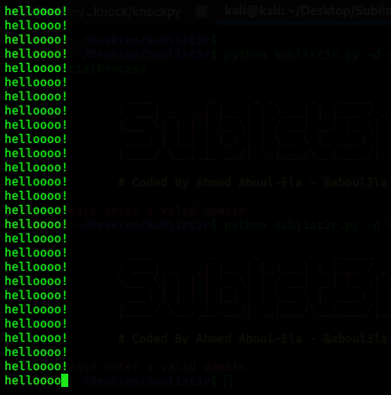

5)Write a C program to implement Simple reader – writer algorithm using shared memory segment with semaphore

Output:

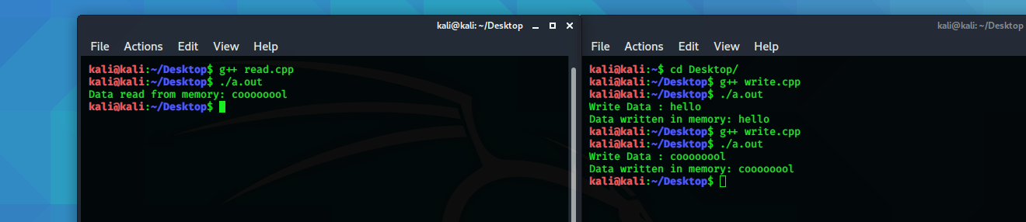

6) Hot Question

Write a bash shell script to monitor the health of your system. Let the details be stored and archived in any folder of your choice.

**hot.sh**

top -b -d 1 -n 5 >> hot.txt

echo " "

echo "Memory Stats"

free -m >> hot.txt

echo " "

echo "Netw. Stats"

netstat >> hot.txt

echo " "

echo "CPU Load and Vmstat"

vmstat -s >> hot.txt

Output:

