**913-20 guruh talabasi**

**Solayeva Oybibi**

**Laboratoriya № 5**

**Motivation 21 day dasturining figmada ko’rinishi**

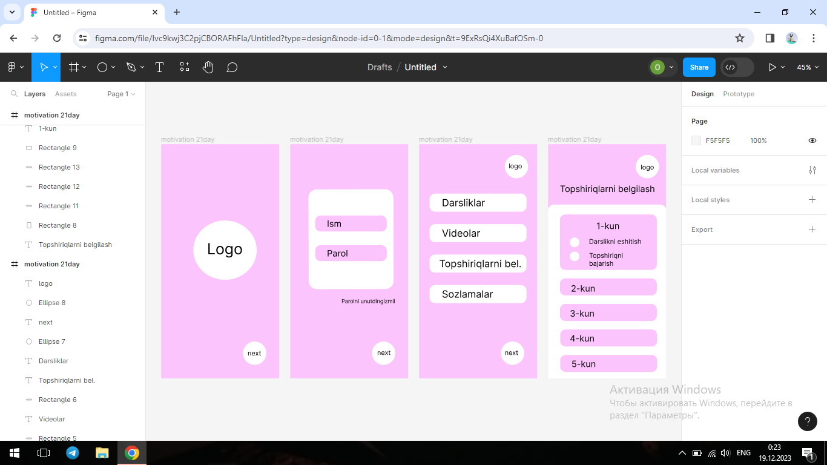

1-rasm. Dasturning umumiy ko’rinishi.

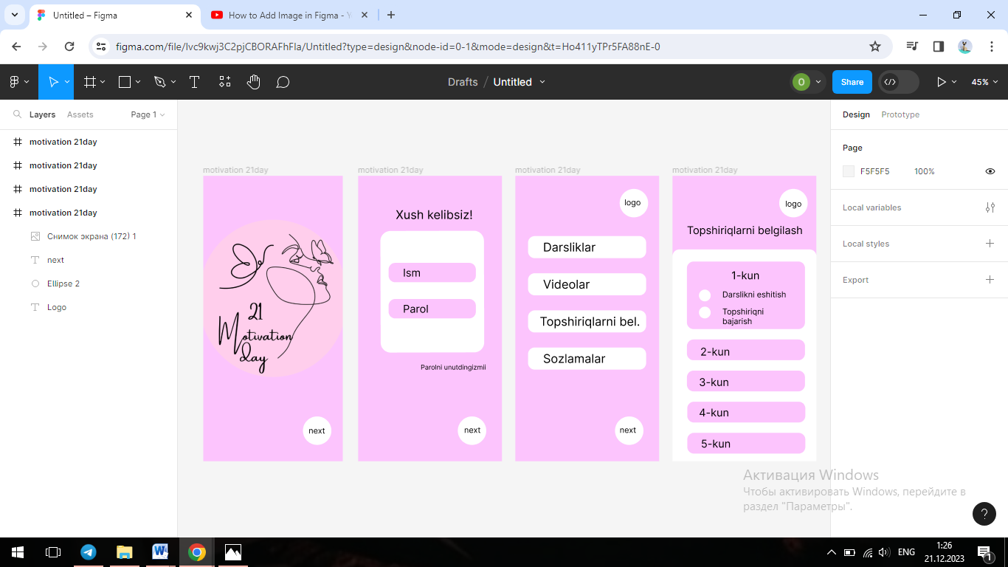

2-rasm. 3-oynada qo’llanilgan kampanentalar

Dastur silkasi:

https://www.figma.com/file/Ivc9kwj3C2pjCBORAFhFIa/Untitled?type=design&node-id=0-1&mode=design&t=RPxBNuPSPclxExps-0