

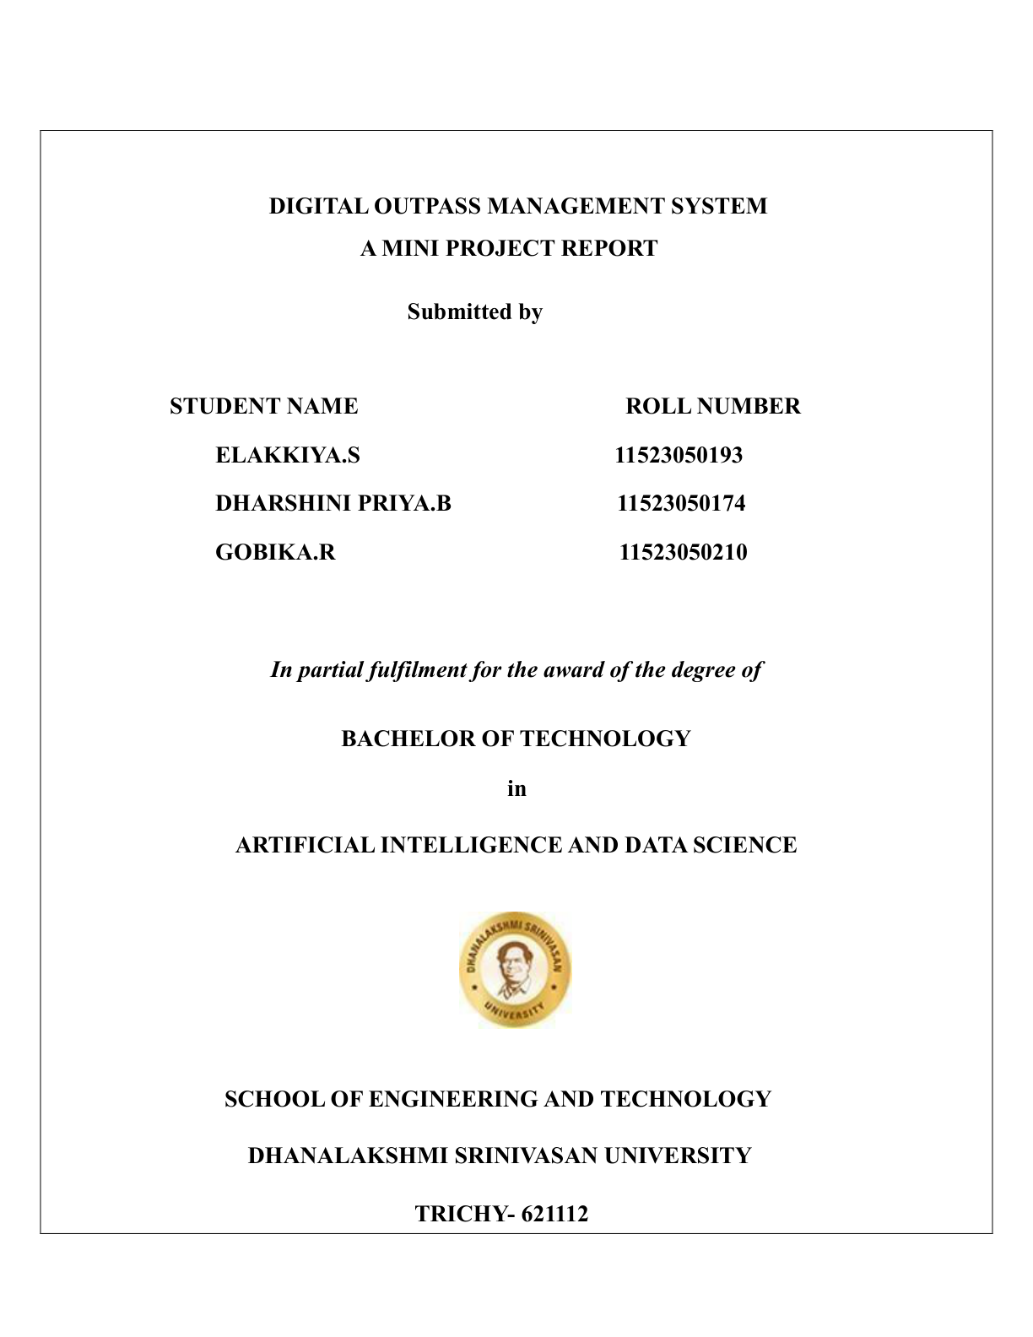



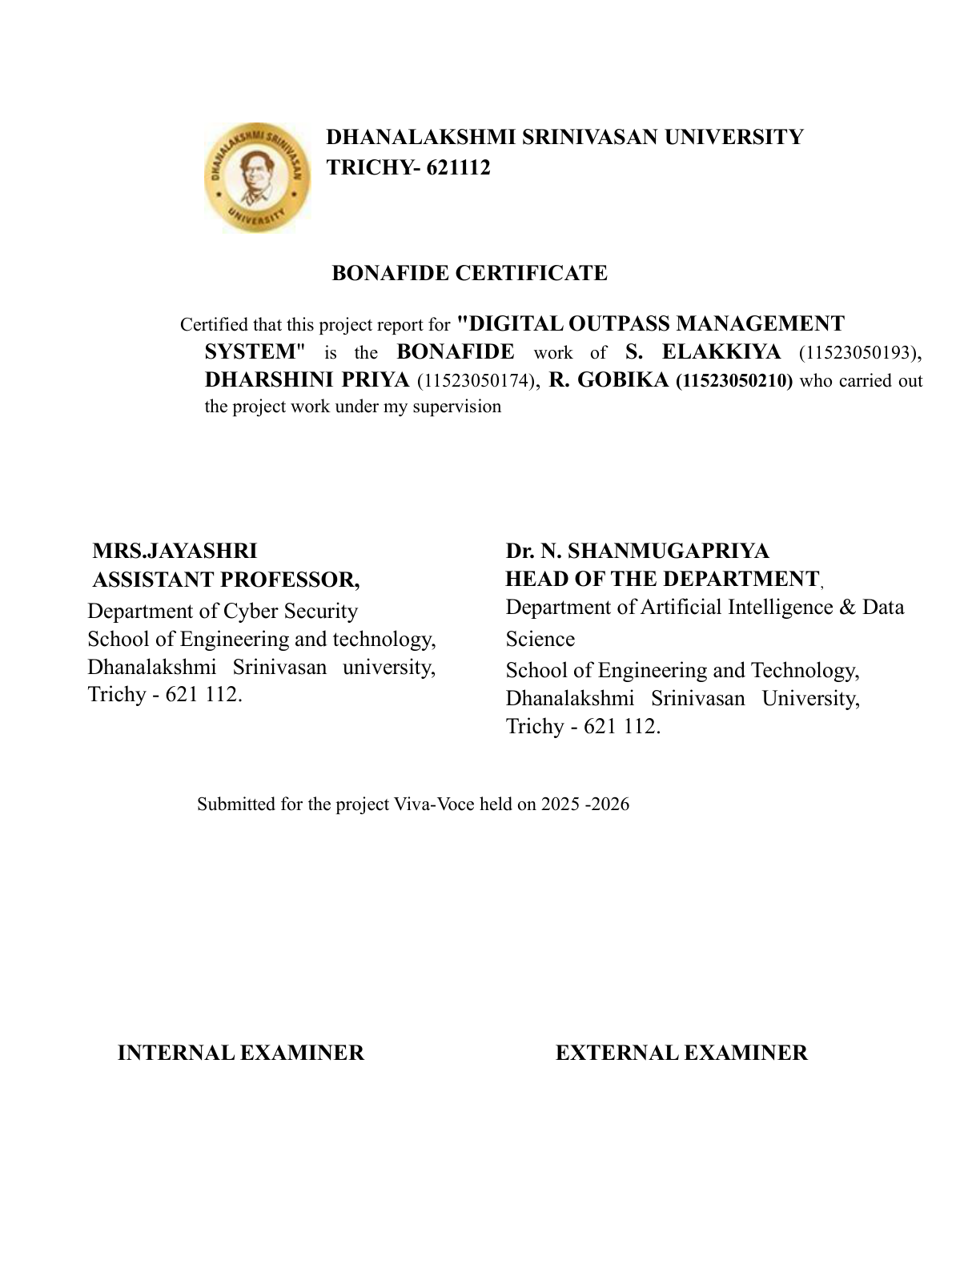

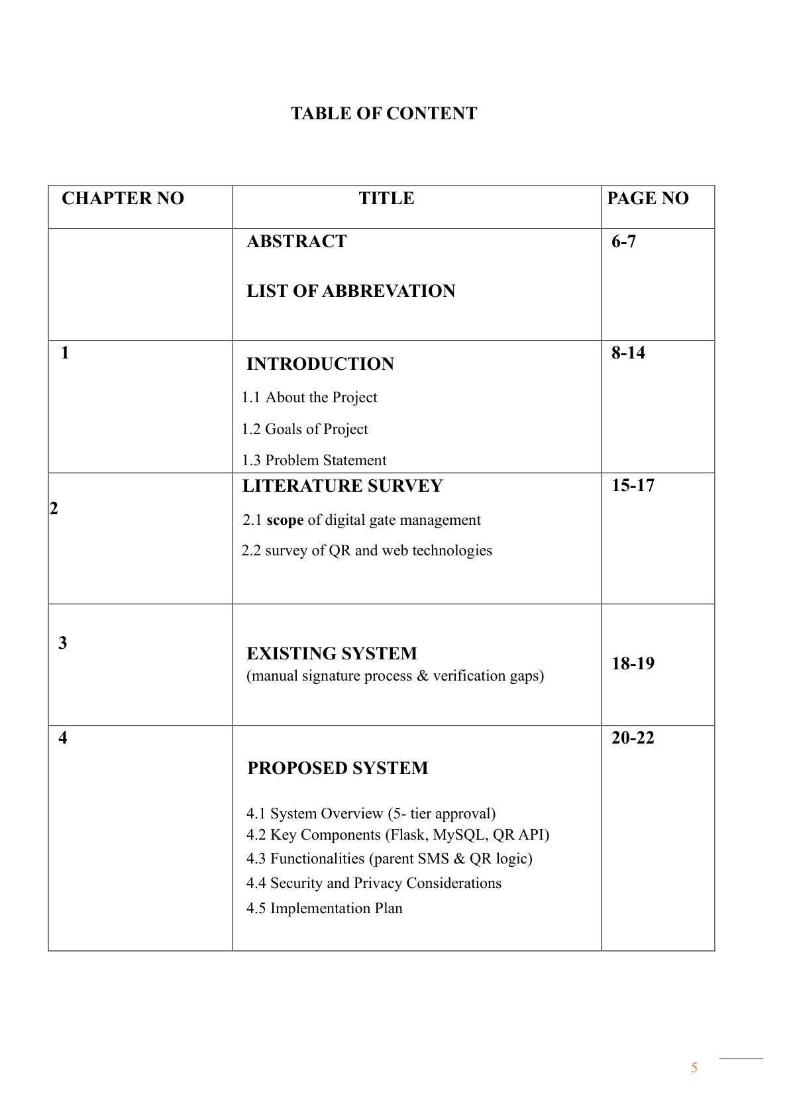
8
ABSTRACT
The Digital Out pass Management System (DOMS) is a secure and automated web-based application
developed to replace the traditional manual out pass process used in colleges and educational institutions. In
many institutions, the existing paper-based system consumes more time, requires multiple manual signatures,
and may lead to issues such as data loss, unauthorized student movement, fake permissions, and lack of
proper monitoring. To overcome these challenges, the proposed system provides a centralized digital
platform for managing student out pass requests efficiently and securely.
The system follows a multi-level approval workflow involving Student, Mentor, Parent, Head of Department
(HOD), Dean, and Security personnel. Initially, a student submits an outpass request through the web
application by entering the required details and reason for leave. The request is first sent to the mentor for
verification and approval. Once approved, a notification is sent to the student’s parent through SMS or voice-
call confirmation for parental consent. After parent approval, the request is forwarded to the HOD and then to
the Dean for final authorization. Each approval or rejection status is updated in real time and can be viewed
by the student, mentor, and parents, ensuring transparency throughout the process.
A major feature of this project is the QR code-based verification system integrated with the security module.
Once the out pass request receives final approval, the system automatically generates a unique QR code for
the student. At the college gate, the security staff or warden scans the QR code using a mobile device. If the
out pass is valid and approved, a green verification screen is displayed, allowing the student to exit or enter
the campus. If the QR code is invalid, expired, or rejected, a red cross alert appears, preventing unauthorized
access. This feature enhances campus security and ensures accurate gate monitoring.
The project is developed using HTML, CSS, and JavaScript for the frontend, Python Flask for backend
processing, and MySQL for database management. The system provides role-based authentication, request
tracking, secure data handling, responsive dashboards, and efficient communication between authorities.
Overall, the Digital Out pass Management System reduces paperwork, improves administrative efficiency,
enhances security, and provides a modern digital solution for student movement management in educational
institutions.
9

1.INTRODUCTION
1.1 About the project:
The Digital Out pass Management System (DOMS) is a web-based application developed to automate and
secure the student out pass process in colleges and educational institutions. The project is designed to
replace the traditional paper-based permission system, which is time-consuming, difficult to manage, and
prone to manual errors or unauthorized approvals. By digitizing the entire workflow, the system improves
efficiency, transparency, and campus security.
The main objective of this project is to provide a secure platform where students can apply for outpasses
online and track their approval status in real time. The system includes multiple user roles such as Student,
Mentor, Parent, Head of Department (HOD), Dean, Security, and Admin. Each user is provided with a
separate login and dashboard based on their responsibilities.
In this system, a student submits an out pass request through the web application by entering details such as
reason, date, and time of leave. The request is first sent to the mentor for approval or rejection. After mentor
approval, the system contacts the student’s parents through SMS or voice-call confirmation to obtain
parental permission. Once parents approve the request, it is forwarded to the HOD and then to the Dean for
final approval. The approval or rejection status is updated instantly and can be viewed by all authorized
users.
After successful approval from all authorities, the system generates a unique QR code for the student. At the
college gate, the security officer or warden scans the QR code using a mobile device. If the out pass is valid,
the system displays a green confirmation message allowing the student to exit or enter the campus. If the
request is invalid or rejected, a red alert or cross mark is displayed, preventing unauthorized movement.
The application is developed using HTML, CSS, and JavaScript for frontend design, Python Flask for
backend processing, and MySQL for database management. The system also provides secure authentication,
role-based access control, request tracking, QR verification, and gate log maintenance.
Overall, the Digital Out pass Management System offers a reliable, secure, and modern solution for
managing student permissions digitally while reducing paperwork and improving institutional safety.
1.2 Goal of the project
The main goal of the Digital Out pass Management System (DOMS) is to automate and simplify the
traditional out pass process used in educational institutions. The project aims to provide a secure, fast, and
transparent system for managing student movement inside and outside the campus through digital approval
and QR-based verification.
• To replace the manual paper-based out pass system with a fully digital and automated process.
• To reduce the time required for obtaining permissions from mentors, parents, HOD, and Dean.
• To provide a secure multi-level approval workflow for student out pass requests.
• To enable parents to approve or reject requests through SMS or voice-call confirmation.
10
• To improve communication between students, mentors, parents, and college authorities.
• To provide real-time tracking of out pass request status for all authorized users.
• To generate secure QR codes for approved out pass to avoid misuse or fake permissions.
• To allow security staff or wardens to verify student permissions instantly using QR code scanning.
• To display green verification for valid out passes and red alerts for invalid or rejected requests.
• To maintain digital records of requests, approvals, and gate entry/exit logs for future reference.
• To improve campus security and ensure authorized student movement.
• To provide a user-friendly and responsive web interface for all users.
• To reduce paperwork, manual errors, and administrative workload in institutions.
• To develop the system using modern web technologies such as HTML, CSS, JavaScript, Python Flask,
and MySQL.
1.3 Problem statement:
In many colleges and educational institutions, the out pass process is still managed manually using paper
forms and physical signatures. This traditional method consumes more time, creates administrative
difficulties, and lacks proper security and transparency. Students are required to visit multiple authorities
such as mentors, HODs, and deans to obtain permission, which makes the process slow and inconvenient.
The manual system also increases the chances of human errors, loss of records, fake signatures, unauthorized
permissions, and miscommunication between students, parents, and college authorities. In emergency
situations, obtaining parent approval becomes difficult because there is no proper digital communication
system integrated into the process. Additionally, security staff at the college gate often face challenges in
verifying whether a student has valid permission to leave the campus.
Another major issue is the absence of real-time tracking and centralized record management. Authorities
cannot easily monitor the status of requests, and maintaining paper records for future reference becomes
difficult. The traditional system also lacks proper authentication and verification mechanisms, which may
affect campus safety and student monitoring.
To overcome these problems, there is a need for a secure, automated, and web-based solution that can digitize
the complete out pass approval workflow. The proposed Digital Outpass Management System aims to
provide online request management, multi-level approval, parent verification through SMS or voice call, QR
code-based security verification, and centralized digital record maintenance to improve efficiency,
transparency, and campus security.
11

2. LITERATURE SURVEY
2.1 scope of digital gate management :
The Digital Gate Management System is an important part of the Digital Out pass Management System
developed to automate and secure the verification process at college or institutional gates. The system is
designed to monitor and control student entry and exit activities using digital approval methods and QR code
verification technology. It replaces the traditional manual checking process, which is time-consuming, less
secure, and difficult to maintain.
The scope of the system includes secure student verification, real-time approval tracking, gate log
maintenance, and prevention of unauthorized campus movement. The system ensures that only students with
approved out passes are allowed to leave or enter the campus. It also improves communication between
students, parents, mentors, HODs, deans, and security personnel through a centralized digital platform.
In this system, students submit out pass requests online through the web application. The request passes
through multiple approval stages including Mentor, Parent, HOD, and Dean. After successful approval, the
system generates a unique QR code for the student. At the college gate, the security officer scans the QR code
using a mobile device or scanner. If the request is valid, a green confirmation message appears. If the request
is rejected, expired, or invalid, a red alert or cross mark is displayed, preventing unauthorized access.
The Digital Gate Management System also stores gate entry and exit records in a database for future
monitoring and administrative purposes. This helps institutions maintain accurate records of student
movement and improve campus security management. The system can be implemented in colleges,
universities, hostels, and educational campuses to provide a secure and efficient out pass verification process.
ope of digital gate management
Key Requirements
• Functional Requirements
• Student registration and login system
• Online out pass request submission
• Multi-level approval workflow (Mentor → Parent → HOD → Dean)
• Parent approval through SMS or voice-call confirmation
• Real-time request status tracking
• QR code generation for approved out passes
• QR code scanning and verification at the security gate
• Green/Red alert display for valid or invalid passes
12
• Gate log maintenance for entry and exit records
• Admin dashboard for monitoring users and requests
• Non-Functional Requirements
• Secure user authentication and authorization
• Fast response time during QR verification
• User-friendly and responsive interface
• Reliable database management using MySQL
• Data privacy and secure record maintenance
• Scalability for future enhancements
• Compatibility with mobile and desktop devices
• Hardware Requirements
• Computer or Laptop
• Smartphone or QR Scanner Device
• Internet Connection
• Server System
• Software Requirements
• HTML, CSS, JavaScript
• Python Flask Framework
• MySQL Database
• VS Code or PyCharm IDE
• Web Browser (Chrome, Edge, Firefox)
2.2 survey of QR and web technologies
QR (Quick Response) codes and modern web technologies play an important role in developing
secure and efficient digital management systems. In recent years, many educational institutions and
organizations have shifted from manual processes to web-based automated systems for better security,
transparency, and faster communication. The Digital Out pass Management System uses QR technology along
with web technologies to provide secure student verification and real-time approval management.
13
QR codes are two-dimensional barcodes capable of storing information such as student identity, request ID,
approval details, and verification status. QR technology is widely used in ticketing systems, payment
applications, attendance systems, and access control because of its fast-scanning capability and high data
storage efficiency. In this project, QR codes are generated automatically after the final approval of an out pass
request. The generated QR code acts as a secure digital pass that can be scanned by security personnel at the
college gate. This technology reduces the possibility of fake permissions and improves verification accuracy.
Web technologies are used to develop the online platform for handling the complete out pass workflow.
HTML (Hypertext Markup Language) is used to create the structure of the web pages, while CSS (Cascading
Style Sheets) is used to design responsive and user-friendly interfaces. JavaScript is used to provide
interactive features such as form validation, status updates, and QR scanning functionality.
The backend of the system is developed using Python Flask, a lightweight web framework that helps manage
routing, authentication, request processing, and database operations efficiently. Flask is suitable for mini-
project development because of its simplicity, flexibility, and easy integration with databases and APIs.
MySQL is used as the database management system to store user details, out pass requests, approval records,
and gate verification logs. It provides reliable data storage, quick retrieval, and secure management of records.
The integration of QR technology with web applications provides several advantages such as faster
verification, reduced paperwork, real-time monitoring, centralized data management, and improved campus
security. The survey of these technologies shows that combining QR-based verification with modern web
development tools creates an efficient and secure digital gate management solution for educational institutions
Web technologies are used to develop the online platform for handling the complete out pass workflow.
HTML (Hypertext Markup Language) is used to create the structure of the web pages, while CSS (Cascading
Style Sheets) is used to design responsive and user-friendly interfaces. JavaScript is used to provide
interactive features such as form validation, status updates, and QR scanning functionality.
The backend of the system is developed using Python Flask, a lightweight web framework that helps manage
routing, authentication, request processing, and database operations efficiently. Flask is suitable for mini-
project development because of its simplicity, flexibility, and easy integration with databases and APIs.
14

3. EXISTING SYSTEM
Manual Signature Process and Verification gaps
The approval process generally starts with the mentor or class advisor. Once the mentor signs the request, the
student must approach the Head of Department (HOD) and sometimes the Dean or hostel warden for
additional approvals. Only after collecting all required signatures can the student show the out pass at the
security gate to receive permission to exit the campus. This process is repetitive, time-consuming, and
difficult to manage when there are many students requesting permissions at the same time
One of the major drawbacks of the manual system is delay in approval. If any authority is unavailable due to
meetings, leave, or other responsibilities, the student must wait for long periods to obtain approval. This
becomes a serious problem during emergencies where immediate permission is required. The process also
wastes academic time because students need to move between departments and offices instead of attending
classes.
Another important issue is the possibility of human errors and document mismanagement. Since all records
are maintained manually on paper, there is a high chance of losing documents, incorrect data entry, damaged
records, or duplication of information. Maintaining large numbers of paper records becomes difficult for the
administration, and retrieving previous records for verification or auditing purposes consumes additional time
and effort.
The manual system also suffers from major security and verification gaps. Physical signatures can be forged
or copied, making it possible for students to misuse fake out passes. Security personnel at the gate may not
always be able to identify whether a signature is genuine or whether the out pass has already been used.
Because there is no digital verification mechanism, unauthorized student movement can occur easily,
affecting campus discipline and safety.
In the traditional system, parent communication is also very limited. In many cases, parents are not informed
immediately when students request permission to leave the campus. This creates a lack of transparency and
reduces trust between parents and the institution. There is no automated system for sending notifications,
collecting approvals, or maintaining proof of parent consent.
The existing system does not provide real-time tracking or monitoring capabilities. Students cannot easily
know the current status of their request, and authorities cannot efficiently track pending approvals or rejected
requests. Security staff also do not have access to a centralized verification system to confirm whether a
student has received final approval from all authorities.
Another limitation of the manual system is the lack of proper reporting and analytics. Institutions cannot
generate reports related to student movement, approval history, gate entries, or frequently requested
permissions. This makes administrative analysis and decision-making more difficult.
15
Due to these limitations, educational institutions require a modern digital solution that can automate the
approval process, improve communication, strengthen security, and maintain accurate digital records. The
proposed Digital Out pass Management System overcomes these issues by providing online request
management, multi-level approval workflows, parent verification through SMS or voice calls, QR code-
based gate verification, and centralized database management for secure and efficient campus monitoring.
Limitations of the Existing System:
Time-Consuming and Inefficient Process: Students spend an excessive amount of time walking across
departments and administrative buildings just to locate individual authorities for signatures. If any authority
is absent or in a meeting, the entire approval process comes to a standstill.
High Risk of Forgery and Fraud: Because permissions rely on handwritten signatures on paper slips, it is
incredibly easy for students to forge signatures of Mentors, HODs, or Deans. Security guards at the gate have
no reliable, real-time method to authenticate whether a signature is genuine or faked.
Lack of Real-Time Parent Verification: Parental consent is handled via random manual phone calls or
unverified text messages. There is no automated, secure validation channel (like structured SMS/Voice APIs),
meaning students can easily bypass parental oversight by providing fake phone numbers or having friends
answer the confirmation calls.
Poor Data Management and Loss of Records: Maintaining paper slips and massive handwritten logbooks
at the security gate is highly unstable. Physical registers are prone to wear and tear, water damage, or
complete misplacement. Tracking a student's past entry/exit history for a specific date requires flipping
through hundreds of paper pages manually, making auditing close to impossible.
Lack of Centralized Tracking and Communication: There is no synchronized screen or dashboard
connecting the Student, Mentor, Parent, HOD, and Dean simultaneously. If an outpass is rejected by an
authority, the student and parents have no immediate way of knowing unless they inquire physically.
Furthermore, administration cannot instantly view a real-time list of how many students are currently outside
the campus bounds at any given second.
Congestion at the Security Gate: During peak hours, holidays, or weekends, manual entry of student
information into physical registers causes severe bottlenecking and crowding at the exit gates, increasing
human error by the security personnel.
16

4.PROPOSED SYSTEM
To overcome the architectural and physical deficiencies of the manual system, a web-based
Digital Out pass Management System (DOMS) is introduced. The system acts as a centralized
operational hub that digitizes and links all stakeholders—Students, Mentors, Parents, HODs,
Deans, and Gate Security personnel. Developed using a highly lightweight framework, it
shifts administrative overhead into automated backend logical switches, preventing long
physical queues, removing validation delays, and providing absolute protection against
handwritten document falsification. By incorporating programmatic communication
webhooks and a localized scanning interface at institutional entry and exit terminals, the
architecture turns a traditionally cumbersome paper trail into an instantaneous, auditable,
and entirely transparent software ecosystem.
4.1 System Overview (5-tier approval)
The core processing mechanics of the proposed application rely on a structured, directional 5-tier approval
hierarchy. A student request cannot bypass intermediate nodes; every structural gatekeeper must evaluate
and forward the state before the system marks an out pass as valid.
The operational steps are organized sequentially as follows:
1. Student Tier (Request Initiation): The student authenticates into their dedicated web portal and
compiles a digital form, specifying variables such as destination, leave rationale, departure timestamp, and
return deadline.
2. Mentor Tier (First-Level Assessment): The transaction appears immediately on the Mentor’s tracking
screen. The mentor performs an initial verification. Upon authorization, the record state changes to allow
parental routing; a rejection completely drops the workflow.
3. Parent Tier (Consent Validation): Once cleared by the mentor, the system halts manual student
intervention and initiates an outbound communication loop. The application queries parent parameters from
the database and uses automated APIs to dispatch authorization hooks to the parent's phone.
4. Head of Department (HOD) Tier (Academic Approval): When parental clearance updates the server,
the data payload moves to the HOD's administrative screen. The HOD assesses current departmental leaves
and provides high-level department clearance.
5. Dean Tier (Final Authorization): The final security authorization layer sits at the Dean's node. When
the Dean logs a favourable decision, the request enters an finalized state, updating records across the system
and triggering the automated code generation module.
17
4.2 Key Components (Flask, MySQL, QR API)
The system uses a highly responsive, modern development stack to balance processing speed with
enterprise data management:
Backend Controller (Python Flask): Flask manages the central application routing logic. It intercepts
form payloads, authenticates active user sessions using secure server-side tokens, executes state transitions
across the 5 tiers, and serves the correct views based on user roles.
Relational Database Engine (MySQL): The persistence layer uses structured relational database
architecture to keep records secure, using three primary transactional tables:
Users: Stores user verification data, hashed passwords, access permission roles, and registered parent
phone contacts.
Out pass requests: Logs request IDs, status flags, timestamps, and multi-tier signature checkpoints.
QR logs: Tracks gate security execution results, capturing absolute check-out and check-in times.
Barcoding API (QR Code Generation Engine): Once a request successfully passes the Dean tier, an
integrated library maps key parameters (such as Request ID, User ID, and a valid expiration time window)
into a structured data string, rendering a high-density QR matrix code on the student’s portal.
4.3 Functionalities (parent SMS & QR logic)
The design provides direct, live updates across all active stakeholders, eliminating the need for manual
check-ins.
Simultaneous Dashboard State Broadcast
When any of the internal authorities log an approval or rejection, the system changes the entry status inside
the database instantly. This synchronized change updates the tracking panels of the Student, the Mentor, and
the active log visible to administrative authorities simultaneously.
Parental SMS & Voice Interaction Gateway
To prevent students from falsifying verification, the backend connects directly to programmable cloud
communication gateways:
* The system automatically generates a text payload with quick verification links or unique authorization
pins sent to the parent’s phone.
18
* Alternatively, an interactive voice interface places a call, instructing the parent to press specified keypad
values to grant permission.
* The incoming webhook response is read directly by Flask, advancing the record to the HOD tier without
manual staff data entry.
Gate QR Code Scanning Verification Logic
The final verification at the institutional boundary relies entirely on an automated scan workflow that
removes human error or biases from gate security personnel:
* The student displays the dynamically generated QR code on their mobile screen to the gate marshal.
* The guard utilizes the dedicated **Security Module** via a mobile camera or standard scanner device.
* The scanned image payload is decoded and dispatched as an asynchronous API call to the Flask endpoint
`/verify_ QR`.
* The server queries the MySQL database to validate the signature authenticity, the current time window,
and the multi-tier approval completion flag.
4.4 Security and Privacy Considerations
To ensure system integrity and protect sensitive student records, explicit safety components
are built directly into the software design:
Role-Based Access Control (RBAC): Strict view decorators are declared over backend endpoints. A
student cannot gain access to approval routines, and an authority can only process entries relative to their
structural tier.
QR Cryptographic Hashing: The underlying data string inside the QR barcode matrix is encrypted. This
prevents tech-savvy students from reverse-engineering the pass parameters or forging localized mock
barcodes to bypass gate terminals.
Input Field Sanitation: All data items from front-end HTML forms, API parameters, or
callback communication webhooks are parsed through sanitation checks to block SQL
Injection vectors and Cross-Site Scripting (XSS) logic.
Credential Protection: High-level password hashing algorithms are applied to user login
credentials before saving data to MySQL, ensuring user identity profiles remain protected.
4.5 Implementation Plan
The system is constructed through systematic, overlapping development increments:
1.Database Schema Setup: Designing the MySQL structure, setting primary and foreign key constraints,
and indexing verification fields to ensure rapid query execution.
19
2.Core Workflow Engineering: Coding the Python Flask framework routes, handling role-based user
sessions, and writing the backend logic that controls status adjustments across the 5-tier workflow.
3.UI/UX Construction: Building clean, responsive layout interfaces for all 5 roles using structured HTML,
modern CSS rules, and JavaScript asynchronous components to ensure pages load without refreshing.
4.Communication Handshake Integration: Linking external SMS and voice messaging APIs to route
communication payloads and handle incoming parent response webhooks.
5.Gate Validation Terminal Setup: Implementing script-based barcode decoders on the Security
dashboard view to build the visual alert response component (Green Pass vs. Red Cross).
6. System Optimization and Refinement: Conducting mock tests to ensure data is updated properly
across all dashboards and verification displays function correctly under heavy server loads.
20

5.SYSTEM REQUIREMENTS
5.1 Hardware requirements (pc)
To develop, host, and seamlessly run the Digital Out pass Management System (DOMS), the hardware
components must comfortably support concurrent server requests, database indexing, and real-time QR
generation. Below are the minimum and recommended hardware specifications required for the deployment
machine (PC/Server) and client devices:
Development Server & Administration Workstation (PC)
Processor (CPU): Intel Core i3 (Minimum) / Intel Core i5 or AMD Ryzen 5 (Recommended) with a clock
speed of 2.5 GHz or higher.
Random Access Memory (RAM): 4 GB DDR4 (Minimum) / 8 GB DDR4 or higher (Recommended) to
support parallel execution of Flask routing processes and the MySQL engine.
Storage Capacity (Hard Drive): 20 GB of available solid-state storage space (SSD preferred for faster
read/write operations of database logs).
Display / Monitor: Standard desktop or laptop display panel with a resolution of $1280 \times 720$ pixels
or higher to evaluate user interface layouts.
Peripherals: Standard keyboard, interactive mouse pointer device, and an integrated network interface
card (NIC).
Client Terminal / Guard Verification Device
Gate Security Device: Any modern smartphone, tablet, or workstation laptop equipped with an integrated
high-resolution web-camera or specialized imaging peripheral capable of capturing and decoding matrix
barcodes at a rapid frame-rate.
5.2 Software requirements (HTML, CSS, JS, FLASK)
The software stack for this architecture is selected to remain lightweight while establishing a highly secure
development environment. The software prerequisites are categorized below:
21
Client-Side Technologies (Frontend Framework)
Structure Layer: HTML5 (Hypertext Markup Language) for designing semantic, accessible, and
structured document forms across all role-based dashboards.
Presentation Layer: CSS3 (Cascading Style Sheets) containing modern flexbox/grid variables to achieve
a completely responsive layout across both mobile devices and PC browsers.
Interactive Behaviour Layer: JavaScript (ES6+) to implement asynchronous data operations (`Fetch
API`), process incoming QR scanner webcam feeds locally, and dynamically render background alert
themes.
Server-Side & Storage Technologies (Backend Framework)
Primary Language Environment: Python 3.8 to Python 3.11 runtime environment.
Web Framework Application: Python Flask (v2.x or newer), acting as the centralized Model-View-
Controller framework handling session guards, cryptographic routines, and role routing blocks.
Relational Database Server: MySQL Community Server 8.0 (or integrated via an active XAMPP/WAMP
architecture), housing data transaction files.
Database Driver Extension: `Flask-MySQL dB` or `Py MySQL` components to map structured execution
strings seamlessly from Python into the active SQL engine memory space.
Auxiliary Operational Tools
Operating System Environment: Microsoft Windows 10/11, Ubuntu Linux, or Apple macOS.
Development Workspace Environment (IDE): Visual Studio Code (VS Code), PyCharm, or an
equivalent code editor.
Target Web Browser Platforms: Google Chrome, Mozilla Firefox, or Microsoft Edge with JavaScript
parsing targets enabled.
5.3 Network and functional requirements
The continuous deployment of this application relies on standard network protocols and explicit functional
blocks
22
Network Infrastructure Requirements
Transport Protocol Layer: The system operates over the standard **HTTP** (Hypertext Transfer
Protocol) during local development testing and relies on **HTTPS** (Secure Sockets Layer/TLS
encryption) when deployed on live servers to shield session tokens from sniffing utilities.
Network Connectivity Parameter: An active Local Area Network (LAN), campus-wide Wi-Fi intranet,
or an external cellular connection is required. This ensures the security gate workstation can transmit
decoded token data to the central database server instantly.
Communication Interface Access: Unrestricted outbound web sockets or standard internet access
channels are necessary for the Flask engine to forward text instructions to downstream programmable cloud
communication platforms (e.g., Twilio or regional SMS/Voice gateways).
Functional Requirements
The system's features are mapped directly to five user roles to ensure smooth operation across the platform:
[Student Request] ──> [Mentor Appr.] ──> [Parent SMS Verification] ──> [HOD Appr.] ──> [Dean
Final Appr.] ──> [QR Code Issued]
User Identity Processing Layer: The application must maintain distinct login paths for Students, Mentors,
Parents, HODs, Deans, Admin accounts, and Security personnel.
Directional Routing Block (5-Tier Out pass Logic): The system must systematically advance request
tokens through the validation hierarchy (Student $\right arrow$ Mentor $\right arrow$ Parent Response
Verification $\right arrow$ HOD $\right arrow$ Dean Final Clearance).
Asynchronous Notification Handshake: The server must automatically trigger external API callbacks to
parents' mobile handsets when a mentor clears an initial validation flag.
Dynamic Document Serialization: Upon registration of the Dean’s approval, the backend must instantly
assemble data vectors into an encrypted QR pass matrix accessible inside the student's dashboard interface.
Gate Evaluation Module: The gate security layout must display a highly visible, unambiguous feedback
visual (Green Background/Pass text for active credentials and a bold Red Cross with an entry denial label
for unauthorized or expired credentials).
23

6.SYSTEM DESIGN
6.1 System Architecture
The system design stage transforms the functional requirements of the Digital Outpass Management System
(DOMS) into a technical blueprint. This phase defines how the web interfaces, server-side framework, and
relational databases interact with one another. By structuring the software into clear design tiers and
modular boundaries, the application ensures high security during verification, data accuracy within the log
tables, and an intuitive user experience for students, college authorities, and security guards alike. The
following sections describe the system architecture, behavioural workflows, relational data configurations,
and core security logic governing the campus gate terminal.
6.1 system architecture
The architecture of the Digital Out pass Management System is built upon the Model-View-Controller
(MVC) architectural pattern. This design pattern separates the application into three interconnected core
layers, isolating user interaction from database operations to optimize security and maintainability:
The View Layer (Frontend): Composed of clean, semantically structured HTML5 web templates, styled
beautifully using responsive CSS3 layouts, and made interactive via JavaScript. It provides unique
dashboard interfaces for each of the system's roles, displaying out pass forms, dynamic approval states, or
QR code scanning modules.
The Controller Layer (Backend Framework): Powered by Python Flask, this layer functions as the brain
of the ecosystem. It manages HTTP request processing, handles state transition rules across the five
approval tiers, securely intercepts webhook data from parent communication interfaces, and manages
authenticated user sessions using cryptographically signed cookies.
The Model Layer (Persistence Engine): Managed using a MySQL relational database. The controller
executes standard SQL operations against structured data sets. It maintains integrity across records by
enforcing strict primary and foreign key constraints between user classification models and real-time
movement entries.
24
6.2 Flow Diagram (student to security gate)
The out-pass transaction follows a strict linear path, moving through a specific operational chain to ensure
no checkpoint is bypassed. The sequential flow of data from initiation by the student to final clearance at
the physical gate boundary is structured as follows:
The system flow diagram illustrates the sequential step-by-step path an outpass request travels from its start
to final exit logging. The process operates on a strict conditional chain where each tier acts as a validation
checkpoint. If any authority in the 5-tier chain logs a rejection, the system instantly stops the workflow,
shifts the status to "Rejected," and updates the dashboards of all involved parties. This structured, linear
data flow ensures that no intermediate approval level can be bypassed by the student, making sure parental
verification and departmental clearance are fully recorded before the backend generates the dynamic QR
pass token for physical gate verification.
25
[Student Portal]
│ (Submits out pass details)
▼
[Mentor Dashboard] ────► [If Rejected: Terminates & Notifies Student]
│ (Provisionally Approves)
▼
[Parent Handset] ──────► [If Rejected: Terminates & Updates Dashboards]
│ (Verifies via SMS Link or Voice API Keypad Press)
▼
[HOD Dashboard] ───────► [If Rejected: Terminates & Updates Dashboards]
│ (Reviews & Approves Academic Clearance)
▼
[Dean Dashboard] ──────► [If Rejected: Terminates & Updates Dashboards]
│ (Logs Final Authorization Sign-off)
▼
[QR Code Engine] (Assembles Encrypted Data Matrix on Student Mobile Screen)
│
▼
[Security Scanner] ────► [Validates Token with MySQL Database]
│
├─► (Success) ──► [Displays GREEN UI on Mobile Screen] ──► [Access Allowed]
└─► (Fail) ──► [Displays RED CROSS UI on Mobile Screen] ──► [Access Denied]
6.3 Module Description (Admin, Authority, Security)
The application splits operational workflows into isolated functional modules, ensuring that
users interact exclusively with tasks relevant to their assigned administrative clearance:
1. Student Module
Authentication Access: Allows students to register profiles and log securely into the portal.
Out pass Application Interface: A dynamic digital form capturing data fields including destination, reason,
exit date, and return time.
26
Tracking Feed: Real-time visibility into the exact tier where the request is currently sitting.
QR Delivery Component: Dynamically displays the verifiable leave slip graphic once the Dean clears the
request.
Authority Module (Mentor, HOD, and Dean Interfaces)
Pending Queue Feed: Displays a prioritized DataGrid containing incoming out pass files relevant to that
specific authority's approval tier.
Action Terminal: Simple command triggers enabling the respective authority to immediately approve or
reject a request with optional comment inputs.
Student Overview Monitor: Provides high-level visibility to check which historical leaves have been taken
by individual students.
3. Security Module
Scanner Interface: Harnesses the device’s internal camera hardware using JavaScript tracking libraries to
capture QR code matrix layouts in real time.
API Verification Channel: Forwards the decoded data payload immediately to the Flask backend logic.
Visual Response Panel: Changes the guard's mobile UI colour to flat Green or displays a prominent Red
Cross with alert tones based on the validation response.
4. Admin Module
System Provisioning Workspace: Allows creation, updating, or deletion of user accounts (adding new staff or
students).
Audit Trail Logs: Complete access to search, filter, and review all database transactions, parental verification
callbacks, and gate entry/exit logs.
6.3 Data Flow (database schema)
Data travels through the system based on explicit entity connections. The structure of the underlying database
schema is divided into three key transactional tables inside the MySQL engine:
27
Table 1: users
Keeps record profiles secure and maps organizational hierarchies:
* `id` (INT, Primary Key, Auto-Increment)
* `username` (VARCHAR)
* `password hash` (VARCHAR, securely encrypted)
* `role` (ENUM: 'student', 'mentor', 'hod', 'dean', 'security', 'admin')
* `phone number` (VARCHAR, Used for parent/user references)
Table 2: out pass requests
Tracks states and data attributes throughout the 5-tier process:
* `request id` (INT, Primary Key, Auto-Increment)
* `student id` (INT, Foreign Key referencing `users.id`)
* `reason for leave` (TEXT)
* `destination` (VARCHAR)
* `departure time` (DATETIME)
* `arrival time` (DATETIME)
* `status` (ENUM: 'pending mentor', 'pending parent', 'pending hod', 'pending dean', 'approved', 'rejected')
* `security token` (VARCHAR, Encrypted string representing the unique pass ID)
Table 3: QR logs
Logs the movement records created at the gate terminal:
* `log id` (INT, Primary Key, Auto-Increment)
* `request id` (INT, Foreign Key referencing `out pass requests. Request id`)
28
* `actual exit time` (DATETIME, Nullable until scanned out)
* `actual entry time` (DATETIME, Nullable until scanned back in)
* `gate status` (ENUM: 'checked out', 'checked in')
6.5 Security Design (QR green/red logic)
The final gate verification logic uses automated system calls to remove human error or visual bias at the exit
boundary.
When a student presents their mobile device, the security module uses a JavaScript library (like `html5-
qrcode`) to capture and read the matrix barcode. The decoded payload isolates the `security token`. This token
is sent to the Flask controller route `/verify QR` via an asynchronous POST request.
The system processes the token using two distinct logical branches:
[Scan Captured at Gate]
│
[Flask Query to Database]
│
Is out pass approved, current time
within window, and status matching?
/\
/ \
YES / \ NO
/ \
▼ ▼
[GREEN PASS UI] [RED CROSS UI]
29
Branch A: The Green Pass (Access Granted)
If the database query confirms that:
1. The out-pass row matching the token has an active `'approved'` status flag,
2. The current system time falls within the allowed departure time window,
3. The out pass has not been marked as already used or expired,
The backend returns a JSON payload ` {"status": "allowed", "student": "Name”} `. JavaScript intercepts this
response, playing a high-pitched notification chime and turning the background of the guard's mobile screen
bright Green. The gate state automatically changes to `'checked out'` inside the `QR logs` table.
Branch B: The Red Cross (Access Denied)
If the database query flags any of the following inconsistencies:
1. The out-pass request was rejected or is still sitting pending in one of the intermediate tiers (e.g., Pending
Parent Approval),
2. The current time is past the allowed departure window,
3. The token has been altered or contains forged signature variables,
The backend returns a JSON payload ` {"status": "denied", "reason": "Invalid Pass"}`. The security module
catches this state, plays an error tone, and displays a prominent flashing **Red Cross** across the screen,
blocking the student's exit attempt.
30

7. SYSTEM IMPLEMENTATION
System implementation represents the phase where the theoretical designs, structural architectures, and logical
flowcharts are converted into functional web code. During this stage, the backend routing architecture is fully
instantiated, the relational database tables are built and indexed inside the memory engine, and third-party
communication interfaces are systematically wired into the core runtime environment. By ensuring tight
integration between the controller logic and frontend dashboard endpoints, the implementation phase delivers
a highly secure, interactive platform that automates student leave workflows while removing the dependencies
and vulnerabilities of manual documentation.
7.1 Backend Setup and Workflow Coding
Environment Setup and Initialization
The initial development phase begins by establishing an isolated runtime environment using Python's virtual environment module
(`venv`). This ensures that dependencies, external communication libraries, and database connectors remain strictly isolated and
versions do not conflict.
Once the environment is initialized, the central application module—typically managed via an `app.py` script—is constructed. The
core Python Flask application instance is initialized alongside security variables, declaring a cryptographically secure `secret key`
to sign user session cookies and defend against unauthorized cookie injection attacks.
python
# Core Backend Framework Setup Example
from flask import Flask, render template, request, redirect, url_for, session, jsonify
from flask_mysqldb import MySQL
import secrets
app = Flask(__name__)
app.secret_key = secrets.token_hex(16)
#Relational Database Configuration
app.config['MYSQL_HOST'] = 'localhost'
app.config['MYSQL_USER'] = 'root'
31
app.config['MYSQL_PASSWORD'] = 'secure_password'
app.config['MYSQL_DB'] = 'outpass_management_system'
mysql = MySQL(app)
Database Connectivity Mapping
With the Flask instance active, connectivity pipelines are mapped directly into the MySQL database daemon using the `flask my
SQL Db` connection driver interface. The initialization logic configures authentication pointers, including the target database host
address, user credentials, database access passwords, and the storage partition name.
Using localized context managers, database cursor utilities are instantiated within individual application routes to execute sanitized
SQL query strings, process relational data sets, and dynamically commit data states back to the database tables.
Multi-Tier Workflow Programming and Status Switching Logic
The fundamental core of the backend system is the workflow engine that controls status changes across the 5 distinct roles. This
mechanism is developed as an state-machine using conditional database operations.
Rather than allowing unstructured database adjustments, the system exposes distinct endpoints governed by authentication state
checks to advance the request through its lifecycle:
[Student Submission] ──► Status: 'pending_mentor'
│
[Mentor Logs Approval]
│
▼
Status Switches to: 'pending_parent' (Triggers SMS Hook)
│
[Parent Responds Webhook]
│
▼
32
Status Switches to: 'pending_hod'
│
[HOD Logs Approval]
│
▼
Status Switches to: 'pending_dean'
│
[Dean Logs Final Approval]
│
▼
Status Switches to: 'approved' (Triggers QR Code API)
1.Submission State Routing: When a student hits submit on the out pass form, the backend sanitizes the text
entry fields and executes an `INSERT INTO out pass requests` command, writing the row payload with an
initial default status flag set to `'pending_mentor'`.
2. Mentor Evaluation Route:The mentor dashboard reads all active requests holding a `'pending_mentor'`
flag. Upon hitting the accept button, an update command switches that unique record ID target status to
`'pending_parent'`. This specific query hook automatically calls an asynchronous background function to
execute the external cloud communications API dispatch.
3. Parent Callbacks Interception: The server maintains an unauthenticated webhook API route (e.g.,
`/api/parent_response`) specifically designed to intercept incoming API payloads from external cellular
communication servers. When a parent text reply or automated telephone keypad numerical press is registered,
the callback parsing routine decodes the payload, isolates the associated outpass transaction ID, and advances
the database status directly to `'pending_hod'`.
4. Academic Higher Clearance: Parallel conditional logic routines govern the Head of Department and Dean
dashboards. When these endpoints capture safe user submission actions, they consecutively update the active
33
row targets from `'pending_hod'` to `'pending_dean'`, and ultimately to the finalized `'approved'` token marker
state.
Tokenized QR Serialization Routine
The final step of the coding loop involves writing code for the generation module. When the final state change
to `'approved'` is saved into the database, the backend compiles a dictionary containing the authenticated
`student_id`, the validated `request_id`, and the approved exit window timestamp boundaries. This structure
is compressed into a data string wrapper.
34

8. TESTING
Software testing is a critical phase in the development lifecycle of the Digital Outpass Management System
(DOMS). It ensures that the application operates reliably, handles database transactions securely, and
processes student verification requests without latency or logical errors. Given the multi-tier nature of the
approval workflow and the real-time constraints at the physical gate terminal, testing is performed
systematically across different operational levels. This process uncovers underlying bugs, verifies data
integrity across MySQL tables, and guarantees a smooth, error-free experience for students, academic
authorities, parents, and gate guards.

8.1 Unit Testing
Unit testing focuses on validating the smallest isolated components of the software application independently,
ensuring each independent code block, utility module, or database function runs exactly as intended.
Authentication and Role Authorization Logic: Testing the Flask user session modules to ensure credentials
match against the MySQL `users` database table. It verifies that different account roles (e.g., Student, Mentor,
Dean) are directed strictly to their designated dashboard views and blocked from accessing unauthorized
pages.
Form Field Validation and Data Input Processing: Validating that outpass input parameters—such as target
departure and return times—cannot accept overlapping intervals or logically impossible timestamps (e.g.,
selecting a return date that occurs before the departure date).
QR String Tokenization Engine: Testing the independent cryptographic library to confirm that raw outpass
data inputs are correctly converted into encrypted, high-density matrix barcodes without losing or corrupting
data parameters.

8.2 Integration Testing
Integration testing evaluates how different independently engineered software layers, communication
modules, and storage blocks interact with one another when coupled together.
Multi-Tier Status Switching Operations: Verifying the linear flow of variables across the database structure.
This test ensures that when a Mentor approves an out-pass request, the row state changes to `'pending parent'`
within the MySQL engine and successfully renders on the next authority's queue.
35
Third-Party Communication Webhooks: Testing the integration between external cloud communication
APIs (like Twilio) and the Flask server framework. It ensures the system correctly dispatches an outbound
alert to the parent and catches incoming reply webhooks to update the out pass request status automatically.
Scanner to Database Connectivity: Testing the real-time data link between the security guard's webcam
decoding interface and the backend server. This ensures that the decoded string variable is transmitted quickly
to the server endpoint, triggering a database query to verify authorization.

8.3 User Acceptance Testing (UAT)
User Acceptance Testing (UAT) evaluates the final end-to-end software delivery against actual operational
campus conditions, ensuring the user experiences meet real-world institutional standards.
Administrative Evaluation: Simulating complete leave requests from generation to final clearance across
actual non-technical administrative staff (Mentors, HODs, and Deans) to confirm that dashboard buttons,
tables, and tracking status feeds are highly intuitive and accessible.
Gate Terminal Simulation (Green/Red Logic): Conducting real-world validation exercises at the gate
boundary with dynamic test tokens. This process verifies that valid codes consistently produce a Green Pass
UI overlay within seconds, while expired, duplicated, or unapproved tokens trigger a clear **Red Cross UI**
message on the security guard's device screen.
System Resilience Under Peak Load Conditions: Simulating high volumes of simultaneous student requests
and guard barcode scans—typical during Friday afternoons and weekend holiday rushes—to confirm the
application handles heavy server loads without crashing or dropping active user connections.
36

9. CONCLUSION AND FUTURE ENHANCEMENT

9.1 Conclusion
The Digital Out Pass Management System (DOMS) successfully addresses the inherent vulnerabilities,
inefficiencies, and security gaps of traditional paper-based out pass workflows. By replacing manual
signatures and physical register logbooks with a centralized, automated web platform built on **Python
Flask** and a relational **MySQL database**, the system establishes an undeniable, secure operational
process.
The successful implementation of the strict **5-tier approval hierarchy** (Student $\right arrow$ Mentor
$\right arrow$ Parent SMS/Voice Verification $\right arrow$ HOD $\right arrow$ Dean) ensures absolute
administrative transparency and eliminates the risk of forged authority signatures. Furthermore, the integration
of programmable cloud communication APIs ensures that authentic parental consent is recorded directly via
real-time webhooks.
At the campus perimeter, the gate scanning module utilizes tokenized, high-density **QR code technology**
to instantly provide clear, binary visual feedback to security personnel (**Green Pass UI** for verified
permissions and a **Red Cross UI** for expired, unauthorized, or falsified tokens). This eliminates human
bias and clerical data errors at the exit boundary, drastically reducing congestion during peak hours. Ultimately,
the system improves institutional efficiency, simplifies record audits, and ensures robust, reliable safety
monitoring for the student community.
9.2 Future Enhancement
Native Mobile Application with Push Notifications: Porting the student, authority, and security layouts into
cross-platform native mobile applications (using frameworks like Flutter or React Native) will optimize
accessibility. This allows the system to send instant, low-latency push notifications directly to smartphones,
serving as a reliable backup when traditional SMS telecom networks encounter delivery delays.
Geofencing and Real-Time Tracking: Implementing GPS-based geofencing parameters within the student
app interface can provide campus wardens with automatic status logs. For instance, the system can
automatically mark a student as "Returned to Campus" the moment their device reconnects with the campus
Wi-Fi perimeter or crosses predefined geographic boundaries.
37
Machine Learning Predictive Analytics: Integrating a lightweight predictive analytics engine can help
administration evaluate student movement patterns. By analysing the historical frequency, duration, and
destinations of out pass requests, the AI can automatically flag unusual behaviour patterns or frequent travel
anomalies for specialized mentor review.
Biometric Integration at Entry/Exit Gates: Integrating facial recognition or fingerprint scanners with the main
gate security system would eliminate reliance on physical ID cards or static QR codes. This ensures that the
student checking out matches the digital record exactly, preventing identity fraud or manual proxy logging.
Automated Digital Signature Verification: Implementing cryptographic digital signatures for parents and
mentors within the approval loop would guarantee authenticity. This process ensures that outpass requests
cannot be tampered with or unauthorizedly approved via intercepted notification links, heavily reducing
security vulnerabilities.
Advanced Reporting and Dynamic Block-listing: Developing an administrative analytical module that
automatically flags students who repeatedly overstay their outpass deadlines. The system could dynamically
place chronic policy-violators onto a temporary "restricted block-list," requiring direct HOD or Dean clearance
before their next outpass application can be processed.
38

10. APPENDIX
10.1 Source Code
STEP 1: Flask Application Backend Configuration (`app.py`)
The main script (`app.py`) handles the backend infrastructure of the system using the Flask framework. It
initializes the database connection via SQL Alchemy, establishes the object-relational mapping (ORM) data
models, and sets up routing and authentication logic for the diverse ecosystem of system users.
2. Database Model
39
STEP 2: Front-End UI Dashboard Design (HTML Templates)
This phase involves the HTML template structures that define the presentation layer for each
dynamic user environment. These files use Jinja2 templating syntax inside Flask to
conditionally render and loop through relevant data payloads (such as Out pass requests and
workflow statuses) depending on the active user session role.
student_dashboard.html:
Provides students an interface to initialize and monitor outpass request trends.
mentor_dashboard.html:
Provides a dashboard layout for faculty mentors to evaluate, add comments, and process initial
request approvals.
40
*
parent_dashboard.html:
Provides a read-only portal for parents to track and monitor their ward's outpass status and safety logs. It
displays real-time SMS or email alert logs and gives a clear view of approved or rejected leaves.
hod_dashboard.html:
41
A tailored UI layout for Head of Departments to track, accept, or reject escalated requests.
dean_dashboard.html:
Provides an institutional governance dashboard for the head of administration to review campus-wide outpass
statistics. It allows management of system configurations, emergency lockdown controls, and administrative
policy updates.
42
security_dashboard.html:
Provides an interface for main-gate security personnel to verify, scan, and log the actual check-in and check-
out times of students. It cross-references active, approved outpasses against student IDs to prevent
unauthorized movement.
43
10.2 Screenshots (UI dashboard)
1.DOMS Central Portal
2.student_dashboard
44
3.mentor_dashboard
4.parent_dashboard
45
5.dean_dashboard
6.securit_dashboard
46

11.REFERENCE
[1] A. Silberschatz, H. F. Korth, and S. Sudarshan, Database System Concepts, 7th ed. New York, NY, USA:
McGraw-Hill, 2019.
[2] M. Grinberg, Flask Web Development: Developing Web Applications with Python, 2nd ed. Sebastopol,
CA, USA: O'Reilly Media, 2018.
[3] S. Upadhyay, S. Sharma, and R. Kumar, "Automated Campus Leave Management System Using Web
Technologies," International Journal of Computer Applications, vol. 174, no. 9, pp. 22–27, Jan. 2021.
[4] W. Stallings, Cryptography and Network Security: Principles and Practice, 8th ed. Boston, MA, USA:
Pearson, 2020.
[5] Bootstrap Team, "Bootstrap v5.3 Documentation," Bootstrap, 2023. [Online]. Available:
https://getbootstrap.com/docs/5.3/. [Accessed: May 12, 2026].
[6] Python Software Foundation, "Flask-Limiter Documentation (Version 3.5)," Read the Docs, 2024.
[Online]. Available: https://flask-limiter.readthedocs.io/. [Accessed: May 15, 2026].
[7] P. De Ryck, "Pragmatic Web Security: Securing Token-Based Architectures with JSON Web Tokens," IEEE
Security & Privacy, vol. 19, no. 4, pp. 88–92, Jul. 2021.
[8] N. Provos and D. Mézières, "A Future-Adaptable Password Scheme," in Proc. USENIX Security
Symposium, 1999, pp. 81–92. (Classic reference for Bcrypt authentication).
47
[9] J. S. Edwards, Agile Web Development with Flask: Scaling Python Applications, 1st ed. London, UK:
Pack Publishing, 2021.
[10] R. Fielding and J. Reschke, "Hypertext Transfer Protocol (HTTP/1.1): Semantics and Content," IETF,
RFC 7231, Jun. 2014.
[11] M. Massimi, "Real-time Notification Architecture for Multi-user Educational Portals," Journal of Systems
and Software, vol. 162, p. 110492, Apr. 2020.
[12] W3C, "Cascading Style Sheets Level 3 (CSS3) Specification," W3C Recommendation, 2022. [Online].
Available: https://www.w3.org/Style/CSS/. [Accessed: May 17, 2026].
48
49

